ShopWorld E-Commerce Platform
Screen Design Specification
Design principles · Design system · Screen inventory and transitions · Screen specifications

Item | Value
Document ID | SW-SCR-001
Version | 1.1 – adds automatic product-area detection (green box)
Date | 25 September 2026
Status | Draft – for technical review
System | ShopWorld E-Commerce Platform (repository eshop-web, internal code name “auramart”)
Baseline | Git branch main, commit b2e8dbe plus the product-area change set
Standards applied | ISO/IEC/IEEE 12207:2017, 15289:2019, 29148:2018, 42010:2022, ISO/IEC 25010:2023, ISO 9241-110:2020, ISO/IEC/IEEE 29119-3:2021
Classification | Internal

Document control
Revision history
Version | Date | Author | Description of change
1.0 | 2026-09-25 | Development team | Baseline derived from the source code
1.1 | 2026-09-25 | Development team | Automatic product-area detection with an adjustable glowing green box for image search and product image registration (web, admin, Android, API); split into four specifications

Review and approval
Role | Name | Signature | Date
Product owner
Technical lead / architect
Quality assurance lead

Related documents
ID | Document | Content
SW-SRS-001 | Software Requirements Specification | Stakeholder needs, functional and quality requirements, use cases
SW-SDS-001 | System Design Specification | Architecture, detailed design, data and interface design
SW-SCR-001 | Screen Design Specification | Design principles, screen inventory, transitions, per-screen specifications
SW-TCS-001 | Test Case Specification | Test strategy, test cases, execution results, traceability

Table of contents
Document control 2
1 Introduction 4
1.1 Purpose 4
1.2 Scope 4
1.3 Intended readers 4
1.4 Conformance to standards 4
1.5 Definitions 4
1.6 References 5
2 Screen design 6
2.1 Design principles 6
2.2 Visual design system 6
2.3 Screen inventory 7
2.4 Screen transition diagrams 8
2.5 Product-area selector (green box) 9
2.6 Storefront screen specifications 10
2.7 Admin panel screen specifications 15
2.8 Android screen specifications 18

1 Introduction

1.1 Purpose
This Screen Design Specification defines the user interface of the storefront, the admin panel and the Android app: design principles, visual design system, every screen with its elements, data, behaviour and states, and the transitions between screens.
The document describes the system as built: statements were derived from the source code, and the product-area feature was verified by the tests reported in SW-TCS-001.

1.2 Scope
ShopWorld is a multi-channel shop with four software items sharing one REST API: the API (Node.js 18, Express 4, MongoDB 6), the customer storefront (React 18), the admin panel (React 18) and the Android app (Java, API 24–35). Version 1.1 specifies the product-area selector (glowing green box) on the visual-search screens and in the admin product form, with screenshots of the implemented web UI.

1.3 Intended readers
Reader | Use of this document
UI designers | Chapter 2: principles, design system, product-area selector
Web and Android developers | Screen specifications and transitions
QA | States and messages per screen to design UI tests

1.4 Conformance to standards
Table 1 – Standards
Standard | Applied to
ISO 9241-110:2020 | Interaction principles
ISO 9241-112:2017 | Presentation of information
ISO/IEC 40500:2012 (WCAG 2.0) | Accessibility (contrast, keyboard, reduced motion)
ISO/IEC/IEEE 15289:2019 | Information item content and document control

1.5 Definitions
Table 2 – Glossary
Term | Definition
Customer / Guest | Registered shopper (role customer) / visitor who is not signed in.
Staff / Super admin | Back-office roles manager, admin, superadmin; only a super admin manages staff accounts.
DINOv3 | Self-supervised vision transformer (ViT-S/16) that turns an image into a 384-number feature vector.
Patch token | The model's 384-number feature for one 16 × 16 pixel patch of the input image.
Embedding / vector | L2-normalised 384-d vector of an image; images are compared by cosine similarity.
Product area / region | Rectangle {x, y, w, h} in fractions (0–1) of the upright photo that shows the product; drawn as the glowing green box.
Automatic / manual region | A region chosen by the detector / one moved or resized by a user.
IoU | Intersection over union of two rectangles; 1 = identical, 0 = no overlap.
REM | Second listing currency; no exchange rate exists, so USD and REM cannot be mixed in a cart.
SF / AD / AN | Screen-ID prefixes: storefront, admin panel, Android.
UC / FR / NFR / TC | Use case, functional requirement, non-functional requirement, test case identifiers.

1.6 References
ID | Reference
[R1] | Repository README.md, backend/README.md, backend/ml/README.md, android/README.md
[R2] | backend/src – routes, controllers, services, models (authoritative for business rules)
[R3] | backend/.env.example, backend/src/config/env.js – configuration
[R4] | SW-SRS-001, SW-SDS-001, SW-SCR-001, SW-TCS-001 – this document set
[R5] | DINOv3 model card, onnx-community/dinov3-vits16-pretrain-lvd1689m-ONNX

2 Screen design

2.1 Design principles
Screens are designed against the seven interaction principles of ISO 9241-110:2020 and the presentation guidance of ISO 9241-112:2017. The table shows how each principle is realised.
Table 3 – Interaction principles
ISO 9241-110 principle | Realisation in ShopWorld
Suitability for the user's tasks | Checkout limited to 3 steps; buy-now shortcut; inventory list shows only products that need action
Self-descriptiveness | Step indicator; stock badges (“Only N left”); free-shipping meter; “N % match” on image results
Conformity with user expectations | Standard e-commerce layout (header search, cart icon with badge, bottom tab bar on phones); status colours consistent across web, admin and app
Learnability | Demo-account buttons on sign-in; placeholders show formats (4242 4242 4242 4242, WELCOME10)
Controllability | Filters as removable chips; back navigation between checkout steps with Edit links; manual (not auto-playing) web hero carousel
Use-error robustness | Field-level messages from server errors[]; confirmation for deletes and order cancel; disabled buttons while a request runs
User engagement | Micro-animations (badge pop, reveal) that respect prefers-reduced-motion; personal greeting after sign-in

2.2 Visual design system
Table 4 – Design tokens
Token | Value | Use
--primary / green-600 | #16A34A | Primary buttons, links, active navigation, Android colorPrimary, theme-color
--primary-dark | #15803D | Hover, headings, admin accents
--success | #0D9488 | Delivered, in-stock
Red 500 / 600 | #EF4444 / #DC2626 | Discounts, destructive actions, errors, cancelled
Amber | #F59E0B / #B45309 | Pending, low stock, warnings
Blue | #3B82F6 / #2563EB | Processing, info
Purple | #8B5CF6 / #6D28D9 | Shipped
Ink 900 / text-muted | #0B1F14 / #5A7566 | Body text / secondary text (contrast 5.0 : 1)
Radii | 8, 12, 18, 999 px | Inputs, cards, panels, pills
Typography | Inter 400–800; Noto Sans SC / JP | Latin and CJK text
Layout | Container 1280 px; header 128 px (62 px mobile) | Page grid

Table 5 – Responsive breakpoints (storefront)
Breakpoint (max-width) | Behaviour
1280 px | Home top grid narrows (200 / 1fr / 248 px)
1100 px | Department rail hidden
1024 px | Single-column shop, cart, checkout and account layouts; filter panel behind a “Filters” toggle
860 px | Auth side panel hidden; visual-search layout stacked
768 px | Compact header without top bar and category nav; 2-column product grid; bottom tab bar (Home, Categories, Cart, Wishlist, Account)
480 px | Checkout step labels hidden (numbers only)

2.2.1 Common UI patterns
- Feedback: toasts (success, error, info; 3.2 s; aria-live polite) on web and admin; snackbars and toasts on Android.
- Loading: skeleton grids for product lists, spinners for detail pages, disabled buttons with “…ing” labels during submission.
- Empty state: icon, title, message and one recovery action (e.g. “Clear all filters”, “Start shopping”).
- Status badges: pending amber, processing blue, shipped purple, delivered green/teal, cancelled red — identical on all three clients.
- Prices: Intl currency format for USD in the active locale; REM shown as “n REM”; compare price struck through with “−X %” pill.

2.3 Screen inventory
Table 6 – Screen inventory
ID | Screen | Route / class | Access | Use cases
SF-01 | Home | / | Public | UC-03
SF-02 | Product listing | /products | Public | UC-03, UC-04
SF-03 | Product detail | /product/:slug | Public | UC-06, UC-10
SF-04 | Visual search | /visual-search | Public | UC-05
SF-05 | Cart | /cart | Public | UC-07
SF-06 | Checkout | /checkout | Customer | UC-08
SF-07 | Order success | /order-success/:no | Customer | UC-08
SF-08 | Order history | /orders | Customer | UC-09
SF-09 | Order detail | /orders/:no | Customer | UC-09
SF-10 | Account (profile, addresses, security) | /account/* | Customer | UC-12, UC-13
SF-11 | Wishlist | /wishlist | Customer | UC-11
SF-12 | Sign in | /login | Public | UC-02
SF-13 | Register | /register | Public | UC-01
SF-14 | Not found | * | Public | —
AD-01 | Staff sign in | /login | Public | UC-02
AD-02 | Dashboard | / | Staff | UC-14
AD-03 | Products | /products | Staff | UC-15, UC-23
AD-04 | Categories | /categories | Staff | UC-16
AD-05 | Inventory | /inventory | Staff | UC-17
AD-06 | Orders | /orders | Staff | UC-18
AD-07 | Customers | /customers | Staff | UC-19
AD-08 | Promotions | /promotions | Staff | UC-21
AD-09 | Reviews | /reviews | Staff | UC-20
AD-10 | Content (banners) | /content | Staff | UC-22
AD-11 | Reports | /reports | Staff | UC-14
AD-12 | Settings | /settings | Staff | UC-12, UC-13
AD-13 | Administrators | /administrators | Super admin | UC-24
AN-01 | Splash | SplashActivity | Public | UC-02
AN-02 | Sign in | LoginActivity | Public | UC-02
AN-03 | Register | RegisterActivity | Public | UC-01
AN-04 | Main shell (bottom navigation) | MainActivity | Public | —
AN-05 | Home tab | HomeFragment | Public | UC-03
AN-06 | Categories tab | CategoriesFragment | Public | UC-03
AN-07 | Cart tab | CartFragment | Customer | UC-07
AN-08 | Product list | ProductListActivity | Public | UC-03, UC-04
AN-09 | Search by image | VisualSearchActivity | Public | UC-05
AN-10 | Product detail | ProductDetailActivity | Public | UC-06, UC-10
AN-11 | Checkout | CheckoutActivity | Customer | UC-08
AN-12 | Order success | OrderSuccessActivity | Customer | UC-08
AN-13 | Orders | OrdersActivity | Customer | UC-09
AN-14 | Order detail | OrderDetailActivity | Customer | UC-09
AN-15 | Account tab | AccountFragment | Public | UC-12, UC-13
AN-16 | Addresses | AddressListActivity | Customer | UC-12
AN-18 | Wishlist | WishlistActivity | Customer | UC-11

2.4 Screen transition diagrams
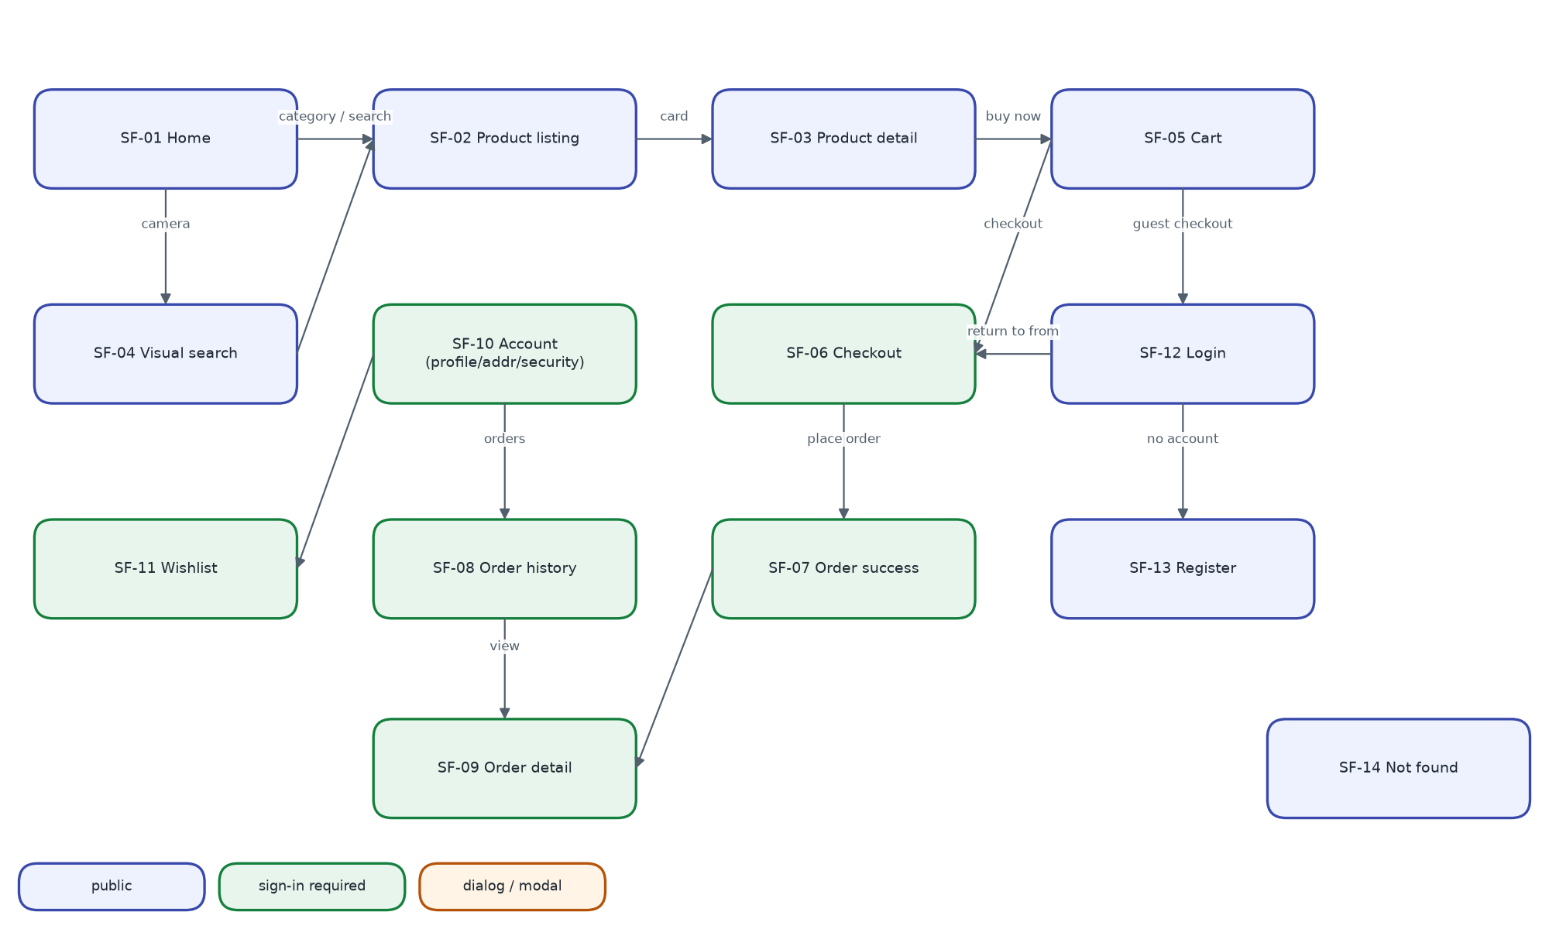
Figure 1 – Storefront screen transitions
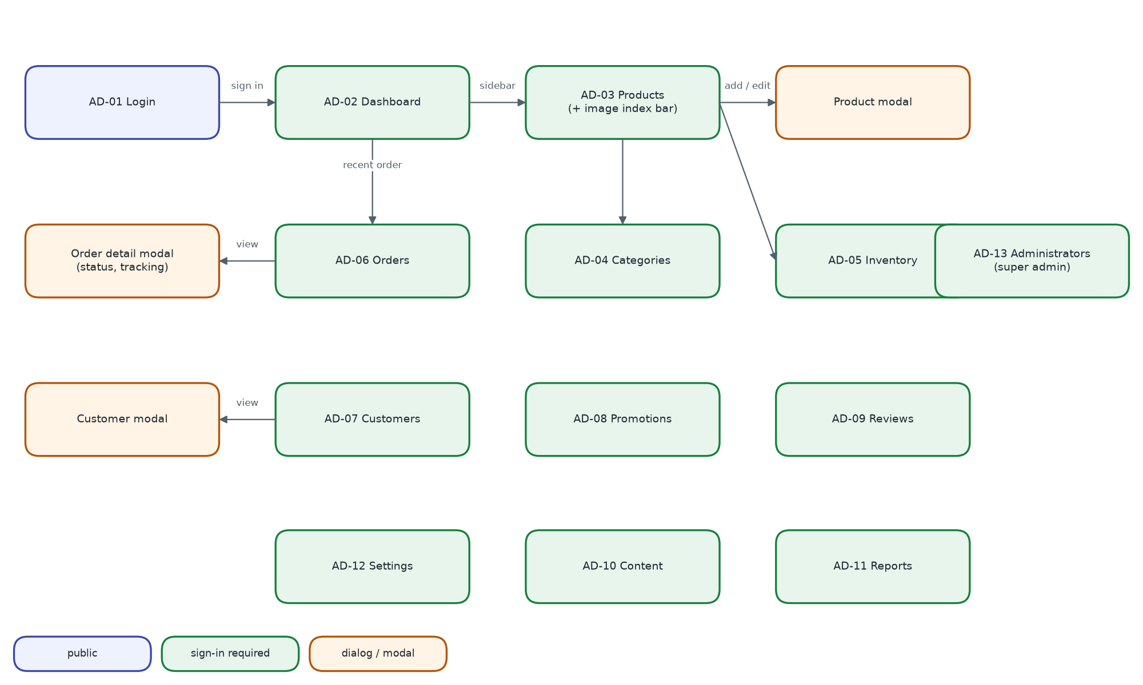
Figure 2 – Admin panel screen transitions (every page is also reachable from the sidebar)
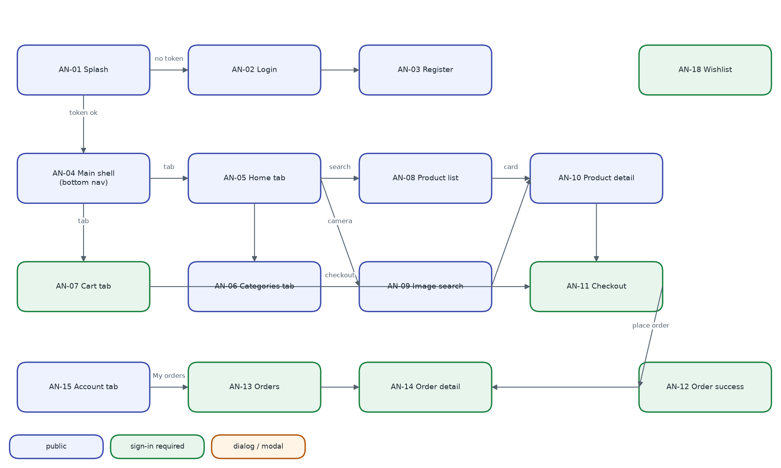
Figure 3 – Android screen transitions

2.5 Product-area selector (green box)
One interaction pattern is used on three screens (SF-04, AD-03, AN-09): a photo with the product area drawn as a glowing green rectangle. It is specified once here; the screen specifications refer to it.
Table 7 – Green-box interaction specification
Aspect | Specification
Rectangle | 2 px solid #22C55E border, 4 px corner radius; glow = 8–18 px green shadow pulsing every 1.8 s (static when reduced motion is requested); outside of the rectangle dimmed with rgba(11, 31, 20, 0.38)
Handles | 8 handles (corners and edge midpoints), white fill, 2 px #16A34A ring; 14 px on pointer devices, 22 px on touch (web), 12 dp drawn / 24 dp touch target (Android)
Move | Drag inside the rectangle; the rectangle is kept inside the photo
Resize | Drag a handle; minimum side 4 % of the photo
Draw new | Drag on the photo outside the rectangle
Keyboard | Tab focuses the rectangle; arrow keys move 1 % (Alt: 0.2 %), Shift + arrows resize; the search runs 450 ms after the last key
When it searches | Once per finished gesture (pointer up / touch up), never during a drag
Disabled | While the first detection runs: progress cursor, handles hidden
Status line | Detected: “Searching the product in the green box.” · Adjusted: “Searching the area you selected.” · Nothing found: “No single product stood out, so the whole photo is searched…”
Actions | “Use detected area” (enabled only after an adjustment) · “Search whole photo” (disabled when the rectangle already is the whole photo)
Accessibility | Rectangle is a focusable group with an aria-label describing the keys; forced-colours mode uses Highlight; Android content description explains the gestures

Table 8 – Main messages in the three languages
Key | English | 中文 | 日本語
regionAuto | Searching the product in the green box. | 正在搜索绿色框中的商品。 | 緑の枠内の商品を検索しています。
regionAdjusted | Searching the area you selected. | 正在搜索您选择的区域。 | 選択した範囲を検索しています。
resetRegion | Use detected area | 使用自动识别区域 | 自動検出の範囲に戻す
wholePhoto | Search whole photo | 搜索整张照片 | 写真全体を検索
products.region.manual | Adjusted by you | 已手动调整 | 手動で調整済み

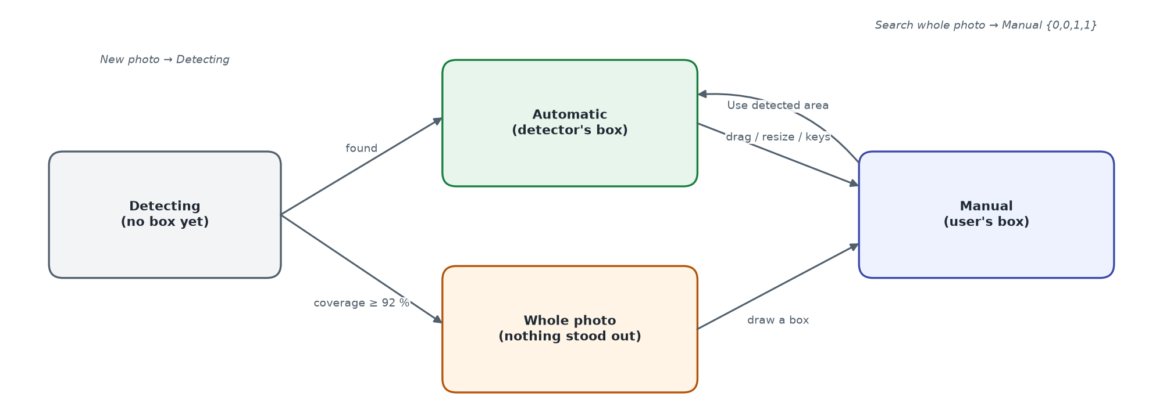
Figure 4 – Search-area states and the actions that change them

2.6 Storefront screen specifications

2.6.1 Global header, footer and mobile navigation
- Top bar: shipping, money-back and support promises; compact language switcher; USD label.
- Main bar: brand (links to /), search with type-ahead (≥ 2 chars, 280 ms, 5 suggestions + “See all results”), camera button (only when image search is available), sign-in/register or user menu (account, orders, addresses, settings, sign out), wishlist and cart icons with count badges.
- Category nav: “All categories” plus up to 9 root categories; active category highlighted.
- Footer: brand, contact, shop links, help links, accepted payments, copyright.
- Mobile (≤ 768 px): compact header and bottom tab bar Home · Categories · Cart · Wishlist · Account.

2.6.2 SF-01 Home
Field | Description
Purpose | Entry point that exposes categories, promotions and product selections
Layout | Department rail · hero carousel · 4 promise cards / category ring chips / deal band (Hot deals, Best-seller top 5, promo tile) / trust strip / New arrivals / Active promotions / Featured products
Data | GET /banners?placement=hero, /categories?parent=root&withCounts=true, /products/featured, /products/best-sellers, /products?sort=newest&limit=6, /promotions — in parallel; refetched on language change
Actions | Carousel prev/next/dots (manual); category chip → SF-02 filtered; “See all” → SF-02 with sort/flag; product card → SF-03; Add to cart; wishlist heart
States | Skeleton grids while loading; a failed section renders empty

2.6.3 SF-02 Product listing
Field | Description
Purpose | Filter, sort and page through products
Layout | Breadcrumb · left filter panel (Category radio, Price min/max, Brand checkboxes, Colour swatches, Rating “& up”, Availability) · toolbar (title, count, Filters toggle ≤ 1024 px, Sort) · active-filter chips · product grid · pagination
Data | GET /categories?withCounts=true, /products/filters?category=…, /products?{query}
Behaviour | All state in the URL query; any filter change resets page to 1; pagination window of 5 with first/last and ellipses
Sort options | Best selling (default), Newest, Price low–high, Price high–low, Rating, Name A–Z
States | 8-card skeleton; empty state with “Clear all filters”

2.6.4 SF-03 Product detail
Field | Description
Purpose | Evaluate and buy one product
Layout | Breadcrumb · gallery (thumbnails + zoomable main image) · info column (brand, SKU, featured badge, name, rating/reviews/sold, price + compare + % off, short description, colour swatches, size chips, quantity stepper, stock badge, Add to cart, Buy now, wishlist) · trust row · tabs Description / Specs / Reviews · related products
Data | GET /products/:slug, /related, /reviews?limit=10, /reviews/summary
Validation | Quantity 1..stock; out-of-stock sizes disabled; buttons disabled when out of stock or busy
Review form | Star picker 1–5 (default 5), title, comment; disabled for guests with sign-in link; POST /reviews then summary refresh
States | Spinner; not found → empty state “Browse products”

2.6.5 SF-04 Visual search (updated)
Field | Description
Purpose | Find products similar to the product in a photo
Layout | Left (340 px; full width ≤ 860 px): photo with green box, status line, “Use detected area” / “Search whole photo”, hint, “Try another photo”. Right: result count and grid with “N % match” labels
Data | POST /products/visual-search?limit=24 (multipart image, optional box); response data[] + region
Behaviour | New photo → automatic detection; adjusted box → new search with that box; language change → same search again
States | Skeleton while searching; 503 → “Image search is not available right now”; empty → “Nothing similar found”

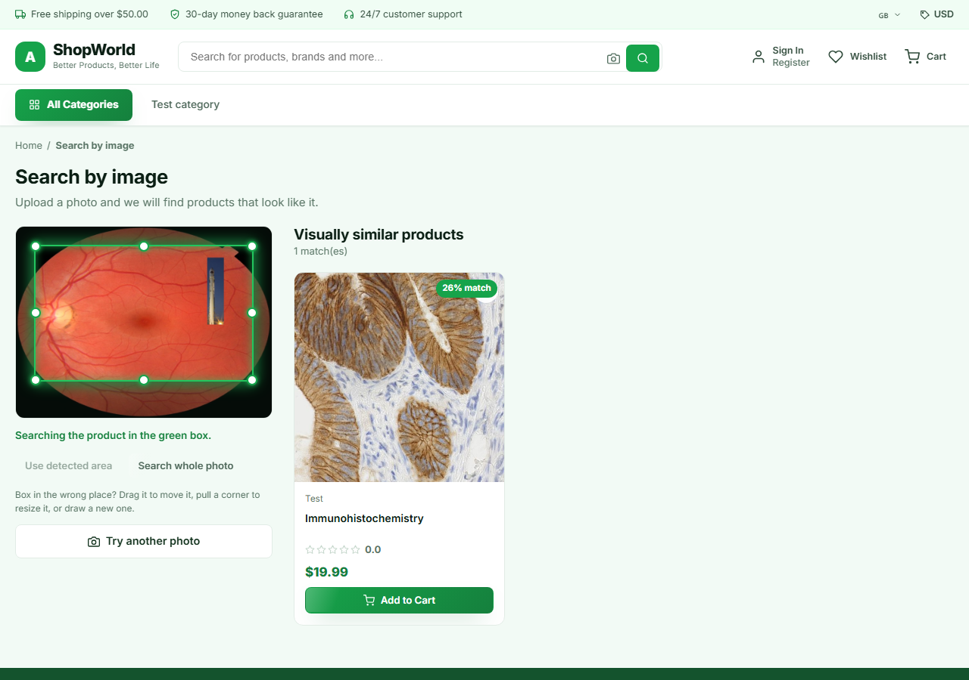
Figure 5 – SF-04 – detection on a busy background puts the box in the wrong place (top result 26 %)
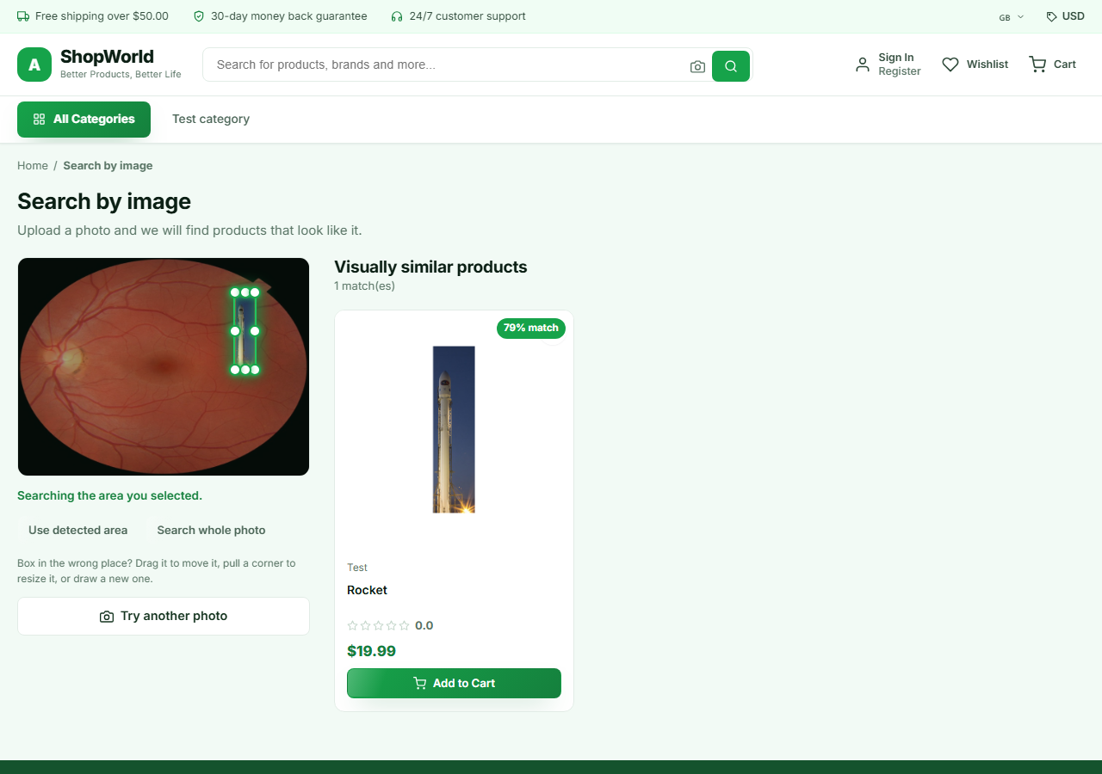
Figure 6 – SF-04 – after the user resized the box onto the rocket, the correct product ranks first (79 %)
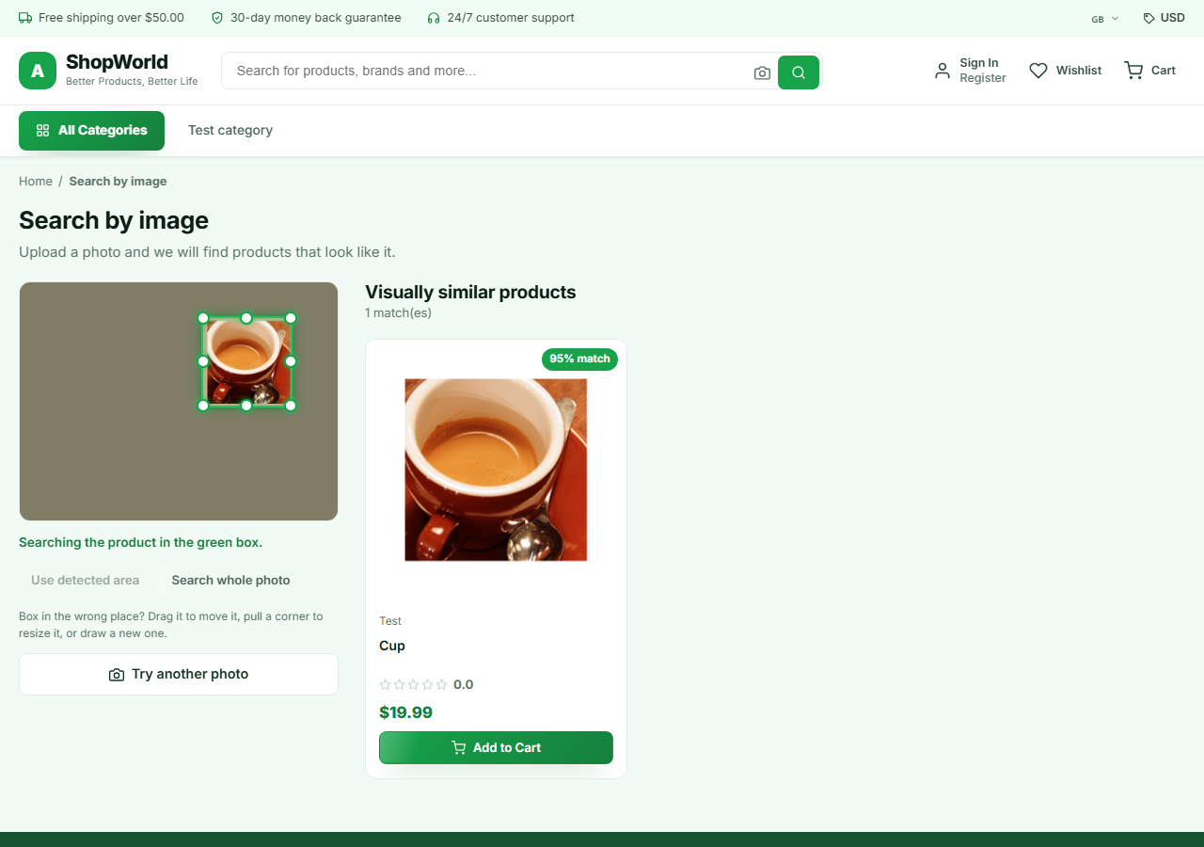
Figure 7 – SF-04 – plain background: the box fits the cup automatically (95 %)
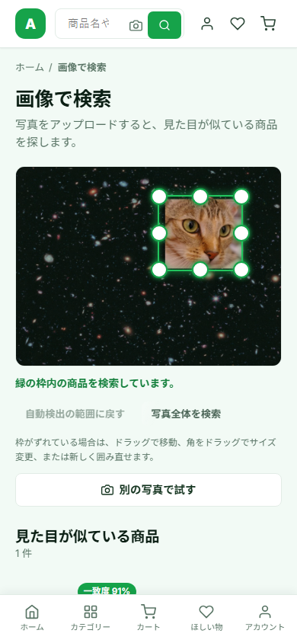
Figure 8 – SF-04 – phone width, Japanese

2.6.6 SF-05 Cart
Field | Description
Purpose | Review items and totals, apply a promo code
Layout | Title “Cart (n)” with Continue shopping and Clear cart · free-shipping progress bar · line list (image, name, variant, unit price, quantity stepper, remove, line total) · summary (subtotal, discount, shipping, tax, total) · promo code field · Proceed to checkout
Data | GET /cart; PATCH/DELETE /cart/items/:id; DELETE /cart; POST/DELETE /cart/coupon
Validation | Quantity 1..min(stock, 99); promo code upper-cased, Apply disabled when empty; guests must sign in to use a code
States | Empty → “Start shopping”; the line being updated is disabled; server notices shown as info toasts

2.6.7 SF-06 Checkout
Field | Description
Purpose | Collect address and payment and place the order
Layout | Step indicator 1 Shipping · 2 Payment · 3 Complete; right-hand summary always visible
Step 1 fields | Saved-address radio cards or new address: full name*, phone, street*, city*, state, ZIP*, country* (default Finland); “Save to my addresses”
Step 2 fields | Card / PayPal / Apple Pay / Cash on delivery. Card: number (≥ 12 digits), name*, expiry NN/NN or NN/NNNN, CVC 3–4 digits; demo-gateway notice
Step 3 | Shipping and payment cards with Edit links; items; “Place order – $total” → POST /orders
States | Spinner “Preparing…”; empty cart → “Browse products”; failure → toast and back to step 2; success → SF-07 (replace)

2.6.8 SF-07 Order success
Field | Description
Content | Check icon, order number, status badge, items, total paid, carrier, tracking number, estimated delivery
Actions | View order → SF-09; Continue shopping → SF-02

2.6.9 SF-08 Order history
Field | Description
Layout | Status chips (all, pending, processing, shipped, delivered, cancelled) · order cards (number, date, total, status badge, up to 3 items, “+N more”) · pagination (8 per page)
Data | GET /orders?status=&page=&limit=8
States | Spinner; empty message per filter with “Start shopping”

2.6.10 SF-09 Order detail
Field | Description
Layout | Header (order no., date, status, Cancel order) · tracking card (carrier, tracking no., ETA, timeline) · items · payment summary · shipping address
Data | GET /orders/:no, /orders/:no/track; POST /orders/:no/cancel
Rules | Cancel shown only for pending/processing; confirmation dialog; cancelled orders show the reason

2.6.11 SF-10 Account
Field | Description
Layout | Side navigation: Profile, Addresses, Orders, Wishlist, Security, Sign out
SF-10a Profile | Name, e-mail (read-only), phone, preferred language, member since → PATCH /users/profile
SF-10b Addresses | Address cards with Make default, Edit, Delete; inline form (label, full name*, street*, city*, state, ZIP*, country*, phone)
SF-10c Security | Current password*, new password* (≥ 6), confirm*; mismatch → error; success → sign out and SF-12

2.6.12 SF-11 Wishlist
Field | Description
Content | Product grid of saved items; heart removes an item; empty state “Browse products”
Data | GET /users/wishlist; POST /users/wishlist/:id

2.6.13 SF-12 Sign in
Field | Description
Layout | Card (brand, “Welcome back”, language switcher, demo-account buttons, e-mail, password, Sign in, link to Register) + decorative brand panel (hidden ≤ 860 px); no header/footer
Behaviour | POST /auth/login → merge guest cart → welcome toast → return to from page or Home
Errors | Alert box with server message

2.6.14 SF-13 Register
Field | Description
Fields | Name* (≥ 2), e-mail*, phone, password* (≥ 6, hint), confirm password*
Behaviour | Mismatch → field error; server errors[] mapped to fields; success → merge cart, toast, Home

2.6.15 SF-14 Not found
Field | Description
Content | Search icon, title, message, “Back home”

2.7 Admin panel screen specifications
Layout for all pages: left sidebar grouped Overview / Catalog / Sales / Engagement / Insights with Storefront link and Sign out; top bar with menu toggle, page title, language switcher and user chip. Tables page at 20 rows; search boxes debounce 260 ms; deletes use a confirmation modal.

2.7.1 AD-01 Staff sign in
Field | Description
Fields | E-mail*, password*; demo buttons Admin / Manager
Behaviour | Customer accounts rejected; success → toast “Signed in as {name}” → previous page or Dashboard

2.7.2 AD-02 Dashboard
Field | Description
Controls | Range chips 7 Days · 30 Days (default) · 3 Months · 1 Year
KPI cards | Total revenue, Total orders, Total customers, Conversion rate — each with % change versus previous period
Charts | Sales overview (area, revenue per day); Sales by category (donut, top 5 + Other); Customer growth (area, 6 months)
Lists | Recent orders (ID → Orders search, customer, date, status, total); Top products (image, name, sold, stock, price)
States | Spinner “Loading dashboard…”; error → empty state “Could not load the dashboard”

2.7.3 AD-03 Products
Field | Description
Header | Product count, Add Product; image-search bar (model status, “N of M products indexed · V vectors”, Rebuild index, Re-extract all, progress polled every 2 s)
Filters | Search, category, status (active/inactive), stock (low/out)
Table | Image, name (brand · SKU), category, price (currency, compare), stock, stock badge, Active switch (optimistic), image-search badge, actions (re-extract, edit, delete)
Modal fields | Name*, brand, category*, currency USD/REM, price* ≥ 0, compare at, cost, stock* ≥ 0, colours, short description (≤ 300), description, tags, images (upload ≤ 8, remove), Active, Featured, Free shipping, zh/ja translations
Rules | Server errors mapped under fields; warning toast if image indexing failed; delete confirmation mentions reviews are deleted too

2.7.4 AD-03 Products – product area of each image (added)
Field | Description
Thumbnails | Each image thumbnail shows its area as a small green rectangle (dashed when adjusted by staff); a spinner while detection runs. Hint: “The green box on each image marks the detected product. Click an image to adjust it.”
Editor | Clicking a thumbnail opens the inline panel “Product area for image search” below the images: status badge (Detected automatically / Adjusted by you / Nothing stood out / Not detected yet), the photo with the green box, hint, buttons Detect again · Use whole image · Done
Data | POST /admin/visual-search/detect {image} on upload and on “Detect again”; imageRegions sent with Save
Rules | Adjusting sets auto = false; removing an image removes its region; the editor is inline (not a nested dialog) so Esc still closes only the product dialog

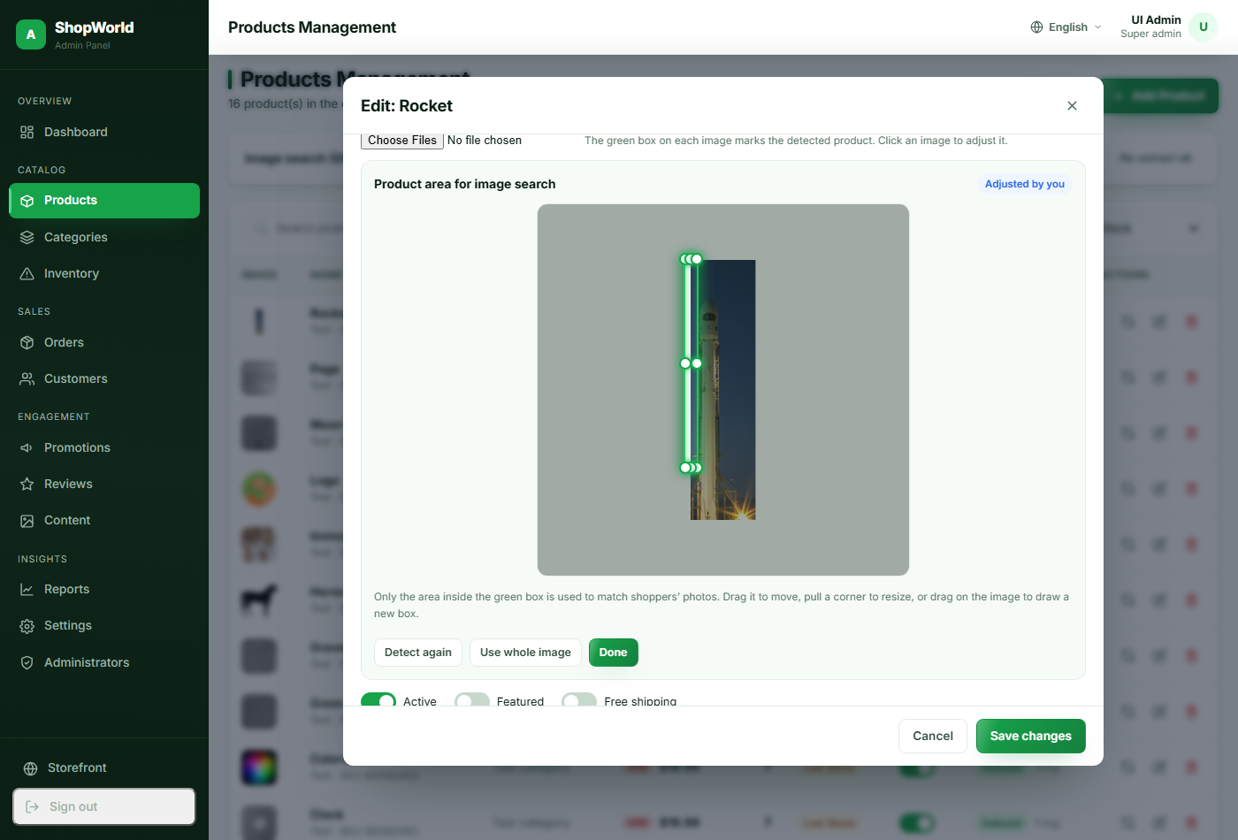
Figure 9 – AD-03 – editing the product area of a catalogue image

2.7.5 AD-04 Categories
Field | Description
Table | Name (image), slug, parent, product count, order, status (Active/Hidden), actions
Modal fields | Name* (≥ 2), description, parent (top level or a root category, not itself), sort order, Visible switch, translations
Rules | Delete refused (409) while products or children exist

2.7.6 AD-05 Inventory
Field | Description
KPI cards | Out of stock, Low stock, Needs attention
Table | Product (image, name, SKU), category, price, current stock, status badge, New stock input + Save
Validation | New stock must be a number ≥ 0; success toast “{name} restocked to {n}” and reload

2.7.7 AD-06 Orders
Field | Description
Filters | Search (order no., customer, e-mail; can be pre-filled from Dashboard); status tabs with counts
Table | Order ID, date, customer (name, e-mail), items, total, payment badge, status badge, View
Detail modal | Status and payment badges; carrier + tracking inputs with Save; customer and shipping cards; items; totals; timeline; optional status note; “Mark as {next status}” buttons (Cancel in red) or “No further changes”
Rules | Only allowed transitions are offered (see the order state machine in the System Design Specification); no confirmation before a status change (finding F-09)

2.7.8 AD-07 Customers
Field | Description
Controls | Search, status filter, Export CSV
Table | Name, e-mail, phone, orders, total spent, joined, Active switch, View
Detail modal | Orders, total spent, average order, reviews; contact; addresses; recent orders
Export | Downloads customers.csv (all customers, localised headers, UTF-8 BOM)

2.7.9 AD-08 Promotions
Field | Description
Table | Code + description, discount (x % or amount, max cap), min purchase, used/limit, expires, status Active/Paused/Expired, actions
Modal fields | Code* (≥ 3, upper case), type* percent/fixed, description, value* ≥ 0, min purchase, max discount (0 = uncapped), usage limit (0 = unlimited), expiry date, Active

2.7.10 AD-09 Reviews
Field | Description
Filters | Tabs All / Published / Hidden; rating 1–5
Table | Product, customer (Verified badge), stars, title + comment, date, status, Publish/Hide toggle, Delete

2.7.11 AD-10 Content (banners)
Field | Description
Layout | Card grid: image, placement badge (Homepage hero / Promo strip / Mobile app), Live/Hidden, title, subtitle, CTA, Edit, Delete
Modal fields | Title*, subtitle, button text (Shop Now), button link (/products), placement, sort order, image, Live, translations

2.7.12 AD-11 Reports
Field | Description
Content | Range chips (default 3 months); KPI cards Revenue, Orders, Average order value, Active products; line chart orders per day; bar chart revenue by category; bar chart new customers per month (12); best-selling products table (units, revenue, stock)

2.7.13 AD-12 Settings
Field | Description
Content | Account card (name, e-mail, role, last sign-in, panel language); environment card (API and asset URLs, storefront link); change password form (current*, new* ≥ 6, confirm*)
Behaviour | Password change → forced sign-out → AD-01

2.7.14 AD-13 Administrators
Field | Description
Access | Menu shown to super admins only; API returns 403 to others
Table | Name + e-mail, role badge, permission badges (or “All sections”), status, last sign-in, Edit/Delete (disabled for super admins)
Modal fields | Full name*, e-mail* (not editable later), password (required on create, ≥ 6; blank keeps), role manager/admin, section checkboxes (7), Account active

2.8 Android screen specifications
Material 3 light theme (primary #16A34A). Activities slide horizontally; tabs and splash cross-fade. Pull-to-refresh on lists; snackbars for errors; guests who try a member action are sent to AN-02.

2.8.1 AN-01 Splash
Field | Description
Behaviour | No token → AN-02; token → GET /auth/me → AN-04, or clear session → AN-02

2.8.2 AN-02 Sign in
Field | Description
Elements | Logo, tagline, demo hint (tap to fill), error text, e-mail, password, Sign in, “No account?”, Continue as guest
Validation | E-mail format; password ≥ 6; inline errors; buttons disabled while loading

2.8.3 AN-03 Register
Field | Description
Elements | Full name (≥ 2), e-mail, phone (optional), password (≥ 6), confirm (must match), Sign up

2.8.4 AN-04 Main shell
Field | Description
Elements | Fragment container + bottom navigation: Home, Categories, Cart (badge), Account; EXTRA_TAB selects start tab

2.8.5 AN-05 Home tab
Field | Description
Elements | Search bar with camera icon (visible when image search available) and wishlist icon; hero ViewPager2 (auto-advance 5 s); category chips; Featured row; Best-seller 2-column grid; “See all” links
Data | banners, root categories, featured, best sellers, visual-search status

2.8.6 AN-06 Categories tab
Field | Description
Elements | Title, search bar, category rows with counts; empty state “No categories yet”

2.8.7 AN-07 Cart tab
Field | Description
Elements | “Your cart (n)”, Clear, free-shipping hint, item list with steppers and remove, promo field + Apply, applied-coupon row, summary card, Checkout
States | Signed out → sign-in prompt; empty → Start shopping; notices as snackbars

2.8.8 AN-08 Product list
Field | Description
Elements | Toolbar title, search (320 ms debounce), camera button, sort dialog, result count, 2-column grid with endless scroll (page 12)

2.8.9 AN-09 Search by image (updated)
Field | Description
Elements | Camera / Gallery buttons; RegionSelectorView (220 dp high, fit-centre photo with green box and 8 handles); status line; text buttons “Use detected area” and “Whole photo”; result count; 2-column results with “% match”
Behaviour | Photo → on-device detection (320 px) → crop → on-device embedding → vector search. Box change → re-crop and search. No model → upload; the server's region is drawn. Rotation keeps the user's box
States | Finding the product… · Detected · Adjusted · Nothing stood out · Unreadable photo · Failed

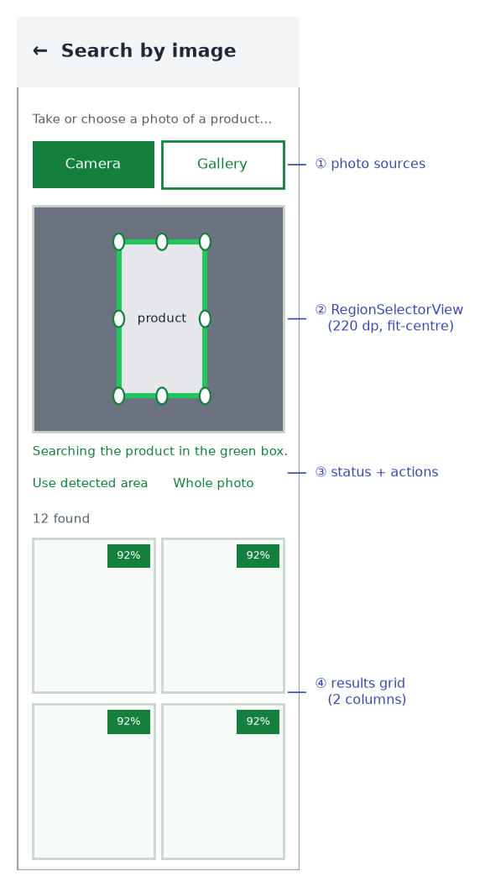
Figure 10 – AN-09 wireframe

2.8.10 AN-10 Product detail
Field | Description
Elements | Image pager with dots, discount badge, wishlist, brand · SKU, name, rating, sold, price/compare, stock badge, variant chips, stepper, shipping/warranty/returns badges, description, 5 reviews + Write review dialog, related row, bottom bar Add to cart / Buy now

2.8.11 AN-11 Checkout
Field | Description
Elements | Address radio group + Add address dialog; payment radio group; card box (number, name); order summary; “Place order · $total”
Validation | Required address fields; card number ≥ 12 digits

2.8.12 AN-12 Order success
Field | Description
Elements | Success icon, order number, items, total, carrier · tracking, ETA, View order, Continue shopping

2.8.13 AN-13 Orders
Field | Description
Elements | Status chips, order list with endless scroll (10), pull to refresh

2.8.14 AN-14 Order detail
Field | Description
Elements | Number, date, status, tracking, timeline, items, totals, payment, address, Cancel order (pending/processing, confirmation)

2.8.15 AN-15 Account tab
Field | Description
Elements | Avatar initial, name, e-mail, Edit profile dialog; rows My orders, Addresses, Wishlist, Language (System/English/中文/日本語), Settings; Sign out; version

2.8.16 AN-16 Addresses
Field | Description
Elements | Address cards with Make default and Delete (confirmation); Add (+) opens address dialog; empty state

2.8.17 AN-18 Wishlist
Field | Description
Elements | 2-column grid; open, add to cart, remove; guests redirected to sign-in

