ShopWorld E-Commerce Platform
System Design Specification
Architecture description · Detailed design · Data design · Interface design

Item | Value
Document ID | SW-SDS-001
Version | 1.1 – adds automatic product-area detection (green box)
Date | 25 September 2026
Status | Draft – for technical review
System | ShopWorld E-Commerce Platform (repository eshop-web, internal code name “auramart”)
Baseline | Git branch main, commit b2e8dbe plus the product-area change set
Standards applied | ISO/IEC/IEEE 12207:2017, 15289:2019, 29148:2018, 42010:2022, ISO/IEC 25010:2023, ISO 9241-110:2020, ISO/IEC/IEEE 29119-3:2021
Classification | Internal

Document control
Revision history
Version | Date | Author | Description of change
1.0 | 2026-09-25 | Development team | Baseline derived from the source code
1.1 | 2026-09-25 | Development team | Automatic product-area detection with an adjustable glowing green box for image search and product image registration (web, admin, Android, API); split into four specifications

Review and approval
Role | Name | Signature | Date
Product owner
Technical lead / architect
Quality assurance lead

Related documents
ID | Document | Content
SW-SRS-001 | Software Requirements Specification | Stakeholder needs, functional and quality requirements, use cases
SW-SDS-001 | System Design Specification | Architecture, detailed design, data and interface design
SW-SCR-001 | Screen Design Specification | Design principles, screen inventory, transitions, per-screen specifications
SW-TCS-001 | Test Case Specification | Test strategy, test cases, execution results, traceability

Table of contents
Document control 2
1 Introduction 5
1.1 Purpose 5
1.2 Scope 5
1.3 Intended readers 5
1.4 Conformance to standards 5
1.5 Definitions 5
1.6 References 6
2 Architecture description 7
2.1 Stakeholders and concerns 7
2.2 Viewpoints 7
2.3 Container view 7
2.4 Backend layered view 9
2.5 Behaviour view 9
2.6 Deployment view 9
2.7 Architecture decisions 10
3 Detailed software design 11
3.1 Backend module decomposition 11
3.2 Authentication and session design 12
3.3 Pricing algorithm 12
3.4 Cart revalidation 13
3.5 Checkout and transaction design 13
3.6 Order life-cycle state machine 14
3.7 Image-search design 14
3.8 Security design 15
3.9 Internationalisation design 16
3.10 Error handling and logging 16
3.11 Web client design 16
3.12 Android client design 17
3.13 Product-area detection design 17
4 Data design 22
4.1 Logical data model 22
4.2 Collection specifications 22
4.3 Indexes and integrity rules 24
4.4 Data retention and seed data 24
5 Interface design 25
5.1 API conventions 25
5.2 Endpoint catalogue 25
5.3 Example exchange 26
5.4 Client–OS interfaces (Android) 26
6 Review findings and deviations 28
Appendix A – Configuration reference 29
Appendix B – Build, run and release procedure 29

1 Introduction

1.1 Purpose
This System Design Specification (SDS) describes how ShopWorld is built: its architecture (ISO/IEC/IEEE 42010 views), the detailed design of each module, the data model and the interfaces.
The document describes the system as built: statements were derived from the source code, and the product-area feature was verified by the tests reported in SW-TCS-001.

1.2 Scope
ShopWorld is a multi-channel shop with four software items sharing one REST API: the API (Node.js 18, Express 4, MongoDB 6), the customer storefront (React 18), the admin panel (React 18) and the Android app (Java, API 24–35). Version 1.1 documents the product-area detection design: a training-free detector over DINOv3 patch tokens, used by the API, the admin panel and the Android app.

1.3 Intended readers
Reader | Use of this document
Architect, developers | Chapters 2–5
Operations, security | Deployment view, security design, Appendix A
Reviewers | Chapter 6 known issues

1.4 Conformance to standards
Table 1 – Standards
Standard | Applied to
ISO/IEC/IEEE 42010:2022 | Stakeholders, concerns, viewpoints and views (chapter 2)
ISO/IEC/IEEE 15289:2019 | Software design description content (chapters 3–5)
ISO/IEC 27002:2022 | Security controls referenced in the security design
ISO/IEC/IEEE 12207:2017 | Architecture and design definition processes (tailored)

1.5 Definitions
Table 2 – Glossary
Term | Definition
Customer / Guest | Registered shopper (role customer) / visitor who is not signed in.
Staff / Super admin | Back-office roles manager, admin, superadmin; only a super admin manages staff accounts.
DINOv3 | Self-supervised vision transformer (ViT-S/16) that turns an image into a 384-number feature vector.
Patch token | The model's 384-number feature for one 16 × 16 pixel patch of the input image.
Embedding / vector | L2-normalised 384-d vector of an image; images are compared by cosine similarity.
Product area / region | Rectangle {x, y, w, h} in fractions (0–1) of the upright photo that shows the product; drawn as the glowing green box.
Automatic / manual region | A region chosen by the detector / one moved or resized by a user.
IoU | Intersection over union of two rectangles; 1 = identical, 0 = no overlap.
REM | Second listing currency; no exchange rate exists, so USD and REM cannot be mixed in a cart.
SF / AD / AN | Screen-ID prefixes: storefront, admin panel, Android.
UC / FR / NFR / TC | Use case, functional requirement, non-functional requirement, test case identifiers.

1.6 References
ID | Reference
[R1] | Repository README.md, backend/README.md, backend/ml/README.md, android/README.md
[R2] | backend/src – routes, controllers, services, models (authoritative for business rules)
[R3] | backend/.env.example, backend/src/config/env.js – configuration
[R4] | SW-SRS-001, SW-SDS-001, SW-SCR-001, SW-TCS-001 – this document set
[R5] | DINOv3 model card, onnx-community/dinov3-vits16-pretrain-lvd1689m-ONNX

2 Architecture description
This section is an architecture description in the sense of ISO/IEC/IEEE 42010:2022. It identifies the stakeholders' architecture concerns, the viewpoints chosen to address them, the resulting views and the decisions with their rationale.

2.1 Stakeholders and concerns
Table 3 – Architecture concerns
Concern | Stakeholders | Addressed by view
What does the system interact with? | All | Context view (SRS, product perspective)
Which deployable parts exist and how do they communicate? | Architect, developers, operations | Container view
Where does each business rule live? | Developers, QA | Layered view, detailed design
How is it deployed and configured? | Operations | Deployment view, configuration reference
How is data structured and kept consistent? | Developers, DBA | Data design
How are users authenticated and data protected? | Security officer | Security design
How does image search work offline and on the phone? | Product owner, developers | Image-search and product-area design

2.2 Viewpoints
Table 4 – Viewpoints used
Viewpoint | Model kinds | Concerns framed
Context | Context diagram | Scope, external actors and systems
Functional / container | Box-and-line container diagram, layer diagram | Decomposition, responsibilities, technology
Information | Entity-relationship diagram, collection tables | Data ownership, integrity, indexing
Behaviour | Sequence diagrams, state machine | Critical flows: authentication, checkout, image search, order life cycle
Deployment | Deployment diagram, configuration table | Runtime nodes, ports, volumes, environment
Security (perspective) | Control table | Authentication, authorisation, input handling, transport, secrets

2.3 Container view
The system is a classic three-tier, API-centric architecture. The API is stateless (JWT), so it can be scaled horizontally, with one caveat: the image-search index is held in process memory and rebuilt lazily per process (see 6.7).
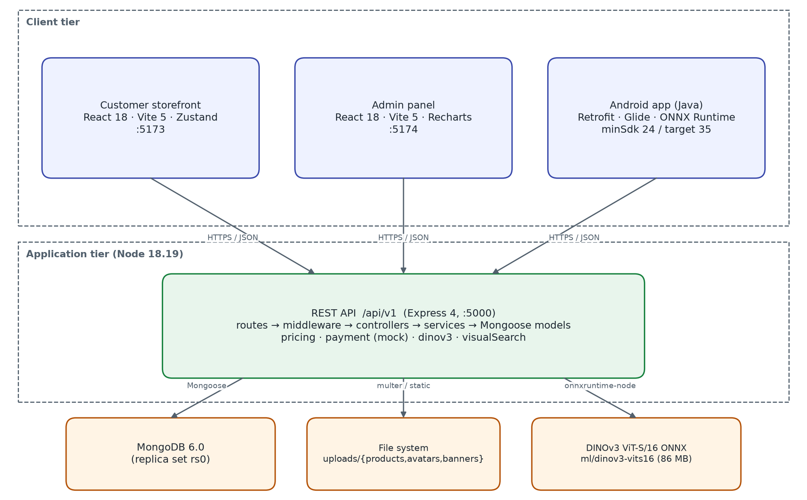
Figure 1 – Container view
Table 5 – Containers
Container | Responsibility | Key technology
Customer storefront | Shopping UI for browsers; guest cart; client-side routing; i18n | React 18, React Router 6, Zustand, Axios, Vite 5
Admin panel | Back-office UI; charts; CRUD forms; CSV download | React 18, Recharts 2, Zustand, Axios, Vite 5
Android app | Native shopping UI; on-device image embedding; share target | Java 17, AppCompat, Material 3, Retrofit 2.11, OkHttp 4.12, Glide 4.16, onnxruntime-android 1.22
REST API | All business rules, persistence, authentication, uploads, image search | Express 4.19, Mongoose 8, jsonwebtoken 9, bcryptjs, multer, sharp 0.34, onnxruntime-node 1.22
MongoDB | Documents for users, catalogue, carts, orders, reviews, coupons, banners, embeddings | MongoDB 6.0, replica set rs0
File store | Product, avatar and banner images served under /uploads (7-day cache) | Local disk / Docker bind mount
Model files | DINOv3 ViT-S/16 ONNX weights and preprocessing config | 86 MB fp32; also bundled in the APK

2.4 Backend layered view
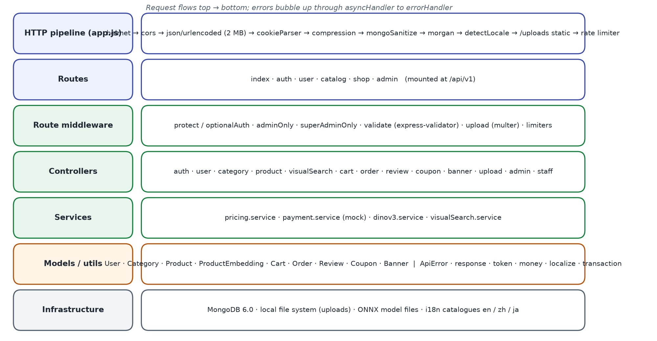
Figure 2 – Backend layers and HTTP pipeline
Each route file binds URL patterns to middleware and a controller. Controllers are thin: they parse the request, call models and services, and answer through utils/response.ok(). Errors are thrown as ApiError(status, i18nKey) and translated by the central error handler. Business rules that are used by more than one controller live in services (pricing, payment, dinov3, visualSearch).

2.5 Behaviour view
The critical flows are specified as sequence diagrams in the detailed design: authentication and token refresh, checkout, and image search with product-area detection. The order life cycle is specified as a state machine.

2.6 Deployment view
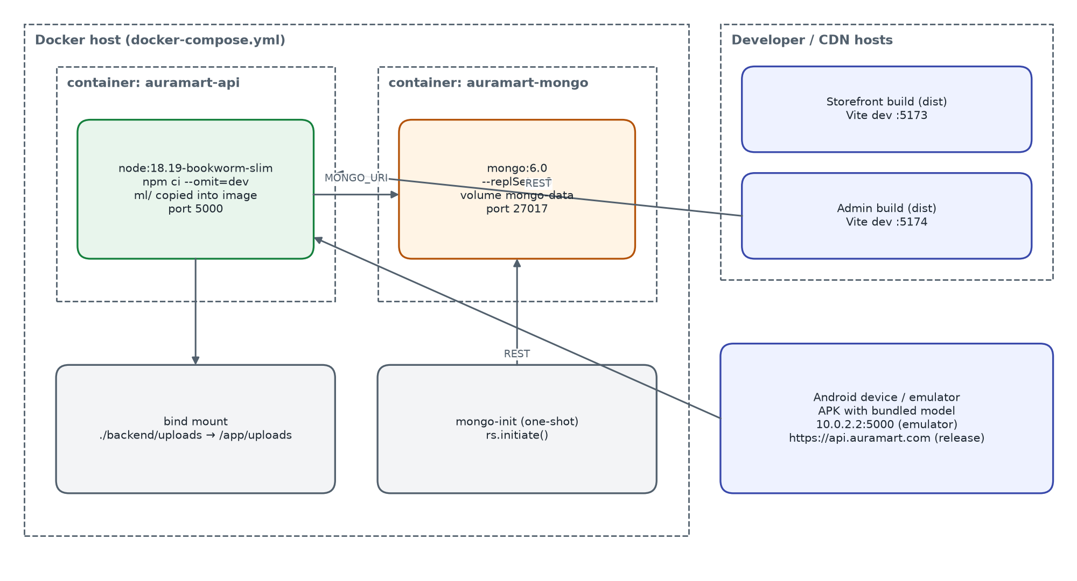
Figure 3 – Deployment view (development / single-host)
docker-compose.yml starts MongoDB 6.0 as a single-node replica set (so checkout runs in a real transaction), a one-shot mongo-init container that initiates the replica set, and the API container built from backend/Dockerfile (node:18.19-bookworm-slim, production dependencies only, model files copied into the image). The two React apps are built to static files (npm run build) and can be served by any web server or CDN; during development Vite serves them on ports 5173 and 5174. Configuration is by environment variables (see the configuration reference).

2.7 Architecture decisions
Table 6 – Architecture decisions
ID | Decision | Rationale | Consequences
AD-01 | One REST API for all clients | Single place for rules; web and Android behave the same | API versioning needed for breaking changes
AD-02 | MongoDB document model with embedded addresses, order snapshots | Orders must not change when products change; fewer joins | Denormalised data; aggregation for reports
AD-03 | Stateless JWT access token + rotated refresh token stored per user | Horizontal scaling; revocation on password change and deactivation | Access token valid up to 15 min after revocation
AD-04 | Pricing centralised in pricing.service | Cart, preview and order can never disagree | Guest-cart display on web duplicates the formula
AD-05 | Conditional atomic stock decrement inside a transaction | No overselling under concurrency | Replica set recommended; manual rollback path on standalone
AD-06 | Self-hosted DINOv3 with ONNX Runtime | No per-call cost, works offline, same model on phone | 86 MB model in image and APK; CPU inference
AD-07 | Brute-force in-memory cosine search | Simple and exact for catalogues up to ~100 k images | Memory per process; rebuild on change; ANN index needed beyond that scale
AD-08 | On-device embedding on Android, upload fallback | Less data sent, privacy (photo stays on phone) | Model id must match server; larger APK
AD-09 | i18n by key catalogues + per-document translations | Three languages with English fallback | Every new text needs three entries
AD-10 | No UI framework; CSS custom properties | Small bundles, consistent brand on web | Components maintained in-house

3 Detailed software design

3.1 Backend module decomposition
Table 7 – Backend modules
Module | Files | Responsibilities
Configuration | config/env.js, db.js, constants.js | Environment parsing with defaults; MongoDB connection (pool 20, 10 s selection timeout); roles, permissions, order flow, stock thresholds
Auth | routes/auth, controllers/auth, middleware/auth, utils/token | Register, login, refresh rotation, logout, me, password; protect, optionalAuth, adminOnly, superAdminOnly
Users | controllers/user | Profile, avatar, language, address book (single default), wishlist toggle
Catalogue | controllers/category, product, banner, coupon (public part) | Category tree and counts, product query builder with facets, related products, reviews listing, banners, promotions, coupon validation
Cart | controllers/cart | Server cart CRUD, merge, coupon attach/detach, buildCartPayload revalidation
Orders | controllers/order, services/payment, utils/transaction, utils/ids | Checkout, listing, tracking, customer cancel; order and tracking numbers
Reviews | controllers/review, models/Review | Create/update/delete, verified purchase, helpful counter, rating sync
Admin | controllers/admin, staff, upload, visualSearch | Dashboard aggregations, back-office CRUD, order workflow, CSV export, staff, uploads, image index
Pricing | services/pricing | computeTotals – the only implementation of order arithmetic
Image search | services/dinov3, services/visualSearch, models/ProductEmbedding | Model loading, preprocessing, inference queue, indexing, in-memory matrix search
i18n | middleware/locale, i18n/, utils/localize | Language detection, message catalogues, folding of translated catalogue fields
Cross-cutting | middleware/error, validate, rateLimit, upload; utils/ApiError, response, asyncHandler | Error mapping, validation to 422, rate limits, multer configuration, response envelope

3.2 Authentication and session design
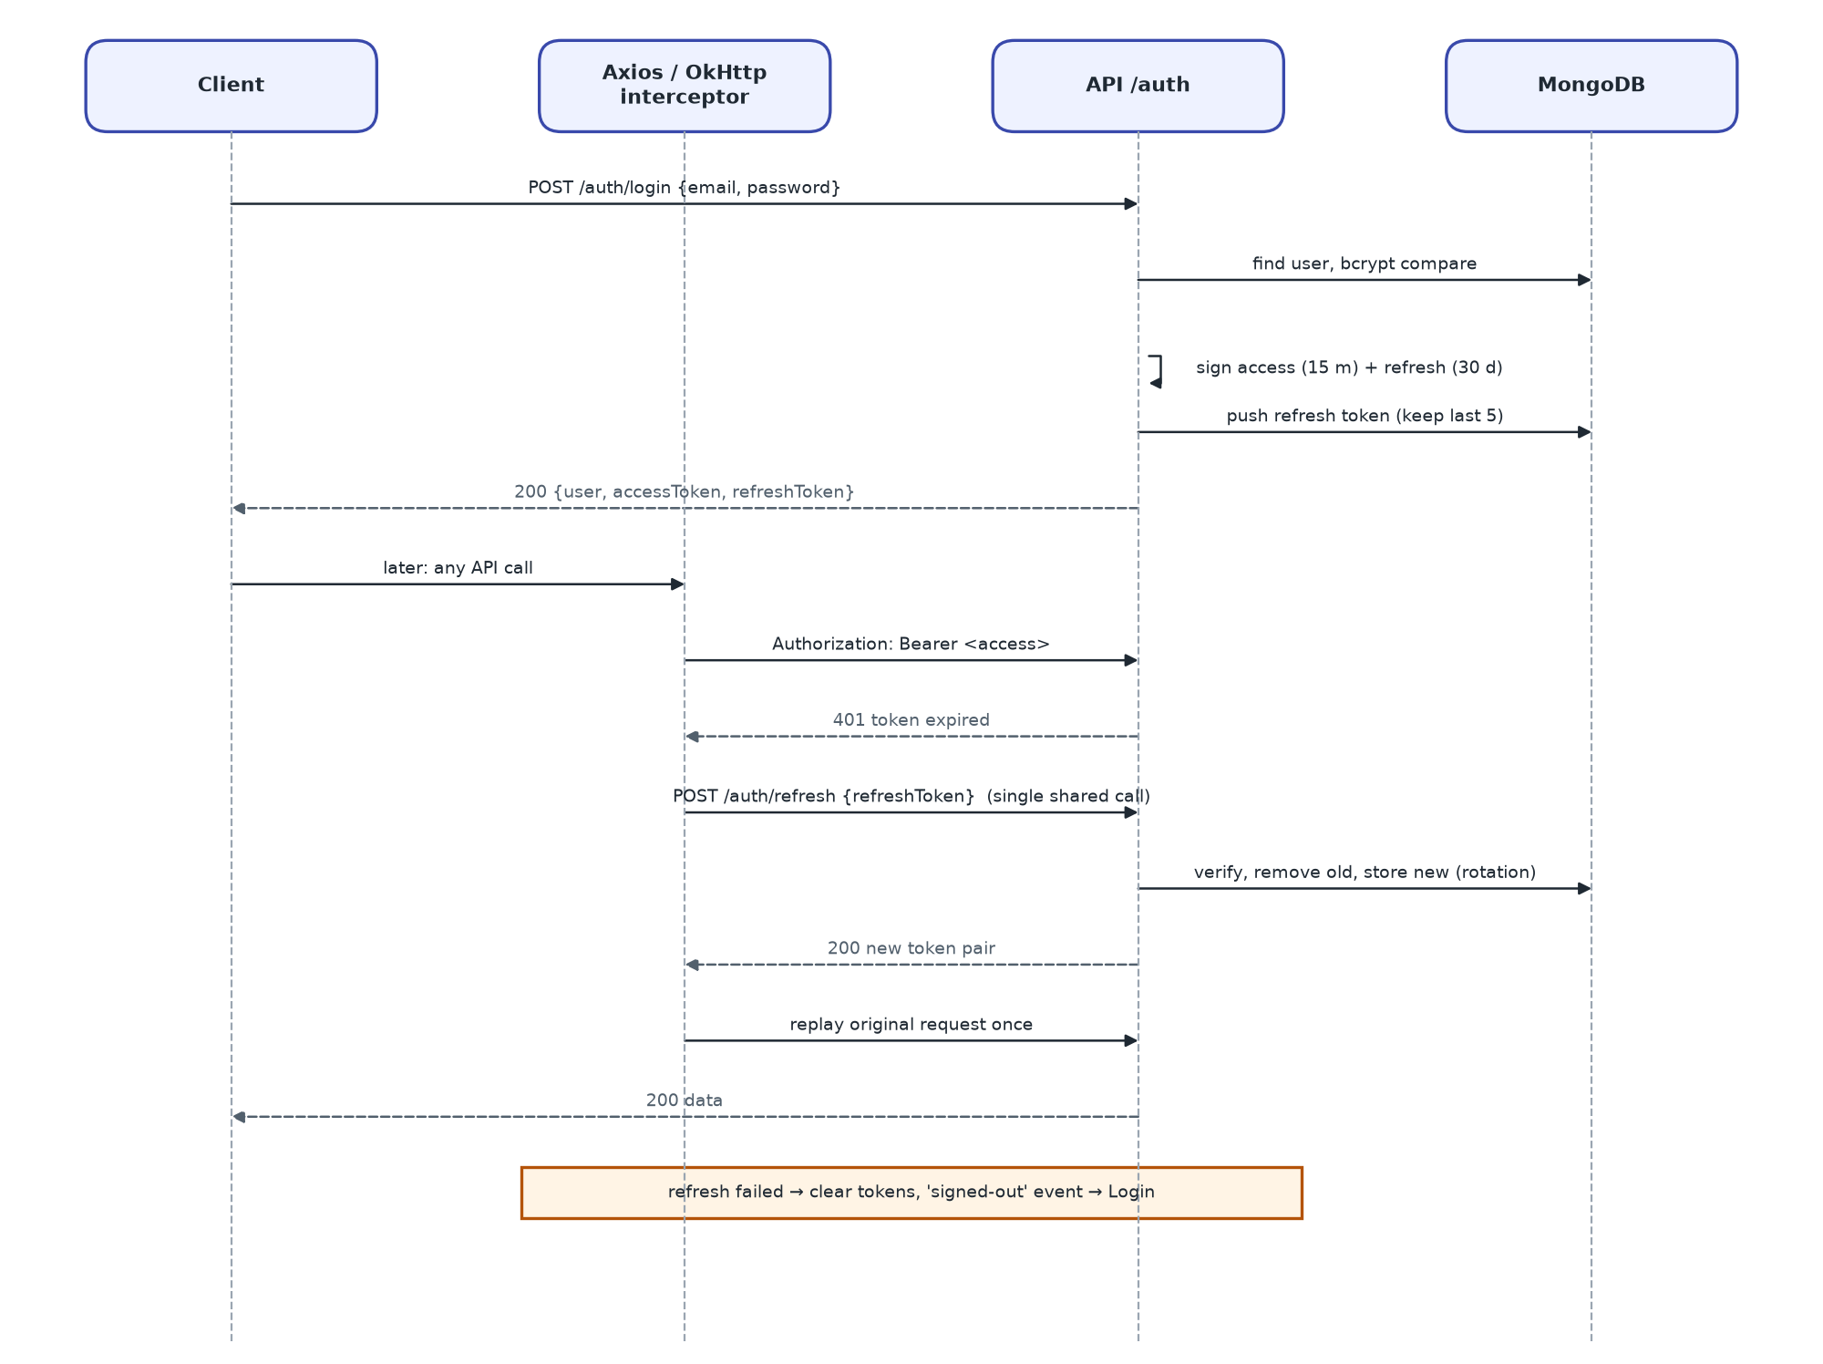
Figure 4 – Sign-in and transparent token refresh
- Tokens: access JWT {sub, role, email} signed with JWT_ACCESS_SECRET, 15 min; refresh JWT {sub, type:'refresh'} signed with JWT_REFRESH_SECRET, 30 days.
- Storage on the server: User.refreshTokens (hidden from queries) keeps the last 5 refresh tokens; reuse of a rotated token is rejected as revoked.
- Transport: Authorization: Bearer header or accessToken cookie; refresh token in the body or refreshToken cookie.
- Revocation: password change, staff role/permission change and deactivation clear all refresh tokens; protect also rejects inactive users on every request (403).
- Clients: web and admin use one shared in-flight refresh promise so concurrent 401s trigger a single refresh; Android serialises refresh with a lock inside an OkHttp interceptor.

3.3 Pricing algorithm
pricing.service.computeTotals(lines, {discount, freeShipping}) is called by the cart, the checkout preview, order placement and the seed script:
1. unit price = product.price + variant.priceDelta; subtotal = round2(Σ unit × quantity)
2. discount = min(coupon discount, subtotal); taxable = subtotal − discount
3. shipping = 0 if freeShipping option, or every item has freeShipping, or taxable ≥ FREE_SHIPPING_THRESHOLD (50), or taxable = 0; otherwise SHIPPING_FLAT_RATE (9.99)
4. tax = round2(taxable × TAX_RATE (0.10)) — shipping is not taxed
5. total = round2(taxable + shipping + tax)
Coupon discount: percent → subtotal × value / 100, fixed → value; capped by maxDiscount when > 0; rounded to cents; capped at the subtotal. Example: subtotal 120.00 with WELCOME10 → discount 12.00, taxable 108.00, shipping 0, tax 10.80, total 118.80.

3.4 Cart revalidation
Every cart read or write passes through buildCartPayload, which (1) removes lines whose product is missing, inactive or out of stock, (2) clamps quantities to available stock, (3) refreshes priceAtAdd from the current price, (4) re-checks the attached coupon and detaches it if no longer redeemable, and (5) returns {items, itemCount, coupon, totals, rules, notices}. notices are human-readable messages the clients show as toasts/snackbars, so the customer learns why the cart changed.

3.5 Checkout and transaction design
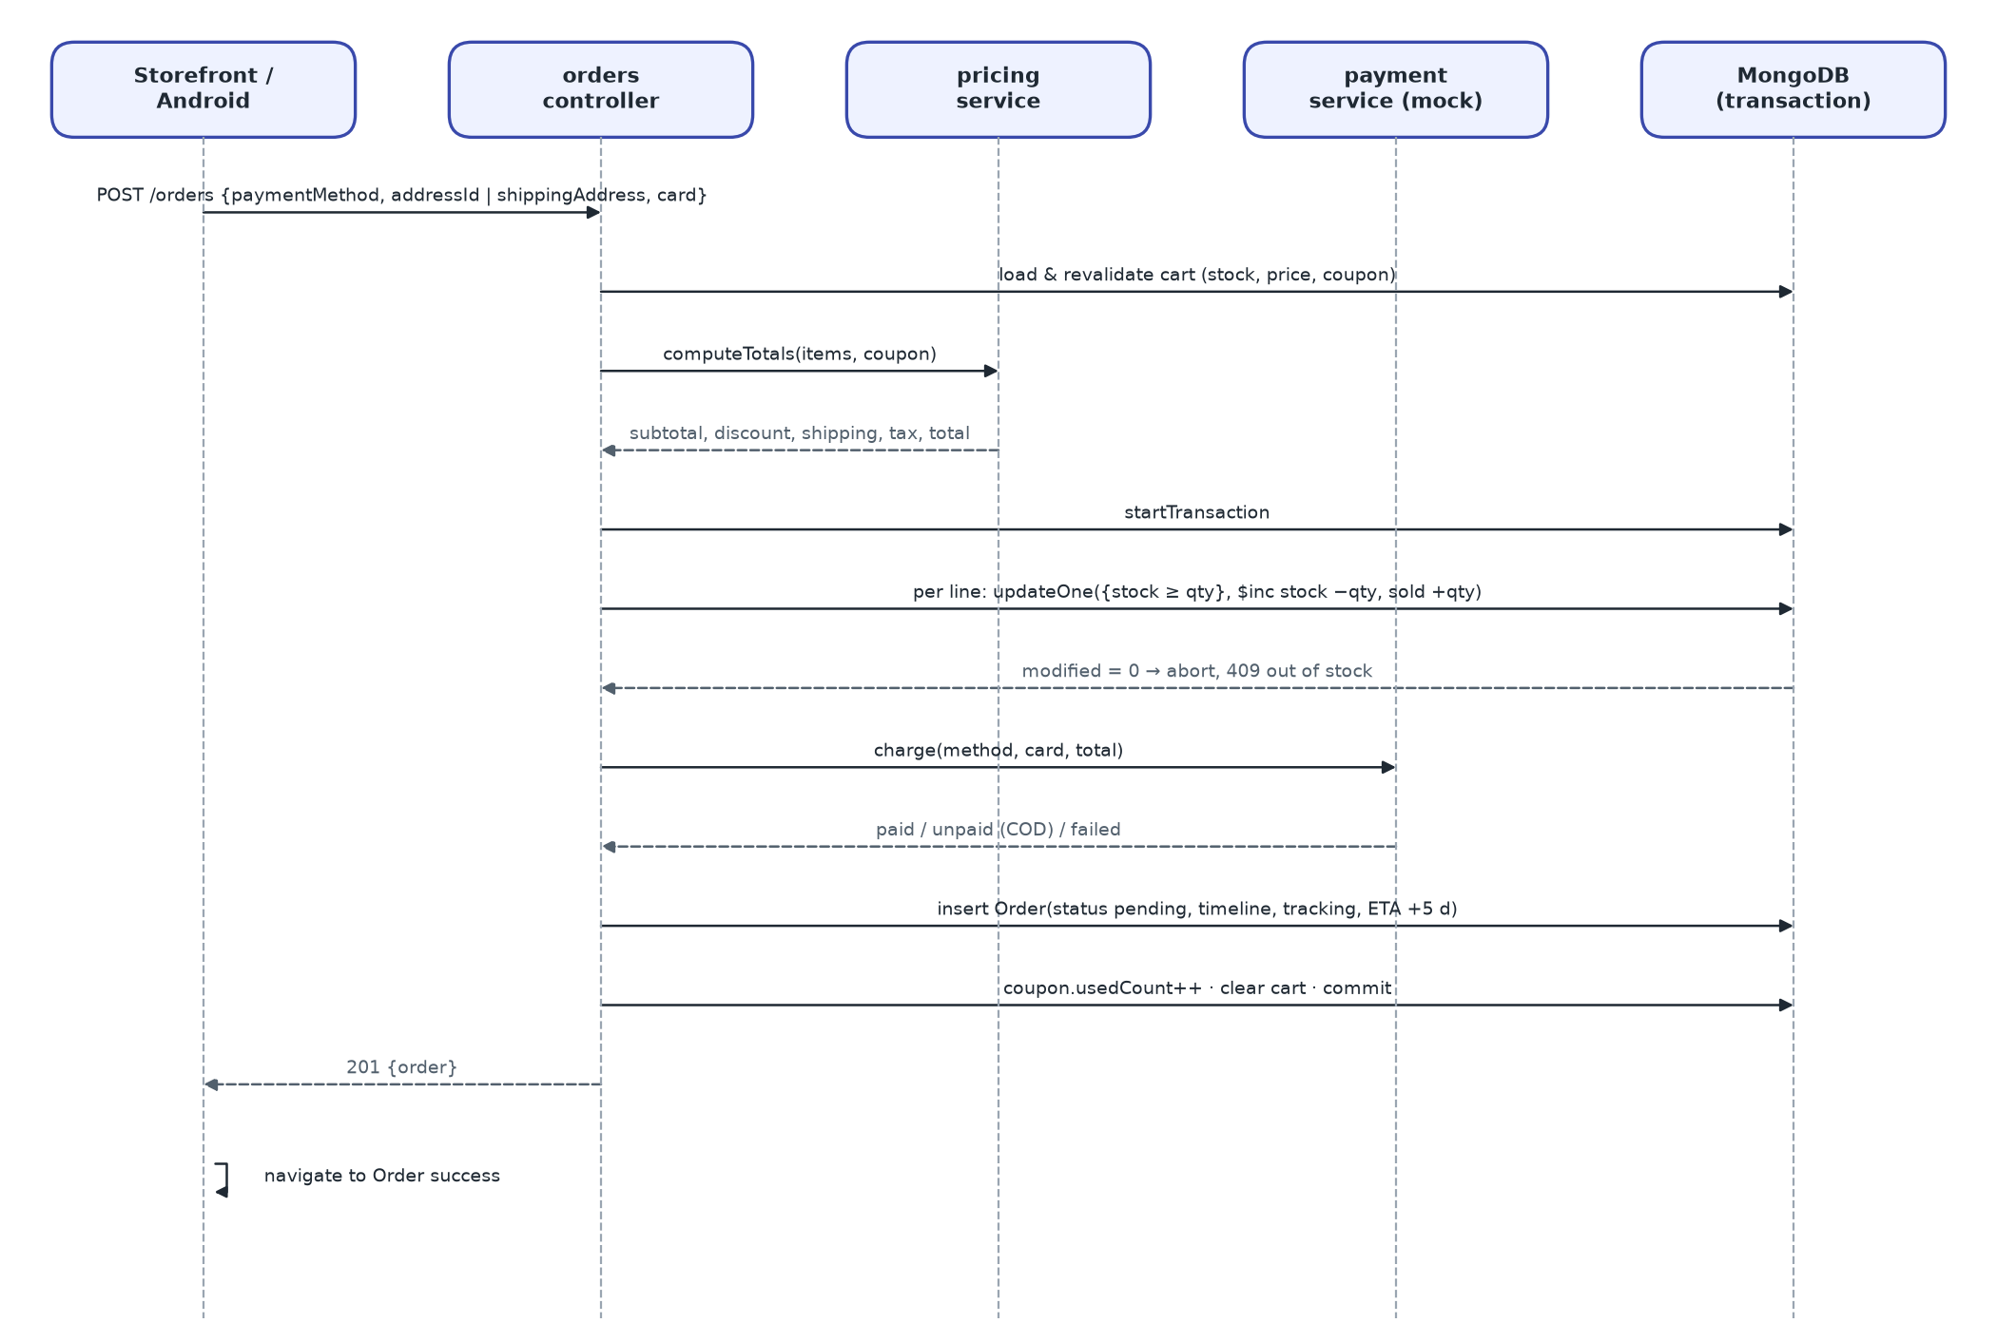
Figure 5 – Checkout sequence
runInTransaction opens a MongoDB session. On a standalone server (error code 20 / IllegalOperation) it logs one warning and re-runs the work without a session; stock that was already reserved is then rolled back by hand if a later step fails. The conditional update updateOne({_id, stock: {$gte: qty}}, {$inc: {stock: -qty, soldCount: qty}}) is the concurrency guard: two customers buying the last unit cannot both succeed.

3.6 Order life-cycle state machine
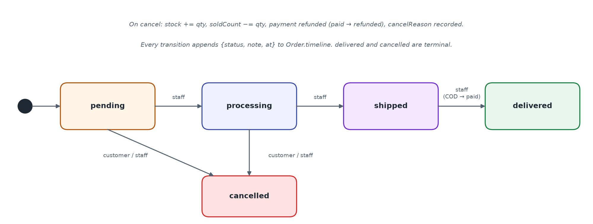
Figure 6 – Order status state machine
Table 8 – Order transitions
From | To | Who | Side effects
(new) | pending | System at checkout | Timeline “Order placed”; payment paid/unpaid; tracking no.; ETA +5 days
pending | processing | Staff | Timeline entry
pending / processing | cancelled | Customer or staff | Stock restored; soldCount reduced; refund if paid; cancelledAt, cancelReason
processing | shipped | Staff | Timeline entry (carrier/tracking can be edited separately)
shipped | delivered | Staff | deliveredAt; COD payment → paid
delivered / cancelled | — | — | Terminal; any further change → 400

3.7 Image-search design
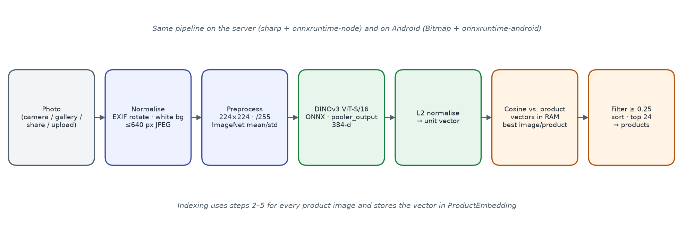
Figure 7 – Image embedding and ranking pipeline
- Model: DINOv3 ViT-S/16 (onnx-community/dinov3-vits16-pretrain-lvd1689m-ONNX), fp32, 384 dimensions, 12 layers, 4 register tokens; model id dinov3-vits16/model.onnx.
- Server runtime: onnxruntime-node on CPU, graph optimisation “all”, thread count VISUAL_SEARCH_THREADS (0 = auto); loaded lazily once; inferences serialised by a promise queue.
- Preprocessing: sharp: EXIF rotate → flatten on white → resize 224 × 224 (fill, linear) → sRGB → remove alpha → CHW float, /255, ImageNet mean/std from preprocessor_config.json.
- Descriptor: pooler_output (normalised CLS token), falling back to row 0 of last_hidden_state; then L2-normalised.
- Index: one ProductEmbedding document per product image and model (Float32 little-endian buffer, 1.5 KB). Product.visualIndex keeps status pending / indexed / partial / failed / no_images / unavailable.
- Search: vectors of active products are loaded into one Float32 matrix, rebuilt when a generation counter changes (index writes, deletes, activation toggles). Score = dot product; a product scores as its best image; keep ≥ minScore (0.25), sort, limit (default 24, 1–60).
- Guide values: same product in another photo ≥ 0.85; same kind of object ≈ 0.3; unrelated < 0.1.
- Android: same weights bundled in assets/model (stored uncompressed, copied to no-backup storage on first use), Bitmap preprocessing that matches the server to cosine ≈ 0.9998, vector sent to /visual-search/vector; upload fallback.
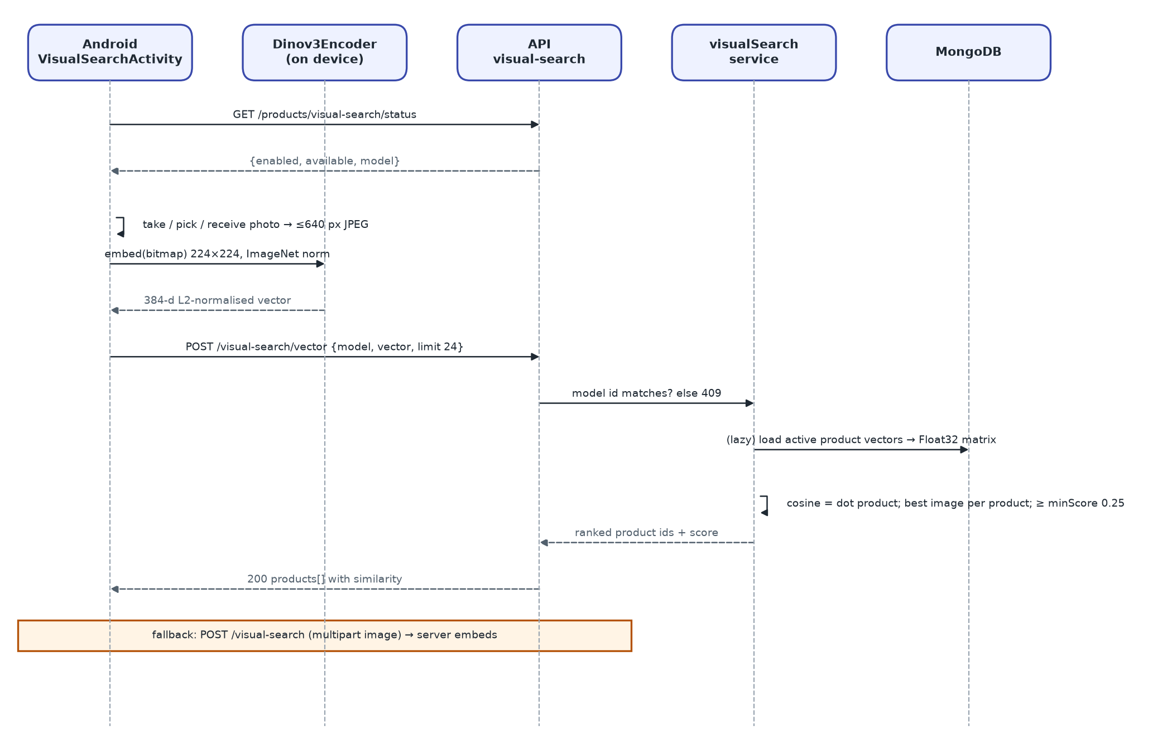
Figure 8 – Image search from Android with upload fallback

3.8 Security design
Table 9 – Security controls
Control area (ISO/IEC 27002) | Implementation
Authentication (8.5) | bcrypt(10) password hashes; JWT access/refresh with separate secrets; refresh rotation; session cap 5
Access control (8.3) | protect on customer routes; adminOnly (manager/admin/superadmin) on /admin; superAdminOnly on /admin/staff; ownership checks on orders and reviews
Input validation (8.28) | express-validator chains → 422 {field, message}; express-mongo-sanitize strips $ and . keys; regex search input escaped; 2 MB body limit
File upload (8.28) | multer: MIME whitelist jpeg/png/webp/gif/avif, ≤ UPLOAD_MAX_MB (5) each, ≤ 8 files; generated file names; delete endpoint blocks path traversal
Transport and headers (8.20) | helmet defaults (cross-origin resource policy relaxed for images); CORS whitelist from CORS_ORIGINS, localhost allowed outside production; HTTPS in release Android build
Capacity / abuse protection (8.6) | express-rate-limit in production: api 1000/15 min, auth 30/15 min, write 60/min, image search 20/min
Secrets (8.24) | JWT secrets and DB URI from environment; defaults are for development only and must be overridden
Logging (8.15) | morgan access log; [error] for 5xx; stack traces only outside production
Mobile (8.1) | Only INTERNET and ACCESS_NETWORK_STATE permissions; camera via system app (no CAMERA permission); FileProvider not exported; cleartext only for emulator hosts

Weaknesses found during the review are listed under Known issues (findings F-01, F-05 to F-08).

3.9 Internationalisation design
- Supported locales: en (default), zh, ja; aliases such as zh-CN, zh-Hant, ja-JP and en-GB map to them.
- API resolution order: ?lang → X-Language → saved user language → Accept-Language (q-ranked) → en. The API sets Content-Language and Vary: Accept-Language.
- Messages are dotted keys (e.g. error.productNotFound) with {{param}} interpolation; missing keys fall back to English, then to the key.
- Catalogue documents carry translations.{en,zh,ja} for name, descriptions, titles and CTA texts. Storefront responses are folded to flat fields; admin routes receive the raw object for editing.
- Web clients detect ?lang, then localStorage, then the browser language; Android uses per-app locales (AppCompatDelegate, locales_config.xml).
- Prices are formatted with Intl for the active locale but never converted.

3.10 Error handling and logging
Table 10 – Error mapping
Condition | HTTP | Body
Validation failure (express-validator) | 422 | {success:false, message, errors:[{field, message}]}
Mongoose ValidationError | 422 | field details
Invalid ObjectId (CastError) | 400 | message
Duplicate key (11000) | 409 | message naming the field
Missing / invalid / expired JWT | 401 | message
Inactive account, wrong role, not owner | 403 | message
Business rule (stock, coupon, transition) | 400 / 409 | translated message
Image-search model unavailable | 503 | error.visualSearchUnavailable
Rate limit exceeded (production) | 429 | “Too many requests, please try again later”
Unhandled error | 500 | generic message; stack outside production

3.11 Web client design
- Structure: main.jsx → I18nProvider → BrowserRouter → App; api/ (Axios client and endpoint groups), store/ (Zustand: auth, cart, toast), components/, pages/, i18n/, utils/, styles/global.css.
- API client: base URL from VITE_API_URL; 20 s timeout (60 s for image upload); adds Bearer token and X-Language; unwraps the envelope; single shared refresh on 401; dispatches auramart:signed-out on failure.
- Routing guard: ProtectedRoute waits for auth bootstrap, then redirects to /login with state.from so the user returns after sign-in. Admin panel uses the equivalent RequireStaff guard.
- State: authStore (user, status), cartStore (server or guest cart, totals, notices), toastStore (3.2 s toasts).
- Motion and accessibility: scroll-reveal and page-enter animations disabled under prefers-reduced-motion; forced-colors supported; toasts use aria-live=polite.

3.12 Android client design
- Packages: data.local (SessionManager, Dinov3Encoder), data.model (DTOs), data.remote (ApiClient, ApiService), data.repository (Repo), ui.* (one package per feature), util (Formats, Images, LocaleManager, SearchPhotos, Dinov3Preprocessor, Ui, Validators).
- Pattern: Activities/Fragments call Repo.call() which enqueues Retrofit calls and unwraps the envelope into onSuccess(data, message) / onError(message). View Binding is used for layouts; no ViewModel layer.
- Networking: BuildConfig.API_BASE_URL (10.0.2.2 in debug, api.auramart.com in release); timeouts 20/30/30 s; X-Language header; AuthInterceptor with synchronized refresh; image URLs pointing at localhost are rewritten to the API origin.
- Session: SharedPreferences auramart.session stores tokens, user JSON, wishlist ids and cart count; SessionExpiredListener opens Login with a cleared task.
- Build: compile/target SDK 35, min SDK 24, Java 17, AGP 8.13, R8 minification in release; checkDinov3Model fails the build if model files are missing.

3.13 Product-area detection design
The feature adds one step in front of every embedding: find the product inside the photo, then embed only that rectangle. It deliberately uses no second model. DINOv3's own patch tokens already separate an object from its surroundings, so the detector is a short, deterministic algorithm over the output of one extra forward pass of the model that is already loaded.

3.13.1 Algorithm
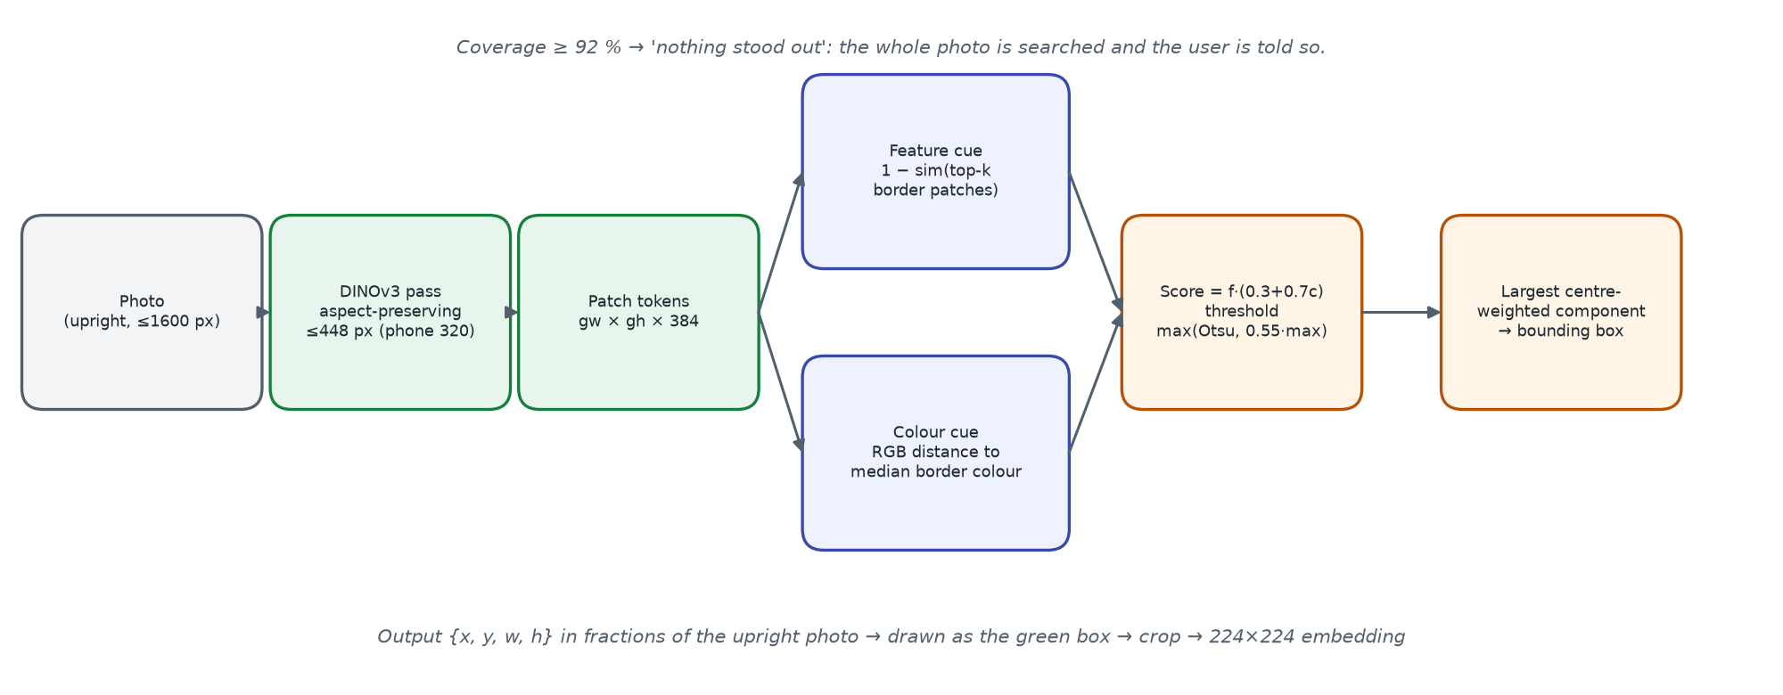
Figure 9 – Product-area detection pipeline
1. Decode the photo upright (EXIF rotation), flatten transparency on white, cap the longest side at 1600 px.
2. Resize, keeping the aspect ratio, so the longest side is about 448 px (320 px on Android) and both sides are multiples of 16; run DINOv3 and keep the gw × gh patch tokens (token 0 is CLS, tokens 1–4 are registers). DINOv3 uses rotary position embeddings, so any such size is valid.
3. Feature cue: for every patch, the mean cosine similarity to its k most similar border patches (k = max(3, border/8)); the cue is its negative, scaled to 0–1 with the 2nd/98th percentiles.
4. Colour cue: on a (gw·8) × (gh·8) thumbnail, the mean RGB distance of each patch's pixels from the median colour of the outermost pixel ring, divided by 48 and clipped to 1.
5. Score = normalise(feature × (0.3 + 0.7 × colour)); threshold = max(Otsu over 64 bins, 0.55 × max score).
6. 4-connected components of the thresholded mask; choose the component with the largest sum of score × (1 − 0.5 × distance from centre).
7. Its bounding box in patch units divided by (gw, gh) is the region. If it covers ≥ 92 % of the photo the result is marked found = false and the whole photo is embedded.
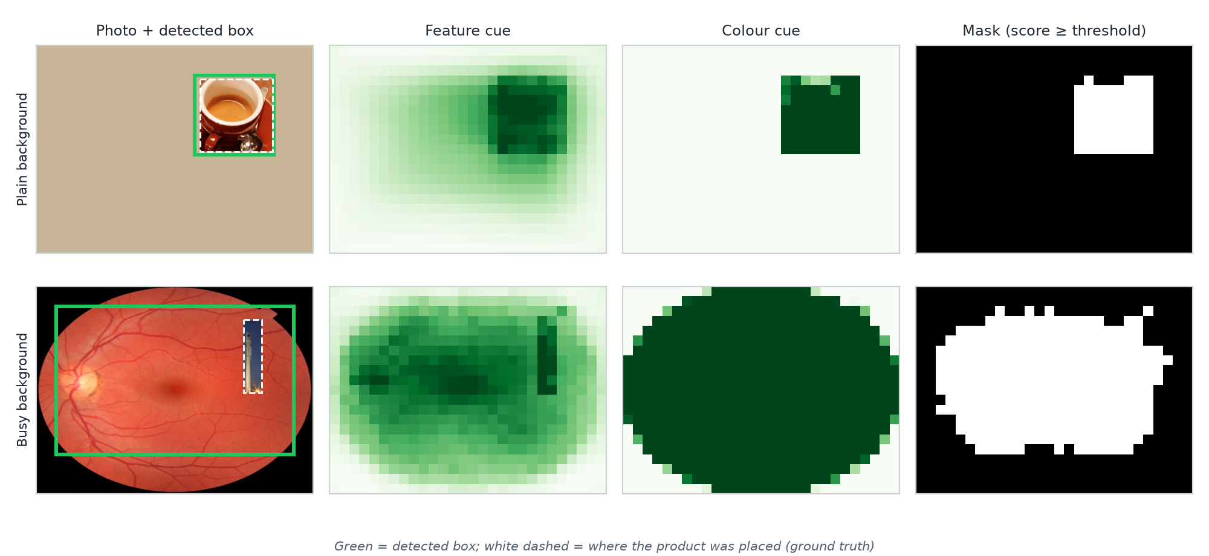
Figure 10 – Worked example: cues, mask and detected box on a plain and a busy background
Table 11 – Detector parameters
Parameter | Value | Where
Detection size (longest side) | 448 px server (VISUAL_SEARCH_DETECT_SIDE), 320 px Android | env.js, VisualSearchActivity.DETECT_LONG_SIDE
Colour scale / weight | 48 RGB units / 0.7 | regionDetect.js, RegionDetector.java
Relative threshold | 0.55 × max | same
Whole-image coverage | ≥ 0.92 → found = false | same
Minimum box side (user) | 0.02 server validation, 0.04 client UI | sanitizeBox, RegionSelector
Detector id | dinov3-border-v1 (or 'none' when disabled) | DETECTOR_ID, visualSearch.detectorId()

Why this design: training-free (no labelled data, no licence for a detection model), no extra download (the 86 MB model already ships on server and phone), deterministic and identical across platforms, and fast (one extra pass). Its weakness is photos where the background is as varied as the product; there the user adjusts the box (UC-25), which the evaluation in the Test Case Specification quantifies.

3.13.2 Module changes
Table 12 – Changed and new units
Unit | Change
services/regionDetect.js (new) | Pure functions detectRegion, sanitizeBox, sameBox; DETECTOR_ID
services/dinov3.service.js | decode() once per image; embed(image, box) crops before the 224 × 224 resize; patchGrid(image, longSide, ppp) returns patch tokens + RGB thumbnail; reads patch size and register count from config.json
services/visualSearch.service.js | search() returns {hits, region}; accepts box or detect=false; indexProduct() embeds each image's manual region or auto-detects and stores it; detectForImage(src) for the admin panel; needsIndexFilter includes a detector-version change
controllers/product.controller.js | Parses box/detect from the multipart body; returns region; sanitises imageRegions on create/update and re-indexes when manual regions change
controllers/visualSearch.controller.js, routes/admin.routes.js | POST /admin/visual-search/detect
models/Product.js, ProductEmbedding.js | imageRegions[]; visualIndex.detector; embedding region, regionAuto, detector
frontend: RegionSelector.jsx (new), VisualSearch.jsx, api/index.js, global.css, i18n | Green-box editor, re-search on change, reset / whole-photo actions, messages in en/zh/ja
admin-panel: RegionSelector.jsx (copy), ProductsPage.jsx (RegionPanel), api, admin.css, i18n | Detect on upload, boxes on thumbnails, inline editor, imageRegions in the save payload
android: RegionDetector.java (new), RegionSelectorView.java (new), Dinov3Encoder.patchGrid, VisualSearchActivity, Repo.callEnvelope, Models.SearchRegion, ApiService box part, layout and strings | On-device detection, custom view with glowing box and 8 handles, re-crop and re-search on change, upload fallback with box

3.13.3 Behaviour
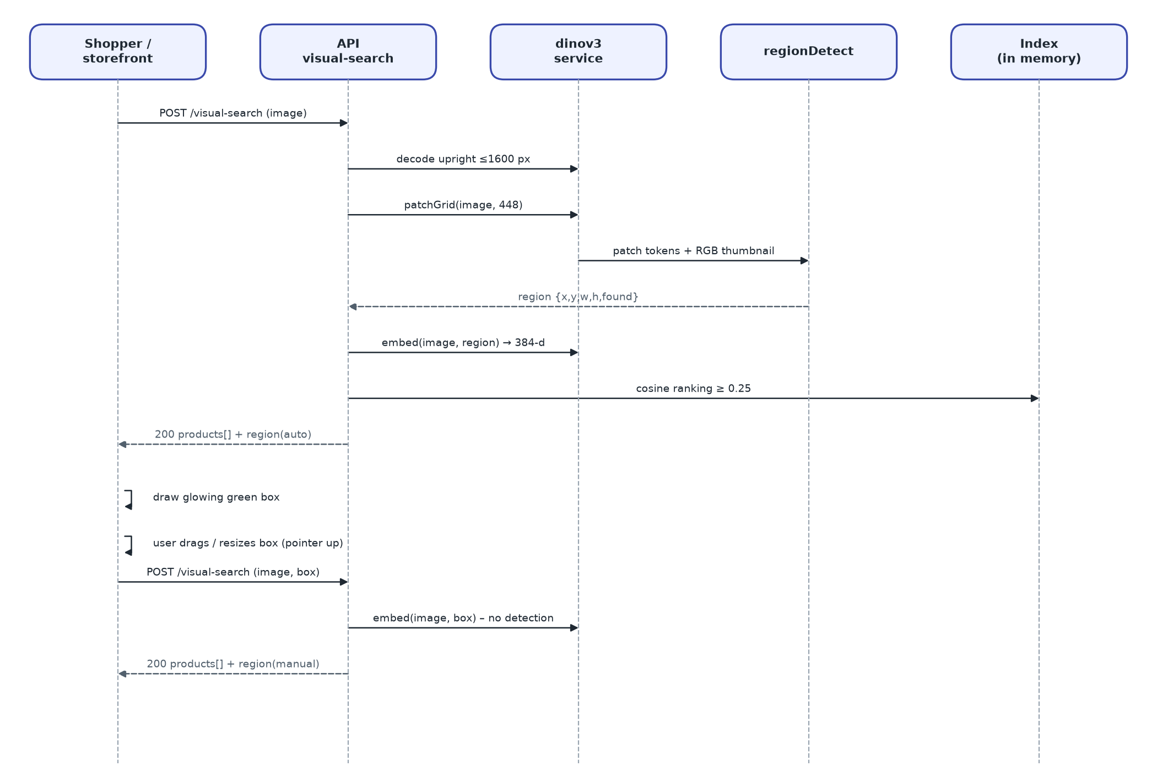
Figure 11 – Search with automatic detection, then with the user's box
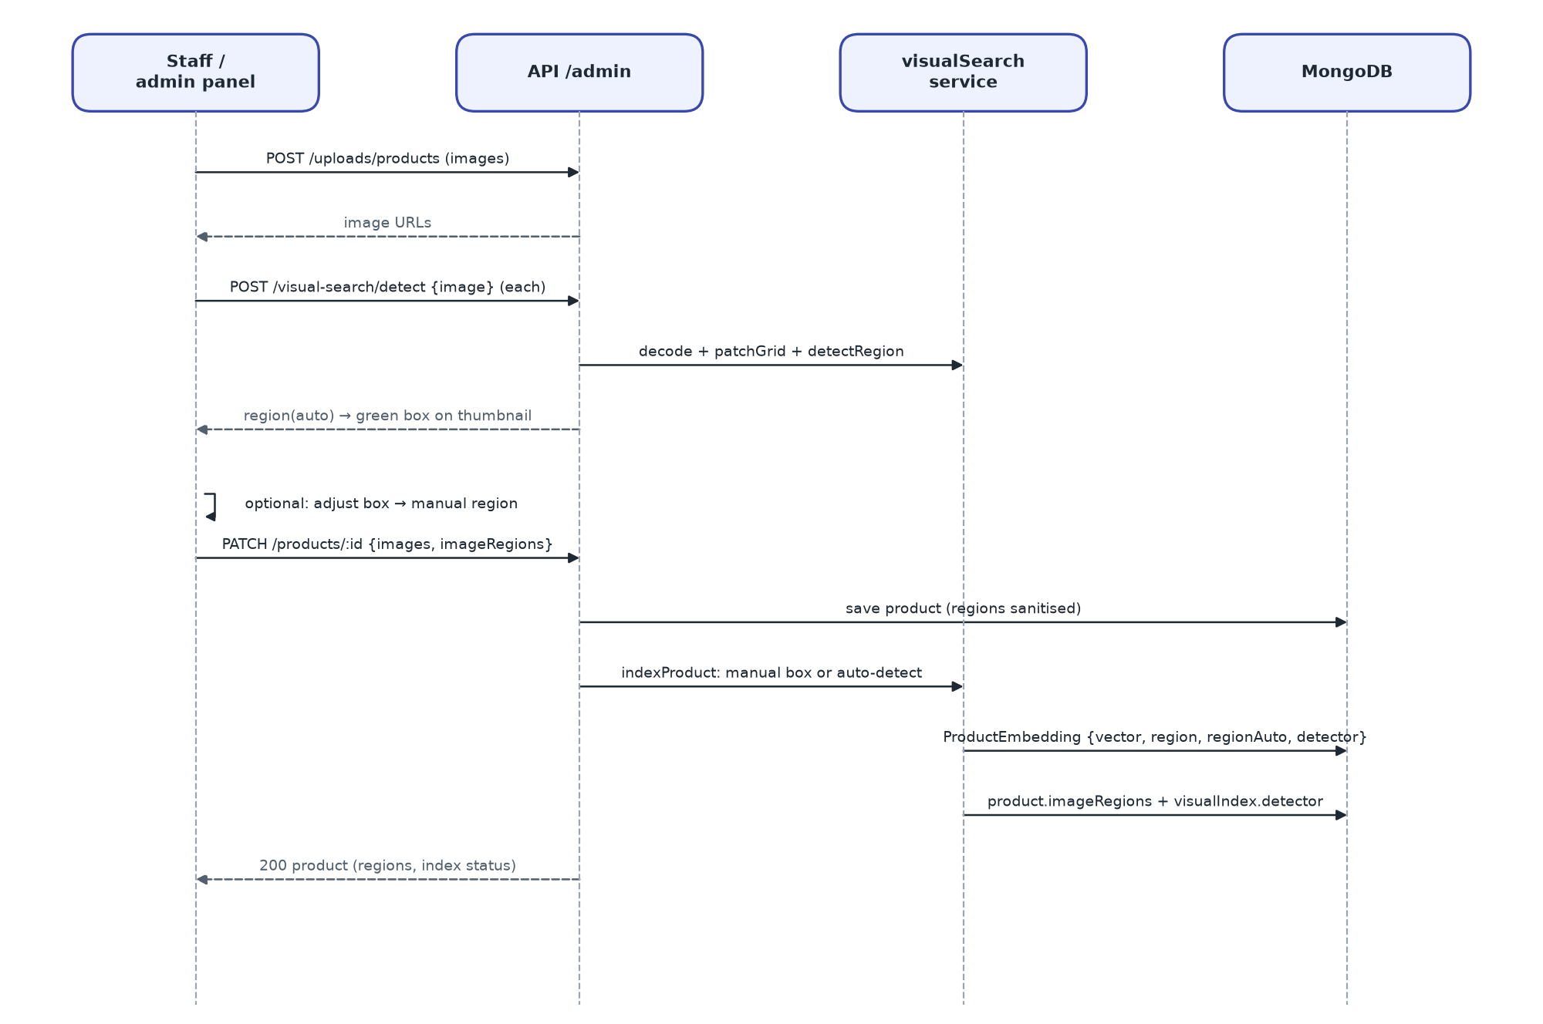
Figure 12 – Registration of product images with product areas
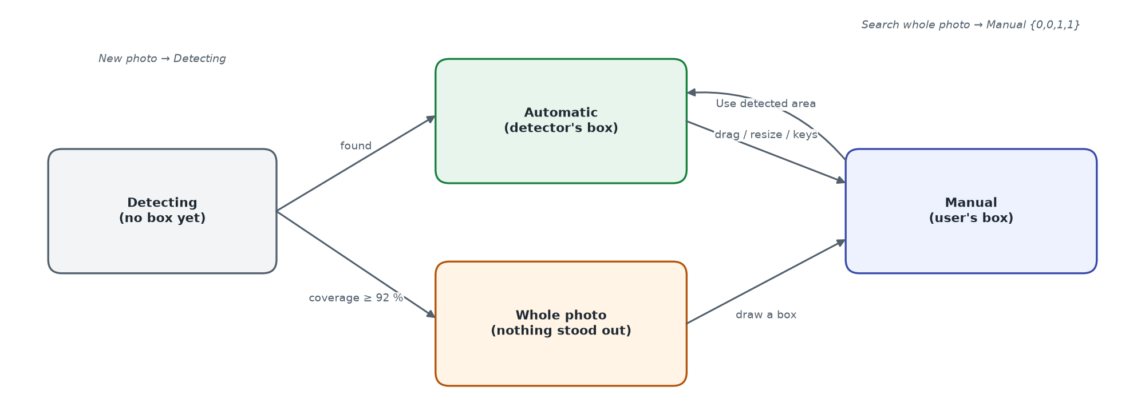
Figure 13 – States of the search area in the clients

3.13.4 Data and interface changes
Table 13 – Data and interface changes
Element | Specification
Product.imageRegions[] | {image: String, x, y, w, h: Number 0–1, auto: Boolean (default true)} — one per image; manual entries (auto = false) come from staff
Product.visualIndex.detector | Detector id the vectors were cropped with
ProductEmbedding.region / regionAuto / detector | Area that was embedded; whether the detector chose it; detector id. A vector is current when (manual: same box) or (auto: same detector)
POST /products/visual-search | New optional multipart fields: box (JSON {x,y,w,h}), detect ('false' = whole photo). Response adds region {x, y, w, h, auto, found}
POST /admin/visual-search/detect | Body {image: url of a stored image} → {x, y, w, h, coverage, found, auto: true, detector, width, height}
PATCH/POST /admin/products | Accepts imageRegions; entries for images the product does not have are dropped; a region counts as manual unless it is sent with auto: true
GET /admin/visual-search/status | Adds detector
Error | 400 error.visualBoxInvalid (en/zh/ja) for a malformed box
Configuration | VISUAL_SEARCH_DETECT=true, VISUAL_SEARCH_DETECT_SIDE=448

3.13.5 Coordinate convention
All rectangles are fractions of the upright image: browsers and Android display photos EXIF-rotated, and the server rotates before decoding, so one rectangle means the same pixels everywhere. The web frame shrinks to the rendered photo (width: fit-content), so CSS percentages equal image fractions; the Android view computes the fit-centre rectangle of the bitmap and maps touches through it.

4 Data design

4.1 Logical data model
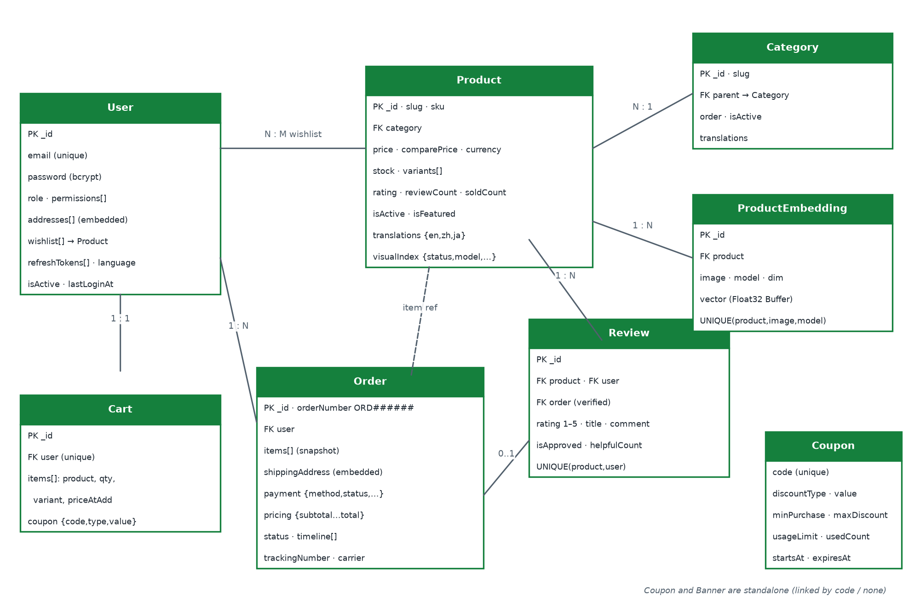
Figure 14 – Entity-relationship diagram (MongoDB collections)
All collections carry createdAt and updatedAt (Mongoose timestamps). Embedded documents (addresses, cart items, order items, timeline) are used where the child has no life of its own.

4.2 Collection specifications

4.2.1 users
Field | Type | Constraints / notes
name | String | required, ≤ 80
email | String | required, unique, lower-case
password | String | bcrypt, ≥ 6, not selected by default
role | Enum | customer | manager | admin | superadmin (default customer)
permissions | [Enum] | products, orders, customers, reviews, content, reports, settings
isActive | Boolean | default true
addresses[] | Embedded | label, fullName*, phone, street*, city*, state, zipCode*, country* (Finland), isDefault — exactly one default
wishlist[] | ObjectId[] → products
refreshTokens[] | String[] | last 5; not selected
language | Enum | en | zh | ja
lastLoginAt, avatar, phone | Date / String

4.2.2 products
Field | Type | Constraints / notes
name, slug, sku | String | name ≤ 160; slug = slugify(name)+id suffix, unique; sku unique (default SKU-xxxxxxxx)
category | ObjectId → categories | required, indexed
price, comparePrice, cost | Number | ≥ 0; price indexed
currency | Enum | USD | REM
stock | Number | ≥ 0; stockStatus virtual: ≤ 0 out, ≤ 10 low
variants[] | Embedded | name*, value*, hex, priceDelta, stock
images[], tags[], colors[] | String[] | tags indexed
rating, reviewCount, soldCount, viewCount | Number | rating 0–5 (indexed), soldCount indexed
isActive, isFeatured, freeShipping | Boolean | indexed flags
warrantyMonths, returnDays | Number | defaults 12 and 30
translations | Object | {en, zh, ja} × name, description, shortDescription
visualIndex | Object | status, model, vectors, error, indexedAt

4.2.3 orders
Field | Type | Constraints / notes
orderNumber | String | ORD + 6 digits, unique
user | ObjectId → users | indexed
customerName, customerEmail | String | snapshot
items[] | Embedded | product, name, image, sku, price, quantity ≥ 1, variant, subtotal
shippingAddress | Embedded | fullName, phone, street, city, state, zipCode, country
payment | Embedded | method card|paypal|applepay|cod; status unpaid|paid|failed|refunded; transactionId; cardLast4; paidAt
pricing | Embedded | subtotal, shipping, tax, discount, total (≥ 0)
status, timeline[] | Enum, Embedded | pending…cancelled; {status, note, at}
trackingNumber, carrier, estimatedDelivery | String, Date | AM-XXXXXXXXXX, default UPS
deliveredAt, cancelledAt, cancelReason, couponCode, notes | Mixed

4.2.4 other collections
Collection | Fields and constraints
categories | name ≤ 60, slug (unique), parent → categories, order, isActive, icon, image, translations
carts | user (unique), items[{product, quantity, variant, priceAtAdd}], coupon {code, discountType, discountValue}
reviews | product, user, order?, rating 1–5, title ≤ 120, comment ≤ 2000, isApproved, isVerifiedPurchase, helpfulCount; unique (product, user)
coupons | code (unique, upper case), discountType percent|fixed, discountValue, minPurchase, maxDiscount, usageLimit, usedCount, startsAt, expiresAt, isActive
banners | title, subtitle, image, ctaText, ctaLink, placement hero|promo|mobile, order, isActive, translations
productembeddings | product, image, model, dim, vector (Buffer); unique (product, image, model)

4.3 Indexes and integrity rules
- Unique: users.email, products.slug, products.sku, categories.slug, orders.orderNumber, carts.user, coupons.code, reviews(product,user), productembeddings(product,image,model).
- Query indexes: products text(name, description, brand, tags), products(category, price), products(createdAt −1), orders(createdAt −1), orders(user, createdAt −1), plus single-field indexes on flags and counters.
- Referential integrity is enforced by the application: deleting a product deletes its reviews and embeddings; deleting a category is refused while products or children exist.
- Order items and addresses are snapshots; later product edits never change historical orders.

4.4 Data retention and seed data
No automatic retention or purge exists at the baseline. npm run seed wipes all collections and creates 9 categories, 16 products (every 4th in REM), 8 users (1 super admin, 1 manager, 6 customers), 90 orders spread over 6 months, reviews and the coupons WELCOME10, SAVE20 and MEGA50, then indexes all product images.

5 Interface design

5.1 API conventions
- Base URL {host}/api/v1; JSON UTF-8; multipart only for uploads and image search.
- Success envelope {success:true, message, data, pagination?} with pagination {page, limit, total, totalPages, hasNext, hasPrev}.
- Error envelope {success:false, message, errors?} (see Error handling and logging).
- Authentication: Authorization: Bearer <accessToken>. Language: X-Language: en|zh|ja or ?lang=.
- Identifiers: MongoDB ObjectIds; products also by slug; orders also by orderNumber.

5.2 Endpoint catalogue

5.2.1 Public and identity endpoints
Method | Path | Access | Purpose
GET | /health | Public | Status, DB state, uptime
GET | /languages | Public | Supported locales
POST | /auth/register | Public · auth limiter | Create customer, return tokens
POST | /auth/login | Public · auth limiter | Sign in
POST | /auth/refresh | Public | Rotate token pair
POST | /auth/logout | User | Revoke one or all refresh tokens
GET | /auth/me | User | Current profile
PATCH | /auth/password | User | Change password, revoke sessions
PATCH | /users/profile · /users/language | User | Update name, phone, language
POST | /users/avatar | User | Upload avatar
GET/POST | /users/addresses | User | List / add address
PATCH/DELETE | /users/addresses/:id[/default] | User | Edit, delete, set default
GET · POST | /users/wishlist · /users/wishlist/:productId | User | List · toggle

5.2.2 Catalogue endpoints (public)
Method | Path | Access | Purpose
GET | /categories · /categories/tree · /categories/:slug | Public | Categories, tree, one category
GET | /products | Public | List with filters, sort, pagination
GET | /products/filters | Public | Facets
GET | /products/featured · /products/best-sellers | Public | Home page lists
GET | /products/:slug | Public (optional auth) | Detail; staff see inactive
GET | /products/:slug/related · /reviews · /reviews/summary | Public | Related, reviews, rating summary
GET | /products/visual-search/status | Public | {enabled, available, model}
POST | /products/visual-search | Public · image limiter | Multipart image → ranked products
POST | /products/visual-search/vector | Public · image limiter | {model, vector} → ranked products
GET | /banners · /promotions · /coupons/validate | Public | Banners, active coupons, coupon check

5.2.3 Shopping endpoints (customer)
Method | Path | Access | Purpose
GET/DELETE | /cart | User | Get revalidated cart / clear
POST | /cart/items | User | Add item
PATCH/DELETE | /cart/items/:itemId | User | Change quantity (0 removes) / remove
POST/DELETE | /cart/coupon | User | Apply / remove coupon
POST | /cart/merge | User | Merge guest cart
GET | /checkout/preview | User | Totals before order
POST | /orders | User · write limiter | Place order
GET | /orders · /orders/:id · /orders/:id/track | User (owner) / staff | List, detail, tracking
POST | /orders/:id/cancel | User (owner) | Cancel pending/processing order
POST | /reviews | User · write limiter | Create review
PATCH/DELETE | /reviews/:id | Owner (delete also staff) | Edit / delete review
POST | /reviews/:id/helpful | User | Increment helpful count

5.2.4 Back-office endpoints (prefix /admin, staff)
Method | Path | Access | Purpose
GET | /dashboard/stats · sales-overview · sales-by-category · customer-growth · recent-orders · top-products | Staff | Dashboard data (range 7d/30d/90d/12m or from/to)
GET/POST | /products | Staff | List / create
PATCH/DELETE | /products/:id[/status|/stock] | Staff | Edit, toggle, restock, delete
POST | /products/:id/visual-index | Staff | Re-index one product
GET · POST | /visual-search/status · /visual-search/reindex | Staff | Index status · start job {force}
POST/PATCH/DELETE | /categories[/:id] | Staff | Category CRUD
GET · PATCH | /orders[/:id] · /orders/:id/status · /orders/:id/tracking | Staff | List with statusCounts, detail, transition, tracking
GET · PATCH | /customers · /customers/export · /customers/:id[/status] | Staff | List, CSV, detail, activation
GET | /inventory/alerts | Staff | Stock ≤ 10 with summary
GET/PATCH/DELETE | /reviews · /reviews/:id/moderate · /reviews/:id | Staff | Moderation
CRUD | /coupons · /banners | Staff | Promotions and content
POST/DELETE | /uploads/products · /uploads/banners · /uploads/:folder/:file | Staff | Image upload and removal
CRUD | /staff · /staff/options | Super admin | Staff accounts

5.3 Example exchange
POST /api/v1/cart/coupon with body {"code":"WELCOME10"} returns 200 with data.totals = {subtotal: 120, discount: 12, shipping: 0, tax: 10.8, total: 118.8}, data.coupon = {code:"WELCOME10", discountType:"percent", discountValue:10} and data.rules = {freeShippingThreshold: 50, flatRate: 9.99, taxRate: 0.1}.

5.4 Client–OS interfaces (Android)
Interface | Specification
Launcher | SplashActivity: MAIN / LAUNCHER
Share target | VisualSearchActivity exported with intent filter ACTION_SEND, category DEFAULT, mimeType image/*; label “Search on ShopWorld” (localised)
Camera | ActivityResultContracts.TakePicture into cache/visual-search/camera.jpg via FileProvider ${applicationId}.fileprovider (not exported, grants URI permission)
Gallery | PickVisualMedia (ImageOnly) — system photo picker, no storage permission
Per-app language | locales_config.xml (en, zh, ja), AppCompatDelegate.setApplicationLocales

6 Review findings and deviations
While deriving this document from the code, the following deviations from the requirements, from good practice or from the project's own README files were found. They are recorded here so they can be planned as change requests; none has been fixed in the baseline. Severity: H = high, M = medium, L = low.
Table 14 – Findings
ID | Sev. | Area | Finding | Recommendation
F-01 | H | Authorisation | Staff section permissions are stored and editable, but requirePermission() is never applied to a route; any manager or admin can use every back-office section except staff management. | Apply requirePermission per /admin route group and hide menu items the user lacks (FR-AUTH-09).
F-02 | M | Admin UI | Reviews filter tabs render empty labels and always filter “All” (uses the translator t instead of the tab object). | Rename the map variable and reference tab.value / tab.label.
F-03 | L | Admin UI | Banner placement drop-down shows blank labels (renders p.label, list defines labelKey). | Render t(p.labelKey).
F-04 | L | i18n | Hard-coded English strings remain in the admin panel (e.g. “Add Banner”, “Order #”, “Verified”) and in the Android app (e.g. “% OFF”, “n sold”, “Free over $50”, settings dialog). | Move to the en/zh/ja catalogues (FR-I18N-01).
F-05 | H | Android security | Tokens are stored in plain SharedPreferences and the manifest sets allowBackup="true"; debug builds log full HTTP bodies (passwords, tokens, card numbers). | Use EncryptedSharedPreferences, exclude session prefs from backup, log headers only (NFR-SE-05).
F-06 | H | Payment | The full card number is sent to the API (mock gateway). A real integration must tokenise on the client so card data never reaches the API (PCI-DSS). | Integrate a PSP SDK / hosted fields before go-live.
F-07 | M | API security | Create/update of coupons, categories, banners and products pass req.body to the model (mass assignment; only visualIndex is stripped from products). | Whitelist fields per endpoint.
F-08 | M | Android network | network_security_config lists “192.168.0.0” as a domain, which does not match LAN IPs; a physical device on a LAN address is blocked from cleartext, contrary to the README. | Document an HTTPS dev proxy or add the concrete host; keep cleartext out of release.
F-09 | M | Usability | No confirmation before order status changes (including cancel) in the admin panel, before clearing the cart, or before deleting an address on the web. | Add confirmation dialogs (NFR-IU-03).
F-10 | L | Coupons | usedCount is not decremented when an order is cancelled; there is no per-customer usage limit. | Decrement on cancel; add optional per-user limit.
F-11 | L | Reviews | Helpful votes are not de-duplicated per user. | Store voter ids or a separate votes collection.
F-12 | L | Documentation | README says the seeded admin is role admin (it is superadmin), Android AGP 8.9.1 (it is 8.13.0) and ShopWorldApp.java (class is AuraMartApp). | Correct the README files.
F-13 | M | Visual search UX | Resolved in 1.1: the camera icons used to stay hidden when the status call failed; they are now always shown and the result screen reports unavailability. | None
F-14 | M | Testing | Apart from the product-area detector (backend npm test, Android RegionDetectorTest), the projects have no automated tests. | Implement the Test Case Specification (NFR-MA-02).
F-15 | L | Checkout | Card expiry and CVC are validated on the web client but not sent or checked by the API. | Irrelevant once a PSP is integrated (F-06); otherwise validate server-side.

Appendix A – Configuration reference
Table 15 – Environment variables
Variable | Default | Purpose
NODE_ENV | development | production enables rate limits and hides stack traces
PORT / API_PREFIX | 5000 / /api/v1 | Listening port and route prefix
MONGO_URI | mongodb://127.0.0.1:27017/auramart | Database connection (use ?replicaSet=rs0 for transactions)
JWT_ACCESS_SECRET / JWT_REFRESH_SECRET | dev_access_secret / dev_refresh_secret | Token signing secrets — must be changed in production
JWT_ACCESS_EXPIRES / JWT_REFRESH_EXPIRES | 15m / 30d | Token lifetimes
CORS_ORIGINS | (empty = all) | Comma-separated allowed origins; .env.example lists 5173, 5174, 10.0.2.2:5000
PUBLIC_URL | http://localhost:5000 | Base for stored image URLs
UPLOAD_MAX_MB | 5 | Maximum upload size per file
FREE_SHIPPING_THRESHOLD / SHIPPING_FLAT_RATE / TAX_RATE | 50 / 9.99 / 0.1 | Pricing parameters
VISUAL_SEARCH_ENABLED | true | Master switch for image search
VISUAL_SEARCH_MODEL_DIR / _MODEL_FILE | ml/dinov3-vits16 / model.onnx | Model location; together form the model id
VISUAL_SEARCH_THREADS | 0 (auto) | ONNX Runtime intra-op threads
VISUAL_SEARCH_MIN_SCORE | 0.25 | Minimum cosine similarity returned
VISUAL_SEARCH_INDEX_ON_BOOT | true | Index pending products at start-up
VISUAL_SEARCH_FETCH_REMOTE | false | Allow indexing of http(s) image URLs
VISUAL_SEARCH_DETECT | true | Detect the product area (green box) before embedding
VISUAL_SEARCH_DETECT_SIDE | 448 | Longest side (px) of the photo used for area detection
SEED_ADMIN_EMAIL / SEED_ADMIN_PASSWORD | admin@auramart.com / Admin@123 | Seeded super admin
VITE_API_URL / VITE_ASSET_URL (web, admin) | http://localhost:5000/api/v1 / http://localhost:5000 | Client API and asset bases
BuildConfig.API_BASE_URL (Android) | http://10.0.2.2:5000/api/v1/ (debug) | Release: https://api.auramart.com/api/v1/

Appendix B – Build, run and release procedure
Table 16 – Procedure
Step | Command / action | Result
1 | npm install at repository root | Dependencies for backend, storefront and admin (npm workspaces)
2 | cp backend/.env.example backend/.env and set secrets | Configuration
3 | npm run model:fetch (and npm run model:android for the APK) | DINOv3 weights in backend/ml and android assets, SHA-256 verified
4 | docker compose up -d or local MongoDB 6.0 replica set | Database (and API) running
5 | npm run seed | Demo data and image index
6 | npm run dev | API :5000, storefront :5173, admin :5174
7 | npm run build | Static builds in frontend/dist and admin-panel/dist
8 | cd android && ./gradlew assembleRelease | Minified APK with bundled model (build fails if model files are missing)
9 | Smoke test: GET /api/v1/health, sign in on each client, one test order | Release candidate accepted

