Screen Design Specification
OCR Translator (falcon-ocr-trans for Android)

Document ID | FOT-SDS-001
Version | 1.0
Status | Baseline draft
Date | 2026-09-25

Revision History
Version | Date | Author | Description
1.0 | 2026-09-25 | [Author] | All ten screens; compact screen-relative controls (halved from the first draft); collapsible side menu with right-hand toggle; Korean removed from language lists.

Contents
Right-click and choose Update Field.

1. Introduction
This document specifies every screen of the application: layout, components, sizes, behaviour, navigation and messages. Requirement IDs refer to FOT-SRS-001. Wireframes are schematic: they show structure, proportion and numbering on a 360 × 760 dp phone in the app's dark theme, not final artwork. Red numbered markers match the component tables.
Note. Sizes are written phone / tablet. Tablet values apply when the smallest screen width is at least 600 dp (resource qualifier sw600dp).

2. Common Design Rules

2.1 Screen flow
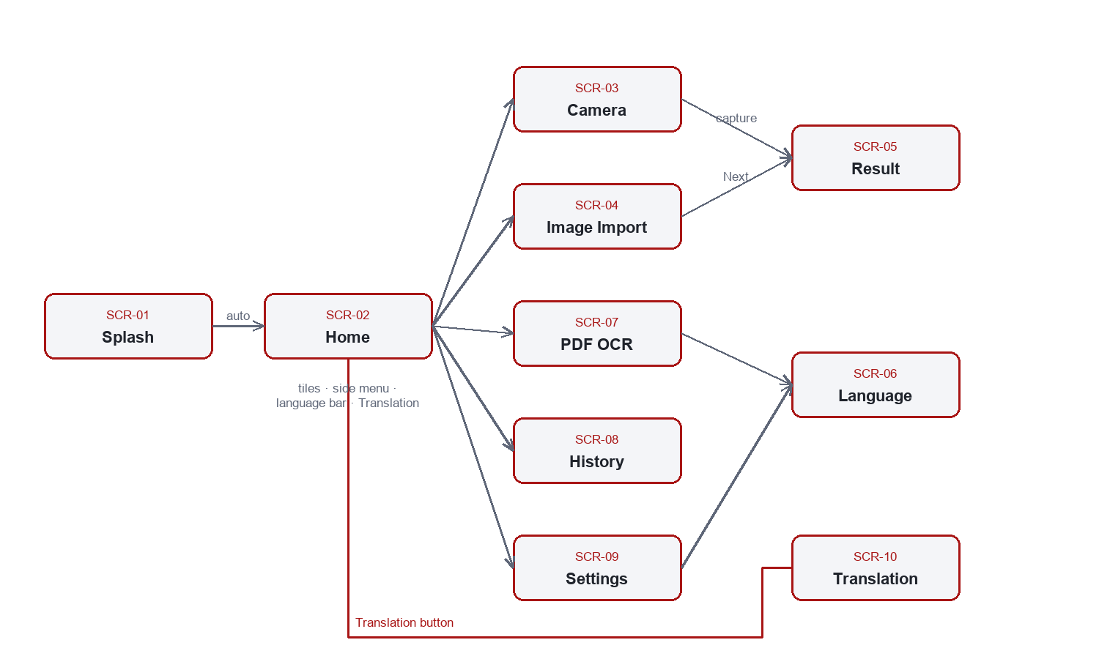
Figure 1. Screen flow

2.2 Colour palette
Table 1. Colour tokens
Token | Value | Use
bg_base | #070A12 | Window background
bg_surface | #101726 | Toolbars, side menu, cards
bg_surface_high / bg_elevated | #18202F / #1E2838 | Search field, tonal buttons
divider | #26314A | Outlines, separators
brand_red / brand_red_dark | #E02020 / #A81515 | Primary buttons, selected menu item, accents
tile_red / blue / green / orange | #DC2626 / #1D6FE0 / #10A45B / #E8880C | Home tiles
text_primary / secondary / tertiary | #FFFFFF / #9BA6BD / #66738C | Text hierarchy
status_warn | #E8880C | Model warning, pivot notes
scrim | #B3000000 (70 % black) | Dims content behind the expanded side menu

2.3 Size tokens
Controls are compact and scale with the screen class (FR-22). Several touch targets are below Android's 48 dp guideline by design (KI-07); raise the tokens in dimens.xml if accessibility takes priority.
Table 2. Size tokens
Token | Phone | Tablet | Applies to
button_height | 30 dp | 36 dp | Primary (red), tonal and outlined buttons
button_text | 12 sp | 14 sp | Button labels
icon_button | 28 dp | 32 dp | Toolbar back/action, camera top bar, gallery/auto, menu toggle, model status
icon_button_small | 24 dp | 28 dp | Copy, clear, swap
shutter_size | 44 dp | 54 dp | Camera shutter
row_min_height | 32 dp | 38 dp | Settings and PDF option rows
toolbar_height | 56 dp | 64 dp | All toolbars
tile_min_height / tile_padding | 70 dp / 9 dp | 100 dp / 12 dp | Home tiles (wrap to content)
tile_icon / tile_title / tile_subtitle | 22 dp / 14 sp / 11 sp | 32 dp / 16 sp / 12 sp | Home tile content
banner_height | 110 dp | 150 dp | Home banner
nav_rail_width | 40 dp | 52 dp | Side menu, collapsed
nav_rail_expanded_width | 104 dp | 140 dp | Side menu, expanded
nav_item_height / nav_icon / nav_label | 32 dp / 15 dp / 12 sp | 40 dp / 19 dp / 14 sp | Side-menu items
gutter / gutter_small | 16 / 12 dp | 24 / 16 dp | Spacing

2.4 Interaction rules
Table 3. Interaction rules
Pattern | Rule
Long operations | Blocking overlay 'Working…' with optional detail ('Page i of n'); input ignored while shown.
Errors | Toast with the underlying message, or 'Something went wrong'; no crash.
Destructive actions | Confirmation dialog with Cancel / Delete.
Choices from a short list | Alert dialog list (image quality, page range, output format).
Back | Closes the screen; on Home with the menu expanded it collapses the menu first; during a PDF job it cancels the job.
Icons without text | Content description always; tooltip for collapsed side-menu items.
Languages shown | English, Japanese, Chinese only (Korean is withheld, FR-21).

3. Screen Specifications

SCR-01 Splash
Screen ID | SCR-01
Activity / layout | SplashActivity / activity_splash.xml
Purpose | Brand screen shown at launch while the model tree is validated.
Entry | Application launch (LAUNCHER activity).
Exit | Automatically to SCR-02 when validation completes (success or failure).
Requirements | FR-19

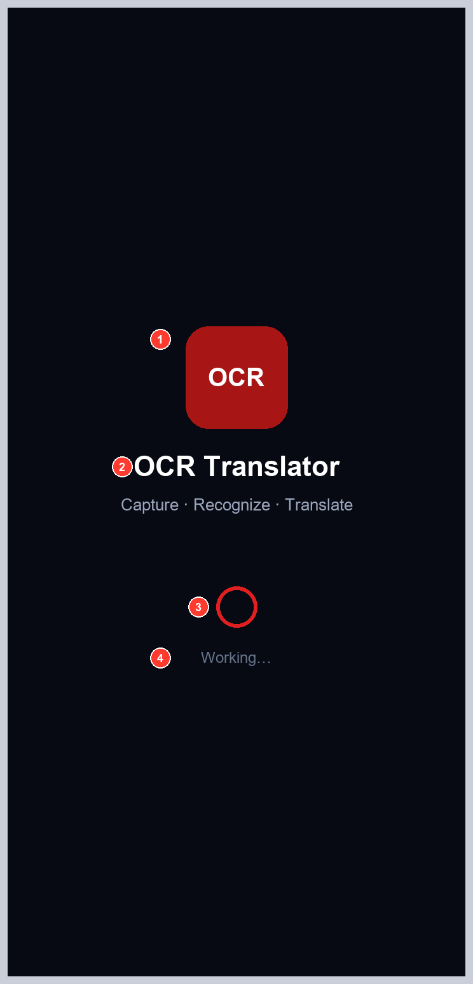
Figure 2. Splash wireframe
Table 4. SCR-01 components
No. | Component | Widget | View ID | Size (phone / tablet) | Behaviour
1 | Brand mark | ImageView | - | - | Static.
2 | App name and tagline | TextView | - | 22 sp / 13 sp | Static.
3 | Progress | ProgressBar | splash_progress | - | Indeterminate while validating.
4 | Status | TextView | splash_status | 12 sp | 'Working…', then tagline, or 'Models are not installed' / 'Something went wrong'.

SCR-02 Home
Screen ID | SCR-02
Activity / layout | MainActivity / activity_main.xml
Purpose | Entry point: action tiles, language pair, manual translation, side menu.
Entry | From SCR-01; Home item in the side menu.
Exit | Tiles and menu items to SCR-03/04/07/08/09; language bar to SCR-06; Translation to SCR-10.
Requirements | FR-17, FR-19, FR-22, FR-23

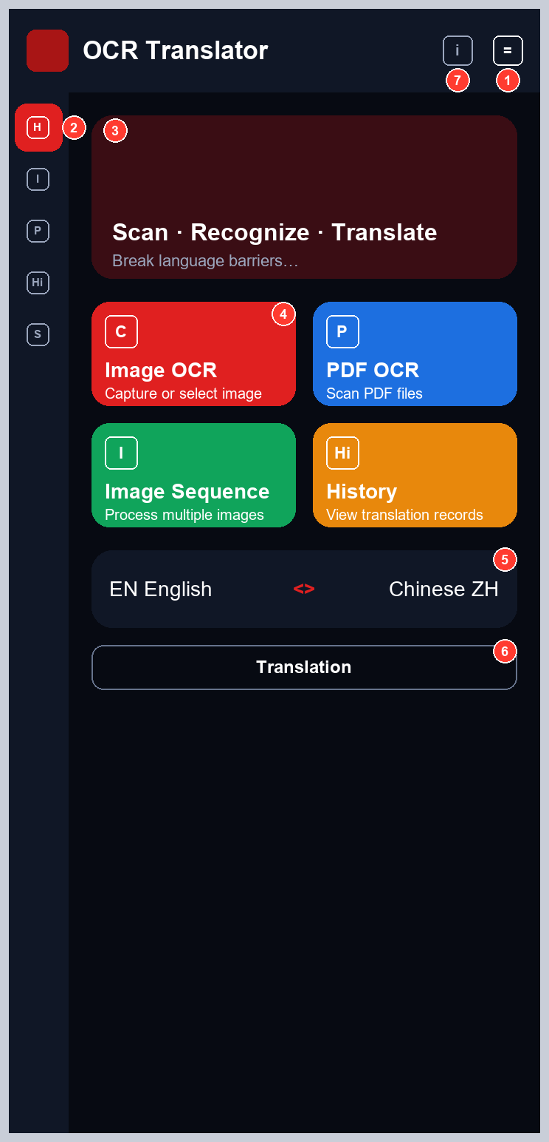
Figure 3. Home — side menu collapsed (default)
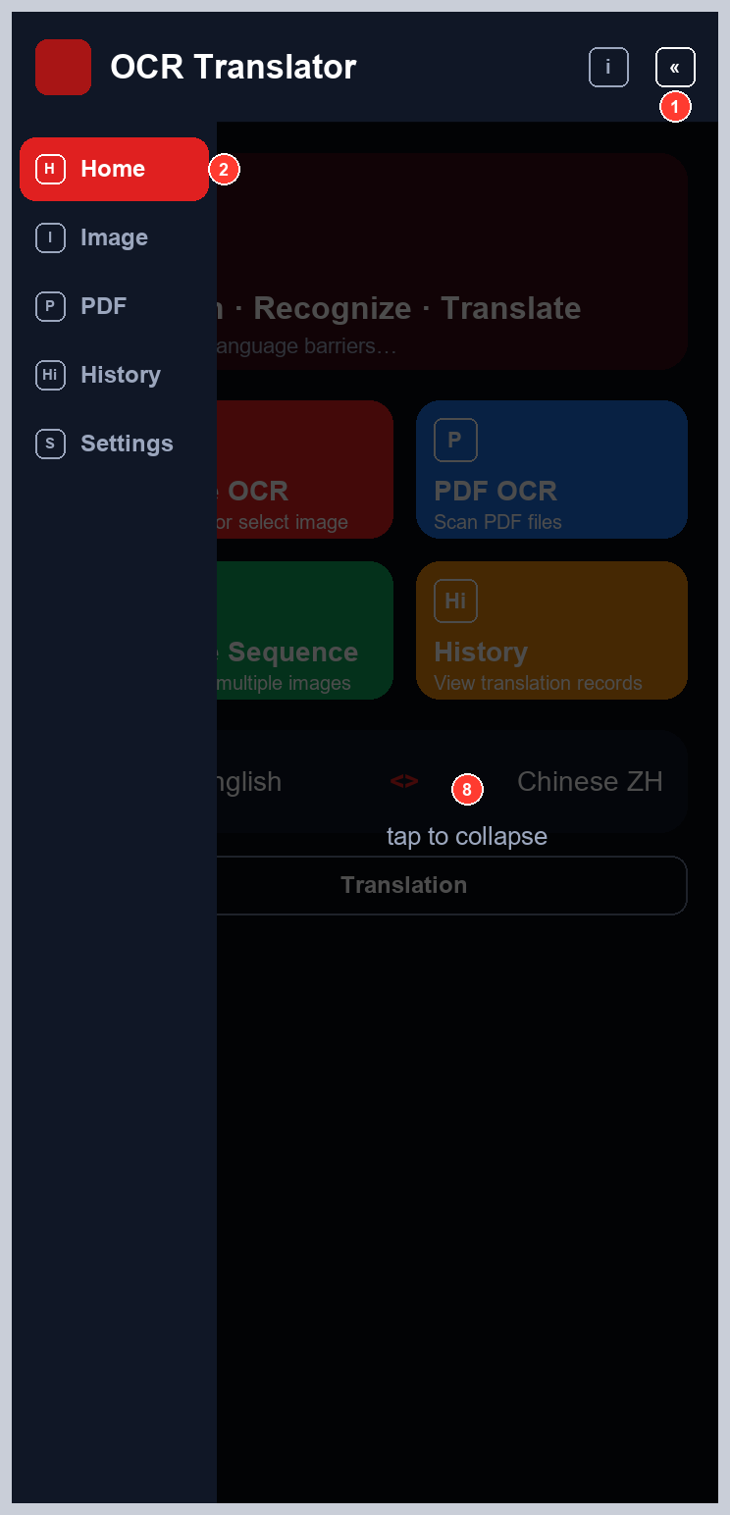
Figure 4. Home — side menu expanded over the content
Table 5. SCR-02 components
No. | Component | Widget | View ID | Size (phone / tablet) | Behaviour
1 | Side-menu toggle (right-hand) | ImageButton | main_nav_toggle | 28 dp / 32 dp | Expands the side menu over the content (icon changes to 'menu open'); pressed again collapses it.
2 | Side menu | LinearLayout of item_nav | nav_rail, nav_home … nav_settings | 40 dp collapsed / 104 dp expanded (52 / 140 on tablets); items 32 dp (40 dp) tall | Home (selected), Image, PDF, History, Settings. Collapsed: icons with tooltips. Expanded: icons and labels, content dimmed.
3 | Banner | LinearLayout | - | 110 dp / 150 dp | Static title and subtitle.
4 | Action tiles (4) | item_action_tile | tile_image, tile_pdf, tile_sequence, tile_history | Wrap content, min 70 dp (100 dp); icon 22 dp (32 dp); title 14 sp (16 sp) | Image OCR -> SCR-03; PDF OCR -> SCR-07; Image Sequence -> SCR-04; History -> SCR-08.
5 | Language bar | view_language_bar | language_bar | Swap button 24 dp (28 dp); names 14 sp | Tap a side -> SCR-06 for that side; swap exchanges source and target.
6 | Translation button | MaterialButton (Outlined) | main_manual_translate | height 30 dp (36 dp), 12 sp (14 sp) | Opens SCR-10.
7 | Model status | ImageButton | main_models_status | 28 dp / 32 dp | Opens SCR-09.
8 | Scrim (expanded only) | View | nav_scrim | Fills content area | Dims content while expanded; tap collapses the menu.
9 | Model warning | TextView | main_model_warning | 12 sp | Shown only when models are missing; tap opens SCR-09.

Side-menu behaviour
1. At launch the menu is collapsed: a 40 dp (52 dp) rail of 15 dp (19 dp) icons; Home is highlighted in red.
2. The right-hand button at the end of the title bar (callout 1) expands the menu to 104 dp (140 dp) in 220 ms. The menu slides over the content, which dims behind a 70 % scrim; labels fade in near the end.
3. The same button (now showing the 'menu open' icon), a tap on the dimmed area, or the Back key collapses it.
4. Choosing an item opens its screen whether the menu is collapsed or expanded.
5. Collapsed icons show their label as a tooltip on long-press and are announced by TalkBack.

Tile layout
Banner, two rows of two tiles, language bar and the Translation button are stacked in a scrolling column. Tiles wrap to their content (about 70 dp on a phone) and do not stretch to fill the screen; the column scrolls if the screen is too short.

SCR-03 Camera OCR
Screen ID | SCR-03
Activity / layout | CameraActivity / activity_camera.xml
Purpose | Live preview and capture; gallery shortcut.
Entry | Image OCR tile.
Exit | Result (SCR-05) after processing; Back to SCR-02.
Requirements | FR-01, FR-02, FR-22

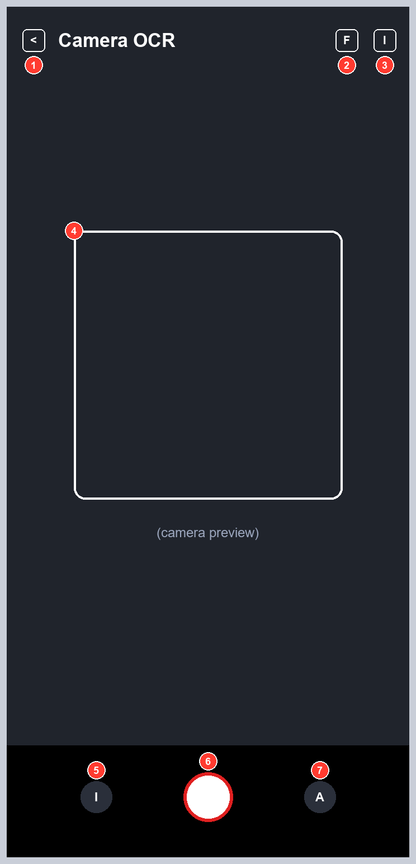
Figure 5. Camera OCR wireframe
Table 6. SCR-03 components
No. | Component | Widget | View ID | Size (phone / tablet) | Behaviour
1 | Back | ImageButton | camera_back | 28 dp / 32 dp | Closes the screen.
2 | Flash | ImageButton | camera_flash | 28 dp / 32 dp | Toggles flash mode (dimmed when off).
3 | Gallery (top) | ImageButton | camera_gallery_top | 28 dp / 32 dp | Opens the system image picker.
4 | Preview and frame | PreviewView | camera_preview | Full screen | Back camera preview; framing guide.
5 | Gallery | circle button | camera_gallery | 28 dp / 32 dp | Opens the system image picker.
6 | Shutter | ImageButton | camera_shutter | 44 dp / 54 dp | Captures and processes; ignored while busy.
7 | Auto | circle button | camera_auto | 28 dp / 32 dp | Shows 'Auto' (informational).

SCR-04 Image Import
Screen ID | SCR-04
Activity / layout | ImageImportActivity / activity_image_import.xml
Purpose | Select one or several images for processing.
Entry | Image Sequence tile; Image item in the side menu. The picker opens immediately.
Exit | Result (SCR-05) with the last processed image.
Requirements | FR-02, FR-03, FR-22

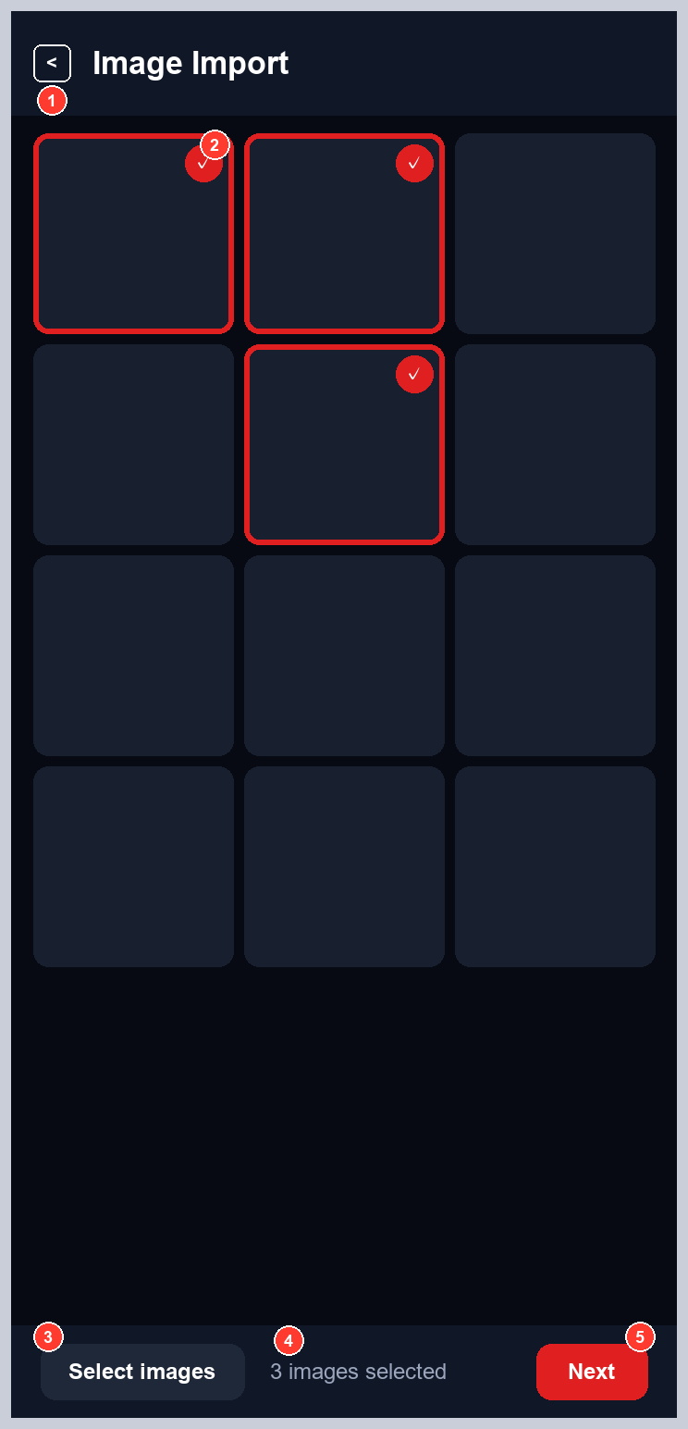
Figure 6. Image Import wireframe
Table 7. SCR-04 components
No. | Component | Widget | View ID | Size (phone / tablet) | Behaviour
1 | Toolbar | view_toolbar | toolbar_back | 56 dp bar, 28 dp buttons | Back closes.
2 | Thumbnail grid | RecyclerView (3 columns) | import_grid | Square cells | Tap toggles selection (red frame and check).
3 | Select images | MaterialButton (Tonal) | import_add | 30 dp / 36 dp | Opens the multi-image picker.
4 | Selection count | TextView | import_count | 12 sp | 'n images selected'.
5 | Next | MaterialButton (Primary) | import_next | 30 dp / 36 dp | Processes the selection; with none selected shows 'Select at least one image'.

SCR-05 Translation Result
Screen ID | SCR-05
Activity / layout | ResultActivity / activity_result.xml
Purpose | Show the re-rendered page and the texts; edit, speak, save.
Entry | After processing from SCR-03 or SCR-04.
Exit | Back to the previous screen.
Requirements | FR-11, FR-12, FR-13, FR-14, FR-22, FR-24

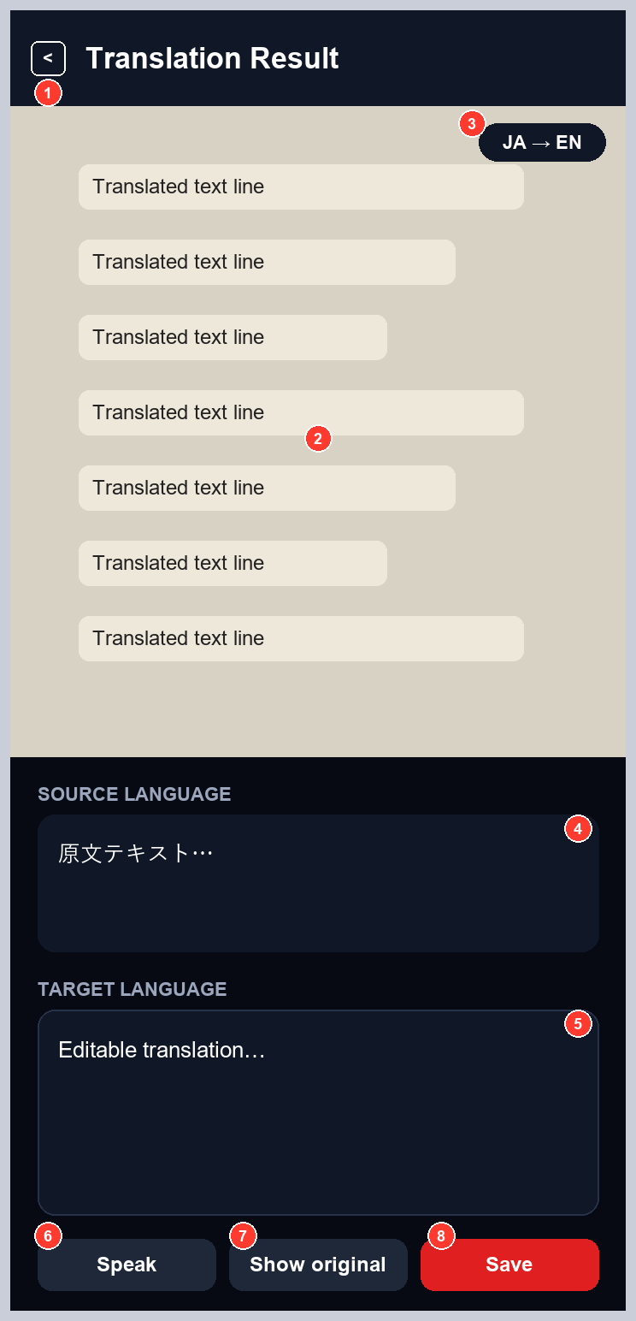
Figure 7. Translation Result wireframe
Table 8. SCR-05 components
No. | Component | Widget | View ID | Size (phone / tablet) | Behaviour
1 | Toolbar | view_toolbar | toolbar_back | 56 dp bar | Back closes and releases page bitmaps.
2 | Page image | ImageView | result_image | Upper area | Rendered page (translucent highlight + halo text) or original.
3 | Direction badge | TextView | result_mode_badge | 11 sp | Effective source -> target, e.g. JA -> EN.
4 | Source text | TextView | result_source_text | Scrollable | Recognised text.
5 | Translation | EditText | result_translated_text | Scrollable | Editable before saving and speaking.
6 | Speak | MaterialButton (Tonal) | result_speak | 30 dp / 36 dp | Reads the translation; disabled without a voice.
7 | Show original / translated | MaterialButton (Tonal) | result_toggle | 30 dp / 36 dp | Toggles the image.
8 | Save | MaterialButton (Primary) | result_save | 30 dp / 36 dp | Saves to history; toast 'Saved to history'.

Rendered page appearance
Each translated paragraph sits on a faint, soft-edged highlight in the paper colour sampled from the page (alpha 150/255): the paper texture remains visible and the original text shows only as a faint ghost. The translation has no opaque background of its own; it is drawn in the sampled ink colour with a thin paper-coloured halo, at the largest size that fits, rotated to the paragraph's angle.

SCR-06 Language Settings
Screen ID | SCR-06
Activity / layout | LanguageActivity / activity_language.xml
Purpose | Choose the source or target language.
Entry | Language bar (SCR-02, SCR-07, SCR-10); default language rows in SCR-09.
Exit | Back, or selecting a language (saves and closes).
Requirements | FR-10, FR-17, FR-21

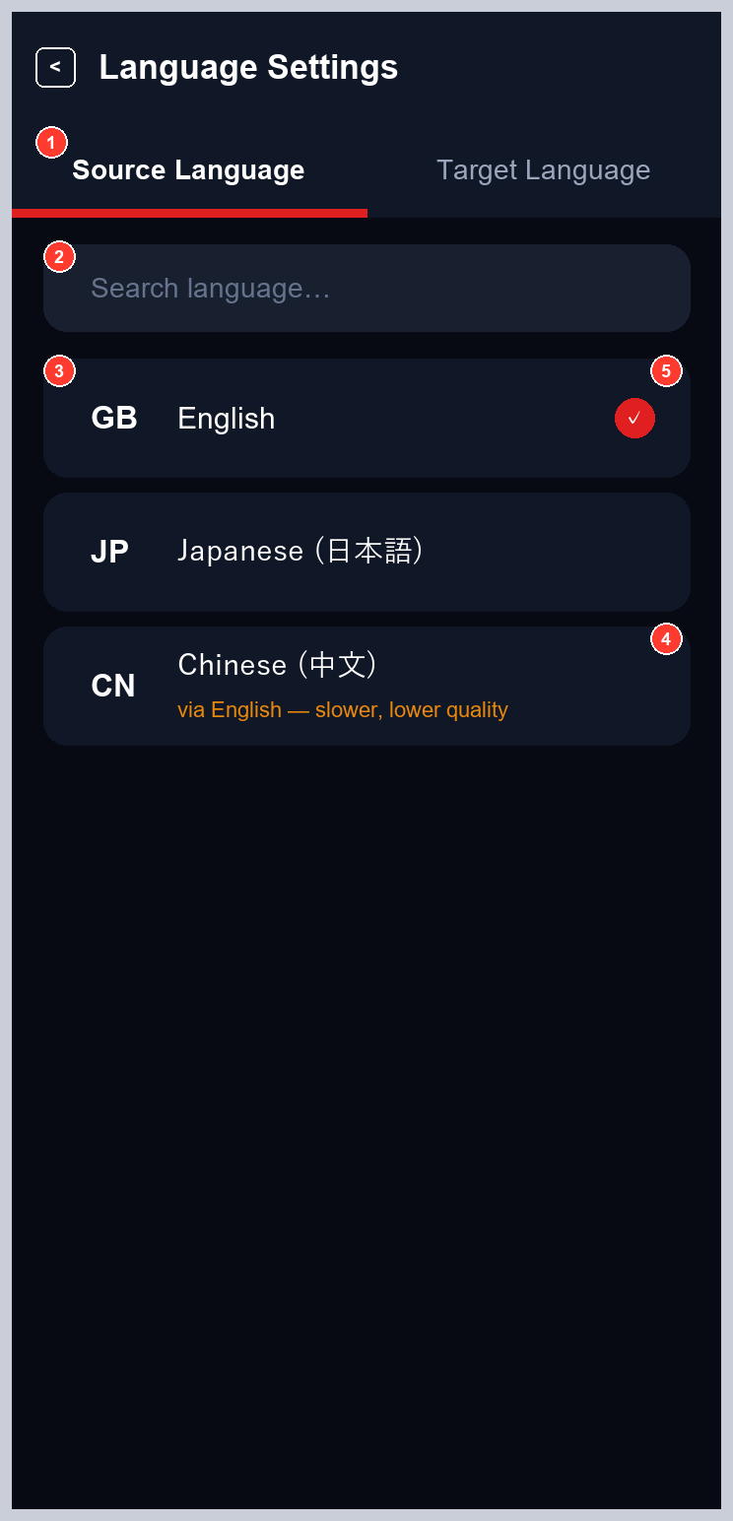
Figure 8. Language Settings wireframe
Table 9. SCR-06 components
No. | Component | Widget | View ID | Size (phone / tablet) | Behaviour
1 | Source / Target tabs | TabLayout | language_tabs | - | Switch the side being edited.
2 | Search | EditText | language_search | Full width | Filters by English name, native name or code.
3 | Language rows | RecyclerView of item_language | language_list | - | Flag, name (with native name), note. English, Japanese, Chinese only - Korean is not listed.
4 | Availability note | TextView | - | 11 sp | 'Model not installed' or 'via English - slower, lower quality'.
5 | Selected mark | ImageView | - | - | Marks the current choice.

SCR-07 PDF OCR
Screen ID | SCR-07
Activity / layout | PdfActivity / activity_pdf.xml
Purpose | Translate a PDF document.
Entry | PDF OCR tile; PDF item in the side menu.
Exit | Back (cancels a running job).
Requirements | FR-04, FR-20, FR-17, FR-22

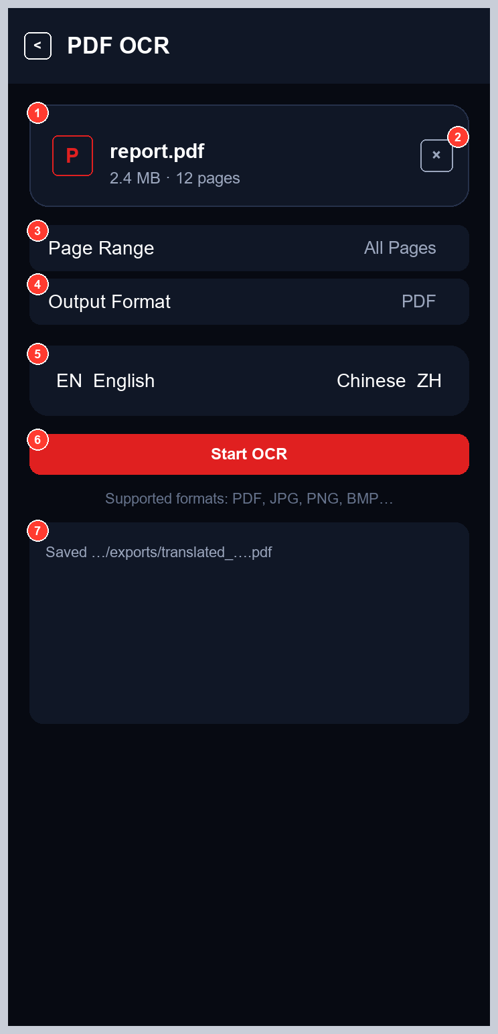
Figure 9. PDF OCR wireframe
Table 10. SCR-07 components
No. | Component | Widget | View ID | Size (phone / tablet) | Behaviour
1 | File card | LinearLayout | pdf_file_card | Full width | Tap opens the document picker (PDF).
2 | Clear | ImageButton | pdf_file_clear | 24 dp / 28 dp | Clears the selected file.
3 | Page Range | item_option_row | pdf_row_range | min 32 dp | All Pages, 1-5, 1-10, 1-20.
4 | Output Format | item_option_row | pdf_row_format | min 32 dp | PDF, DOCX, TXT (persisted).
5 | Language bar | view_language_bar | pdf_language_bar | - | As on SCR-02.
6 | Start OCR | MaterialButton (Primary) | pdf_start | 30 dp / 36 dp | Starts the job; without a file shows 'Choose a PDF' and opens the picker.
7 | Result | TextView | pdf_result | Text | Output path and combined text.

SCR-08 History
Screen ID | SCR-08
Activity / layout | HistoryActivity / activity_history.xml
Purpose | Review and manage saved translations.
Entry | History tile; History item in the side menu.
Exit | Back.
Requirements | FR-15

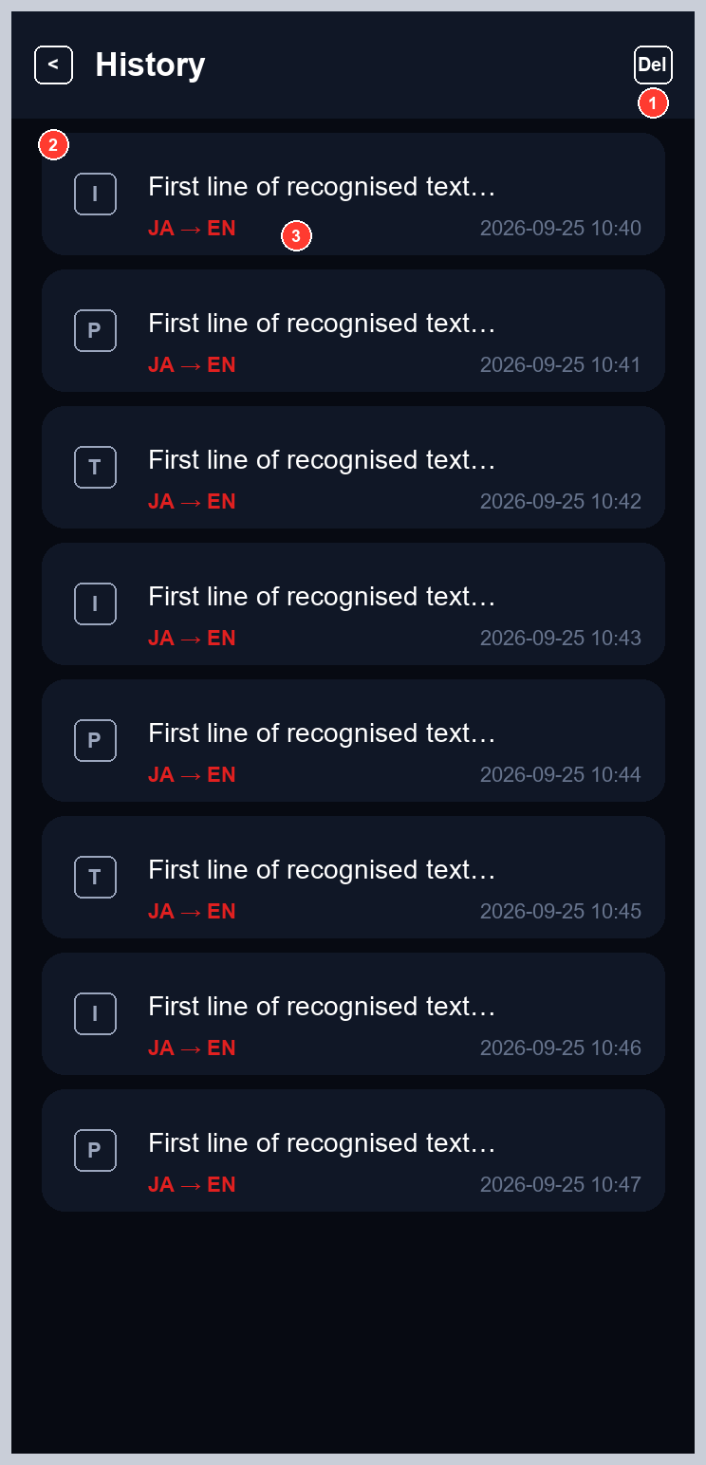
Figure 10. History wireframe
Table 11. SCR-08 components
No. | Component | Widget | View ID | Size (phone / tablet) | Behaviour
1 | Clear history | ImageButton (toolbar action) | toolbar_action | 28 dp / 32 dp | Confirms, then deletes all entries.
2 | Entry list | RecyclerView of item_history | history_list | - | Kind icon, first line (max 60 chars), direction, timestamp. Tap: detail dialog. Long-press: delete.
3 | Empty state | LinearLayout | history_empty | - | 'No translations yet' with hint.

SCR-09 Settings
Screen ID | SCR-09
Activity / layout | SettingsActivity / activity_settings.xml
Purpose | Preferences and model report.
Entry | Settings item in the side menu; model status button on SCR-02; model warning.
Exit | Back.
Requirements | FR-09, FR-18, FR-19, FR-21

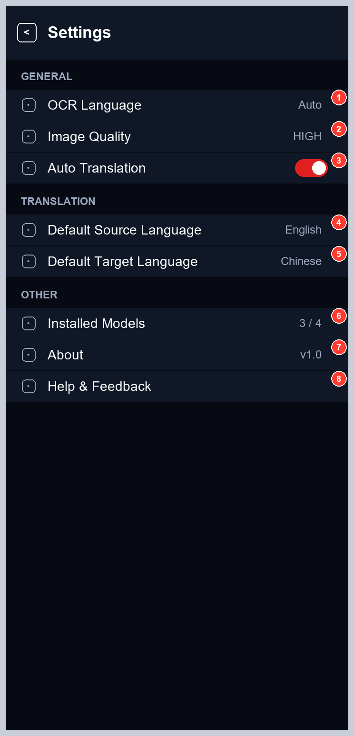
Figure 11. Settings wireframe
Table 12. SCR-09 components
No. | Component | Widget | View ID | Size (phone / tablet) | Behaviour
1 | OCR Language | item_option_row | settings_ocr_language | min 32 dp | Toggles Auto / configured source.
2 | Image Quality | item_option_row | settings_image_quality | min 32 dp | LOW 640 / MEDIUM 960 / HIGH 1280 px.
3 | Auto Translation | item_option_row (switch) | settings_auto_translate | min 32 dp | Translate after recognition.
4 | Default Source Language | item_option_row | settings_default_source | min 32 dp | Opens SCR-06 (source).
5 | Default Target Language | item_option_row | settings_default_target | min 32 dp | Opens SCR-06 (target).
6 | Installed Models | item_option_row | settings_models | min 32 dp | 'OCR languages / MT pairs' (3 / 4 with Korean hidden); tap shows report and pivoted pairs.
7 | About | item_option_row | settings_about | min 32 dp | Version and model licences.
8 | Help & Feedback | item_option_row | settings_help | min 32 dp | Usage tips.

SCR-10 Translation (manual)
Screen ID | SCR-10
Activity / layout | TranslateActivity / activity_translate.xml
Purpose | Translate typed text without OCR.
Entry | Translation button on SCR-02.
Exit | Back.
Requirements | FR-10, FR-16, FR-17, FR-22

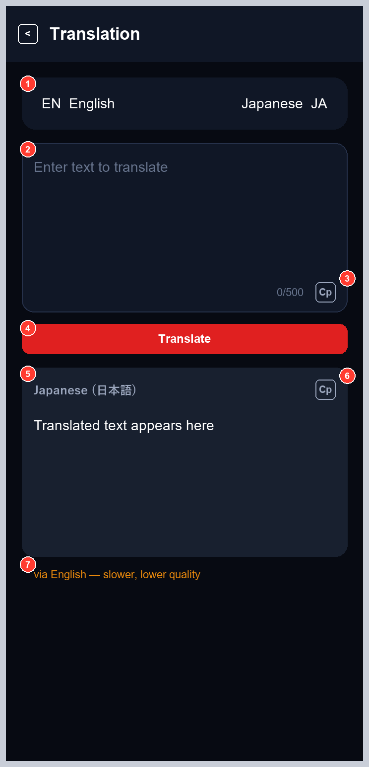
Figure 12. Translation (manual) wireframe
Table 13. SCR-10 components
No. | Component | Widget | View ID | Size (phone / tablet) | Behaviour
1 | Language bar | view_language_bar | translate_language_bar | - | As on SCR-02.
2 | Input | EditText | translate_input | Multi-line | Up to 500 characters.
3 | Copy input / counter | ImageButton, TextView | translate_copy_source, translate_input_counter | 24 dp / 28 dp | Copies input; shows n/500.
4 | Translate | MaterialButton (Primary) | translate_action | 30 dp / 36 dp | Translates and saves to history; same language copies the input.
5 | Output language | TextView | translate_output_lang | 12 sp | Target display name.
6 | Copy output | ImageButton | translate_copy_output | 24 dp / 28 dp | Copies the translation.
7 | Pivot note | TextView | translate_note | 11 sp | Shown when routed through English.

4. Message Catalogue
Table 14. User-visible messages
String resource | Text | Where
working | Working… | Busy overlay, splash
result_saved | Saved to history | SCR-05 toast
result_no_text | No text found in this image | SCR-05
import_none_selected | Select at least one image | SCR-04 toast
pdf_progress | Page %1$d of %2$d | Overlay detail (SCR-04, SCR-07)
pdf_done | Saved %1$s | SCR-07 result
lang_pivoted | via English — slower, lower quality | SCR-06, SCR-10
lang_unavailable | Model not installed | SCR-06
history_clear_confirm | Delete all saved translations? This cannot be undone. | SCR-08 dialog
history_cleared | History cleared | SCR-08 toast
translate_copied | Copied to clipboard | SCR-10 toast
camera_permission_rationale | Camera access is needed to scan text… | SCR-03 toast
camera_unavailable | Camera unavailable on this device | SCR-03 toast
error_models_missing (+ _hint) | Models are not installed / Run tools/fetch_models.sh… | SCR-01, SCR-02, SCR-09
error_generic | Something went wrong | Anywhere
nav_expand / nav_collapse | Expand menu / Collapse menu | SCR-02 toggle description

