Fully Offline, Layout-Preserving Image Translation on Commodity Smartphones: A Dependency-Light Pipeline with Translucent Re-Rendering
by
[Author Name]
A Dissertation Submitted in Partial Fulfillment of the Requirements for the Degree of Doctor of Philosophy
[Department]
[University]
Advisor: [Advisor]
September 2026

Approval Page
This dissertation, entitled Fully Offline, Layout-Preserving Image Translation on Commodity Smartphones: A Dependency-Light Pipeline with Translucent Re-Rendering, submitted by [Author Name] in partial fulfillment of the requirements for the degree of Doctor of Philosophy in [Department], has been examined and approved by the committee listed below.
Role | Name | Signature | Date
Advisor | [Advisor]
Committee member | [Committee Member 1]
Committee member | [Committee Member 2]
Committee member | [Committee Member 3]
External examiner | [External Examiner]
Head of department | [Department Head]

[Placeholder: the approval page is completed by the graduate school according to its own template.]

Abstract
Image translation applications recognise the text in a photograph or scanned page, translate it, and paint the translation back over the original. Most deployed systems send the image to a server. That design is convenient for the provider, but it excludes the documents for which translation is often most needed — medical and legal paperwork, identity documents, material under data-residency rules — and it fails wherever there is no network connection. This dissertation designs, analyses and specifies the evaluation of a complete image translation system for Android that runs entirely on the device, requests no network permission, and is written in managed Java with no native code of its own beyond the inference runtime.
The system chains PP-OCR text detection, 180° orientation classification and connectionist temporal classification (CTC) recognition with OPUS-MT Transformer translation; all models are executed by ONNX Runtime, the translation models on dynamically quantised int8 weights. Three technical contributions make the pipeline work within the constraints of a phone. First, the Differentiable Binarization (DB) post-processing that reference implementations delegate to OpenCV and a polygon-clipping library is reimplemented from first principles. We prove that restricting the convex-hull input to the leftmost and rightmost pixel of each row is exact (Lemma 4.1), derive a closed-form unclip offset for rectangles, and score candidate regions over their own pixels rather than their bounding boxes to remove a systematic bias against rotated text. Second, translation between Chinese, Japanese and Korean, for which no compact direct models are published, is routed through English with whole-page batching per leg and at most one model pair resident in memory; the cost of a decoder without a key-value cache is analysed exactly as n(n+1)/2 decoder positions for n generated tokens. Third, the usual opaque erase of the original text is replaced by a translucent, feathered highlight in the locally estimated paper colour, combined with a paper-coloured glyph halo. We prove that inside the highlight the original glyph contrast and the page texture are both attenuated by exactly (1 − α) in the compositing colour space (Proposition 6.1), which is 0.41 at the default α = 150/255, while the halo restores full contrast around every new glyph. A bisection search chooses the largest feasible font size under high-quality line breaking in a bounded number of layouts.
The engine implements English, Korean, Japanese and Chinese; the deployed user interface exposes three of them through a single build-time list, and uses compact, screen-relative control sizes and a collapsible overlay side menu. The dissertation specifies a full evaluation protocol for five research questions: faithfulness of the library-free detection post-processing against the reference implementation on ICDAR 2015 and MLT-2019; recognition accuracy with and without orientation correction; translation quality on FLORES-200 for all twelve directions with BLEU, chrF and COMET, including int8 versus fp32, greedy versus beam search, and pivoted versus direct translation; on-device latency and memory on three device tiers; and a within-subjects user study of rendering variants analysed with mixed-effects models. The system has not yet been benchmarked. All experimental results are therefore reported as explicit placeholders pending execution of the protocol, and every number in this document is either a repository fact or an analytical consequence of a stated formula.
Keywords: optical character recognition; machine translation; on-device inference; scene text; layout preservation; image compositing; mobile computing; privacy; human–computer interaction.

Acknowledgments
[Placeholder for acknowledgments: advisor, committee, colleagues, funding bodies and family.]
The system described here uses third-party model weights: PaddleOCR models (Apache License 2.0) and OPUS-MT models by the Helsinki-NLP group (CC-BY 4.0). Their authors' work is gratefully acknowledged; attribution is also shown in the application's About dialog.

Table of Contents
Right-click and choose Update Field.

List of Tables
Right-click and choose Update Field.

List of Figures
Right-click and choose Update Field.

List of Abbreviations
Abbreviation | Meaning
ANR | Application Not Responding (Android watchdog)
API | Application programming interface
APK | Android application package
ARGB | Alpha–red–green–blue pixel format
BLEU | Bilingual evaluation understudy
CJK | Chinese, Japanese and Korean
CLMM | Cumulative link mixed model
COMET | Crosslingual optimized metric for evaluation of translation
CRNN | Convolutional recurrent neural network
CTC | Connectionist temporal classification
DB | Differentiable Binarization
dp | Density-independent pixel (Android)
DOCX | Office Open XML word-processing document
dpi | Dots per inch
fp32 | 32-bit floating point
H-mean | Harmonic mean of precision and recall
HCI | Human–computer interaction
int8 | 8-bit integer (quantised) arithmetic
IoU | Intersection over union
JVM | Java virtual machine
KV cache | Key–value cache of decoder self-attention states
LID | Language identification
MT | Machine translation
NDK | Android Native Development Kit
NED | Normalised edit distance
NMT | Neural machine translation
OCR | Optical character recognition
ONNX | Open Neural Network Exchange
OOXML | Office Open XML
ORT | ONNX Runtime
PDF | Portable Document Format
PP-OCR | PaddlePaddle OCR system family
PSS | Proportional set size (memory)
RQ | Research question
sp | Scale-independent pixel (Android text size)
SPM | SentencePiece model
sRGB | Standard RGB colour space
TOST | Two one-sided tests (equivalence)
TTS | Text to speech
TXT | Plain text
UI | User interface

Chapter 1 Introduction
Camera-based translation has become one of the most common ways in which people read text in a language they do not know. A traveller points a phone at a menu, a migrant photographs a letter from a public authority, a clinician receives a discharge summary written abroad, a researcher scans a page of a foreign-language monograph. In each case the user wants more than a list of translated sentences: they want to see the translation where the original text was, in the context of the page, so that headings still look like headings, a price stays next to its dish and a form field stays next to its label. Systems that provide this experience work in three stages: recognition (optical character recognition, OCR), translation (machine translation, MT) and re-rendering, which paints the translated text back into the image in place of the original [1].
This dissertation is about building all three stages so that they run completely on a commodity smartphone, with no server, and about understanding the design decisions that this constraint forces. It is grounded in a concrete, complete system — an Android application written in Java — whose source code is the primary artefact studied. Every algorithmic parameter quoted in the following chapters has been checked against that code, and Appendix A lists each one with the file that defines it.

1.1 Motivation

1.1.1 Privacy and confidentiality
In widely deployed translation services the first two stages, and often the third, run on a server. The image leaves the device, is processed by a third party, and may be retained for quality improvement or abuse detection. For a photograph of a street sign this is harmless. For many of the documents that people most need to understand, it is not. Medical records, legal correspondence, identity documents, bank statements and employment contracts contain personal data whose transfer to a processor is regulated in many jurisdictions; in the European Union, for example, such processing falls under the General Data Protection Regulation [2], which requires a lawful basis, purpose limitation and, for transfers outside the Union, additional safeguards. Corporate and governmental users face data-residency rules that may forbid sending documents to an external service at all. A translation tool that never transmits the image removes this entire class of concerns by construction rather than by policy.
The system studied here takes the strongest available form of that guarantee on Android: its manifest does not request the INTERNET permission. Without that permission the operating system denies the application network sockets, so the claim that no image or text leaves the device does not depend on the correctness of application code. This is a stronger property than a privacy policy or an "offline mode" switch, and it is cheap to audit: a reviewer needs to read one XML file rather than the entire code base.

1.1.2 Connectivity
The second motivation is availability. Translation is needed precisely in situations — travel, field work, humanitarian settings, roaming abroad, basements, aircraft — where connectivity is absent, expensive or unreliable. A server-based system degrades to nothing in those settings. An on-device system has constant availability, and its latency does not depend on the network. The price is that everything must fit on the device: the models, their working memory, and the computation needed to run them within a time that users will accept.

1.1.3 Regulated and sensitive documents
A third motivation combines the first two. Institutions that handle sensitive documents — hospitals, courts, social services, border agencies, law firms — increasingly encounter documents in languages their staff do not read. Their information-governance rules often prohibit cloud services, and their staff frequently work away from a desk. A tool that can be installed on a managed phone, that is demonstrably unable to transmit data, and that preserves the layout of the document so that the translation can be cross-checked against the original fills a real gap. Preserving layout matters here beyond aesthetics: when the translation of a field appears exactly where the field was, a reader can verify which value belongs to which label, a property that a list of translated sentences does not have.

1.2 Problem Statement
Moving the full image translation pipeline onto a phone raises four problems, which together define the scope of this dissertation.
1. Resources. Text detection, text recognition for several scripts and a Transformer translator [3] must fit together within a mobile process whose memory is policed by the operating system's low-memory killer [4], and must complete within a few seconds per page on mid-range hardware without making the user interface unresponsive.
2. Dependencies. Reference OCR pipelines depend on OpenCV [5] for contour extraction and minimum-area rectangles and on a polygon-clipping library for region dilation [6], [7]. On Android that forces a native build per CPU architecture through the NDK, increasing application size, build complexity and maintenance cost.
3. Language coverage. Compact open translation models are published predominantly for English-centric pairs; for the directions between Chinese, Japanese and Korean (CJK) no compact OPUS-MT model exists [8]. Massively multilingual models that do cover these directions [9], [10] are far larger than the per-pair budget of a phone application.
4. Re-rendering. Removing the original text convincingly normally requires an inpainting or text-erasure network [11], [12], a further model that competes for the same memory. The cheap alternative, filling every text box with a flat colour, leaves visible patches over photographs, gradients and paper texture and makes the translation look like a sticker.
The problem addressed is therefore: how can a complete, layout-preserving image translation pipeline be engineered to run fully offline on commodity smartphones, with no native code of its own and a bounded memory footprint, while covering all directions among four languages and producing re-rendered pages whose treatment of the original content is analytically understood? The question has an engineering side (can it be built, and how) and a scientific side (which design choices are exact, which are approximations, and what do they cost). This dissertation treats both.

1.3 Research Questions
The dissertation is organised around five research questions. They are aligned one-to-one with the evaluation protocol of the companion journal manuscript, and Chapter 8 operationalises each of them into hypotheses, datasets, metrics and analyses.
Table 1.1. Research questions and where they are addressed
RQ | Question | Method chapter | Protocol / results
RQ1 | Is the library-free DB post-processing (component-mean score, row-extreme hull, rectangle unclip) faithful to the reference OpenCV + polygon-clipping implementation, and does the component-restricted score reduce the bias against rotated text? | 4 | 8.4 / 9.1
RQ2 | How accurate is on-device recognition across the four scripts, and how much does the conservative 180° orientation classifier contribute? | 4 | 8.5 / 9.2
RQ3 | What translation quality do int8 OPUS-MT models achieve on-device for all twelve directions, and what do quantisation, greedy decoding and English pivoting cost? | 5 | 8.6 / 9.3
RQ4 | What are per-stage latency, peak memory and model-load time on commodity devices of different price tiers, and what is the measured overhead of cache-less decoding? | 3, 5 | 8.7 / 9.4
RQ5 | How do users perceive translucent, halo-assisted re-rendering compared with opaque erasure and with inpainting, and does measured texture retention follow the analytical prediction 1 − α? | 6 | 8.8 / 9.5

1.4 Contributions
The dissertation makes the following contributions.
- A dependency-light, fully offline pipeline. End-to-end OCR plus MT runs in managed Java code over ONNX Runtime [13], with no network permission, a single serialised inference thread, recognition sessions cached per language, and at most one translation model pair resident at a time (Chapter 3).
- Library-free DB post-processing with proofs. An exact reduction of the convex-hull input to per-row extreme pixels (Lemma 4.1, with a complete proof), a closed-form unclip offset for rectangles (Equation 4.6), a complexity analysis of the whole post-processing chain, and a component-restricted confidence score that removes a systematic penalty on rotated text (Chapter 4).
- Analysed on-device translation. A pure-Java SentencePiece unigram encoder with exact Viterbi segmentation, greedy Marian decoding whose cache-less cost is derived exactly, sentence-level chunking, and English-pivoted routing for the six CJK↔CJK directions with an analysis of error compounding (Chapter 5).
- Translucent, layout-preserving re-rendering. A feathered paper-colour highlight over the geometric union of the text regions, whose effect on the original glyphs and the page texture is bounded exactly by Proposition 6.1, a halo that restores full local contrast, and a bisection size-fitting procedure with a proven iteration bound and feasibility guarantee (Chapter 6).
- An evaluation protocol with pre-specified hypotheses. Datasets, metrics, device protocol, ablations and a within-subjects user study with a mixed-effects analysis plan, together with result tables that are deliberately left empty until the protocol is executed (Chapters 8 and 9).
- A usable system. The implementation includes compact, screen-relative control sizes defined as dimension tokens, a collapsible overlay side menu and language gating that allows a fully implemented language to be withheld from users by editing a single list (Chapter 7).

1.5 Thesis Statement
Thesis. A complete image translation pipeline — detection, recognition, translation and layout-preserving re-rendering — can run entirely on a commodity smartphone in managed code without any native dependency of its own; its geometric post-processing can be made exact without computer-vision libraries, its coverage of language pairs without direct models can be obtained by bounded-memory pivoting, and its re-rendering can replace model-based text removal with a translucent compositing scheme whose effect on the original content is analytically bounded and whose legibility is locally guaranteed.
The statement makes three kinds of claim. Claims of feasibility are supported by the existence of the implementation, which builds and runs, and are described in Chapters 3 and 7. Claims of exactness and boundedness are supported by proofs and derivations in Chapters 4, 5 and 6. Claims about quality — that the library-free post-processing is as accurate as the reference, that translation quality is acceptable, that users find the translucent rendering at least as legible and more natural — are empirical. They are stated as hypotheses in Chapter 8 and remain open until the protocol is executed; Chapter 9 provides the result tables that will receive those measurements.

1.6 A Note on the Status of Empirical Results
The system has not yet been benchmarked. This dissertation therefore adopts a strict reporting rule: no experimental number appears anywhere in the text. Every cell of every results table contains the placeholder [TBD], and each results section states which hypothesis the table will test once filled. Numbers that do appear are of two kinds only. The first kind are repository facts: configuration constants read from the source code (for example the binarisation threshold 0.3), and sizes stated in the project documentation (a model tree of about 230 MB, about 35 MB per translation pair, 50 unit tests, a universal debug APK of about 78 MB before models). The second kind are analytical values that follow from a stated formula, such as the retained contrast 1 − α = 0.41 for α = 150/255, or the number of bisection steps required for a given tolerance; these are always labelled as analytical. Figures that show images or curves are either schematics derived from the code or synthetic illustrations, and their captions say which.

1.7 Organisation of the Dissertation
Chapter 2 reviews the literature on text detection and recognition, neural machine translation and its compression, scene-text removal and in-image translation, on-device inference runtimes and mobile interaction design, and closes with a gap analysis. Chapter 3 states the requirements and presents the architecture, threading and memory model, data flow and deployment of the system. Chapter 4 develops the library-free detection post-processing, recognition, colour estimation, layout analysis and script-based source verification, with proofs and complexity bounds. Chapter 5 covers tokenisation, decoding, chunking and pivot routing. Chapter 6 presents the translucent re-rendering model, its analysis and the size-fitting procedure. Chapter 7 describes the Android implementation, model conversion and graph repair, the user interface and the testing strategy. Chapter 8 specifies the experimental methodology and Chapter 9 the result tables and an analytical discussion of expected trade-offs and limitations. Chapter 10 concludes. Appendices list every parameter with its source file, the model inventory, placeholders for user-study materials, and build and reproducibility instructions.

Chapter 2 Background and Literature Review
Image translation sits at the intersection of four research areas that rarely cite each other: text detection and recognition in computer vision, neural machine translation in natural language processing, image editing and inpainting in graphics, and efficient inference and interaction design in mobile computing. This chapter reviews each area to the depth needed to position the design decisions of Chapters 3 to 7, and closes with a synthesis that identifies the gap this dissertation addresses. The review is selective rather than exhaustive; surveys such as that of Long, He and Yao [14] cover scene-text methods more broadly.

2.1 Optical Character Recognition

2.1.1 From document OCR to scene text
Classical OCR engines were designed for scanned documents: high-resolution, fronto-parallel, dark text on a light, mostly uniform background, laid out in columns. Tesseract, originally developed at Hewlett-Packard and described by Smith [15], is the best-known open engine of this lineage; its pipeline finds text lines through connected-component analysis and page-layout heuristics before recognising words. Photographs taken with a phone violate most of the assumptions behind that design. Text appears at arbitrary angles and scales, under perspective distortion, over textured or photographic backgrounds, with uneven illumination, blur and specular highlights, and often as isolated fragments — a label, a sign, a price — rather than as a paragraph. The research community responded with scene-text methods, driven by benchmarks such as the ICDAR Robust Reading competitions [16], [17] and by large synthetic training corpora [18], [19]. Modern systems, including the one studied here, separate the problem into detection (where is text?) and recognition (what does a given text region say?), each solved by a neural network, with hand-written geometry in between.

2.1.2 Regression-based and segmentation-based detection
Text detectors fall into two broad families. Regression-based detectors predict box parameters directly. CTPN [20] detects fine-scale vertical text proposals and links them with a recurrent network into horizontal lines. EAST [21] is a single-stage fully convolutional network that predicts, at every pixel of a score map, the geometry of a rotated rectangle or quadrilateral, followed by non-maximum suppression. Regression works well for straight text of moderate aspect ratio but struggles with very long lines and curved text, because a single receptive field must see the whole instance.
Segmentation-based detectors instead predict a per-pixel text probability and recover instances from it by post-processing. CRAFT [22] predicts character-region and affinity scores and groups characters into words. PSENet [23] predicts several kernels of increasing size for each instance and expands them progressively, which separates adjacent instances that a single binary map would merge. Differentiable Binarization (DB) [24] simplifies this family considerably. The network predicts a probability map P and a threshold map T; during training an approximate, differentiable step function B = 1/(1 + e^{−k(P − T)}) lets the binarisation threshold be learned jointly with the segmentation. Ground-truth text regions are shrunk before training by an offset D = A(1 − r_{s}²)/L, where A and L are the area and perimeter of the polygon and r_{s} is a shrink ratio, so that adjacent instances are separated in the probability map. At inference the threshold map is discarded, P is binarised at a fixed threshold, and each connected region is dilated ("unclipped") back to full size by an offset proportional to its area over its perimeter. DB++ [25] adds adaptive scale fusion to the feature pyramid. Because DB's inference-time post-processing is cheap and its network is small, it has become the default detector of lightweight OCR systems, including PP-OCR.
The inference-time post-processing of DB is the part of the detector that this dissertation reimplements. In the reference implementation [6] it consists of: binarising P; extracting contours of connected regions with OpenCV's border-following algorithm [26], [5]; scoring each contour by the mean of P over its axis-aligned bounding box; fitting a minimum-area rectangle; dilating the resulting polygon with the Vatti clipping algorithm [7] as implemented in a polygon-clipping library; and fitting a minimum-area rectangle again to the dilated polygon. Chapter 4 shows that each step admits a short, exact, library-free replacement.

2.1.3 Sequence recognition with CTC and attention
Recognition networks map an upright crop of a text line to a character string. The dominant lightweight design is the convolutional-recurrent network (CRNN) of Shi, Bai and Yao [27]: a convolutional backbone turns the crop into a horizontal sequence of feature columns, a bidirectional LSTM [28] models context along the sequence, and a per-column classifier predicts a distribution over the character set plus a special blank symbol. The network is trained with connectionist temporal classification (CTC) [29], which marginalises over all alignments between the column sequence and the target string. At inference, greedy CTC decoding takes the most probable symbol per column, collapses consecutive repeats and removes blanks; the blank is what allows genuine double letters to survive, since "l-blank-l" collapses to "ll" while "l-l" collapses to "l". Attention-based recognisers such as ASTER [30] replace CTC with an autoregressive decoder and add a learned rectification of curved text; they are typically more accurate on irregular text and slower. Baek et al. [31] decompose recognisers into transformation, feature extraction, sequence modelling and prediction stages and show that many reported gains shrink under a consistent training and evaluation protocol — a caution that motivates the careful comparison protocol of Chapter 8.

2.1.4 The PP-OCR family
PP-OCR [32] is an engineering-oriented OCR system that packages a DB detector, a small text-direction classifier and a CRNN-style CTC recogniser, all with lightweight backbones derived from MobileNetV3 [33], [34], and a collection of training strategies chosen to keep the total model size small. The direction classifier decides whether a cropped line is upside down and is used to rotate it by 180° before recognition. PP-OCRv3 [35] revised the detector training and the recogniser architecture; later versions, including the PP-OCRv4 models used in this work, are distributed through the project repository [6]. Recognisers are released per script or language, each with a character dictionary. The weights are released under the Apache 2.0 licence, and the project's own mobile demonstration runs them through a C++ runtime together with OpenCV. The present work uses the released weights unchanged and reimplements all of the algorithmic code around them in Java.

2.1.5 Computational geometry for text boxes
Turning a pixel region into an oriented box is a classical computational-geometry task. The convex hull of n planar points can be computed in O(n log n) time by Graham's scan [36] or by Andrew's monotone chain [37], which sorts the points lexicographically and builds the lower and upper hulls in two linear passes; standard texts [38], [39] give the analysis. Freeman and Shapira [40] proved that a minimum-area rectangle enclosing a convex polygon has one side collinear with an edge of the polygon, which reduces the continuous search over orientations to a finite set of candidates. Toussaint's rotating calipers [41] enumerate those candidates in linear time by advancing four support lines around the hull. Polygon offsetting — dilating a polygon by a fixed distance — is harder in general: the Vatti algorithm [7] handles arbitrary, possibly self-intersecting polygons at the price of a substantial implementation. Finally, rectifying an oriented quadrilateral into an upright crop is a planar homography determined by four point correspondences [42].

2.2 Neural Machine Translation

2.2.1 Encoder–decoder models and the Transformer
Neural machine translation models the conditional probability of a target sentence given a source sentence with an encoder–decoder network. Early systems used recurrent networks [43]; attention [44] let the decoder consult all encoder states at every step, and large production systems followed [45]. The Transformer [3] replaced recurrence with multi-head self-attention and became the standard architecture. Decoding is autoregressive: the decoder produces one token at a time, each conditioned on the source encoding and on all previously generated tokens. Greedy decoding takes the arg-max at each step; beam search keeps the k best partial hypotheses and usually improves quality modestly at roughly k times the decoder cost.
Because each decoding step attends over all previous target positions, a naive implementation recomputes the keys and values of the whole prefix at every step. Production inference caches them — the key–value (KV) cache — so that each step processes only the newest position; the memory and bandwidth implications of the cache are a central concern of large-scale Transformer inference [46]. Exporting a model with a KV cache to a portable graph format requires threading the cache tensors of every layer through the graph as explicit inputs and outputs, which is why simpler exports omit it. Chapter 5 analyses exactly what that omission costs.

2.2.2 Marian, OPUS and OPUS-MT
Marian [47] is an efficient C++ toolkit for training and serving NMT models. OPUS [48] is a large collection of openly licensed parallel corpora. OPUS-MT [8] combines the two: the Helsinki-NLP group trained and released Transformer models for many language pairs on OPUS data, which are also distributed in a form usable with the Hugging Face Transformers library [49] and can therefore be exported to ONNX with Hugging Face Optimum [50]. The models are released under CC-BY 4.0, which requires attribution. Most published OPUS-MT models are English-centric; for pairs among Chinese, Japanese and Korean there is no direct model, which is the origin of the pivoting problem addressed in Chapter 5.

2.2.3 Subword tokenisation
NMT models operate on subword units so that the vocabulary is finite while rare words remain representable. Byte-pair encoding [51] merges frequent symbol pairs greedily. The unigram language model of Kudo [52] instead assigns each piece in a vocabulary a probability and segments a string into the sequence of pieces with maximum total log-probability, which is found exactly by the Viterbi algorithm [53]. SentencePiece [54] implements both schemes language-independently: it treats the input as a raw character stream, applies Unicode normalisation, and represents word boundaries with a visible meta-symbol (U+2581) so that detokenisation is lossless. OPUS-MT models ship SentencePiece models for source and target, and a vocabulary that maps pieces to ids. A segmentation that differs from the one used in training still produces valid ids, so tokeniser errors are silent — a property that shapes the testing strategy of Chapter 7.

2.2.4 Compression: quantisation, distillation and efficient architectures
Transformer translation models have tens to hundreds of millions of parameters. Three families of techniques reduce their cost. Quantisation stores weights, and optionally activations, as 8-bit integers: Jacob et al. [55] established integer-arithmetic-only inference for convolutional networks, Krishnamoorthi [56] surveyed post-training and per-channel schemes, and Bhandare et al. [57] applied 8-bit quantisation to Transformer translation. Dynamic quantisation quantises weights offline and activations at run time from their observed range, requiring no calibration data, which is what the conversion script of this system uses. Knowledge distillation trains a small student to imitate a large teacher [58]; sequence-level distillation [59] is especially effective for NMT. Architectural choices such as a deep encoder with a shallow decoder [60] shift computation to the encoder, which runs once, and away from the decoder, which runs once per output token; efficiency-focused systems combine all three [61]. Model pruning and weight sharing [62] are further options not used here.

2.2.5 Pivot translation and multilingual models
When no direct model exists for a pair, a classical remedy is to translate through a third pivot language. In phrase-based statistical MT, Utiyama and Isahara compared sentence-level pivoting (translate twice) with phrase-table triangulation [63], and Wu and Wang developed the triangulation approach further [64]. Sentence-level pivoting is simple and always applicable, but it costs two translations and compounds errors: information lost or distorted in the first leg cannot be recovered in the second, and phenomena that the pivot language does not mark — honorific levels, zero pronouns, topic marking — are especially at risk between languages that share them but that English lacks.
Multilingual NMT offers an alternative. Firat, Cho and Bengio [65] shared an attention mechanism across many language pairs; Johnson et al. [66] trained a single model with a target-language token and observed zero-shot translation between pairs never seen together in training. M2M-100 [10] trained explicitly on non-English directions, and NLLB-200 [9] scaled the approach to two hundred languages and released distilled variants, the smallest of which has about 600 million parameters. These models cover the CJK directions directly, but even the distilled variants are an order of magnitude larger than an OPUS-MT pair. For a phone application that must also hold OCR models, that difference decides the design; Chapter 8 nevertheless includes NLLB-200-distilled-600M as an off-device upper-bound reference for the pivoted directions.

2.3 Text Removal, Editing and In-Image Translation

2.3.1 Inpainting
Replacing text in an image requires first removing the original. The general problem is image inpainting: filling a masked region plausibly from its surroundings. Bertalmio et al. [67] propagated isophotes into the hole with partial differential equations; Criminisi, Pérez and Toyama [68] copied exemplar patches in a priority order that preserves linear structures; Telea [69] proposed a fast marching method that is simple enough to be included in OpenCV. These classical methods work for thin masks on smooth backgrounds — text strokes on paper are a good case — but produce smears over structured textures. Learned inpainting, exemplified by LaMa [11], uses fast Fourier convolutions to obtain an image-wide receptive field and handles large masks and repetitive structure far better, at the cost of a sizeable network.

2.3.2 Scene-text erasing and editing
Text-specific erasure networks learn to remove text without an explicit mask. Scene Text Eraser [70] operated on image patches; EnsNet [12] erased text from whole images end to end with a set of losses designed to make the result indistinguishable from text-free backgrounds. Scene-text editing goes further and synthesises replacement text in the style of the original: SRNet [71] decomposes the task into background inpainting, text conversion and fusion, and STEFANN [72] edits individual characters with a font-adaptive network. For translation, style transfer across scripts is especially difficult because the target glyphs have no counterpart in the source style.

2.3.3 End-to-end in-image translation
Mansimov et al. [1] framed in-image translation as a single pixel-to-pixel problem, producing an image of the translated text directly from an image of the source text. The formulation is elegant but, at the time of writing, far from the robustness and language coverage of cascaded OCR–MT–rendering systems, and it offers no intermediate text that a user could copy, correct or have read aloud.

2.3.4 Compositing
Whatever removes or de-emphasises the original, the final image is assembled by compositing. Porter and Duff [73] formalised compositing algebra with an alpha channel; the source-over operator, which blends a source colour S with coverage α over a destination D as αS + (1 − α)D, is the default of every 2-D graphics library including Android's. On Android the blend is performed on gamma-encoded sRGB values [74], not on linear light, which matters when interpreting any analysis in terms of perceived contrast. Chapter 6 builds the re-rendering method directly on this operator and analyses it exactly.

2.4 On-Device Machine Learning Runtimes
Deploying neural networks on phones requires an inference runtime that executes a portable model representation with kernels optimised for mobile CPUs, GPUs or neural accelerators. TensorFlow [75] provides a mobile runtime in its ecosystem; MNN [76] is a lightweight engine designed for mobile deployment; PaddlePaddle ships Paddle Lite, which the PaddleOCR mobile demonstration uses; and ONNX Runtime [13] executes models in the Open Neural Network Exchange format [77], with a Java API on Android and graph-level optimisations such as operator fusion and constant folding. Benchmarks such as AI Benchmark [78] document the wide spread of neural-network performance across Android devices, which is why Chapter 8 prescribes measurements on several price tiers rather than one flagship.
Choosing a runtime also chooses a conversion path. PaddleOCR models are converted to ONNX with paddle2onnx [79]; OPUS-MT models are exported with Optimum [50]. Conversions are not always clean: Chapter 7 documents a rank mismatch in shape-assembling Concat nodes emitted for some PaddleOCR graphs that makes ONNX Runtime refuse to load them, and the repair applied. A further, often decisive consideration on Android is whether the runtime and its surrounding code need native libraries built per CPU architecture. ONNX Runtime ships its native library inside a standard Android archive; everything else in the present system is Java, so the application itself needs no NDK build.

2.5 Mobile Interaction Design

2.5.1 Touch-target sizing
Fitts' law [80] relates the time to acquire a target to the ratio of its distance and width, and underlies most guidance on target size. On touch screens the finger's contact area and occlusion of the target add a floor below which error rates rise sharply. Parhi, Karlson and Bederson [81] studied one-handed thumb use on small touch screens and found that targets of roughly 9–10 mm were needed before performance stopped improving. Platform guidance encodes similar floors: Android recommends touch targets of at least 48 × 48 dp [82], and WCAG 2.1 success criterion 2.5.5 (level AAA) asks for 44 × 44 CSS pixels [83]. The users of an image translation app are frequently holding a document or standing in front of a sign, often with one hand. Chapter 7 describes how the system sizes its controls, and why several of them deliberately fall below these floors in favour of a compact interface.

2.5.2 Navigation patterns
Mobile applications organise top-level destinations with a bottom navigation bar, a navigation drawer or a navigation rail. Material Design describes the rail as a vertical strip of destination icons along the side of the screen, optionally expandable to show labels, intended for medium and larger screens [84]. On a narrow phone a rail competes with content for width, and an expanded rail that pushes content aside can squeeze it severely; an overlay that expands over the content with a scrim avoids that at the cost of temporarily hiding it. Chapter 7 motivates the choice made in this system on exactly this trade-off.

2.5.3 Contrast and legibility
WCAG 2.1 defines contrast ratio from relative luminance and requires 4.5:1 for normal text at level AA [83]. The definition is non-linear in encoded sRGB values, so a linear attenuation of encoded colour differences — which is what translucent compositing produces — maps monotonically but not proportionally to contrast ratio. This distinction is made explicit in Chapter 6, where the analytical result is stated in the compositing colour space and its perceptual interpretation is deferred to the user study.

2.6 Synthesis and Gap Analysis
2.1 summarises the design space. Server-based services are excluded by the privacy and connectivity requirements. Cascaded on-device pipelines built on OpenCV and a native runtime are feasible but carry a per-architecture native build. Model-based text removal and editing produce the most seamless images but add a network of comparable size to the whole OCR stack and offer no analytical control over what remains of the original. End-to-end in-image translation is not yet a practical alternative. No approach in the reviewed literature combines full offline operation, a managed-code implementation without native dependencies of its own, coverage of pairs without direct models under a bounded memory budget, and a re-rendering scheme with a stated, provable effect on the original content.
Table 2.1. Qualitative comparison of approaches to image translation (derived from the literature reviewed in this chapter; not a measurement)
Approach | Offline | No own native code | CJK↔CJK without direct model | Original text treatment | Extra model for removal | Analytical guarantee
Server-based cascaded services | No | n/a | Provider-dependent | Varies | Varies | No
Classical OCR engine + offline MT [15] | Yes | Usually no | Only if pivoted | Usually none (text only) | No | n/a
PP-OCR reference mobile pipeline [6] | Yes | No (C++, OpenCV) | n/a (OCR only) | n/a | No | n/a
Cascade + learned inpainting [11] | Possible | Depends | Depends | Removed | Yes (large) | No
Scene-text editing [71], [72] | Research | No | n/a | Replaced in style | Yes | No
End-to-end in-image NMT [1] | Research | No | n/a | Regenerated | Integral | No
This work | Yes | Yes (Java + ORT) | Pivot, bounded memory | Attenuated by 1 − α, halo | No | Yes (Lemma 4.1, Prop. 6.1)

The remaining chapters fill this gap. The approach is deliberately analytic where the literature is predominantly learned: geometry that can be computed exactly is computed exactly and proved correct, and re-rendering is built from a compositing operator whose effect can be stated in closed form. Learned components are used where nothing else will do — detection, recognition and translation — and are taken unchanged from open releases, so that the contributions of this work are isolated from model training.

Chapter 3 System Requirements and Architecture
This chapter describes the system as a whole before Chapters 4 to 6 examine its algorithms. It states the requirements the design answers to, the principles that guided it, and the architecture that results: packages and their responsibilities, the processing pipeline and its data types, the threading and memory model, the model tree and its validation, and deployment. The description is derived from the source code under app/src/main/java/com/falcon/ocrtrans/ and from the project's technical documentation.

3.1 Requirements
The requirements below were reconstructed from the implementation and its documentation rather than taken from a separate specification; each is phrased so that it can be checked against the code or measured by the protocol of Chapter 8. 3.1 lists the functional requirements and 3.2 the non-functional ones.
Table 3.1. Functional requirements
ID | Requirement | Realised by
FR1 | Accept input from the camera, from one or more gallery images, and from PDF files with a selectable page range. | CameraActivity, ImageImportActivity, PdfActivity
FR2 | Detect text regions at arbitrary orientation and return them as ordered quadrilaterals in page pixels. | PaddleOcrEngine.detect, DbPostProcessor
FR3 | Recognise English, Korean, Japanese and Chinese text with a per-script recogniser. | PaddleOcrEngine.recognizeCrops, CtcDecoder, CharDict
FR4 | Group lines into reading order and paragraphs so that translation sees sentences. | LineGrouper, Paragraph
FR5 | Optionally verify the configured source language from the recognised script and re-recognise with the matching head. | ScriptDetector, TranslationPipeline
FR6 | Translate between every ordered pair of the four languages (12 directions). | MarianTranslator, PivotTranslator
FR7 | Re-render the translation over the page, preserving position, orientation, relative size and colours. | LayoutRenderer, TextFitter
FR8 | Export PDF jobs as re-rendered PDF, DOCX or plain text. | PdfJob, DocxWriter
FR9 | Allow the recognised and translated text to be edited, copied, read aloud and saved to a local history. | ResultActivity, HistoryStore
FR10 | Translate typed text without OCR. | TranslateActivity
FR11 | Report precisely which model files are missing instead of failing later. | ModelValidator, SplashActivity, MainActivity

Table 3.2. Non-functional requirements
ID | Requirement | Design response / verification
NFR1 Privacy | No image or text leaves the device. | No INTERNET permission in the manifest; verified by inspection.
NFR2 Offline | Full function without connectivity. | All models bundled under assets/model/.
NFR3 Portability | No native code of the application's own; one code base for all ABIs. | Java only; ONNX Runtime AAR supplies the only native library.
NFR4 Memory | Bounded model residency; no per-page accumulation. | One MT pair resident; recognition sessions cached per language; PDF pages processed one at a time.
NFR5 Responsiveness | The UI thread never runs inference. | Single background worker falcon-engine below normal priority; results posted via a Handler.
NFR6 Latency | Seconds per page on mid-range hardware. | Measured by RQ4 (Chapter 8).
NFR7 Robustness | Silent-failure components are unit-tested. | 50 JVM unit tests (Chapter 7).
NFR8 Accessibility | Screen-relative control sizes; labels available for icon-only controls. | Dimension tokens per screen class, several deliberately below 48 dp (compact UI); tooltips and content descriptions (Chapter 7).
NFR9 Licensing | Third-party model licences honoured. | Apache 2.0 (PaddleOCR) and CC-BY 4.0 (OPUS-MT) attribution in the About dialog.

3.2 Design Principles
Four principles recur throughout the implementation and explain many of its specific choices.
- Exactness before approximation. Where a computation can be done exactly at acceptable cost — the convex hull, the minimum-area rectangle, Viterbi segmentation — it is done exactly, and any deviation from the reference algorithm is argued to be either exact (the row-extreme hull) or a deliberate, stated change (the component-mean score).
- Fail loudly where failure would otherwise be silent. Several components can fail by producing plausible but wrong output: a recogniser with a mismatched dictionary shifts every character, a wrong decoder start token produces fluent text unrelated to the input, detector and recogniser normalisations are easily confused. The code checks each of these explicitly (for example, the dictionary size is reconciled against the class count read from the loaded graph) and the unit tests concentrate on them.
- Serialise rather than synchronise. The inference sessions are not thread-safe. Instead of locking, all inference is confined to one worker thread, which makes the concurrency argument trivial and bounds peak memory.
- Degrade visibly. When a model is missing, the application says which file; when a direction is pivoted, the language picker says so; when a translation does not fit its box even at the minimum size, the renderer flags it (and a debug mode outlines it in red).

3.3 Architecture
3.1 shows the package structure. The code is organised in four layers. The presentation layer (ui) contains the activities and widgets. The orchestration layer (engine) owns the inference engines and the worker thread, validates the model tree, and runs the pipeline. The algorithm layer contains one package per concern: ocr, mt, render and pdf. The foundation layer holds value types shared by all stages (core) and persistence (data). The inference runtime and the model assets sit below the code.
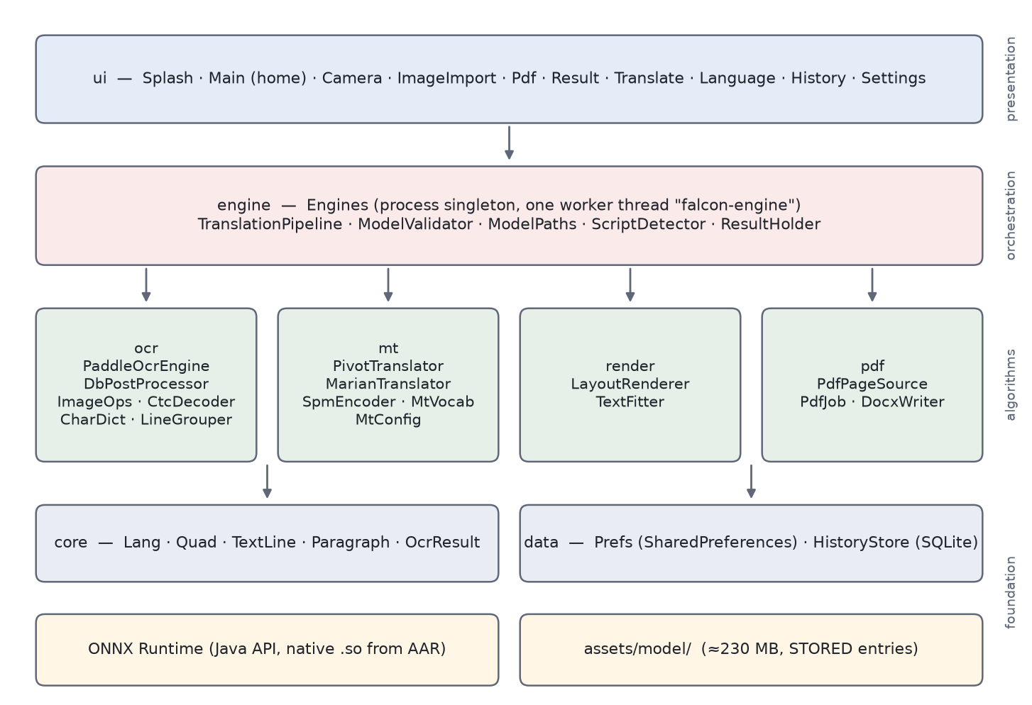
Figure 3.1. Package architecture of the system (schematic derived from the source tree). Arrows denote the principal direction of calls.
Table 3.3. Package responsibilities
Package | Responsibility | Key types
core | Value types shared by all stages | Lang, Quad, TextLine, Paragraph, OcrResult
ocr | Detection, cropping, orientation, recognition, grouping | PaddleOcrEngine, DbPostProcessor, CtcDecoder, CharDict, ImageOps, LineGrouper
mt | Tokenisation and translation | SpmEncoder, MtVocab, MtConfig, MarianTranslator, PivotTranslator
render | Repainting translated text over the page | LayoutRenderer, TextFitter
pdf | Page rasterisation and PDF/DOCX/TXT output | PdfPageSource, PdfJob, DocxWriter
engine | Engine lifetime, threading, validation, orchestration | Engines, TranslationPipeline, ModelValidator, ModelPaths, ScriptDetector
data | Preferences and SQLite history | Prefs, HistoryStore, HistoryItem
ui | Activities, adapters, widgets | MainActivity and other activities, LanguageBar, OptionRow, Flags

Two interfaces decouple the pipeline from concrete engines. OcrEngine exposes recognize(bitmap, lang) and is implemented by PaddleOcrEngine. Translator exposes supports, translate and translateAll; it is implemented by MarianTranslator, and PivotTranslator is a decorator that implements the same interface over a delegate. The pipeline therefore sees one translator that supports all twelve directions, and the routing decision is invisible to it.

3.4 Processing Pipeline and Notation
3.2 shows the stages that TranslationPipeline.process executes for one bitmap. The input is a bitmap I of size W × H, a source language ℓ_{s} and a target language ℓ_{t}, drawn from 𝓛 = {EN, KO, JA, ZH}. Recognition produces a set of lines, each with an oriented quadrilateral q_{i}, a string x_{i}, a confidence c_{i} and a pair of colours (κ_{i}, π_{i}) for ink and paper. Lines are grouped into paragraphs 𝒫_{j}; each paragraph receives a translation y_{j}; and the renderer produces a new image Î in which each y_{j} occupies the geometry of 𝒫_{j}. 3.4 collects the notation used in the remaining chapters.
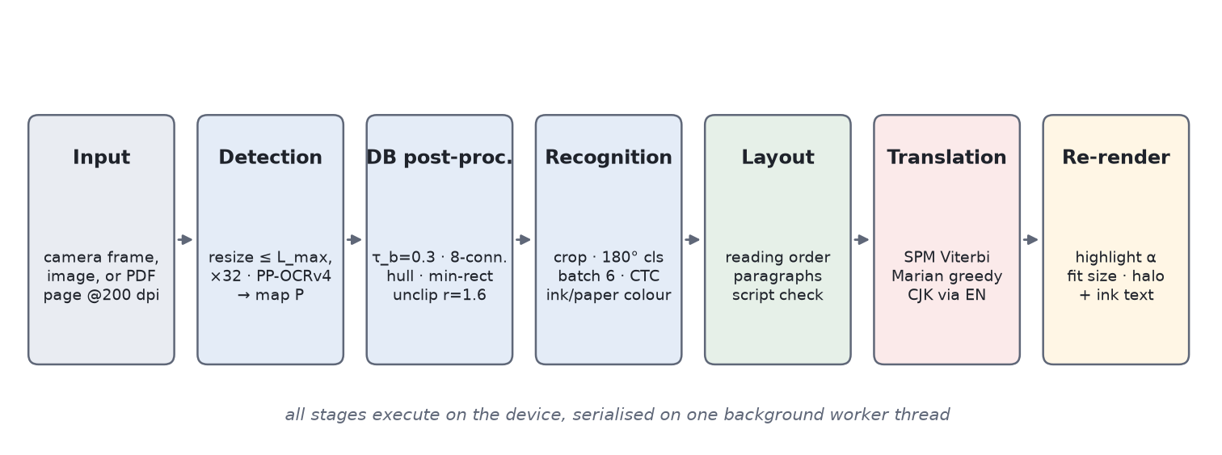
Figure 3.2. Processing pipeline. All stages run on the device, serialised on one worker thread (schematic).
Table 3.4. Principal notation
Symbol | Meaning | Default / range (source)
I, W × H | Input bitmap and its size in pixels | —
𝓛, ℓ_{s}, ℓ_{t} | Implemented languages; source and target | {EN, KO, JA, ZH}
L_{max} | Detector long-edge limit (Image Quality setting) | 640 / 960 / 1280; clamped 320–2048
P | Detector probability map, h × w | values in [0, 1]
τ_{b} | Binarisation threshold | 0.3 (DbPostProcessor)
τ_{s} | Component score threshold | 0.6 (DbPostProcessor)
r | Unclip ratio | 1.6 (DbPostProcessor)
q_{i}, x_{i}, c_{i} | Line quadrilateral, text, confidence | c_{i} ≥ 0.5 kept (PaddleOcrEngine)
κ_{i}, π_{i} | Estimated ink and paper colour of line i | ImageOps.sampleColors
𝒫_{j}, y_{j} | Paragraph j and its translation | —
α | Highlight opacity | 150/255 ≈ 0.59 (LayoutRenderer)
γ | Highlight growth factor | 0.06 (LayoutRenderer)
h | Median line height of a block | —
p, s, s* | Preferred, candidate and fitted font size | p = 0.82 h (LayoutRenderer)

The pipeline logic is short enough to state in full. The following pseudocode mirrors TranslationPipeline.process:
ocr = ocrEngine.recognize(bitmap, source)
effectiveSource = source
if ocr not empty and options.autoDetectSource:
guess = ScriptDetector.detect(ocr.plainText(), source)
if not guess.isUserFacing(): guess = source # language gating (Ch. 7)
if guess != source:
second = ocrEngine.recognize(bitmap, guess) # detection runs again too
if second not empty: ocr = second; effectiveSource = guess
if options.translate and ocr not empty and effectiveSource != target:
translateInPlace(ocr, effectiveSource, target) # paragraph-level, whole page batched
if options.render and ocr not empty:
rendered = LayoutRenderer.render(bitmap, ocr, options.renderOptions)
3.3 traces the data types that flow between stages. The OCR domain works in page pixels: the probability map is scaled back to page coordinates by the ratio of page size to map size, where the map's own tensor shape is taken as authoritative because the exported graph may round dimensions differently from the resizing code. The rendering domain consumes paragraphs and their translations and produces a new bitmap; the source bitmap is never modified.
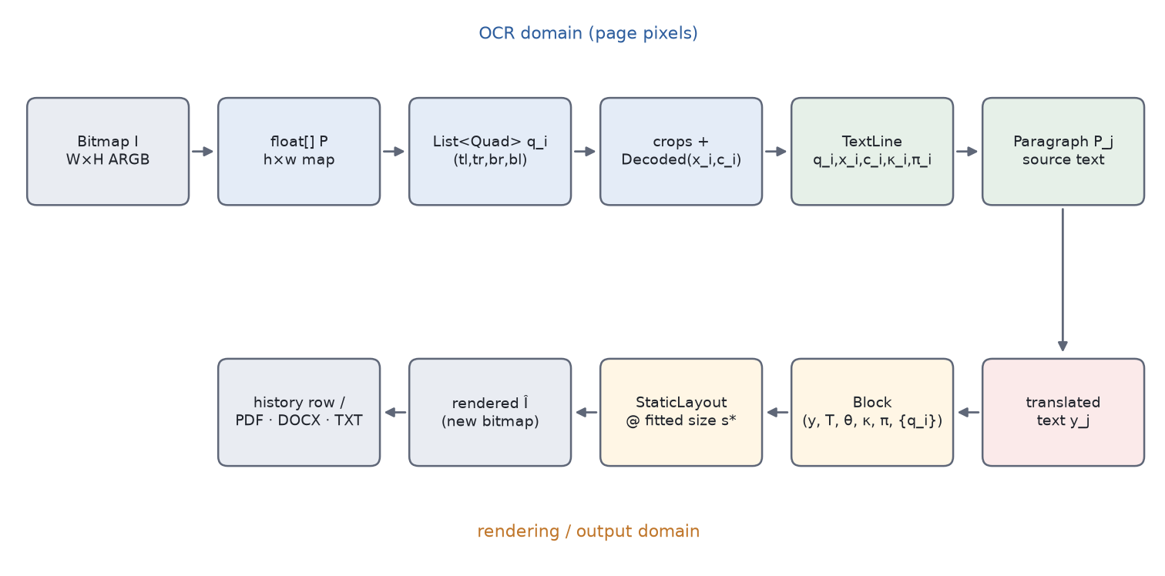
Figure 3.3. Data flow between stages, with the principal Java types (schematic).
Table 3.5. Core value types
Type | Content | Notes
Quad | Four corners (tl, tr, br, bl), clockwise from top-left, in page pixels | Width and height are the means of opposite edge lengths; the baseline angle is the mean direction of the top and bottom edges, positive clockwise to match Canvas.rotate.
TextLine | Quad, recognised text, confidence, foreground and background colour, per-line translation | Per-line translation is used only by the per-line render mode and the editable text view.
Paragraph | Ordered lines, source text, translated text | Source text joins lines with a space except between two CJK characters; bounds are the union of line bounds; the median line height sets the font size.
OcrResult | Ordered lines, paragraphs, page size, elapsed time | Empty result when no box survives detection.

After translation, each paragraph's translation is also distributed across its lines in proportion to the source-line lengths, preferring to break at the last space before the proportional cut. A single-line paragraph receives its translation exactly; for multi-line paragraphs the split is approximate, which is acceptable because the default renderer reflows the whole paragraph and only the per-line mode and the editable view use the split.

3.5 Threading Model
Engines is a process-wide singleton that owns one PaddleOcrEngine, one PivotTranslator and a single-thread executor named falcon-engine, whose thread priority is NORM_PRIORITY − 1. Building the engines costs seconds and tens of megabytes of native session state, so they outlive any one screen. Neither engine is thread-safe; rather than locking, every call that touches an engine is submitted to the single worker, and results are posted back to the main thread through a Handler bound to the main looper (3.4). The serialisation is the point rather than a limitation: it makes the concurrency argument trivial and prevents two pages from holding working buffers at the same time. Parallelism is still exploited inside each inference call, where ONNX Runtime uses an intra-operator thread pool of max(1, min(4, cores − 1)) threads, leaving at least one core for the UI thread.
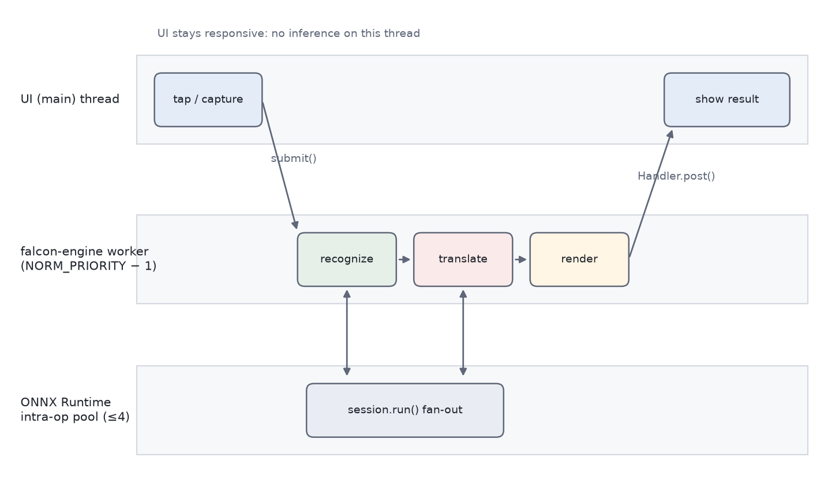
Figure 3.4. Threading model: the UI thread submits work to the single engine thread, which fans out inside ONNX Runtime and posts results back (schematic).
One subtlety concerns configuration changes. The detection limit backs the user-visible Image Quality setting; Engines.ocr() re-applies the current preference on every access rather than only at construction, so a change takes effect on the next scan without restarting the process. The model inventory computed by ModelValidator is cached, because scanning the asset tree touches a few hundred entries, and can be invalidated after a debug model push.

3.6 Memory Model
Memory, not computation, is usually the binding constraint of on-device pipelines, because Android terminates background — and under pressure foreground — processes whose memory it needs [4]. The design bounds three contributors (3.6).
Table 3.6. Residency policy by component (from the source code and documentation)
Component | Policy | Rationale
Detector, classifier | Created on first use; kept for the process lifetime | Language independent; needed for every page
Recognisers | Cached per language after first use | Switching source language costs one extra load, not one per page
Translation | Exactly one directed pair resident; loading another closes the previous | ≈35 MB per pair; several resident pairs invite the low-memory killer
Pivoted page | Two pairs loaded in sequence, once each per page | Whole-page batch per leg (Chapter 5)
PDF pages | Rasterised, processed and released one at a time | Page bitmaps dominate transient memory
Rendered output | New ARGB_8888 copy of the page | Source bitmap never modified

For page bitmaps the arithmetic is simple. An A4 page (8.27 × 11.69 in) rasterised at 200 dpi is 1654 × 2339 pixels; at four bytes per pixel that is about 15.5 MB (analytical). The renderer holds a second, rendered copy of the page while it works, and pages with a longer side above 3000 pixels are downscaled at rasterisation (PdfPageSource.MAX_DIMENSION). The detector input is much smaller — at the HIGH quality level the long edge is at most 1280 pixels before rounding — and its float tensor has three channels of four bytes each.
Model bytes are read from the APK into a Java byte array and passed to OrtEnvironment.createSession. The Gradle configuration marks model files as uncompressed (noCompress) so that the asset's length is known and it can be read in one exact-size allocation; the byte array is transient, but the session's own copy of the weights persists for the session's lifetime. Memory-mapping the models directly would avoid the transient copy and is listed as future work in Chapter 10.

3.7 Model Tree and Validation
All model paths are defined once in engine/ModelPaths and mirrored by the conversion scripts under tools/ (3.5). The OCR subtree holds one language-independent detector, an optional orientation classifier and four recognisers with their dictionaries. The MT subtree holds six directed English-centric pairs, each with an int8 encoder and decoder, a SentencePiece table, a vocabulary and a configuration file. Appendix B lists the inventory in full.
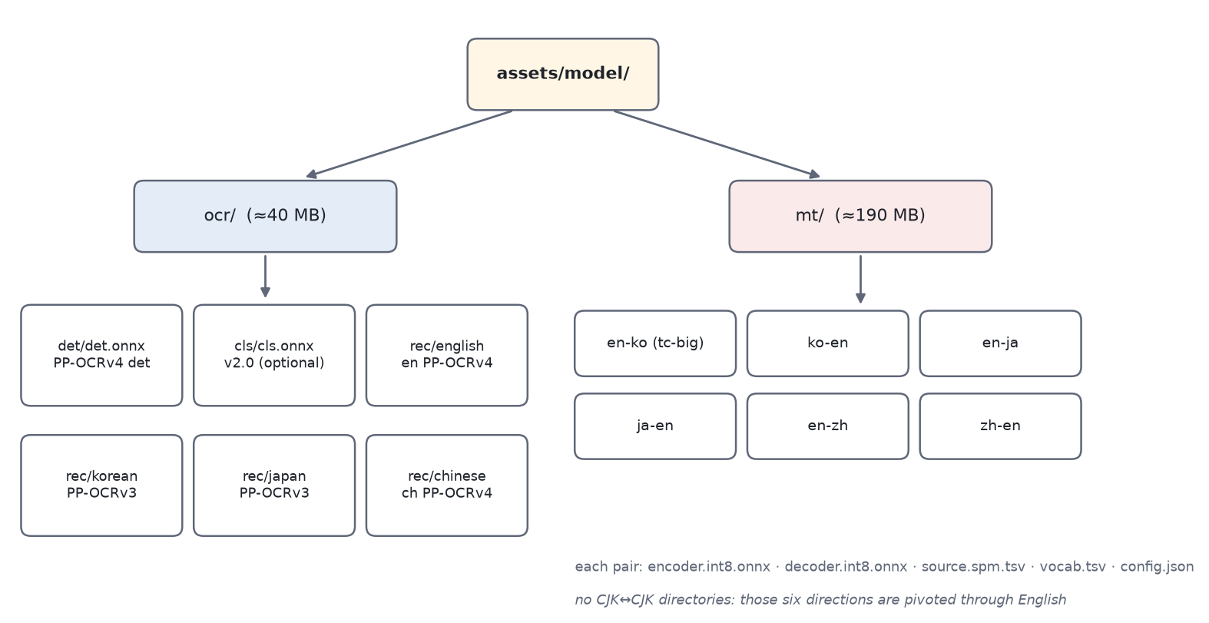
Figure 3.5. Model tree under assets/model/ with approximate sizes from the project documentation (schematic).
ModelValidator.validate checks the tree at start-up and returns a report of available OCR languages, available MT pairs and missing files. Two rules keep the report meaningful. Only user-facing languages are required, so a hidden language's missing files do not mark the installation incomplete; and only pairs involving English are required, because the CJK↔CJK pairs do not exist upstream and are expected to be pivoted. The splash screen runs the scan while the brand mark is displayed, and the home screen shows a warning that links to the model report if anything required is missing — so that the first symptom of an incomplete install is a precise message rather than a failure several taps deep.

3.8 Deployment
The application targets Android API 24 as minimum and API 35 as compile and target level, is written in Java 17 and builds with Gradle 8.13. Its principal dependencies are AndroidX, Material Components, CameraX 1.4.1 and ONNX Runtime for Android 1.20.0. ABI splits produce per-architecture APKs for arm64-v8a, armeabi-v7a and x86_64 plus a universal APK. According to the project documentation the universal debug APK is about 78 MB without models and about 255 MB with them, which exceeds the 150 MB limit of the Google Play store for a single APK; sideloading and internal testing work as is, and Play distribution requires moving the model tree into an install-time asset pack. The model tree itself is not versioned in the repository; a script downloads and converts it (Appendix D).
Table 3.7. Deployment facts (repository)
Minimum / target SDK | 24 / 35
Language / build | Java 17; Gradle 8.13
Inference runtime | com.microsoft.onnxruntime:onnxruntime-android:1.20.0
ABIs | arm64-v8a, armeabi-v7a, x86_64, plus universal APK
Permissions | CAMERA only; no INTERNET
Model tree | ≈230 MB (OCR ≈40 MB, MT ≈190 MB), fetched by tools/fetch_models.sh
APK size | ≈78 MB without models; ≈255 MB with models (universal debug build)
Licences of weights | PaddleOCR: Apache 2.0; OPUS-MT: CC-BY 4.0 (attribution required)

Chapter 4 Library-free Text Detection and Recognition
This chapter develops the recognition half of the pipeline: preparing the detector input, turning the detector's probability map into oriented boxes without OpenCV or a polygon-clipping library, rectifying and orienting each line, recognising it, estimating its colours, arranging lines into reading order and paragraphs, and verifying the source language. The neural networks are the released PP-OCR models, used unchanged; everything described here is the algorithmic code around them, implemented in Java in the ocr and engine packages. The central results are Lemma 4.1, which shows that the convex-hull input can be reduced to row extremes without changing the hull, and Proposition 4.1, which shows that the closed-form rectangle unclip coincides with a round-join polygon offset followed by a minimum-area refit.

4.1 Detector Input Preparation
The detector is fully convolutional, so it accepts any input size, but its cost grows with the number of pixels. The page is therefore scaled so that its long edge is at most L_{max}, the value behind the user-visible Image Quality setting (LOW 640, MEDIUM 960, HIGH 1280 pixels; the stored default is HIGH, and the engine clamps any value to the range 320–2048). Pages already smaller than L_{max} are not enlarged. Both sides are then rounded to a multiple of 32:
ρ = min(1, L_{max} / max(W, H)), w′ = 32 · max(1, round(ρW / 32)), h′ = 32 · max(1, round(ρH / 32)) (4.1)
with a floor of 32 pixels per side. The rounding matters because the detector's backbone has five stride-2 stages (a total stride of 32); a side that is not a multiple of 32 makes the upsampled output disagree with the input by a pixel or two and shifts every box. Note that rounding to the nearest multiple can exceed L_{max} by up to 16 pixels and changes the aspect ratio slightly; both effects are harmless because the map is scaled back with separate horizontal and vertical factors. The image is converted to an NCHW float tensor in RGB order normalised with ImageNet statistics (mean 0.485, 0.456, 0.406; standard deviation 0.229, 0.224, 0.225). The recogniser, in contrast, normalises to [−1, 1]; confusing the two produces confident nonsense rather than an error, which is why the two normalisations live in separate, explicitly named functions of ImageOps.
The detector outputs a probability map P ∈ [0, 1]^{h×w}. Its tensor shape, not the size of the resized input, is taken as authoritative: the page-space scale factors are s_{x} = W / w and s_{y} = H / h, computed from the map itself. Because detection cost is roughly proportional to w′h′, moving from MEDIUM to HIGH multiplies the number of detector input pixels by about (1280/960)² ≈ 1.78 and from LOW to HIGH by 4 (analytical, for pages larger than L_{max}); RQ4 measures the resulting latency.

4.2 DB Post-processing without Libraries
4.1 illustrates the post-processing chain on a synthetic probability map, and 4.1 lists its steps with their defaults and the upstream operation each one replaces. The chain is implemented in DbPostProcessor.extract within a single Java class of under 400 lines.
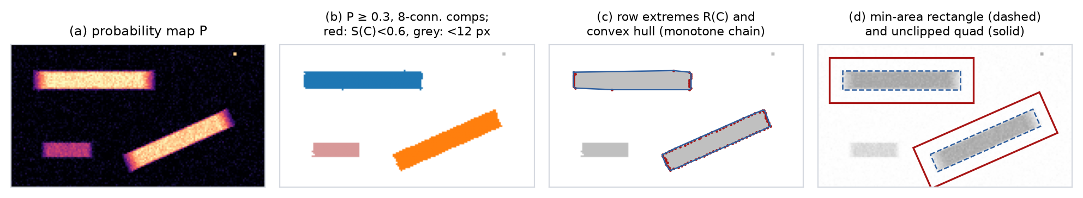
Figure 4.1. DB post-processing on a synthetic probability map (illustration, not detector output): (a) map P; (b) 8-connected components of P ≥ 0.3, with a low-scoring component (red) and a speck (grey) rejected; (c) row extremes and convex hull; (d) minimum-area rectangle and unclipped quadrilateral.
Table 4.1. Steps of the library-free DB post-processing (defaults from DbPostProcessor)
Step | Operation | Default | Replaces upstream
1 | Binarise: keep pixels with P ≥ τ_{b} | τ_{b} = 0.3 | Threshold
2 | Iterative 8-connected flood fill with explicit stack | — | Contour extraction (border following)
3 | Reject specks: |C| < a_{min} | a_{min} = 12 px | Size filter
4 | Score over component pixels, keep S(C) ≥ τ_{s} | τ_{s} = 0.6 | Box-mean score
5 | Row-extreme outline R(C) | — | Contour points
6 | Convex hull (Andrew's monotone chain) | — | Convex hull
7 | Minimum-area rectangle over hull edges | — | Minimum-area rectangle
8 | Reject slivers: min side < 3 px | 3 px | Size filter
9 | Closed-form unclip d = A r / L | r = 1.6 | Polygon offset + refit
10 | Order corners, clamp to map, scale to page | — | Box ordering
— | Safety valve: stop after N_{max} boxes | N_{max} = 1000 | —

4.2.1 Binarisation and connected components
Pixels with P ≥ τ_{b} = 0.3 are foreground. Components are extracted by an iterative flood fill that scans seeds in raster order, pushes unvisited foreground neighbours onto an explicit integer stack, and collects each component's pixel indices in a growable integer array. Recursion is avoided deliberately: a full-page paragraph is routinely a single component of 10⁵ or more pixels, which would overflow the call stack. Eight-connectivity keeps diagonally touching strokes in one run. A boolean visited array of size hw guarantees that every pixel is pushed at most once, so the fill is O(hw) in time over the whole map, with O(hw) auxiliary memory for the visited flags and a stack that starts at min(hw, 2¹⁶) entries and doubles on demand. Components with fewer than 12 pixels are discarded as specks. As a safety valve on pathological maps, extraction stops after 1000 boxes.

4.2.2 Component-restricted confidence score
Each surviving component C is scored by the mean probability over its own pixels:
S(C) = (1 / |C|) · Σ_{p ∈ C} P(p), keep C ⇔ S(C) ≥ τ_{s} = 0.6 (4.2)
The project documentation and the companion manuscript contrast this with a reference score that averages P over the component's axis-aligned bounding box. To see why the distinction matters, consider a straight text line of length ℓ and thickness t at angle θ whose pixels all have probability q, on a background of probability approximately zero. Its axis-aligned bounding box has area (ℓ cos θ + t sin θ)(ℓ sin θ + t cos θ), so the box mean is
S_{box}(θ) ≈ q · ℓt / [(ℓ cos θ + t sin θ)(ℓ sin θ + t cos θ)], S(C) = q (4.3)
For θ = 0 the two scores agree; as θ grows the box mean falls quickly because the box fills with background. 4.2 evaluates the factor S_{box}/S(C) for a few aspect ratios and angles. For a 10:1 line at 20°, a box-averaged score of a line whose pixels all have probability 1 would be about 0.24 — far below τ_{s} — so a pure axis-aligned box mean would discard it. The component mean is invariant to rotation by construction.
Table 4.2. Analytical attenuation factor S_{box}/S(C) of an axis-aligned box mean for a uniform line on a zero background (Equation 4.3; analytical, not measured)
Aspect ratio | θ = 0° | θ = 5° | θ = 20° | θ = 45°
ℓ/t = 5 | 1.00 | 0.69 | 0.37 | 0.28
ℓ/t = 10 | 1.00 | 0.53 | 0.24 | 0.17
ℓ/t = 20 | 1.00 | 0.36 | 0.13 | 0.09

Two qualifications keep this analysis honest. First, the author's reading of the upstream implementation is that its fast scoring mode masks the minimum-area (rotated) rectangle inside the bounding box before averaging, in which case the real bias of the reference is much smaller than 4.2 suggests; the table is an upper bound that applies only to an unmasked box mean. Second, averaging over the component alone has its own bias: a component is by definition the set of pixels above τ_{b}, so S(C) ≥ τ_{b} always, and the score measures confidence within the detected region rather than contrast against its surroundings. Whether the component mean helps, hurts or is neutral relative to the reference on real data is therefore an empirical question, which is exactly the box-mean versus component-mean ablation of RQ1, stratified by text angle (8.4).

4.2.3 Exact hull reduction to row extremes
The minimum-area rectangle of a component depends only on its convex hull. Computing the hull of all pixels of a large component would dominate the post-processing time, so the point set is reduced first.
Definition 4.1. Let C ⊂ ℤ² be finite. For each row y with C_{y} = {(x, y) ∈ C} non-empty, let l_{y} and r_{y} be the elements of C_{y} with minimum and maximum x. The row-extreme set of C is R(C) = ∪_{y} {l_{y}, r_{y}}.
Lemma 4.1. For every finite C ⊂ ℤ², conv(R(C)) = conv(C).
Proof. Since R(C) ⊆ C, monotonicity of the convex hull gives conv(R(C)) ⊆ conv(C). For the reverse inclusion, recall two standard facts about a finite point set [39]: conv(C) is a convex polygon (possibly degenerate) whose vertices — its extreme points — all belong to C; and conv(C) is the convex hull of its extreme points. It therefore suffices to show that every extreme point v of conv(C) lies in R(C). Suppose v = (v_{x}, y₀) ∈ C is extreme but not a row extreme. Then v ≠ l_{y₀} and v ≠ r_{y₀}, so there exist a = l_{y₀} and b = r_{y₀} in C with a_{x} < v_{x} < b_{x} and a_{y} = b_{y} = y₀. Setting λ = (b_{x} − v_{x}) / (b_{x} − a_{x}) ∈ (0, 1) gives v = λa + (1 − λ)b, a convex combination of two points of conv(C) distinct from v, which contradicts the extremality of v. Hence every extreme point lies in R(C), and conv(C) = conv(ext conv(C)) ⊆ conv(R(C)). ∎
Three remarks complete the picture. (i) The reduced set has at most 2h_{C} points, where h_{C} is the number of rows the component spans; a row containing a single pixel contributes it once, as in the implementation, which adds the right extreme only when it differs from the left. (ii) Nothing in the proof depends on rows specifically: column extremes are equally exact, and for vertical text, whose components are tall and narrow, using columns would give at most 2w_{C} points instead; choosing the smaller of the two is a free optimisation not currently implemented. (iii) The reduction also removes the need for contour tracing altogether: the row extremes are collected in one pass over the component's pixel list, O(|C|) time and O(h_{C}) memory.
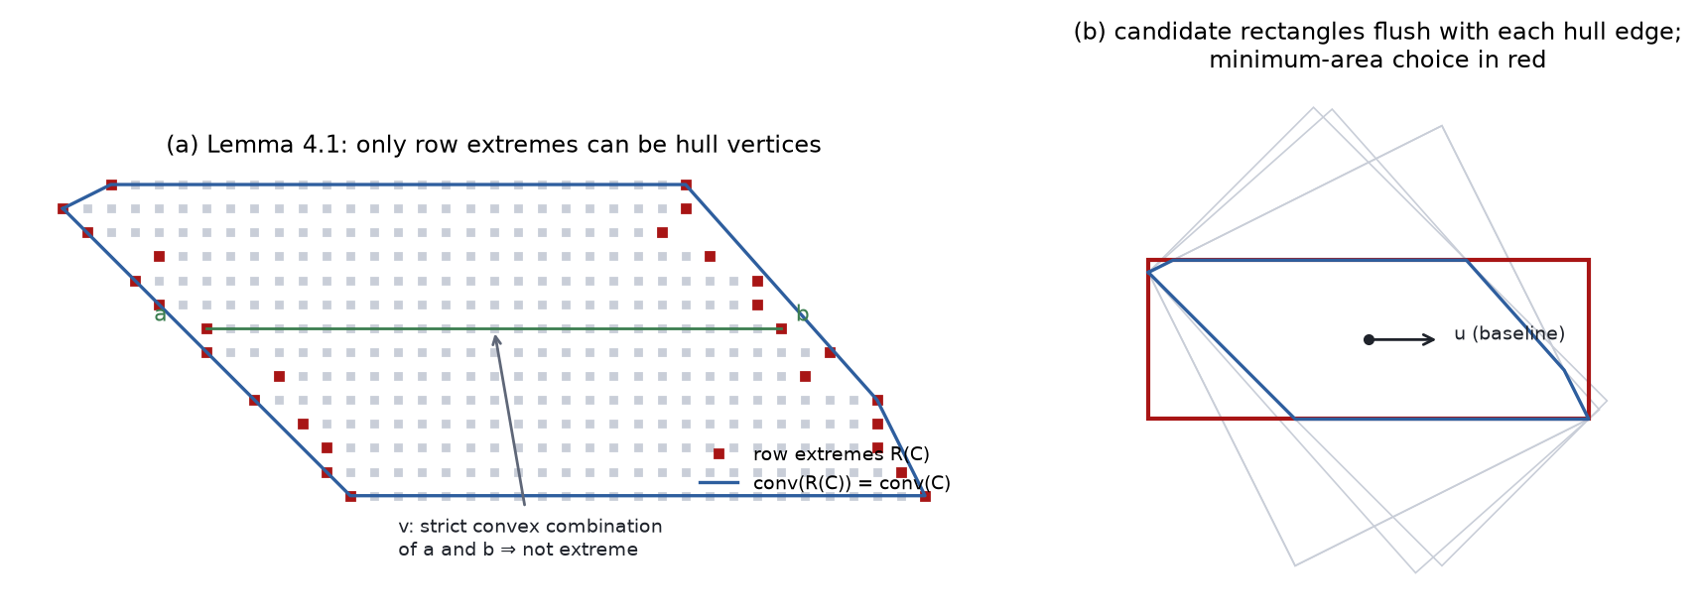
Figure 4.2. Geometry of the hull reduction and the minimum-area rectangle on a synthetic component: (a) interior points of a row are strict convex combinations of that row's extremes, so only row extremes can be hull vertices; (b) one candidate rectangle per hull edge, with the minimum-area choice highlighted (schematic).

4.2.4 Convex hull by monotone chain
The hull of R(C) is computed with Andrew's monotone chain [37]. The m ≤ 2h_{C} points are sorted lexicographically by (x, y); the lower hull is built by scanning left to right and popping the last point while the last two points and the new one fail to make a strict counter-clockwise turn; the upper hull is built by the symmetric right-to-left scan. The turn test is the sign of the cross product
cross(o, a, b) = (a_{x} − o_{x})(b_{y} − o_{y}) − (a_{y} − o_{y})(b_{x} − o_{x}) (4.4)
evaluated in 64-bit integer arithmetic, so it is exact for any pixel coordinates. Popping on cross ≤ 0 discards collinear points, which does not change the hull. The cost is O(m log m) for the sort and O(m) for the scans, i.e. O(h_{C} log h_{C}) per component — independent of the component's area, which is the purpose of Lemma 4.1.

4.2.5 Minimum-area rectangle
Freeman and Shapira [40] proved that some minimum-area rectangle enclosing a convex polygon has a side collinear with one of the polygon's edges. The implementation uses this directly: for each hull edge with unit direction u = e / ‖e‖ and normal v = (−u_{y}, u_{x}), it projects every hull vertex p onto both axes and takes the extents
[u_{min}, u_{max}] = [min_{p} p·u, max_{p} p·u], [v_{min}, v_{max}] = [min_{p} p·v, max_{p} p·v], A(u) = (u_{max} − u_{min})(v_{max} − v_{min}) (4.5)
and keeps the edge with the smallest A(u). The result is stored as a centre c, half-extents (a, b) along (u, v), and the unit axis u, which directly gives the baseline angle the renderer needs. With k hull vertices this exhaustive enumeration costs O(k²); the rotating-calipers technique [41] would reduce it to O(k) by advancing four support indices monotonically around the hull. The quadratic version is kept because k is small in practice — hulls of text components are close to rectangles, and collinear points have already been removed — and because it is simpler to verify. The theorem guarantees that the enumeration is exhaustive, so the result is an exact minimum-area rectangle, not an approximation.

4.2.6 Closed-form unclip
DB trains the network to predict text regions shrunk by an offset D = A(1 − r_{s}²)/L [24]. At inference the region is dilated back by an offset proportional to its area over its perimeter, d = A r / L, with unclip ratio r = 1.6; upstream this is a general polygon offset computed by a clipping library [7]. For a w × h rectangle, A = wh and L = 2(w + h), which gives the closed form
d = w h r / (2(w + h)), (a, b) ← (a + d, b + d) (4.6)
so the unclipped rectangle has size (w + 2d) × (h + 2d) with unchanged centre and axis. 4.3 plots d. For a long line (w ≫ h) the offset approaches r h / 2 = 0.8 h, so each side grows by 0.8 times the shrunk height — consistent with the purpose of the unclip, which is to recover ascenders, descenders and the end glyphs that the shrunk prediction clips.
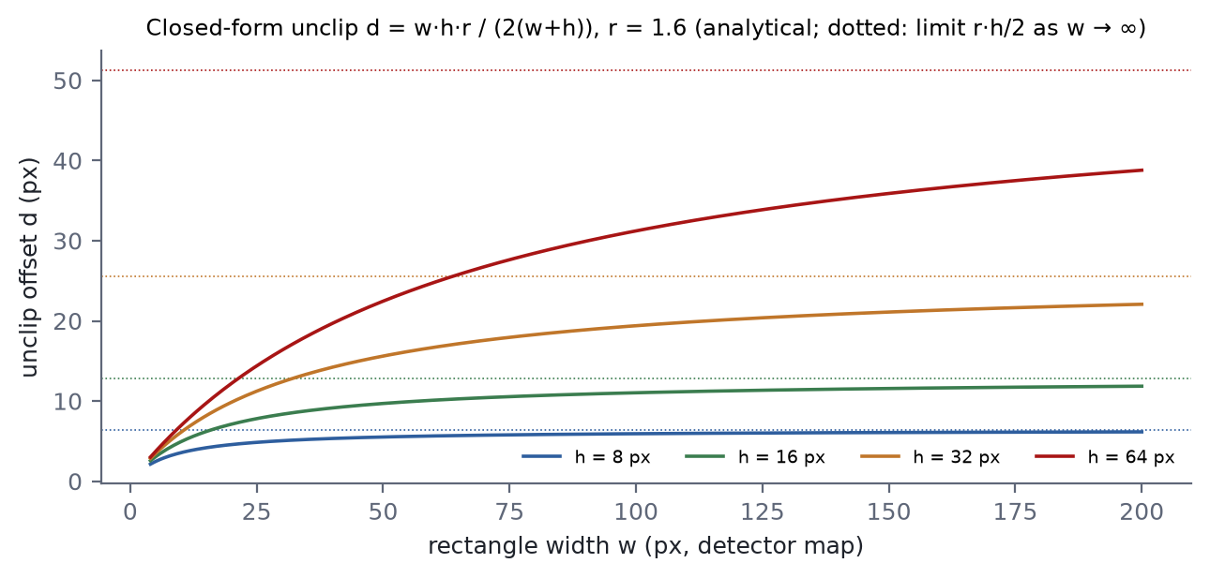
Figure 4.3. Closed-form unclip offset as a function of rectangle width for several heights (analytical).
A natural question is whether replacing the polygon offset by Equation 4.6 changes the final box. The reference implementation, as the author reads it, offsets the four corners of the minimum-area rectangle with rounded joins and then fits a minimum-area rectangle to the offset polygon. The following result shows that, under that reading, the two procedures agree exactly (up to the discretisation of arcs by the clipping library).
Proposition 4.1. Let K be a w × h rectangle with axis u, and let K_{d} = K ⊕ B_{d} be its offset by distance d > 0 with round joins (the Minkowski sum with a disc of radius d). Then a minimum-area rectangle enclosing K_{d} is the rectangle with axis u, the same centre as K, and size (w + 2d) × (h + 2d).
Proof. The width of K in direction φ (measured from u) is ω_{K}(φ) = w|cos φ| + h|sin φ|, and Minkowski addition of a disc adds 2d to every width: ω_{K_d}(φ) = ω_{K}(φ) + 2d. The enclosing rectangle of K_{d} with sides along φ and φ + 90° has area f(φ) = (ω_{K}(φ) + 2d)(ω_{K}(φ + 90°) + 2d). By symmetry it suffices to take φ ∈ [0, 90°] and write c = cos φ, s = sin φ ≥ 0. Then f(φ) = (wc + hs)(ws + hc) + 2d[(wc + hs) + (ws + hc)] + 4d². The first product equals wh(c² + s²) + (w² + h²)cs = wh + (w² + h²)cs ≥ wh, and the bracket equals (w + h)(c + s) ≥ w + h because c + s ≥ 1 on [0, 90°]. Hence f(φ) ≥ wh + 2d(w + h) + 4d² = (w + 2d)(h + 2d) = f(0). The rectangle at φ = 0 encloses K_{d} (its extents are those of K plus d on each side) and attains the minimum. ∎
With square joins (a mitred offset) the offset polygon is the (w + 2d) × (h + 2d) rectangle, so the same conclusion holds trivially. Where the reference unclips the raw contour instead of its rectangle, the two procedures can differ for strongly non-convex components; the polygon-versus-rectangle unclip ablation of RQ1 quantifies that case. Rectangles with a side shorter than 3 pixels (before unclipping) are rejected as slivers.

4.2.7 Corner ordering, clamping and scaling
The four corners c ± (a + d)u ± (b + d)v are ordered clockwise from the top-left using sums and differences of coordinates: the top-left corner minimises x + y, the bottom-right maximises it, the top-right maximises x − y and the bottom-left minimises it. If a degenerate box maps two roles onto one corner, the raw order is kept rather than emitting a quadrilateral with duplicated vertices. Corners are clamped to the map and scaled by (s_{x}, s_{y}) to page pixels. The result is a Quad.

4.2.8 Complexity of the whole chain
4.3 collects the costs. The dominant term for typical pages is the linear flood fill; Lemma 4.1 ensures that the geometric work per component depends on its height, not its area.
Table 4.3. Asymptotic cost of the DB post-processing (analytical; h × w map, component C spanning h_{C} rows with k_{C} hull vertices)
Step | Time | Memory
Flood fill (all components) | O(hw) | O(hw) visited flags + stack
Score, bounds, row extremes | O(|C|) per component; O(hw) total | O(h_{C})
Monotone-chain hull | O(h_{C} log h_{C}) | O(h_{C})
Minimum-area rectangle | O(k_{C}²) (O(k_{C}) with rotating calipers) | O(1)
Unclip, ordering, scaling | O(1) | O(1)
Total | O(hw + Σ_{C} (h_{C} log h_{C} + k_{C}^{2})) | O(hw)

4.3 Rectification and Orientation
Each quadrilateral q = (p₀, p₁, p₂, p₃) is mapped onto an upright crop of size w_{q} × h_{q}, where w_{q} and h_{q} are the rounded mean lengths of opposite edges, capped at 4096 pixels per side to guard against pathological detections. The map is the planar homography H determined by the four correspondences p₀ ↦ (0, 0), p₁ ↦ (w_{q}, 0), p₂ ↦ (w_{q}, h_{q}), p₃ ↦ (0, h_{q}) [42], computed by the platform's Matrix.setPolyToPoly:
[x′, y′, z′]^{T} = H [x, y, 1]^{T}, (u, v) = (x′ / z′, y′ / z′) (4.7)
Because the map is projective rather than a rotation, mild keystone distortion from photographing a page at an angle is corrected at the same time. Detected boxes are rectangles, so the homography is in practice a similarity; the projective generality costs nothing. If the corners are collinear and no homography exists, the crop falls back to the axis-aligned bounds. The crop is drawn with bilinear filtering onto a white background.
An orientation classifier (the PP-OCR v2.0 angle classifier, input 48 × 192, optional) decides for each crop whether it is upside down. The crop is rotated by 180° only when the classifier's probability for the rotated class exceeds 0.9. The asymmetry is intentional and can be justified as a cost-sensitive decision. Let p be the classifier's probability that the crop is rotated, C_{w} the cost of wrongly flipping a correct crop, and C_{m} the cost of missing a rotated one. Flipping minimises expected cost when p C_{m} > (1 − p) C_{w}, i.e.
flip ⇔ p > C_{w} / (C_{w} + C_{m}) (4.8)
A threshold of 0.9 therefore corresponds to treating a wrong flip as nine times as costly as a missed one (analytical). The asymmetry is plausible: a wrongly flipped crop is recognised as garbage and cannot be recovered downstream, whereas a missed flip on an upside-down crop merely lowers recognition accuracy on text that was already unusual. If the classifier model is absent the stage is skipped with a log message, and if classification fails for any crop the remaining crops keep their orientation. RQ2 measures recognition with and without this stage.

4.4 Batched Recognition
Crops are resized to a height of 48 pixels, preserving aspect ratio, and normalised to [−1, 1]. They are processed in batches of six. Within a batch all tensors must share a width, so shorter crops are right-padded; the padded width of a batch is
W_{pad} = clamp(8 · ⌈48 · ρ_{max} / 8⌉, 16, 1200) (4.9)
where ρ_{max} is the largest width-to-height ratio in the batch. Crops wider than W_{pad} after resizing — which happens only when a line's aspect ratio exceeds 1200/48 = 25 — are squeezed horizontally to fit rather than padded. The padding value is zero after normalisation, which corresponds to mid-grey in the original intensity scale; CTC recognisers generally emit blanks over such featureless regions, but a model trained with a different padding convention could behave differently, which is one reason the evaluation compares batched and unbatched recognition implicitly through the RQ2 protocol.
To minimise padding, crops are first sorted by aspect ratio and then batched in order (4.4). The following lemma shows that this is optimal for the padded tensor area when the number of crops is a multiple of the batch size.
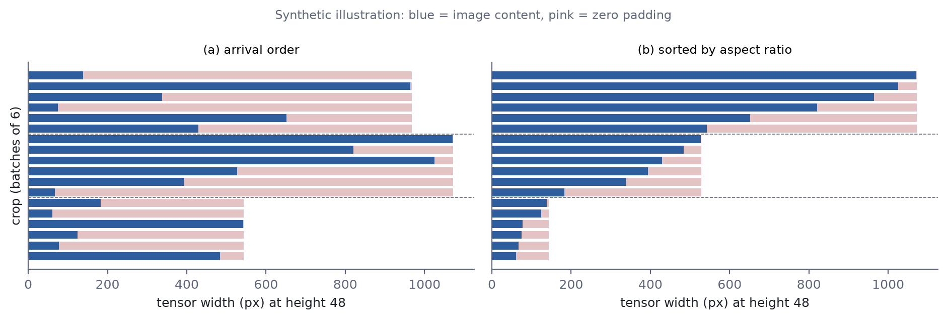
Figure 4.4. Padding waste for recognition batches of six in arrival order (a) and after sorting by aspect ratio (b), on randomly generated aspect ratios (synthetic illustration).
Lemma 4.2. Let n = kb crops with padded widths ω₁ ≥ ω₂ ≥ … ≥ ω_{n} be partitioned into k batches of size b, and let the cost of a partition be Σ_{batches G} b · max_{i∈G} ω_{i}. Sorting and cutting into consecutive groups minimises the cost.
Proof. Order the batch maxima of any partition decreasingly as M₁ ≥ … ≥ M_{k}. The (j − 1)b + 1 widest crops ω₁, …, ω_{(j−1)b+1} cannot fit in j − 1 batches of size b, so they meet at least j distinct batches, each of which therefore has maximum at least ω_{(j−1)b+1}. Hence M_{j} ≥ ω_{(j−1)b+1} for every j, and the cost is at least b Σ_{j} ω_{(j−1)b+1}. Sorted consecutive batching attains this bound with equality. ∎
When n is not a multiple of b the last, partial batch receives the narrowest crops, which is also the cheapest place for it; the lemma's bound argument extends with minor bookkeeping. Sorting costs O(n log n) for n lines, negligible beside the network.

4.4.1 Greedy CTC decoding
For each crop the recogniser outputs, per time step t = 1…T, a probability vector over C classes (the exported PP-OCR graphs include the softmax). Greedy CTC decoding [29] takes the arg-max class at each step, collapses runs of identical classes and removes the blank. With k_{t} = argmax_{j} y_{t,j}, the output string and line confidence are
x = 𝓑(k₁ … k_{T}), c = (1 / |𝒦|) Σ_{t ∈ 𝒦} max_{j} y_{t,j} (4.10)
where 𝓑 collapses repeats and then drops blanks, and 𝒦 is the set of time steps whose class was emitted (the first step of each non-blank run). Lines whose trimmed text is empty or whose confidence is below 0.5 are discarded. Greedy decoding returns the most probable path, not the most probable string, but for CRNN-style recognisers with peaky output distributions the difference is usually small, and beam search over CTC would add cost to every line.

4.4.2 Dictionary alignment
PP-OCR dictionary files list only the glyphs. The label set the network predicts is that list wrapped in two extras: the CTC blank at index 0 and, for models trained with a space class, a space appended at the end. Class j ≥ 1 therefore maps to glyph j − 1, and the class count must satisfy
C ∈ { |G| + 1, |G| + 2 } (4.11)
where |G| is the number of glyphs after trailing empty lines (an exporter artefact) are removed. An off-by-one here does not throw; it shifts every character of every result. The engine therefore reads C from the loaded graph's output shape, rejects a dynamic class count with an explicit error, and CharDict refuses a dictionary that satisfies neither case of Equation 4.11. Four unit tests exercise exactly these rules (Chapter 7).

4.5 Ink and Paper Colour Estimation
The renderer needs, for every line, the colour of the original glyphs (ink κ) and of their background (paper π). ImageOps.sampleColors estimates both in one pass over a subsampled crop. With a sampling step δ = max(1, ⌊√(w_{q} h_{q} / 4096)⌋) about 4096 pixels are visited. Each pixel's luminance is computed with the Rec. 601 weights [85] in integer arithmetic,
Y = (299 R + 587 G + 114 B) / 1000 (4.12)
and the pixels are split at the mid-range Y_{mid} = (Y_{min} + Y_{max}) / 2 into a dark and a light class, each averaged in RGB. The class with fewer pixels is taken as ink and the other as paper; ties go to dark ink on light paper. If the crop has no luminance range at all, black on white is returned. The minority rule handles dark-on-light and light-on-dark text alike, because in a tight text box the glyph strokes occupy less area than the background.
The estimator can be read as a single step of two-cluster k-means on luminance, initialised at the extremes; it is cheaper and less stable than Otsu thresholding but adequate for the purpose, since the renderer uses the colours to blend and to draw, not to segment. Its failure modes follow from its assumptions: very bold, large text in a tight box can make glyphs the majority and swap ink and paper; a strong illumination gradient across the crop splits the paper into both classes; and a single specular highlight stretches Y_{max}. Paragraph blocks take their colours from the first line of the paragraph, so a heading-like first line with unusual colours would colour the whole block.

4.6 Reading Order and Paragraph Grouping
Detection returns boxes in the raster order of their seed pixels, which is not reading order, and it has no notion of a paragraph. Both matter downstream: the translator needs whole sentences, and the renderer needs to know across which boxes it may reflow text. LineGrouper first sorts lines top to bottom, treating two lines as the same row when the vertical centres of their bounding boxes differ by less than 0.6 times the smaller box height, and orders lines within a row left to right.
A comparator with a tolerance is not transitive: three lines whose centres are successively within tolerance of each other but not end to end can be ordered inconsistently, and Java's sort is entitled to reject such a comparator at run time. The situation requires unusual geometry (a staircase of small vertical offsets across one row), but a robust alternative — clustering centres into rows first and then sorting rows and lines within rows — would remove the possibility entirely and is recorded as a limitation.
Lines are then grouped greedily: a line n continues the paragraph of its predecessor m if and only if all of the following hold (4.5):
max(h_{m}, h_{n}) / min(h_{m}, h_{n}) ≤ 1.7, |θ_{m} − θ_{n}| ≤ 8° (4.13)
top_{n} − bot_{m} ≤ 1.6 · max(h_{m}, h_{n}), cy_{n} ≥ cy_{m}, overlap_{x}(m, n) / min(w_{m}, w_{n}) ≥ 0.25 (4.14)
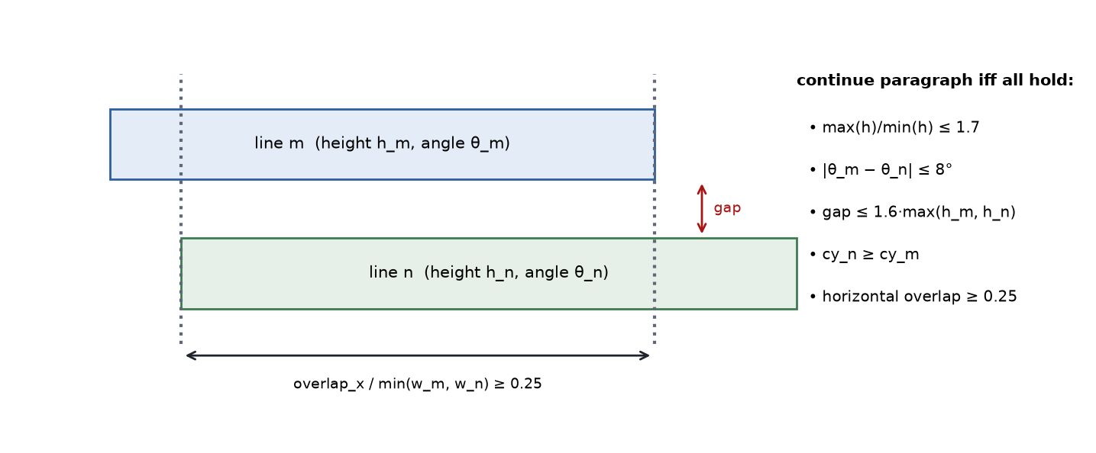
Figure 4.5. Paragraph-continuation conditions between consecutive lines (schematic).
Heights h and angles θ are those of the quadrilaterals; vertical positions, overlap and widths are taken from axis-aligned bounds. The conditions encode typographic regularities: the height ratio separates headings from body text, the angle condition separates rotated labels, the gap condition separates blocks, and the overlap and centre-order conditions separate columns — a line that starts above its predecessor is the top of a new column, not a wrap. Negative gaps (overlapping boxes, common after unclipping) are allowed.
Paragraph source text is assembled by joining lines with a space, except when the characters on both sides of the join are CJK; in CJK text a space at that position would be a real character rather than a line-wrap artefact. The CJK test covers the CJK unified ideographs (and extension A), CJK symbols and punctuation, Hiragana, Katakana, Hangul syllables and Jamo, and half-width and full-width forms. Including Hangul in this test is correct for Chinese and Japanese conventions but not for Korean, which separates words with spaces; a Korean line that wraps between two words is therefore joined without a space. Since Korean is hidden in the deployed interface (Chapter 7) the issue does not arise for users today, but it would need attention before Korean is enabled.

4.7 Script-based Source Verification
A recogniser for the wrong script produces confident garbage rather than an error. The pipeline therefore checks the first recognition pass with a script test. Let n_{hg}, n_{kn}, n_{han} and n_{lat} count the Hangul (syllables, Jamo, compatibility Jamo), Kana (Hiragana, Katakana), Han (CJK unified ideographs and extension A) and Latin letters (Basic Latin and Latin-1 Supplement) in the recognised text, ignoring whitespace and digits, and let N be their sum. Then
ℓ̂ = KO if n_{hg}/N > 0.08; else JA if n_{kn}/N > 0.08; else ZH if n_{han} > 0 ∧ n_{han} ≥ n_{lat}; else EN if n_{lat} > 0; else ℓ_{s} (4.15)
If N = 0 the configured source ℓ_{s} is kept. Hangul and Kana are exclusive to Korean and Japanese respectively, so a small share settles the question; the genuine ambiguity is Han, shared by Chinese and Japanese, which is resolved by the presence of Kana — Japanese prose almost always contains some. The known failure mode is Japanese written only in Kanji (a sign reading 出口, "exit", for example), which is classified as Chinese; a character-bigram language identifier is the natural remedy.
If ℓ̂ differs from ℓ_{s} and is user-facing, the page is recognised again with the head for ℓ̂ — detection runs again as well, which is the cost of auto-detection — and the second result is kept only if it is non-empty. The test is run on text produced by the wrong recogniser, which is less paradoxical than it appears: recognisers for Latin script emit Latin letters on CJK input and vice versa, so the test mainly detects mismatches between the user's setting and the page, which is its purpose. A detected language that is implemented but hidden from the user interface is ignored, so a hidden language can never become the source behind the user's back.
Table 4.4. Behaviour of the script test on representative inputs (from the unit tests of ScriptDetector)
Input characteristic | Result | Unit test
Hangul text | KO | hangulIsKorean
Kana text | JA | kanaIsJapanese
Han without Kana | ZH | hanWithoutKanaIsChinese
Latin letters | EN | latinIsEnglish
Han mixed with Kana | JA | mixedHanAndKanaIsJapanese
Small Hangul share above 8% | KO | smallHangulShareStillWins
Digits and punctuation only | fallback ℓ_{s} | digitsAndPunctuationFallBack
Null or empty | fallback ℓ_{s} | nullAndEmptyFallBack
Kanji-only Japanese | ZH (known failure) | pureKanjiJapaneseIsReportedAsChinese

Chapter 5 On-device Translation
This chapter describes how recognised paragraphs are translated on the device: tokenisation with a pure-Java SentencePiece unigram encoder, encoding and greedy decoding with an OPUS-MT Transformer on int8 weights, chunking of long inputs, and routing of directions without a direct model through English. Each design decision trades quality or speed for simplicity and bounded memory, and the chapter quantifies the trade wherever it can be derived analytically; measurements are deferred to RQ3 and RQ4.

5.1 Translation Interface and Page-level Batching
The pipeline calls translateAll(sources, from, to) once per page with the list of paragraph source texts, not once per paragraph. The call is served by PivotTranslator, which either delegates to MarianTranslator for a direct pair or runs two whole-page legs through English. Batching at page level matters because translation sessions are loaded lazily and only one pair is kept resident: translating paragraph by paragraph through a pivot would load and unload two model pairs per paragraph. Empty or whitespace-only paragraphs yield an empty translation without invoking the model, and if source and target coincide the input is returned unchanged.

5.2 SentencePiece Unigram Tokenisation

5.2.1 Normalisation
SentencePiece ships its model as a protocol buffer parsed by a C++ library. Rather than reimplement that format, the conversion script flattens the source-side model into a two-column table of pieces and log-probabilities, and SpmEncoder consumes the table. Input text is first normalised as SentencePiece does by default [54]: Unicode NFKC normalisation, collapsing runs of whitespace to one space and trimming, then replacing every space with the boundary marker ▁ (U+2581) and prefixing the string with one marker. The leading marker ("add dummy prefix") makes the first word of a sentence tokenise identically to the same word in mid-sentence.

5.2.2 Formulation and Viterbi segmentation
A unigram language model [52] assigns each piece w in a vocabulary V a probability p(w), and the probability of a segmentation 𝐱 = (x₁, …, x_{K}) of a normalised string z is the product of its piece probabilities. The tokeniser returns the most probable segmentation:
𝐱* = argmax_{𝐱 ∈ S(z)} Σ_{k=1}^{K} log p(x_{k}) (5.1)
where S(z) is the set of segmentations of z into pieces. Because the objective is a sum over consecutive pieces, it decomposes over prefixes and is solved exactly by dynamic programming — the Viterbi algorithm [53] on the lattice whose nodes are character positions and whose arcs are pieces (5.1). With B(0) = 0 and ℓ_{max} the length of the longest piece in V,
B(e) = max [ B(s) + σ(z_{s:e}) ] over e − ℓ_{max} ≤ s < e, σ(w) = log p(w) if w ∈ V; −10 if |w| = 1 and w ∉ V; −∞ otherwise (5.2)
and back-pointers recover 𝐱*. The single-character escape with a fixed penalty of −10 guarantees that every string is segmentable, so an unseen glyph cannot make a whole sentence untranslatable; such a character is later mapped to the vocabulary's unknown id. Ties are broken towards the earliest start position, because the recurrence updates B(e) only on a strict improvement.
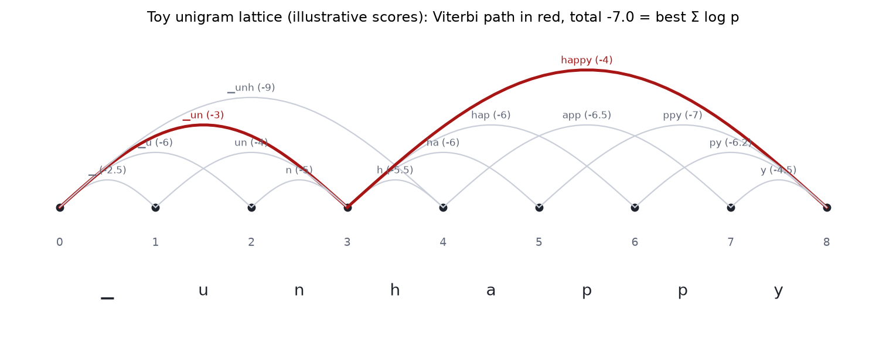
Figure 5.1. Viterbi segmentation on a toy unigram lattice for "▁unhappy" with invented piece scores (illustration of the algorithm, not model data). Arcs are pieces; the red path is the maximum-score segmentation.
For a normalised string of n characters the recurrence examines at most n ℓ_{max} arcs; each arc requires a substring and a hash lookup of cost O(ℓ_{max}), so the time is O(n ℓ_{max}²) character operations and the memory O(n). For OCR-length inputs this is negligible beside the network. Relative to the reference library the implementation is exact for the segmentation objective given the same piece scores; it does not reproduce features the OPUS-MT source models are not expected to need, such as byte fallback, user-defined symbols or sampling-based subword regularisation. Because a subtly different segmentation still produces valid ids — and the model then produces fluent text that is not a translation of the input — the encoder is covered by eight unit tests (Chapter 7).

5.2.3 Vocabulary, special tokens and detokenisation
Marian models share one vocabulary between source and target, so a single token<TAB>id table serves both directions of lookup; it is split on the last tab of each line because a token may itself contain a tab. Pieces are mapped to ids, with unknown pieces mapped to the id of <unk>, and the end-of-sequence id is appended. Special-token ids and decoding limits are read from a per-pair configuration file rather than hard-coded, because they differ between releases and a wrong decoder start id fails silently (5.1). On output, ids are mapped back to pieces, pieces that look like special tokens (<…>) are dropped, the pieces are concatenated and markers become spaces.
Table 5.1. Per-pair configuration read by MtConfig (fallback defaults from the code)
Field | Fallback | Use
pad_token_id | 58100 | Padding; also stops decoding if emitted
eos_token_id | 0 | Appended to the source; stops decoding
unk_token_id | 1 | Unknown id (vocabulary's own <unk> preferred)
decoder_start_token_id | = pad | First decoder input (Marian reuses pad)
max_length | 256, clamped to [8, 512] | Hard ceiling n_{max} on generated tokens
vocab_size | 0 (informational) | —

5.3 Encoder and Greedy Decoding
For each chunk the encoder runs once on the source ids 𝐮 = (u₁, …, u_{m}) — the pieces plus the end-of-sequence id, so m includes it — with an all-ones attention mask, and its hidden states are reused at every decoder step. Decoding is greedy:
y_{t} = argmax_{v} p_{θ}(v | y_{0:t−1}, 𝐮), y₀ = decoder start id (5.3)
and stops when y_{t} is the end-of-sequence or padding id, or when the step limit
n_{lim} = min( n_{max}, max(16, ⌊3m⌋ + 8) ) (5.4)
is reached. The limit is a backstop against runaway, repetitive output: a translation that exceeds three times the source length plus a constant is almost certainly degenerate, while the floor of 16 protects very short inputs. Beam search is not used; a beam of k keeps k hypotheses and roughly multiplies decoder cost by k for a typically modest quality gain, and RQ3 measures that gain for beam 4 off-device.
The decoder graph's input names are resolved at load time, first by exact match and then by substring, because the exporter has renamed them between releases and a mismatch otherwise surfaces as an opaque runtime error. The decoder's own id input is resolved separately among input_ids and decoder_input_ids so that it cannot collide with the encoder attention mask, whose name also contains "attention_mask".

5.4 Cost of Decoding without a Key–Value Cache
The decoder is the cache-less export (use_cache=False). At step t it receives the whole prefix y_{0:t−1} of t tokens and recomputes every layer for all t positions; only the last position's logits are used. If decoding runs for n steps (including the final step that emits end-of-sequence), the number of decoder positions processed is
N_{nocache}(n) = Σ_{t=1}^{n} t = n(n + 1) / 2, N_{cache}(n) = n (5.5)
so the overhead factor on position-proportional work is (n + 1)/2 (analytical; 5.2). This factor applies to the projections and feed-forward layers, whose cost is linear in the number of positions. Attention terms scale differently, as 5.2 shows: self-attention over a prefix of length t costs O(t²d) when recomputed and O(td) with a cache, so its cumulative ratio is Σt²/Σt = (2n + 1)/3.
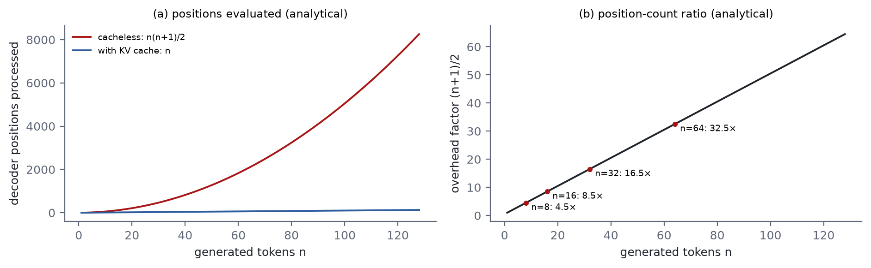
Figure 5.2. Decoder positions processed with and without a key–value cache and their ratio (analytical, from Equation 5.5).
Table 5.2. Cumulative decoder cost over n steps with and without a KV cache (analytical; d model width, m source length, V vocabulary size, L layers omitted as a common factor)
Term | Cache-less (this system) | With KV cache | Ratio
Projections and feed-forward | O(d² · n(n+1)/2) | O(d² · n) | (n + 1)/2
Self-attention | O(d · n(n+1)(2n+1)/6) | O(d · n(n+1)/2) | (2n + 1)/3
Cross-attention | O(d m · n(n+1)/2) | O(d m · n) | (n + 1)/2
Output projection (logits) | O(d V · n(n+1)/2) | O(d V · n) | (n + 1)/2
Logits copied to the JVM | V · n(n+1)/2 floats | V · n floats | (n + 1)/2

The last two rows deserve attention because the vocabulary is large. The exported decoder computes logits for every position of the prefix, and the implementation copies the full t × V logit block into a Java array at each step before reading its last row. The fallback pad id in MtConfig, 58100, reflects vocabularies of about 5.8 × 10⁴ entries for the Marian models the code was written against. Under that assumption, a 32-step decode copies 58 101 × 528 ≈ 3.1 × 10⁷ floats (about 123 MB) cumulatively, with at most 32 × 58 101 × 4 bytes ≈ 7.4 MB in a single step (analytical). Reading only the last row of the output buffer — or exporting a decoder that emits only the last position — would remove this transfer without any change to the model.
Why accept a quadratic cost at all? Because the inputs are OCR lines and short paragraphs, whose translations are typically tens of tokens long; at n = 16 the position overhead is 8.5 and at n = 32 it is 16.5 (analytical), which multiplies a per-step cost that is small in absolute terms for a model of this size. In exchange, the cache-less graph has three inputs and one output, whereas a cached decoder must thread the key and value tensors of every layer, for both self- and cross-attention, through every step by name. The trade is sound for short segments and wrong for long documents; the KV-cached export is the first item of future work, and RQ4 measures the actual ratio on device.

5.5 Chunking Long Inputs
Transformer translation models degrade past the sequence lengths they were trained on, and their positional encodings impose a hard limit. A paragraph whose encoding exceeds 192 source tokens is therefore split at sentence punctuation — ., !, ?, 。, ！, ？, … and newline — keeping each delimiter attached to the sentence it ends. Sentences are packed greedily into chunks: a sentence is appended to the current chunk while the re-encoded candidate stays within 192 tokens, and otherwise starts a new chunk. A single sentence longer than the budget is sent whole rather than cut mid-clause, which translates worse than a clean split but far better than a severed one. Chunk translations are concatenated with a single space.
Two consequences follow from the implementation. The greedy packer re-encodes the growing candidate at every step, so packing s sentences costs O(s) encodings of up to 192 tokens each — negligible in practice. And because chunk outputs are joined with a space irrespective of the target language, a Chinese or Japanese translation of a paragraph long enough to be chunked contains a space between sentences where the target orthography would have none; this is a minor typographic artefact, visible only for long paragraphs.

5.6 Pivot Routing through English
Over 𝓛 = {EN, KO, JA, ZH} there are 4 × 3 = 12 directed pairs. OPUS-MT provides models for the six English-centric directions; for the six CJK↔CJK directions no model exists. PivotTranslator composes them as ℓ_{s} → EN → ℓ_{t} (5.3). Its routing rule is:
1. If ℓ_{s} = ℓ_{t}, return the input.
2. If the delegate supports ℓ_{s} → ℓ_{t} directly (both encoder and decoder files exist), use it. A direct model therefore always takes precedence; dropping a genuine ko-ja pair into assets/model/mt/ko-ja/ makes the pivot step aside with no code change.
3. Otherwise, if neither language is English and both legs ℓ_{s} → EN and EN → ℓ_{t} are supported, translate the whole page with the first leg, then the whole page of English with the second.
4. Otherwise fail with a message naming the missing leg.
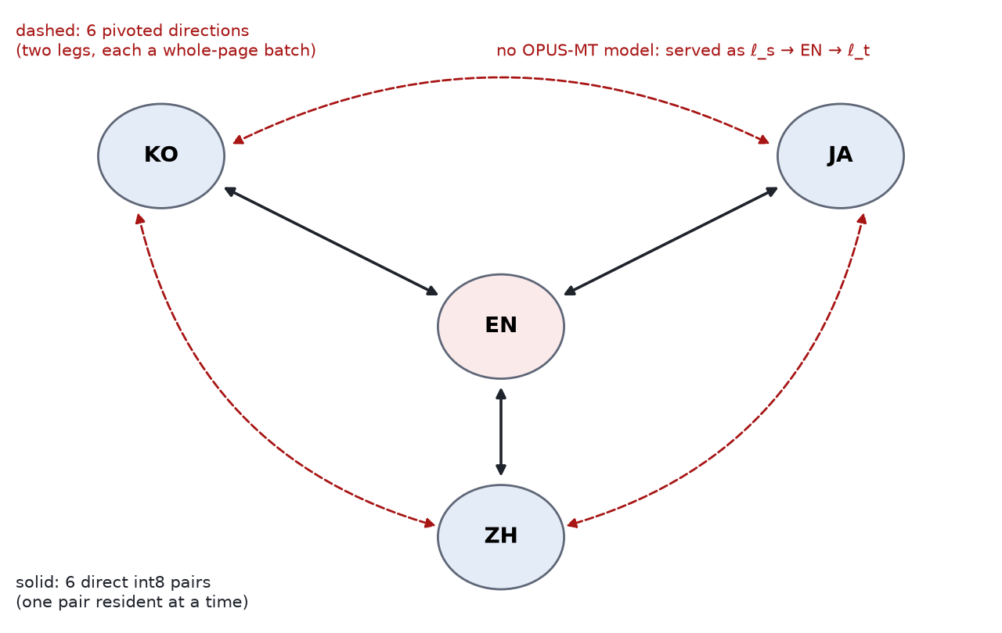
Figure 5.3. Routing over the four implemented languages: six direct English-centric pairs and six directions pivoted through English (schematic).
isPivoted(from, to) exposes the decision so that the language picker can label a pivoted pair ("via English — slower, lower quality"). 5.3 lists all twelve directions. In the deployed interface, where Korean is hidden, the user can reach four direct and two pivoted directions (EN↔JA, EN↔ZH direct; JA↔ZH pivoted).
Table 5.3. Routing of the twelve directed pairs (from PivotTranslator and the model tree)
Direction | Route (model directories) | Model passes | Exposed in UI
EN → KO | Direct: en-ko | 1 | No (KO hidden)
EN → JA | Direct: en-ja | 1 | Yes
EN → ZH | Direct: en-zh | 1 | Yes
KO → EN | Direct: ko-en | 1 | No (KO hidden)
KO → JA | Pivot: ko-en, en-ja | 2 | No (KO hidden)
KO → ZH | Pivot: ko-en, en-zh | 2 | No (KO hidden)
JA → EN | Direct: ja-en | 1 | Yes
JA → KO | Pivot: ja-en, en-ko | 2 | No (KO hidden)
JA → ZH | Pivot: ja-en, en-zh | 2 | Yes
ZH → EN | Direct: zh-en | 1 | Yes
ZH → KO | Pivot: zh-en, en-ko | 2 | No (KO hidden)
ZH → JA | Pivot: zh-en, en-ja | 2 | Yes

5.6.1 Cost of pivoting
A pivoted page costs two encode–decode passes per chunk, so its translation latency is roughly the sum of the two legs; the second leg's input length is that of the intermediate English, which may differ from the source length. Memory is unaffected because only one pair is resident at a time. Model loading, however, interacts with residency: within one page each leg's pair is loaded once, but for a multi-page PDF translated along a pivoted direction the resident pair alternates between the two legs, so each page reloads both pairs — 2P loads for P pages instead of 2 if both pairs could stay resident (analytical). Whether this matters depends on the load time, which RQ4 measures as cold-start model-load time; keeping both legs resident during a PDF job is a simple optimisation if it does.

5.6.2 Error compounding
Pivoting compounds errors in two ways. First, errors of the first leg become the input of the second, and the second model has no access to the original. Under a crude independence model in which each leg preserves a given unit of meaning with probability a₁ and a₂, the pivot preserves it with probability a₁a₂ ≤ min(a₁, a₂); the pivoted direction is never better than its weaker leg on such a unit, and the losses multiply. Second, and more systematically, information that the source and target languages share but English does not encode is lost at the pivot regardless of model quality. Between Korean and Japanese this includes speech levels and honorifics, topic marking, frequently omitted subjects that English forces the first model to make explicit (and sometimes to guess), and Sino-Korean and Sino-Japanese vocabulary whose direct correspondence is obscured by an English paraphrase. Between Chinese and Japanese, shared Han-character terms and proper names risk being transliterated or paraphrased in English and then rendered inconsistently in the target. RQ3 therefore compares each pivoted direction with a direct NLLB-200-distilled-600M translation [9], a model that does not fit the on-device budget but indicates how much quality the pivot costs.
One further caveat concerns the English→Japanese leg. The conversion script maps it to the Hugging Face repository Helsinki-NLP/opus-mt-en-jap, whose name uses a three-letter code rather than the ISO 639-1 code ja used for the reverse direction (opus-mt-ja-en). The training data and intended language variety of that checkpoint should be confirmed from its model card before the RQ3 results for the EN→JA direction, and for every pivoted direction ending in Japanese, are interpreted.

5.7 Memory Residency and Session Management
MarianTranslator.ensureLoaded keys the resident pair by its directory name (for example en-ja). If the requested pair is already loaded it is reused; otherwise the resident pair's encoder and decoder sessions are closed before the new pair is created. A loaded pair comprises the two ONNX sessions, the SentencePiece table, the vocabulary and the configuration. Each directed pair occupies about 35 MB on disk according to the project documentation; the resident footprint additionally includes the runtime's working buffers, which RQ4 measures as peak proportional set size. Sessions use the same threading and optimisation options as the OCR sessions: max(1, min(4, cores − 1)) intra-operator threads and full graph optimisation.
Table 5.4. Translation parameters (from MarianTranslator, SpmEncoder, PivotTranslator)
Parameter | Value | Effect
Chunk budget | 192 source tokens | Longer paragraphs split at sentence punctuation
Length limit | min(n_{max}, max(16, ⌊3m⌋ + 8)) | Backstop against runaway decoding
Decoding | Greedy, no KV cache | n(n+1)/2 decoder positions
Unknown character penalty | −10 | Guarantees segmentability
Boundary marker | ▁ (U+2581) | Lossless detokenisation
Pivot language | English | Six CJK↔CJK directions
Resident pairs | 1 | ≈35 MB per pair on disk
Quantisation | Dynamic int8, per channel | Set by the conversion script

Chapter 6 Translucent Layout-Preserving Re-rendering
The third stage paints each translation back into the page where its source text was. This chapter presents the rendering model implemented in LayoutRenderer and TextFitter. Its central idea is to replace the usual opaque erase of the original text with a translucent, feathered highlight in the locally estimated paper colour, and to secure legibility locally with a halo drawn around each new glyph. The model is simple enough to analyse exactly: Proposition 6.1 states precisely how much of the original glyphs and of the page texture survives, and Proposition 6.2 bounds the cost and quality of the size-fitting search.

6.1 Goals and Constraints
The renderer must preserve, for every translated block, its position, its geometry, its rotation, its size relative to neighbouring text, its ink and paper colours, and — the property that opaque erasure destroys — the texture of the page underneath: paper grain, gradients, photographs behind signage. It must keep the translation legible whatever lies beneath. And it must do so without a further neural network, because the OCR and MT models already occupy the memory budget. It does not attempt to reproduce the typeface, weight or letterforms of the original; the system font is substituted, which carries CJK coverage through the platform's font fallback without bundling a font.

6.2 Block Model
Rendering works on blocks. By default a block is one translated paragraph; an option renders one block per line instead. A block carries its text y, an upright layout rectangle T, a rotation angle θ, a preferred text size p and a line height h, an ink colour κ and a paper colour π, and the quadrilaterals {q_{i}} of its source lines (6.1).
Table 6.1. Fields of a paragraph block and how they are derived (LayoutRenderer.paragraphBlocks)
Field | Derivation | Reason
y | Paragraph translation | Blocks with an empty translation are skipped, so the original is left untouched where nothing replaces it
θ | Median of the line angles (element ⌊n/2⌋ of the sorted angles); |θ| ≤ 0.75° treated as 0 | One skewed detection cannot tilt the paragraph; avoids needless rotation
T (upright) | Union of line bounds | —
T (rotated) | Centred on the union of line bounds; width = widest line along its baseline; height = height of the union of bounds | Layout happens in the block's own frame
h | Median line height | Robust to a mis-sized line
p | 0.82 h | Line height includes leading; the glyph size is smaller
κ, π | Colours of the paragraph's first line | One estimate per block
{q_{i}} | Source line quadrilaterals | Region the highlight must cover

For a rotated block the height of T is taken from the axis-aligned bounds of the rotated lines, which exceeds the upright height: for a single line of width w and height h at angle θ the axis-aligned height is w sin θ + h cos θ. The rectangle is therefore generous in height for rotated paragraphs, which makes overflow less likely but lets the highlight extend beyond the original lines along the normal. Rendering runs in two passes over all blocks — first every highlight, then all text — so that a neighbouring block's highlight can never fade glyphs that have already been drawn. The source bitmap is copied to a new ARGB_8888 bitmap and never modified.

6.3 Highlight Region
Let 𝓔_{γ} scale a shape by 1 + γ about its centre, 𝓔_{γ}(q) = c_{q} + (1 + γ)(q − c_{q}), and let 𝓡_{θ} rotate about the centre of T. The highlight region of a block is
Ω = ( ∪_{i} 𝓔_{γ}(q_{i}) ) ∪ 𝓡_{θ}( 𝓔_{γ}(T) ), γ = 0.06 (6.1)
The growth γ covers the fringe of antialiased pixels that a tight detection box leaves outside, and including T covers wherever the new text will land, which may extend beyond the original lines. The union is computed geometrically, with path Boolean operations, before any pixel is filled. The order matters: filling overlapping translucent shapes one after another compounds their opacity. Two overlapping layers of opacity α have an effective opacity 1 − (1 − α)²; for α = 150/255 that is about 0.83 instead of 0.59 (analytical), and adjacent line boxes, which overlap after unclipping and growth, would show darker (or lighter) bands between lines. 6.1 illustrates the difference on a synthetic example.
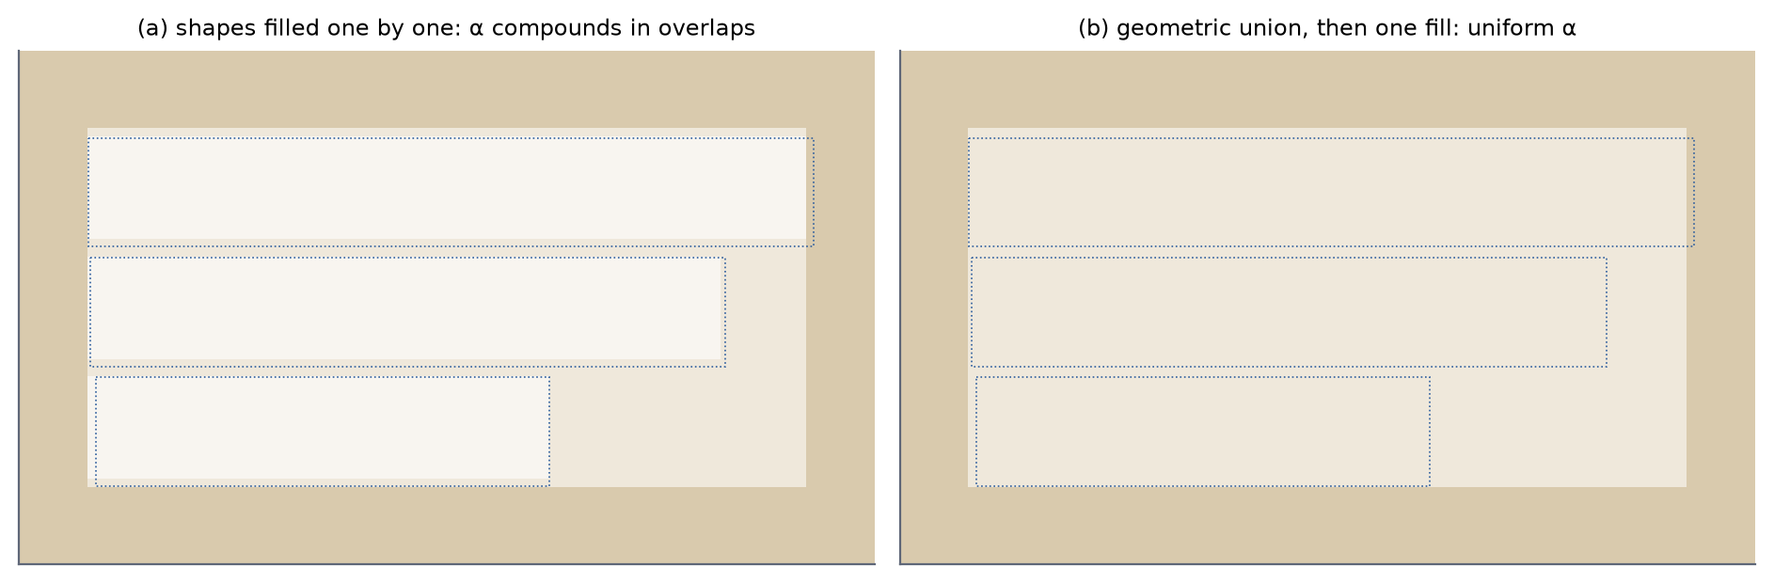
Figure 6.1. Filling grown line boxes one by one compounds opacity in their overlaps (a); filling their geometric union once gives a uniform α (b). Synthetic illustration; dotted outlines are the grown line boxes.

6.4 Compositing
Ω is filled with the paper colour π at opacity α using source-over compositing [73]. The shape's corners are rounded with radius 0.18 h, and its edge is feathered with a Gaussian blur mask of radius 0.06 h (applied only when that radius is at least half a pixel; blur mask filters are honoured because the canvas is bitmap-backed and therefore rendered in software). Writing α(p) for the effective opacity at pixel p — equal to α in the interior of Ω and falling smoothly to 0 across the feathered edge — the output is
Î(p) = α(p) π + (1 − α(p)) I(p), 0 ≤ α(p) ≤ α (6.2)
The default opacity is α = 150/255 ≈ 0.59 (LayoutRenderer.DEFAULT_HIGHLIGHT_ALPHA). Setting α = 255/255 reproduces the former opaque erase, and α = 0 disables the highlight.

6.4.1 Analysis of attenuation
Proposition 6.1. Let an original glyph pixel have colour κ on paper of colour π, and model page texture as a perturbation δ of the paper colour, so that a background pixel has colour π + δ. At a pixel of Ω with effective opacity α(p), compositing with Equation 6.2 yields a ghost contrast |κ̂ − π̂| = (1 − α(p)) |κ − π| and a texture amplitude |δ̂| = (1 − α(p)) |δ|. In the interior of Ω both retain exactly the fraction 1 − α; everywhere in Ω they retain at least 1 − α. The statement holds per colour channel in the colour space in which compositing is performed.
Proof. Apply Equation 6.2 to the three colours involved. The paper maps to π̂ = απ + (1 − α)π = π (dropping the argument p). A glyph pixel maps to κ̂ = απ + (1 − α)κ, so κ̂ − π̂ = (1 − α)(κ − π). A textured paper pixel maps to απ + (1 − α)(π + δ) = π + (1 − α)δ, so δ̂ = (1 − α)δ. Taking absolute values channel by channel gives the equalities; since α(p) ≤ α, 1 − α(p) ≥ 1 − α. ∎
Three consequences follow. First, compositing is affine in the destination colour, so every colour difference inside Ω — between glyph and paper, between texture and paper, between two texture values — is scaled by the same factor 1 − α. The highlight is a uniform contrast reduction toward π, not a removal: the page texture is attenuated, not erased, and the patch artefact of opaque filling, whose interior has zero texture, is avoided. With the default α ≈ 0.59, the retained fraction is 1 − α ≈ 0.41 (analytical; 6.2). Second, the result is exact only in the compositing colour space. Android blends gamma-encoded sRGB values [74], so the proposition holds for encoded values; perceived contrast and the WCAG contrast ratio [83], which are defined on linearised luminance, follow monotonically but not linearly. Third, the analysis assumes that the estimated paper colour equals the true local paper colour. If the estimate is biased by ε, the region's mean shifts by αε toward the estimate — a visible tint of the highlighted area — while the contrast statements, which concern differences, are unaffected.
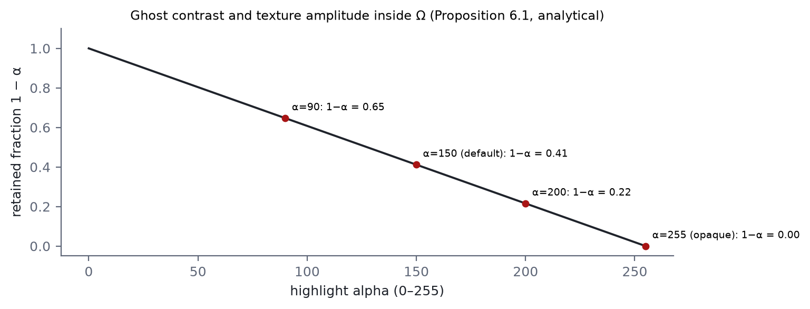
Figure 6.2. Fraction of glyph contrast and texture amplitude retained inside the highlight as a function of α (analytical, Proposition 6.1).
To connect the encoded-value result with perceived contrast, 6.2 evaluates the simplest case — black ink (κ = 0) on white paper (π = 255) in all channels — for several opacities. The ghost glyph takes the encoded value 255α, and its WCAG contrast ratio against the paper follows from the sRGB transfer function. At the default opacity the ghost retains 41% of the encoded difference but has a contrast ratio of about 3:1, below the 4.5:1 level that WCAG requires for body text; the original remains recognisable as a ghost while the new text, protected by the halo, keeps the full 21:1 (analytical).
Table 6.2. Ghost of black text on white paper under the highlight (analytical: Proposition 6.1 and the WCAG 2.1 contrast formula)
α (0–255) | Retained fraction 1 − α | Ghost encoded value | Ghost contrast ratio vs paper
0 | 1.00 | 0 | 21.0 : 1
90 | 0.65 | 90 | 3.0 : 1
150 | 0.41 | 150 | 7.1 : 1
200 | 0.22 | 200 | 12.6 : 1
255 | 0.00 | 255 | 21.0 : 1

6.5 Halo
The ghost of the original could compete with the new glyphs, especially where a long original sits behind a short translation or where strokes of both overlap. The renderer therefore draws the laid-out translation twice with the same text layout: first stroked in the paper colour π with stroke width w_{h} = 0.16 s (s the fitted text size) and round joins, then filled in the ink colour κ.
Corollary 6.1. Every point within distance w_{h}/2 = 0.08 s of the outline of a new glyph, outside the glyph, has colour exactly π after the halo pass, provided no later draw covers it. The new glyphs therefore have their full original contrast |κ − π| against their immediate surroundings, independently of α and of what lies beneath.
Proof. A stroke of width w_{h} centred on the glyph outline paints every point within w_{h}/2 of the outline with π at full opacity, replacing whatever the highlight left there, including any ghost. The subsequent fill paints the glyph interior with κ. Hence, locally, the glyph is κ on π. ∎
Because stroking does not change glyph advances, the line breaks chosen during size fitting remain valid for the halo pass. The proviso in the corollary is not vacuous: blocks are typeset one after another, so if two blocks' layout rectangles overlap, the halo of the later block can overpaint glyphs of the earlier one. Within a block the order is safe, because the layout strokes all its lines before filling any of them. The halo and the highlight divide the work: the highlight lowers the ghost uniformly and keeps the texture; the halo guarantees legibility locally. This is why the highlight can stay faint.

6.6 Size Fitting by Bisection
Translations change length: English into Chinese or Japanese typically shortens, the reverse typically lengthens. Reusing the source size overflows the box often enough to be the norm, so the size is searched for. Let H(s) be the height of the translation laid out at font size s and width |T|_{w} with the platform's high-quality line breaking [86]. With anchor p = 0.82 h, the target is
s* = max { s ∈ [s_{lo}, s_{hi}] : H(s) ≤ |T|_{h} }, s_{lo} = max(4, 0.45 p), s_{hi} = max(s_{lo}, 1.15 p) (6.3)
The lower bound keeps text legible (and never below 4 pixels); the upper bound stops short translations from looking shouty. TextFitter.fit proceeds as follows:
paint.size = lo; L = layout(text, width)
if L.height > boxH: return (L, lo, overflowed = true) # even the minimum overflows
best = L; bestSize = lo
while hi - lo > 0.25: # ε = 0.25 px
mid = (lo + hi) / 2; L = layout(text, width) at mid
if L.height <= boxH: best = L; bestSize = mid; lo = mid
else: hi = mid
return (best, bestSize, overflowed = false)
Proposition 6.2. Let Δ = s_{hi} − s_{lo} and ε = 0.25 px. (i) The search performs one feasibility layout and exactly k = max(0, ⌈log₂(Δ / ε)⌉) bisection layouts. (ii) If H(s_{lo}) ≤ |T|_{h}, the returned size is feasible. (iii) If moreover H is non-decreasing on [s_{lo}, s_{hi}], the returned size is within ε of the largest feasible size in the interval.
Proof. (i) Each iteration halves hi − lo, starting from Δ, and the loop stops at the first k with Δ/2^{k} ≤ ε. (ii) The variable best is initialised to the feasible layout at s_{lo} and is replaced only by layouts that were tested and found feasible; the returned size is always that of best. (iii) The loop maintains the invariant that lo is feasible (or equals s_{lo}) and that hi is either infeasible or equals s_{hi}. If H is non-decreasing, every feasible size lies in [s_{lo}, hi], so the largest feasible size ŝ satisfies lo ≤ ŝ ≤ hi at termination, and hi − lo ≤ ε. The returned size equals lo, since best is updated exactly when lo is. ∎
For p ≥ 8.9 px the interval length is Δ = 0.7p, so k = ⌈log₂(0.7p / ε)⌉; for p = 24 px this is 7, and the total is 8 layouts including the feasibility check (6.3, analytical). The cost grows only logarithmically with the text size. 6.3 shows the search on a synthetic height function.
Table 6.3. Layouts needed by the size search (analytical, Proposition 6.2)
p (px) | s_{lo} | s_{hi} | Δ | Bisection layouts k | Total layouts
8 | 4.00 | 9.20 | 5.20 | 5 | 6
12 | 5.40 | 13.80 | 8.40 | 6 | 7
24 | 10.80 | 27.60 | 16.80 | 7 | 8
48 | 21.60 | 55.20 | 33.60 | 8 | 9
96 | 43.20 | 110.40 | 67.20 | 9 | 10

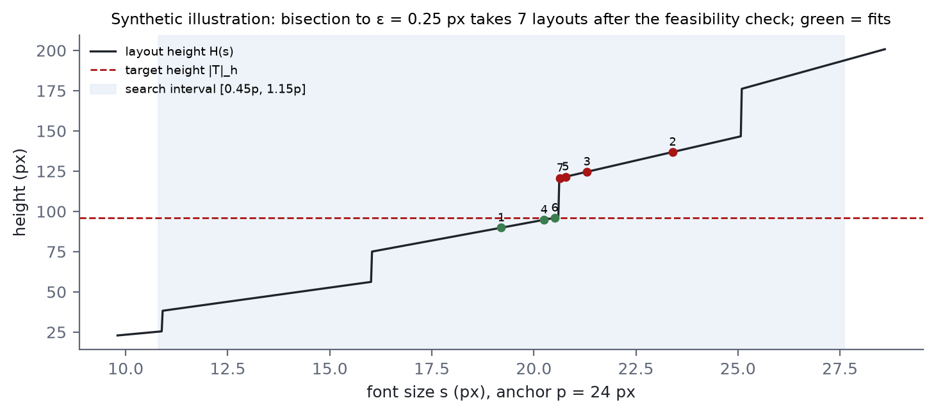
Figure 6.3. Bisection on a synthetic layout-height function H(s) built from a greedy line-breaking model; numbers give the iteration order (synthetic illustration, not a measurement of the platform's layout engine).
Monotonicity of H is the delicate assumption. Layout height is a step function of s: it jumps whenever a larger size forces an extra line break, and is otherwise proportional to s. For greedy first-fit breaking it is non-decreasing. Optimal-fit breaking of the Knuth–Plass kind, which minimises a global badness rather than the number of lines, can occasionally choose more lines at a smaller size, so H may have small non-monotone excursions. Parts (i) and (ii) of the proposition do not depend on monotonicity: the search always terminates in the stated number of layouts and always returns a size that fits. Only the optimality claim (iii) may fail, and then only by returning a feasible size smaller than the largest one.
If even s_{lo} overflows, the minimum size is used and the fit is flagged as overflowed, on the reasoning that a slightly cropped translation is better than a blank region. The renderer does not install a clipping rectangle, so the overflowing lines extend beyond the bottom of T; with the debug option enabled, overflowed blocks are outlined in red and fitting blocks in blue. Layout uses the high-quality break strategy — without it, CJK text, which has no spaces, would never wrap — with hyphenation disabled, unit line-spacing multiplier and no extra font padding. For rotated blocks the canvas is rotated by θ about the centre of T and the text is laid out upright, so line breaking operates in the block's own frame; rotating individual glyph runs by hand would lose it.

6.7 Comparison with Opaque Erasure and Inpainting
6.4 contrasts the translucent scheme with the two alternatives, and 6.4 applies opaque filling and translucent highlighting with and without the halo to a synthetic textured patch. The figure is an illustration of the compositing rules of this chapter on generated content; it is not an experimental result, and the user study of RQ5 is what will establish how the variants are perceived.
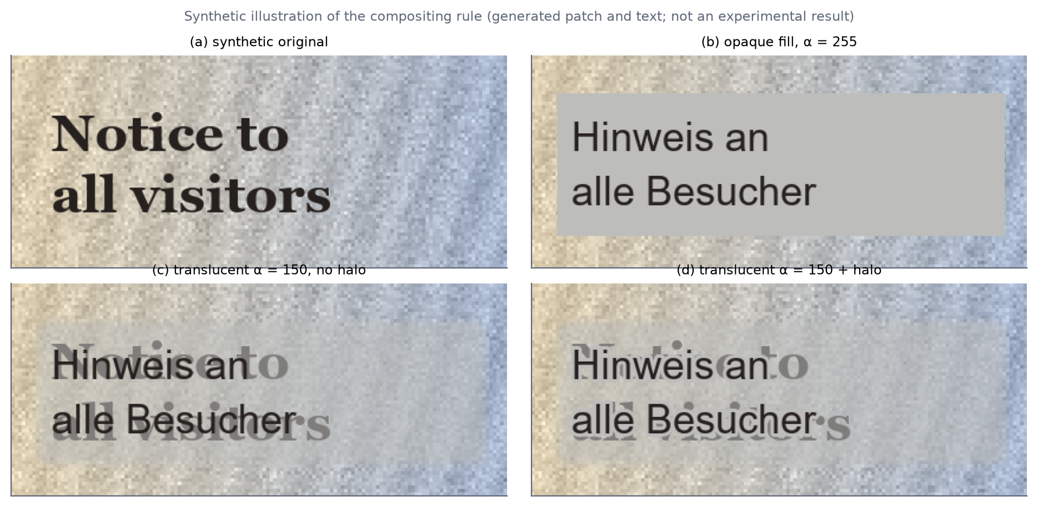
Figure 6.4. Synthetic illustration of the rendering variants on a generated textured patch with generated text: (a) original; (b) opaque fill in the estimated paper colour (α = 255); (c) translucent highlight, α = 150, without halo; (d) the same with the paper-coloured halo. Not an experimental result.
Table 6.4. Properties of re-rendering strategies (analytical where marked; otherwise from the literature and the implementation)
Property | Opaque erase (α = 1) | Translucent + halo (this work) | Learned inpainting
Texture retained inside region | 0 (analytical) | 1 − α ≈ 0.41 (analytical) | Synthesised; model-dependent
Ghost of original | None | (1 − α)|κ − π| outside halo | None if successful
Legibility of new text | Full contrast | Full contrast within 0.08 s (Cor. 6.1) | Full contrast
Additional model | No | No | Yes (large)
Cost | One fill per block | Path union, one blurred fill, two text passes | Network inference on masked region
Characteristic failure | Flat "sticker" patch over texture | Visible ghost behind short translations | Hallucinated or smeared structure

6.8 Options and Output
Table 6.5. Rendering options (LayoutRenderer.Options)
Field | Default | Effect
highlightAlpha | 150 | 0 disables the highlight; 255 reproduces the opaque erase
halo | true | Paper-coloured outline behind glyphs
perLine | false | Typeset each line in its own quadrilateral instead of reflowing paragraphs
debugBoxes | false | Outline each target: blue if the text fits, red if it overflowed

For PDF input with PDF output, each rendered page is drawn into a PdfDocument page scaled from 200-dpi pixels back to points by 72/200, so each output page keeps the physical size of its source page. DOCX and plain-text outputs need only text, so rendering is skipped for them.

6.9 Limitations of the Rendering Model
- The typeface, weight and letterforms of the original are not reproduced.
- A high-contrast original behind a much shorter translation remains visible as a ghost outside the halo band, with retained contrast 1 − α; this is the direct price of Proposition 6.1.
- The paragraph highlight covers the paragraph's rectangle, so the empty tails of short lines in ragged-right text are highlighted too.
- Block colours come from the paragraph's first line.
- For rotated paragraphs the layout rectangle's height is the axis-aligned height, which is generous and can enlarge the highlight.
- Vertical CJK text is recognised as rotated horizontal lines and typeset horizontally.
- Overflowing text at the minimum size is not clipped and can extend below its block.

Chapter 7 Implementation and User Interface
This chapter turns from algorithms to the artefact. It describes the Android implementation, the conversion of the third-party models to ONNX including a graph repair without which the runtime refuses to load several of them, the design of the user interface — screen flow, compact screen-relative control sizes, a collapsible overlay side menu and language gating — and the testing strategy.

7.1 Android Implementation
The application consists of 50 Java source files, about 7,600 lines in total including comments, organised in the eight packages of 3.3. It has no Kotlin, no native code of its own and no code generation beyond Android's view binding and build configuration. Every screen derives from BaseActivity, which wires the toolbar, provides access to the Engines singleton, and implements a blocking progress overlay with a message and a detail line; a helper runs a task on the engine thread and delivers either a result or an exception to a callback on the main thread. ProcessingActivity factors out "run the pipeline on one image, then show the result", which the camera and gallery screens share.
Table 7.1. Screens and their responsibilities
Activity | Responsibility
SplashActivity | Scans the model tree while the brand mark is shown
MainActivity | Home: action tiles, language bar, collapsible side menu, model warning
CameraActivity | CameraX preview and capture, torch, gallery shortcut; then the pipeline
ImageImportActivity | One or more images; each processed in turn, earlier ones saved to history and the last shown
PdfActivity | PDF selection, page range, output format (PDF, DOCX, TXT), cancellation
ResultActivity | Rendered page alongside editable recognised and translated text; copy, text-to-speech, save
HistoryActivity | Saved translations from SQLite, loaded in pages of 200
TranslateActivity | Typed text (up to 500 characters) translated without OCR
LanguageActivity | Source/target picker; flags pivoted and unavailable pairs
SettingsActivity | Preferences and the model report

Persistent settings are held by Prefs in a private shared-preferences file (7.2). Language preferences are read through Lang.userFacingOr, so a stored code for a language that is implemented but hidden resolves to the default.
Table 7.2. Persisted settings and defaults (data/Prefs)
Setting | Default | Notes
Source language | EN | Hidden languages fall back to the default
Target language | ZH | Hidden languages fall back to the default
Auto-detect source script | on | Enables script-based verification (Chapter 4)
Image quality | HIGH (1280 px) | LOW 640, MEDIUM 960
Auto-translate | on | Translate after recognition
PDF output | PDF | Alternatives DOCX, TXT

PDF jobs are handled by PdfJob. The document is copied to the application cache so that the platform's PdfRenderer can open a seekable descriptor; pages are rasterised at 200 dpi on a white background (transparent PDF backgrounds would otherwise reach the detector as black), processed and released one at a time; cancellation is polled between pages; and the output is written to the application's private exports directory. The DOCX writer is a minimal Office Open XML producer — the required package parts, one paragraph per page text, XML escaping, removal of control characters, preserved whitespace and line breaks — and is unit-tested.

7.2 Model Conversion and Graph Repair
The model tree is produced by two scripts. tools/convert_ocr.py converts the PaddleOCR inference models with paddle2onnx [79] at opset 14 with dynamic axes: the PP-OCRv4 detector, the PP-OCRv4 English and Chinese recognisers, the PP-OCRv3 Korean and Japanese recognisers, and the v2.0 orientation classifier, together with their dictionaries. tools/convert_mt.py exports the six OPUS-MT pairs with Hugging Face Optimum [50] (ORTModelForSeq2SeqLM with export=True, use_cache=False), quantises encoder and decoder dynamically to int8 with per-channel weights, flattens the source SentencePiece model into a piece/log-probability table, writes the vocabulary as a token/id table, and extracts the special-token ids and length limits into a small JSON file.

7.2.1 The Concat rank repair
The PaddleOCR conversion needs a repair step. paddle2onnx emits Concat nodes that assemble a shape vector from a mixture of rank-1 components and rank-0 scalars. Paddle's own runtime accepts that; the ONNX specification requires all inputs of Concat to have the same rank, and ONNX Runtime refuses to load the graph with a shape-inference error ("All inputs to Concat must have same rank"). tools/fix_onnx_concat.py inserts an Unsqueeze before each rank-0 input to promote it to a one-element vector — numerically a no-op and exactly what the graph meant. It touches only Concat nodes whose widest input has rank 1, i.e. shape-building concatenations; concatenations of real feature tensors are left alone, because promoting a scalar there would be wrong. According to the model documentation, the PP-OCRv4 recognisers and the v2.0 classifier carry the defect, while the PP-OCRv3 recognisers and the detector do not.

7.2.2 Quantisation settings
The quantisation configuration used is Optimum's AutoQuantizationConfig.avx2(is_static=False, per_channel=True): dynamic quantisation, in which weights are quantised offline and activation ranges are computed at run time, so no calibration data is needed. The preset is named after an x86 instruction set; the operators it produces are standard ONNX integer operators that ONNX Runtime also executes on ARM, but whether the preset's choices are the best for ARM kernels is an efficiency question that RQ4 can answer only indirectly and that is noted as a threat to validity. The quality cost of quantisation is measured directly by the fp32-versus-int8 comparison of RQ3.

7.3 User Interface Design
7.1 shows the screen flow. The home screen offers four action tiles (camera recognition, PDF recognition, image import and history), a language bar with a swap button, a shortcut to typed translation, and the side menu. Every path that processes an image converges on the result screen, which shows the rendered page with the recognised and translated text; the translation stays editable, because both OCR and MT make mistakes and correcting the text is cheaper than repeating the capture.
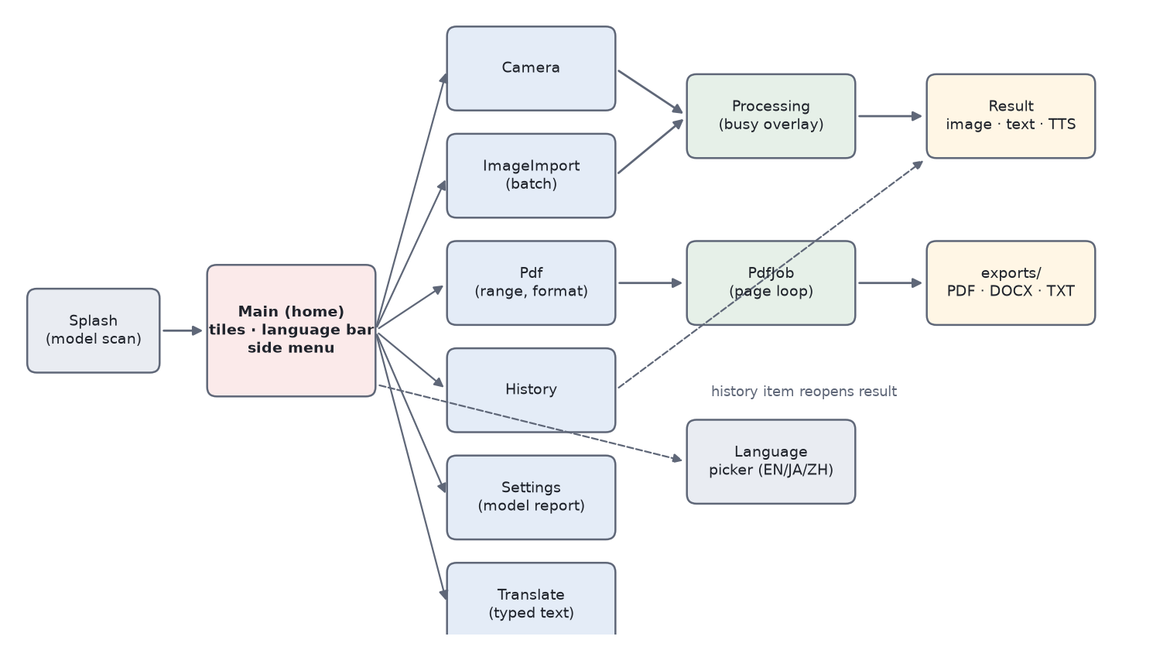
Figure 7.1. Screen flow of the application (schematic derived from the activities and their intents).

7.3.1 Compact, screen-relative control sizes
Every control size is a named dimension token rather than a literal, with phone values in res/values/dimens.xml and tablet values in res/values-sw600dp/dimens.xml, so that all controls scale with the screen class (7.3, 7.2). The current token set is deliberately compact: every control was halved relative to an earlier, larger token set, so that more of the screen is available for the page and its translation. Primary buttons are 30 dp high on phones, title-bar icon buttons 28 dp, secondary icon buttons 24 dp, list rows at least 32 dp, side-menu items 32 dp and the camera shutter 44 dp.
This is a conscious trade-off against accessibility guidance, and it should be stated plainly. Android recommends touch targets of at least 48 × 48 dp [82], and WCAG 2.1's target-size criterion asks for 44 × 44 CSS pixels at level AAA [83]. On phones every interactive token is below 48 dp, the 44 dp shutter included; on tablets only the 54 dp shutter reaches it. At the nominal 160 dp per inch, 24 dp corresponds to about 3.8 mm and 32 dp to about 5.1 mm (analytical), well below the 9–10 mm that Parhi et al. [81] found sufficient for one-handed thumb input. Error rates for small targets can therefore be expected to rise, particularly in the one-handed, standing situations in which the application is often used. The resource file records the decision and the remedy: raising the tokens restores larger targets everywhere without code changes. Measuring the effect of the compact tokens on tap accuracy, or offering a larger accessibility size set, is listed as future work; the RQ5 study concerns rendering and does not evaluate the controls.
Table 7.3. Control dimension tokens (resource files; configuration values, not measurements)
Token | Phone (values/) | Tablet (values-sw600dp/) | Used for
icon_button_small | 24 dp | 28 dp | Secondary icon buttons
icon_button | 28 dp | 32 dp | Title-bar buttons, including the menu toggle
button_height | 30 dp | 36 dp | Primary buttons (text 12 sp / 14 sp)
row_min_height | 32 dp | 38 dp | Option and list rows
nav_item_height | 32 dp | 40 dp | Side-menu items (icon 15 dp / 19 dp, label 12 sp / 14 sp)
shutter_size | 44 dp | 54 dp | Camera shutter
tile_min_height | 70 dp | 100 dp | Home action tiles (icon 22 dp / 32 dp)
toolbar_height | 56 dp | 64 dp | Title bar
nav_rail_width | 40 dp | 52 dp | Collapsed side menu
nav_rail_expanded_width | 104 dp | 140 dp | Expanded side menu

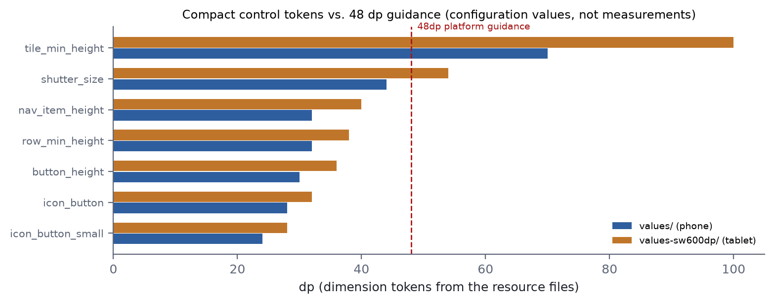
Figure 7.2. Principal control tokens for phones and tablets compared with the 48 dp platform guidance; most compact tokens fall below it by design (values from the resource files).
The home action tiles are laid out two per row at their compact height: each row wraps its content, and the tiles have a minimum height of 70 dp (100 dp on tablets). They share the row's width equally but no longer stretch to fill the remaining screen height; the home column sits in a scroll view, so on short or landscape screens it scrolls.

7.3.2 Collapsible overlay side menu
Top-level destinations (home, image import, PDF, history, settings) are reachable from a side menu on the home screen (7.3). Collapsed, the menu is a narrow rail of icons (nav_rail_width: 40 dp on phones, 52 dp on tablets). The scrolling content always reserves that width through its start margin, so the collapsed rail never covers a tile. A toggle button on the right-hand side of the title bar (main_nav_toggle) expands the menu: MainActivity.applyNavState animates the rail's width to nav_rail_expanded_width (104 dp / 140 dp) over 220 ms with a decelerating interpolator, over the content rather than pushing it aside. A scrim (nav_scrim, 70% black) fades in behind the rail in proportion to the animation's progress, and the item labels become visible once the rail is 60% of the way open, fading in over the remaining 40% so that they are never squeezed into an ellipsis mid-animation. When collapsing, labels are hidden before the rail narrows. The menu collapses on a second press of the toggle, on a tap on the scrim, or on the system Back action, which is handled by an OnBackPressedCallback that is enabled only while the menu is expanded, so Back otherwise keeps its normal meaning.
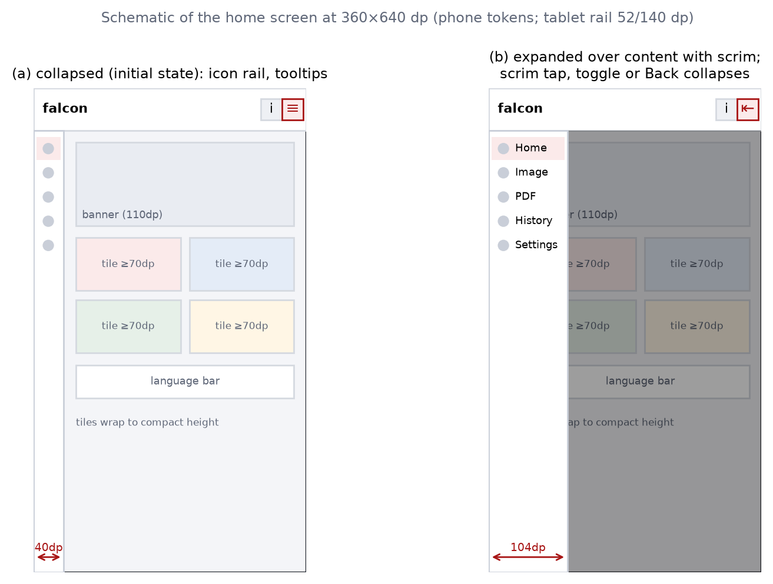
Figure 7.3. Home screen with the side menu collapsed (a) and expanded over the content behind a scrim (b), drawn to scale for a 360 × 640 dp phone using the phone tokens (schematic).
Overlaying rather than pushing keeps the content's geometry stable: the tiles neither change size nor reflow while the menu animates, and closing the menu returns exactly the previous layout. The width arithmetic shows what pushing would cost. On a 360 dp-wide phone with 16 dp gutters and a 12 dp gap between the two tiles of a row, the collapsed rail leaves (360 − 40 − 2·16 − 12)/2 = 138 dp per tile; if the expanded 104 dp rail pushed the content, each tile would narrow to (360 − 104 − 2·16 − 12)/2 = 106 dp (analytical). With the earlier, larger token set (80 dp and 208 dp rails) the same arithmetic gave 118 dp and 54 dp, which is what originally motivated the overlay. The menu always starts collapsed and its state is not persisted, so that the tiles are never hidden behind the scrim at launch. Screen-reader accessibility is preserved in both states: every item carries its label as a content description for screen readers, collapsed items additionally show the label as a tooltip, the toggle's content description switches between "expand" and "collapse", and the scrim is excluded from accessibility focus.

7.3.3 Language gating
The engine implements four languages end to end — recognition heads and dictionaries, both translation directions for each English pair, Hangul script detection, the text-to-speech locale and the flag — but the deployed interface exposes three: English, Japanese and Chinese. Korean is withheld by a single, commented build-time list in core/Lang.java:
private static final Lang[] USER_FACING = {
EN,
// KO, // Korean: implemented, hidden from the UI. Uncomment to enable.
JA,
ZH,
};
KO stays in the enumeration so that code, tests, stored preferences and history rows keep compiling and resolving. Every screen, default and auto-detection path reads the list through three methods — Lang.userFacing(), isUserFacing() and userFacingOr(code, fallback) — instead of enumerating all values (7.4). Re-enabling Korean means uncommenting one line, restoring the language name in the help text and updating one unit test. The mechanism separates the question "is it implemented?" from "is it ready to ship?", which is useful whenever a language's models, typography or evaluation lag behind the others — for Korean, the line-joining issue noted in Chapter 4 is one such item.
Table 7.4. Call sites that enforce language gating
Site | Behaviour
LanguageActivity | The picker lists user-facing languages only; search cannot find Korean
Prefs.sourceLang/targetLang | A stored "ko" resolves to the default (EN / ZH)
TranslationPipeline.process | A Hangul-based detection guess is ignored; the configured source is kept
ModelValidator.validate | Only user-facing languages and pairs are required and reported
SettingsActivity (model report, help) | Pivoted pairs and help text name user-facing languages only

The language picker also reports what the installed models can do for each choice: a pair served through English is labelled as slower and of lower quality, and a pair with no route at all is shown as unavailable rather than failing later.

7.4 Testing Strategy
The unit-test suite is small and targeted: 50 JVM tests in six classes, run with ./gradlew test and requiring neither a device nor the model tree. Its guiding principle is to test the code that fails silently — whose errors produce plausible output rather than exceptions — because loud failures are found anyway (7.5).
Table 7.5. Unit tests by class and what they protect (test names from app/src/test)
Test class | Tests | What is covered | Silent failure prevented
SpmEncoderTest | 8 | Viterbi prefers higher-scoring segmentations and splits when that scores better; unknown-character fallback; normalisation (marker prefix, whitespace collapse, blank input, NFKC); detokenisation restores spaces | Wrong segmentation → fluent but wrong translation
CtcDecoderTest | 8 | Repeat collapsing and blank removal; blank separating doubled characters; all-blank input; dictionary with and without space class; mismatched dictionary rejected; trailing empty line ignored | Index shift → every character wrong
DbPostProcessorTest | 9 | Single and separate blocks; unclip enlarges the raw blob; low-probability noise and tiny components ignored; scaling to source resolution; empty map; thresholds honoured | Mis-sized or missing boxes
ScriptDetectorTest | 9 | Hangul, Kana, Han, Latin; mixed Han/Kana; small Hangul share; digits and punctuation; null/empty; Kanji-only Japanese reported as Chinese | Re-recognition with the wrong head
LangTest | 8 | Canonical codes; jp alias; region suffixes; unknown codes; fallback; pair keys match model directories; Korean implemented but not user-facing; user-facing languages survive the filter | Wrong model directory; hidden language leaking
DocxWriterTest | 8 | Required package parts; one paragraph per entry; XML escaping; control characters stripped; line breaks; significant whitespace; CJK text; empty document | Corrupt DOCX output

The renderer depends on android.graphics and has no JVM tests; the build configures unit tests to return default values from Android stubs so that pure algorithms that merely mention Android types can run on the JVM. The renderer is checked on a device with the debug outline option against a fixed checklist: dark text on white paper; white text on a dark or coloured sign; text over a photograph or gradient; a paragraph rotated by at least 5°; and a translation much longer than its source, which must show a red overflow outline. There are no instrumented end-to-end tests with real models; the experimental protocol of Chapter 8 plays that role for accuracy, and a regression suite built from its datasets is proposed as future work.

Chapter 8 Experimental Methodology
This chapter specifies how the five research questions will be answered. It is written as a protocol to be executed, with hypotheses, datasets, metrics, procedures, ablations and analyses fixed in advance, so that the results reported in Chapter 9 cannot be shaped by the data. Where a quantity must be chosen before execution — the number of pages, participants or devices — it is marked [TBD] and must be fixed, with its justification, before data collection begins. Exact software versions, model checksums, random seeds and device builds are to be recorded with every run.

8.1 Overview
8.1 summarises the design. RQ1 and RQ2 are offline comparisons on public OCR benchmarks, run on a workstation with the same ONNX models and the same Java post-processing code as the device (the post-processing is pure Java and runs unchanged on a desktop JVM). RQ3 evaluates translation offline on FLORES-200. RQ4 is measured on physical phones. RQ5 is a within-subjects user study. 8.1 lists the hypotheses; each result table in Chapter 9 names the hypothesis it tests.
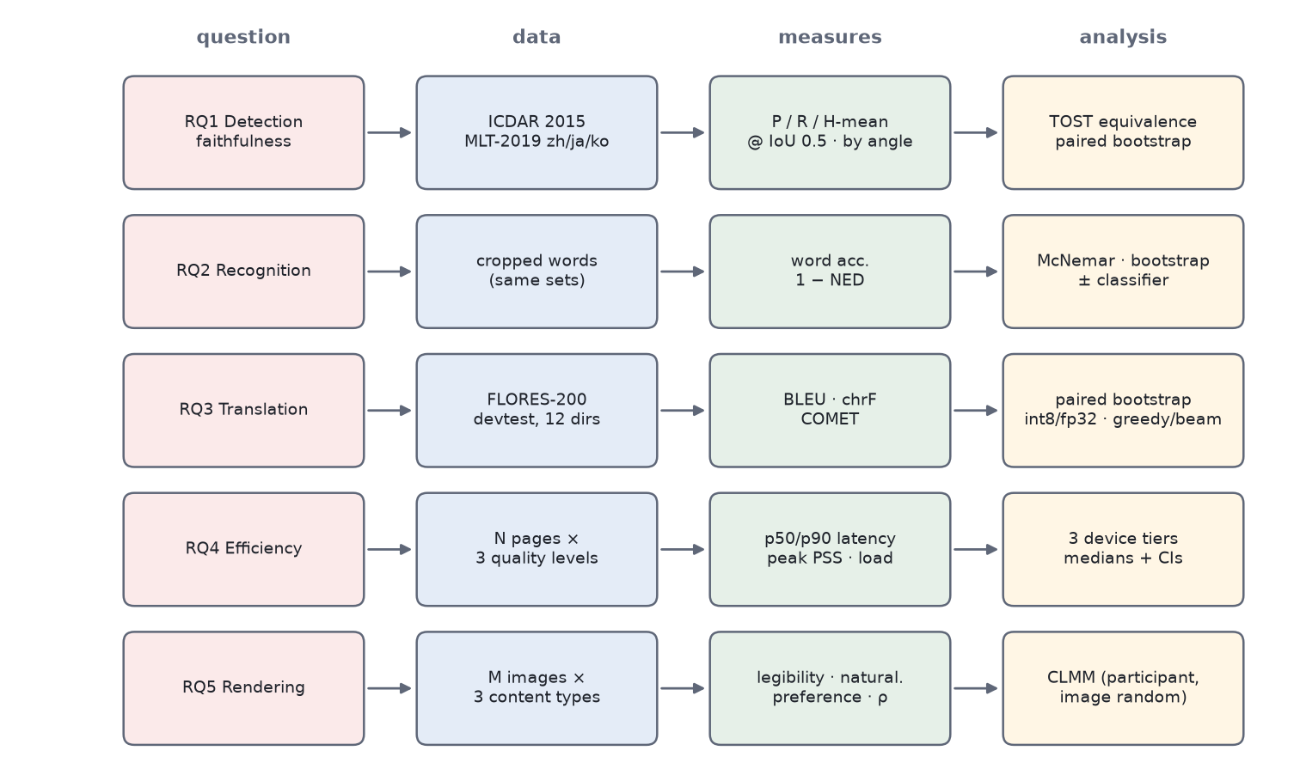
Figure 8.1. Experimental design: research questions, data, measures and analyses (schematic).
Table 8.1. Pre-specified hypotheses
ID | Hypothesis | Test
H1a | The library-free post-processing (component-mean score, rectangle unclip) is equivalent to the reference in H-mean on each dataset, within a margin of ±1 percentage point (margin to be confirmed before execution). | TOST on paired bootstrap differences [87], [88]
H1b | Component-mean scoring increases recall relative to box-mean scoring for text rotated more than 20°, without reducing precision for text under 5°. | Paired bootstrap per angle stratum
H1c | Rectangle unclip and polygon unclip give the same H-mean (Proposition 4.1 predicts identity for rectangle inputs). | Paired bootstrap; count of differing boxes
H2 | The orientation classifier increases word accuracy on crops that are upside down and does not decrease it on upright crops. | McNemar's test on paired word outcomes [89]
H3a | Int8 dynamic quantisation changes chrF and COMET by less than a practically negligible margin relative to fp32 (margin to be fixed a priori). | Paired bootstrap [90]
H3b | Beam search (k = 4) improves on greedy decoding by a small amount relative to its cost. | Paired bootstrap; cost from RQ4
H3c | Pivoted CJK↔CJK directions score below a direct multilingual reference. | Paired bootstrap vs NLLB-200-distilled-600M
H4a | Detection latency scales approximately with the number of detector input pixels (Chapter 4). | Regression of latency on w′h′
H4b | The measured decoder cost ratio without/with KV cache approaches the analytical (n + 1)/2 for position-proportional work. | Ratio per output-length bin
H5a | Translucent highlight with halo (α = 150) is rated no less legible than opaque erasure. | CLMM, non-inferiority contrast
H5b | Translucent highlight with halo is rated more natural than opaque erasure. | CLMM contrast
H5c | Measured texture retention ρ inside Ω follows 1 − α (Proposition 6.1). | Regression of ρ on 1 − α

8.2 Datasets
Table 8.2. Datasets and their roles
Dataset | Content | Used for | Notes
ICDAR 2015 Incidental Scene Text [16] | English scene text captured incidentally with wearable cameras; word-level quadrilaterals | RQ1 (en), RQ2 (en) | Standard test split
MLT-2019 [17] | Multi-lingual scene text in ten languages including Chinese, Japanese and Korean; line/word quadrilaterals with script labels | RQ1, RQ2 (zh, ja, ko) | Script subsets selected by annotation; split to be fixed
FLORES-200 devtest [9], [91] | Professionally translated, multi-way parallel sentences | RQ3, all 12 directions | Same sentences in every language, enabling pivot vs direct comparison
In-house document photographs | [TBD] photographed pages: forms, letters, menus, signage, text over photographs | RQ4 pages; RQ5 stimuli; RQ1 external validity | Consent, licence and anonymisation required
User-study stimulus set | [TBD] images in three strata: flat documents, light-on-dark signs, text over photographs | RQ5 | Balanced across strata and languages

Two caveats apply to the public OCR benchmarks. Their test ground truth may be withheld by the competition organisers, in which case evaluation uses a held-out portion of the public annotations with the split documented; and the released PP-OCR weights may have been trained on data that overlap these benchmarks. The second caveat is harmless for RQ1 — both post-processing variants use the same network, so contamination affects them equally — but it inflates absolute recognition accuracy in RQ2, which is why an in-house set of photographed documents, collected for this study, is also required.

8.3 Metrics

8.3.1 Detection
A predicted quadrilateral matches a ground-truth quadrilateral when their intersection over union exceeds 0.5, with one-to-one matching; regions marked "do not care" in the annotations are excluded. With TP matched pairs, precision, recall and H-mean are
P = TP / |pred|, R = TP / |gt|, H = 2PR / (P + R) (8.1)

8.3.2 Recognition
Word accuracy is the fraction of ground-truth crops whose recognised string equals the reference exactly after a documented normalisation (Unicode NFKC; for English, case folding and removal of punctuation, following common scene-text practice). Normalised edit distance uses the Levenshtein distance [92] between prediction x̂ and reference x:
NED = (1/N) Σ_{i} d_{L}(x̂_{i}, x_{i}) / max(|x̂_{i}|, |x_{i}|), reported as 1 − NED (8.2)
Recognition is evaluated on ground-truth crops so that it is isolated from detection, and also end to end on detected crops for the in-house set.

8.3.3 Translation
BLEU [93] is computed with sacreBLEU [94] using the tokeniser appropriate to the target language — 13a for English, zh for Chinese, ja-mecab for Japanese and ko-mecab for Korean — and the full signature is reported. chrF [95], a character n-gram F-score, is less sensitive to tokenisation and is treated as the primary automatic metric for CJK targets. COMET [96], a learned metric that correlates better with human judgement [97], is reported with the exact model identifier. Differences between systems are tested with paired bootstrap resampling over sentences [90].

8.3.4 Efficiency
Latency is wall-clock time per stage — detection, detection post-processing, classification and recognition, translation, rendering — and end to end, reported as the median and the 90th percentile over pages. Memory is the peak proportional set size (PSS) of the process during a page. Cold-start model-load time is the time to create each ONNX session from its asset. The application currently logs total recognition time and total pipeline time; a measurement build adds monotonic-clock timestamps around each stage, with instrumentation compiled out of release builds.

8.3.5 Rendering
Participants rate legibility and naturalness on 5-point scales and give pairwise preferences. The objective companion metric is texture retention inside the highlight region, measured on non-glyph pixels of Ω (pixels whose distance from any original or new glyph exceeds a margin):
ρ = σ_{out} / σ_{in} (8.3)
where σ_{in} and σ_{out} are the standard deviations of luminance over the same pixel set before and after rendering. Proposition 6.1 predicts ρ = 1 − α in the interior of Ω, and ρ ≥ 1 − α including the feathered edge; deviations measure the effect of feathering, quantisation to 8 bits and the halo. SSIM [98] between original and rendered image outside the new glyphs is reported as a secondary measure.

8.4 RQ1 Protocol: Detection Post-processing
The same PP-OCRv4 detector ONNX model is run once per image, and its probability map is post-processed by (a) the reference PaddleOCR post-processing (OpenCV contours, box-mean score, polygon unclip with a clipping library) and (b) the library-free Java implementation, with identical thresholds (τ_{b} = 0.3, τ_{s} = 0.6, r = 1.6) and identical detector input resolution for each quality level. Because the network output is shared, any difference is attributable to post-processing alone. Two ablations isolate the two deliberate deviations: box-mean versus component-mean scoring, and polygon versus rectangle unclip. Results are stratified by the angle of the ground-truth box (< 5°, 5–20°, > 20°) to test the rotation-bias hypothesis behind S(C). Post-processing time per image is recorded on the same workstation for both implementations as a secondary outcome.

8.5 RQ2 Protocol: Recognition
Word accuracy and 1 − NED are computed per script on ground-truth crops of ICDAR 2015 and the MLT-2019 subsets, with and without the orientation classifier. To test H2 specifically, each crop set is evaluated twice: as annotated, and rotated by 180°; the classifier should recover most rotated crops and leave upright crops unchanged. Confidence calibration of the CTC line confidence is examined by plotting accuracy against confidence, which informs whether the discard threshold of 0.5 is well placed. The effect of the automatic script check is measured separately on the in-house set by deliberately misconfiguring the source language.

8.6 RQ3 Protocol: Translation Quality
All twelve directions are evaluated on FLORES-200 devtest. The main configuration is the deployed one: int8 models, greedy decoding, the length limit of Equation 5.4, and the chunking rule of Chapter 5, run through the Java tokeniser and decoding loop on a desktop JVM with ONNX Runtime so that tokenisation and decoding are identical to the device. Ablations: fp32 versus int8 (H3a), greedy versus beam 4 (H3b, beam search run with the reference Transformers implementation of the same checkpoints), and, for the six pivoted directions, NLLB-200-distilled-600M direct translation as an upper-bound reference that does not fit the device budget (H3c). To separate tokeniser fidelity from model quality, the Java SentencePiece segmentation is compared with the reference library on all source sentences, and any mismatch is reported.

8.7 RQ4 Protocol: Efficiency on Device
Three devices from different price tiers are used (8.3). Each device is reset to a documented state: airplane mode, fixed screen brightness, battery above 50% and not charging, no other user applications running, and a cool-down period between runs so that thermal throttling does not drift across conditions. For each quality level (640, 960 and 1280 pixels) [TBD] pages from the in-house set are processed, preceded by warm-up runs that are discarded. Measured are per-stage latency (median and 90th percentile), peak PSS, cold-start session creation time per model, and, for translation, the ratio of decoder time without and with a key–value cache, the latter using an experimental cached export of the same checkpoints and binned by output length to compare with the analytical (n + 1)/2 (H4b).
Table 8.3. Devices for RQ4 (to be fixed before execution)
Tier | Device model | SoC | RAM | Android version | Build / ORT version
Low | [TBD] | [TBD] | [TBD] | [TBD] | [TBD]
Mid | [TBD] | [TBD] | [TBD] | [TBD] | [TBD]
High | [TBD] | [TBD] | [TBD] | [TBD] | [TBD]

8.8 RQ5 Protocol: User Study of Rendering

8.8.1 Design and conditions
A within-subjects study compares rendering variants of the same images (8.2). The variant factor crosses highlight opacity α ∈ {255 (opaque erase), 200, 150, 90} with halo ∈ {on, off}; to keep sessions short, the core set shown to every participant is α = 255, α = 200 with halo, α = 150 with halo (default), α = 150 without halo and α = 90 with halo, plus an off-device LaMa-inpainted reference [11] in which the original text is removed before the translation is typeset with the same fitting and halo. All variants of an image use identical detection, translation and fitted layouts, so they differ only in the treatment of the original.
Table 8.4. User-study conditions (analytical retained fraction from Proposition 6.1)
Condition | α (0–255) | Halo | 1 − α (analytical)
C1 Opaque erase | 255 | off | 0.00
C2 | 200 | on | 0.22
C3 Default | 150 | on | 0.41
C4 | 150 | off | 0.41
C5 | 90 | on | 0.65
C6 LaMa inpainting (off-device) | — | on | —

8.8.2 Participants, stimuli and procedure
[TBD] participants will be recruited, with the number fixed by a power analysis or a simulation-based estimate for the CLMM contrasts before recruitment. Inclusion requires normal or corrected-to-normal vision and reading ability in the target language of the stimuli; the source language should be one the participant does not read, so that the ghost of the original does not act as a crib. Stimuli are [TBD] images balanced across the three content strata. Each session comprises consent and demographics, two practice images, a rating block in which each image–condition pair is shown once in randomised order on a calibrated phone held by the participant, a block of pairwise preferences between conditions of the same image, and a debrief with the System Usability Scale [99] for the application as a whole and free-text comments. Ratings are 5-point scales for legibility ("the translated text is easy to read") and naturalness ("the translation looks like part of the page").
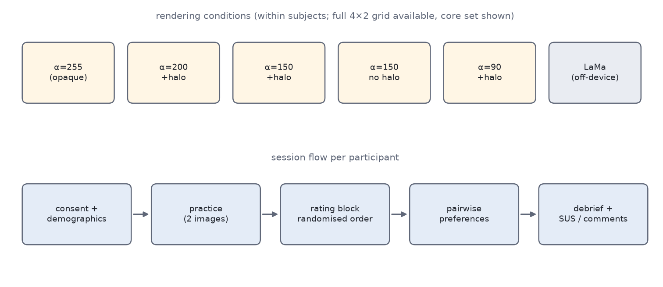
Figure 8.2. User-study conditions and per-participant session flow (schematic).

8.8.3 Analysis
Ratings are ordinal, so they are analysed with cumulative link mixed models (CLMM) [100] with condition as a fixed effect and crossed random intercepts for participant and image [101], adding random slopes as far as the data support [102]; linear mixed models fitted with lme4 [103] on the raw ratings, and aligned-rank-transform ANOVA [104], serve as robustness checks. H5a is tested as a non-inferiority contrast of C3 against C1 on legibility with a pre-specified margin; H5b as a superiority contrast on naturalness. Pairwise preferences are analysed with a Bradley–Terry model [105]. Content stratum is added as a fixed effect and in interaction with condition in a secondary model, since the opaque erase is expected to fare worst over photographs. H5c is tested by regressing measured ρ on 1 − α across conditions and images.

8.8.4 Ethics
The study requires approval from the institutional review board of [University] before recruitment. Participants give informed consent, may withdraw at any time without consequence, and are compensated at [TBD]. No personal documents are used as stimuli; in-house photographs are of documents created for the study or with rights cleared, and any personal data visible in them is removed. Responses are stored pseudonymously, separated from consent forms, and retained for [TBD] years. Appendix C holds placeholders for the consent form, instructions and questionnaire.

8.9 Statistical Conventions
All confidence intervals are 95% and are obtained by bootstrap unless a model provides them. Families of related tests — the angle strata of RQ1, the twelve directions of RQ3, the condition contrasts of RQ5 — are corrected with the Holm procedure [106]. Equivalence and non-inferiority margins are fixed before execution and justified in terms of practical significance, not statistical convenience. Effect sizes are reported alongside every test, and no result is dropped for being non-significant.
Table 8.5. Ablations and the question each answers
ID | Factor | Levels | RQ / hypothesis
A1 | Detection score | box mean / component mean | RQ1, H1b
A2 | Unclip | polygon offset / closed-form rectangle | RQ1, H1c
A3 | Orientation classifier | off / on | RQ2, H2
A4 | Detector input size | 640 / 960 / 1280 | RQ1, RQ4 (H4a)
A5 | MT weights | fp32 / int8 | RQ3 (H3a), RQ4
A6 | Decoding | greedy / beam 4 | RQ3 (H3b), RQ4
A7 | CJK↔CJK route | English pivot / NLLB direct (off-device) | RQ3 (H3c)
A8 | Decoder export | cache-less / KV cache | RQ4 (H4b)
A9 | Rendering | α ∈ {255, 200, 150, 90} × halo | RQ5 (H5a–c)
A10 | Recognition batching | arrival order / sorted by aspect ratio | RQ4
A11 | Script verification | off / on | RQ2, RQ4

8.10 Threats to Validity
Following the usual classification [107], the main threats and their mitigations are as follows.
- Internal validity. RQ1 and RQ3 compare implementations that share networks, so model variation is controlled; the remaining risk is configuration drift, mitigated by running both variants from one script with one parameter file. On-device timing is confounded by thermal state, background activity and frequency scaling; the device protocol controls these as far as possible and reports variability.
- Construct validity. BLEU is a weak proxy for translation quality, especially for CJK targets where it depends on segmentation; chrF and COMET are therefore reported and the tokenisers fixed. H-mean at IoU 0.5 rewards boxes that a translation renderer might still place poorly; the in-house set allows inspection of rendered pages. Rating scales measure perceived legibility, not reading performance; a reading-time or comprehension task is a possible extension.
- External validity. Public benchmarks are scene-text-heavy, while many intended uses concern documents; the in-house set addresses this but its composition must be described. Three devices cannot represent the Android ecosystem [78]. Participants in a lab study are not travellers in front of a sign.
- Conclusion validity. Multiple testing is controlled with Holm corrections; sample sizes are fixed in advance; non-significant results are reported with confidence intervals rather than as evidence of no effect, except where an equivalence test is specified.
- Model provenance. The EN→JA checkpoint is taken from a repository whose name uses a non-standard language code (Chapter 5); its model card must be checked. Benchmark overlap with the OCR training data would inflate absolute accuracies (Section 8.2).

Chapter 9 Results and Discussion
This chapter contains the result tables for every research question. In accordance with the reporting rule stated in Chapter 1, all experimental values are pending execution of the protocol in Chapter 8 and appear as [TBD]. For each table the text states what the table will show, which hypothesis of 8.1 it tests, and what outcome would confirm or refute it. Columns that contain analytical values derived from formulas in earlier chapters are labelled as such. The chapter closes with a discussion of the trade-offs that can be anticipated from the analysis alone, and of the limitations of the system.

9.1 RQ1: Faithfulness of Library-free Detection Post-processing
9.1 will report H-mean at IoU 0.5 for the reference post-processing and for the library-free implementation with each of its two deviations switched on separately. It tests H1a (equivalence of the deployed configuration, last row, with the reference, first row, within the pre-specified margin) and H1c (identity of the two unclip variants, rows two and four versus three and five). Proposition 4.1 predicts that the rectangle and round-join polygon unclips coincide whenever the reference unclips the minimum-area rectangle; any difference between those rows would therefore point to contour-mode unclipping or to discretisation effects.
Status. Values pending execution of the protocol in Chapter 8. Every cell marked [TBD] is to be filled from measured data; no value in this table is a measurement.
Table 9.1. Detection H-mean (%) at IoU 0.5 by post-processing variant (pending)
Post-processing | IC15 | MLT-zh | MLT-ja | MLT-ko
Reference (OpenCV + polygon clipping, box-mean score) | [TBD] | [TBD] | [TBD] | [TBD]
Library-free, box-mean score, polygon unclip | [TBD] | [TBD] | [TBD] | [TBD]
Library-free, box-mean score, rectangle unclip | [TBD] | [TBD] | [TBD] | [TBD]
Library-free, component-mean score, polygon unclip | [TBD] | [TBD] | [TBD] | [TBD]
Library-free, component-mean score, rectangle unclip (deployed) | [TBD] | [TBD] | [TBD] | [TBD]

9.2 breaks precision and recall down by the angle of the ground-truth text and tests H1b. The analysis of Section 4.2.2 predicts that any advantage of component-mean scoring should grow with angle and vanish for near-horizontal text; a recall gain concentrated in the > 20° stratum with unchanged precision below 5° would confirm H1b, while no difference in any stratum would indicate that the reference's masked box score already avoids the bias.
Status. Values pending execution of the protocol in Chapter 8. Every cell marked [TBD] is to be filled from measured data; no value in this table is a measurement.
Table 9.2. Detection precision, recall and H-mean (%) by text angle and score (pending)
Angle stratum | Score | P | R | H-mean | Boxes (n)
< 5° | box mean | [TBD] | [TBD] | [TBD] | [TBD]
< 5° | component mean | [TBD] | [TBD] | [TBD] | [TBD]
5–20° | box mean | [TBD] | [TBD] | [TBD] | [TBD]
5–20° | component mean | [TBD] | [TBD] | [TBD] | [TBD]
> 20° | box mean | [TBD] | [TBD] | [TBD] | [TBD]
> 20° | component mean | [TBD] | [TBD] | [TBD] | [TBD]

Table 9.3. Post-processing time per image on the workstation (ms, median [p90]; pending)
Implementation | IC15 | MLT-zh | MLT-ja | MLT-ko
Reference (Python + OpenCV + clipping) | [TBD] | [TBD] | [TBD] | [TBD]
Library-free (Java) | [TBD] | [TBD] | [TBD] | [TBD]

9.3 is a secondary outcome. It will show whether the library-free implementation is competitive in speed on a common platform; the complexity analysis of 4.3 predicts that both are dominated by a linear pass over the map.

9.2 RQ2: Recognition Accuracy
9.4 will report word accuracy and 1 − NED per script on ground-truth crops, with the orientation classifier off and on, both for crops as annotated and for the same crops rotated by 180°. It tests H2: the classifier should raise accuracy substantially on rotated crops (where, without it, the recogniser reads upside-down text) and leave upright crops essentially unchanged, which is what the conservative threshold of 0.9 is designed to achieve.
Status. Values pending execution of the protocol in Chapter 8. Every cell marked [TBD] is to be filled from measured data; no value in this table is a measurement.
Table 9.4. Recognition word accuracy / 1 − NED (%) by script and orientation handling (pending)
Script | Upright, cls off: acc | 1−NED | Upright, cls on: acc | 1−NED | Rotated, cls off: acc | 1−NED | Rotated, cls on: acc | 1−NED
English (IC15) | [TBD] | [TBD] | [TBD] | [TBD] | [TBD] | [TBD] | [TBD] | [TBD]
Chinese (MLT) | [TBD] | [TBD] | [TBD] | [TBD] | [TBD] | [TBD] | [TBD] | [TBD]
Japanese (MLT) | [TBD] | [TBD] | [TBD] | [TBD] | [TBD] | [TBD] | [TBD] | [TBD]
Korean (MLT) | [TBD] | [TBD] | [TBD] | [TBD] | [TBD] | [TBD] | [TBD] | [TBD]

9.5 will report the effect of script-based source verification on the in-house set when the configured source language is deliberately wrong, including the rate at which the known failure mode (Kanji-only Japanese classified as Chinese) occurs and the added latency of the second recognition pass.
Status. Values pending execution of the protocol in Chapter 8. Every cell marked [TBD] is to be filled from measured data; no value in this table is a measurement.
Table 9.5. Script-based source verification with a misconfigured source (pending)
Configured → true source | Pages | Correctly re-recognised (%) | End-to-end word acc. (%) | Added latency (ms)
EN → JA | [TBD] | [TBD] | [TBD] | [TBD]
EN → ZH | [TBD] | [TBD] | [TBD] | [TBD]
JA → ZH | [TBD] | [TBD] | [TBD] | [TBD]
ZH → JA | [TBD] | [TBD] | [TBD] | [TBD]

9.3 RQ3: Translation Quality
9.6 will report BLEU, chrF and COMET for all twelve directions in the deployed configuration (int8, greedy). It will show the level of quality the device offers per direction and, by comparing pivoted rows (†) with the direct rows of the same target language, the cost of pivoting. The comparison with a direct model is made formally in 9.8.
Status. Values pending execution of the protocol in Chapter 8. Every cell marked [TBD] is to be filled from measured data; no value in this table is a measurement.
Table 9.6. Translation quality on FLORES-200 devtest, int8 and greedy decoding; † pivoted through English (pending)
Directions (a / b) | BLEU a | BLEU b | chrF a | chrF b | COMET a | COMET b
en → ko / ko → en | [TBD] | [TBD] | [TBD] | [TBD] | [TBD] | [TBD]
en → ja / ja → en | [TBD] | [TBD] | [TBD] | [TBD] | [TBD] | [TBD]
en → zh / zh → en | [TBD] | [TBD] | [TBD] | [TBD] | [TBD] | [TBD]
ko → ja† / ja → ko† | [TBD] | [TBD] | [TBD] | [TBD] | [TBD] | [TBD]
ko → zh† / zh → ko† | [TBD] | [TBD] | [TBD] | [TBD] | [TBD] | [TBD]
ja → zh† / zh → ja† | [TBD] | [TBD] | [TBD] | [TBD] | [TBD] | [TBD]

9.7 tests H3a and H3b. It will show the change in chrF and COMET when int8 weights replace fp32 and when beam search (k = 4) replaces greedy decoding, together with the latency cost from RQ4. H3a is confirmed if the int8 differences fall inside the equivalence margin for all directions; H3b concerns whether the beam gain justifies an approximately k-fold decoder cost for OCR-length inputs.
Status. Values pending execution of the protocol in Chapter 8. Every cell marked [TBD] is to be filled from measured data; no value in this table is a measurement.
Table 9.7. Effect of quantisation and beam search (differences in points; pending)
Direction | ΔchrF int8 − fp32 | ΔCOMET int8 − fp32 | ΔchrF beam4 − greedy | ΔCOMET beam4 − greedy | Decode time ratio beam4/greedy
en → ja | [TBD] | [TBD] | [TBD] | [TBD] | [TBD]
ja → en | [TBD] | [TBD] | [TBD] | [TBD] | [TBD]
en → zh | [TBD] | [TBD] | [TBD] | [TBD] | [TBD]
zh → en | [TBD] | [TBD] | [TBD] | [TBD] | [TBD]
en → ko | [TBD] | [TBD] | [TBD] | [TBD] | [TBD]
ko → en | [TBD] | [TBD] | [TBD] | [TBD] | [TBD]

9.8 tests H3c by comparing the six pivoted directions with direct translation by NLLB-200-distilled-600M, which covers these pairs but does not fit the device budget. It will show how much quality the English pivot costs relative to a direct multilingual model. The tokeniser-fidelity check — the number of FLORES source sentences on which the Java SentencePiece segmentation differs from the reference library — is reported in the last column and is expected to be zero.
Status. Values pending execution of the protocol in Chapter 8. Every cell marked [TBD] is to be filled from measured data; no value in this table is a measurement.
Table 9.8. Pivoted on-device translation versus direct NLLB-200-distilled-600M (off-device; pending)
Direction | chrF pivot | chrF NLLB | COMET pivot | COMET NLLB | SPM mismatches (src)
ko → ja | [TBD] | [TBD] | [TBD] | [TBD] | [TBD]
ja → ko | [TBD] | [TBD] | [TBD] | [TBD] | [TBD]
ko → zh | [TBD] | [TBD] | [TBD] | [TBD] | [TBD]
zh → ko | [TBD] | [TBD] | [TBD] | [TBD] | [TBD]
ja → zh | [TBD] | [TBD] | [TBD] | [TBD] | [TBD]
zh → ja | [TBD] | [TBD] | [TBD] | [TBD] | [TBD]

9.4 RQ4: Latency and Memory on Device
9.9 will report median per-stage latency at the HIGH quality level on each device tier; 9.10 the dependence of detection latency on the quality level (H4a), for which Chapter 4 predicts a roughly proportional relationship to the number of detector input pixels — analytical input-pixel ratios of 1 : 2.25 : 4 for 640 : 960 : 1280 on pages larger than the limit. 9.11 reports memory and model-load times.
Status. Values pending execution of the protocol in Chapter 8. Every cell marked [TBD] is to be filled from measured data; no value in this table is a measurement.
Table 9.9. Median on-device latency per page (ms), quality HIGH (1280 px); p90 in brackets (pending)
Stage | Low tier | Mid tier | High tier
Detection | [TBD] | [TBD] | [TBD]
Detection post-processing | [TBD] | [TBD] | [TBD]
Classification + recognition | [TBD] | [TBD] | [TBD]
Script check + re-recognition (when triggered) | [TBD] | [TBD] | [TBD]
Translation, direct pair | [TBD] | [TBD] | [TBD]
Translation, pivoted pair | [TBD] | [TBD] | [TBD]
Rendering | [TBD] | [TBD] | [TBD]
End to end, direct pair | [TBD] | [TBD] | [TBD]

Table 9.10. Detection latency (ms, median) by quality level; analytical pixel ratio relative to LOW (pending)
Quality level | L_{max} | Pixel ratio (analytical) | Low tier | Mid tier | High tier
LOW | 640 | 1.00 | [TBD] | [TBD] | [TBD]
MEDIUM | 960 | 2.25 | [TBD] | [TBD] | [TBD]
HIGH | 1280 | 4.00 | [TBD] | [TBD] | [TBD]

Table 9.11. Memory and model loading (pending)
Quantity | Low tier | Mid tier | High tier
Peak PSS, direct page (MB) | [TBD] | [TBD] | [TBD]
Peak PSS, pivoted page (MB) | [TBD] | [TBD] | [TBD]
Peak PSS, PDF job at 200 dpi (MB) | [TBD] | [TBD] | [TBD]
Detector session creation (ms) | [TBD] | [TBD] | [TBD]
Recogniser session creation, per language (ms) | [TBD] | [TBD] | [TBD]
MT pair load, encoder + decoder (ms) | [TBD] | [TBD] | [TBD]

9.12 tests H4b. For each output-length bin it lists the analytical overhead factor (n + 1)/2 for position-proportional work, computed at the bin's midpoint, beside the measured ratio of decoder time without and with a key–value cache. Because attention terms grow faster (5.2) and fixed per-step overheads grow slower, the measured ratio may lie on either side of the analytical column; the table will show which effect dominates on real hardware.
Status. Values pending execution of the protocol in Chapter 8. Every cell marked [TBD] is to be filled from measured data; no value in this table is a measurement.
Table 9.12. Decoder cost ratio without / with KV cache by output length (analytical column from Equation 5.5; measured columns pending)
Steps n | (n + 1)/2 at bin midpoint (analytical) | Measured, low tier | Measured, mid tier | Measured, high tier
1–8 | 2.75 | [TBD] | [TBD] | [TBD]
9–16 | 6.75 | [TBD] | [TBD] | [TBD]
17–32 | 12.75 | [TBD] | [TBD] | [TBD]
33–64 | 24.75 | [TBD] | [TBD] | [TBD]

9.5 RQ5: Perceived Rendering Quality
9.13 will report mean ratings and measured texture retention for each condition. The rightmost column is analytical (Proposition 6.1). The table tests H5a (C3 not less legible than C1), H5b (C3 more natural than C1) and H5c (ρ tracks 1 − α). The contrast between C3 and C4 isolates the halo; the contrast between C3 and C6 compares the analytic approach with learned inpainting.
Status. Values pending execution of the protocol in Chapter 8. Every cell marked [TBD] is to be filled from measured data; no value in this table is a measurement.
Table 9.13. User study: mean ratings (1–5) and texture retention ρ (pending; last column analytical)
Condition | Legibility | Naturalness | Preference share | ρ (measured) | 1 − α (analytical)
C1 α = 255, opaque erase | [TBD] | [TBD] | [TBD] | [TBD] | 0.00
C2 α = 200, halo | [TBD] | [TBD] | [TBD] | [TBD] | 0.22
C3 α = 150, halo (default) | [TBD] | [TBD] | [TBD] | [TBD] | 0.41
C4 α = 150, no halo | [TBD] | [TBD] | [TBD] | [TBD] | 0.41
C5 α = 90, halo | [TBD] | [TBD] | [TBD] | [TBD] | 0.65
C6 LaMa inpainting (off-device) | [TBD] | [TBD] | [TBD] | [TBD] | —

Table 9.14. CLMM estimates for condition contrasts (log-odds, 95% CI; pending)
Contrast | Outcome | Estimate | 95% CI | p (Holm) | Hypothesis
C3 − C1 | Legibility | [TBD] | [TBD] | [TBD] | H5a (non-inferiority)
C3 − C1 | Naturalness | [TBD] | [TBD] | [TBD] | H5b
C3 − C4 | Legibility | [TBD] | [TBD] | [TBD] | Halo effect
C3 − C6 | Naturalness | [TBD] | [TBD] | [TBD] | Analytic vs inpainting
Condition × stratum | Naturalness | [TBD] | [TBD] | [TBD] | Secondary

9.15 will summarise the outcome of every hypothesis once the tables are filled.
Table 9.15. Summary of hypothesis outcomes (pending)
Hypothesis | Table(s) | Outcome | Effect size / CI
H1a | 9.1 | [TBD] | [TBD]
H1b | 9.2 | [TBD] | [TBD]
H1c | 9.1 | [TBD] | [TBD]
H2 | 9.4 | [TBD] | [TBD]
H3a | 9.7 | [TBD] | [TBD]
H3b | 9.7 | [TBD] | [TBD]
H3c | 9.8 | [TBD] | [TBD]
H4a | 9.10 | [TBD] | [TBD]
H4b | 9.12 | [TBD] | [TBD]
H5a | 9.13, 9.14 | [TBD] | [TBD]
H5b | 9.13, 9.14 | [TBD] | [TBD]
H5c | 9.13 | [TBD] | [TBD]

9.6 Discussion of Expected Trade-offs
Although no measurement is yet available, the analysis of the preceding chapters already determines the shape of several trade-offs. This section states them, so that the measured results can be read against explicit expectations; none of the statements below is an empirical finding.

9.6.1 Exactness of the geometry
Lemma 4.1 and Proposition 4.1 imply that, for components whose reference treatment is "minimum-area rectangle, then round-join offset, then minimum-area rectangle", the library-free boxes are identical to the reference boxes up to arc discretisation. Differences in 9.1 can therefore arise only from the score (a deliberate change), from contour-mode unclipping of non-convex components, from connectivity conventions of contour tracing versus flood fill, and from the order of size filters. This is a narrow and testable set of causes, which makes RQ1 a sharp test.

9.6.2 Rendering: completeness of removal versus fidelity of texture
Proposition 6.1 makes the central trade-off of the renderer explicit. Lowering α retains more texture and more of the original's ghost in exactly equal proportion; no choice of α removes the ghost while keeping the texture. The halo breaks this coupling locally, but only within 0.08 s of each new glyph. The practical question for RQ5 is therefore where the balance lies for users, and whether it differs by content: for flat documents the texture is weak and an opaque fill may look acceptable, whereas over photographs the flat patch of α = 1 is expected to be most conspicuous. The retained ghost contrast at the default α — about 3:1 for black on white by the WCAG formula (6.2) — sits below the 4.5:1 level for body text, which is consistent with the design intention that the ghost be noticeable but not compete with the halo-protected translation at 21:1.

9.6.3 Translation: quadratic decoding and pivoting
The cache-less decoder's overhead factor (n + 1)/2 is modest for short outputs — 8.5 at 16 steps — but reaches 32.5 at 64 steps (analytical), and the logit transfer of 5.2 grows with the same factor times the vocabulary size. The design is therefore expected to be adequate for signs, labels and short paragraphs and to become the dominant cost for dense document pages, where paragraphs approach the 192-token chunk budget. Pivoting roughly doubles translation time and, on the independence model of Chapter 5, can only lose meaning relative to its weaker leg; its measured cost relative to NLLB in 9.8 will decide whether shipping direct CJK↔CJK models is worth their size.

9.6.4 Quality level as the main speed knob
Detection is the only stage whose cost the user controls directly. The analytical pixel ratios in 9.10 imply that LOW processes a quarter of the pixels of HIGH; if detection dominates end-to-end latency on low-tier devices, LOW may be the better default there, at a cost in small-text recall that RQ1's per-level results will quantify.

9.7 Limitations
The limitations of the system, collected from the preceding chapters, are:
- Recognition. Vertical CJK text is not typeset vertically, and the script test cannot distinguish Kanji-only Japanese from Chinese. The reading-order comparator uses a tolerance and is not transitive. Colour estimation assumes that glyphs are the minority of a crop.
- Korean. Paragraph assembly joins Korean line wraps without a space, although Korean separates words with spaces; this must be fixed before Korean is exposed in the interface.
- Translation. Greedy, cache-less decoding suits short segments but not long documents; the full logit block is copied at every step; chunk outputs are joined with a space even for CJK targets; pivoting doubles latency and compounds errors; and multi-page pivoted jobs reload both model pairs on every page.
- Rendering. The typeface is not reproduced; a high-contrast original remains as a ghost outside the halo; paragraph highlights cover the empty tails of ragged lines; overflowing text is not clipped; and colours are taken from a paragraph's first line.
- Interface. The compact dimension tokens place most touch targets below the 48 dp platform guidance (24–32 dp for most controls on phones), a deliberate trade-off for screen space that can be expected to raise tap-error rates, especially one-handed; it has not been evaluated.
- Memory. Model files are copied into a Java byte array before session creation instead of being memory-mapped.
- Evaluation. At the time of writing none of the protocol has been executed; every experimental claim of the thesis statement remains a hypothesis.

Chapter 10 Conclusion and Future Work

10.1 Summary
This dissertation set out to show that a complete, layout-preserving image translation pipeline can run entirely on a commodity smartphone, in managed code, without native dependencies of its own, and to understand exactly what that constraint costs. The system studied does so. It requests no network permission, so its privacy guarantee is enforced by the operating system rather than by policy. It chains PP-OCR detection, orientation classification and CTC recognition with OPUS-MT translation over ONNX Runtime, serialises all inference on one worker thread, caches recognition sessions per language and keeps one translation pair resident.
Three analytical contributions accompany the artefact. First, the Differentiable Binarization post-processing was rebuilt without OpenCV or a clipping library: Lemma 4.1 proves that the convex hull of a component equals the hull of its row extremes, reducing the geometric work from the component's area to its height; the minimum-area rectangle is exact by the Freeman–Shapira theorem; and Proposition 4.1 proves that the closed-form rectangle unclip coincides with a round-join polygon offset followed by a minimum-area refit. Second, the translation stage was analysed exactly: the Viterbi tokeniser solves the unigram objective, the cache-less decoder processes n(n + 1)/2 positions for n steps, and English pivoting covers the six CJK↔CJK directions under a one-pair memory bound at a cost in latency and error compounding that the evaluation will quantify. Third, the re-rendering replaces opaque erasure with a translucent highlight whose effect is stated in closed form — Proposition 6.1: glyph contrast and texture both retain exactly 1 − α, 0.41 at the default — while a halo restores full contrast around every new glyph (Corollary 6.1), and a bisection search returns a feasible font size in a logarithmic number of layouts (Proposition 6.2).
The implementation also addresses use: compact, screen-relative control sizes defined as dimension tokens, a side menu that expands over the content rather than reflowing it, and a language-gating mechanism that lets a fully implemented language be withheld from users by editing one list.

10.2 Answers to the Research Questions
Because the evaluation protocol has not yet been executed, the research questions can at present be answered only in part. 10.1 states, for each, what is established analytically and what awaits measurement.
Table 10.1. Status of the research questions
RQ | Established analytically | Pending measurement
RQ1 | Hull reduction exact (Lemma 4.1); rectangle unclip equals round-join offset + refit (Prop. 4.1); box-mean bias bound for unmasked boxes | H-mean vs reference; angle-stratified effect of the score
RQ2 | Cost-sensitive interpretation of the 0.9 flip threshold; optimality of sorted batching (Lemma 4.2) | Word accuracy and 1 − NED per script; classifier effect
RQ3 | Exact Viterbi segmentation; pivot error-compounding bound under independence | BLEU, chrF, COMET for 12 directions; int8, beam and pivot costs
RQ4 | Decoder cost n(n + 1)/2; detection cost ∝ input pixels; one-pair residency | Latency, peak PSS, load times on three tiers; measured KV-cache ratio
RQ5 | Retention 1 − α (Prop. 6.1); halo guarantee (Cor. 6.1); ghost contrast ratio | Legibility, naturalness, preferences; measured ρ

10.3 Future Work
- Execute the protocol. Fill every [TBD] of Chapter 9, report the outcomes of all hypotheses including negative ones, and release the evaluation scripts and in-house data where licences and consent permit.
- Key–value-cached decoding. Export the decoder with past key–values and thread the cache through the decoding loop, reducing position-proportional decoder work from n(n + 1)/2 to n; independently, read only the last row of the logits.
- Direct CJK↔CJK translation. Evaluate compact direct models, for example distilled from a multilingual teacher [59], [9], which the router would prefer automatically.
- Compact on-device text erasure. Combine a small erasure or inpainting model with the halo renderer, using the highlight as a fallback when the model is not confident.
- Vertical CJK layout in both grouping and typesetting, and per-line highlight shapes for ragged paragraphs.
- Language identification by character bigrams to resolve Kanji-only Japanese.
- Korean release. Fix line joining for Korean, evaluate it, and enable it in Lang.USER_FACING.
- Memory. Memory-map model files instead of copying them to the Java heap, keep both pivot legs resident during multi-page jobs if RQ4 shows reloading to be costly, and move models into an install-time asset pack for store distribution.
- Accessibility. Evaluate tap accuracy with the compact control tokens and provide an alternative token set that meets the 48 dp guidance, selectable in settings or by the system font-scale preference.
- Robustness. Replace the tolerance comparator of reading order with explicit row clustering, and add a regression suite built from the evaluation datasets.

10.4 Closing Remarks
Much of the recent progress in image translation has come from larger learned models. This work took a complementary route: it asked which parts of the problem can be solved exactly, proved them, and used learned models only where nothing else will do. The result is a system whose behaviour can be stated in closed form wherever it is not a neural network — which boxes it produces, how much of the original page survives its rendering, how many layouts its size search needs — and which runs, privately and offline, on the phone in a user's pocket. Whether users prefer what it produces is the question the evaluation now has to answer.

References
[1] E. Mansimov, M. Stern, M. Chen, O. Firat, J. Uszkoreit, and P. Jain, "Towards end-to-end in-image neural machine translation," in Proc. First Int. Workshop on Natural Language Processing Beyond Text, 2020, pp. 70–74.
[2] European Parliament and Council of the European Union, "Regulation (EU) 2016/679 (General Data Protection Regulation)," Official Journal of the European Union, L 119, 2016.
[3] A. Vaswani, N. Shazeer, N. Parmar, J. Uszkoreit, L. Jones, A. N. Gomez, Ł. Kaiser, and I. Polosukhin, "Attention is all you need," in Advances in Neural Information Processing Systems (NeurIPS), vol. 30, 2017.
[4] Android Developers, "Overview of memory management." [Online]. Available: https://developer.android.com/topic/performance/memory-overview (accessed 2026).
[5] G. Bradski, "The OpenCV library," Dr. Dobb's Journal of Software Tools, 2000.
[6] PaddlePaddle Authors, "PaddleOCR: Awesome multilingual OCR toolkits based on PaddlePaddle." [Online]. Available: https://github.com/PaddlePaddle/PaddleOCR (accessed 2026).
[7] B. R. Vatti, "A generic solution to polygon clipping," Commun. ACM, vol. 35, no. 7, pp. 56–63, 1992.
[8] J. Tiedemann and S. Thottingal, "OPUS-MT – Building open translation services for the world," in Proc. 22nd Annu. Conf. European Association for Machine Translation (EAMT), 2020, pp. 479–480.
[9] NLLB Team, M. R. Costa-jussà et al., "No language left behind: Scaling human-centered machine translation," arXiv:2207.04672, 2022.
[10] A. Fan et al., "Beyond English-centric multilingual machine translation," J. Machine Learning Research, vol. 22, no. 107, pp. 1–48, 2021.
[11] R. Suvorov, E. Logacheva, A. Mashikhin, A. Remizova, A. Ashukha, A. Silvestrov, N. Kong, H. Goka, K. Park, and V. Lempitsky, "Resolution-robust large mask inpainting with Fourier convolutions," in Proc. IEEE/CVF Winter Conf. Applications of Computer Vision (WACV), 2022, pp. 2149–2159.
[12] S. Zhang, Y. Liu, L. Jin, Y. Huang, and S. Lai, "EnsNet: Ensconce text in the wild," in Proc. AAAI Conf. Artificial Intelligence, vol. 33, 2019, pp. 801–808.
[13] ONNX Runtime developers, "ONNX Runtime." [Online]. Available: https://onnxruntime.ai (accessed 2026).
[14] S. Long, X. He, and C. Yao, "Scene text detection and recognition: The deep learning era," Int. J. Computer Vision, vol. 129, no. 1, pp. 161–184, 2021.
[15] R. Smith, "An overview of the Tesseract OCR engine," in Proc. 9th Int. Conf. Document Analysis and Recognition (ICDAR), 2007, pp. 629–633.
[16] D. Karatzas, L. Gomez-Bigorda, A. Nicolaou, S. Ghosh, A. Bagdanov, M. Iwamura, J. Matas, L. Neumann, V. R. Chandrasekhar, S. Lu, F. Shafait, S. Uchida, and E. Valveny, "ICDAR 2015 competition on robust reading," in Proc. 13th Int. Conf. Document Analysis and Recognition (ICDAR), 2015, pp. 1156–1160.
[17] N. Nayef, Y. Patel, M. Busta, P. N. Chowdhury, D. Karatzas, W. Khlif, J. Matas, U. Pal, J.-C. Burie, C.-L. Liu, and J.-M. Ogier, "ICDAR2019 robust reading challenge on multi-lingual scene text detection and recognition – RRC-MLT-2019," in Proc. 15th Int. Conf. Document Analysis and Recognition (ICDAR), 2019, pp. 1582–1587.
[18] A. Gupta, A. Vedaldi, and A. Zisserman, "Synthetic data for text localisation in natural images," in Proc. IEEE Conf. Computer Vision and Pattern Recognition (CVPR), 2016, pp. 2315–2324.
[19] M. Jaderberg, K. Simonyan, A. Vedaldi, and A. Zisserman, "Reading text in the wild with convolutional neural networks," Int. J. Computer Vision, vol. 116, no. 1, pp. 1–20, 2016.
[20] Z. Tian, W. Huang, T. He, P. He, and Y. Qiao, "Detecting text in natural image with connectionist text proposal network," in Proc. European Conf. Computer Vision (ECCV), 2016, pp. 56–72.
[21] X. Zhou, C. Yao, H. Wen, Y. Wang, S. Zhou, W. He, and J. Liang, "EAST: An efficient and accurate scene text detector," in Proc. IEEE Conf. Computer Vision and Pattern Recognition (CVPR), 2017, pp. 5551–5560.
[22] Y. Baek, B. Lee, D. Han, S. Yun, and H. Lee, "Character region awareness for text detection," in Proc. IEEE/CVF Conf. Computer Vision and Pattern Recognition (CVPR), 2019, pp. 9365–9374.
[23] W. Wang, E. Xie, X. Li, W. Hou, T. Lu, G. Yu, and S. Shao, "Shape robust text detection with progressive scale expansion network," in Proc. IEEE/CVF Conf. Computer Vision and Pattern Recognition (CVPR), 2019, pp. 9336–9345.
[24] M. Liao, Z. Wan, C. Yao, K. Chen, and X. Bai, "Real-time scene text detection with differentiable binarization," in Proc. AAAI Conf. Artificial Intelligence, vol. 34, no. 07, 2020, pp. 11474–11481.
[25] M. Liao, Z. Zou, Z. Wan, C. Yao, and X. Bai, "Real-time scene text detection with differentiable binarization and adaptive scale fusion," IEEE Trans. Pattern Anal. Mach. Intell., vol. 45, no. 1, pp. 919–931, 2023.
[26] S. Suzuki and K. Abe, "Topological structural analysis of digitized binary images by border following," Computer Vision, Graphics, and Image Processing, vol. 30, no. 1, pp. 32–46, 1985.
[27] B. Shi, X. Bai, and C. Yao, "An end-to-end trainable neural network for image-based sequence recognition and its application to scene text recognition," IEEE Trans. Pattern Anal. Mach. Intell., vol. 39, no. 11, pp. 2298–2304, 2017.
[28] S. Hochreiter and J. Schmidhuber, "Long short-term memory," Neural Computation, vol. 9, no. 8, pp. 1735–1780, 1997.
[29] A. Graves, S. Fernández, F. Gomez, and J. Schmidhuber, "Connectionist temporal classification: Labelling unsegmented sequence data with recurrent neural networks," in Proc. 23rd Int. Conf. Machine Learning (ICML), 2006, pp. 369–376.
[30] B. Shi, M. Yang, X. Wang, P. Lyu, C. Yao, and X. Bai, "ASTER: An attentional scene text recognizer with flexible rectification," IEEE Trans. Pattern Anal. Mach. Intell., vol. 41, no. 9, pp. 2035–2048, 2019.
[31] J. Baek, G. Kim, J. Lee, S. Park, D. Han, S. Yun, S. J. Oh, and H. Lee, "What is wrong with scene text recognition model comparisons? Dataset and model analysis," in Proc. IEEE/CVF Int. Conf. Computer Vision (ICCV), 2019, pp. 4715–4723.
[32] Y. Du, C. Li, R. Guo, X. Yin, W. Liu, J. Zhou, Y. Bai, Z. Yu, Y. Yang, Q. Dang, and H. Wang, "PP-OCR: A practical ultra lightweight OCR system," arXiv:2009.09941, 2020.
[33] A. Howard, M. Sandler, G. Chu, L.-C. Chen, B. Chen, M. Tan, W. Wang, Y. Zhu, R. Pang, V. Vasudevan, Q. V. Le, and H. Adam, "Searching for MobileNetV3," in Proc. IEEE/CVF Int. Conf. Computer Vision (ICCV), 2019, pp. 1314–1324.
[34] M. Sandler, A. Howard, M. Zhu, A. Zhmoginov, and L.-C. Chen, "MobileNetV2: Inverted residuals and linear bottlenecks," in Proc. IEEE Conf. Computer Vision and Pattern Recognition (CVPR), 2018, pp. 4510–4520.
[35] C. Li, W. Liu, R. Guo, X. Yin, K. Jiang, Y. Du, Y. Du, L. Zhu, B. Lai, X. Hu, D. Yu, and Y. Ma, "PP-OCRv3: More attempts for the improvement of ultra lightweight OCR system," arXiv:2206.03001, 2022.
[36] R. L. Graham, "An efficient algorithm for determining the convex hull of a finite planar set," Information Processing Letters, vol. 1, no. 4, pp. 132–133, 1972.
[37] A. M. Andrew, "Another efficient algorithm for convex hulls in two dimensions," Information Processing Letters, vol. 9, no. 5, pp. 216–219, 1979.
[38] F. P. Preparata and M. I. Shamos, Computational Geometry: An Introduction. New York, NY, USA: Springer, 1985.
[39] M. de Berg, O. Cheong, M. van Kreveld, and M. Overmars, Computational Geometry: Algorithms and Applications, 3rd ed. Berlin, Germany: Springer, 2008.
[40] H. Freeman and R. Shapira, "Determining the minimum-area encasing rectangle for an arbitrary closed curve," Commun. ACM, vol. 18, no. 7, pp. 409–413, 1975.
[41] G. T. Toussaint, "Solving geometric problems with the rotating calipers," in Proc. IEEE MELECON '83, 1983.
[42] R. Hartley and A. Zisserman, Multiple View Geometry in Computer Vision, 2nd ed. Cambridge, U.K.: Cambridge Univ. Press, 2004.
[43] I. Sutskever, O. Vinyals, and Q. V. Le, "Sequence to sequence learning with neural networks," in Advances in Neural Information Processing Systems (NeurIPS), vol. 27, 2014.
[44] D. Bahdanau, K. Cho, and Y. Bengio, "Neural machine translation by jointly learning to align and translate," in Proc. Int. Conf. Learning Representations (ICLR), 2015.
[45] Y. Wu et al., "Google's neural machine translation system: Bridging the gap between human and machine translation," arXiv:1609.08144, 2016.
[46] R. Pope, S. Douglas, A. Chowdhery, J. Devlin, J. Bradbury, J. Heek, K. Xiao, S. Agrawal, and J. Dean, "Efficiently scaling transformer inference," in Proc. Machine Learning and Systems (MLSys), vol. 5, 2023.
[47] M. Junczys-Dowmunt, R. Grundkiewicz, T. Dwojak, H. Hoang, K. Heafield, T. Neckermann, F. Seide, U. Germann, A. F. Aji, N. Bogoychev, A. F. T. Martins, and A. Birch, "Marian: Fast neural machine translation in C++," in Proc. ACL 2018, System Demonstrations, 2018, pp. 116–121.
[48] J. Tiedemann, "Parallel data, tools and interfaces in OPUS," in Proc. 8th Int. Conf. Language Resources and Evaluation (LREC), 2012, pp. 2214–2218.
[49] T. Wolf et al., "Transformers: State-of-the-art natural language processing," in Proc. 2020 Conf. Empirical Methods in Natural Language Processing: System Demonstrations, 2020, pp. 38–45.
[50] Hugging Face, "Optimum: Accelerate training and inference of Transformers." [Online]. Available: https://github.com/huggingface/optimum (accessed 2026).
[51] R. Sennrich, B. Haddow, and A. Birch, "Neural machine translation of rare words with subword units," in Proc. 54th Annu. Meeting Assoc. Computational Linguistics (ACL), 2016, pp. 1715–1725.
[52] T. Kudo, "Subword regularization: Improving neural network translation models with multiple subword candidates," in Proc. 56th Annu. Meeting Assoc. Computational Linguistics (ACL), 2018, pp. 66–75.
[53] G. D. Forney, "The Viterbi algorithm," Proc. IEEE, vol. 61, no. 3, pp. 268–278, 1973.
[54] T. Kudo and J. Richardson, "SentencePiece: A simple and language independent subword tokenizer and detokenizer for neural text processing," in Proc. EMNLP 2018: System Demonstrations, 2018, pp. 66–71.
[55] B. Jacob, S. Kligys, B. Chen, M. Zhu, M. Tang, A. Howard, H. Adam, and D. Kalenichenko, "Quantization and training of neural networks for efficient integer-arithmetic-only inference," in Proc. IEEE Conf. Computer Vision and Pattern Recognition (CVPR), 2018, pp. 2704–2713.
[56] R. Krishnamoorthi, "Quantizing deep convolutional networks for efficient inference: A whitepaper," arXiv:1806.08342, 2018.
[57] A. Bhandare, V. Sripathi, D. Karkada, V. Menon, S. Choi, K. Datta, and V. Saletore, "Efficient 8-bit quantization of transformer neural machine language translation model," arXiv:1906.00532, 2019.
[58] G. Hinton, O. Vinyals, and J. Dean, "Distilling the knowledge in a neural network," arXiv:1503.02531, 2015.
[59] Y. Kim and A. M. Rush, "Sequence-level knowledge distillation," in Proc. 2016 Conf. Empirical Methods in Natural Language Processing (EMNLP), 2016, pp. 1317–1327.
[60] J. Kasai, N. Pappas, H. Peng, J. Cross, and N. A. Smith, "Deep encoder, shallow decoder: Reevaluating non-autoregressive machine translation," in Proc. Int. Conf. Learning Representations (ICLR), 2021.
[61] Y. J. Kim, M. Junczys-Dowmunt, H. Hassan, A. F. Aji, K. Heafield, R. Grundkiewicz, and N. Bogoychev, "From research to production and back: Ludicrously fast neural machine translation," in Proc. 3rd Workshop on Neural Generation and Translation (WNGT), 2019, pp. 280–288.
[62] S. Han, H. Mao, and W. J. Dally, "Deep compression: Compressing deep neural networks with pruning, trained quantization and Huffman coding," in Proc. Int. Conf. Learning Representations (ICLR), 2016.
[63] M. Utiyama and H. Isahara, "A comparison of pivot methods for phrase-based statistical machine translation," in Proc. NAACL-HLT, 2007, pp. 484–491.
[64] H. Wu and H. Wang, "Pivot language approach for phrase-based statistical machine translation," Machine Translation, vol. 21, no. 3, pp. 165–181, 2007.
[65] O. Firat, K. Cho, and Y. Bengio, "Multi-way, multilingual neural machine translation with a shared attention mechanism," in Proc. NAACL-HLT, 2016, pp. 866–875.
[66] M. Johnson et al., "Google's multilingual neural machine translation system: Enabling zero-shot translation," Trans. Assoc. Computational Linguistics, vol. 5, pp. 339–351, 2017.
[67] M. Bertalmio, G. Sapiro, V. Caselles, and C. Ballester, "Image inpainting," in Proc. 27th Annu. Conf. Computer Graphics and Interactive Techniques (SIGGRAPH), 2000, pp. 417–424.
[68] A. Criminisi, P. Pérez, and K. Toyama, "Region filling and object removal by exemplar-based image inpainting," IEEE Trans. Image Processing, vol. 13, no. 9, pp. 1200–1212, 2004.
[69] A. Telea, "An image inpainting technique based on the fast marching method," J. Graphics Tools, vol. 9, no. 1, pp. 23–34, 2004.
[70] T. Nakamura, A. Zhu, K. Yanai, and S. Uchida, "Scene text eraser," in Proc. 14th IAPR Int. Conf. Document Analysis and Recognition (ICDAR), 2017, pp. 832–837.
[71] L. Wu, C. Zhang, J. Liu, J. Han, J. Liu, E. Ding, and X. Bai, "Editing text in the wild," in Proc. 27th ACM Int. Conf. Multimedia, 2019, pp. 1500–1508.
[72] P. Roy, S. Bhattacharya, S. Ghosh, and U. Pal, "STEFANN: Scene text editor using font adaptive neural network," in Proc. IEEE/CVF Conf. Computer Vision and Pattern Recognition (CVPR), 2020, pp. 13228–13237.
[73] T. Porter and T. Duff, "Compositing digital images," ACM SIGGRAPH Computer Graphics, vol. 18, no. 3, pp. 253–259, 1984.
[74] International Electrotechnical Commission, IEC 61966-2-1:1999, Multimedia systems and equipment – Colour measurement and management – Part 2-1: Colour management – Default RGB colour space – sRGB, 1999.
[75] M. Abadi et al., "TensorFlow: A system for large-scale machine learning," in Proc. 12th USENIX Symp. Operating Systems Design and Implementation (OSDI), 2016, pp. 265–283.
[76] X. Jiang et al., "MNN: A universal and efficient inference engine," in Proc. Machine Learning and Systems (MLSys), vol. 2, 2020.
[77] ONNX Community, "Open Neural Network Exchange (ONNX)." [Online]. Available: https://onnx.ai (accessed 2026).
[78] A. Ignatov, R. Timofte, W. Chou, K. Wang, M. Wu, T. Hartley, and L. Van Gool, "AI Benchmark: Running deep neural networks on Android smartphones," in Proc. European Conf. Computer Vision (ECCV) Workshops, 2018.
[79] PaddlePaddle Authors, "Paddle2ONNX." [Online]. Available: https://github.com/PaddlePaddle/Paddle2ONNX (accessed 2026).
[80] P. M. Fitts, "The information capacity of the human motor system in controlling the amplitude of movement," J. Experimental Psychology, vol. 47, no. 6, pp. 381–391, 1954.
[81] P. Parhi, A. K. Karlson, and B. B. Bederson, "Target size study for one-handed thumb use on small touchscreen devices," in Proc. 8th Conf. Human-Computer Interaction with Mobile Devices and Services (MobileHCI), 2006, pp. 203–210.
[82] Android Developers, "Make apps more accessible." [Online]. Available: https://developer.android.com/guide/topics/ui/accessibility/apps (accessed 2026).
[83] World Wide Web Consortium, "Web Content Accessibility Guidelines (WCAG) 2.1," W3C Recommendation, 2018. [Online]. Available: https://www.w3.org/TR/WCAG21/
[84] Google, "Material Design 3: Navigation rail." [Online]. Available: https://m3.material.io/components/navigation-rail (accessed 2026).
[85] International Telecommunication Union, Recommendation ITU-R BT.601: Studio encoding parameters of digital television for standard 4:3 and wide-screen 16:9 aspect ratios.
[86] D. E. Knuth and M. F. Plass, "Breaking paragraphs into lines," Software: Practice and Experience, vol. 11, no. 11, pp. 1119–1184, 1981.
[87] D. J. Schuirmann, "A comparison of the two one-sided tests procedure and the power approach for assessing the equivalence of average bioavailability," J. Pharmacokinetics and Biopharmaceutics, vol. 15, no. 6, pp. 657–680, 1987.
[88] B. Efron and R. J. Tibshirani, An Introduction to the Bootstrap. New York, NY, USA: Chapman & Hall, 1993.
[89] Q. McNemar, "Note on the sampling error of the difference between correlated proportions or percentages," Psychometrika, vol. 12, no. 2, pp. 153–157, 1947.
[90] P. Koehn, "Statistical significance tests for machine translation evaluation," in Proc. 2004 Conf. Empirical Methods in Natural Language Processing (EMNLP), 2004, pp. 388–395.
[91] N. Goyal, C. Gao, V. Chaudhary, P.-J. Chen, G. Wenzek, D. Ju, S. Krishnan, M. Ranzato, F. Guzmán, and A. Fan, "The Flores-101 evaluation benchmark for low-resource and multilingual machine translation," Trans. Assoc. Computational Linguistics, vol. 10, pp. 522–538, 2022.
[92] V. I. Levenshtein, "Binary codes capable of correcting deletions, insertions, and reversals," Soviet Physics Doklady, vol. 10, no. 8, pp. 707–710, 1966.
[93] K. Papineni, S. Roukos, T. Ward, and W.-J. Zhu, "BLEU: A method for automatic evaluation of machine translation," in Proc. 40th Annu. Meeting Assoc. Computational Linguistics (ACL), 2002, pp. 311–318.
[94] M. Post, "A call for clarity in reporting BLEU scores," in Proc. Third Conf. Machine Translation (WMT), 2018, pp. 186–191.
[95] M. Popović, "chrF: Character n-gram F-score for automatic MT evaluation," in Proc. Tenth Workshop on Statistical Machine Translation (WMT), 2015, pp. 392–395.
[96] R. Rei, C. Stewart, A. C. Farinha, and A. Lavie, "COMET: A neural framework for MT evaluation," in Proc. 2020 Conf. Empirical Methods in Natural Language Processing (EMNLP), 2020, pp. 2685–2702.
[97] T. Kocmi, C. Federmann, R. Grundkiewicz, M. Junczys-Dowmunt, H. Matsushita, and A. Menezes, "To ship or not to ship: An extensive evaluation of automatic metrics for machine translation," in Proc. Sixth Conf. Machine Translation (WMT), 2021, pp. 478–494.
[98] Z. Wang, A. C. Bovik, H. R. Sheikh, and E. P. Simoncelli, "Image quality assessment: From error visibility to structural similarity," IEEE Trans. Image Processing, vol. 13, no. 4, pp. 600–612, 2004.
[99] J. Brooke, "SUS: A 'quick and dirty' usability scale," in Usability Evaluation in Industry, P. W. Jordan, B. Thomas, B. A. Weerdmeester, and I. L. McClelland, Eds. London, U.K.: Taylor & Francis, 1996, pp. 189–194.
[100] A. Agresti, Analysis of Ordinal Categorical Data, 2nd ed. Hoboken, NJ, USA: Wiley, 2010.
[101] R. H. Baayen, D. J. Davidson, and D. M. Bates, "Mixed-effects modeling with crossed random effects for subjects and items," J. Memory and Language, vol. 59, no. 4, pp. 390–412, 2008.
[102] D. J. Barr, R. Levy, C. Scheepers, and H. J. Tily, "Random effects structure for confirmatory hypothesis testing: Keep it maximal," J. Memory and Language, vol. 68, no. 3, pp. 255–278, 2013.
[103] D. Bates, M. Mächler, B. Bolker, and S. Walker, "Fitting linear mixed-effects models using lme4," J. Statistical Software, vol. 67, no. 1, pp. 1–48, 2015.
[104] J. O. Wobbrock, L. Findlater, D. Gergle, and J. J. Higgins, "The aligned rank transform for nonparametric factorial analyses using only ANOVA procedures," in Proc. SIGCHI Conf. Human Factors in Computing Systems (CHI), 2011, pp. 143–146.
[105] R. A. Bradley and M. E. Terry, "Rank analysis of incomplete block designs: I. The method of paired comparisons," Biometrika, vol. 39, no. 3/4, pp. 324–345, 1952.
[106] S. Holm, "A simple sequentially rejective multiple test procedure," Scandinavian J. Statistics, vol. 6, no. 2, pp. 65–70, 1979.
[107] C. Wohlin, P. Runeson, M. Höst, M. C. Ohlsson, B. Regnell, and A. Wesslén, Experimentation in Software Engineering. Berlin, Germany: Springer, 2012.

Appendix A Parameter Table
Every threshold and constant quoted in this dissertation, with the file that defines it. Paths are relative to app/src/main/java/com/falcon/ocrtrans/ unless they start with app/ or tools/. Values were read from the source code at the time of writing.
Table A.1. Parameters and their sources
Parameter | Value | Source file
Detector long-edge limit (LOW / MEDIUM / HIGH) | 640 / 960 / 1280 px | data/Prefs.java (ImageQuality)
Stored Image Quality default | HIGH | data/Prefs.java
Engine default detection limit; clamp | 960 px; 320–2048 px | ocr/PaddleOcrEngine.java
Detector side rounding; minimum side | multiple of 32; 32 px | ocr/ImageOps.java
Detector normalisation | ImageNet mean (0.485, 0.456, 0.406), std (0.229, 0.224, 0.225) | ocr/ImageOps.java
Binarisation threshold τ_{b} | 0.3 | ocr/DbPostProcessor.java
Component score threshold τ_{s} | 0.6 | ocr/DbPostProcessor.java
Unclip ratio r | 1.6 | ocr/DbPostProcessor.java
Minimum component area | 12 px | ocr/DbPostProcessor.java
Minimum box side (before unclip) | 3 px | ocr/DbPostProcessor.java
Maximum candidates per map | 1000 | ocr/DbPostProcessor.java
Flood-fill connectivity; initial stack | 8; min(hw, 65 536) entries | ocr/DbPostProcessor.java
Crop size cap | 4096 px per side | ocr/ImageOps.java
Classifier input; flip threshold | 48 × 192; p > 0.9 | ocr/PaddleOcrEngine.java
Recogniser input height | 48 px | ocr/PaddleOcrEngine.java
Recognition batch size | 6 | ocr/PaddleOcrEngine.java
Padded width rounding; clamp | multiple of 8; 16–1200 px | ocr/PaddleOcrEngine.java
Recogniser normalisation | [−1, 1] | ocr/ImageOps.java
Minimum line confidence | 0.5 | ocr/PaddleOcrEngine.java
Colour sampling budget | ≈4096 pixels | ocr/ImageOps.java
Luminance weights | 299 / 587 / 114 (÷1000) | ocr/ImageOps.java
Row tolerance (reading order) | 0.6 × smaller height | ocr/LineGrouper.java
Maximum line gap | 1.6 × larger height | ocr/LineGrouper.java
Maximum height ratio | 1.7 | ocr/LineGrouper.java
Maximum angle difference | 8° | ocr/LineGrouper.java
Minimum horizontal overlap | 0.25 of narrower line | ocr/LineGrouper.java
Script share threshold | 0.08 | engine/ScriptDetector.java
Intra-op threads; optimisation | max(1, min(4, cores − 1)); ALL_OPT | ocr/PaddleOcrEngine.java, mt/MarianTranslator.java
Worker thread priority | NORM_PRIORITY − 1 | engine/Engines.java
Unknown-character penalty | −10 | mt/SpmEncoder.java
Chunk budget | 192 source tokens | mt/MarianTranslator.java
Length safety factor; floor; offset | 3; 16; +8 | mt/MarianTranslator.java
MT config fallbacks (pad, eos, unk, max length) | 58100, 0, 1, 256 (clamped 8–512) | mt/MtConfig.java
Pivot language | English | mt/PivotTranslator.java
Highlight alpha (default) | 150 / 255 | render/LayoutRenderer.java
Highlight growth γ | 0.06 | render/LayoutRenderer.java
Angle epsilon | 0.75° | render/LayoutRenderer.java
Corner radius; edge softness | 0.18 h; 0.06 h | render/LayoutRenderer.java
Halo width | 0.16 s | render/LayoutRenderer.java
Preferred size from line height | 0.82 | render/LayoutRenderer.java
Size bounds; bisection precision | 0.45p – 1.15p (≥ 4 px); 0.25 px | render/TextFitter.java
PDF rasterisation; maximum dimension | 200 dpi; 3000 px | pdf/PdfPageSource.java
PDF output scale | 72 / 200 | pdf/PdfJob.java
Typed-translation limit | 500 characters | ui/TranslateActivity.java
History page size | 200 | ui/HistoryActivity.java
Side-menu animation | 220 ms; labels from 60% progress | ui/MainActivity.java
Scrim colour | #B3000000 (70% black) | app/src/main/res/values/colors.xml
Dimension tokens (phone / tablet) | see Table 7.3 | app/src/main/res/values*/dimens.xml
ONNX opset for OCR conversion | 14 | tools/convert_ocr.py
MT quantisation | dynamic int8, per channel | tools/convert_mt.py

Appendix B Model Inventory
The model tree is not stored in the repository; tools/fetch_models.sh downloads and converts it. Sizes are the approximate figures given in the project's model documentation.
Table B.1. Model inventory under app/src/main/assets/model/
Path | Source release | Role | Notes
ocr/det/det.onnx | ch_PP-OCRv4_det | Text detection (DB) | Language independent
ocr/cls/cls.onnx | PP-OCR v2.0 angle classifier | 180° orientation | Optional; Concat repair
ocr/rec/english/ | en_PP-OCRv4_rec + en_dict.txt | English recognition | Concat repair
ocr/rec/korean/ | korean_PP-OCRv3_rec + korean_dict.txt | Korean recognition | Bundled; hidden in UI
ocr/rec/japan/ | japan_PP-OCRv3_rec + japan_dict.txt | Japanese recognition | —
ocr/rec/chinese/ | ch_PP-OCRv4_rec + ppocr_keys_v1.txt | Chinese recognition | Concat repair
mt/en-ko/ | Helsinki-NLP/opus-mt-tc-big-en-ko | EN → KO | tc-big release; hidden in UI
mt/ko-en/ | Helsinki-NLP/opus-mt-ko-en | KO → EN | Hidden in UI
mt/en-ja/ | Helsinki-NLP/opus-mt-en-jap | EN → JA | Check model card (Chapter 5)
mt/ja-en/ | Helsinki-NLP/opus-mt-ja-en | JA → EN | —
mt/en-zh/ | Helsinki-NLP/opus-mt-en-zh | EN → ZH | —
mt/zh-en/ | Helsinki-NLP/opus-mt-zh-en | ZH → EN | —

Table B.2. Approximate sizes (project documentation)
Component | Approximate size
OCR detection + classifier | 5 MB
OCR recognition × 4 scripts | 35 MB
OPUS-MT int8 × 6 directed pairs | 190 MB (≈35 MB per pair)
Total | ≈230 MB

Each MT directory contains encoder.int8.onnx, decoder.int8.onnx, source.spm.tsv (piece and log-probability), vocab.tsv (token and id) and config.json (special-token ids and decoding limits). Licences: PaddleOCR weights Apache 2.0; OPUS-MT weights CC-BY 4.0, which requires attribution in the shipped application.

Appendix C User-Study Materials
This appendix is a placeholder for the materials of the RQ5 study, to be inserted after approval by the institutional review board.
Table C.1. User-study materials (placeholders)
Item | Content | Status
C.1 Information sheet | [Placeholder] | [TBD]
C.2 Consent form | [Placeholder] | [TBD]
C.3 Demographic questionnaire | [Placeholder] | [TBD]
C.4 Instructions to participants | [Placeholder] | [TBD]
C.5 Rating items (legibility, naturalness) | 5-point items as worded in Chapter 8 | Draft
C.6 Pairwise preference protocol | [Placeholder] | [TBD]
C.7 System Usability Scale | Standard ten items | Draft
C.8 Stimulus list and licences | [Placeholder] | [TBD]
C.9 Ethics approval reference | [Placeholder] | [TBD]

Appendix D Reproducibility and Build Instructions

D.1 Building the application
Requirements: a JDK 17, the Android SDK with platform 35, and Python 3 for the model scripts. From the repository root:
tools/fetch_models.sh # once; downloads and converts ~230 MB of models
tools/fetch_models.sh --ocr-only # PaddleOCR only
tools/fetch_models.sh --mt-only # OPUS-MT only
./gradlew test # 50 JVM unit tests; no device or models needed
./gradlew assembleDebug # per-ABI and universal debug APKs
The model conversion needs paddle2onnx for OCR and optimum[onnxruntime], transformers and sentencepiece for MT. The application validates the model tree at start-up and names any missing file.

D.2 Checking the renderer
Enable LayoutRenderer.Options.debugBoxes and process, on a device: dark text on white paper; white text on a dark or coloured sign; text over a photograph or gradient; a paragraph rotated by at least 5°; and a translation much longer than its source, which must show a red overflow outline.

D.3 Re-enabling Korean
Uncomment KO in Lang.USER_FACING, restore Korean in the help text of SettingsActivity.showHelp, and update LangTest.koreanIsImplementedButNotUserFacing.

D.4 Regenerating this document
This dissertation is generated from Python sources in docs/word/_src/ (build_dissertation.py and the dissertation_parts package), which draw every figure with matplotlib and PIL and write the Word file with python-docx:
python docs/word/_src/build_dissertation.py
The table of contents and the lists of tables and figures are Word fields; Word updates them when the document is opened (or via Update Field).

D.5 Recording an experimental run
For every run of the Chapter 8 protocol record: the git commit of the application; SHA-256 checksums of every model file; ONNX Runtime and Optimum versions; device model, SoC, RAM, Android version and build number; quality level; random seeds of bootstrap procedures; and the sacreBLEU and COMET signatures.

