System Design Document
OCR Translator (falcon-ocr-trans for Android)

Document ID | FOT-SDD-001
Version | 1.0
Status | Baseline draft
Date | 2026-09-25

Revision History
Version | Date | Author | Description
1.0 | 2026-09-25 | [Author] | Initial design baseline, including translucent re-rendering, Korean UI gating, screen-relative sizing and the collapsible side menu.

Contents
Right-click and choose Update Field.

1. Introduction

1.1 Purpose and audience
This document describes how the system satisfies the requirements in FOT-SRS-001. It is written for developers who maintain or extend the application and for reviewers who verify the design. Screen-level detail is in FOT-SDS-001; test design is in FOT-TCS-001.

1.2 Design goals
Table 1. Design goals
Goal | Design response
Nothing leaves the device | No INTERNET permission; all models bundled; app-private storage only.
No native build | Pure Java over the ONNX Runtime Java API; DB post-processing reimplemented without OpenCV/Clipper.
Fit in a phone's memory | One engine thread; one MT pair resident; PDF pages streamed; images capped at 2400 px.
Preserve the page's look | Geometry-, angle- and colour-aware re-rendering with a translucent highlight and halo.
Honest failure | Model validation at start; precise messages instead of stack traces.
Usable one-handed | Screen-relative large controls; collapsible side menu that never squeezes the tiles.

2. Architecture

2.1 Layered view
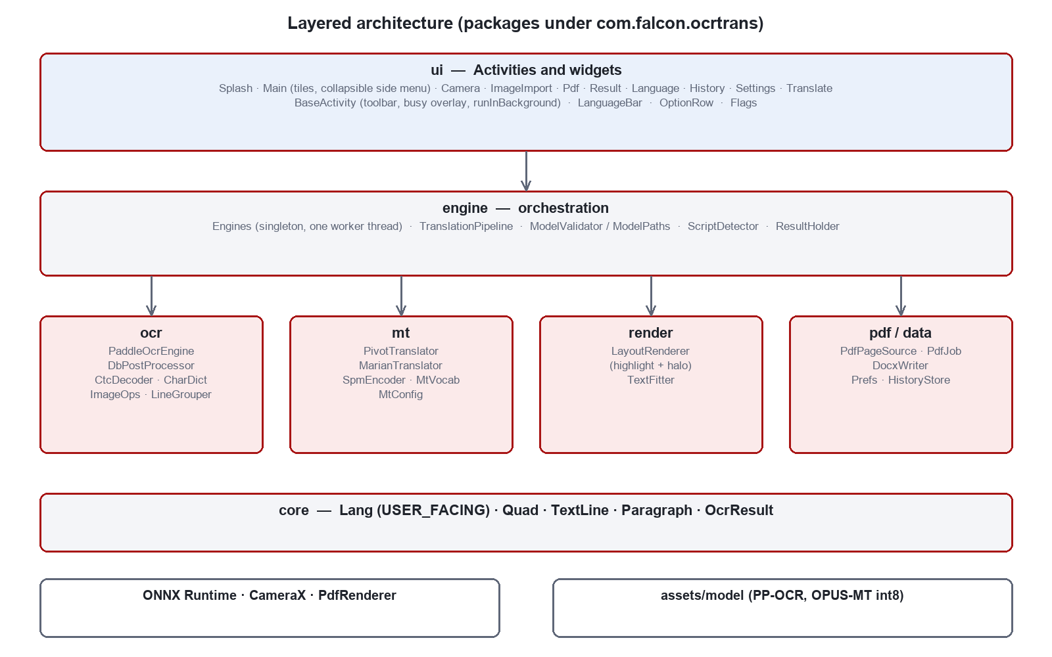
Figure 1. Layered architecture
Dependencies point downward only. The ui layer never calls a model directly; it submits work to engine, which owns the engines and the worker thread. core holds plain value types shared by all layers.
Table 2. Package responsibilities
Package | Responsibility | Key types
core | Value types shared by every stage | Lang, Quad, TextLine, Paragraph, OcrResult
ocr | Detection, cropping, orientation, recognition, grouping | PaddleOcrEngine, DbPostProcessor, CtcDecoder, CharDict, ImageOps, LineGrouper
mt | Tokenisation and translation | SpmEncoder, MtVocab, MtConfig, MarianTranslator, PivotTranslator
render | Re-rendering translated text | LayoutRenderer, TextFitter
pdf | Rasterisation and document output | PdfPageSource, PdfJob, DocxWriter
engine | Lifetime, threading, validation, orchestration | Engines, TranslationPipeline, ModelValidator, ModelPaths, ScriptDetector, ResultHolder
data | Settings and history | Prefs, HistoryStore, HistoryItem
ui | Activities and widgets | MainActivity and nine other activities, LanguageBar, OptionRow, Flags
util | Asset and image I/O | Assets, ImageLoader

2.2 Process and threading view
- Main thread: all views, animations (side menu), dialogs and toasts.
- falcon-engine: a single-thread executor owned by Engines, priority NORM_PRIORITY - 1. Every inference call, model validation, file save and database access runs here, serialised, because the ONNX sessions are not thread-safe.
- BaseActivity.runInBackground submits work and posts the outcome back through a main-thread Handler, only if the activity is still alive (not finishing or destroyed).
- ONNX sessions use min(4, cores - 1) intra-op threads with ALL_OPT graph optimisation.
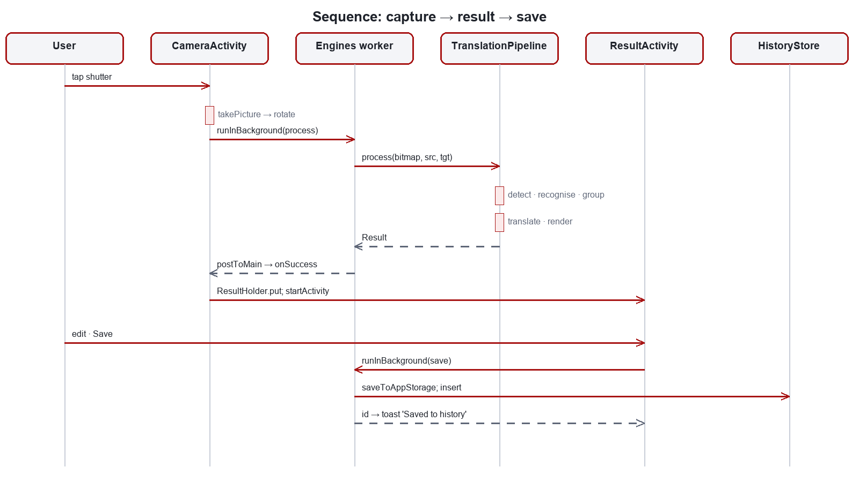
Figure 2. Sequence for capture, result and save

2.3 Data flow per page
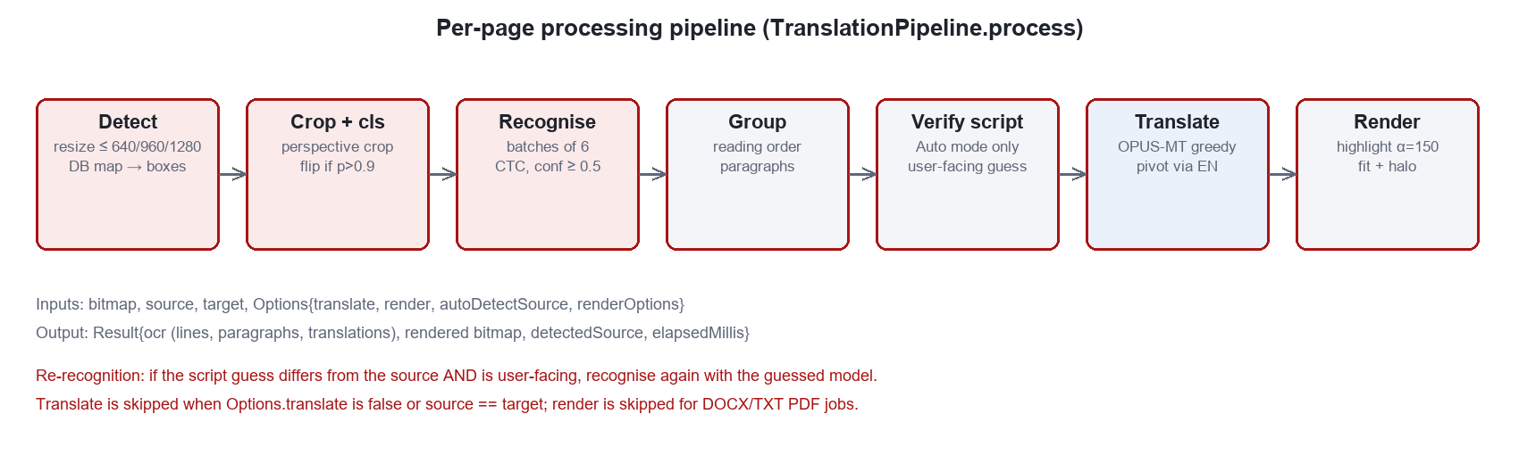
Figure 3. Per-page processing pipeline

3. Detailed Component Design

3.1 Engines (engine)
Process-wide singleton. Lazily creates PaddleOcrEngine and PivotTranslator(MarianTranslator). ocr() re-applies the Image Quality detection limit on every access, so a settings change takes effect on the next scan. models() caches the ModelValidator report. releaseEngines() closes native sessions while keeping the worker.

3.2 Text detection (PaddleOcrEngine, DbPostProcessor)
Table 3. Detection design
Step | Design | Parameters
Resize | Scale so the long edge is at most the limit; round sides to multiples of 32 | LOW 640 / MEDIUM 960 / HIGH 1280; clamp 320-2048
Normalise | NCHW float, ImageNet mean/std, RGB | -
Binarise | P >= threshold | 0.3
Components | Iterative 8-connected flood fill (explicit stack) | min area 12 px
Score | Mean probability over the component's own pixels | >= 0.6
Outline | Leftmost and rightmost pixel per row (exact for the hull) | -
Hull + rectangle | Monotone chain; rotating calipers over hull edges | -
Unclip | Grow half-extents by d = w·h·r / (2(w + h)) | r = 1.6; min side 3 px
Output | Ordered quad (clockwise from top-left), scaled, clamped | max 1000 candidates

3.3 Recognition
- Crop by 4-point perspective map (Matrix.setPolyToPoly); fallback to axis-aligned bounds.
- Optional 180° classifier (48×192); flip only if p(rotated) > 0.9.
- Height 48; crops sorted by aspect ratio; batches of 6; width padded to a multiple of 8 within [16, 1200].
- Normalisation to [-1, 1] (differs from detection).
- Dictionary size checked against the graph's class count; greedy CTC; drop lines with confidence < 0.5.
- Ink/paper colour: luminance midpoint split, minority side = ink.

3.4 Layout analysis (LineGrouper)
Table 4. Paragraph grouping rules
Rule | Threshold
Same row if centre distance < | 0.6 × smaller height
Height ratio of neighbours | <= 1.7
Angle difference | <= 8°
Vertical gap | <= 1.6 × larger height
Next line's centre above previous | starts a new paragraph (column)
Horizontal overlap / narrower width | >= 0.25

3.5 Source verification (ScriptDetector)
Counts Hangul, Kana, Han and Latin letters in the first pass's text. Hangul > 8 % -> Korean; Kana > 8 % -> Japanese; Han >= Latin -> Chinese; any Latin -> English; else the configured source. TranslationPipeline discards a guess that is not user-facing (Section 5), and re-runs recognition only when the guess differs from the configured source. Because the test reads the first pass's output, it can only notice scripts the first-pass model can emit (KI-02).

3.6 Translation (mt)
Table 5. Translation design
Aspect | Design
Tokeniser | SentencePiece unigram as a piece/log-prob TSV; exact Viterbi; unknown character -10
Encoder | Once per chunk; input_ids + attention_mask; names resolved from the graph
Decoder | Greedy, cacheless (use_cache=False): n tokens cost n(n+1)/2 decoder positions
Length limit | min(config.maxLength, max(16, 3·source + 8))
Chunking | Source > 192 tokens split at . ! ? 。 ！ ？ … or newline; an overlong sentence kept whole
Residency | One directed pair loaded at a time (about 35 MB each)
Pivot | PivotTranslator: direct model if installed, else src -> en -> tgt, each leg as a page batch
Line split | Paragraph translation split across lines by source length, preferring spaces

3.7 Re-rendering (LayoutRenderer, TextFitter)
Rendering produces a new bitmap and never modifies the source. It works on blocks (a paragraph, or a line in per-line mode) and runs two passes: all highlights, then all text, so no highlight can fade text already drawn. Blocks without a translation are skipped, leaving the original untouched.
Table 6. Rendering design
Element | Design | Default
Highlight area | Union of source quads (grown 6 %) and the layout rectangle rotated to the block angle; unioned before filling so overlaps do not darken | -
Highlight fill | Sampled paper colour, translucent, rounded corners, feathered edge | alpha 150/255; radius 0.18 h; blur 0.06 h
Effect on the page | Original text and paper texture keep (1 - alpha) of their contrast (about 41 %) | -
Size fitting | Largest size in [0.45 p, 1.15 p] whose layout fits; bisection to 0.25 px; clip and flag overflow | p = 0.82 × line height
Rotation | Canvas rotated about the target centre; median line angle; < 0.75° treated as upright | -
Halo | Same layout stroked in paper colour, then filled in ink colour | width 0.16 × text size
Options | highlightAlpha, halo, perLine, debugBoxes | 150, true, false, false

Design change. The earlier design filled each line with an opaque paper colour, which gave translated text a solid background and left flat patches over photographs. Setting highlightAlpha = 255 reproduces it.

3.8 PDF processing (pdf)
- PdfPageSource rasterises at 200 dpi (PdfRenderer needs a seekable descriptor; persistable read permission is taken).
- PdfJob processes the range one page at a time; rendering is enabled only for PDF output.
- PDF output draws each rendered page into PdfDocument scaled back to points (physical size kept).
- DOCX via DocxWriter (minimal OOXML, escaping tested); TXT as UTF-8 with blank lines between pages.
- Cancellation polled between pages; output in filesDir/exports; a PDF history entry is written.

3.9 Persistence (data)
Prefs wraps SharedPreferences (source_lang, target_lang, ocr_auto_detect, image_quality, auto_translate, pdf_output_format). HistoryStore wraps an SQLite table 'history' indexed by created_at DESC; schema upgrades drop and recreate because history is a cache. Pages are saved as JPEG (quality 90) under filesDir/pages.

4. User Interface Design

4.1 Screen architecture
One activity per screen. BaseActivity supplies the toolbar, the busy overlay and runInBackground. ProcessingActivity holds the shared 'image -> pipeline -> result' flow for CameraActivity and ImageImportActivity. ResultHolder passes large bitmaps to ResultActivity without serialising them (peek on recreation, clear on finish).

4.2 Screen-relative sizing
All control sizes come from dimension tokens. values/dimens.xml holds phone values and values-sw600dp/dimens.xml tablet values, so every control grows with the screen class. On Home the column is match_parent inside a ScrollView with fillViewport, and the two tile rows have weight 1, so the tiles share whatever height is left; on short screens their minimum height wins and the column scrolls.
Table 7. Dimension tokens
Token | Phone | Tablet (sw600dp) | Used by
button_height / button_text | 60 dp / 18 sp | 72 dp / 22 sp | Primary, tonal, outlined buttons
icon_button | 56 dp | 64 dp | Toolbar and camera buttons, menu toggle
icon_button_small | 48 dp | 56 dp | Copy, clear, swap
shutter_size | 88 dp | 108 dp | Camera shutter
row_min_height | 64 dp | 76 dp | Settings and option rows
tile_min_height / tile_icon / tile_title | 140 dp / 44 dp / 20 sp | 200 dp / 64 dp / 28 sp | Home tiles
toolbar_height | 64 dp | 72 dp | Toolbars
nav_rail_width / nav_rail_expanded_width | 80 / 208 dp | 104 / 280 dp | Side menu
nav_item_height / nav_icon / nav_label | 64 dp / 30 dp / 16 sp | 80 dp / 38 dp / 20 sp | Side-menu items

4.3 Collapsible side menu
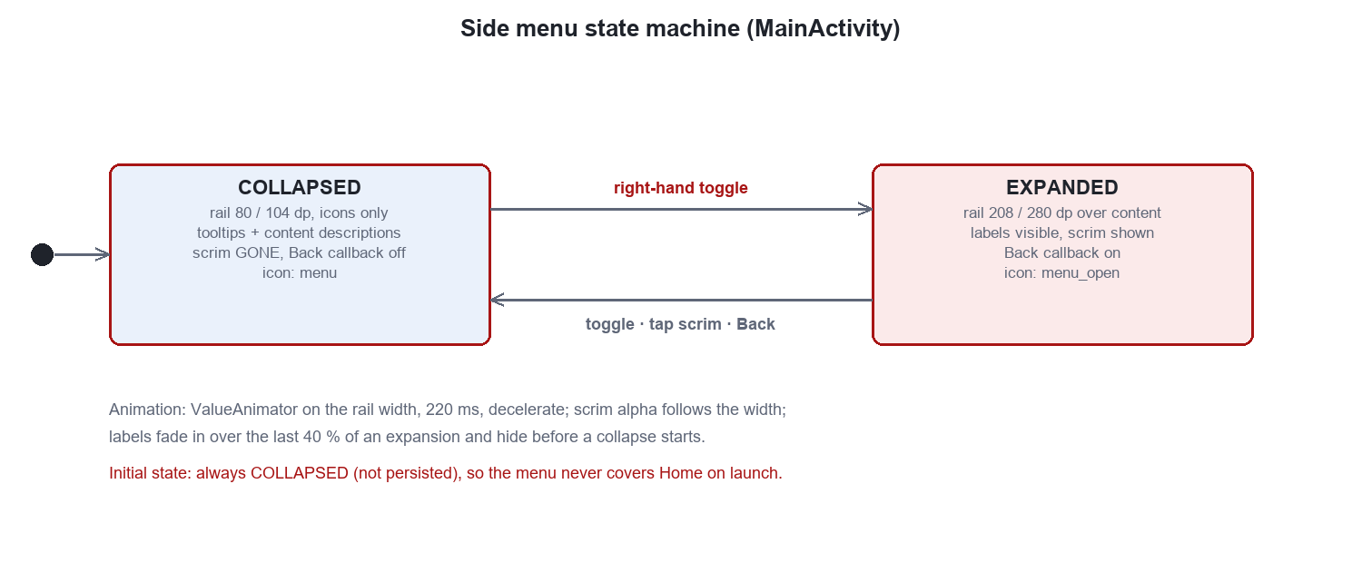
Figure 4. Side-menu state machine
- Layout: the content ScrollView has marginStart = nav_rail_width, so the collapsed rail never covers it; the scrim and the rail are later children of the same FrameLayout, the rail with 8 dp elevation.
- Toggle: the right-hand title-bar ImageButton main_nav_toggle; its icon and content description switch between 'menu / Expand menu' and 'menu open / Collapse menu'.
- Expanded: the rail animates over the content; the scrim fades in with the width; labels fade in over the last 40 % of the animation.
- Collapse: toggle, tap on the scrim, or Back (an OnBackPressedCallback enabled only while expanded).
- Accessibility: every item carries its label as content description; collapsed items also carry a tooltip.
- Why overlay: expanding by pushing would leave about 50 dp for each tile on a 360 dp phone, contradicting FR-22.

5. Language Gating Design (Korean)
Lang keeps KO in the enum so code, tests, stored data and model paths still resolve. A private array Lang.USER_FACING lists the languages the interface may show, with the Korean line commented out. Every user-visible path reads that list:
Table 8. Gating sites
Site | Mechanism
LanguageActivity.rebuild | Iterates Lang.userFacing(); search cannot reach Korean
Prefs.sourceLang / targetLang | Lang.userFacingOr(stored, default): a stored 'ko' falls back
TranslationPipeline.process | A detector guess that is not user-facing is replaced by the configured source
ModelValidator.validate | Checks and reports user-facing languages and pairs only
SettingsActivity | Pivoted-pair report over user-facing languages; help text names Japanese and Chinese only

To enable Korean, uncomment KO in Lang.USER_FACING, restore 'Korean' in the help text and update LangTest.

6. Error Handling and Security
Table 9. Error handling
Situation | Handling
Model file missing | ModelValidator names it; Splash continues; Home shows a warning linking to Settings; engine exceptions name the asset and the fetch script
Camera permission denied | Toast with rationale; activity finishes
Camera unavailable / bind failure | Toast 'Camera unavailable'; activity finishes
Image cannot be decoded | Toast with message
Inference or I/O exception on the worker | Delivered to Callback.onError on the main thread; toast; overlay hidden
Activity destroyed before result | Result dropped (checked in runInBackground)
PDF provider without persistable permission | Falls back to the session grant

- No INTERNET permission; no analytics; no third-party SDK that transmits data.
- Files only in app-private storage; history can be cleared by the user.
- PDF URIs opened read-only.

7. Deployment and Build
Table 10. Build and deployment
Item | Value
Build | Gradle 8.13; minSdk 24; compileSdk 35; Java
Models | tools/fetch_models.sh -> convert_ocr.py (paddle2onnx, opset 14, fix_onnx_concat.py) and convert_mt.py (Optimum export, dynamic int8, per channel)
Model tree | about 230 MB: ocr/det, ocr/cls, ocr/rec/{english,korean,japan,chinese}, mt/{en-ko,ko-en,en-ja,ja-en,en-zh,zh-en}
APK | about 78 MB without models, 255 MB with; Play requires an install-time asset pack
Tests | ./gradlew test — 50 JVM unit tests

8. Design Decisions
Table 11. Design decisions
# | Decision | Alternatives | Rationale
D1 | ONNX Runtime in Java | Paddle Lite + C++/OpenCV | No NDK layer; one language; same weights
D2 | Reimplement DB post-processing | OpenCV + Clipper | Removes native dependencies; rectangle unclip is closed-form
D3 | Pivot through English | Omit CJK pairs; ship a large multilingual model | Only English-centric OPUS-MT pairs exist; size budget
D4 | Cacheless greedy decoder | KV-cached decoder; beam search | Simpler wiring; inputs are short; revisit for long documents
D5 | Translucent highlight + halo | Opaque erase; inpainting model | Keeps page texture; no extra model; legibility from halo
D6 | Korean hidden via USER_FACING | Delete Korean code; build flavour | Keeps the implementation; one-line re-enable; tests stay valid
D7 | Overlay side menu, always starts collapsed | Push layout; persist state | Tiles keep their size on phones; Home is never covered at launch
D8 | Dimension tokens + sw600dp | Runtime computation of sizes | Declarative, previewable, standard Android practice

9. Requirements Allocation
Table 12. Requirement to component allocation
Requirement | Components
FR-01 Camera capture | CameraActivity, ImageOps.rotate
FR-02 Single image import | CameraActivity, ImageLoader
FR-03 Batch image import | ImageImportActivity, HistoryStore
FR-04 PDF input and job options | PdfActivity, PdfPageSource
FR-05 Text detection | PaddleOcrEngine.detect, DbPostProcessor
FR-06 Orientation correction | PaddleOcrEngine.classifyAndFlip
FR-07 Text recognition | PaddleOcrEngine.recognizeCrops, CtcDecoder, CharDict
FR-08 Reading order and paragraphs | LineGrouper, Paragraph
FR-09 Source script auto-detection | ScriptDetector, TranslationPipeline
FR-10 Translation | MarianTranslator, PivotTranslator, SpmEncoder
FR-11 Layout-preserving re-rendering | LayoutRenderer, TextFitter
FR-12 Result presentation | ResultActivity, ResultHolder
FR-13 Speech output | ResultActivity.initTts
FR-14 Save to history | HistoryStore, ImageLoader.saveToAppStorage
FR-15 History management | HistoryActivity, HistoryStore
FR-16 Manual text translation | TranslateActivity
FR-17 Language selection | LanguageActivity, LanguageBar, Prefs
FR-18 Settings | SettingsActivity, Prefs, Engines.ocr
FR-19 Model validation | ModelValidator, SplashActivity
FR-20 PDF job execution | PdfJob, DocxWriter, PdfActivity
FR-21 Korean withheld from the interface | Lang, Prefs, TranslationPipeline, ModelValidator
FR-22 Large, screen-relative controls | dimens.xml, values-sw600dp/dimens.xml, themes.xml
FR-23 Collapsible side menu | MainActivity.bindNavToggle, activity_main.xml, item_nav.xml
FR-24 Recognition without translation | TranslationPipeline.Options.translate

10. Known Issues
Table 13. Known issues
ID | Area | Description | Handling
KI-01 | Rendering | A translucent highlight attenuates but does not remove the original text; a high-contrast original behind a much shorter translation remains faintly visible outside the halo. | By design; inpainting is future work.
KI-02 | Auto-detection | Script detection runs on the first pass's output, so it can only notice scripts the first-pass model can emit. With English as the source, CJK pages are never re-detected. | Choose the source language; future: run detection on a multi-script first pass.
KI-03 | Language gating | History rows saved before Korean was hidden still display 'KO -> ..' in their direction label. | Cosmetic; affects only pre-existing data.
KI-04 | Batch import | Only the last image of a batch opens in the result screen; the others are in History. | By design.
KI-05 | PDF range | Page ranges are limited to All, 1-5, 1-10, 1-20. | Enhancement candidate.
KI-06 | Build verification | The UI changes (large controls, collapsible menu) and the rendering change have not yet been compiled or run on a device in this revision. | Run ./gradlew test assembleDebug and the System tests.

