Help Document

Recipe Search

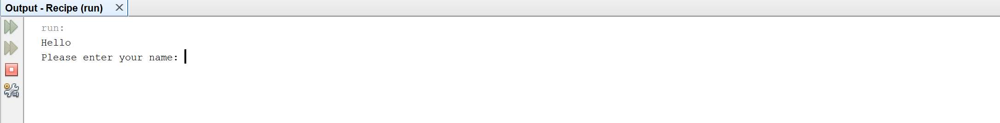

The first part of the program will be the entering of the user’s name. The name can be in any case and can have spaces.

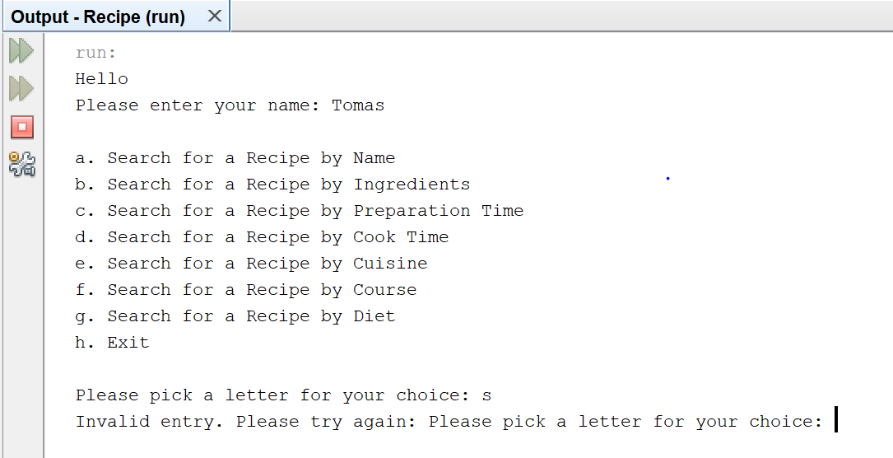

The second part of the program is choosing what the user wants to search. The user must choose a letter or there will be an error message

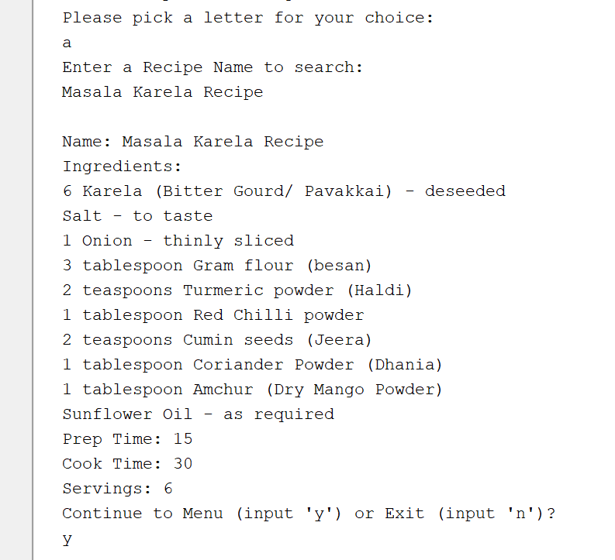

When choosing the first option the user will input a recipe name. This is not case sensitive. If found the recipe will be printed out with certain key items from the spreadsheet. At the end of the information the program will ask the user if it should return to the main menu. The user needs to input the letter y or n.

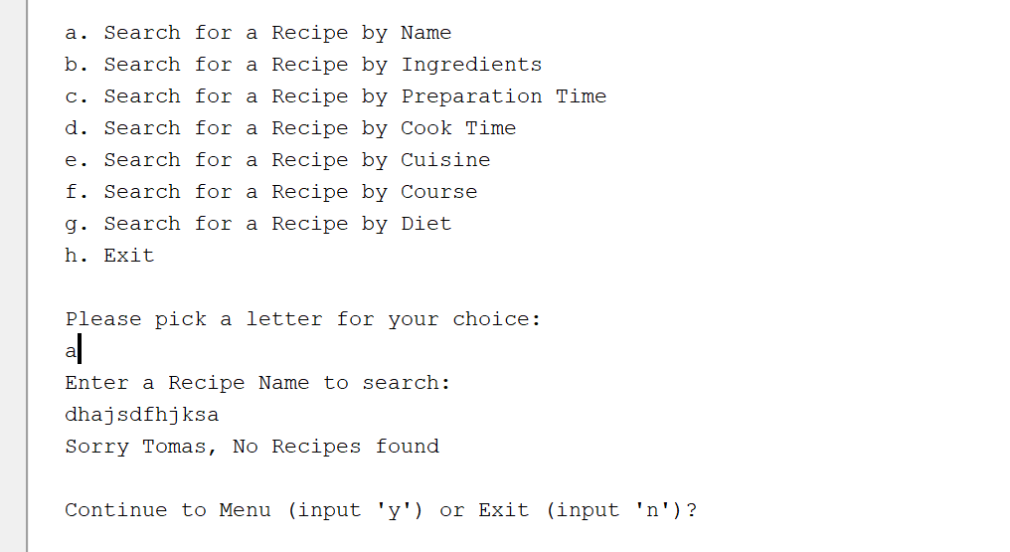

If the program does not find the recipe by the search parameters, then the program will input the message not found. Again, the program will ask the user if they wish to return to the main menu.

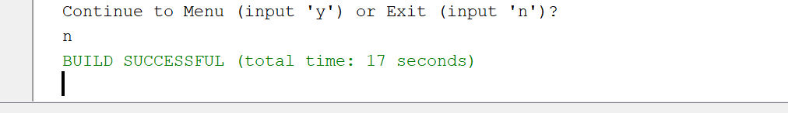

The user can choose input of n to exit the program or return to the main menu and choose option h to exit.

The user can choose other options to search the recipe sheet. All searches will be non-case sensitive. The user will have the option to return to the menu after every search. The program will return an error statement if not found or the user inputs and incorrect item.