**Changes to Brain Network Functional Connectivity During Learning**

**MA 703 – Project Proposal**

Thomas Morin, Graduate Program for Neuroscience, Boston University

**Problem Statement**

The goal of this project is to use functional magnetic resonance imaging (fMRI) to examine how the functional network architecture of the human brain evolves during learning. Previously, researchers in our lab conducted an fMRI experiment in which thirty naïve subjects were asked to learn a novel associative memory task (identifying which pairs of images “go-together”) over the course of an hour while they were in the scanner. This task differs from the majority of previous research on learning because the learning occurs while the subject is in the scanner (rather than scanning pre- and post-learning). Notably, subjects were given very little instruction about the task they were about to complete, and had to develop their own unique strategy for approaching the problem. As expected, subject performance on this task varied considerably, with some subjects achieving ceiling-levels of accuracy almost instantly, and others struggling to learn anything during the full hour.

Previous research shows that functional connectivity between brain regions can shift depending on the task at hand. In other words, the correlation in blood oxygenation level dependent (BOLD) signal between regions can increase or decrease as the subject forms internal mental models and tests them against the information available out in the world. Throughout learning, brain regions may change their network “allegiance” as the subject implements different strategies, only settling into a steady state once the subject has learned the necessary rules that govern the memory task. Presumably, the degree of switching (flexibility) should vary for different brain regions. For example, we would expect regions of the frontoparietal control network (a system important for integrating information and managing energy use by other brain regions) to be more flexible during learning than the visual system, which strictly processes visual information during all stages of learning. For this project, we will examine how functional connectivity between brain regions during learning. We predict that heteromodal systems such as the frontoparietal control network, default mode network, and dorsal/ventral attention networks will exhibit greater flexibility early in learning than unimodal sensory systems such as the visual and somatomotor networks. Additionally, we predict that subjects who learn the associative memory task quickly will show a lesser degree of brain-region flexibility, since they will have settled on a strategy (and into a steady state) early-on in the scan. Conversely, we predict that subjects who failed to learn the task will show a higher degree to brain region flexibility as they continually search the problem space over the course of the scan.

**Characterization of Network Context**

Cortex can be divided into functional regions using resting state fMRI scans. For this project, we will use a standardized functional parcellation to define 400 nodes in each subject (see Figure 1a). A unique network graph of each subject can be created by drawing edges between functionally connected nodes (see Figure 1b). Nodes are considered to be functionally connected if their BOLD signal time courses are highly correlated. Each of the nodes the parcellation shown in Figure 1 have been colored according to an a priori community assignment based on a study that incorporated resting state fMRI scans from 1000 participants (Schaefer et al., 2018; Yeo et al., 2011).

While the community assignments in the network in Figure 1 have been assigned a priori, several methods exist to assign each node to one of the seven communities based on a subject’s unique connectivity pattern (Hacker et al., 2013; Wang et al., 2015). Using the a priori community assignments as a starting point, the connectivity patterns in an individual subject can be used to iteratively reassign nodes to a new community (similar to a k-means approach). This process repeats until the community assignments converge, resulting in a unique set of community assignments for each subject.

**A. B.**

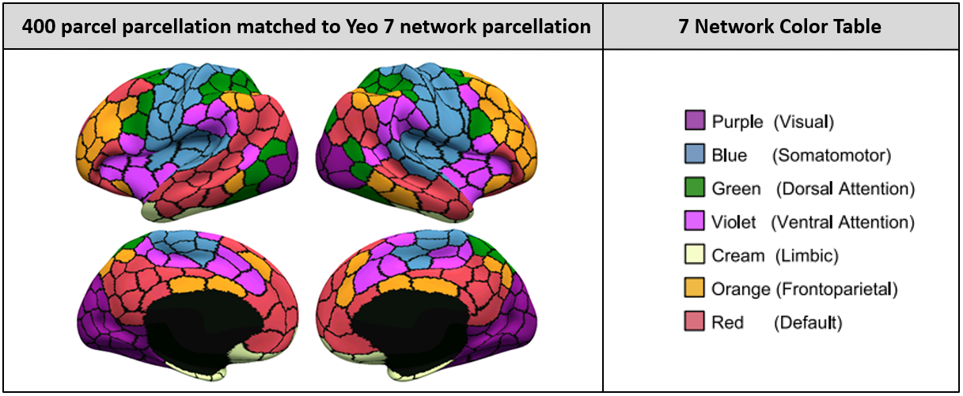****

**Figure 1: (A)** Inflated representation of cortex divided into 400 regions, each assigned to a Yeo-community (adapted from Schaeffer, et al. 2018). **(B)** Network graph of the connectivity between regions in a single subject. Each brain region from (A) is represented by a vertex. Edges represent functional connectivity between regions.

**Proposed Approach**

To examine how brain regions flexibly change their community allegiance while subjects learn the associative memory task, we will construct a dynamic network. Each subject’s scan will be divided into nine 6-minute time-blocks. A full-brain connectivity network will be generated for each time block. For each subject at each time-block, nodes of the network will each be assigned to one of the seven communities according to the algorithm outlined by Wang et al. (2015).

We will examine the flexibility of each brain region by calculating how many times its allegiance switches throughout the scan. We will compare flexibility of nodes in subjects who learned the task relatively quickly with subjects who did not successfully learn the task to see if flexibility is related to learning speed. We will also examine the flexibility of particular networks, and the characteristic transition patterns that nodes tend to take (i.e. do frontoparietal nodes mostly switch over to default mode nodes, etc.). Finally, we will examine how assortativity of each community and betweenness centrality of each node change throughout the scan. We predict that the most flexible communities will also have the lowest assortativity and that the most flexible nodes will have the highest betweenness centrality. Felxible nodes presumably have more connections outside of their communities and integrate information from many different brain regions. As the subjects learn the task and the network reaches a steady state, assortativity of these nodes is expected to increase and betweenness centrality is expected to decrease. When calculating assortativity and betweenness centrality, we will be cautious of comparing these statistics across the different time points, given that topological properties can be influenced by differing number of edges (Ginestet, Fournel, & Simmons, 2014). We will consult Ginestet, Fornell, & Simmons’s 2014 paper for the proper construction of a summary network for evaluating learning-related trends in changing assortativity and betweenness centrality.

**Works Cited**

Ginestet, C. E., Fournel, A. P., & Simmons, A. (2014). Statistical network analysis for functional MRI: summary networks and group comparisons. *Frontiers in Computational Neuroscience*, *8*, 51. https://doi.org/10.3389/fncom.2014.00051

Hacker, C. D., Laumann, T. O., Szrama, N. P., Baldassarre, A., Snyder, A. Z., Leuthardt, E. C., & Corbetta, M. (2013). Resting state network estimation in individual subjects. *NeuroImage*, *82*, 616–633. https://doi.org/10.1016/J.NEUROIMAGE.2013.05.108

Schaefer, A., Kong, R., Gordon, E. M., Laumann, T. O., Zuo, X.-N., Holmes, A. J., … Yeo, B. T. T. (2018). Local-Global Parcellation of the Human Cerebral Cortex from Intrinsic Functional Connectivity MRI. *Cerebral Cortex*, *28*(9), 3095–3114. https://doi.org/10.1093/cercor/bhx179

Wang, D., Buckner, R. L., Fox, M. D., Holt, D. J., Holmes, A. J., Stoecklein, S., … Liu, H. (2015). Parcellating cortical functional networks in individuals. *Nature Neuroscience*, *18*(12), 1853–1860. https://doi.org/10.1038/nn.4164

Yeo, B. T. T., Krienen, F. M., Sepulcre, J., Sabuncu, M. R., Lashkari, D., Hollinshead, M., … Buckner, R. L. (2011). The organization of the human cerebral cortex estimated by intrinsic functional connectivity. *Journal of Neurophysiology*, *106*(3), 1125–1165. https://doi.org/10.1152/jn.00338.2011