Physics 131 Equations – Chapters 11-15

Chapter 11: Rotational Dynamics and Static Equilibrium

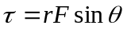 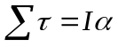 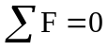 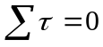 or 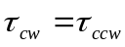 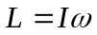

Chapter 12: Gravity 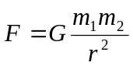

Chapter 13: Oscillations about Equilibrium
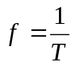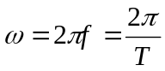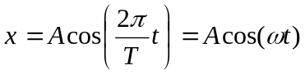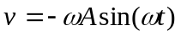
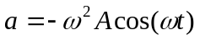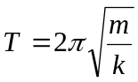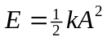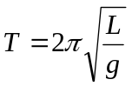
Chapter 14: Waves and Sound
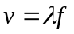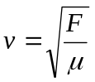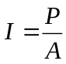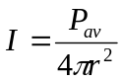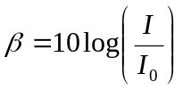
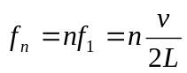 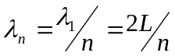 n = 1, 2, 3, …
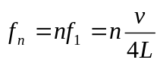 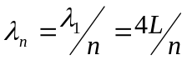 n = 1, 3, 5, …

Chapter 15: Fluids (atmospheric pressure = 1.01 x 10⁵ N/m²)
