Physics 131 Equations chapters 2-5

Chapter 2: One-Dimensional Kinematics

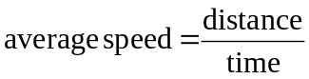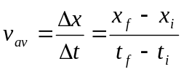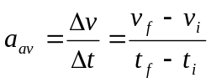

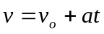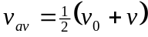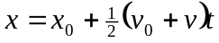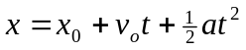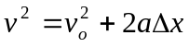

Chapter 3: Vectors in Physics

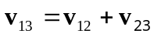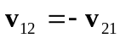

Chapter 4: Two-Dimensional Kinematics

basic equations of projectile motion:
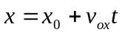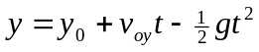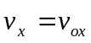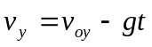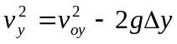

Chapter 5: Newton’s Laws of Motion

