# Overview

In this assignment, we will be using NEURON-Python to simulate the activity of a network of neurons across the subthalamic nucleus (STN) and the Globus Pallidus pars externa (GPe). In this project, we simulated 3 STN and 3 GPe neurons. The STN neurons provide excitatory input to GPe and GPe provides inhibitory feedback to the STN. Each of these connections have a weight which signifies how active the postsynaptic cell will be after receiving the stimulation.

**Figure 1.** Connectivity between STN and GPe. The dendritic synaptic strenght for the incoming connection is signified by the h.NetCon.weight[0] variable in neuron. We will signify the value for STN neurons as stn_con_wt and for GPe as gpe_con_wt.

In this report, we varied the connection weights. We tried a grid of 10, 15, and 20 for each of the GPe and STN synaptic strengths. We opened a random seed on 10 (random.seed(10)), so that experiment repeats are comparable in the smaller sample size. This disclaimer should apply to the analysis here, that the *n* is very small and making a statement comes at the significant risk of over-generalization.

The code for this trial can be accessed on <https://github.com/tmorshed/jpb-1071/>. The file executing the simulation can be accessed at [this link](https://github.com/tmorshed/jpb-1071/blob/main/example/example.py).

## Observation 1:

If we increases the GPe connection strength while keeping the STN connection strength constant, we will see an increase in the firing rate in the GPe neurons. They visibly seem to fire more often. This is expected, as the incoming connection to the GPe from the STN is excitatory (reversal potential = 0 mV).

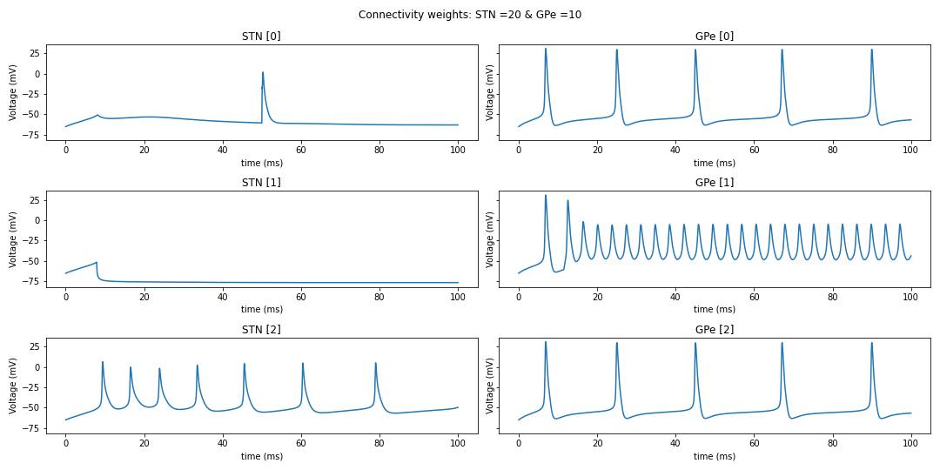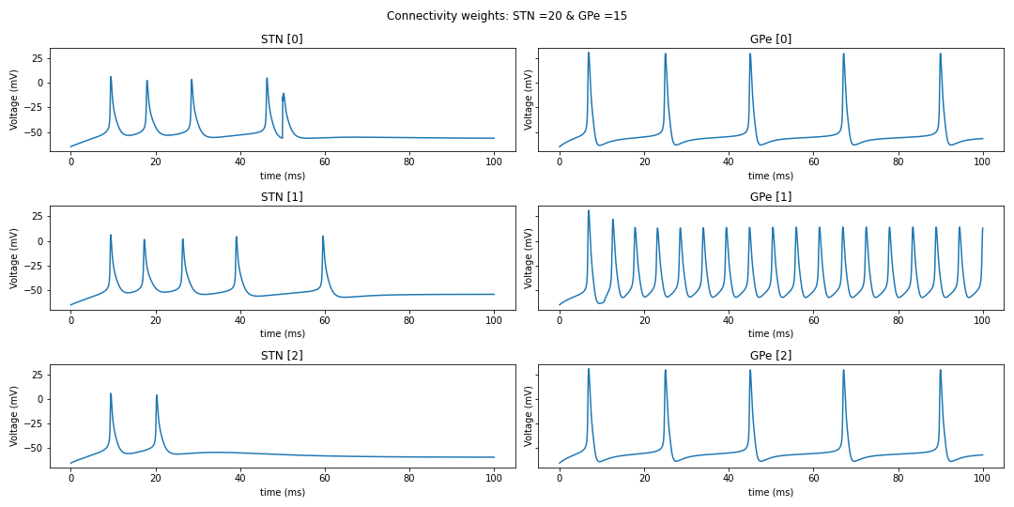

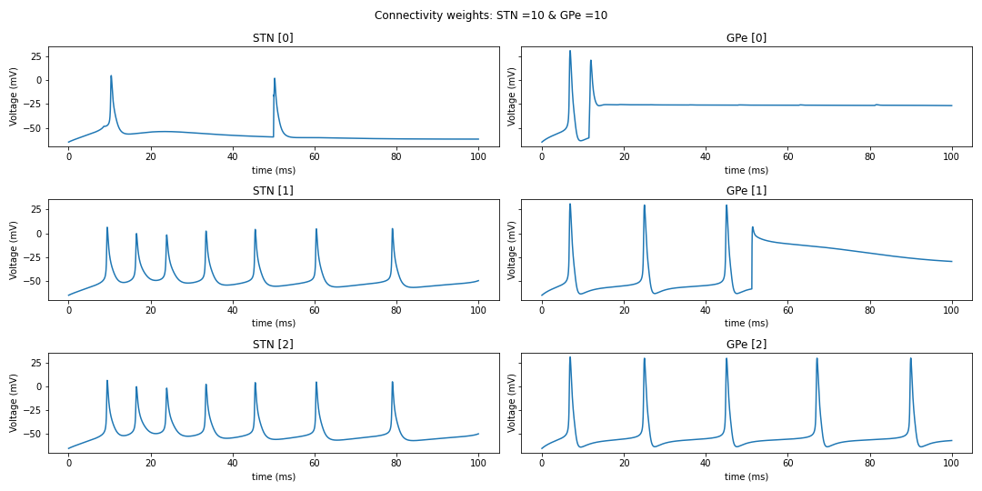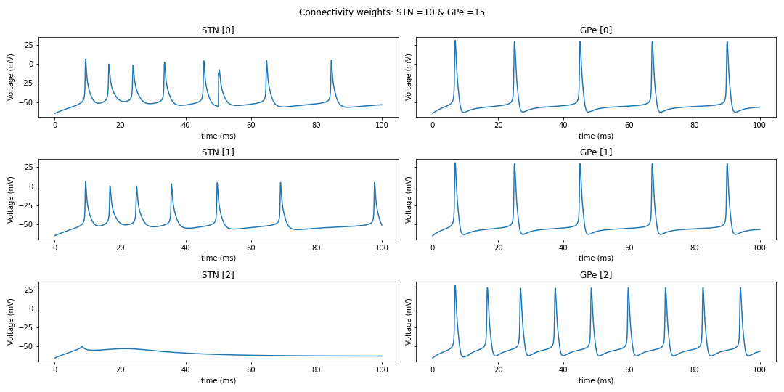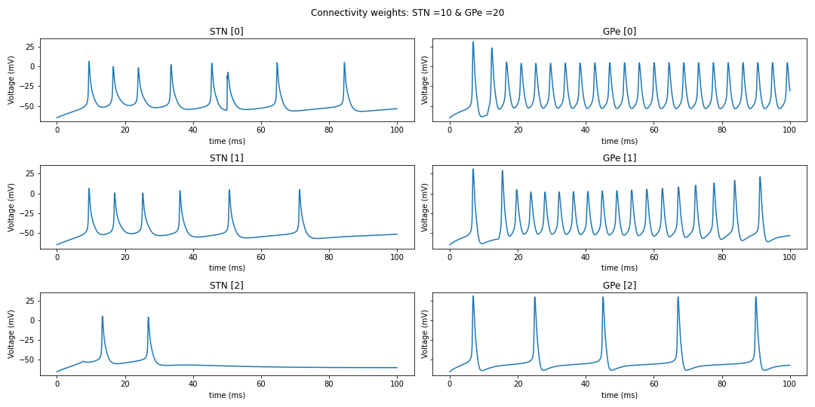

## Observation 2:

If we increases the STN connection strength while keeping the GPe connection strength constant, we will see an decrease in the firing rate in the GPe neurons. This is expected, as the incoming connection to the STN from the GPe is inhibitory (reversal potential = -85 mV).

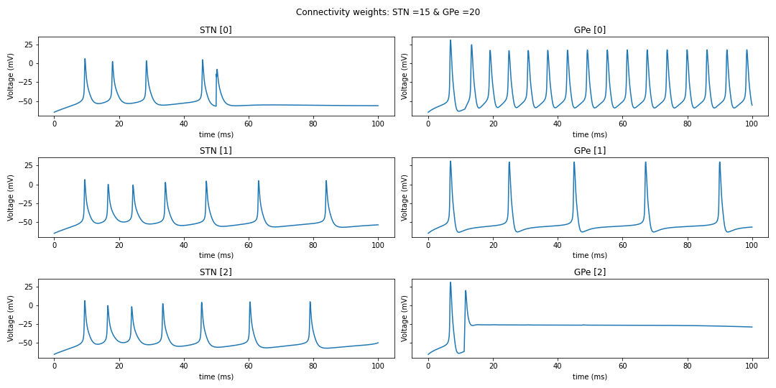

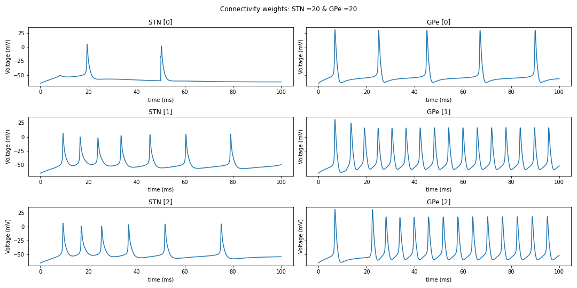

# All observations: