DBS501 Lab2 due on Tuesday, October 05th by 9pm
Just E-mail submission with Subject like : 502-Lab1 by Smith, John
You need to provide BOTH --- Code and Output

1) Write the PL/SQL code that may be used as a temperature system converter -- you will enter firstly your current (input) scale as C or F and then the value to be converted. The output value should be rounded to only one decimal. Use IF .. THEN logic. Here are the outputs:

Top of Form
Enter your input scale (C or F) for temperature: |  | 

Top of Form
Enter your temperature value to be converted: |  | 

This is NOT a valid scale. Must be C or F.
PL/SQL procedure successfully completed.This is NOT a valid scale. Must be C or F.
PL/SQL procedure successfully completed.This is NOT a valid scale. Must be C or F.
PL/SQL procedure successfully completed.This is NOT a valid scale. Must be C or F.
PL/SQL procedure successfully completed.Bottom of Form
This is NOT a valid scale. Must be C or F.
PL/SQL procedure successfully completed.
Top of Form
Enter your input scale (C or F) for temperature: |  | 

Top of Form
Enter your temperature value to be converted:

Your converted temperature in F is exactly 86
PL/SQL procedure successfully completed.Bottom of Form
Bottom of Form
Your converted temperature in F is exactly 86
PL/SQL procedure successfully completed.
Enter your input scale (C or F) for temperature: |  | 

Top of Form
Enter your temperature value to be converted: |  | 

Your converted temperature in C is exactly -31.7
PL/SQL procedure successfully completed.

ANSWER Q1:
SET SERVEROUTPUT ON
SET VERIFY OFF

ACCEPT t_scale PROMPT 'Enter your input scale (C or F) for temperature: '
ACCEPT t_temp PROMPT 'Enter your temperature value to be converted: '
DECLARE
v_scale CHAR := UPPER('&t_scale');
v_temp NUMBER := '&t_temp';
BEGIN
IF v_scale = 'C' THEN
v_temp := (v_temp * 9/5) + 32;
DBMS_OUTPUT.PUT_LINE('Your converted temperature in F is exactly ' || ROUND(v_temp, 1) );
ELSIF v_scale = 'F' THEN
v_temp := (v_temp - 32) * 5/9;
DBMS_OUTPUT.PUT_LINE('Your converted temperature in C is exactly ' || ROUND(v_temp, 1) );
ELSE
DBMS_OUTPUT.PUT_LINE('This is NOT a valid scale. Must be C or F.');
END IF;
END;
/

OUTPUT:

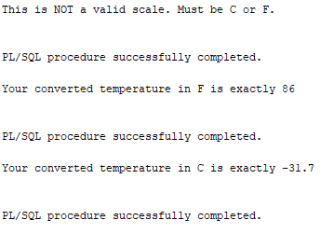

2) Write a PL/SQL block that will ask for Instructor’s Id and then will figure out how many sections does teach that person. It will display then an appropriate message based on that number. Use CASE .. WHEN logic. Here are the possible outputs:
Top of Form
Please enter the Instructor Id: |  | 
Top of Form
This is not a valid instructor
Top of Form
Please enter the Instructor Id: |  | 
Top of Form
Instructor, Tom Wojick, teaches 10 section(s)
This instructor needs to rest in the next term.
PL/SQL procedure successfully completed.
Top of Form
Please enter the Instructor Id: |  | 
Top of Form

Instructor, Fernand Hanks, teaches 9 section(s)
This instructor teaches enough sections.
PL/SQL procedure successfully completed.

Top of Form
Please enter the Instructor Id: |  | 
Top of Form
Instructor, Rick Chow, teaches 0 section(s)
This instructor may teach more sections.
PL/SQL procedure successfully completed.

ANSWER Q2:
SET SERVEROUTPUT ON
SET VERIFY OFF

ACCEPT ins_id PROMPT 'Please enter the Instructor Id: '
DECLARE
v_id section.instructor_id%TYPE := '&ins_id';
v_fname instructor.first_name%TYPE;
v_lname instructor.last_name%TYPE;
v_count NUMBER;
BEGIN

SELECT first_name, last_name
INTO v_fname, v_lname
FROM instructor
WHERE instructor_id = v_id;

SELECT COUNT(*)
INTO v_count
FROM section
WHERE instructor_id = v_id;

DBMS_OUTPUT.PUT_LINE('Instructor, ' || v_fname || ' ' || v_lname || ', teaches ' || v_count || ' section(s)');
CASE
WHEN v_count >= 10 THEN
DBMS_OUTPUT.PUT_LINE('This instructor needs to rest in the next term.');
WHEN v_count > 3 AND v_count < 10 THEN
DBMS_OUTPUT.PUT_LINE('This instructor teaches enough sections.');
WHEN v_count < 3 THEN
DBMS_OUTPUT.PUT_LINE('This instructor may teach more sections. ');
END CASE;

EXCEPTION
WHEN NO_DATA_FOUND THEN
DBMS_OUTPUT.PUT_LINE('This is not a valid instructor');

END;

OUTPUT:
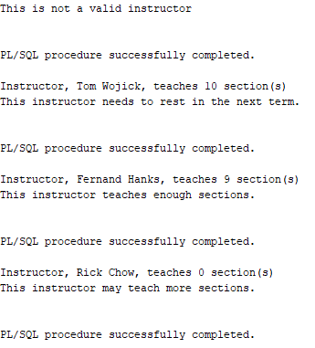
3) Write a PL/SQL block that will ask for a Positive Integer input and then will calculate the sum of all Even ( or Odd) integers between 1 and that value, depending whether the input value is Even or Odd. Use WHILE LOOP control logic. Here are the possible outputs:

Top of Form
Please enter a Positive Integer: |  | 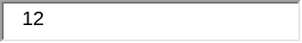
The sum of Even integers between 1 and 12 is 42
PL/SQL procedure successfully completed.
Top of Form
Please enter a Positive Integer: |  | 
The sum of Odd integers between 1 and 901 is 203401
PL/SQL procedure successfully completed.

ANSWER Q3:
SET SERVEROUTPUT ON
SET VERIFY OFF

ACCEPT num PROMPT 'Please enter a Positive Integer: '
DECLARE
v_num NUMBER := '&num';
v_increment NUMBER;
v_sum NUMBER := 0;
v_type VARCHAR(20);
BEGIN
IF v_num > 0 THEN
IF MOD(v_num, 2) = 0 THEN
v_increment := 2;
v_type := 'Even';
ELSE
v_increment := 1;
v_type := 'Odd';
END IF;
WHILE v_increment <= v_num LOOP
v_sum := v_sum + v_increment;
v_increment := v_increment + 2;
END LOOP;
DBMS_OUTPUT.PUT_LINE('The sum of ' || v_type ||' integers between 1 and ' || v_num || ' is ' || v_sum);
ELSE
DBMS_OUTPUT.PUT_LINE('Invalid input, please enter a positive Integer.');
END IF;
END;
/

OUTPUT:
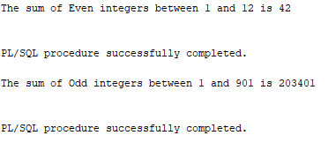

4) Write a PL/SQL block that will ask for department’s Location Id and then will
figure out how many departments exist there and how many employees work on that location. Based on these answers you will construct a Nested For Loop that will display these answers in a numeric format like shown below. The first location 1800 has only one department with 2 employees, while the other location 1400 has 3 departments with 7 employees altogether (after the Update).
Obviously, without an explicit cursor you can NOT show how many employees works in each department. So, this is just an exercise in creating nested loops.
But, firstly you need to relocate departments 40 and 70 to location 1400.
Do NOT commit, you will rollback it when you finish your block.
Top of Form
UPDATE Departments SET location_id = 1400
WHERE department_id IN (40,70) ;
Top of Form
Enter valid Location Id: |  | 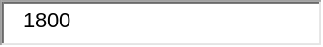
Top of Form

Outer Loop: Department #1
* Inner Loop: Employee #1
* Inner Loop: Employee #2
PL/SQL procedure successfully completed.

Top of Form
Enter valid Location Id: |  | 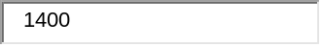
Bottom of Form
Outer Loop: Department #1
* Inner Loop: Employee #1
* Inner Loop: Employee #2
* Inner Loop: Employee #3
* Inner Loop: Employee #4
* Inner Loop: Employee #5
* Inner Loop: Employee #6
* Inner Loop: Employee #7
Outer Loop: Department #2
* Inner Loop: Employee #1
* Inner Loop: Employee #2
* Inner Loop: Employee #3
* Inner Loop: Employee #4
* Inner Loop: Employee #5
* Inner Loop: Employee #6
* Inner Loop: Employee #7
Outer Loop: Department #3
* Inner Loop: Employee #1
* Inner Loop: Employee #2
* Inner Loop: Employee #3
* Inner Loop: Employee #4
* Inner Loop: Employee #5
* Inner Loop: Employee #6
* Inner Loop: Employee #7
PL/SQL procedure successfully completed.
ROLLBACK
Rollback complete.

ANSWER Q4:
SET SERVEROUTPUT ON
SET VERIFY OFF

ACCEPT loc_id PROMPT 'Enter valid Location Id: '
DECLARE
v_locId departments.location_id%TYPE := '&loc_id';
v_dept_count NUMBER := 0;
v_emp_count NUMBER := 0;
BEGIN
SELECT COUNT(*)
INTO v_dept_count
FROM departments
WHERE location_id = v_locId;
IF v_dept_count > 0 THEN
SELECT COUNT(*)
INTO v_emp_count
FROM employees
WHERE department_id IN (
SELECT department_id
FROM departments
WHERE location_id = v_locId
);
IF v_emp_count > 0 THEN
FOR i IN 1..v_dept_count
LOOP
DBMS_OUTPUT.PUT_LINE('Outer Loop: Department #' || i);
FOR n IN 1..v_emp_count
LOOP
DBMS_OUTPUT.PUT_LINE('* Inner Loop: Employee #' || n);
END LOOP;
END LOOP;
ELSE
DBMS_OUTPUT.PUT_LINE('No employees at that location.');
END IF;
ELSE
DBMS_OUTPUT.PUT_LINE('No departments at that location.');
END IF;
EXCEPTION
WHEN NO_DATA_FOUND THEN
DBMS_OUTPUT.PUT_LINE('Invalid location');
END;
/

OUTPUT:

