STANDARD OPERATING PROCEDURE
Rental Vehicle Reduction Process
Sears Home Services | Fleet Operations

Field | Value
Version | 4.0
Effective date | 2026-08-05
Supersedes | v3.0 (2026-07-01)
Document owner | Tyler Morgan, Manager, Business Operations
Audience | Fleet Operations, rental reduction owners, capacity scheduling, Fleet engineering
Next review | 2026-09-05

1. Purpose
This Standard Operating Procedure defines the end-to-end process for reducing rental vehicle usage across the Sears Home Services technician fleet. The objective is to identify, repair, and redeploy company-owned vehicles so technicians come off rental, and to close rentals that are still billing after the technician no longer needs them.
What changed in v4. Since v3 was written, an AI agent (LUCA) took over the repair-shop calling and triage work that used to be done by hand or requested one truck at a time. Several tools named in v3 have stopped running. One team member named throughout v3 has left the company. This version describes the process as it actually runs today, and it states plainly which automation is live and which is not.
⚠ READ SECTION 11 FIRST IF YOU ARE AUTOMATING AGAINST THIS DOCUMENT. Section 11 is the honest status of every automated component named in this SOP. Some are live in production, some are built but not deployed, and some are severed and must not be relied on. Do not assume a tool works because it has a section here.

2. Scope
This SOP applies to all Fleet Operations personnel involved in rental reduction: rental reduction owners, the spare vehicle pipeline team, capacity scheduling, inventory operations, and Fleet engineering. It covers the full lifecycle from a rental appearing on the book through the technician taking delivery and the rental being returned.
Out of scope, covered elsewhere: rental eligibility and denial policy, the technician-facing rental procedure, and vehicle decommissioning beyond the handoff described in Step 8. See the related documents table in Section 12.

3. Roles and Responsibilities
One named owner per responsibility. Where v3 named a team, this version names a person.
Name | Role | Owns
Luca Buccilli | Head of Fleet | Fleet operations leadership and strategic direction for rental reduction. Note: the person Luca Buccilli is distinct from the LUCA agent described in Section 8.
Tyler Morgan | Manager, Business Operations | The LUCA agent and the Fleet agent stack. Rental PO approve and deny decisions in VRM New Rentals. The Enterprise contract implementation. CC'd on every LUCA recovery escalation. Absorbed the Fleet responsibilities previously held by Sean Chen.
Olga Fernandez | Rental Reduction Owner, Region 1 East | End-to-end rental reduction for the 17 states listed in Annex A.3. Works cases from VRM Cases by Region. Receives LUCA escalations for her region.
Oscar Santana | Rental Reduction Owner, Region 2 Central | End-to-end rental reduction for the 17 states listed in Annex A.4.
Sandeep Kalyani | Rental Reduction Owner, Region 3 West | End-to-end rental reduction for the 18 states listed in Annex A.5.
Rob Anderson | Sr Fleet Coordinator | Repair authorization approvals. Shop record corrections on repair POs. Escalation point for stalled repairs and shop changes. Second of only two people who can approve a rental PO.
Jennifer Dyer | Inventory Operations Lead | Offboarding truck movements, new hire truck readiness, physical swaps and inventory counts, final retrieval of decommissioned vehicles, TPMS technician updates.
Melissa Corona | Manager, SHS Inventory Integrity | Inventory integrity through decommission and the inventory merge.
Tim Motard | Sr Manager, Data Architect | Finalizes vehicle transfers across inventory systems after a swap completes. Owns the data pipeline behind the rental feed.
Mandy Riley | Director, Capacity | Owns the scheduling API that rental reduction owners submit pickups to. Escalation point when the API cannot place a slot. She is not a manual step in the routine flow.
Anthia | PMF Coordination | The Park My Fleet vehicle pipeline: vehicles parked with the provider, detailing and prep status, and routing unclaimed spares into PMF.
Sandeep Kalyani / Utsav / Ravi | Spare Vehicle Sourcing | Locating spare and offboarded vehicles, calling offboarded technicians to confirm location and condition, and posting the daily availability list.
LUCA (agent_3201) | Automated repair shop caller | Calls repair shops on the active rental book, classifies each outcome, and escalates to the regional owner. Runs only while clocked in. See Section 8.

⚠ SEAN CHEN HAS DEPARTED. v3 assigned him AI call coordination, fleet analytics, on-demand FleetScrape pulls, the rental extension automation, and all tool requests. Every one of those instructions is void. Do not ping Sean. Tools he personally owned are covered in Section 11.

4. Systems of Record
v3 named FleetScope as the primary dashboard. That is no longer correct. The rental case now lives in Nexus VRM. FleetScope still exists as a module in the same application and over the same database, but it holds truck-level state, not the rental case.
System | Owns | Open it when
Nexus VRM | The rental CASE: workbook status, assignment, technician notes, next action, follow-up date, PO decisions, and LUCA's escalation marks. | You are working a rental. Cases by Region to work. Rental Operations to analyze. New Rentals to approve a rental PO (Tyler or Rob Anderson only).
FleetScope | The TRUCK: main status and sub-status, action history, and the call log where LUCA's transcripts are actually stored. | You need truck-level workflow state or you need to read a call transcript.
AMS | Vehicle identity, physical location, and real-world vehicle status. | You need the vehicle's real-world state. Case comments written in VRM are now mirrored into AMS automatically. Do not double-enter them.
TPMS | Technician-to-truck assignment. | You are reassigning a technician to a truck. This is the one system still fully manual.
Holman Insights | PO authorization and payment state, vehicle master, out-of-service flags. | You need authorization or payment status. Holman PO status is not rental-open status. Long rentals are rewritten each cycle under the same claim, so Holman can show the prior cycle paid while the vehicle is still out.
Enterprise Open Ticket Detail Report | Whether a rental is actually OPEN. | You need to confirm a rental is open or closed. This report governs, not Holman.

⚠ CRITICAL: Update VRM as you go. Do not batch. AMS case comments now flow from VRM automatically, but TPMS does not: a technician-to-truck reassignment is still a manual step you must perform yourself.

5. Process Flow Chart
The diagram below shows the end-to-end process as it runs today. Steps drawn with a dashed purple border are performed by the LUCA agent. The orange step is semi-automated: LUCA produces a result and a person confirms it before it counts.
Part 1 of 2: identifying the vehicle and working the case.
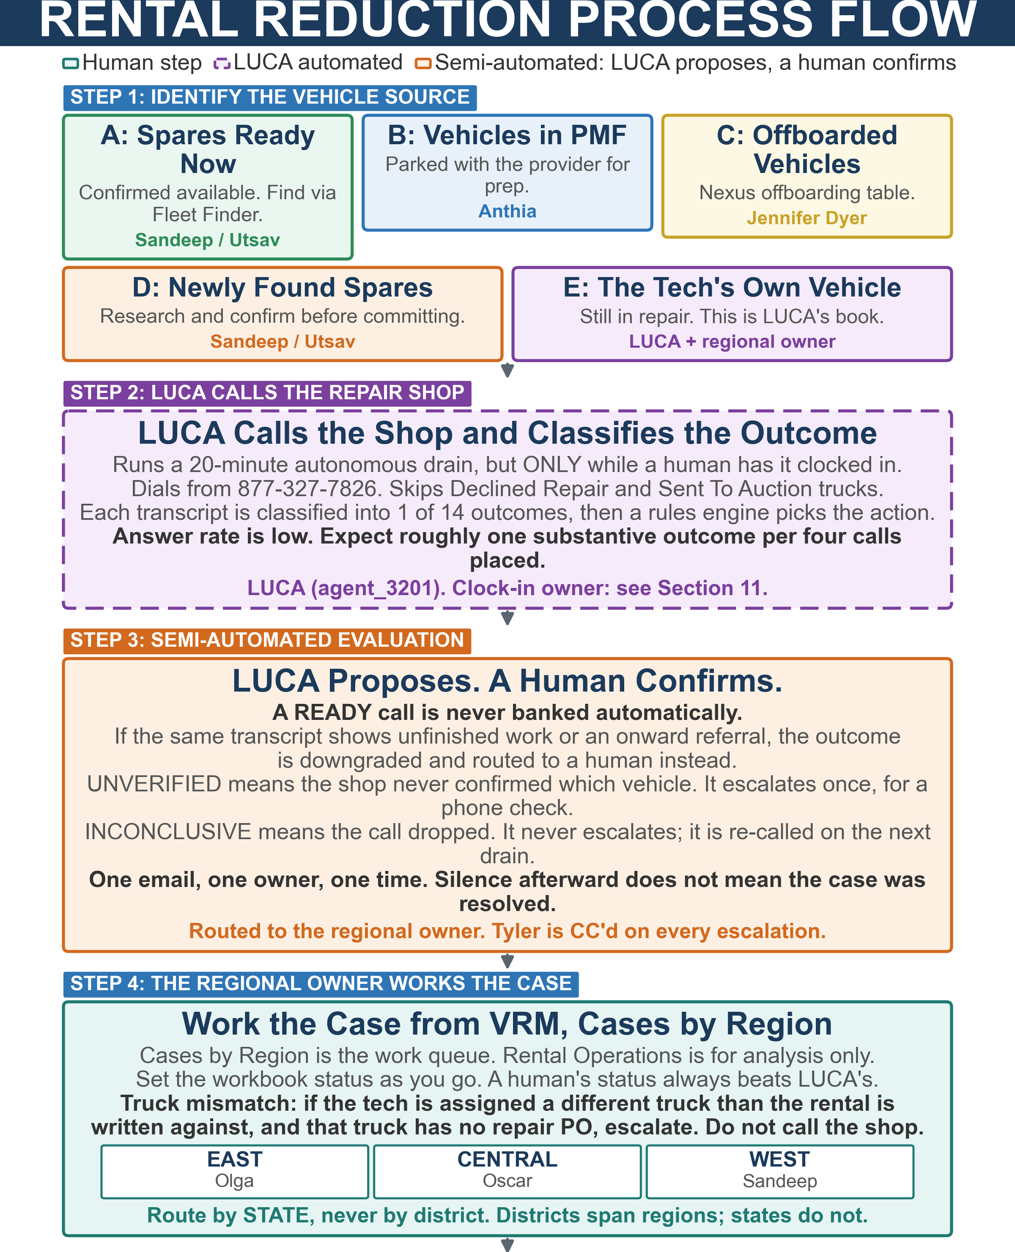

Part 2 of 2: preparing the vehicle through closing the rental.
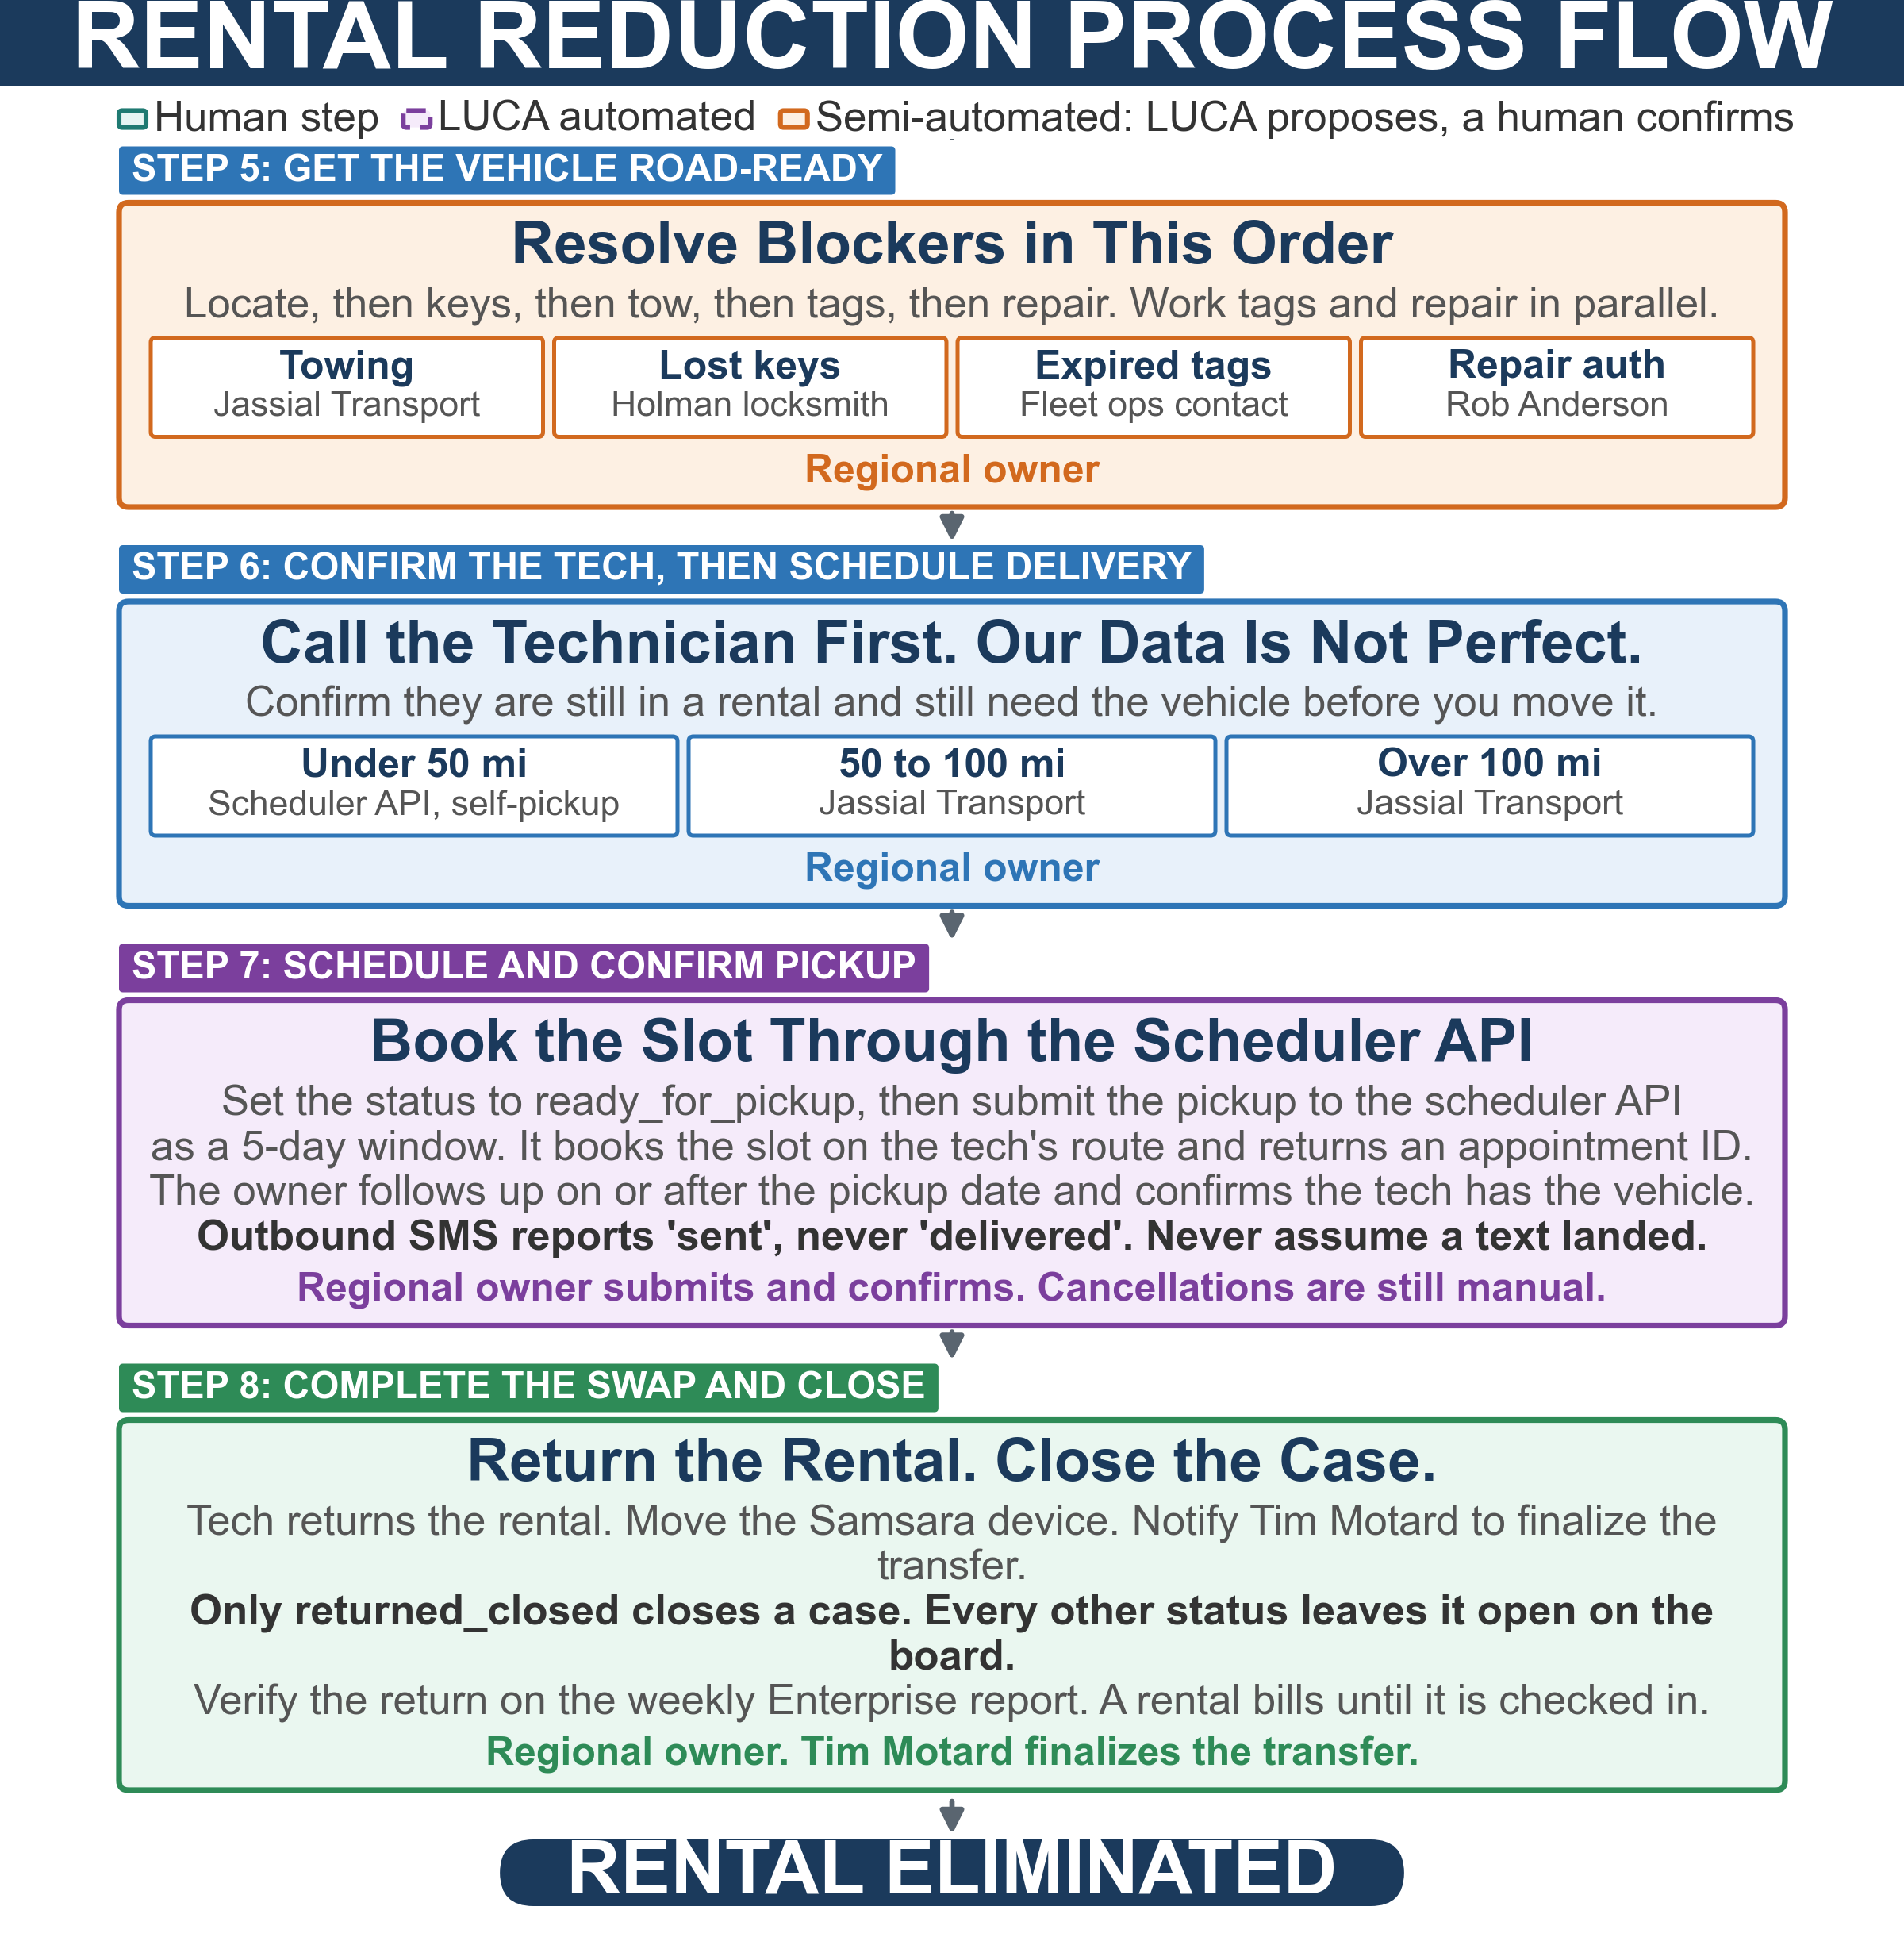

6. The Rental Reduction Process

Step 1: Identify the Source of a Vehicle
Vehicles to replace rentals come from five sources. Sources A through D replace a technician's vehicle. Source E recovers the technician's own vehicle, and is the source LUCA works automatically.
Source | What it is | Owner
A: Spares ready now | Vehicles confirmed available and in working condition. Locate the nearest one with Fleet Finder. | Sandeep Kalyani / Utsav
B: Vehicles in PMF | Parked with the fleet provider for detailing and prep. Available to deploy with minimal work. | Anthia
C: Offboarded technician vehicles | Viewable in the Nexus offboarding table. Jennifer Dyer's team handles the initial movement; the pipeline team then calls the offboarded technician to confirm location and condition. | Jennifer Dyer
D: Newly found spares | Spares at a last known location that need research and confirmation before they can be committed to a technician. | Sandeep Kalyani / Utsav
E: The technician's own vehicle | Still in repair. Often the fastest path off rental is getting the tech's own vehicle back, not finding a different one. This is LUCA's book. | LUCA, then the regional owner

Researching a Source D vehicle. Confirm all of the following before you commit the vehicle to a technician:
- Open Fleet Finder and enter the technician's ZIP code to find the nearest spare.
- Check AMS for the recorded location and status notes.
- Check TPMS for current assignment.
- Check Holman Insights for the latest PO, shop location, and repair history.
- Call the shop or last known location to confirm the vehicle is physically there and in the condition recorded.
⚠ Fleet Finder shows inventory, not confirmed availability. A vehicle can appear in Fleet Finder and still have expired tags, missing keys, or be in worse condition than recorded. Always research before you promise it to a technician.

Step 2: LUCA Calls the Repair Shop
LUCA is an automated caller that works the active rental book. It is not a tool you request per truck. There is no request path and no per-truck trigger; v3's instruction to ping someone to start a call no longer exists.
Behavior | Detail
When it runs | A 20-minute autonomous drain, but only while a human has it clocked in on the Fleet Agents /agents page. When it is clocked out, nothing is called. See Section 11.
What it calls from | 877-327-7826. The same number receives inbound shop callbacks.
What it skips | Trucks in Declined Repair or Sent To Auction. LUCA will never work these, which is precisely why they are the human Priority #1 in Section 7.
What it captures | Repair status, estimated completion date, blockers, shop and caller details. Each transcript is classified into one of fourteen outcomes.
What it will not do | LUCA never texts or calls a technician. All technician contact is human-initiated. It also leaves no voicemail, so an unanswered call means the shop was never told we called.
Expected yield | Answer rates are low. Across a recent ten-day window, 289 calls returned no answer against roughly 90 substantive outcomes. Plan on about one usable outcome per four calls.

Step 3: Semi-Automated Evaluation
LUCA proposes an outcome. A person confirms it. Two guardrails exist specifically to stop the agent from banking a conclusion it is not entitled to draw.
Guardrail | What it does | What you must do
Ready guard | If a call is classified READY but the same transcript shows unfinished work or an onward referral, the outcome is downgraded and flagged for review instead of being banked. | Call the shop and confirm before any pickup is dispatched.
Identity gate | If the shop states a status but never confirms which vehicle it is talking about, the outcome becomes UNVERIFIED and escalates once for human confirmation. This is one of the largest buckets, bigger than READY. | Call the shop, confirm the plate or VIN, and set the real status.
Dropped call | A truncated or dropped call becomes INCONCLUSIVE. It deliberately never escalates. | Nothing. It is re-called on the next drain.

⚠ AN AUTOMATED CLASSIFIER MAY PROPOSE A COMPLETION. IT MAY NEVER BANK ONE. No vehicle is treated as ready to collect on the strength of a machine transcription alone.

Escalation is one email, to one owner, one time. LUCA sends a single escalation per case per outcome to the rental reduction owner for that technician's state, with Tyler CC'd. There is no reminder and no repeat. Silence after an escalation does not mean the case was resolved; it means nobody has touched it.

Step 4: The Regional Owner Works the Case
Work from VRM > Cases by Region. That page is the work queue. Rental Operations is the control center for analysis and bulk actions; it shows the same population, so the two cannot disagree, but Cases by Region is where you work.
Set the workbook status as you go, and record a next action and a follow-up date. A human's status always beats LUCA's: once you set return scheduled, returned and closed, or ready for pickup, the agent will not overwrite it.
⚠ TRUCK MISMATCH: ESCALATE, DO NOT CALL. If the technician on the rental is assigned a different truck than the rental is written against, and that truck has no qualifying repair PO, the rental is very likely closable. Escalate it for closure rather than calling a shop about a vehicle that is not the problem.

A renter name that does not match the technician is normal, not a data error. Enterprise hand-types renter names and frequently mangles them. Identity resolves by renter name first; a truck number can rescue an identity but never contradict one.

Step 5: Get the Vehicle to Working Condition
A vehicle may have several problems at once. Resolve them in this order: locate, then keys, then tow, then tags, then repair. Work tags and repair in parallel where you can.
Issue | Action | Escalate to
Active repair with an ETA | Log the ETA on the case. Follow up the day before if under a week, weekly if one to two weeks. Two slipped ETAs means stalled. | Rob Anderson
Stalled or unresponsive shop | Call Holman first at 1-800-227-2273. Then escalate for a shop change or a decline. | Rob Anderson
Needs estimate or authorization | Push the shop for the estimate and check Holman Insights. | Rob Anderson
Expired tags or registration | Do not wait for tags before starting the repair. Suppress the truck from the calling queue: calling a shop cannot resolve a registration problem. | Fleet ops contact for the region (Annex A)
Lost or missing keys | Confirm the keys are genuinely lost, then arrange a locksmith through Holman at the vehicle's location with the VIN. Schedule this before any tow. | Owner arranges directly
Needs towing | Arrange transport and provide pickup and destination addresses, vehicle details, and a contact at both ends. | Jassial Transport
Location unknown | Check Samsara GPS, call the last technician, and cross-reference AMS, TPMS, and Holman. If still unlocatable after two days, escalate and start sourcing a replacement in parallel. | See Section 11, open item 9
Wrong shop phone on the PO | Correct the shop record on the repair PO. Almost every active rental takes its shop contact from the PO, so a wrong PO means every future call is wrong. | Rob Anderson

Once the vehicle is repaired and road-ready, go to Step 6. If the repair is declined or the vehicle is unrecoverable, the technician becomes Priority #1 for a replacement from Sources A through D.

Step 6: Confirm the Technician, Then Schedule Delivery
Always call the technician first. Our data is not perfect. Confirm they are still in a rental and still need the vehicle before you move anything. Then arrange transport based on the distance between the vehicle and the technician.
Distance | Method | Coordinate with
Under 50 miles | Submit to the scheduler API for self-pickup on the technician's route. | Scheduler API
50 to 100 miles | Arrange transport. | Jassial Transport
Over 100 miles | Arrange transport. | Jassial Transport

Step 7: Schedule and Confirm the Pickup
Pickup scheduling now goes through the scheduler API, not through a person. v3 routed this step through a named capacity analyst who reviewed the board and coordinated each pickup by hand. That step is removed. The rental reduction owner submits the pickup directly and stays accountable for confirming it happened.
- Set the case status to ready for pickup.
- Submit the pickup to the scheduler API as a five-day window, with the technician, the vehicle number, and the job type. The API books the slot on the technician's route and returns an appointment ID.
- Record the appointment ID on the case.
- Follow up on or after the pickup date and confirm the technician has the vehicle and it is in working condition.
- If the pickup did not happen, record why on the case and resubmit.
Submit | Technician, vehicle number, job type, and a five-day window.
Returns | An appointment ID, or a proposed slot if it could not book.
Cancellations are manual | The API creates bookings. Cancelling or moving one is still a manual action. Do not assume a resubmission replaces an earlier booking.
If it cannot place a slot | Escalate to Mandy Riley. Do not fall back to coordinating the pickup by hand without recording it on the case.

⚠ OUTBOUND TEXT MESSAGES REPORT 'SENT', NEVER 'DELIVERED'. There is no delivery or failure signal today. A text that never landed looks identical to one that did. Never treat an unanswered text as evidence the technician was informed, and never close a case on the absence of a reply.

Step 8: Complete the Swap and Close the Case
- Ensure the technician returns the rental vehicle.
- Transition the Samsara device from the rental to the new vehicle.
- Schedule the technician onto the new vehicle.
- Notify Tim Motard that the transfer is complete so he can finalize it across inventory systems.
- Update TPMS with the technician-to-truck reassignment. This step is still manual.
- Set the case status to returned and closed.
⚠ ONLY 'RETURNED AND CLOSED' CLOSES A CASE. Every other status leaves the case open on the board. And the truck going out is not the same event as the rental coming back: verify the return on the weekly Enterprise report. A rental bills until it is physically checked in.

Step 9: Vehicle Decommission (If Unrepairable)
If a vehicle is confirmed unrepairable, no further repairs are permitted once it is marked decommissioned. The assigned technician becomes Priority #1 for a replacement.
Equipment removal. Schedule a Team Lead Technician visit with the assigned technician. The TLT removes the Samsara device (dash cam, wiring, gateway), the Truce beacon if installed, and any EZ-Pass or I-Pass transponders.
Required photo documentation. Six photos, uploaded with the truck number to the Decommission Van chat in Teams:
# | Photo
1 | Front of the truck
2 | Back of the truck
3 | Left side, doors closed
4 | Right side, doors closed
5 | Back with doors open, showing the truck is empty
6 | Front cab, showing the dash camera has been removed

Tools and inventory. Tools return to the assigned technician. If the technician has left the company, work with the Asset Team for a UPS return label. Remaining inventory merges into the technician's new truck, systematically the night before the physical move, with a count scheduled within 30 calendar days.
Final retrieval. Give the vehicle's current location and the contact holding the keys to Jennifer Dyer for retrieval and routing to auction. Melissa Corona owns inventory integrity through this process.

7. Work Priority
Do not work rentals in the order they appear on the board. The priority below reflects a division of labor that did not exist in v3: LUCA works the cases it can call on, and the human works the cases LUCA structurally cannot.

Priority 1: Declined Repair Estimates and Vehicles Sent to Auction
Why this is first | LUCA will never work these. Declined and auction trucks are excluded from its queue by design, so no automation is making progress on them. The technician's only path back to a company vehicle is a reassignment from another source. Roughly a third of open cases sit in this cohort.
Action | Call the technician to confirm they are still in a rental. If yes, identify a replacement from Sources A through D and begin the swap. Work these before anything else.

Priority 2: Cases LUCA Escalated to You
Why this is second | The agent has already done the calling and has told you it needs a human. An escalation arrives once and never repeats, so an untouched escalation stays untouched indefinitely.
Action | Filter Cases by Region to the escalated status. Advance the workbook status, record a next action and a follow-up date, and clear the mark.

Priority 3: Longest Time in Rental
Why this is third | Technicians in rentals the longest carry the greatest cumulative cost. These are also the cases most likely to be stuck on something an automated call cannot fix.
Action | Sort by the date the vehicle went into repair, oldest first, and work down. Call the technician first to understand the full situation, then research the vehicle or source a replacement.

Priority 4: Shops That Never Answer
Why this is fourth | Roughly half of the active book currently sits at no answer, no shop contact, or call failed. LUCA leaves no voicemail, so for these trucks the shop has never been told we called. Automation has taken these as far as it can.
Action | Human callback. If the shop contact itself is missing or wrong, correct the repair PO so future calls reach the right place.

8. Available Tools

LUCA: Automated Repair Shop Caller
LUCA calls repair shops on the active rental book, classifies the outcome, and escalates to the regional owner. It replaces the on-request AI call agent described in v3.
Where it runs | Fleet Agents (fleetagents.replit.app). Clock in and out on the /agents page.
Cadence | A 20-minute drain while clocked in. Nothing runs while clocked out.
Phone number | 877-327-7826, shared with the inbound hotline.
Where results land | The case in VRM, and the call transcript in FleetScope's call log.
Who it emails | One rental reduction owner, by the technician's state, with Tyler CC'd.

Inbound Hotline: 877-327-7826
Repair shops can call in at any time to report a vehicle is ready, give an ETA, or flag a blocker. An inbound agent answers, identifies itself as the Sears Home Services fleet team, collects the vehicle and status details, and files the result to the VRM Inbound Calls page.
⚠ KEY ACTION FOR TECHNICIANS: When dropping a vehicle at any repair shop, technicians must give the shop the fleet hotline number (877-327-7826) alongside their own. This is the single highest-value step for making sure the fleet team learns a repair is finished.

Current inbound volume is low, roughly one to three calls a day. Treat the hotline as a supplement to outbound calling, not as your primary signal that a vehicle is ready.

Fleet Finder: Locate the Nearest Spare
Fleet Finder returns available spare vehicles sorted by proximity to a technician. It is the primary tool for matching Sources A, C, and D to a technician.
Link | https://shs-fleetfinder.replit.app/
How to use it | Enter the technician's Enterprise ID, ZIP code, or city and state. Results are sorted nearest to farthest.
Use the result to decide | Under 50 miles, block the technician's route for self-pickup. Over 50 miles, arrange transport.
Important | It shows inventory, not confirmed availability. Always research the vehicle before committing it.

Holman Insights
Holman Insights is the live source for purchase orders, authorization status, and repair shop details. Use it directly. The weekly FleetScrape feed described in v3 is no longer refreshing; see Section 11.

9. Escalation Scenarios and Resolution Guide
The service level is in business days and starts the day the condition is detected.
Situation | Action | Owner | SLA
Case marked escalated by LUCA | Open it in Cases by Region, advance the status, record a next action and follow-up date. | Regional owner | 2 days
Outcome UNVERIFIED | Call the shop, confirm the plate or VIN, set the real status. | Regional owner | 2 days
Ready guard review | Call the shop and confirm before dispatching a pickup. | Regional owner | 1 day
Shop needs authorization | Approve or reject the repair authorization in Holman. | Rob Anderson | 1 day
Rental PO awaiting decision | Approve or deny in VRM New Rentals. | Tyler Morgan (alternate: Rob Anderson) | 1 day
Vehicle unrepairable, needs tow | Arrange transport. | Regional owner | 2 days
Shop does not have the truck, or vehicle relocated | Locate the vehicle. If still unknown after the first pass, escalate. | Regional owner | 3 days
Shop unreachable (no answer, call failed, no contact) | Human callback. Correct the shop record on the PO if the contact is wrong. | Regional owner | 5 days per truck
Repair stalled: two slipped ETAs, or over 60 days in shop | Call Holman, then escalate for a shop change or a decline. | Rob Anderson | 3 days
Truck mismatch with no repair PO | Escalate for rental closure. Do not call the shop. | Regional owner | 2 days
Declined repair or sent to auction | Priority #1. Source a replacement from Sources A to D. | Regional owner | 5 days to a sourcing decision
Expired tags or registration hold | Suppress from the calling queue, then resolve the registration. | Regional fleet ops contact (Annex A) | 7 days, reviewed weekly
Vehicle ready for pickup | Submit the pickup to the scheduler API as a five-day window. | Regional owner | 2 days
Scheduler API cannot place a slot | Escalate for manual placement and record it on the case. | Mandy Riley | 2 days
Technician unreachable | Attempt contact three times across two business days. Then contact the Technician Team Leader. | Regional owner | 3 days, escalate on day 4
Decommission or approved for sale | Provide location and key contact, then confirm retrieval happened. | Jennifer Dyer | 5 days to confirmed retrieval

10. Enterprise Mobility Extension Requests
⚠ THIS PROCESS IS CURRENTLY MANUAL AND UNOWNED. v3 described an automated pipeline that received the request, auto-replied with an extension, called the shop, classified the transcript, and logged to a tracker. That pipeline no longer functions and nothing has replaced it. Its call leg is broken, it ran on a personal cloud account belonging to a departed employee that nobody at Sears can administer, and its output tracker lived on that employee's personal OneDrive.

Until an owner is assigned, treat every extension request as fully manual:
- Confirm the technician is genuinely still without a vehicle before granting anything.
- Locate the repair shop through Holman Insights or by calling the technician, who will almost always know where the vehicle is.
- Call the shop and get a firm completion date.
- Reply to Enterprise Mobility with an extension to the confirmed pickup date plus two days. Do not grant an open-ended or blanket extension when a specific date is available.
- Record what you did on the rental case in VRM so the next person can see it.
Open question for leadership. Nobody has confirmed who receives these emails today or whether extensions are silently lapsing. This is open item 4 in Section 11 and needs an owner before this section can state a service level.

11. Automation Status and Open Items
This section exists because v3 described tools as working that had stopped. Every automated component named in this SOP is listed below with its verified status as of 2026-08-05. Do not build a process step on anything not marked LIVE.

11.1 Automation Status
Component | Status | What that means for you
LUCA shop calling and outcome classification | LIVE | Working in production, but only while clocked in. See open item 1.
Regional escalation email | LIVE | One owner, one email, with Tyler CC'd. Routes on the technician's state.
Escalation loop guardrail | LIVE | The runaway loop that sent 397 emails is fixed and capped.
Rental approval recommendation and Holman postback | LIVE | The system recommends; a named human presses the button. About 8 percent of rows arrive with no recommendation because the driver name did not match the roster. Blank means no match, not denied.
VRM Cases by Region and Rental Operations | LIVE | In production and syncing nightly.
AMS comment mirroring from VRM | LIVE | Do not double-enter case comments.
Inbound hotline and Inbound Calls page | LIVE, LOW VOLUME | Roughly one to three calls a day, and ingest has lagged. Do not rely on it as your ready signal.
Scheduler API (route slot booking) | LIVE for submission | Pickup requests are submitted and booked through it. Cancellations are still manual.
Autonomous booking by the agent | PROPOSE ONLY | The agent can generate a slot request but cannot book it; the booking client is not yet wired. A person still submits. Open item 3.
Ready-for-pickup notification lane | NOT ROUTING | The recipient addresses are blank, so these notifications currently reach nobody. Open item 3.
Shop-contact-missing escalation | MISROUTING | No dedicated recipient is configured, so it fans out to all three regional owners regardless of region. Open item 3.
Text message delivery confirmation | DOES NOT EXIST | Every outbound message reports sent and never delivered or failed. Never close a case on a technician's silence.
Enterprise Mobility extension automation | SEVERED | Does not run. Nothing replaced it. See Section 10.
Holman FleetScrape weekly feed | FROZEN | It still loads and looks current, but it has not refreshed since mid-July and most of its rows date to April. Use Holman Insights instead. Open item 2.
FleetScope Batch Caller | RETIRED | Has placed no calls since mid-July. The page still renders. Do not use it.
On-demand FleetScrape pull by request | RETIRED | The person who ran these has left. Use Holman Insights.

11.2 Open Items
Each item below needs a named owner and a decide-by date. They are listed in the order they affect this SOP's accuracy.
# | Item | Why it matters | Tag
1 | Who clocks LUCA in and out, and at what time each day. | LUCA only calls while clocked in, and it has been clocked in on 9 of the last 21 days. Until this has an owner and a time, every statement in this SOP about what LUCA does is conditional on an undocumented human action. | FIX
2 | Adoption of the escalated case queue. | Cases marked escalated have accumulated on the board and no human has yet advanced one. The queue is being written but not worked. This SOP describes working it as Priority 2; that needs to become real practice. | FIX
3 | Notification lanes with no recipient, and the unwired booking client. | The ready-for-pickup lane reaches nobody and shop-contact-missing fans out to all three owners; both appear active, so they look configured. Separately, the agent-side booking client is not wired, so slot booking still requires a person to submit. | FIX
4 | Owner and service level for Enterprise Mobility extension requests. | The automation is dead and nothing replaced it. Nobody has confirmed who receives these emails or whether extensions are lapsing. | FIX
5 | Replacement for the frozen Holman FleetScrape feed. | It is stale but still returns data and still drives a readiness signal, so a reader cannot tell it is stale. | FIX
6 | Text message delivery confirmation. | Until this exists, the weekly Enterprise report check is the only reliable close-out. | BUILD
7 | Terminating condition on the Priority 1 sourcing loop. | There is currently no defined point at which we stop searching and choose an alternative. At least one technician has been in a rental for approximately a year. | FIX
8 | Single named recipient for the location-unknown escalation. | Currently a three-way broadcast, which means no individual owns it. | FIX
9 | Owner for the tags and registration hold condition. | There is no reliable automated detection for this state, and shop calls are being spent on trucks that a call cannot help. | FIX

⚠ REGION ROUTING IN LUCA DOES NOT YET MATCH ANNEX A. The deployed agent routes nine states differently from this document, and has no entry for Puerto Rico or the ten states Annex A previously left unassigned. Annex A is authoritative. Annex A.6 lists the exact changes required.

Annex A: Region Allocation and Fleet Operations Coordination
This annex is the authoritative region model. It governs which rental reduction owner works a case, who receives a LUCA escalation, and which fleet operations team supports the truck.
⚠ ROUTE BY STATE, NEVER BY DISTRICT. A state belongs to exactly one region. A district does not: three districts legitimately span two regions (4766 Ohio Valley, 8035 Atlanta, 8206 Mid South). Any system that routes on district will disagree with this document. Resolve on the technician's home state.

A.1 Region Summary
Region | Rental Reduction Owner | States | Districts | Fleet Ops Contact
Region 1: East | Olga Fernandez | 17 | 9 | Rob D & Andrea
Region 2: Central | Oscar Santana | 17 | 14 | Carol & Tasha, Cheryl & Monica, Rob D & Andrea
Region 3: West | Sandeep Kalyani | 18 | 9 | Carol & Tasha, Cheryl & Monica, Rob D & Andrea

PMF coordination for all three regions: Anthia. Spare vehicle sourcing support: Utsav and Ravi.

A.2 Fleet Operations Team District Assignments
Fleet Ops Team | Districts
Carol & Tasha | Mesa (7088), Los Angeles (7108), Dallas (7995), Houston (8107), San Antonio (8147), Hawaii (8158), Denver (8169), N. California (8184), Portland (8228), Mid-Pacific (8366)
Cheryl & Monica | Cleveland (6141), St Louis (7323), Heartland (8096), Upper Midwest (8162), Mid South (8206), Michigan (8220), Detroit (8309), Kansas City (8420), Chicago (8555), Puerto Rico (8935)
Rob D & Andrea | Ohio Valley (4766), Chesapeake (7084), Florida (7435), New England (7670), New York City (7744), Penn-Jersey (7983), Atlanta (8035), Virginia (8175), Wall (8380)

A.3 Region 1: East: Olga Fernandez
17 states. Fleet ops contact varies by district; see the table. New in v4: DC, NH, VT. These states were unassigned in v3 and are marked with an asterisk below.
State | District(s) | Fleet Ops Contact
CT | New England (7670) | Rob D & Andrea
DC * | Chesapeake (7084) | Rob D & Andrea
DE | Chesapeake (7084) | Rob D & Andrea
FL | Florida (7435) | Rob D & Andrea
GA | Atlanta (8035) | Rob D & Andrea
MA | New England (7670) | Rob D & Andrea
MD | Chesapeake (7084) | Rob D & Andrea
ME | New England (7670) | Rob D & Andrea
NC | Chesapeake (7084) | Rob D & Andrea
NH * | New England (7670) | Rob D & Andrea
NJ | Penn-Jersey (7983), Wall (8380) | Rob D & Andrea
NY | New York City (7744) | Rob D & Andrea
PA | Penn-Jersey (7983) | Rob D & Andrea
RI | New England (7670) | Rob D & Andrea
VA | Chesapeake (7084), Virginia (8175) | Rob D & Andrea
VT * | New England (7670) | Rob D & Andrea
WV | Ohio Valley (4766) | Rob D & Andrea

A.4 Region 2: Central: Oscar Santana
17 states. Fleet ops contact varies by district; see the table. New in v4: PR, SD. These states were unassigned in v3 and are marked with an asterisk below.
State | District(s) | Fleet Ops Contact
IA | Heartland (8096) | Cheryl & Monica
IL | Chicago (8555) | Cheryl & Monica
IN | Chicago (8555) | Cheryl & Monica
KS | Kansas City (8420) | Cheryl & Monica
KY | Ohio Valley (4766) | Rob D & Andrea
MI | Michigan (8220), Detroit (8309) | Cheryl & Monica
MN | Upper Midwest (8162) | Cheryl & Monica
MO | St Louis (7323), Kansas City (8420) | Cheryl & Monica
ND | Upper Midwest (8162) | Cheryl & Monica
NE | Heartland (8096) | Cheryl & Monica
OH | Ohio Valley (4766), Cleveland (6141) | Cheryl & Monica, Rob D & Andrea
OK | Dallas (7995) | Carol & Tasha
PR * | Puerto Rico (8935) | Cheryl & Monica
SD * | Upper Midwest (8162) | Cheryl & Monica
TN | Mid South (8206) | Cheryl & Monica
TX | Dallas (7995), Houston (8107), San Antonio (8147) | Carol & Tasha
WI | Upper Midwest (8162) | Cheryl & Monica

A.5 Region 3: West: Sandeep Kalyani
18 states. Fleet ops contact varies by district; see the table. New in v4: AK, MT, NM, NV, WY. These states were unassigned in v3 and are marked with an asterisk below.
State | District(s) | Fleet Ops Contact
AK * | Portland (8228) | Carol & Tasha
AL | Mid South (8206) | Cheryl & Monica
AR | Mid South (8206) | Cheryl & Monica
AZ | Mesa (7088) | Carol & Tasha
CA | Los Angeles (7108), N. California (8184), Mid-Pacific (8366) | Carol & Tasha
CO | Denver (8169) | Carol & Tasha
HI | Hawaii (8158) | Carol & Tasha
ID | Portland (8228) | Carol & Tasha
LA | Mid South (8206) | Cheryl & Monica
MS | Mid South (8206) | Cheryl & Monica
MT * | Denver (8169) | Carol & Tasha
NM * | Mesa (7088) | Carol & Tasha
NV * | Mesa (7088) | Carol & Tasha
OR | Portland (8228) | Carol & Tasha
SC | Atlanta (8035) | Rob D & Andrea
UT | Denver (8169) | Carol & Tasha
WA | Portland (8228) | Carol & Tasha
WY * | Denver (8169) | Carol & Tasha

A.6 Changes Required in the LUCA Agent and VRM
The deployed routing does not currently match this annex. The following changes bring the systems in line with this document. This document is authoritative; the code changes.
Nine states currently route to the wrong owner. Measured against recent traffic this is roughly 15 percent of all escalations landing in the wrong inbox.
State | Annex A (correct) | Currently routes to
OH | Oscar (Central) | Olga (East)
KY | Oscar (Central) | Olga (East)
IN | Oscar (Central) | Olga (East)
MI | Oscar (Central) | Olga (East)
SC | Sandeep (West) | Olga (East)
AL | Sandeep (West) | Oscar (Central)
AR | Sandeep (West) | Oscar (Central)
LA | Sandeep (West) | Oscar (Central)
MS | Sandeep (West) | Oscar (Central)

Puerto Rico must be added. It has no entry in the routing code today, which means a Puerto Rico case fans out to all three owners. Annex A.4 assigns it to Oscar (Central).
Resolve on state, not district. VRM currently assigns each district a single region by a vote of its technicians' home states, while the agent resolves per case on the technician's state. That is why a case can appear in one owner's queue while the email goes to another. Both must resolve on the technician's home state, with the shop address and plate state as fallbacks in that order.
Never fall back to a broadcast. An unmatched state currently sends to all three owners. With this annex every state and territory is assigned, so an unmatched value now indicates bad data. Route it to a single named owner for investigation instead of broadcasting.

Annex B: Status Model and System Field Ownership
This annex is written for engineering. It defines the task model that FleetScope is being realigned to and the crosswalk from the statuses named in v3.

B.1 There Are Four Status Vocabularies, Not One
Vocabulary | What it is | Who sets it
AMS vehicle status | The vehicle's real-world state. | Read from AMS. Not editable here.
AMS bucket | A normalized form of AMS status used for filtering. | Derived. Not editable.
Workload bucket | Whether LUCA may work the case: cannot work, truck mismatch, or workable. | Derived. Not editable.
Workbook status | The human and agent task state. | The only one a person sets.

B.2 The Canonical Workbook Status Chain
In order: new, working, technician contacted, awaiting technician, awaiting shop, blocked, ready for pickup, return scheduled, returned and closed. Plus escalated, which is an off-chain flag rather than a stage.
Rule | Detail
Only one status closes a case | Returned and closed. Every other value leaves the case open.
A human's status beats the agent's | The agent will not regress a human-set returned and closed, return scheduled, or ready for pickup.
Storage is append-only | Each change is a new row; current state is the newest row per case. A nightly ingest can therefore never wipe what a person typed.
Partial saves carry forward | A field left out of an update keeps its previous value. To clear a field you must explicitly blank it.
Actor comes from the session | The logged-in user is recorded automatically and cannot be overridden by the request.
Consume the status list, do not copy it | The vocabulary is served by the API. Two hardcoded copies is exactly how two boards drift apart.

B.3 Crosswalk From the v3 Status Chain
The eight-step chain named in v3 (Declined Repair through Deployed) never existed as a single chain in any system. Map it as follows.
v3 status | FleetScope reality | Workbook equivalent
Declined Repair | Main status Declined Repair. The one v3 value that is real. | Not a workbook state. It is an AMS bucket and a workload bucket.
In Repair | Main status Repairing. | Awaiting shop
Awaiting Authorization | No home in FleetScope. Nearest is Decision Pending with an awaiting-estimate sub-status. | Blocked
Repair Completed | A boolean field, not a status. | Ready for pickup
Scheduling Pickup | Main status Scheduling. | Ready for pickup
Pickup Scheduled | A sub-status under Scheduling. | Return scheduled
Pickup Confirmed | A boolean field, not a status. | Return scheduled
Deployed | Main status On Road. | Still open. Closing requires the rental back, not the truck out.
(no v3 equivalent) |  | New, working, technician contacted, awaiting technician, escalated

B.4 Tables Not to Build Against
The following exist in the schema but hold no production data. A name-based guess will pick the wrong one and silently build against an empty table.
- The rental task projections table is empty. The live task store is the append-only case-actions table.
- The agent review-flags table is empty; no review-flag step exists in practice.
- The VRM call-log table is empty. LUCA's call history is stored in FleetScope's call log and read into VRM by a union.
- The truck-level ready-for-pickup boolean has never been true and has no live writer. Ready for pickup is a workbook status.
- A second, older per-case marker (open, closed, pickup) still exists and drives row tinting on one page. Treat it as retired; do not replicate it.

B.5 Data Cautions
- The identity state field is a resolution status, not a US state. Any geographic rollup must join the technician's home state. The failure is silent and the totals still look plausible.
- A blank decision on a log row means the decision could not be matched, not that no decision was made.
- Holman PO status is not rental-open status. Long rentals are rewritten each cycle under the same claim. The Enterprise report governs.
- Read the source-health indicator before trusting a row. The Holman PO feed is currently flagged for data age.
- VRM and FleetScope share the database, never the routes. Status edits write the database directly.

12. Related Documents
Document | Covers
Rental Vehicle Eligibility and Denial Policy | Who qualifies for a rental and on what grounds one is denied.
Rental Vehicle SOP: Technician | The technician-facing procedure, including the requirement to give the shop the fleet hotline number.
Rental Vehicle Desk Procedure | The desk-level intake procedure for rental requests.
Right Size initiative | Moving technicians already in rentals onto the correct, lower-cost vehicle class. A parallel workstream to this SOP, tracked on its own VRM page.

Revision History
Version | Date | Author | Summary
4.0 | 2026-08-05 | Tyler Morgan | Rewritten against verified production state. Added LUCA and the semi-automated evaluation step; corrected roles after Sean Chen's departure; replaced the FleetScope status chain with the VRM workbook model; completed Annex A to all 50 states plus DC and Puerto Rico and resolved the Rakesh/Sandeep ambiguity in favor of Sandeep; added Section 11 automation status and Annex B for engineering; removed severed tools.
3.0 | 2026-07-01 | Fleet Operations | Prior version.

