Screenshot 1: Query 1 – Insured Patients
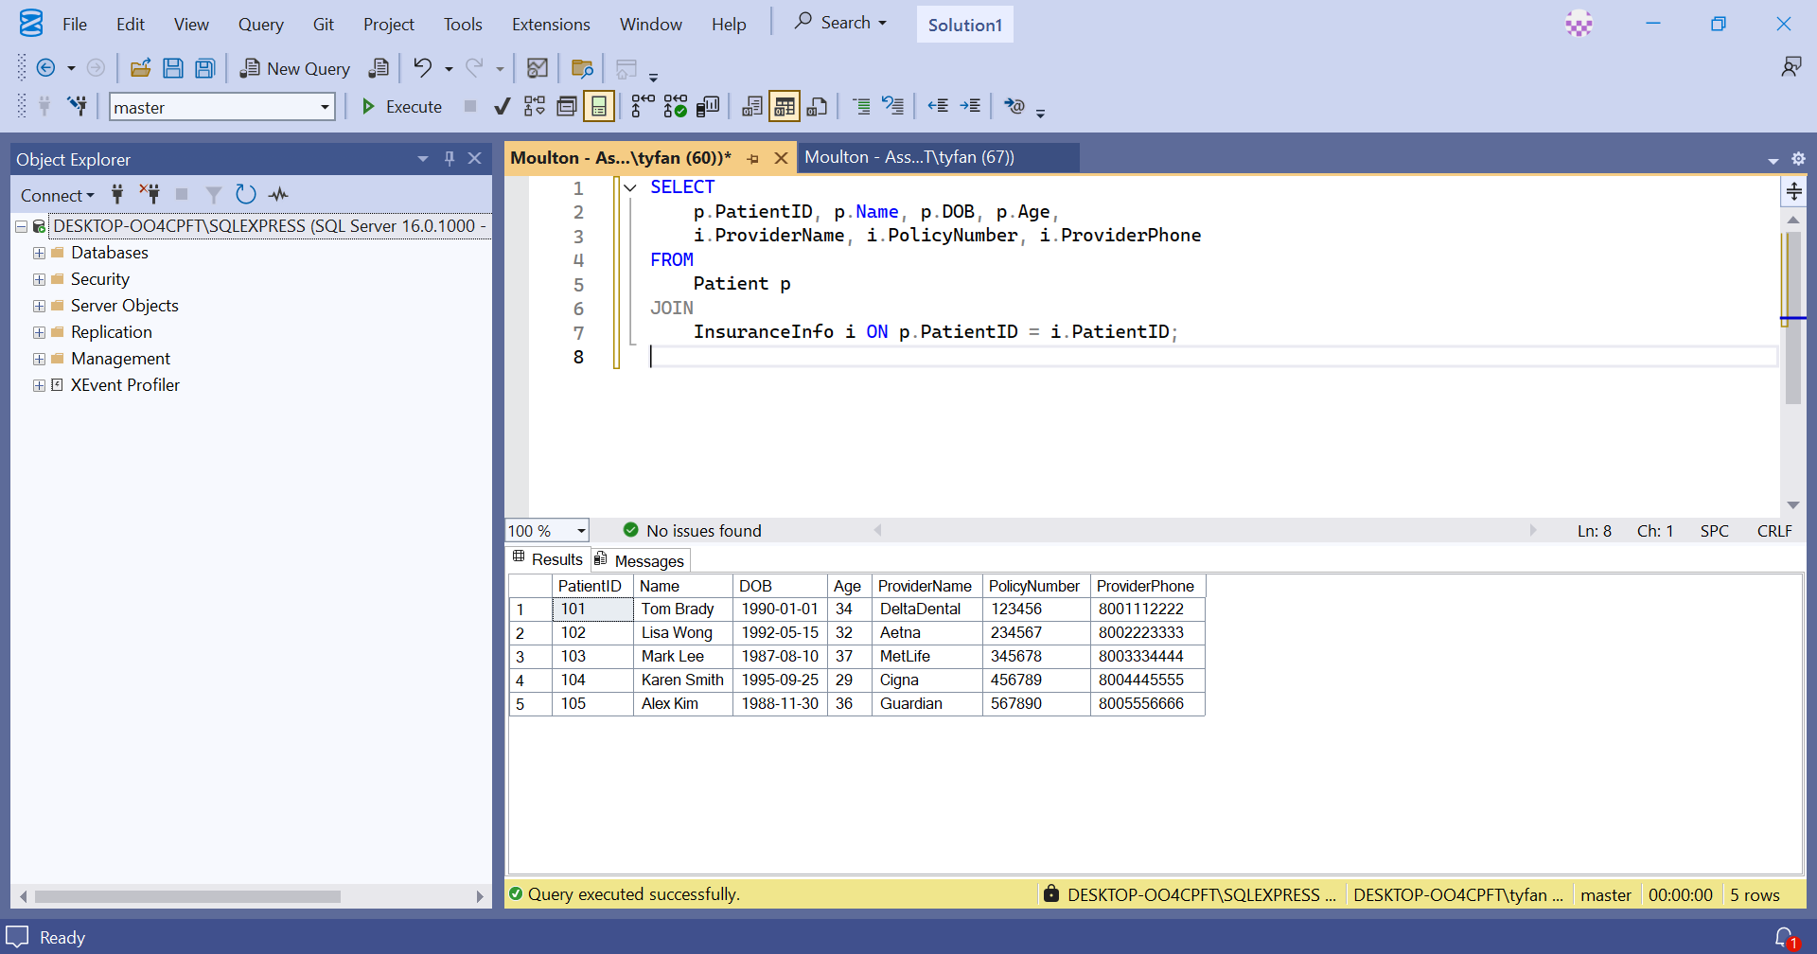
Screenshot 2: Query 2 – Patients & Card Info
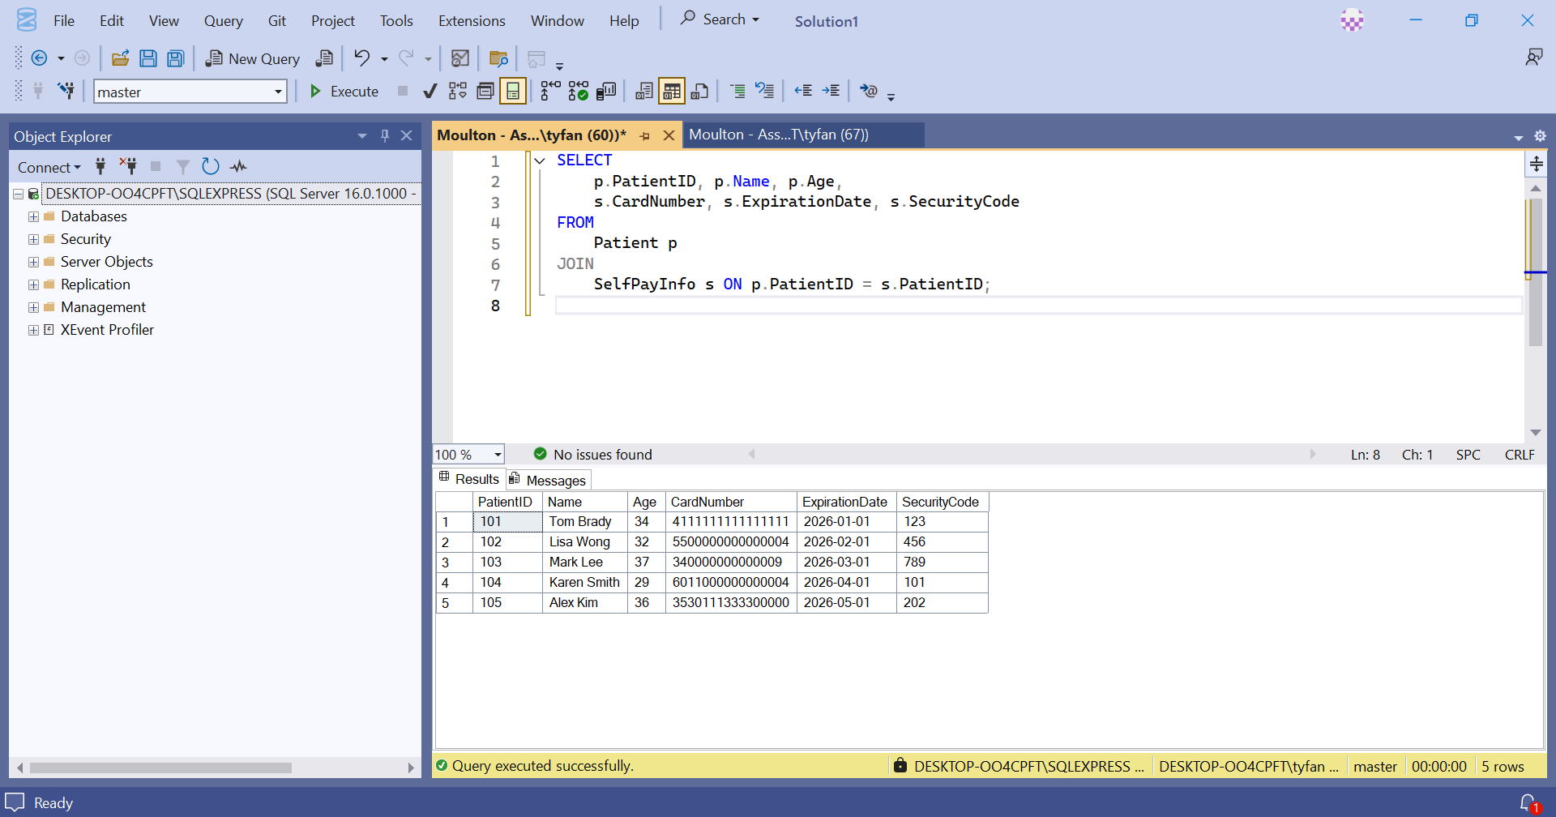

Screenshot 3: Query 3 – Patients Who Visited Dentists
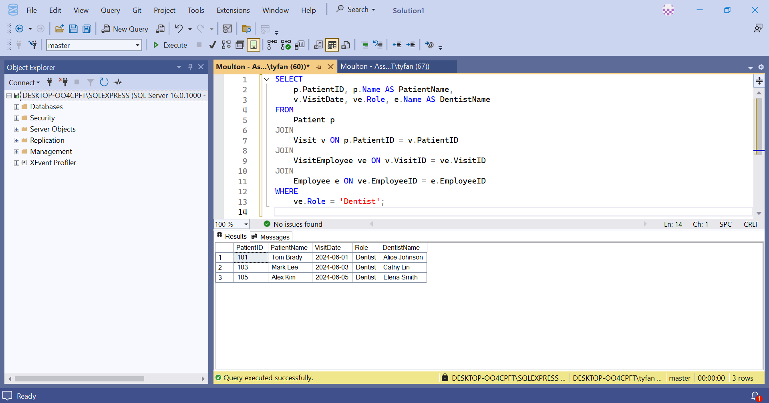
Screenshot 4: Query 4 – All Hygienists Sorted by Last Name
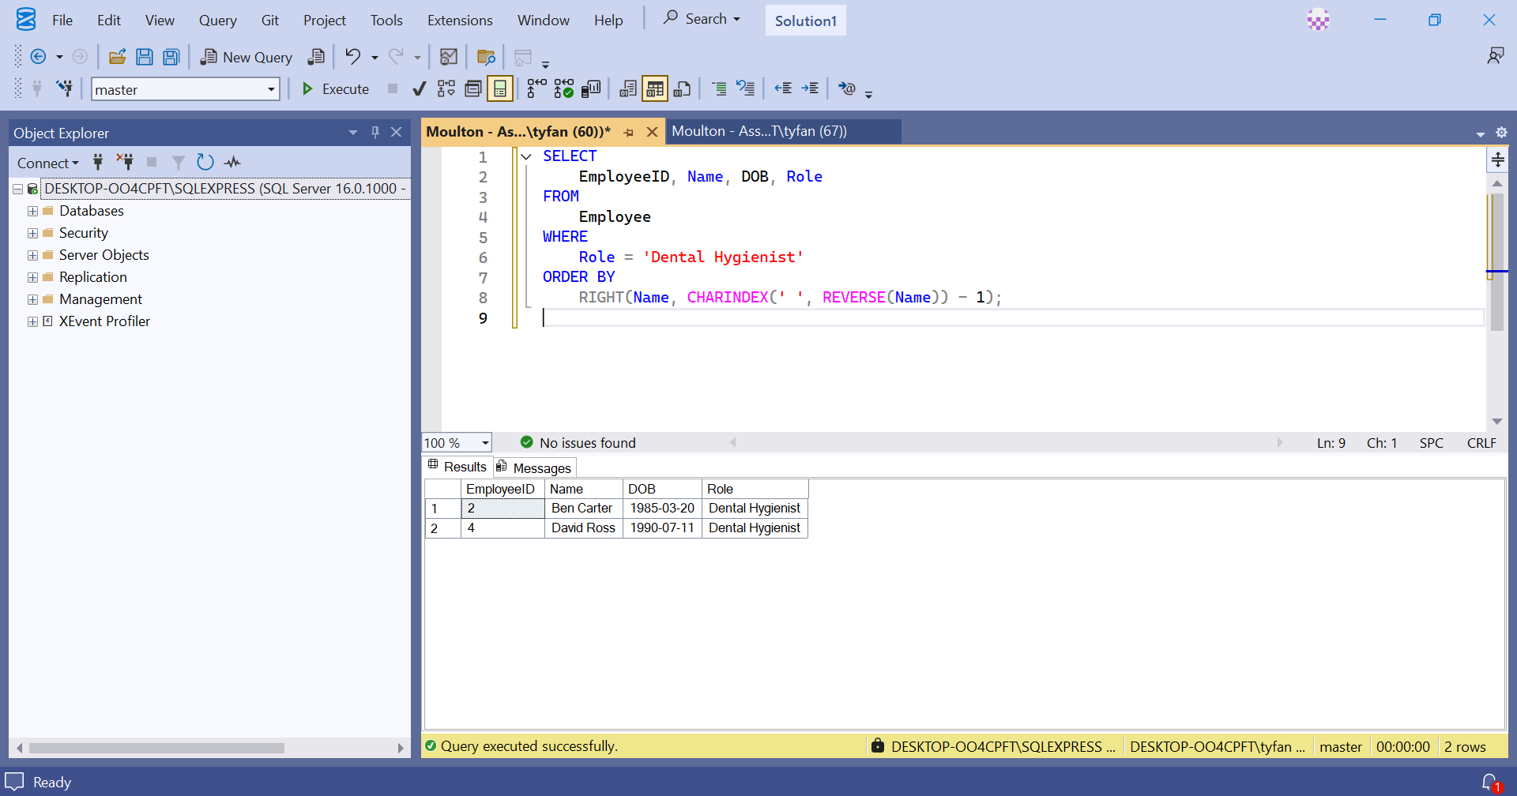

Screenshot 5: Query 5 – Count of Patients Over Age 35
