Obey Your Thirst Sprite Creator User Guide

Created by Obey Your Thirst

12 November 2015

CS 3505

The Obey Your Thirst Sprite Creator is an epic sprite creator filled with incredible features. To run this application, you must install ImageMagick and be running a distribution of Linux. The installation instructions are located on the [ImageMagick site](http://imagemagick.org/script/index.php).

Below is a picture showing the various tools at the user’s disposal:

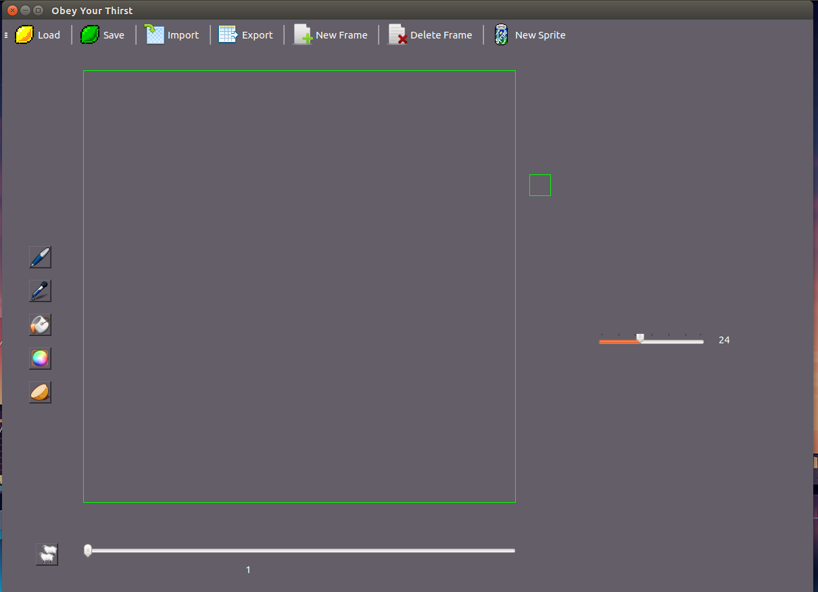

The top menu bar provides a collection of buttons that handle sprite I/O. Their functionality, from left to right, is the following: load a sprite from an .ssp file, saving the current sprite to an .ssp file, importing a gif into the application, export the current sprite into a gif, create a new frame on the current sprite, delete the current frame from the current sprite, or create a new sprite altogether.

The tools’ functionality on the left, from top to bottom, are the following: use the pen tool, select a color to draw with, fill an area, select a color, toggle onionskin view, and clone the current frame.

The bottom slider permits users to choose what frame they are currently editing. The slider on the right permits users to change the playback FPS. The small widget on the right plays back the current sprite.

To paint a specific pixel, select the pencil tool on the left hand side of the screen. You may also change colors by selecting the color tool on the left, below the paint bucket. To fill an area, select the paint bucket and click on an area to fill. Below is a sprite that has been created using the pencil tool:

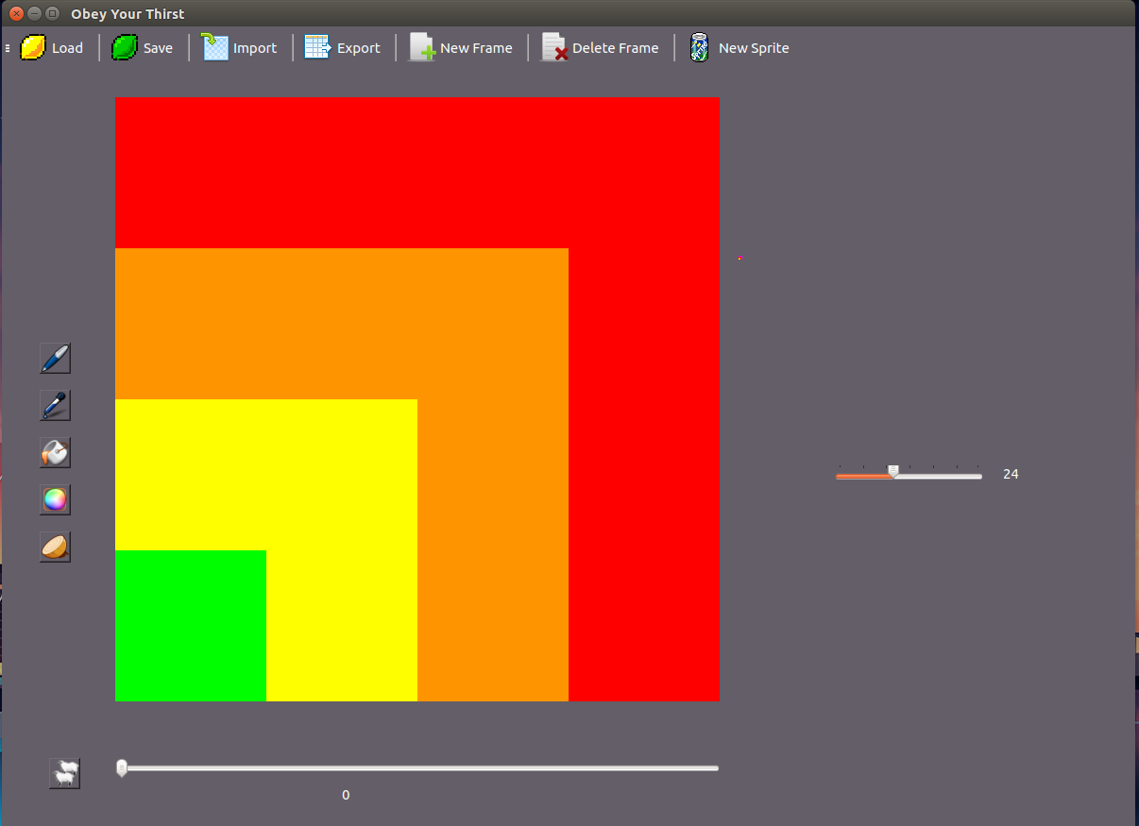

You can save your pixels as .ssp files by clicking on the save button. Name your file, including the .ssp extension, and click the save button to save your file. To load your file or another, click the load button at the top of the window. Select an .ssp file, and then click load to load up the sprite.

As you are working on your sprite, it may be helpful to see what the previous frame looked like. On the left hand side of the window, there is a button with a picture of an onion. Selecting it will enable onionskin viewing, which will allow you to see what the previous frame looked like. Below is an example of the onionskin viewing on a sprite:

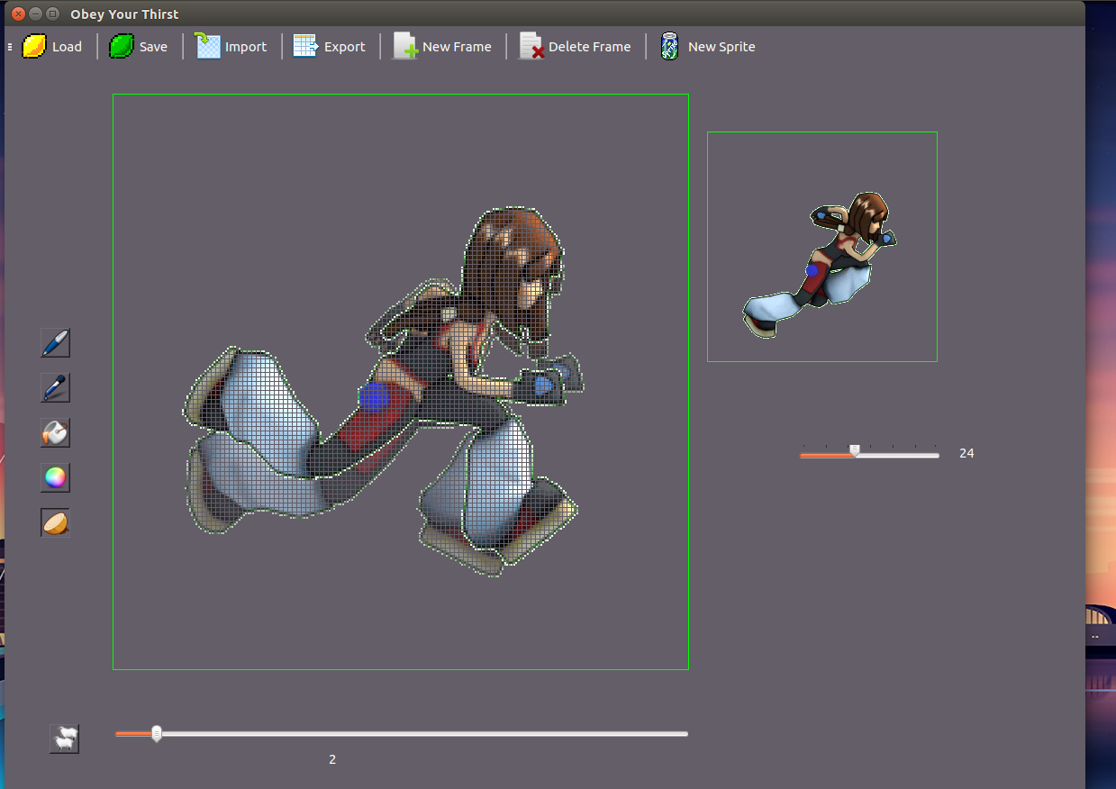

Creating, editing and saving sprites is pretty cool, but sometimes you want to do stuff with .gifs. If you have a gif file that you wish to edit, click on the import button, choose the gif file you want to edit, and the sprite editor will do the rest. To export a sprite that you have made or an edited gif file as a gif file, select the export button, name your new gif including the .gif extension, and your gif will be created. There are certain formats of gifs that don’t play nicely with the sprite editor, so if a gif won’t import, try another gif. Below is a screenshot of a sprite that has been loaded in from a gif:

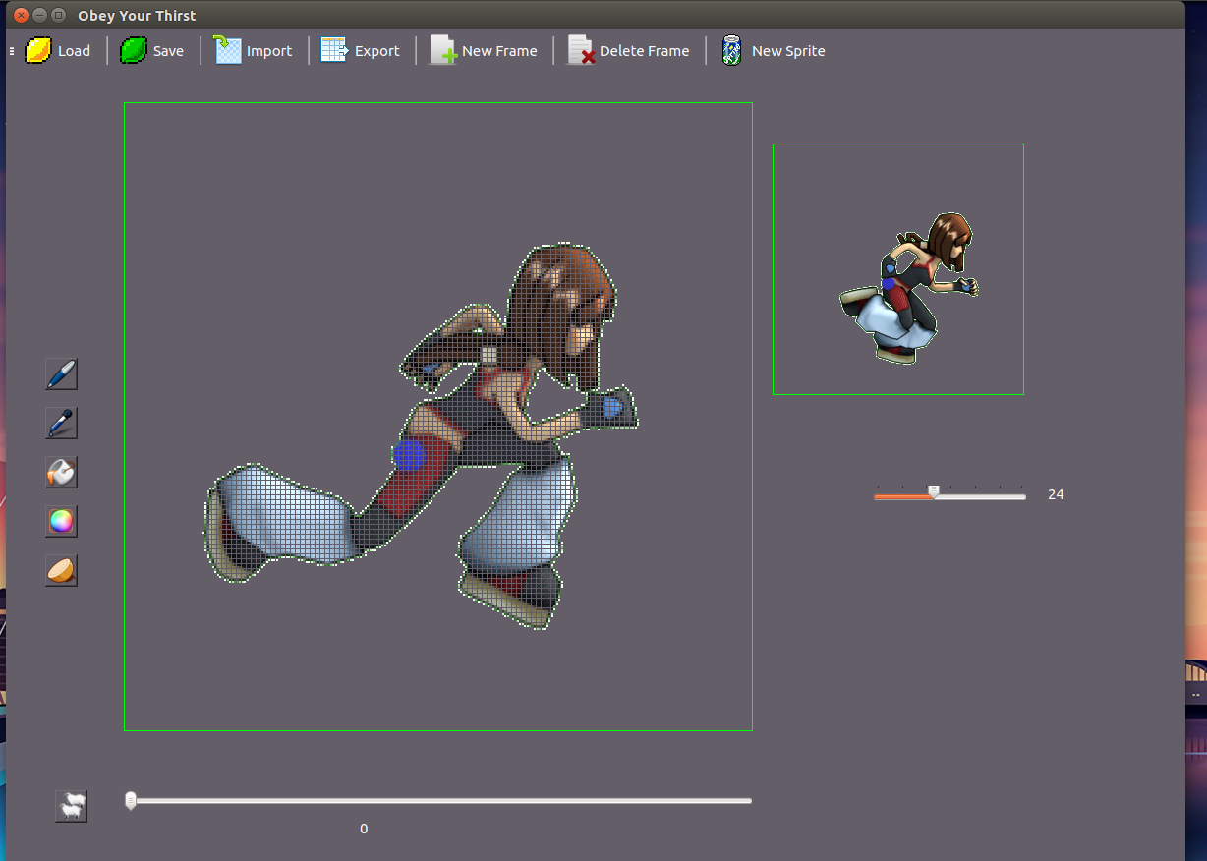

Obey Your Thirst would like to thank Kopakc from Github for his library [WriteToGif](https://github.com/Kopakc/WriteAnimatedGIF). It is due to his work that our export gif functions work. Obey Your Thirst would also like to thank the people who created Magick++, the C++ API for ImageMagick. Without them, importing gif files would not have worked either. In the words of Einstein, our application stands on the shoulders of giants.