**Harbor Problem (PDDL)**

**Problem description**:

There is a harbor that includes a number of docks where stacks of containers are located. Each dock can host an infinite number of container stacks. The docks are connected by bidirectional roads, allowing robots (trucks) equipped with cranes to move between them. These robots can lift and carry one container at a time (maximum capacity per robot = 1 container), stack a container on top of another, or create a new stack. Each dock in the harbor can host only one robot at any given time.

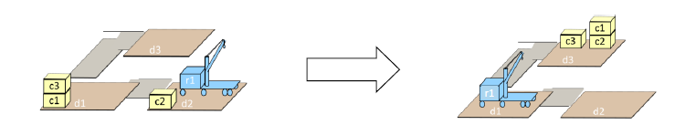

In the problem depicted in the diagram, there are 3 docks (d1, d2, d3), 3 containers (c1, c2, c3), and one robot (r1). There are 2 roads: one connecting d1 to d3 and another connecting d2 to d1. In the initial state, there is a stack of two containers at d1 (c1←c3) and a stack of one container (c2) at d2, while r1 is located at d2.

The goals of the problem are for r1 to be at d1, and for there to be 2 stacks at d3 (c3 and c2←c1).

**Domains:**

* **Docks:** Connected by bidirectional roads.
* **Containers:** Containers are located at docks, and can be placed on top of other containers.
* **Robot:** Robots can move between docks via the bidirectional roads, they can pick up and carry 1 container and place it to a dock.

**Problem Analysis:**

* **Connected docks:** Docks d1-d2 and d1-d3 are connected.
* **Containers:** Initially, container c2 is located at d2, c1 and c3 are located at d1, and c3 is on top of c1.
* **Robots:** Initially, robot r1 is at dock d2.
* **Goal:** Containers c1, c2 and c3 are located in dock d3, container c1 is on top of c2, and robot r1 is at d1.

**Optimal Plan:**

1. (move r1 d2 d1)
2. (unstack r1 c1 c3 d1)
3. (move r1 d1 d3)
4. (drop r1 c3 d3)
5. (move r1 d3 d1)
6. (pickup r1 c1 d1)
7. (move r1 d1 d2)
8. (drop r1 c1 d2)
9. (pickup r1 c2 d2)
10. (move r1 d2 d1)
11. (move r1 d1 d3)
12. (drop r1 c2 d3)
13. (move r1 d3 d1)
14. (move r1 d1 d2)
15. (pickup r1 c1 d2)
16. (move r1 d2 d1)
17. (move r1 d1 d3)
18. (stack r1 c2 c1 d3)
19. (move r1 d3 d1)