**Postman Problem Modeling with FDR**

Μπουλιώνης Θανάσης ΑΕΜ: ΤΝ - 189

**Problem Scenario:**

In a city, several postmen are responsible for collecting letters from houses and depositing them into designated mailboxes. The city consists of a set of points connected by walkable roads. Each point may contain a mailbox and/or a house.

The postmen can walk along the roads, collecting letters from houses and delivering them to any mailbox. Additionally, the city has a circular metro system that the postmen can use for transportation. The metro follows a one-way route, and there are designated boarding/alighting stations at certain points along its path.

To move from one point to another, a postman must either walk along a connecting road or use the metro, provided that both points are metro stations and the movement follows the metro's direction.

### Notes:

* There can be multiple houses, letters, postmen, and mailboxes.
* Each postman can carry multiple letters at once.
* A letter is considered delivered once it is placed in any mailbox within the city.
* Solid lines represent walkable roads, dashed lines represent metro routes, and points marked with a double ellipse indicate metro stations.

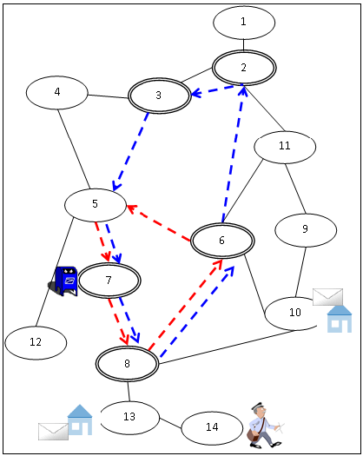

**Objects:**

* **City Nodes**: Connected by bidirectional roads and directional metro routes.
* **Metro Stations:** Where metro can be boarded and off-boarded.
* **Houses:** Contain mails to be collected.
* **Mailbox:** Where mails are to be delivered.
* **Postman:** Moves and collects mails, can carry multiple mails at a time.

**Problem Analysis:**

We need to define the problem in a way that there can be multiple postmen, mails and mailboxes, in other words, to be scalable.

We’ll go by the simple example shown above where we have 1 postman, 1 mailbox and 2 mails:

1. **Define Domains:**

* *Nodes*
* *Postmen*
* *Mails*
* *Mailboxes*
* *Positions:* These are all the positions a mail can be at.

1. **Bidirectional Roads:** Roads that the postman can walk on.
2. **Metro Routes:** One-way routes from station to station. Pay attention where the postman can board, and leave the metro (only on stations).
3. **Define state variables:**

* *Postmen location*
* *Mailboxes location*
* *Mails position*: Mails can be positioned in mailboxes and on postmen as well.

1. **Postman:**

* Can walk on bidirectional roads.
* Can take the metro at metro stations.
* Can collect mail from houses.
* Can deliver mail to the mailbox.

1. **Initial state:**

* House Nodes: 10, 13
* Metro Stations: 2, 3, 6, 7, 8
* Mailbox Nodes: 7
* Postman Nodes: 14

1. **Goal:**

* All mail is inside the mailbox.

**Plan:**

(9 Step)

1. Walk from node 14 to node 13
2. Collect mail
3. Walk on node 8
4. Walk on node 10
5. Collect mail
6. Walk on node 6
7. Take the metro to node 7
8. Deliver mail
9. Deliver mail.

