2D Ising Model
Prajwal Mohanmurthy
Mississippi State University, MS, USA
(Mar 23, 2012)

A 2D spin system will be modeled using numerical Ising model. While 1D system can be solved analytically, it is very difficult to solve a 2D spin system analytically. The difficulty arises in part due to the complexity in the method to calculate the partition function in 2D. The Ising model which was built for the Honors project as a part of PH 4413: Thermal Physics and Statistical Mechanics using the conventional metropolis algorithm will be extended to use Wang-Landau sampling. Also, the code which involved nearest neighbor interaction in a square lattice will be extended to include interactions over a torus topology for second and third nearest interactions. Besides a square lattice, rectangular, triangular and hexagonal lattices will also be investigated. Dependence of the correlation function with temperature will be studied along with studying the system close to the critical temperature using renormalization group transformation. Time permitting; the above investigations will be optimized using Swendsen-Wang and Wolff algorithms.

1. Proposed Methods and Ideas
The critical temperature in simple 2D spin system will be found out for each of the system investigated. This could be easily done by studying the total system energy after N iterations. Another area of interest near critical temperature is the behavior of the correlation length. Ideally the correlation length must diverge at the critical temperature. While it is not expected that the established behavior for the nearest neighbor interaction will change if second and third nearest neighboring interactions are added, the behavior of these might change dramatically in other lattices such as hexagonal or triangular. Block spin transformation introduces variations in system temperature, i.e. after a block spin transformation the temperature scale for the system changes. Variations in the behavior of the systems after successive block spin transformations will be investigated. Using this change in temperature scale, the convergence of system temperature after N block spin transformations will also be studied. The value that the system temperature converges to might depend on the initial temperature. This will be taken into consideration in this study as well. A more efficient way to carry out the metropolis algorithm is to employ the Wang – Landau sampling which takes into account the density of states for the system. This dramatically reduces the time scales required for computing. If time permits, more optimizations algorithms such as Swendsen-Wang and Wolff algorithms which essentially involve reducing the system to multiple spin clusters similar to those in block spin transformation but with random effective spin will be implemented. The reduction in computational time scales will be reported for appropriate cases in which the corresponding algorithm is effective.

2. Preliminary Results
The code which already exists can be used to see how the grid evolved with time for various temperatures as illustrated in Figure.1 and Figure.2.
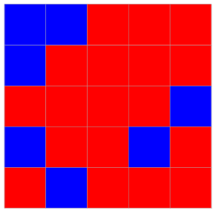
Figure.1. Initial and final grid for T=20K
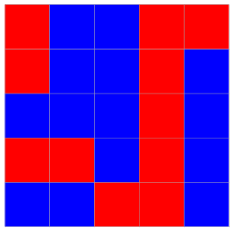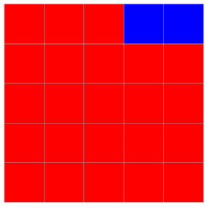
Figure.2. Initial and final grid for T=2K
Similarly, the correlation function has been plotted out for different lengths. The correlation length could be calculated using bisection. A good way to verify the simulations results is to compare the results for a 1D simulation which has a simple analytic solution. Values such as magnetization, total energy and heat capacity should be easy to computer using the simulation. Though plots for convergence of temperature after a number of block spin transformation is carried out is not presented here, the temperatures must converged to the critical temperature, 0 or infinity.

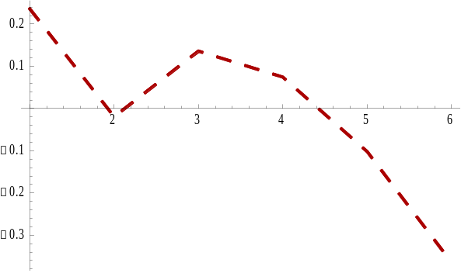
Figure.3. Plot showing the correlation function T=4K

References

DV. Schroeder, An Introduction to Thermal Physics, Chapter 8: 339-56 (Addison Wesley)

RH. Landau, MJ. Paez and, CC. Bordeianu, A Survey of Computational Physics, Chatper 15: 393-409 (Princeton Press)

