

Author: Joseph Lapuz, CBAP, CSM Wellington, New Zealand

Date Created: December 2016 Last Update Date: July 2018 Email: [josephlapuz@gmail.com](mailto:josephlapuz@gmail.com)

The Guide to the Business Analysis Body of Knowledge (BABOK)™ Version 3.0 Framework

1. INTRODUCTION

# DESCRIPTION

A Guide to the Business Analysis Body of Knowledge® (BABOK® Guide) is the globally recognised standard for the practice of business analysis. The BABOK® Guide describes business analysis knowledge areas, tasks, underlying competencies, techniques and perspectives on how to approach business analysis.

# PURPOSE

The primary purpose of the BABOK® Guide is to define the profession of business analysis and provide a set of commonly accepted practices. It helps practitioners discuss and define the skills necessary to effectively perform business analysis work. The BABOK® Guide also helps people who work with and employ business analysts to understand the skills and knowledge they should expect from a skilled practitioner.

# KNOWLEDGE AREAS

Knowledge areas represent areas of specific business analysis expertise that encompass several tasks. The six knowledge areas are:

* 1. **Business Analysis Planning and Monitoring:** describes the tasks that business analysts perform to organise and coordinate the efforts of business analysts and stakeholders. These tasks produce outputs that are used as key inputs and guidelines for the other tasks throughout the BABOK® Guide.
  2. **Elicitation and Collaboration:** describes the tasks that business analysts perform to prepare for and conduct elicitation activities and confirm the results obtained. It also describes the communication with stakeholders once the business analysis information is assembled and the ongoing collaboration with them throughout the business analysis activities.
  3. **Requirements Life Cycle Management:** describes the tasks that business analysts perform in order to manage and maintain requirements and design information from inception to retirement. These tasks describe establishing meaningful relationships between related requirements and designs, and assessing, analyzing and gaining consensus on proposed changes to requirements and designs.
  4. **Strategy Analysis:** describes the business analysis work that must be performed to collaborate with stakeholders in order to identify a need of strategic or tactical importance (the business need), enable the enterprise to address that need, and align the resulting strategy for the change with higher- and lower-level strategies.
  5. **Requirements Analysis and Design Definition:** describes the tasks that business analysts perform to structure and organise requirements discovered during elicitation activities, specify and model requirements and designs, validate and verify information, identify solution options that meet business needs, and estimate the potential value that could be realised for each solution option. This knowledge area covers the incremental and iterative activities ranging from the initial concept and exploration of the need through the transformation of those needs into a particular recommended solution.
  6. **Solution Evaluation:** describes the tasks that business analysts perform to assess the performance of and value delivered by a solution in use by the enterprise, and to recommend removal of barriers or constraints that prevent the full realization of the value.

# DIAGRAM

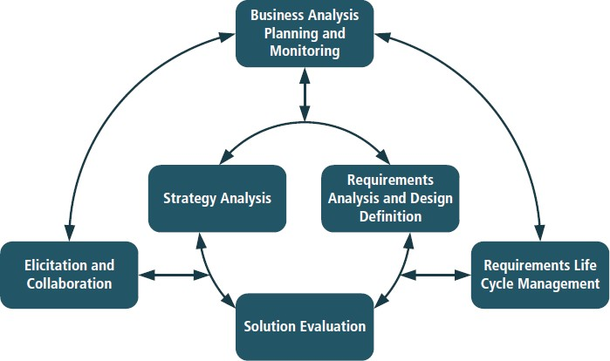

STRUCTURE OF THE BABOK GUIDE

The core content of the BABOK® Guide is composed of business analysis tasks organized into knowledge areas. Knowledge areas are a collection of logically (but not sequentially) related tasks. These tasks describe specific activities that accomplish the purpose of their associated knowledge area. The Business Analysis Key Concepts, Underlying Competencies, Techniques, and Perspectives sections form the extended content in the BABOK® Guide that helps guide business analysts to better perform business analysis tasks.

* **Business Analysis Key Concepts:** define the key terms needed to understand all other content, concepts, and ideas within the BABOK® Guide.
* **Underlying Competencies:** provide a description of the behaviours, characteristics, knowledge, and personal qualities that support the effective practice of business analysis.
* **Techniques:** provide a means to perform business analysis tasks. The techniques described in the BABOK® Guide are intended to cover the most common and widespread techniques practiced within the business analysis community.
* **Perspectives:** describe various views of business analysis. Perspectives help business analysts working from various points of view to better perform business analysis tasks, given the context of the initiative.

Each task in the BABOK® Guide is presented in the following format:

* Purpose
* Description
* Inputs
* Elements
* Guidelines/Tools
* Techniques
* Stakeholders
* Outputs