**Array Data Structure**

**What is called arrays?**

An array is a collection of elements stored in a contiguous memory location. It may have the same or different types of elements.

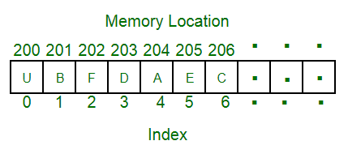

**Why arrays?**

Arrays are used when we need to store many variables with the same type. Instead of creating N number of variables we can use an array of N length.

**How does it work?**

Arrays are stored in contiguous memory locations. Base address of the array stored in the array variable. Using base reference and index we can access and modify every item in the array with constant time.

**How does the index of an array work:**

An array divided into N number of equal size of blocks. For example an int takes 4bytes of memory so that an int array can be divided into blocks where each block must contain 4bytes of memory**.**

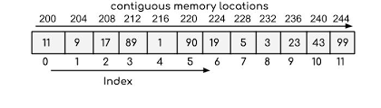

**Formula:**

base = 200

size_of_item = 4bytes or size(int)

index = _______

Item = base+(size_of_item*index)