Landing Page screenshots:

**Landing Page:**

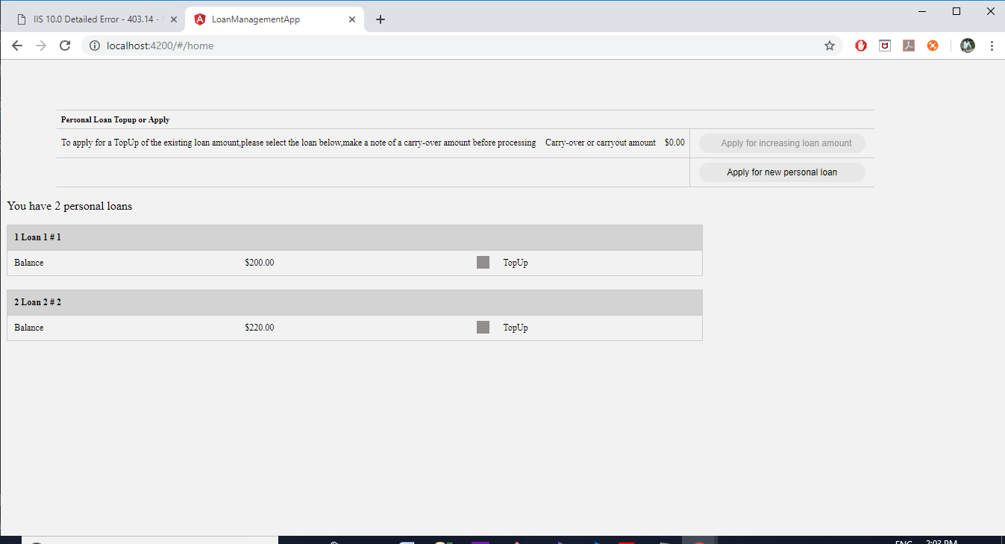

**Landing Page in small screen**

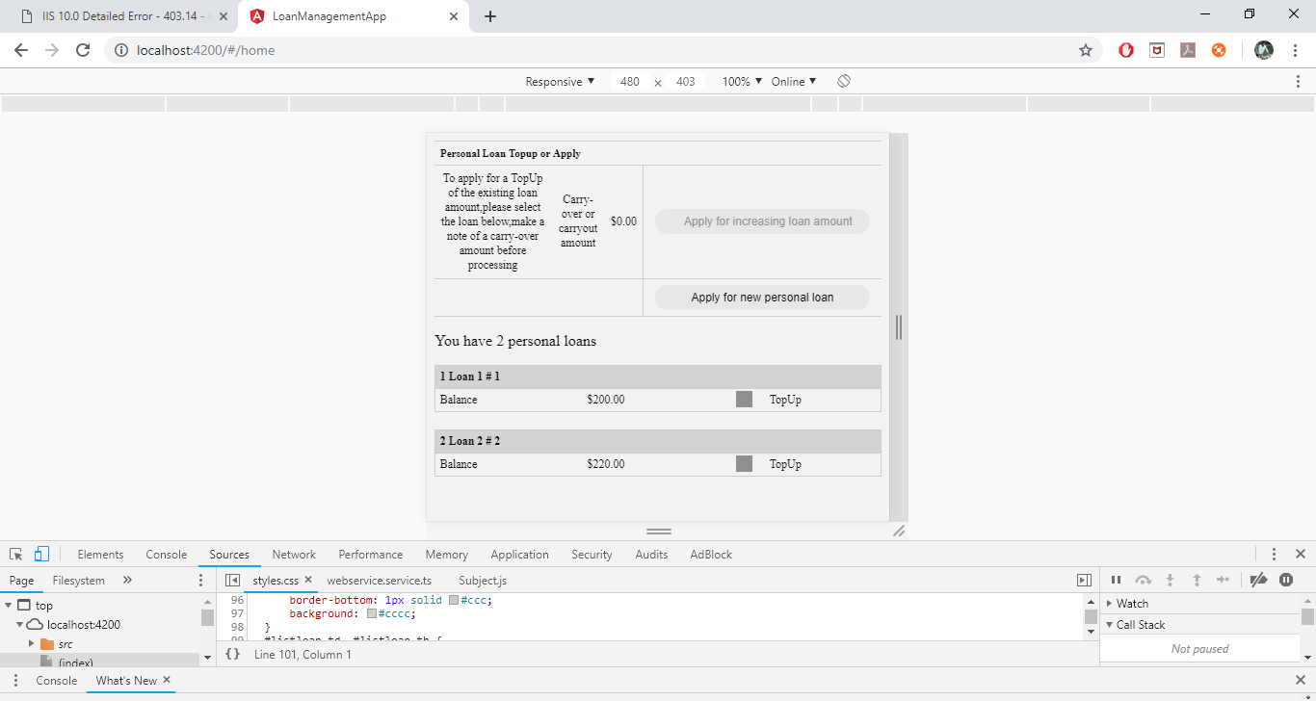

**Landing Page in Very Small screen**

