Debtor Management
Debtor Management covers the student and fee payer record management that underpins accurate fee generation. It includes verifying that each student has the correct academic year, enrolment dates, and sibling order assigned before any fee batch is run, and confirming that financial responsibility percentages across all fee payers on a student's account total 100. It also covers the setup of split financial responsibility, allowing schools to define default billing percentages across multiple fee payers such as parents or guardians. Any errors in this data at the debtor level flow directly through to generated invoices, making this a critical step before running any billing cycle.

Student Master
Accurate fee generation depends entirely on the quality of the data held against each student's record. Before running any fee batch, it is essential to verify that each student has the correct academic year assigned, that their enrolment effective and expiration dates are current, that sibling order numbers are set for students eligible for family discounts, and that the financial responsibility percentages across all fee payers add up to 100. Any gaps or errors in this data at this stage will flow through to the invoices generated, making it significantly harder to correct after the fact.

Check Student Master
- From the FNO dashboard, open Modules ▸ Academic Management.
- Expand Students and click All students.
- Click on a student's name to retrieve their details.
- Confirm the Current academic year under Enrolment details and update if required in the student management system.
- Open the Academic tab in the top toolbar.
- Click on Academic enrolments under Related information.
- Confirm the Effective date and Expiration date and update if needed.
- Click Back in the top toolbar.
- If the student has siblings, confirm the Sibling field under General has a number (e.g., eldest sibling = 1).
- In the Relationships section, ensure the total Paid percentage equals 100.00.
- Click Save if any changes were made.
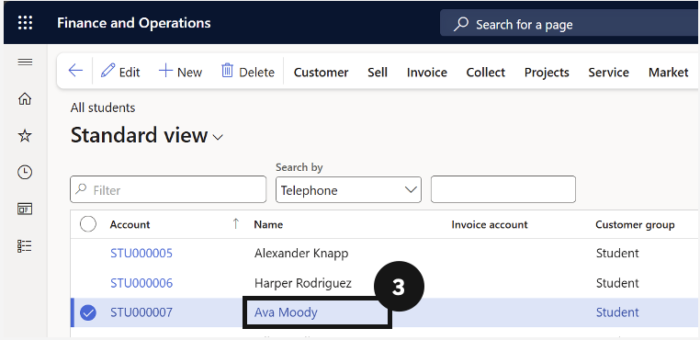
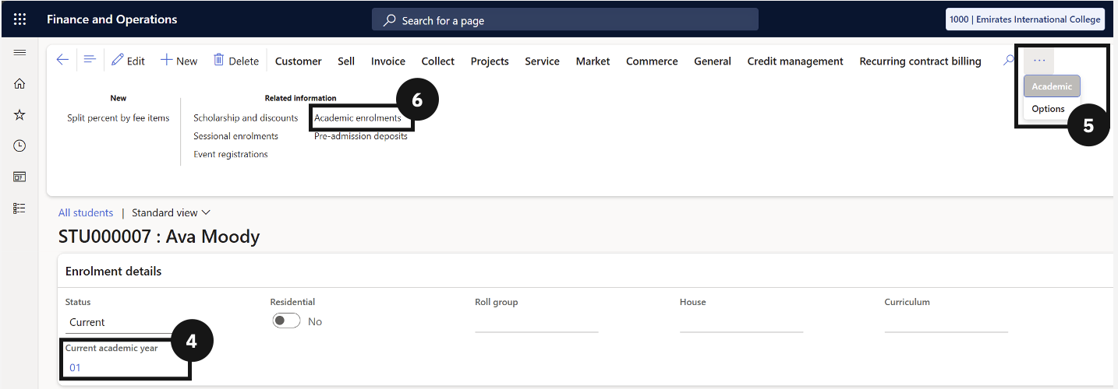
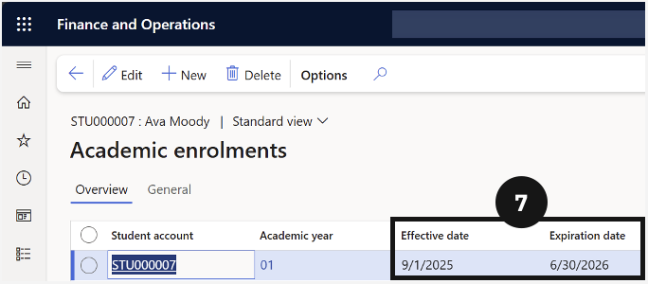
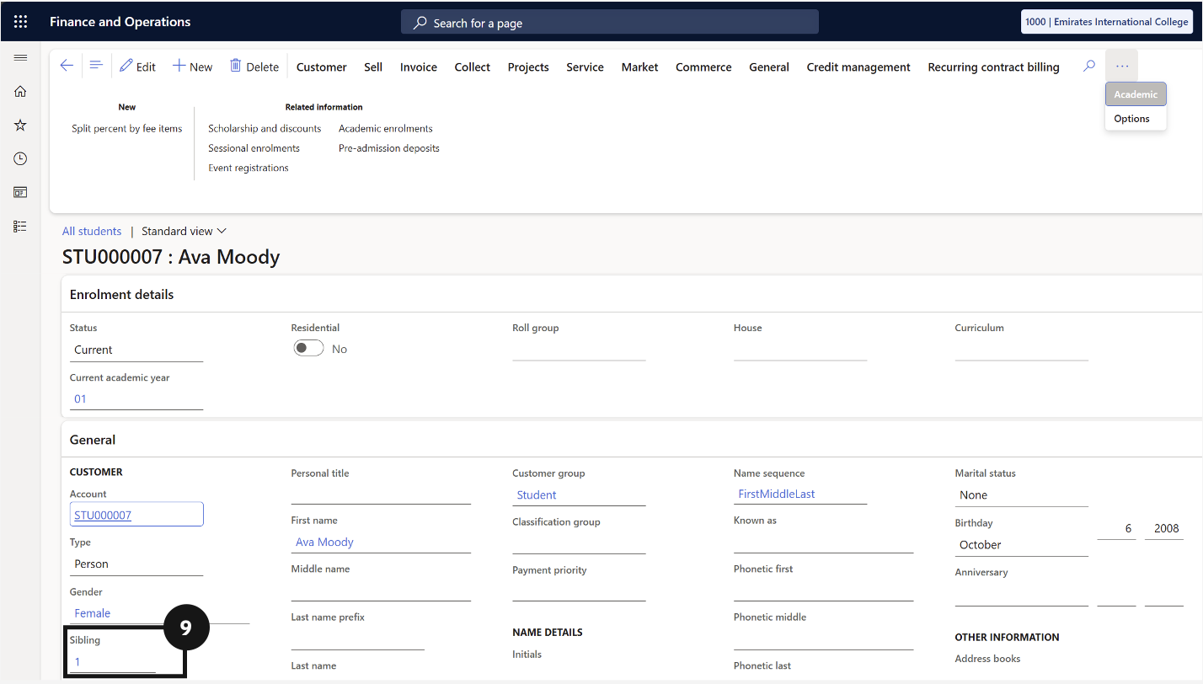

Fee Payer as Customer

Student Setup – Financial Responsibility
- From the FNO dashboard, open Modules ▸ Academic Management.
- Expand Students and click All students.
- Select the student profile.
- Under the student's account in the Relationships section, ensure at least two fee payers are assigned (e.g., Mom and Dad).
- Assign default split percentages for each payer (e.g., 50% each).
Note: This is the baseline for all fees unless overridden.
