COMP 5970/6970 Project 2: 15 points 15% Credit

**Submission due before 11:59 PM Monday March 4**

Instructions:

1. This is a group project. You should do your own work while working collaboratively as a group. Any evidence of copying either from a public source or from the works of other groups without due credits will result in a zero grade and additional penalties/actions against **all members of the involved groups.**
2. **No show in project presentation or final submissions by email or late submissions (even by minutes) will receive a zero grade for the entire group.** No makeup will be offered unless prior permission has been granted, or there is a valid and verifiable excuse.

Submission:

For 5970, one member from each group will upload the following to canvas before 11:59 PM Monday March 4:

1. **Source Code (Member 1)**: Python source files (upload .zip file in case of multiple files) containing your code only (no test data needed) and ReadMe.txt file (template provided) describing how to run your code. Note that we will NOT debug your code. If your code does not execute as described in ReadMe.txt, you will receive a zero grade.
2. **Presentation Slide (Member 2)**: One slide only in PPT/PPTX/PDF format to be used during the oral presentations (see below). If you submitted file span more than a page, we will extract the first page for the oral presentation.
3. **Project Report (Member 3)**: Completed report document in PDF format using template provided. Make sure to have all necessary sections of scientific writing: abstract, introduction, methods, results, discussion, references.

For 6970, one member from each group will upload the following to canvas before 11:59 PM Monday March 4:

1. **Source Code and Project Report (Member 1)**: (i) Python source files (upload .zip file in case of multiple files) containing your code only (no test data needed) and ReadMe.txt file (template provided) describing how to run your code. Note that we will NOT debug your code. If your code does not execute after following your instructions laid out in ReadMe.txt, you will receive a zero grade. (ii) Completed report document in PDF format using template provided. Make sure to have all necessary sections of scientific writing: abstract, introduction, methods, results, discussion, references.
2. **Presentation Slide and Video Demo (Member 2)**: (i) One slide only in PPT/PPTX/PDF format to be used during the oral presentations (see below). If you submitted file span more than a page, we will extract the first page for the oral presentation. (ii) A video demonstration not more than 5 minutes in duration containing a creative demonstration of the working dynamics of your program and the results achieved. Creative ways of visualization and use of graphic tools are encouraged. Please use widely recognized formats for videos.

Presentations:

Presentation will be during the class on **Wednesday March 6** and **Friday March 8**.

For 5970, the member submitting presentation slide will deliver 5 minutes flash presentation accompanied by the submitted slide:

1. At the least, your presentation should contain methods (i.e. implementation), results (e.g. output), and conclusion.
2. Practice your talk not to exceed the time limit or finish too early.
3. No need to bring your slides. We will set things up and decide the presentation sequence.

For 6970, the member submitting presentation slide and video demo will deliver 5 minutes flash presentation accompanied by the submitted slide followed by additional 5 minutes of demo accompanied by the submitted video:

1. At the least, your presentation should contain methods (i.e. implementation), results (e.g. output), and conclusion.
2. Practice your talk not to exceed the time limit or finish too early.
3. The video demo may be accompanied by oral presentation.
4. No need to bring your slides/demo. We will set things up and decide the presentation sequence.

**Implementing decision tree for protein RSA prediction**

Objective: Implement decision tree for protein relative solvent accessibility prediction.

Note: You must use standard Python programming language. You are NOT allowed to use non-standard packages or libraries (e.g. Biopython, scikit-learn, SciPy, NumPy, etc.).

**A: Raw Data:**

Two directors (*fasta* and *sa*) are supplied. The *fasta* directory contains 150 protein sequences in FASTA format. A FASTA file is as follows:

>sequenceID   
AAGTAGGAATAATATCTTATCATTATAGATAAAAACCTTCTGAATTTGCTTAGTGTGTATACGACTAGACATATATCAGCTCGCCGATTATTTGGATTATTCCCTG

The true binary relative solvent accessibility (RSA) labels of these proteins can be found in the *sa* directory. This file is also in FASTA format. RSA labels having two possible values:

‘E: exposed

‘B’: buried

N.B. The true RSA labels are calculated using the DSSP (Dictionary of Protein Secondary Structure: Pattern Recognition of Hydrogen-Bonded and Geometrical Features. Kabsch and Sander, 1983) software at a 25% threshold.

**B: Curating Training and Test (and optionally Validation) Datasets:**

Divide the raw data into non-overlapping sets of training (~75%) and test (~25%) datasets using simple random sampling without replacement. You may further divide the resulting training subset to create a validation set to avoid overfitting (not mandatory to create a validation set).

**C. Feature Extraction:**

Using chemical properties of 20 naturally occurring amino acid residues as detailed in Table 1 and Figure 1, construct a feature matrix (or vector) for the training and test datasets (and optionally validation datasets.

**Table 1.** Chemical properties of 20 naturally occurring amino acid residues (Livingstone & Barton, CABIOS, 9, 745-756, 1993)

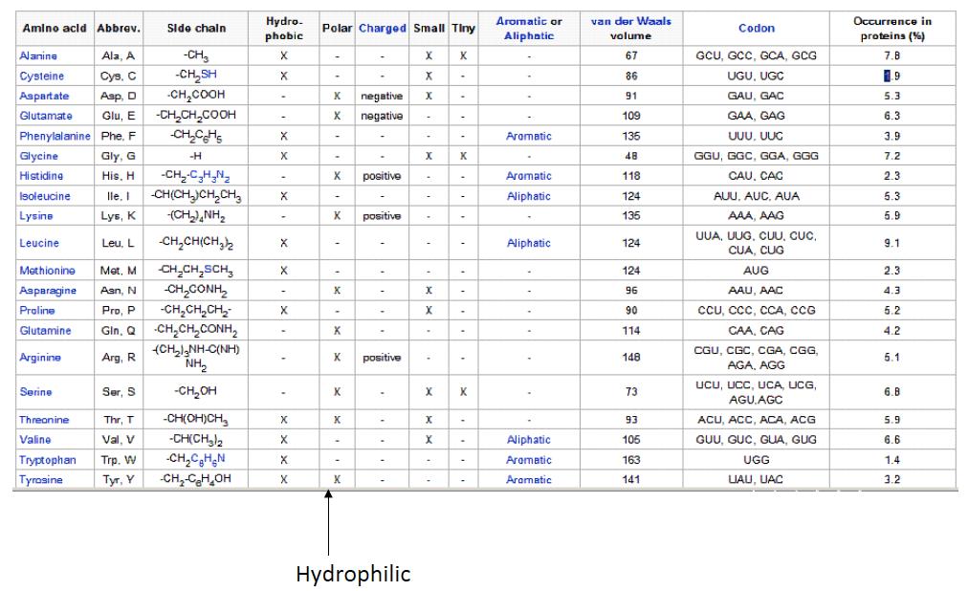

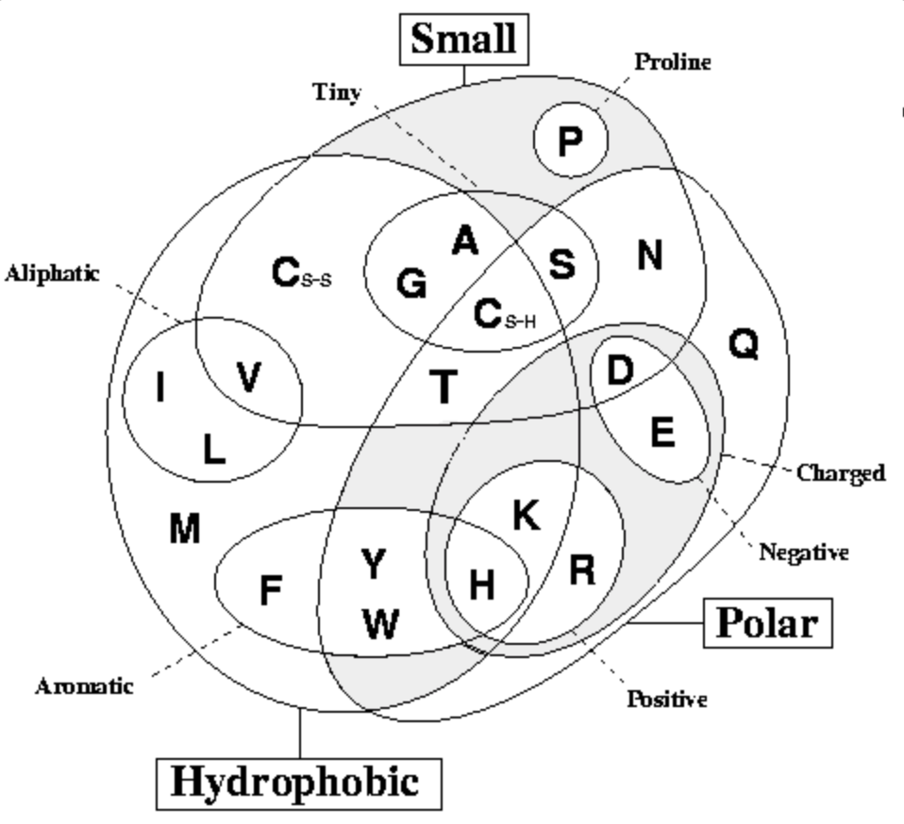

**Figure 1.** Venn diagram of chemical properties of 20 naturally occurring amino acid residues (Livingstone & Barton, CABIOS, 9, 745-756, 1993)

Specifically, the feature set should include the following binary attributes:

|  |  |
| --- | --- |
| **Attribute** | **Description** |
| Hydrophobic | Whether a residue is hydrophobic |
| Polar | Whether a residue is hydrophobic |
| Small | Whether a residue size is small |
| Proline | Whether a residue is Proline (PRO, P) |
| Tiny | Whether a residue size is tiny |
| Aliphatic | Whether a residue is Aliphatic |
| Aromatic | Whether a residue is Aromatic |
| Positive | Whether a residue is Positively Charged |
| Negative | Whether a residue is Negatively Charged |
| Charged | Whether a residue is Charged |

The output labels are already binary (e.g. 1 for exposed, 0 for buried or vice versa).

**D. Decision Tree Learning using ID3 on Training Set:**

Implement the ID3 decision tree learning algorithm that follows a greedy top-down growth of the tree using information gain to learn the best hypothesis on training dataset. You may optionally reduce overfitting by implementing reduced error pruning algorithm over the validation set.

**E. Decision Tree Classification on Test Set:**

Implement decision tree classification algorithm that walks on the trained tree generated from step D and output predicts labels on test dataset.

N.B. ID3 decision tree is an offline-learning algorithm. Therefore, training and classification should be implemented separately. The classification algorithm should take a protein sequence in FASTA format as an input and predict labels in a standalone mode. You may save the parameters learned during training in a file that can be fed into the classifier, in an offline mode.

**F. Evaluate Accuracy:**

Use Precision, Recall, Accuracy, F-1 score, Mathews Correlation Coefficient (MCC) to calculate the accuracy of the decision tree classifier implemented in step E on test dataset.