COMP 5970/6970 Project 5: 15 points 15% Credit

**Final Submission due before 11:59 PM Monday April 22**

Instructions:

1. This is a group project. You should do your own work while working collaboratively as a group. Any evidence of copying either from a public source or from the works of other groups without due credits will result in a zero grade and additional penalties/actions against **all members of the involved groups.**
2. **No show in project presentation or final submissions by email or late submissions (even by minutes) will receive a zero grade.** No makeup will be offered unless prior permission has been granted, or there is a valid and verifiable excuse.

Submission:

For 5970, one member from each group will upload the following to canvas before 11:59 PM Monday April 22:

1. **Source Code (Member 1)**: Python source files (upload .zip file in case of multiple files) containing your code only (no test data needed) and ReadMe.txt file (template provided) describing how to run your code. Note that we will NOT debug your code. If your code does not execute as described in ReadMe.txt, you will receive a zero grade.
2. **Presentation Slide (Member 2)**: One slide only in PPT/PPTX/PDF format to be used during the oral presentations (see below). If you submitted file span more than a page, we will extract the first page for the oral presentation.
3. **Project Report (Member 3)**: Completed report document in PDF format using template provided. Make sure to have all necessary sections of scientific writing: abstract, introduction, methods, results, discussion, references.

For 6970, one member from each group will upload the following to canvas before 11:59 PM Monday April 22:

1. **Source Code and Project Report (Member 1)**: (i) Python source files (upload .zip file in case of multiple files) containing your code only (no test data needed) and ReadMe.txt file (template provided) describing how to run your code. Note that we will NOT debug your code. If your code does not execute after following your instructions laid out in ReadMe.txt, you will receive a zero grade. (ii) Completed report document in PDF format using template provided. Make sure to have all necessary sections of scientific writing: abstract, introduction, methods, results, discussion, references.
2. **Presentation Slide and Video Demo (Member 2)**: (i) One slide only in PPT/PPTX/PDF format to be used during the oral presentations (see below). If you submitted file span more than a page, we will extract the first page for the oral presentation. (ii) A video demonstration not more than 5 minutes in duration containing a creative demonstration of the working dynamics of your program and the results achieved. Creative ways of visualization and use of graphic tools are encouraged. Please use widely recognized formats for videos.

Presentations:

Presentation will be during the class on **Wednesday April 24** and **Friday April 26**.

For 5970, the member submitting presentation slide will deliver 5 minutes flash presentation accompanied by the submitted slide:

1. At the least, your presentation should contain methods (i.e. implementation), results (e.g. output), and conclusion.
2. Practice your talk not to exceed the time limit or finish too early.
3. No need to bring your slides. We will set things up and decide the presentation sequence.

For 6970, the member submitting presentation slide and video demo will deliver 5 minutes flash presentation accompanied by the submitted slide followed by additional 5 minutes of demo accompanied by the submitted video:

1. At the least, your presentation should contain methods (i.e. implementation), results (e.g. output), and conclusion.
2. Practice your talk not to exceed the time limit or finish too early.
3. The video demo may be accompanied by oral presentation.
4. No need to bring your slides/demo. We will set things up and decide the presentation sequence.

**Implementing Linear Regression for Pairwise Protein Structural Similarity Prediction**

Objective: Implement linear regression for pairwise protein structural similarity prediction.

Note: You must use standard Python programming language. You are NOT allowed to use non-standard packages or libraries (e.g. Biopython, scikit-learn, SciPy, NumPy, etc.).

**A: Raw Data:**

fasta, PSSM, and tmalign files for the set of 150 proteins are supplied.

**B: Curating Training and Test Datasets:**

First identify all unique pairs of proteins in the raw dataset and divide the unique pairs into non-overlapping sets of training (~75%) and test (~25%) datasets using simple random sampling without replacement. Be mindful of symmetry when identifying unique pairs of proteins (i.e. Protein_1 vs. Protein_2 is same as Protein_2 vs. Protein_1).

**C. Computing 3D Structural Similarity using TM-align**

After identifying all unique pairs of protein 3D structures, compute their structural similarity via TM-align. TM-align program can be located online at <https://zhanglab.ccmb.med.umich.edu/TM-align/>. For convenience, we have provided the result of running TM-align program for all pairs of proteins in the tmalign directory. The similarity between a pair of proteins is reported through “TM-score” and you will have to parse the tmalign output files to get these values.

Please note that TM-align structural comparison is not symmetric and so take the average of the two TM-scores reported by TM-align program (one normalized by length of Chain_1 and the other normalized by length of Chain_2).

Sample output of TM-align is shown below:

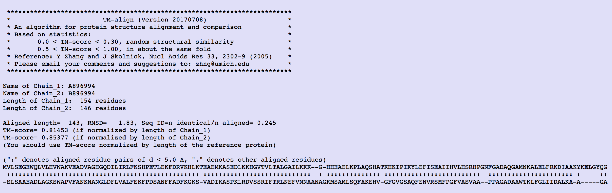

**D. Feature Generation:**

For each unique protein pair:

i) Use the average of the 20 PSSM “weighted observed percentages rounded down” and scale them down to a scale between 0 and 1 (i.e. divide by 100) from the .pssm file. For a pair of proteins, this would result in a total of 40 features (20 features/protein). Naturally, all features are in the range [0,1).

ii) Use your previously developed protein secondary structure predictor to predict three-class secondary structure of the protein pair from their primary sequence. Calculate the proportion of helix (H), strand (E), and coil (C) for each pair, resulting in a total of 6 features (3 features/protein). Consequently, all features are in the range [0,1).

iii) Use your previously developed protein solvent accessibility predictor to predict two-class solvent accessibility of the protein pair from their primary sequence. Calculate the proportion of exposed (E), buried (B) for each pair, resulting in a total of 4 features (2 features/protein). Again, all features are in the range [0,1).

**E. Linear Regression Learning on Training Set:**

Implement the gradient descent based optimization algorithm to learn the weight vector of Linear Regression using the training set. You may choose to optimize MCLE via batch gradient ascent or stochastic gradient ascent (or a combination of both).

**F. Linear Regression on Test Set:**

Implement Linear Regression using the learned weight vector to predict the TM-score of a pair of test protein from their FASTA formatted sequence. Note that you need to predict secondary structure and solvent accessibility for the protein pair using your previously developed program.

N.B. Linear Regression is an offline-learning algorithm. Therefore, training and prediction should be implemented separately. The prediction algorithm should take a protein sequence in FASTA format as an input and predict TM-score in a standalone mode. You may save the parameters learned during training in a file that can be fed into the prediction engine, in an offline mode.

**G. Evaluate Accuracy:**

Report accuracy of average squared error (true TM-score – predicted TM-score)2 on the test set.