Report Machine Learning Project
Group: Tran Khoi DANG, Kim Thang VO, Trung Thai DO, Minh Tue TRUONG
Date of submission: 28 May 2023

Introduction
This project is carried out as part of the 4GMM Machine Learning course at INSA Toulouse. In this project we studied the biodegradability of chemical components in the form of a binary classification problem. We carried out an in-depth study on how to approach a classification problem.
The data were extracted and formatted from the "QSAR biodegradation" dataset available on the UCI Machine Learning Repository. (Reference : Mansouri Kamel, Ringsted Tine, Ballabio Davide, Todeschini Robert, Consonni Viviana. (2013). QSAR biodegradation. UCI Machine Learning Repository)
The dataset includes 1055 observations and 41 variables, from which we selected 20 variables. The objective is to classify 1055 molecules into two classes (ready biodegradable or not ready biodegradable). It is therefore a supervised (binary) classification problem, for which we will apply and compare different models.

Data preprocessing
In this step, we checked that the data don’t have any missing values. One can also check for the outliers (anomalies), but we will do it in the exploratory data step.
We will also encode our target into 0 or 1 in Python (in factor with levels 1, 2 in R). The target refers to the response variable (will be detailed in the next section).

Exploratory data analysis
In this section, we establish our first exploratory data analysis (EDA) to better understand the dataset. To do that, we will do univariate, bivariate, correlation analysis. The objective is to:
- capture the distribution of explanatory variables and of response variable in the dataset
- check if there are outliers, if we need to handle them;
- check if there are qualitative variables with too many modalities that we want to group in favor of some further machine learning methods
- check if we need to transform quantitative variables to be more ‘gaussian’
- check if there are relations between the explanatory variables (in term of correlation for example)
- check if there are relations between the explanatory variables and the response variable

3.1. Response variable
The response variable is the expected result variable that we seek to explain with the explanatory variables (or predictor variables). In our case, if we denote Y the response variable, and X1, …, X20 the explanatory variables, then Y is the qualitative variable with two modalities (or categories) : RB and NRB, respectively indicating if the molecule observed is or not ready biodegradable. The 20 explanatory variables are the 20 attributes (or molecular descriptors) of the molecules.
The response variable of the dataset obviously is unbalanced in terms of category : there are nearly twice more non-biodegradable individuals than biodegradable.
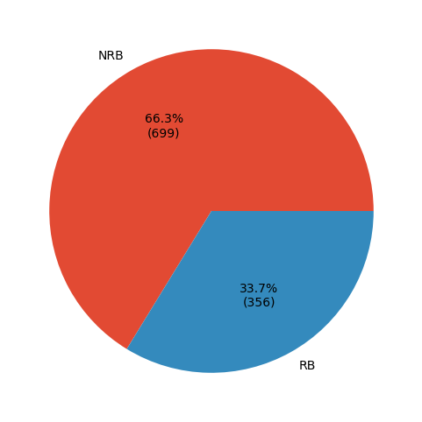
Fig 1 - Distribution of response variable

3.2. Quantitative explanatory variables
Apart from FO3[C-O], BO1[C-Br] and BO3[C-Cl], the remaining variables are quantitative variables.

3.2.1. Univariate analysis
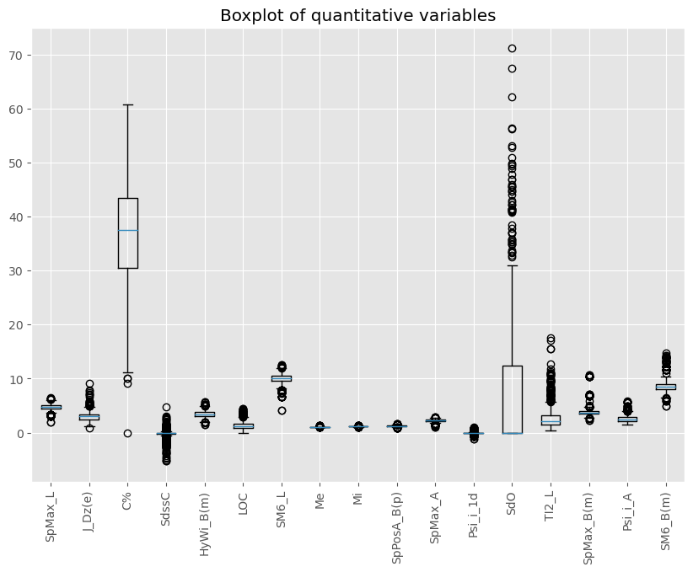
Fig 2 - Boxplot of quantitative variables
We notice the value and scale of these variables are very different, so data standardization is necessary. In addition, there are a large number of anomalies in many variables. We need to look at their distribution before deciding how to treat them.
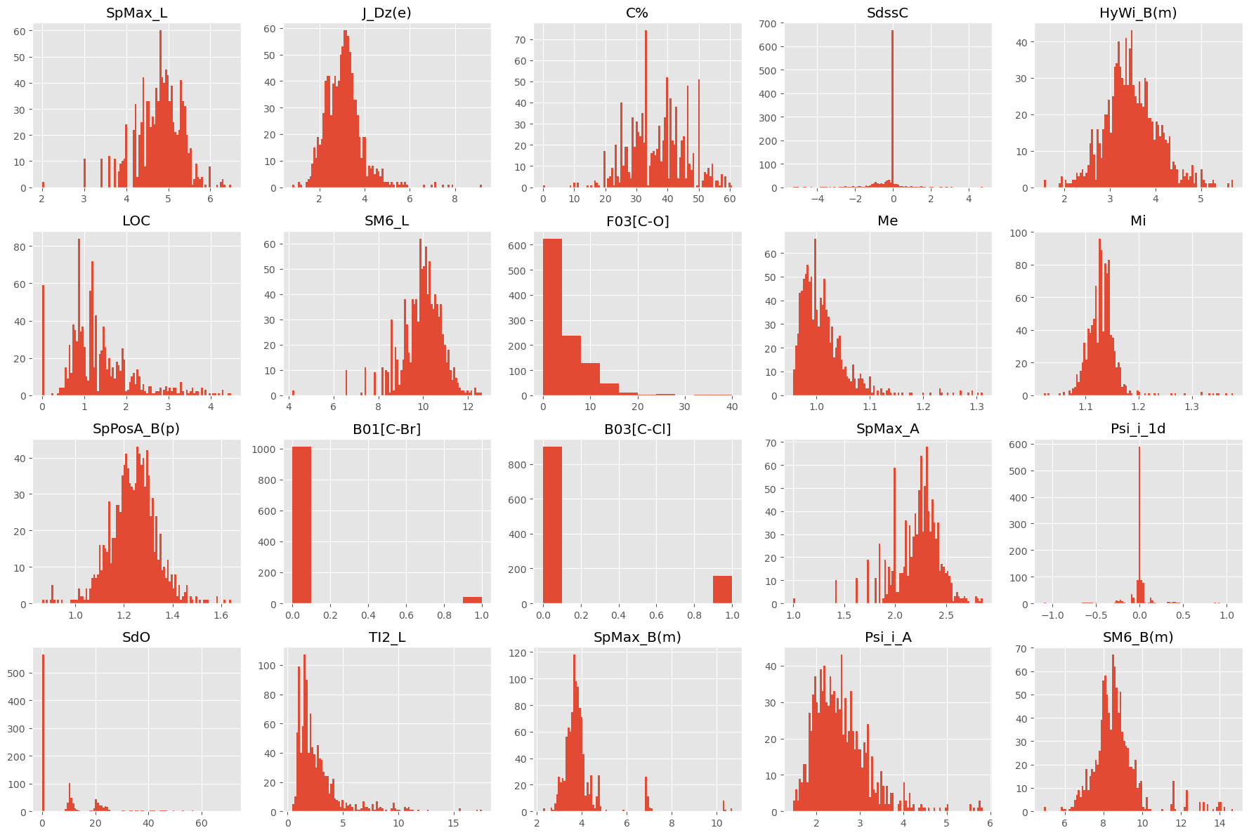
Fig 3 - Distribution of variables

The shape of these distributions suggests transforming some of them could be beneficial to the later machine learning process. Here, we mainly try to reduce the skewness of appropriate quantitative variables via log or square root function. The distributions of transformed dataset is as below:
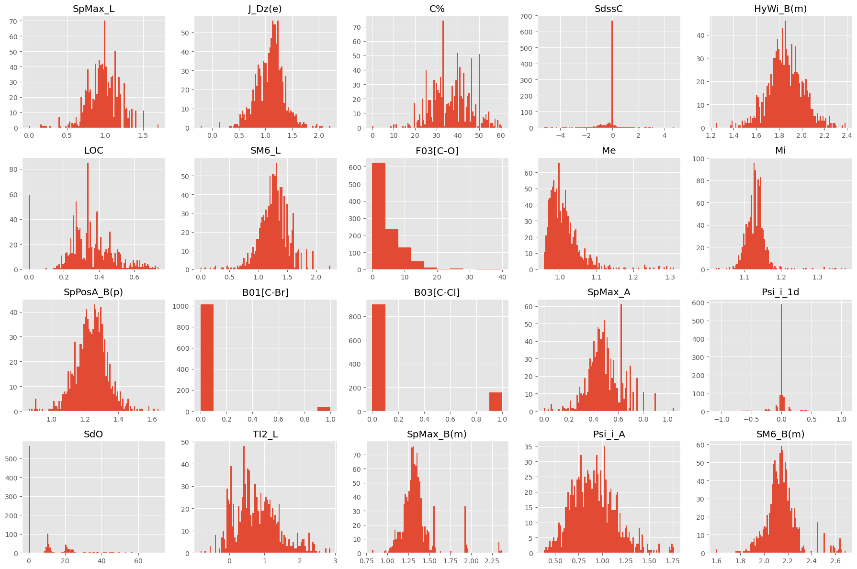
Fig 4 - Distribution of variables after reducing the skewness of appropriate quantitative variables

Transforming the data’s distribution won’t affect tree-based models such as CART, Random Forests, Boosting, but it may highly affect the results of Linear Regression, Logistic Regression and Neural Networks. In these last algorithms, we will do all manipulations on two datasets: the original and the transformed version, and we will select the better result corresponding to each method we apply.

3.2.2. Correlation analysis
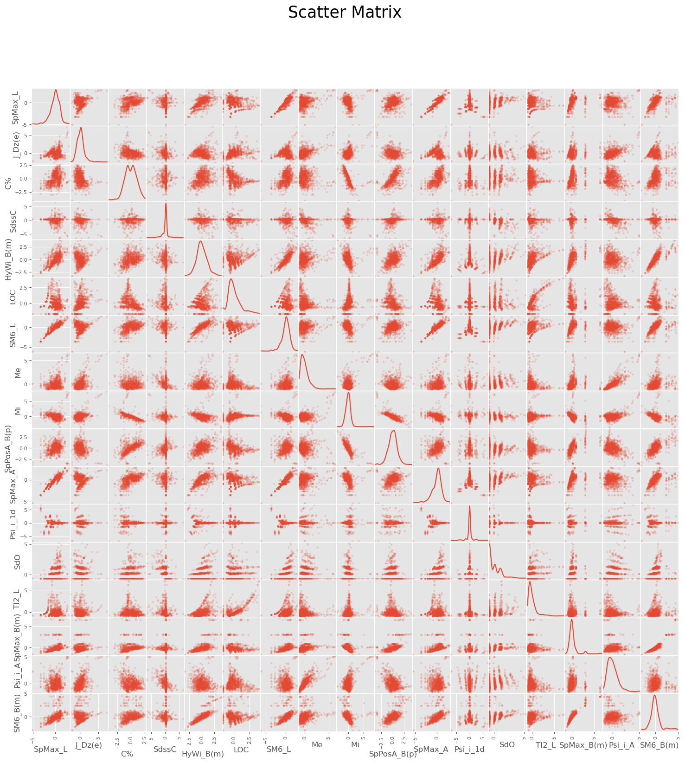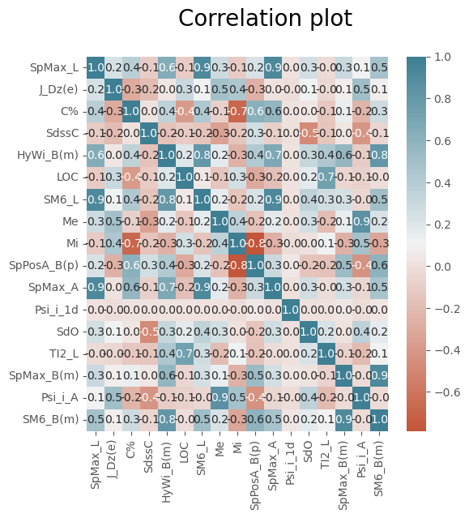
Fig 5 - Scatter plot and correlation plot between variables
With the help of these 2 figures we can detect groups of variables that are highly correlated and almost non-correlated, for instance : SpMax_L, SM6_L and SpMax_A are very strongly correlated with each other, almost having a linear relation; Same thing could be said about HyWi_B(m), SpMax_B(m) and SM6_B(m). However, they are almost non-correlated with J_Dz(e), LOC et Me.
This suggests dimensionality reduction methods might work well, as it might be easy to find combinations of variables to replace the original ones.

3.3. Qualitative explanatory variables
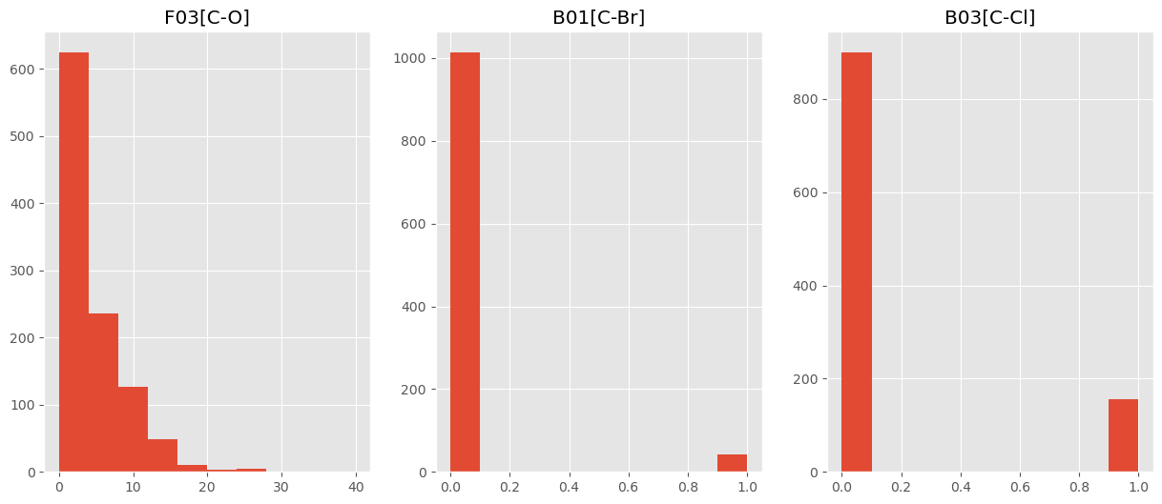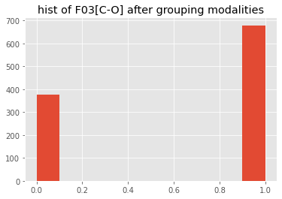
Fig 6 - Histogram plot of qualitative variables
We plot here the histogram of the 3 qualitative variables. The variable F03[C-O] has too many modalities and the number of 0 values is dominant, so we will try to implement one-hot-encode for this nominal categorical variable, i.e., aggregating other values except 0, to 1 (meaning different from 0).

3.4. Dependency between quantitative variables and response variable
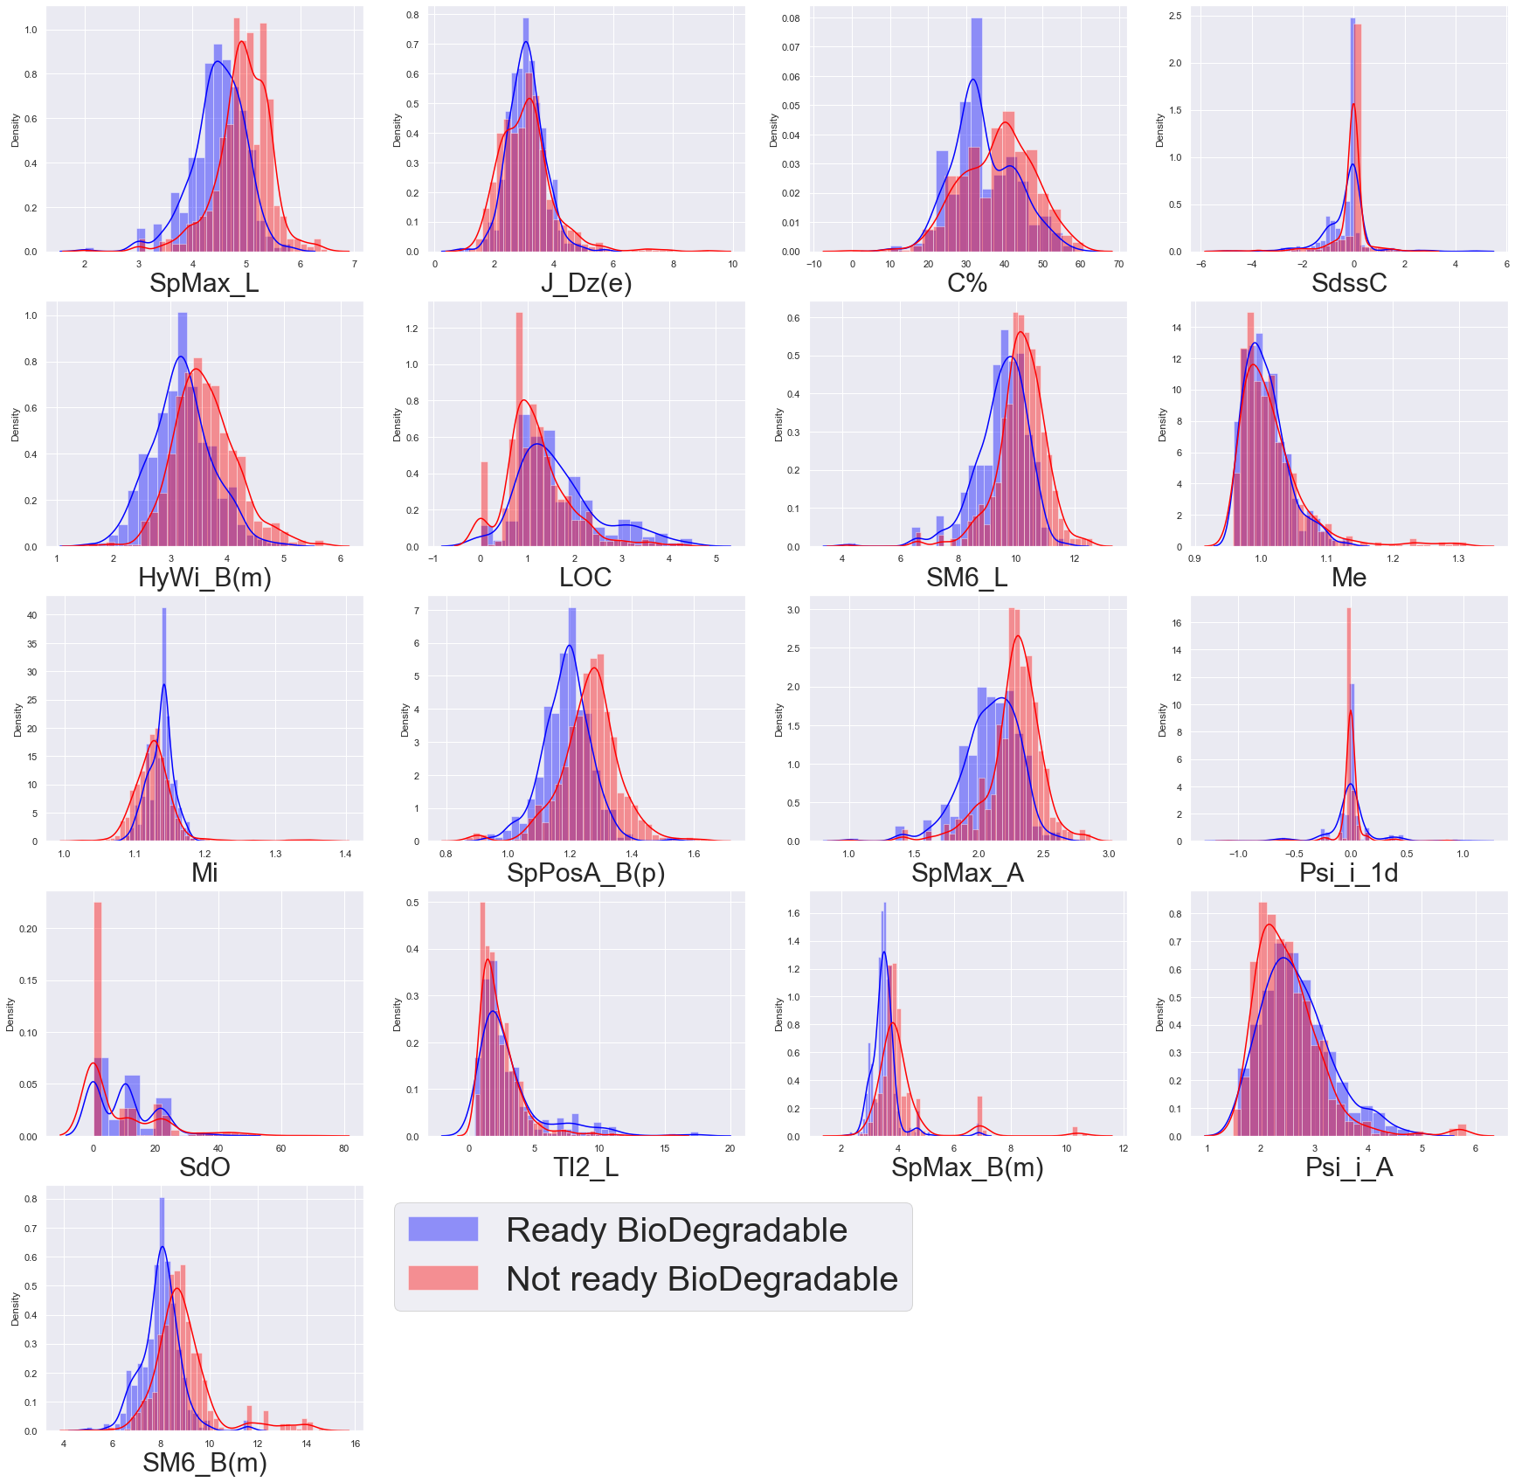
Fig 7 - Distribution of each explanatory quantitative variable according to category of response variable.
Here we separate molecules based on the response variables and see if being ready biodegradable or not has an effect on the distribution of the quantitative variables. From the figure above, we spot variables strongly affected by this separation and thus could be important during our attempt to classify the response variable :
- SpMax_L
- C%
- SdssC
- HyWi_B(m)
- SpPosA_B(p)
- SpMax_A
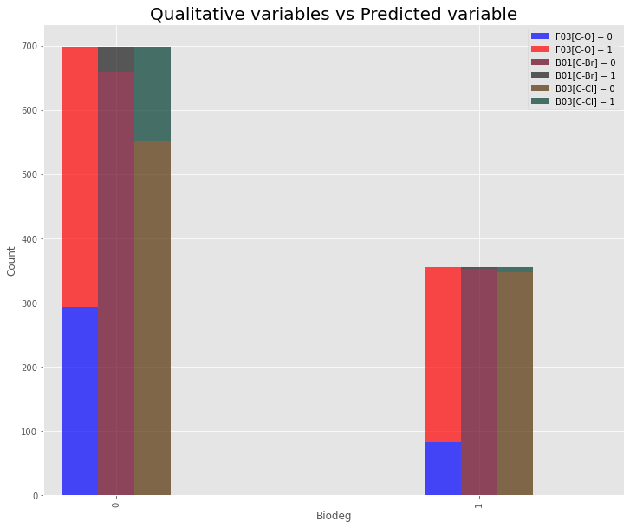
Fig 8 - Dependance between the qualitative variables and the response variable.
From the figure we could say that the qualitative variables are not so important in terms of separation of ready or not biodegradable molecules. In fact, with the figure 8, the ratio of value 0 on 1 of each variable is pretty the same in both cases, not ready biodegradable or ready biodegradable.

Feature extraction with PCA and feature selection
For feature extraction, we apply PCA on our data set. We observe from the graph below (right) after 10 components the dispersion is small so we will take at first 10 principal components. In other words, we reduce the data from 17 quantitative variables to 10 new variables in PCA space.
PCA can be interesting when it comes to computational cost, especially for the Random Forests algorithm, which takes a huge amount of time. The reduction in dimension in our case is from 17 to 10, not too much, but it will allow trading off some model accuracy for cheaper computational cost and will reduce running time. This is not a big deal for a small dataset (like our dataset, but we don’t have too powerful machines nevertheless), but it could be quite important to larger datasets. In addition, PCA brings other advantages like reducing the number of features and removing collinear features (PCA groups them into a component). Thus it’s perhaps (need to test) advantageous for some algorithms such as Random Forests, which do not need correlated aggregated trees. For our small dataset, the inertia of the firsts components is not too high, and if we take 10 components (comparing to 17 quantitative variables), we can reduce some running time of different algorithms but it’s not worth with the performance loss, as for all method we tested the performance on initial data is much more satisfactory. Therefore we won’t present results on PCA-reduced data of most of the algorithms in this report.
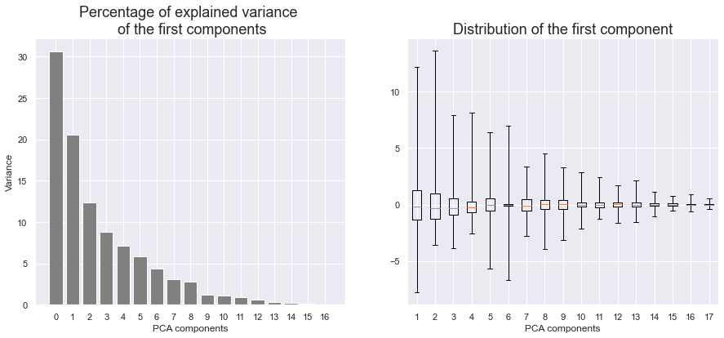
Fig 9 - Components on PCA decomposition

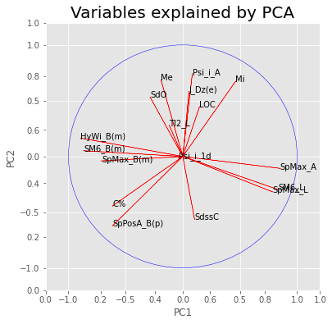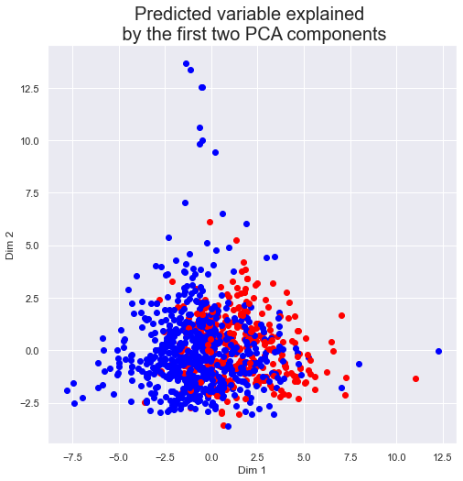
Fig 10 - Explanatory variables and individuals on PCA factor map.
At a first glance we notice that the variables given by PCA are not very easy to interpret. We also note that the data points don't seem very linearly separable. As an alternative, one can use Random Forests algorithm to classify explanatory variables “importance”, from that, one can choose to keep only a part, but not all explanatory variables.

Training and test splitting
It is essential for the machine learning process to split the data into train and test sets. In order to avoid overfitting, i.e. avoid that the machine learning estimator/model fits the data too much and fails to predict new data. It is therefore needed to evaluate our model performance, i.e. the model behavior/prediction accuracy on new data that it has not learned yet.
In our case, we split the initial data in 2 parts with a ratio of 80% of the full data for the training set, and 20% for the test set.
In the following sections, we will try to study different machine learning algorithms, apply it to our case, evaluate it on the test set and finally compare different algorithms results by multiple approaches. We will also compare the importance of explanatory variables found by the algorithms with our interpretations of the importance of variables in terms of response variable separation.

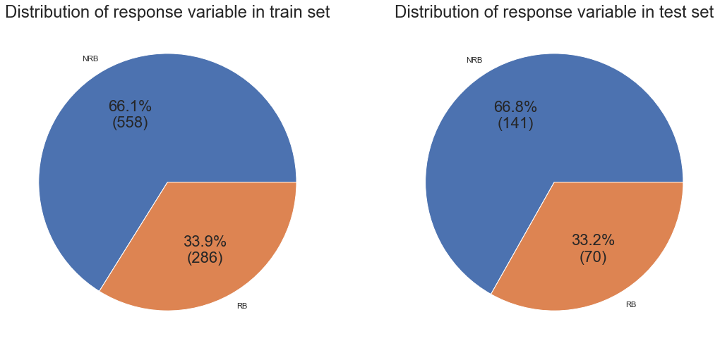
Fig 11 - Distribution of response variable in train and test sets

Logistic regression model with/without variables selection and penalization
Logistic regression is a popular statistical model used for binary classification problems. It estimates the probability of an event occurring based on a set of variables.
Variable selection and penalization techniques can be applied to logistic regression to improve model performance and address potential issues such as multicollinearity and overfitting. Here are two commonly used approaches:
- Variable Selection: Variable selection aims to identify the subset of independent variables that are most relevant for predicting the target variable. It helps in reducing model complexity and improving interpretability. There are several methods for variable selection in logistic regression, including:
- Stepwise Selection
- LASSO (Least Absolute Shrinkage and Selection Operator)
- Ridge Regression
- Penalization: Penalization methods add a penalty term to the logistic regression objective function to prevent overfitting and reduce the impact of irrelevant variables. In addition to LASSO and ridge regression mentioned above, other penalization techniques include:
- L1 Regularization
- L2 Regularization
- Mallow’s Cp, AIC, BIC
The best model is the model with penalty L1 (the result is almost the same with L2 penalty) whose confusion matrix is shown below. We note that the prediction performance is quite similar on both dataset types we mentioned.
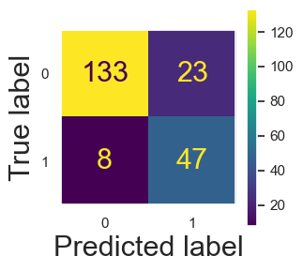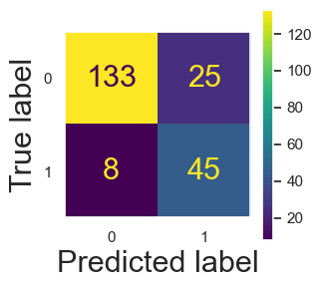
Fig 12 - Confusion matrix on Original dataset (right) and Transformed dataset (left) in logistic regression.

Support Vector Machine
Support Vector Machines (SVMs) is a type of supervised learning method that finds an optimal hyperplane used for regression and classification tasks. In classification, the hyperplane is determined by identifying the decision boundary that possesses the greatest margin, in which the margin represents the separation between the hyperplane and the nearest data points from each class, which is called support vectors. In regression, the objective is to minimize the error between the predicted and actual values while also maximizing the margin around the regression line. The optimal hyperplane in this case focuses on capturing the maximum amount of variation of the data, within a tolerance margin.
One of the strengths of the SVMs algorithm is its ability to find the linear or non-linear optimal hyperplane that fits the data. In case of non linearly separable data, the kernel trick is presented to transform the original input data into a higher-dimensional feature space, where the data points become more separable. There are plenty of kernel functions available, the most popular ones are RBF (Radial Basis Function or Gaussian), linear, p degree polynomial, sigmoid, etc. In addition, the SVM can handle datasets with a high number of features, even when the number of features exceeds the number of samples.
In spite of their effectiveness, SVMs method may be computationally demanding when working with large datasets or datasets containing numerous features. The selection of the kernel function and associated hyperparameters is also much sensitive to the performance of the SVM model.
In this section, we find an optimal SVM model for classification that fits our dataset. Using the GridSearchCV function from the scikit-learn library helps us to select the best group of parameters in this algorithm. The tuned parameters we used are shown in table 1.

Parameter | Description | Values | Reason of search
C | Regularization coefficient. | [0.5, 1, 3, 5, 10, 50, 100, 200] | Choose the suitable regularization to avoid overfitting and underfitting.
Gamma | Kernel coefficient (define how far the influence of a single training example reaches). | [0.005, 0.01,0.05, 0.1, 0.5, 1, 2, 5] | The lower values of gamma result in models with lower accuracy and the same as the higher values of gamma.
Kernel | Choice of kernel. | [ 'rbf', 'sigmoid', 'linear'] | Find the most appropriate kernel for the model
Table 1 : Parameters tuned in SVM.
By using GridSearchCV with the range of parameters defined in table 1, we run two separate procedures to find two optimal models corresponding to the raw dataset and the transformed one, in order to observe the performance of each dataset and also choose the best model. The result shows that the model corresponding to the raw data set is more efficient, with the test error of 0.128, the F1-score of 0.8. The GridSearchCV function returns the associated optimal parameters as follows : {'C': 100, 'gamma': 0.01, 'kernel': 'rbf'}. The kernel found is reasonable since we can see in Fig 10 that two classes in our data are not linearly separable, ‘linear’ kernel function cannot perform well.
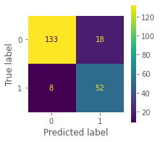
Fig 13 - Result of the optimal SVM model trained with raw data.
Since the kernel function is RBF, the feature importance is not available and we cannot observe the influence of the variables on the predicted value. However, we attempted to build an optimal linear kernel model by using GridSearchCV function with parameter ‘C’ as above, in order to observe the influence of the variables on the output. The result gives us a linear kernel SVM model of parameter C = 1 with the test error of 0.137. We plot here, in absolute value, the feature coefficients in this model, which is the weight of each variable. The higher the weight value is, the more important the variable becomes.
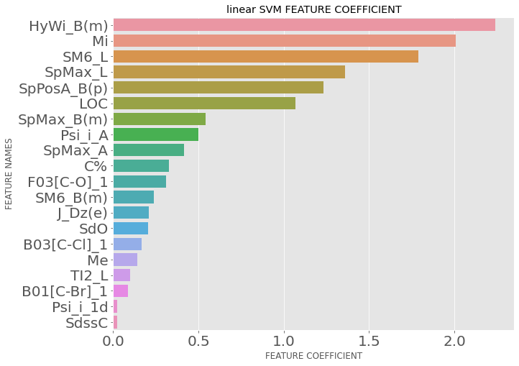
Fig 14 : Weight of the variables in linear SVM.
For the feature importance, the linear SVM algorithm shows important features in decreasing order: HyWi_B(m), Mi, SM6_L, SPMax_L, SpPosA_B(p), LOC. The importance of features here is measured by the weight associated with the variable in the SVM model. .

Classification and Regression Tree (CART)
The CART algorithm is a non-parametric classification (or regression) method to build estimators with high-dimensional datasets. The method outputs a binary decision tree which has the main advantage based on its simplicity and interpretability. In this context of classification problem, the space of input variables (here molecules descriptor) of the learning set is divided into subspaces, each subspace is then associated to one single class (here either ready biodegradable or not ready biodegradable). The resulting tree representation is composed of a sequence of division rules (splits) which is determined each time divided by a single explanatory variable (one of the molecules descriptor). At the end of the sequence, one can observe on the terminal nodes (also called leaf) of the tree, the subspaces of explanatory variables which indicates the predicted class.
The CART method can be favored in terms of its transparency. In fact, a binary decision tree (based on one explanatory variable each time splitted with an easy-to-interpret division criteria) is intuitive and practical when we want to interpret and understand how the final predictions are concluded. The tree methods are also tolerant to missing data, invariant with scaling and do not need normalization of data. Also there exists multiple available efficient algorithms to build trees and to prune them.
Nevertheless, the CART algorithm has high variance and is highly unstable (small variations in the data can cause big changes of prediction rules). In general when comparing with other supervised procedures, CART has poor prediction accuracy. The tree algorithm is also sensitive to imbalance in the dataset, that if not treated well, trees can be biased towards the dominant class, especially when we have seen that our dataset is imbalanced.
More robust method of aggregating trees like Random Forest will be implemented in the next section.
Since CART is invariant with scaling and monotonic transformations of variables, we won’t apply CART on the transformed data, but only on the original data. We also won’t apply CART on PCA-reduced dataset because it makes interpretation of the decision tree more difficult, since we won’t be able to observe split by original explanatory variables (molecules descriptors) but only PCA components.
Here we implement the CART method using the scikit-learn library. The parameters of the algorithm are chosen by an exhaust grid search over specified parameters values of the CART estimator. An optimal tree is selected by testing all those specific parameters with the minimal error mean score based on a cross validation splitting strategy of 10 folds (cv=10).
The parameters and its specific values are given in Table 2. The description of different parameters is provided by scikit-learn documentation and is detailed more if we need to clarify some notions.

Parameters | Description | Values to apply GridSearchCV | Reason of search
max_depth | The maximum depth of the tree | [3, 4,5, 6] | not too low to avoid underfitting, but low to interpret the tree representation easier, not too high to avoid overfitting
min_samples_leaf | The minimum number of samples required to split an internal node, if float, the number is the ratio among all samples | [0.04, 0.06, 0.08] | Too high underfitting  Too low overfitting  Higher values avoid learning of too specific relations between a small set of samples
max_features | The number of features to consider when looking for the best split | [0.2, 0.4,0.6, 0.8] | lower number reduce computational cost and may avoid overfitting
criterion | The function to measure the quality of a split | (default) ‘gini’ | either Gini concentration or Information Gain (cross-entropy), the choice depends on the dataset
class_weight | Weights associated with classes. If None, all classes are supposed to have weight one. | (default) None | can be considered to use when dealing with imbalanced dataset
Table 2 : Parameters tuned in CART.
After applying GridsearchCV on these values, we obtain the optimal tree with mean error score of 0.184 with parameters {'max_depth': 3, 'max_features': 0.4, 'min_samples_leaf': 0.04}. The tree representation is given in Fig 16. We see that with the max_depth of 3, minimal variables are considered as split, in this case only SpPosA_B(m), SpMax_L, SpMax_B(m), HyWi_B(m), SdssC. We cannot say with confidence these last are indeed the most important variables, due to the high instability of the tree. However, it corresponds highly to our ‘important variables’ in the section of exploratory analysis.
The optimal tree estimators are then evaluated on a test set and give a test error rate of 0.171. The confusion matrix of the test set is given in Fig 15.

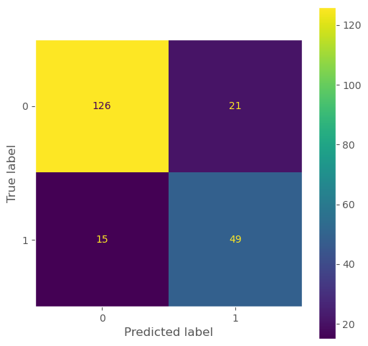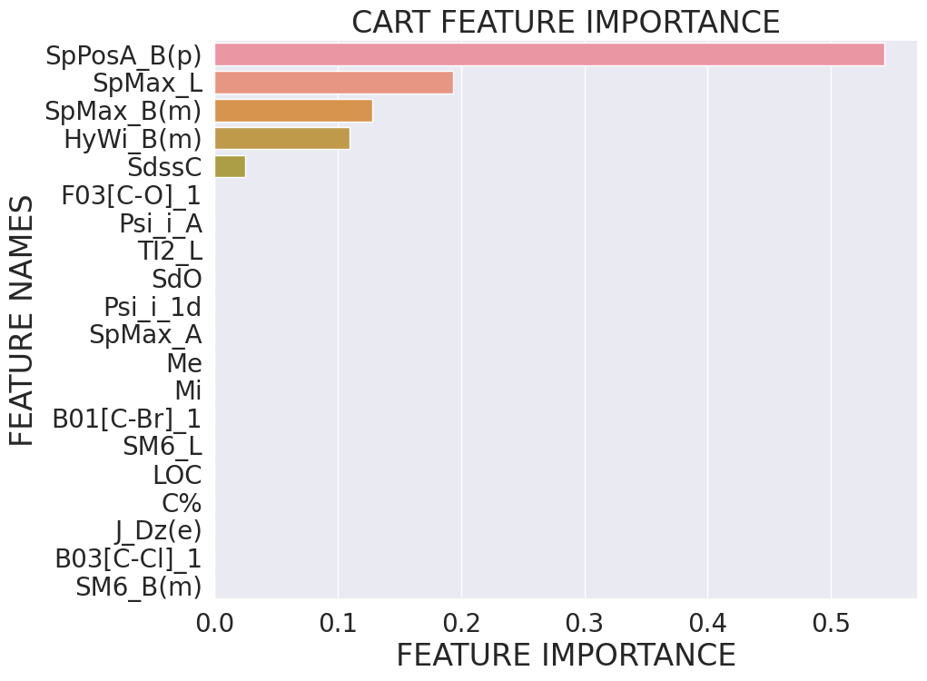
Fig 15: Confusion matrix and weight coefficient of the parameters in CART
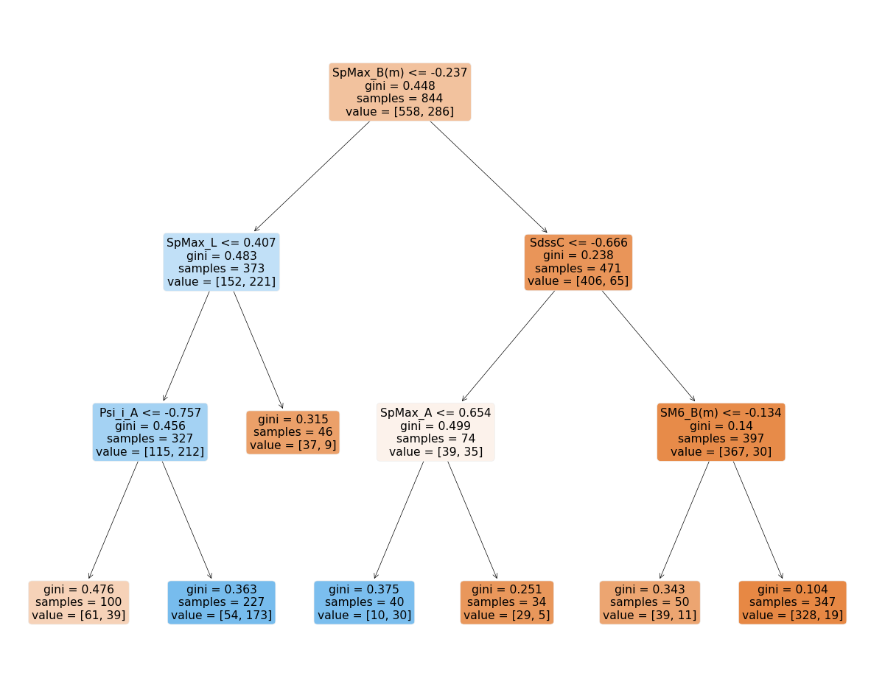
Fig 16 : Optimal tree representation

Random Forests
Note that trees are invariant by normalization or scaling of data, so we will apply Random Forest, which is aggregated trees, on data without transformations and on data reduced by PCA only.
The Random Forests algorithm consists of constructing and aggregating multiple decision trees in the training time. It is an ensemble method that can be used for classification or regression tasks. In the specific case of CART models, the Random Forests is an improvement of the bagging method with feature randomness to create more uncorrelated (or independent) decision trees.
Bagging is averaging the predictions of multiple independent models in order to reduce the overall variance. Bagging is mostly interesting in the case of unstable models (here CART for example), reducing the variance of trees lead to a significant reduction of the prediction error. In theory, it requires multiple independent samples of data, but that would be impractical since the data is limited. Often, these samples are generated with bootstrap, i.e. randomly drawn from a training set with replacement. The estimators are not independent in this case, but we know that if the correlation between predictions is small then the aggregated predictor will have much smaller variance than a single predictor. Thus we will try to add randomness to favor the uncorrelation of trees estimated with these bootstrap samples.
The randomness interferes in the stage of construction of the trees. In fact, at each stage of splitting tree nodes, we don’t take into account all explanatory variables (molecules descriptor) anymore, but we randomly select m variables between our 20 explanatory variables. Among those m variables, the best candidate variable is then chosen for the splitting. By doing this, we increase the variability by highlighting other variables (not always the most important ones) and we want to make the aggregated trees less correlated. In classification tasks, the default choice of number of variables taken is that a third (⅓).
In our context of classification, the result (either readily biodegradable or not readily biodegradable) is indicated by the majority vote of the predicted classes among all the trees of the ‘forest’.
Random Forests algorithm provides more robust predictions than the CART algorithm. It generally has good accuracy, is easy to implement (thus reducing time spent for data pre-processing or data management) and suitable for both classification and regression tasks. However, it is time-and-resource-consuming for large datasets, since it needs to construct each individual tree of the ‘forest’. Also, it is not easy to interpret with aggregation, and can be considered as a black box model. Nevertheless, we often interpret results of Random Forests by measuring the importance of explanatory variables by different measuring criteria such as Mean Decrease Accuracy (MDA), or Mean Decrease Impurity (MDI).
Here we implement the Random Forests algorithm using scikit-learn library. The parameters of the algorithm are chosen by an exhaust grid search over specified parameters values of the Random Forests estimator. An optimal estimator is selected by testing all those specific parameters with the minimal error mean score based on a cross validation splitting strategy of 10 folds (cv=10).
The parameters and its specific values are given in Table 3. The description of different parameters is provided by scikit-learn documentation and is detailed more if we need to clarify some notions.

Parameters | Description | Values to apply GridSearchCV | Reason to search
max_features | The number of features to consider when looking for the best split | [2, 4, 6, 8] | lower number reduce computational cost and may avoid overfitting, may have large impact due to its impact on the splitting process
min_samples_split | The minimum number of samples required to split an internal node | [2, 4, 6, 8, 10] | Too high underfitting  Too low overfitting  Higher values avoid learning of too specific relations between a small set of samples
min_samples_leaf | The minimum number of samples required to be at a leaf node | [1, 3, 5, 7] | Too high underfitting  Too low overfitting  Higher values avoid learning of too specific relations between a small set of samples
n_estimators | The number of trees in the forest. | [300, 500] | usually the bigger the better (except computational cost), but to avoid overfitting it is perhaps interesting to look at
bootstrap | Whether bootstrap samples are used when building trees | True | decrease correlations of aggregated trees
oob_score | Whether to use out-of-bag samples to estimate the generalization score | True | a fast cross validation method
max_depth | The maximum depth of the tree | None | the pruning strategy is elementary in case of Random Forests
Table 3: Parameters tuned in Random Forest model.

After doing GridsearchCV on those values, we obtain the best estimator with mean error score of 0.139 with parameters {'max_features': 6, 'min_samples_leaf': 1, 'min_samples_split': 2, 'n_estimators': 500}.
The estimators are then evaluated on a test set and give a test error of 0.133. The confusion matrix of the test set is given in Fig 17. The predictions on the test set are better than in the case of CART, with FP = 17 and FN = 11. Further comparison of different methods will be discussed in the last section.
For the feature importance, Random Forests algorithm shows important features in decreasing order: SpMax_B(m), SpPosA_P(p), SM6_B(m), SpMax_L, SpMax_A, SdssC. The importance of features is measured with MDI (Mean Decrease Impurity), i.e. the average decrease of heterogeneity each time the feature (variable) is choses as a split at internal nodes.

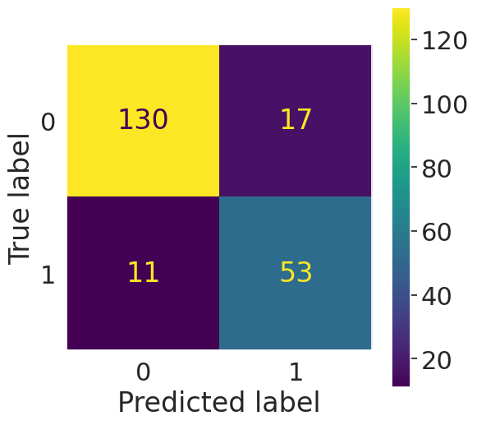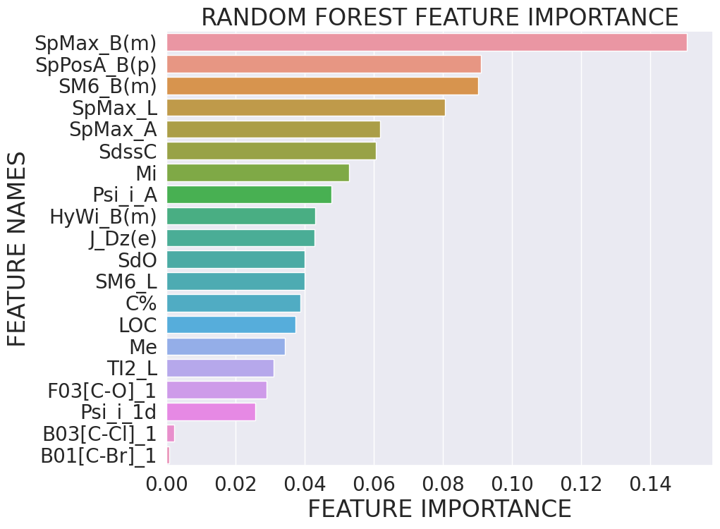
Fig 17 - Result and feature importance in optimal Random Forest model.

Boosting
Boosting is a powerful and popular machine learning ensemble method used for both classification and regression problems. Its main idea is to combine the predictions of multiple weak and simple models in order to create a stronger and more accurate model since the aggregation allows to reduce both the variance and the bias of the single predictors. Boosting algorithms iteratively build a sequence of models, where each subsequent model focuses on correcting the mistakes made by the previous models in the sequence; and the final prediction rule is a linear combination of this recursive sequence. AdaBoost (Adaptive Boosting), Gradient Boosting, and XGBoost are the popular methods in Boosting algorithms.
The boosting algorithms can significantly improve the accuracy of predictions compared to using a single model. They are also capable of handling complex and high dimensional data, and also handling class imbalance. In addition, we can analyze the feature importance by considering the weights assigned to features, which is helpful in feature selection and understanding data.
Nevertheless, this algorithm is much more sensitive to outlier data points, which affect the weight optimization. The aggregation of several models and complex data lead to the large computational resources and time. As an ensemble method, Boosting can be challenging to interpret compared to the single models. And tuning hyperparameters in this case is very important to access an optimal Boosting model.
In this section, we find the optimal model for this dataset by focusing on AdaBoost and Gradient Boosting Model.

10.1. AdaBoost
In classification, the weak classifiers used in AdaBoost are often decision stumps, i.e., decision trees with a single split. The aim in this method is to find the optimal weight corresponding to each weak classifier, by solving the associated optimization problem of minimizing the empirical risk for the exponential loss function. All weights of the weak classifiers are initially equal and they are updated after each iteration. Each weak classifier is finally assigned an optimal weight based on its performance, which indicates its importance in the aggregated model. The final prediction is obtained by combining all weak classifiers with their corresponding optimal weight.
For our experimentation, the parameter “base_estimator” is set as “DecisionTreeClassifier” by default. Since this is a tree-based model, we only need to find the optimal on raw data (Tree-based models are not affected by the distribution of data). The parameters we used in the GridSearchCV function are shown in table 3.

Parameter | Description | Values | Reason of search
n_estimators | The maximum number of estimators at which boosting is terminated. | [100, 300, 500] | usually the bigger the better, but to avoid overfitting it is perhaps interesting to have a look
learning_rate | Weight applied to each classifier at each boosting iteration | [0.1, 0.3, 0.5,1] | find a suitable learning rate to avoid overfitting
Table 3: Parameters tuned in AdaBoost model
The GridSearchCV function returns the optimal parameters as follows : {'learning_rate': 0.3, 'n_estimators': 300}, and the test error of 0.142, the precision and recall of 0.803, the F1-score of 0.779.
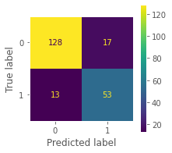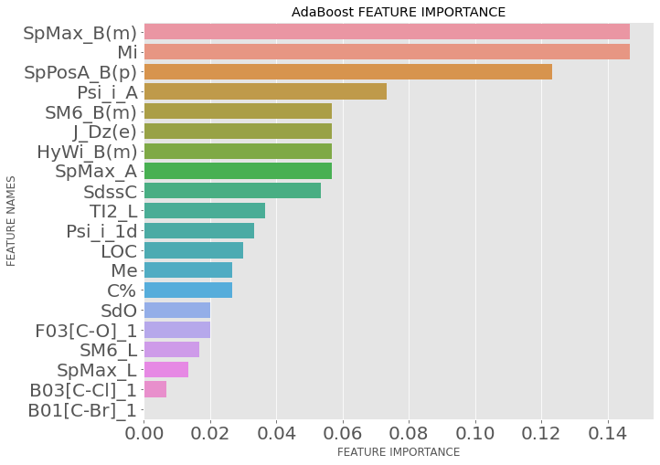
Fig 18 - Result and feature importance in optimal AdaBoost model.
For the feature importance, AdaBoost algorithm shows important features in decreasing order: SpMax_B(m), Mi, SpPosA_P(p), Psi_i_A, SM6_B(m), J_Dz(e), HyWi_B(m), SpMax_A, SdssC. The importance of features is measured with MDI (Mean Decrease Impurity), which is similar to the case of RandomForest.

10.2. Gradient Boosting Models
The difference in Gradient Boosting is its optimization of a differentiable loss function through gradients. The ensemble model starts with a fixed value, typically the mean or median of the target variable. The objective is to discover a group of weak classifiers that most effectively predict the residuals, representing the errors between the current ensemble model's actual and predicted values. During each iteration, the model's parameters are updated using the computed gradient of the loss function concerning the predicted values. Additionally, the weak classifiers' predictions are incorporated into the ensemble model to refine its predictions and minimize residual errors.
For our experimentation, the parameters we used in the GridSearchCV function are shown in table 4. In default setting, the parameter “base_estimator” is DecisionTreeClassifier.

Parameter | Description | Values | Reason of search
n_estimators | The number of boosting stages to perform. | [100, 200, 300] | GBM is fairly robust to overfitting so a large number usually results in better performance.
max_depth | Maximum depth of the individual regression estimators. | [2,3,4] | Control the complexity of the decision tree in model
max_features | The number of features to consider when looking for the best split. | [2,4,6] | A suitable value of max_features allows to reduce variance, however increase bias.
min_samples_leaf | The minimum number of samples required to be at a leaf node. | [1,2,3] | Too big value causes underfitting.  Too low value causes overfitting.  Higher values avoid learning of too specific relations between a small set of samples.
min_samples_split | The minimum number of samples required to split an internal node. | [12,15,18]
Table 4: Parameters tuned in Gradient Boosting Models.
The result shows that the model corresponding to the raw data set is more efficient, with the test error of 0.1279, the F1-score of 0.797. The GridSearchCV function returns the associated optimal parameters as follows : {'max_depth': 3, 'max_features': 2, 'min_samples_leaf': 3, 'min_samples_split': 15, 'n_estimators': 200}.
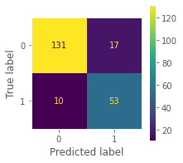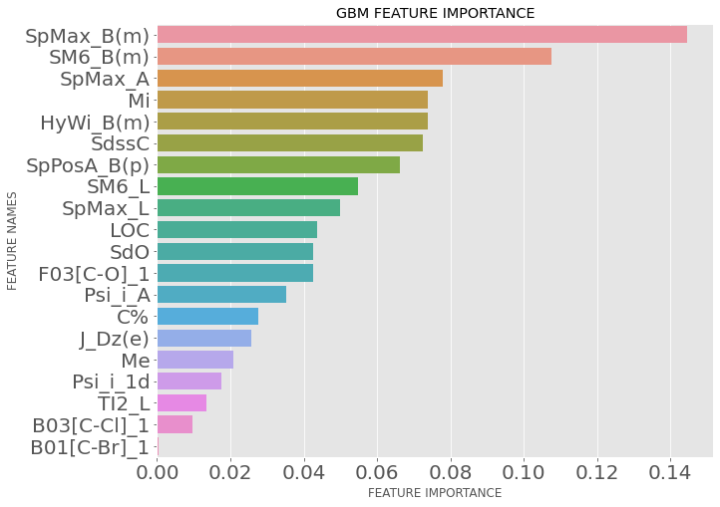
Fig 19 - Result and feature importance in optimal Gradient Boosting model.
For the feature importance, AdaBoost algorithm shows important features in decreasing order: SpMax_B(m), SM6_B(m), SpMax_A, Mi, HyWi_B(m), SpPosA_P(p), SdssC. The importance of features is also measured with Mean Decrease Impurity.

Neural networks
In this section, we will create Neural Network architectures for our classification problem. We will employ Neural Networks with either a single hidden layer or multiple hidden layers, often referred to as Multi-layer Perceptron classifiers. These models will incorporate various activation functions, while the output layer will uniformly utilize the softmax activation function, enabling us to obtain class probabilities.
The learning process involves minimizing a loss function through the utilization of gradient-based optimization algorithms such as Adam and L-BFGS. This optimization is facilitated by the back-propagation technique, which enables the computation of gradients and their subsequent propagation through the network for efficient parameter updates.

11.1. One Hidden-layer Neural Network
We attempt to train a one hidden-layer neural network on our dataset. The Universal Approximation Theorem guarantees that any bounded and continuous function can be approximated to any desired precision by a neural network with a single hidden layer containing a finite number of neurons. However, this theoretical result does not provide practical guidance.
To determine the optimal number of neurons in the hidden layer, we use cross-validation. Through this process, we discover that the most favorable number of neurons is 7 when utilizing the Rectified Linear Unit (ReLU) activation function. During training (on the transformed data), we achieved a prediction accuracy of 0.86 on the training set. The performance on the test set is detailed below:
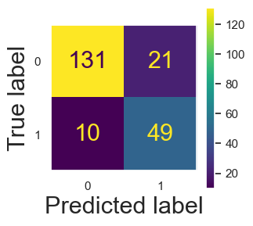
Fig 20 : Confusion matrix of one hidden-layer neural network model
- The prediction accuracy: 0.85
- The F1-score: 0.76
The results demonstrate that the neural network performs well on the test set, achieving a prediction accuracy of approximately 0.85. This accuracy is only slightly lower than the performance on the training set, which is reported to be around 0.86. These results indicate that the model generalizes effectively to unseen data, as it maintains a high level of accuracy on both the training and test sets.

11.2. Multi-layer perceptron Classifier
We explore the use of Multi-layer Perceptron (MLP) models with multiple hidden layers. These architectures are more sophisticated and have the potential to approximate more complex functions compared to models with a single hidden layer.
After testing for different architectures, here are some important remarks:
- Fitting a complex model with an abundance of parameters (weights and biases), i.e., an overparameterized model, can lead to exceptionally high performance on the training set (even 100%). To prevent overfitting, we employed early stopping during optimization.
- Early stopping involves monitoring the performance on a validation set and halting the optimization process if there is a consecutive decrease in performance, even if the loss function continues to decrease. This technique helps prevent overfitting by capturing the point where the model starts to lose its ability to generalize effectively.
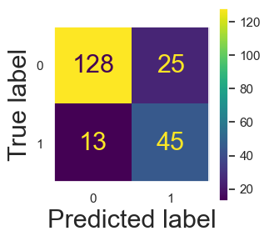
Fig 21 : Confusion matrix of multi-layer perceptron model
The result of the multi-layer model, although quite decent, is better than the one hidden-layer model.

Algorithm comparison
Firstly we plot the ROC curve of the 7 methods above to compare their performance, as shown in figure below. The ROC curve shows the trade-off between sensitivity (True Positive Rate) and specificity (1 – False Positive Rate). Classifiers that give curves closer to the top-left corner indicate a better performance. AUC (Area under the ROC Curve) index of each algorithm is added to aid comparison. Naturally, higher AUC means better performance. Indeed, the figure shows that the performance of classification trees is quite limited compared to the other ones. It is reasonable since the CART algorithm is highly instable and not robust to the learning sample.
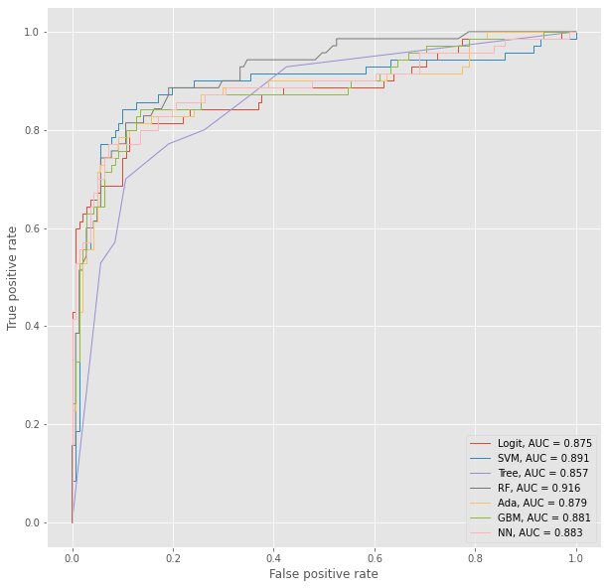
Fig 22 - ROC curve of the 7 optimal models

We see in this test set the RF is the best but we will use Monte Carlo cross-validation to try on different test sets and examine the average results. The result boxplot of the cross-validation process is given in Fig 23.
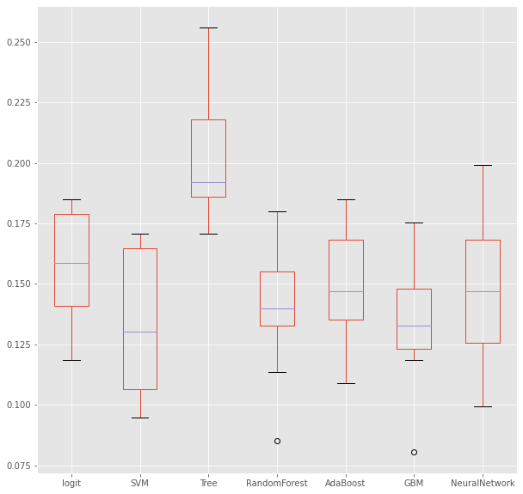
Fig 23 : Test error distribution based on Monte Carlo cross validation

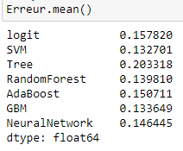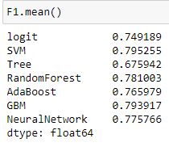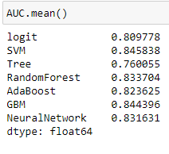
Fig 24 : mean test error, mean F1 score and mean AUC value based on Monte Carlo cross validation
Secondly, we introduce the Monte Carlo cross-validation to verify their performance. Indeed, we plot here the distribution of test set error of these algorithms, with number of iterations B = 10 chosen. We confirm again the limitation of CART.
According to mean test error, mean F1 score, mean AUC value in Fig 24 and the distribution of test error shown in Fig 23, we conclude that the best method in this case is Support Vector Machine.

