Question: Can we pass a structure from C to Fortran 90/95?
Short Answer: Yes – but keep it simple.
Long Answer:
Most people I talked with were cautious (“Yes, but it isn’t pretty”) or extremely pessimistic (“No don’t do it!). Google (and Norbert) were more optimistic. Here is a summary:

Benefits of Using Structures or “Derived Types”:
- Fewer data arguments to pass into subroutines.
- Code can evolve without changing the C/Fortran Programming Interface. New fields can be added to the structures over time without changing the list of arguments in the subroutine calls.

Potential Pitfalls:
- Code may become dependent on a specific machine architecture or Fortran compiler. Maximum portability is achieved when we only use simple data types.
- Current team members might prefer the simple syntax of Fortran 77.
- Padding and Alignment issues:

Byte alignment can be a source of data corruption if memory boundaries between Fortran and C are different. Each language may also align structure data differently. One must preserve the alignment of memory between the C "struct" and Fortran "common block" by ordering the variables in the exact same order and exactly matching the size of each variable.

Although similar in functionality to C structs, Fortran derived types' layout in memory does not (in general) map to a C struct, making it challenging for Fortran codes using derived types to interface to C. This is particularly true for derived types with allocatable members such as pointers, pointer arrays, or allocatable arrays, which are referred herein as deep derived types. This is because Fortran pointers are objects that hold more than just a memory address; a Fortran pointer (or allocatable) array also holds the size of the array, the shape of the array, and perhaps the stride in memory if the array is not contiguous. This information is collectively known as the array descriptor. If the memory layout of the descriptor were known, it would be possible to map a derived type to a C struct. Unfortunately, the Fortran standard is silent as to how array descriptors are coded; each compiler is left free to implement array descriptors and as a result each vendor may choose to encode differently the descriptor information. Code compiled with one Fortran compiler is in general incompatible with code compiled with another Fortran compiler, even on the same architecture. For this reason, mapping a Fortran derived type to a C struct may require reverse engineering the layout of array descriptors.

EXAMPLE: How to Pass a Structure between C and Fortran 90/95:

main.c myfortran.f90
#include <stdio.h>

struct err_struct {
int code;
double arg0, arg1, arg2, arg3, arg4, arg5, arg6,
arg7, arg8, arg9;
};

extern void myfortran_(float *, struct err_struct *);

main ()
{
struct err_struct err_out;
struct err_struct *ptx = &err_out;
float input;

printf("Enter any float number: ");
scanf("%f",&input);

/* Initialize the structure values to 0 */
err_out.arg0 = 0.0;
err_out.arg1 = 0.0;
err_out.arg2 = 0.0;
err_out.arg3 = 0.0;
err_out.arg4 = 0.0;
err_out.arg5 = 0.0;
err_out.arg6 = 0.0;
err_out.arg7 = 0.0;
err_out.arg8 = 0.0;
err_out.arg9 = 0.0;

myfortran_ (&input, ptx);

printf("code = %d\n",err_out.code);
printf("arg0 = %f\n",err_out.arg0);
printf("arg1 = %f\n",err_out.arg1);
printf("arg2 = %f\n",err_out.arg2);
printf("arg3 = %f\n",err_out.arg3);
printf("arg4 = %f\n",err_out.arg4);
printf("arg5 = %f\n",err_out.arg5);
printf("arg6 = %f\n",err_out.arg6);
printf("arg7 = %f\n",err_out.arg7);
printf("arg8 = %f\n",err_out.arg8);
printf("arg9 = %f\n",err_out.arg9);

return 0;
}
SUBROUTINE MYFORTRAN( INPUT, EOUT )

USE Structures
IMPLICIT NONE

REAL :: INPUT
TYPE (ERRCODE) EOUT

print *, 'The input is: ', INPUT

! Return error values
IF (INPUT.GT.3.0) THEN
EOUT%CODE = 101
EOUT%ARG0 = 12.3d0
EOUT%ARG1 = 45.6d0
ELSE
EOUT%CODE = 701
EOUT%ARG0 = 78.9d0
EOUT%ARG1 = 1011.12d0
ENDIF

END

structures.f90
MODULE Structures

TYPE ERRCODE
SEQUENCE
INTEGER :: CODE
REAL(8) :: ARG0, ARG1, ARG2, ARG3, ARG4, &
ARG5, ARG6, ARG7, ARG8, ARG9
END TYPE ERRCODE

END MODULE Structures

This example can be found in:
galaxy:/home/users/cohara/dev/structures/Simple
marauder:/home/cohara/dev/tmt-pcs/structures/Simple/err
Here is the output:
marauder:/home/cohara/dev/tmt-pcs/structures/Simple/err>./a.out
Enter any float number: 3
The input is: 3.000000
code = 701
arg0 = 78.900000
arg1 = 1011.120000
arg2 = 0.000000
arg3 = 0.000000
arg4 = 0.000000
arg5 = 0.000000
arg6 = 0.000000
arg7 = 0.000000
arg8 = 0.000000
arg9 = 0.000000

Cathy’s Questions:
- Let’s choose better variable names (“err_struct” on the C side; ERRCODE on the Fortran side). Variable names have a way of sticking around, and there’s nothing worse than a bad legacy variable name.

Other Useful Google Notes:
- Cathy believes we should NOT compile with -qalign=packed or put #pragmas into the struct.³ A good reason not to do this can be found here: “The ideal solution is to not change the default natural alignment rules. Pragma directives themselves are generally considered problematic and leading to non-portable code.”

Minor Things to Consider Later:

- The Fortran 95 standard requires the SEQUENCE statement in the definition of the derived type to insure that storage sequence order be preserved by the compiler. Cathy wonders if the SEQUENCE type conflicts with Fortran 2003 (see Norbert’s book, “the derived type must not be a sequence type, Appendix B.2.1).

- ISO_C_BINDING may permit better interoperability. We probably *don’t* need to worry about it as long as we stick to simple structures. But, many years from now, it’s possible that Fortran standards will change and we may wish to look into this.

THIS PAGE IS OBSOLETE – FOR REFERENCE ONLY

Option #1: Access external C structures via Fortran global common blocks

In this example, the external C structure ST is accessed in the Fortran subprogram as common block ST.

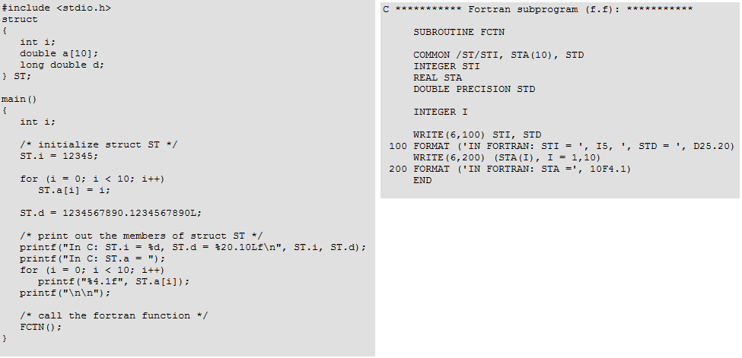

The name of the structure and the Fortran common block must match. This requires that the structure name be uppercase. The C structure members and the Fortran common block member names do not have to match, as is shown in this example. Note this approach does not prevent alignment/padding errors.

Option #2: Fortran “bridge” or Wrappers

For every C/Fortran interface, there exists a C wrapper and a Fortran wrapper. The wrappers either dissect (C) or create (Fortran) the structure in the appropriate language. The C wrapper passes the dissected structure as individual variables into the Fortran wrapper, which then reconstructs the structure in F95 form. This approach avoids alignment/padding issues, but adds significant complexity to the code.

THIS PAGE IS OBSOLETE – FOR REFERENCE ONLY
THIS PAGE IS OBSOLETE – FOR REFERENCE ONLY

Option #3: Fortran 2003 with ISO_C_BINDING

Fortran 2003 provides a standardized mechanism for interoperating with C.
C main program: Fortran subroutine:
typedef struct {
int m, n;
float r;
} myctype;
use, intrinsic :: iso_c_binding
type, bind(c) :: myftype
integer(c_int) :: i, j
real (c_float) :: s
end type myftype

The derived type must not be a sequence type (Appendix B.2.1), have type parameters, have the extends attribute, or have any type-bound procedures. Each component must have interoperable type and type parameters, must not be a zero-sized array, must not be a pointer, and must not be allocatable. No Fortran type is interoperable with a C union type, a C struct type that contains a bit field, or a C struct type that contains a flexible array member.

THIS PAGE IS OBSOLETE – FOR REFERENCE ONLY

K. Miller; T. Logan/W. Bunch; D. McDonald & others on MISR; N. Sigrist; Piotr Piatrou; A. Niessner.
In Fortran, the “derived type” is analogous to the C data structure.
http://www.yolinux.com/TUTORIALS/LinuxTutorialMixingFortranAndC.html
https://sites.google.com/a/gokliya.net/www/ccallingfortranapiwithderivedtypes
http://solidsmoke.blogspot.com/2010/07/woes-of-structure-packing-pragma-pack.html
http://docs.oracle.com/cd/E19059-01/stud.9/817-6694/11_cfort.html
http://docs.cray.com/books/S-2179-52/html-S-2179-52/ppgzmrwh.html
“Modern Fortran explained”, Chapter 12, Michael Metcalf, Jon Reid, and Malcolm Cohen, 2011 Oxford University Press.

