Docker Hub to Harbor to Tanzu

Pull image from docker hub:
❯ docker pull nginx:latest
latest: Pulling from library/nginx
b4d181a07f80: Pull complete
edb81c9bc1f5: Pull complete
b21fed559b9f: Pull complete
03e6a2452751: Pull complete
b82f7f888feb: Pull complete
5430e98eba64: Pull complete
Digest: sha256:47ae43cdfc7064d28800bc42e79a429540c7c80168e8c8952778c0d5af1c09db
Status: Downloaded newer image for nginx:latest
docker.io/library/nginx:latest

❯ docker images
REPOSITORY TAG IMAGE ID CREATED SIZE
nginx latest 4f380adfc10f 6 days ago 133MB

Or create your own image:

❯ docker build -t myimage:20.04.02 .
Sending build context to Docker daemon 15.36kB
Step 1/21 : FROM ubuntu:20.04
### good stuff deleted, but not ignored ###

Tag the image:
For this, we need the IP address of our registry:
In vCenter, go to Hosts and Clusters, select your cluster and go to Configure → Namespaces → Image Registry:
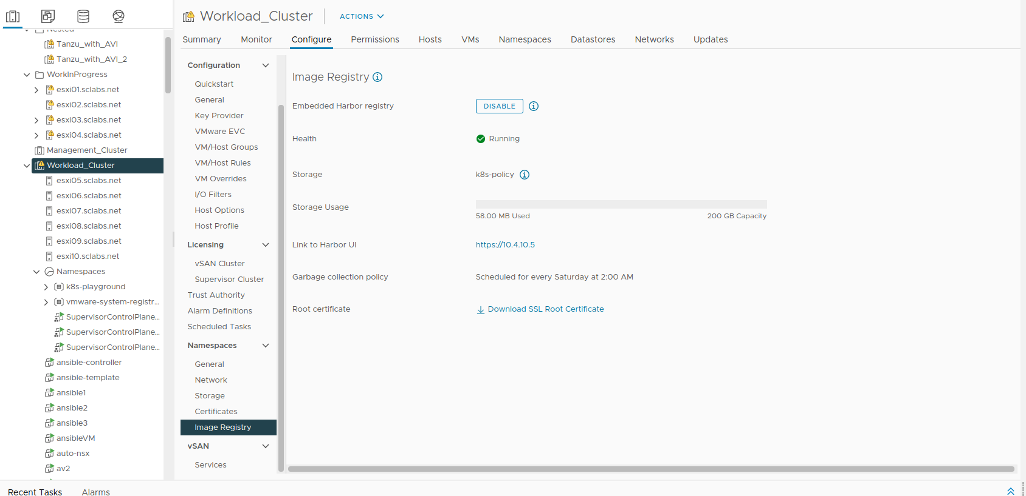
Now set the tag with the IP address of the harbor registry:

❯ docker images
REPOSITORY TAG IMAGE ID CREATED SIZE
nginx latest 4f380adfc10f 6 days ago 133MB
❯ docker tag nginx:latest 10.4.10.5/k8s-playground/nginx:47.11
❯ docker images
REPOSITORY TAG IMAGE ID CREATED SIZE
10.4.10.5/k8s-playground/nginx 47.11 4f380adfc10f 6 days ago 133MB
nginx latest 4f380adfc10f 6 days ago 133MB

k8s-playground is the k8s namespace that also exists as a project in harbor

Push to Harbor:
If this is the first time you use that registry, you need to log in first:

❯ docker login 10.4.10.5
Username: torsten@vdi.sclabs.net
Password:
WARNING! Your password will be stored unencrypted in /home/torsten/.docker/config.json.
Configure a credential helper to remove this warning. See
https://docs.docker.com/engine/reference/commandline/login/#credentials-store

Login Succeeded
Remeber, 10.4.10.5 is the IP address of harbor.
Now push the image:
❯ docker push 10.4.10.5/k8s-playground/nginx:47.11
The push refers to repository [10.4.10.5/k8s-playground/nginx]
c6d74dcb7fe7: Pushed
b50a193ebf2e: Pushed
165eb6c3c0d3: Pushed
cf388fcf3527: Pushed
2418679ca01f: Pushed
764055ebc9a7: Pushed
47.11: digest: sha256:2f1cd90e00fe2c991e18272bb35d6a8258eeb27785d121aa4cc1ae4235167cfd size: 1570

Creating a deployment that pulls the image from harbor:
In order to enable the worker nodes of your TKC (Tanzu Kubernetes Cluster) to pull images, we need to provide the credentials. This is done by first creating a k8s secret while logged in to your TKC. We use the saved credentials from the previous docker login command (they are saved in $HOME/.docker/config.json):
kubectl create secret generic harbor-secret --from-file=.dockerconfigjson=$HOME/.docker/config.json --type=kubernetes.io/dockerconfigjson
We then need to refer to that secret in any deployment manifest that pull from harbor:

example:

❯ cat nginx-only.yaml
---
apiVersion: apps/v1 # for versions before 1.9.0 use apps/v1beta2
kind: Deployment
metadata:
name: nginx1
spec:
strategy:
type: Recreate
selector:
matchLabels:
app: nginx
replicas: 6 # tells deployment to run 6 pods matching the template
template: # create pods using pod definition in this template
metadata:
labels:
app: nginx
spec:
containers:
- name: nginx
image: 10.4.10.5/k8s-playground/nginx:47.11
ports:
- containerPort: 80
imagePullSecrets:
- name: harbor-secret

