# Final Demo Plan: Team 22

### [Video: https://youtu.be/buRkcaKBxUE](https://youtu.be/buRkcaKBxUE)

### Requirements

1. Must have multiple containers to hold several plants with unique needs.
2. Must be able to notify the user when local conditions fall outside of their preferences using a text message.
3. Must be able to receive data from the user on their preferences for the plants from a web-based interface.
4. Must be able to distribute water automatically based on the preferences of the user for both soil moisture and time-based watering of the plants.
5. Must be able to receive data from sensors and adjust based on current “greenbox” conditions.
6. Must be able to monitor the conditions of and administer water to each plant container separately.
7. Must be able to monitor the amount of water stored in the device and notify the user when it needs to be refilled.
8. Must be able to monitor soil moisture, water TDS level, local temperature, light level, and local humidity through web interface.

### Demonstrations

#### Functionality Demonstration:

Requirements: 1, 2, 3, 4, 5, 6, 7, 8

##### Demo

The Device will take a reading of the soil moisture in the various planters, TDS of the Reservoir, and Water Reservoir Level, and will find that the soil moisture in one out of the three planters are deficient as compared to the user preferences, while TDS and Water Reservoir Level are nominal. The Device will then output water into the planter as needed until it reaches the required soil moisture level at which point they will stop outputting water. Additionally it will notify the terminal of the connected device that the valves have been turned off following the water output, and that the soil moisture, TDS, and Reservoir Levels are nominal.

##### Expectation

Customer expects the Device to properly detect a lack of water in the planters and a proper TDS and Water Reservoir Levels and begin to refill the planters with water until the planters no longer need to be refilled with water, at which point it will stop refilling the planters. Additionally, the customer should expect the device to notify them when the valves turn off, and that it should notify them of the values determined from the sensors initially as the device performs its checks.

##### Result

Overall, the demo demonstrated full functionality of the system as expected from the demo and based on the parts of the system that got completed in time. However, some of the requirements were planned to only be partially met based on the waiver we filled out. Requirement 2 is fulfilled but not through text message, but rather through the terminal of a computer. Requirement 3 is only partially met as the web-based UI is complete but unable to connect with the microcontroller. Requirement 8 is only partially met as some of the sensors never reached full functionality.

#### User Interface Demonstration:

Requirements: 2,3

##### Demo

The Web UI shows all the functionalities that are present as a part of the Web UI. The user can access the login and signup using the web UI. Additionality, the user can also enter plant preferences they would like to have.

##### Expectation

The user expects the Web UI to act as a medium through which they would be able to interact with the system as a whole. The user also expects to have a strong user authentication system set up so that their account is not compromised. Lastly, the user expects to store all their plant preference as a part of the database system.

##### Result

Overall, the demo demonstrated the full functionality of the system. The web UI works as expected, and allows the user to log in, signup, and set their plant preferences as expected. However, the Web UI does not fulfill the responsibility to communicate with the overall system using the TCP/IP Stack.

### Block Diagram:

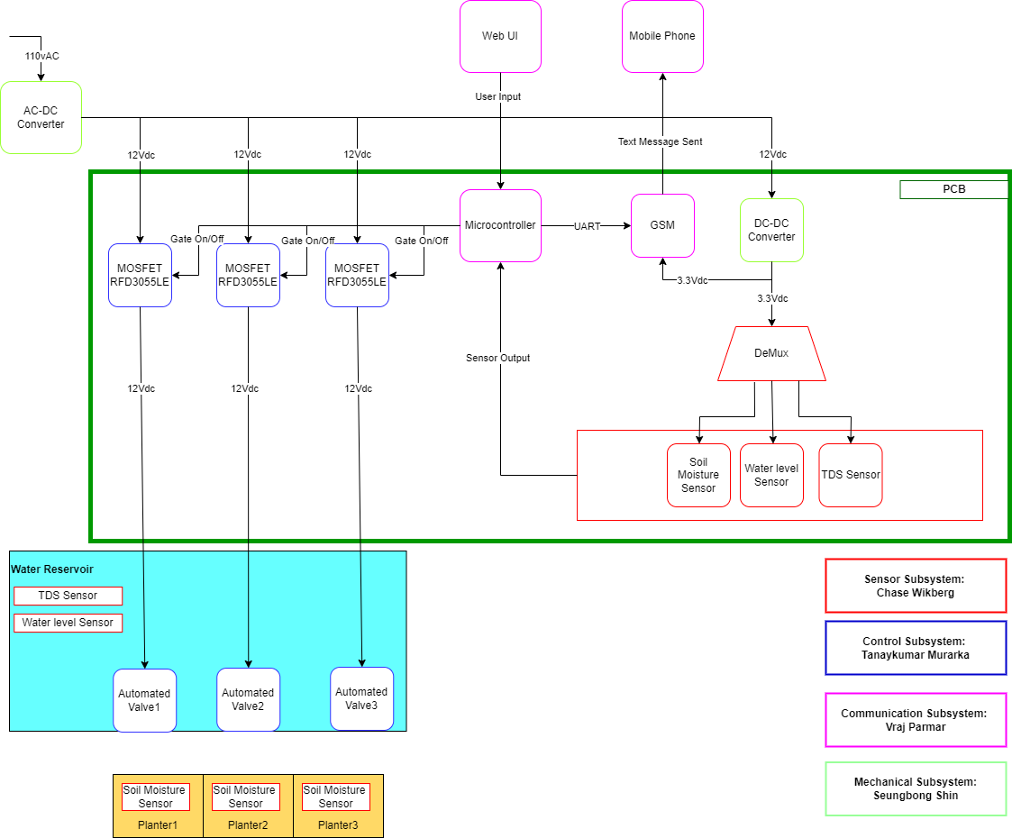

### Circuit Schematic:

