DATA 624 Spring 2019: Homework-1

Ahmed Sajjad, Harpreet Shoker, Jagruti Solao, Chad Smith, Todd Weigel

March 12, 2019

library(mlbench)  
library(tidyr)  
library(dplyr)

##   
## Attaching package: 'dplyr'

## The following objects are masked from 'package:stats':  
##   
## filter, lag

## The following objects are masked from 'package:base':  
##   
## intersect, setdiff, setequal, union

library(ggplot2)

##### HA# 2.3

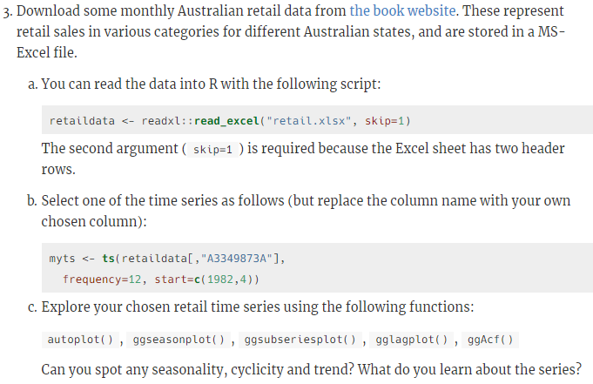

##### HA# 2.7

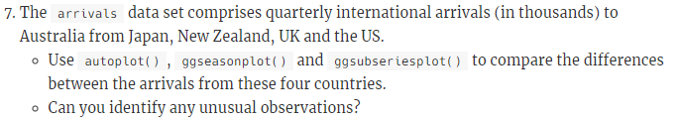

##### HA# 2.10

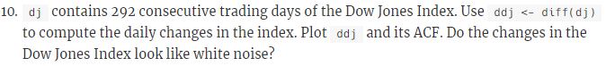

##### HA# 3.1

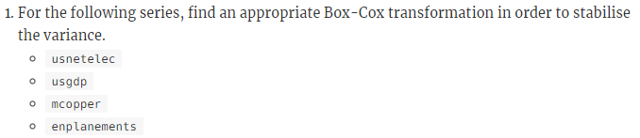

##### HA# 3.8

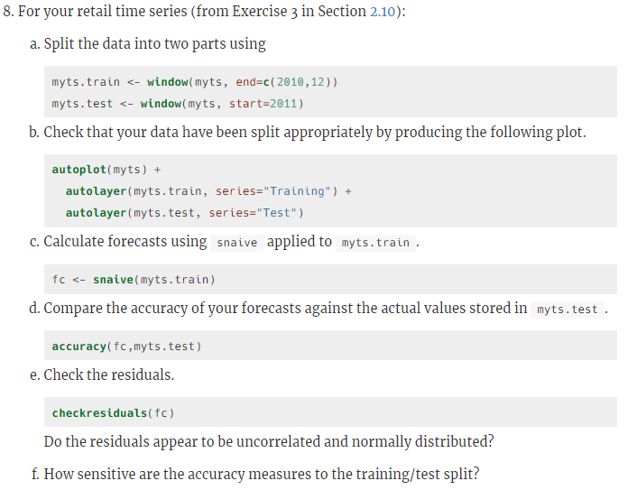

##### HA# 6.2

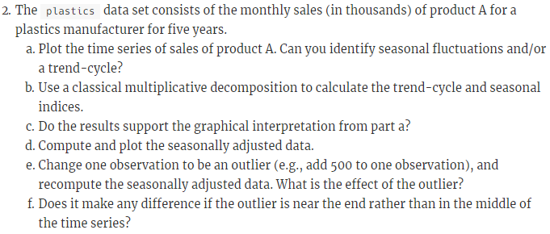

##### HA# 6.6

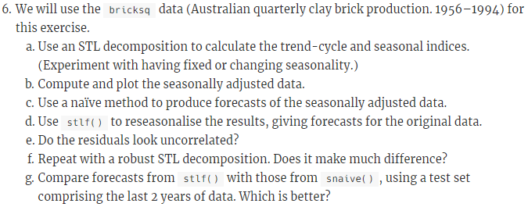

##### KJ# 3.1

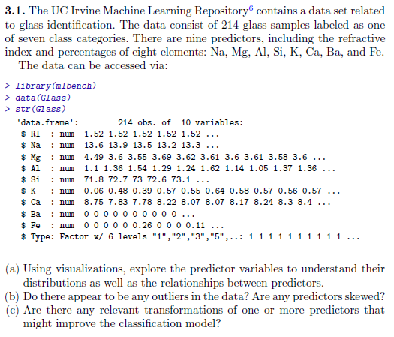

##### KJ# 3.2

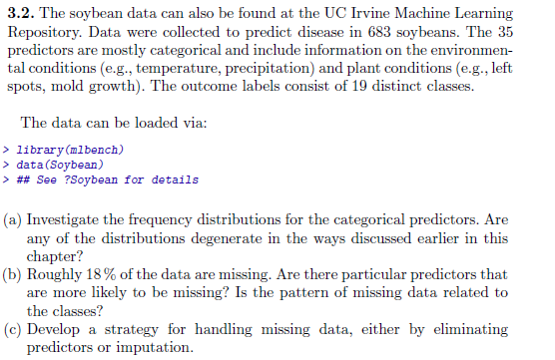

##### HA# 7.5

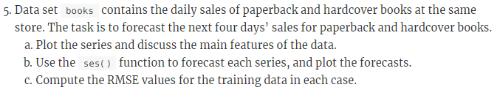

##### HA# 7.6

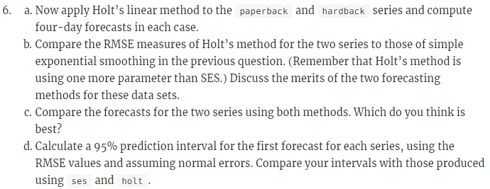

##### HA# 7.10

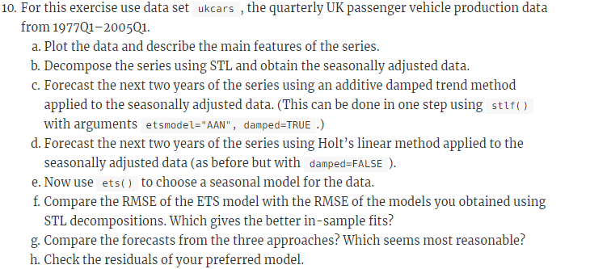

##### HA# 8.1

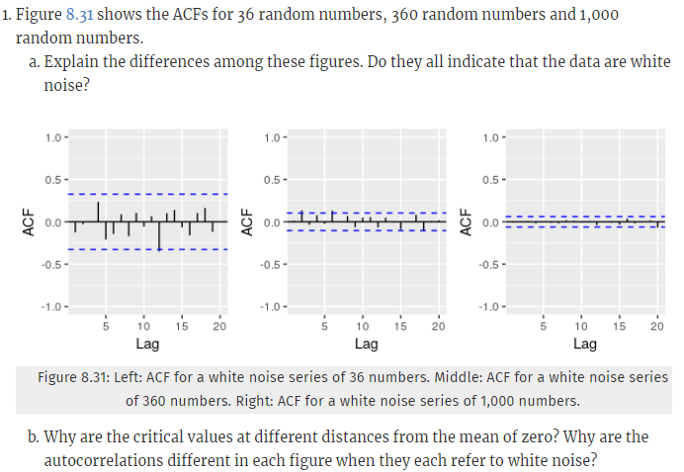

##### HA# 8.2

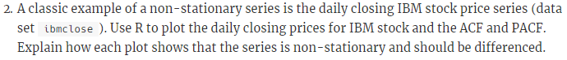

##### HA# 8.7

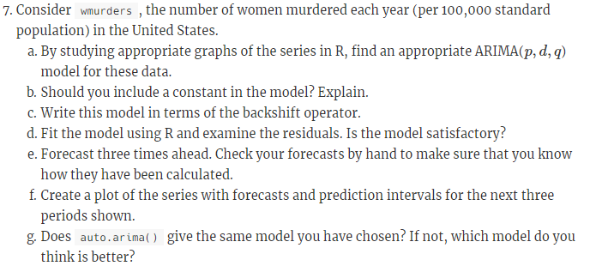

##### HA# 8.12

