**Assignment 2.1 Description and Screen Shots**

**By: Tofik Mussa**

**Submitted to: Dr. Vitaly**

1. **Directory structure**

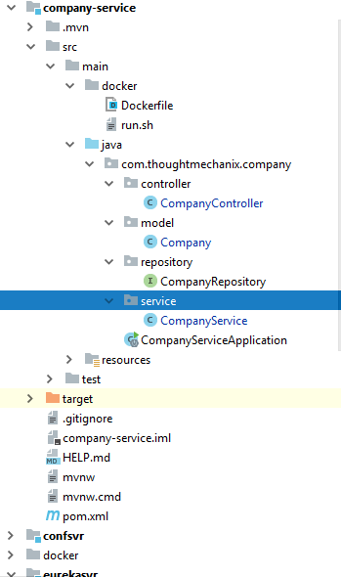

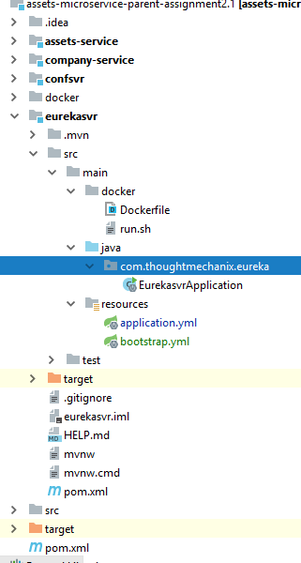

1. **Maven build**

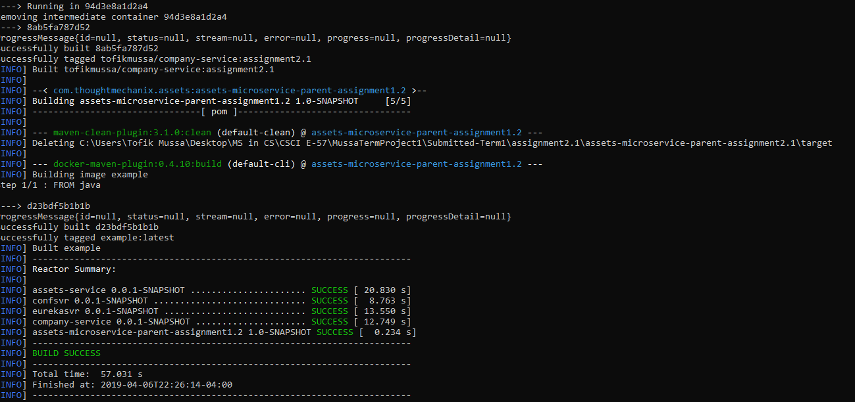

1. **Docker compose**

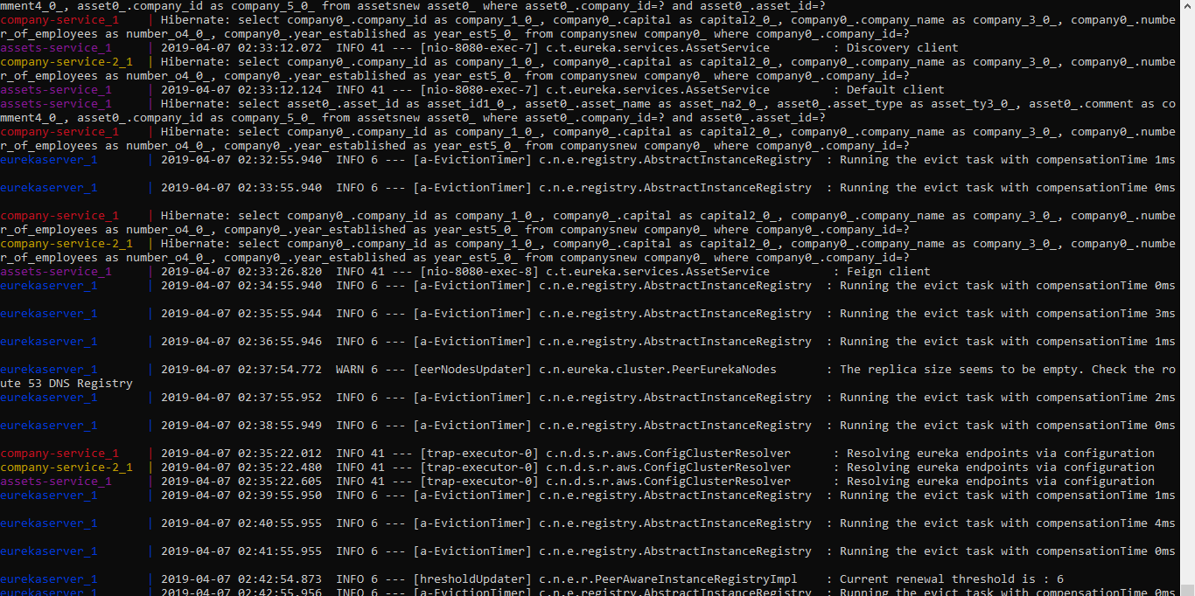

1. **Company service**

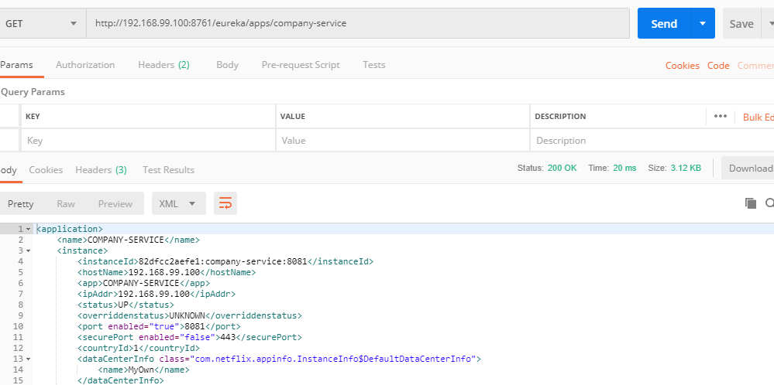

1. **Assets service**

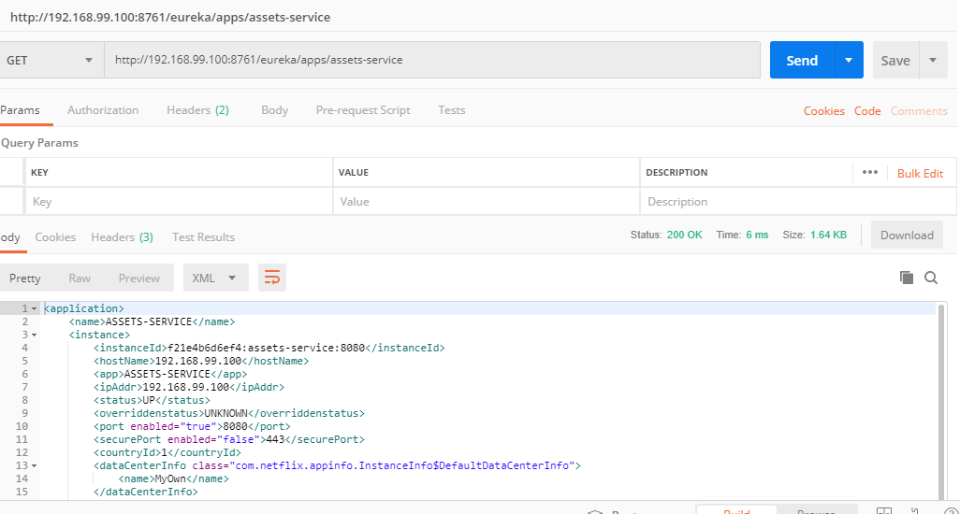

1. **Get all assets for a certain company with** <http://192.168.99.100:8080/v1/companys/2f341f84-accd-43a6-abbc-70d41de2c9d3/assets/>

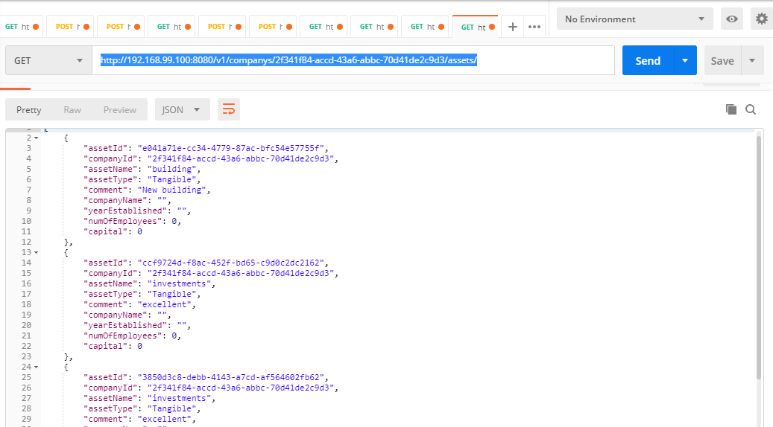

1. **Get a specific asset with**

<http://192.168.99.100:8080/v1/companys/2f341f84-accd-43a6-abbc-70d41de2c9d3/assets/e041a71e-cc34-4779-87ac-bfc54e57755f/default>

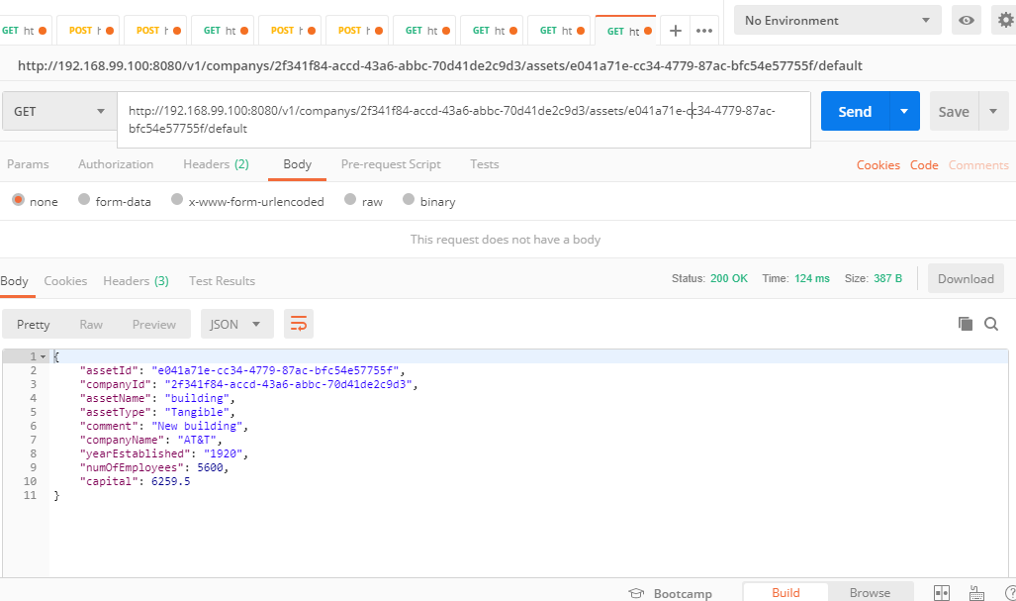

**Logs show “Default Client”**

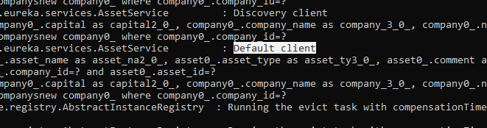

1. **Discovery client**

<http://192.168.99.100:8080/v1/companys/2f341f84-accd-43a6-abbc-70d41de2c9d3/assets/e041a71e-cc34-4779-87ac-bfc54e57755f/discovery>

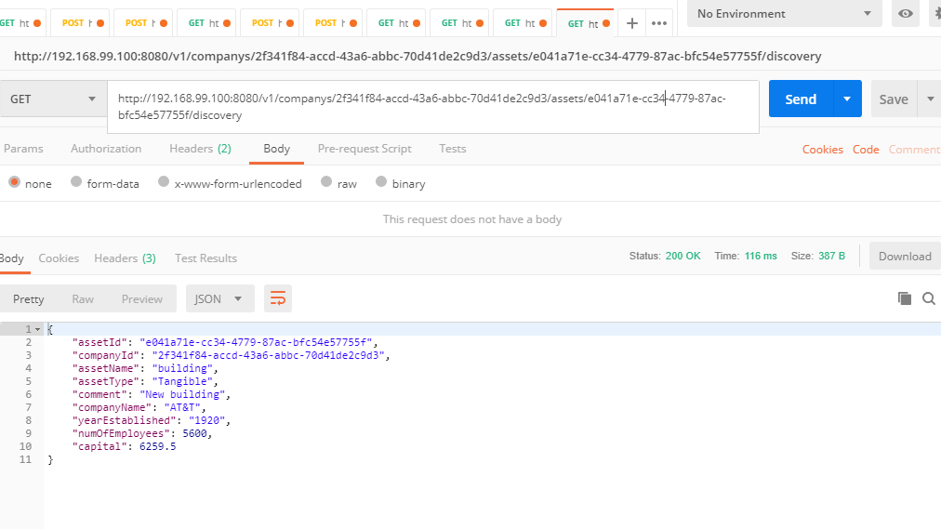

**Logs show discovery client**

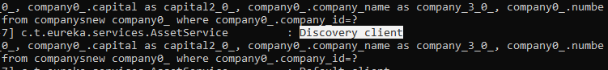

1. **Rest client**

<http://192.168.99.100:8080/v1/companys/2f341f84-accd-43a6-abbc-70d41de2c9d3/assets/e041a71e-cc34-4779-87ac-bfc54e57755f/rest>

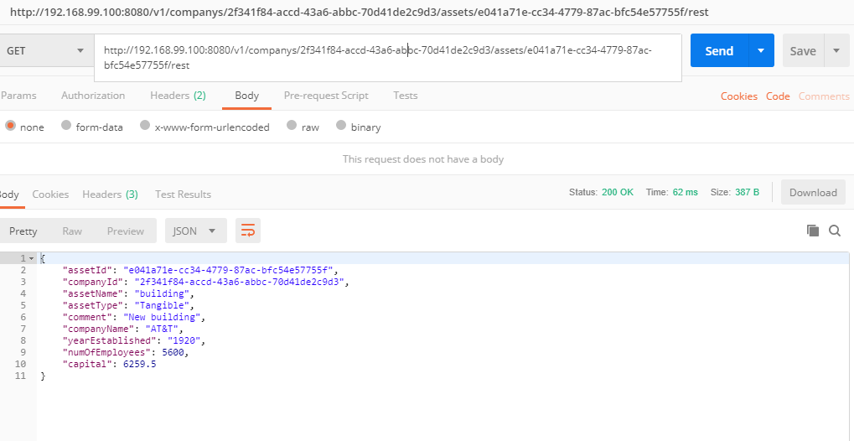

**Logs show rest client**

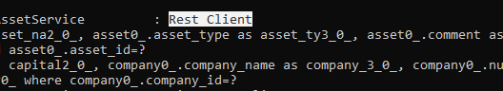

1. **Feign client**

<http://192.168.99.100:8080/v1/companys/2f341f84-accd-43a6-abbc-70d41de2c9d3/assets/e041a71e-cc34-4779-87ac-bfc54e57755f/feign>

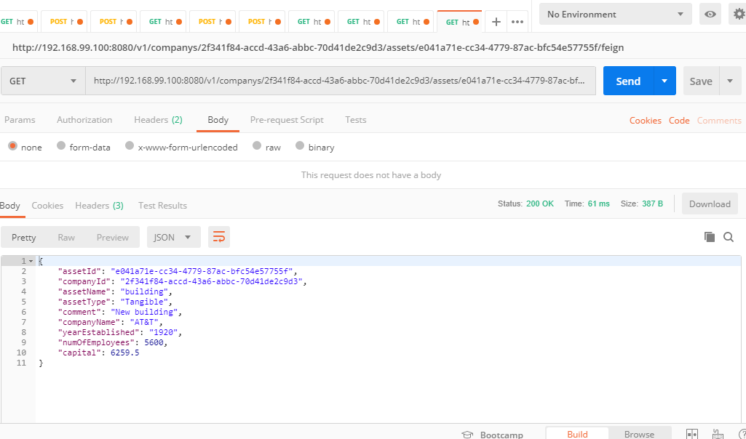

**Logs show feign client**

