CSCIE-55 Homework 6

Fall 2019

# Required for **Windows users only**: The Linux VM.

## **Getting the assets**

**Download and Install 7-Zip if you do not have it:**

* 7-Zip [https://www.7-zip.org/download.html]

**Download**

* VBox [https://www.virtualbox.org/wiki/Downloads]
* VirtualBox 6.0.14 Oracle VM VirtualBox Extension Pack [https://download.virtualbox.org/virtualbox/6.0.14/Oracle_VM_VirtualBox_Extension_Pack-6.0.14.vbox-extpack]

**Install Oracle VirtualBox**

* verify that VBox creates a dir named 'VirtualBox VMs' (OR might be ‘VirtualBoxVMs’) during install. [**Locate this directory. It is usually created under** **C:\Users\<username>\]**
* create a dir under VirtualBox VMs named *CSCIE-55*

**Run installation for VirtualBox Extension Pack**

## **Getting the CSCIE-55 VM**

Create a Directory where you can keep the files below

**Download files from AWS S3 [URLs below. Increment each file ending .00n from .001-.0021].**

https://s3.amazonaws.com/cscie55vm/CSCIE-55_VM.zip.001

https://s3.amazonaws.com/cscie55vm/CSCIE-55_VM.zip.002

… all the way to …

https://s3.amazonaws.com/cscie55vm/CSCIE-55_VM.zip.021

Downloading these files takes time, so start ASAP!

## **Assembling the VM files**

**Open 7-Zip File Manager**

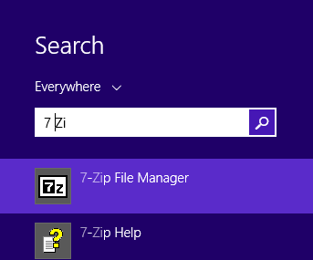

Figure Search for 7 Zip [This example is Window 8 search]

In 7-Zip File Manager, browse to dir where zip files are, and **select ONLY the FIRST one CSCIE-55_VM.zip.001**

Click 'Extract' as shown below.

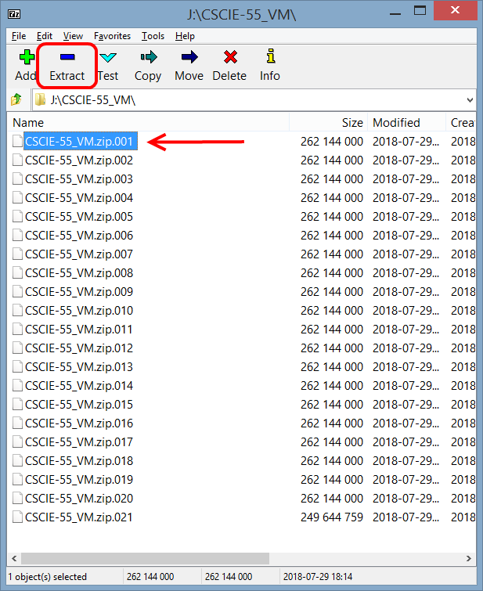

## **Import the VM into VirtualBox**

Browse to your VirtualBox VMs/CSCIE-55 path when prompted 'Extract to', and click OK.

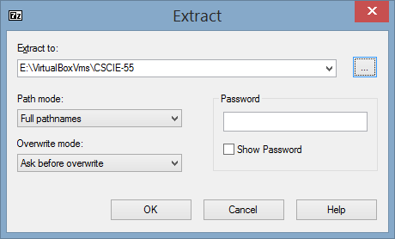

In the host system’s VirtualBox application, click **File -> Import Appliance**

Browse to location of CSCIE-55 2.ova under VirtualBox VMs and click Open.

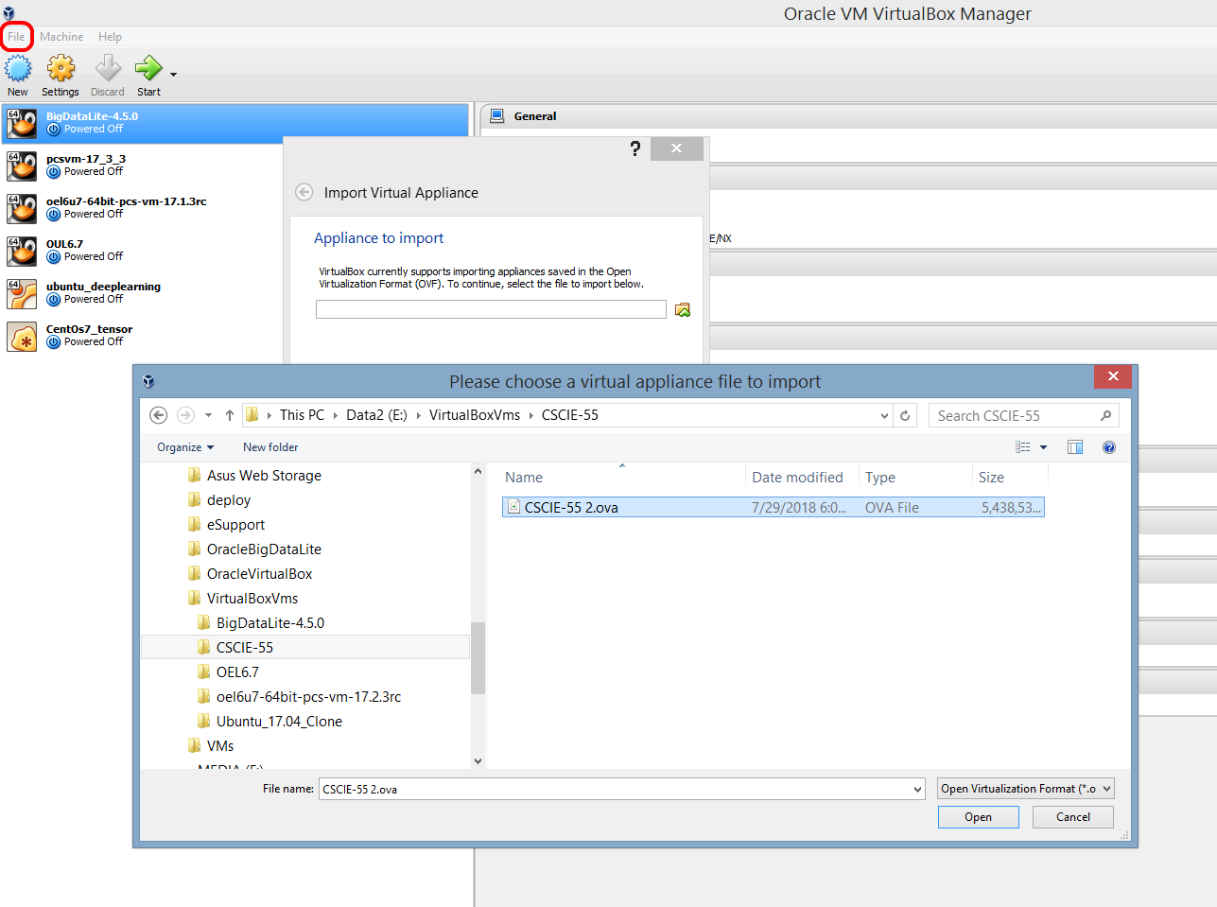

You have imported the Virtual Machine!

**FIRST-TIME ONLY**: Select VM in menu, click Settings button. Select Network -> Advanced. Click the refresh mac address button:

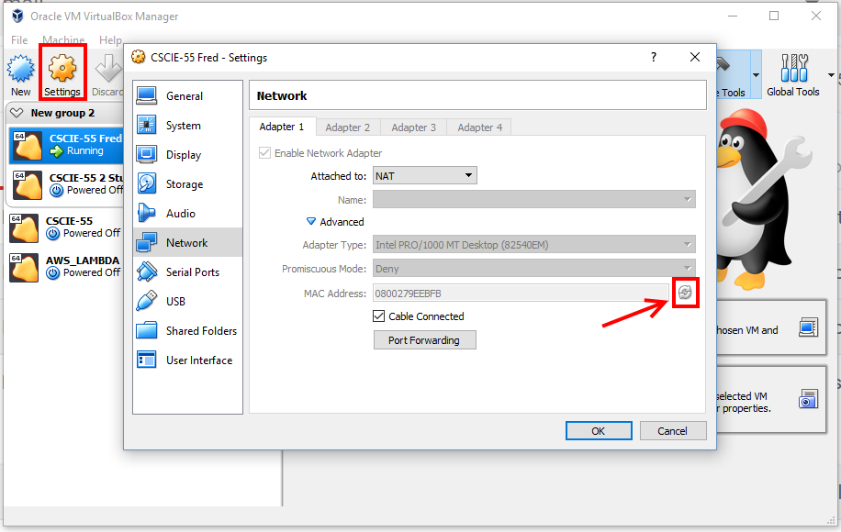

## **Using the VM.**

Launch VM by selecting in left menu and clicking Green Start arrow

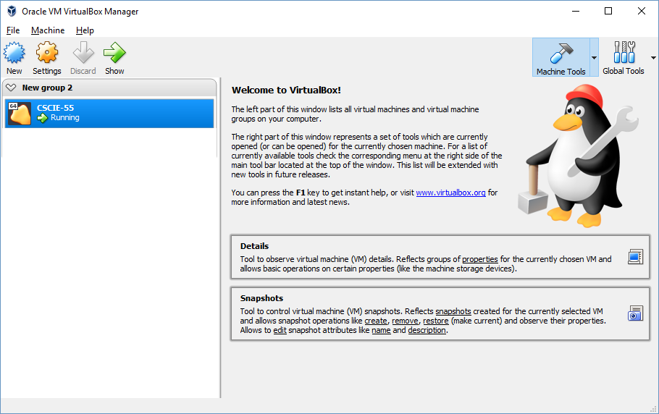

Password is ***cscie-55***. [This is also the password for SUDO – superuser, i.e. the ‘root’ password.]