Enabling Shared folders on Vbox CentOs 7 VM

To enable Shared Folders on the Oracle VirtualBox CentOs 7 VM, follow these steps:

- Be sure that when you installed Oracle Virtual Box you also downlioaded and installed VirtualBox Guest Additions
- In the Host system open Oracle Virtual Box client software and select your VM, click Settings → Shared Folders → Add Shared Folder → browse to directory path on Windows host → Provide a name → check Auto-Mount → OK.
NOTE: In my example, the name I added is “CSCIE-55”, as shown in step 5 in screen shot.

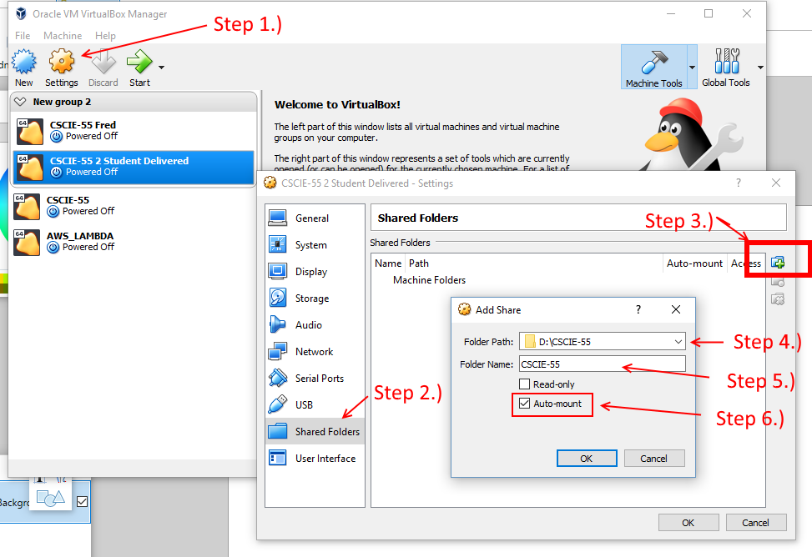

- Launch the VM and login as HU-student with cscie-55 password
- Press keys Right-Ctl & Home to reveal pop-up menu
- Choose Devices → Insert Guest Additions CD image
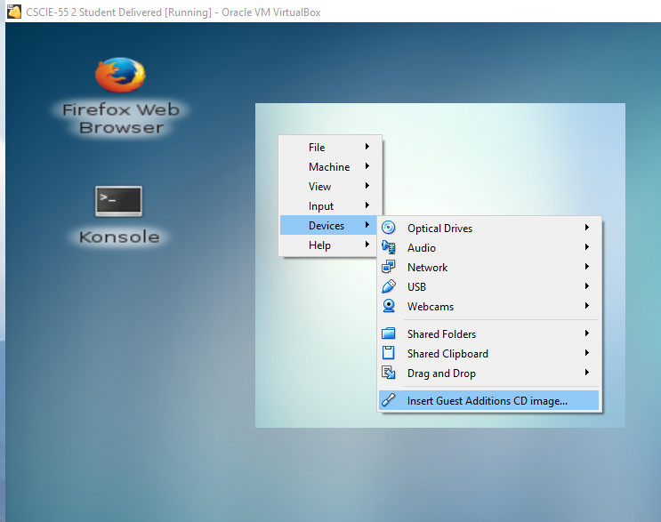
- Select 'show in File System manager to display new Device Vbox_GAs_5.2.16
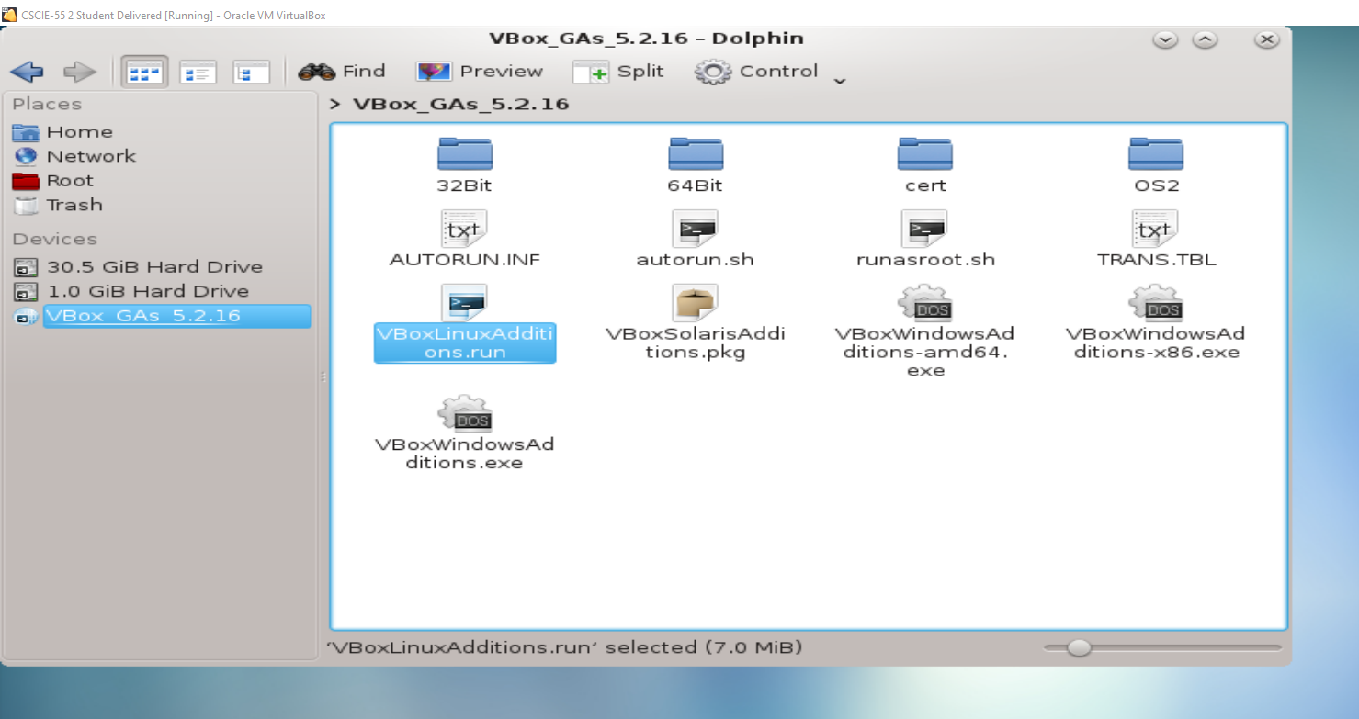
- Copy file 'VboxLinuxAdditions.run to home [~] directory by clicking Home and pasting to Home directory.
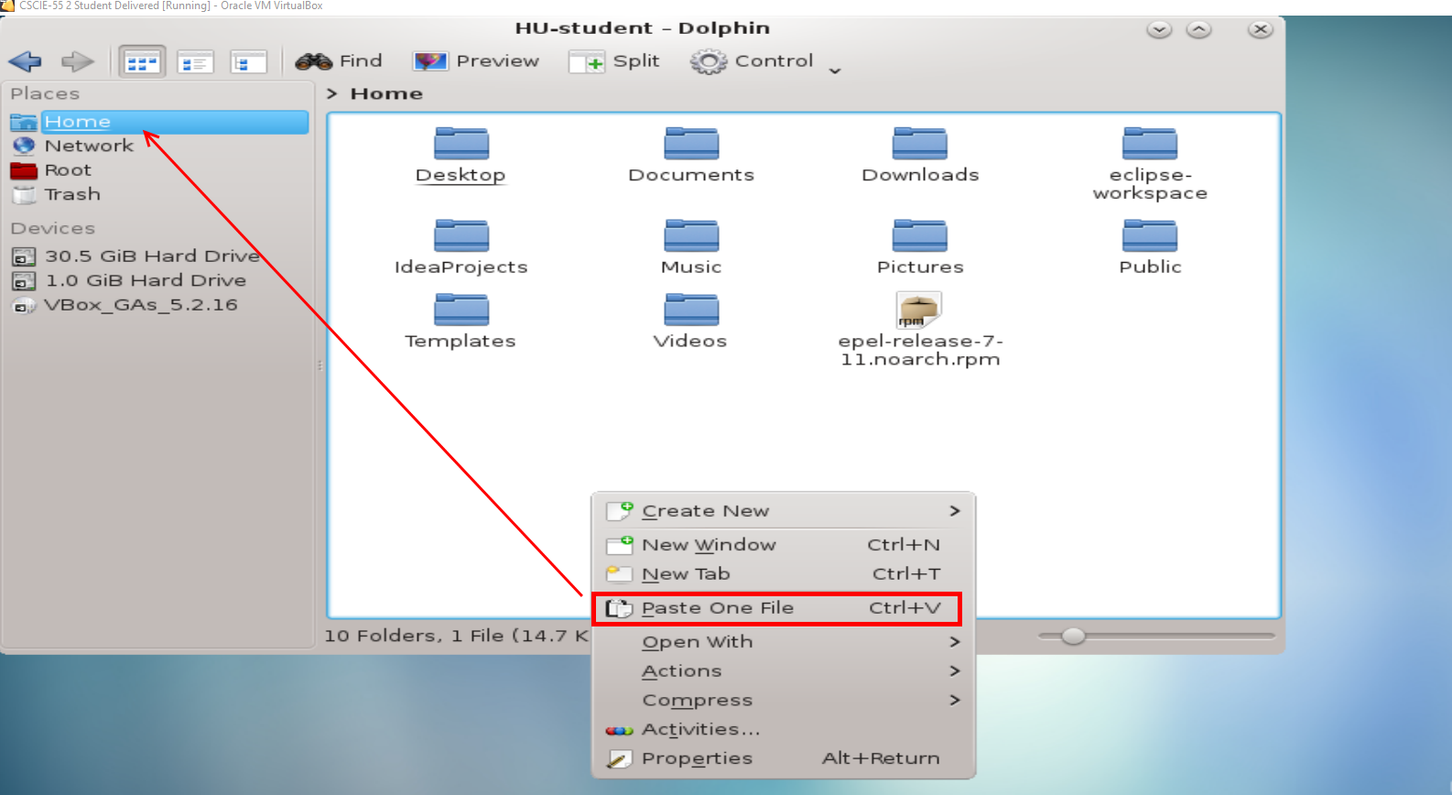
- Results should look like this:
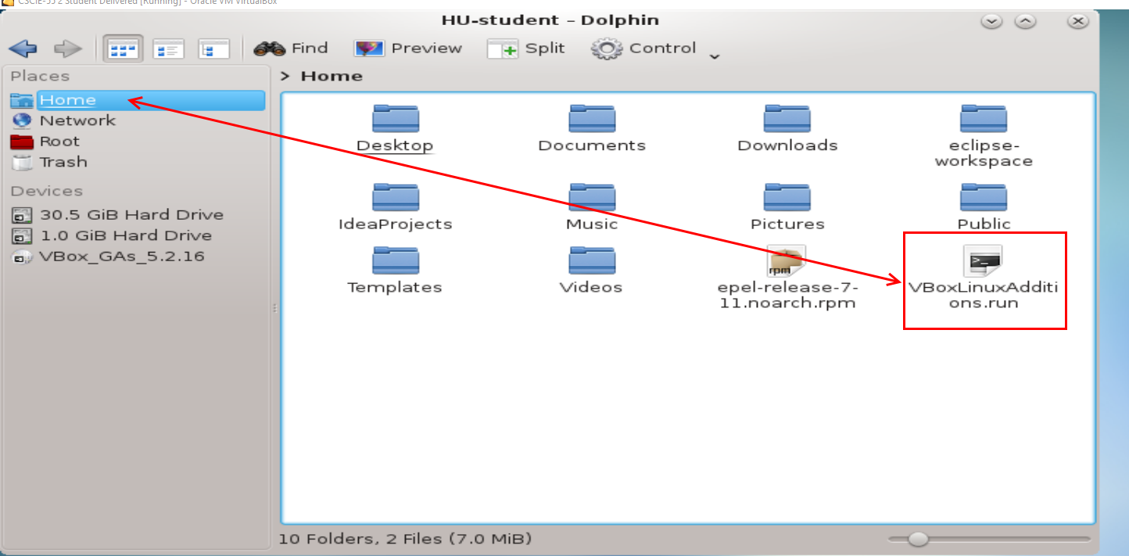
- fOpen the terminal and be sure you are in your Home dir [do: cd ~]
- Do: sudo ./VboxLinuxAdditions.run to run the program. [The sudo password is also cscie-55]
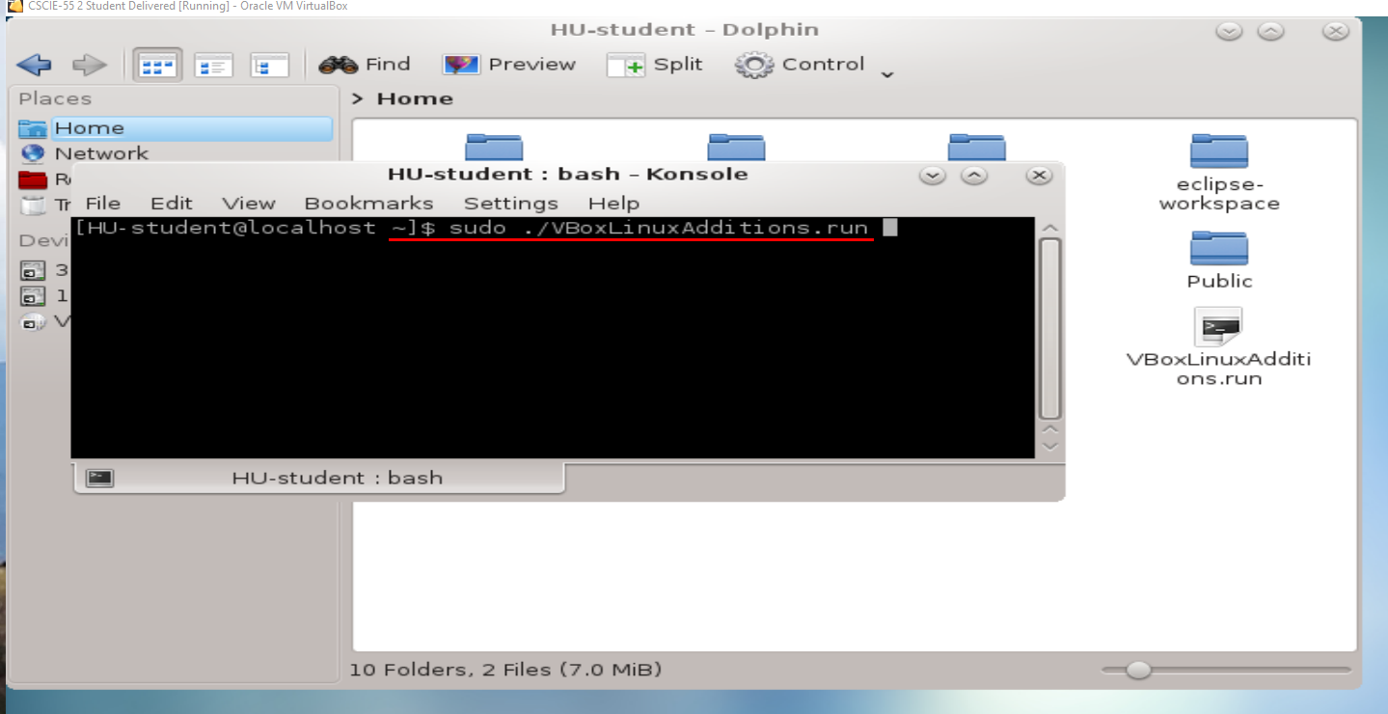
- On completion, the terminal should look like this:
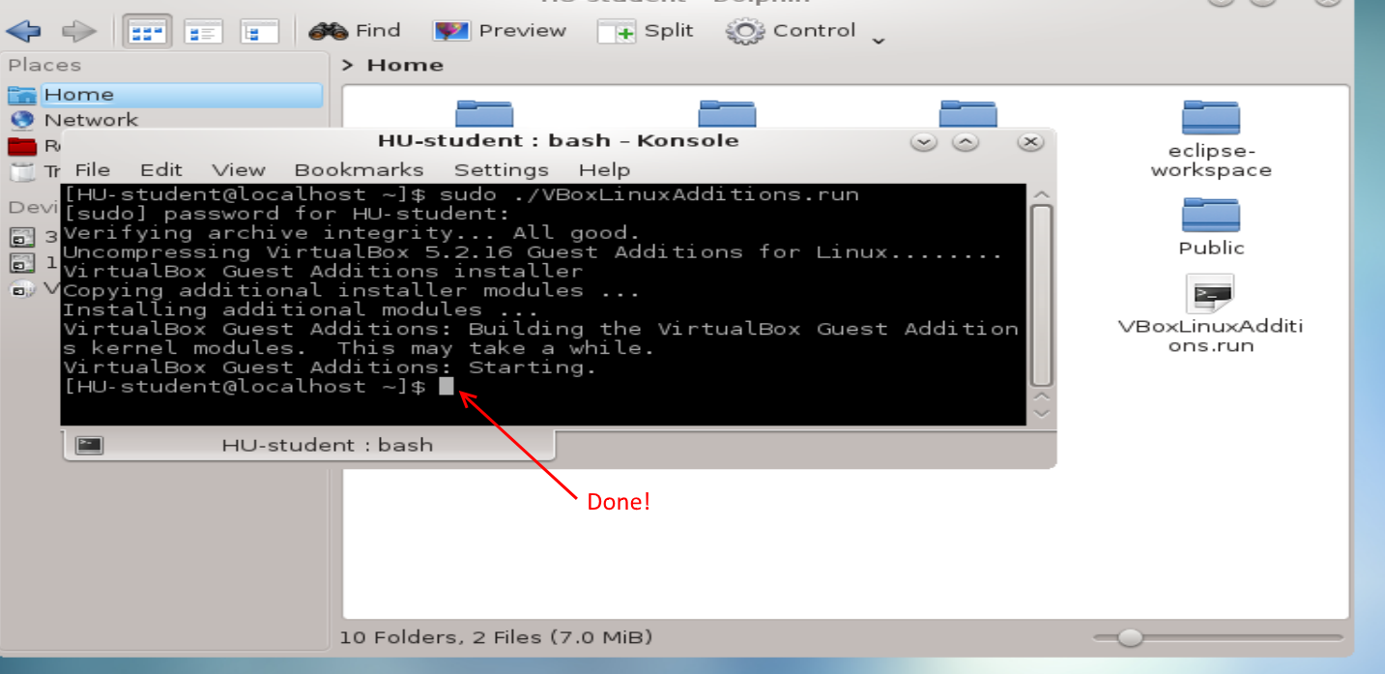
- Do: sudo ls -al /media/sf_CSCIE-55

NOTE: This name is what I added in the Windows Host client software in step 2 above. Vbox adds 'sf_' to that name in the guest [linux] system directory under the /media/ directory.

This should reveal all of the directories and/or files in the host system folder, as seen in screenshot below.
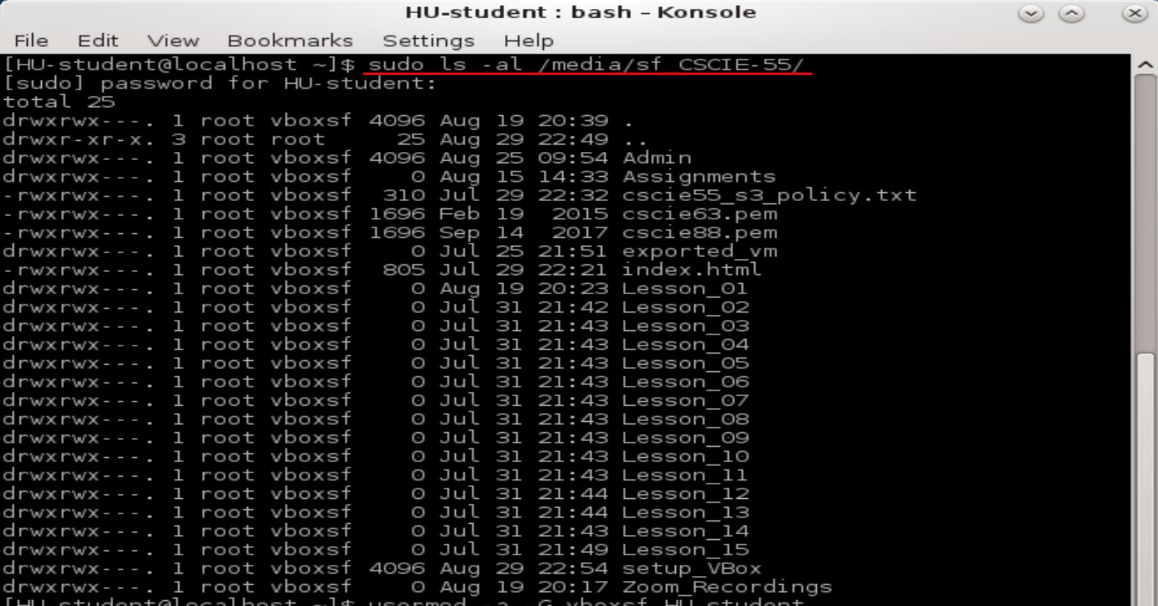
- Notice that all files are assigned to the root superuser, and to a new group named 'vboxsf'. We need to add ourselves to the vboxsf group.
- Do: sudo usermod -a -G vboxsf HU-student
- Notice that the command usermod does not seem to have added the vboxsf group to the HU-student user/
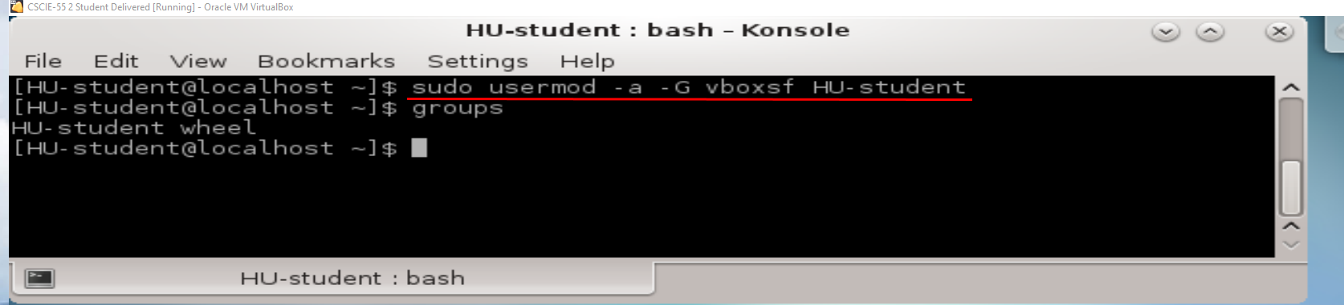
- Restart the VM.
- To verify that your user is in the vboxsf group, do: groups
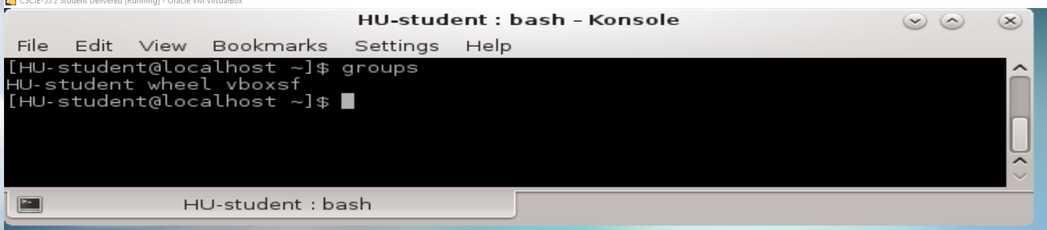
- Do ls -al /media/sf-CSCIE-55, and you will see all of the files in your host Shared Folder in your VM.
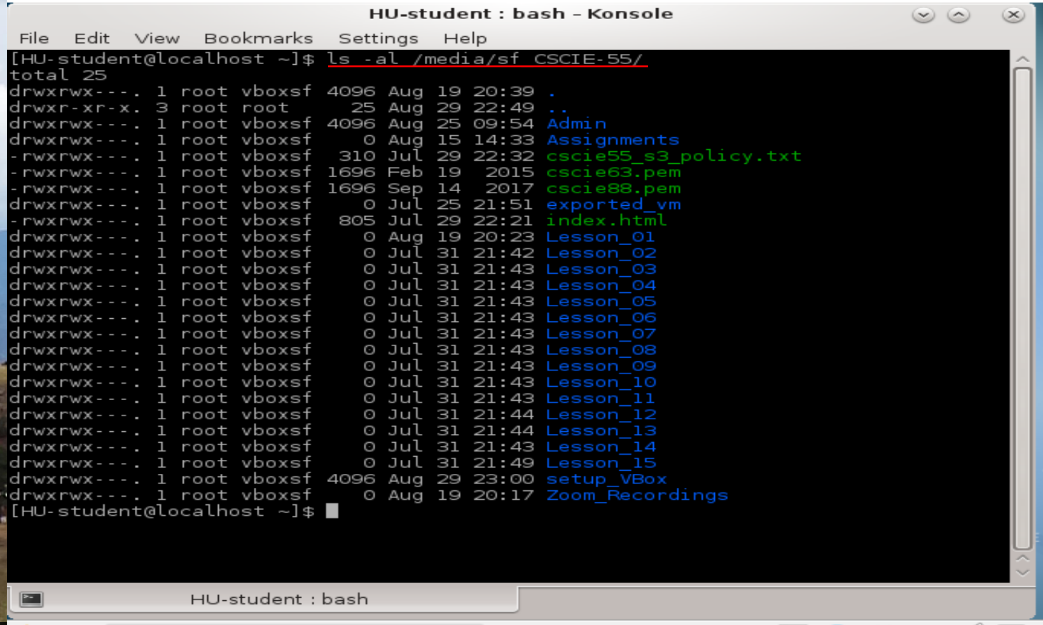
PROBAL: All files are owned by root. Any idea how to make this easier for students to manage???

