CSCIE-55 Homework 6

Fall 2019

# Required for **Windows users only**: The Linux VM.

## **Getting the assets**

**Download and Install 7-Zip if you do not have it:**

* 7-Zip [https://www.7-zip.org/download.html]

**Download**

* VBox [https://www.virtualbox.org/wiki/Downloads]
* VirtualBox 6.0.14 Oracle VM VirtualBox Extension Pack [https://download.virtualbox.org/virtualbox/6.0.14/Oracle_VM_VirtualBox_Extension_Pack-6.0.14.vbox-extpack]

**Install Oracle VirtualBox**

* verify that VBox creates a dir named 'VirtualBox VMs' (OR might be ‘VirtualBoxVMs’) during install. [**Locate this directory. It is usually created under** **C:\Users\<your_username>\]**
* create a dir under VirtualBox VMs named *CSCIE-55*

**Run installation for VirtualBox Extension Pack**

Double-click the extpack file.

## **Getting the CSCIE-55 VM**

Create a Directory where you can keep the files below

**Download files from AWS S3 [URLs below. Increment each file ending .00n from .001-.0021].**

https://s3.amazonaws.com/cscie55vm/CSCIE-55_VM.zip.001

https://s3.amazonaws.com/cscie55vm/CSCIE-55_VM.zip.002

… all the way to …

https://s3.amazonaws.com/cscie55vm/CSCIE-55_VM.zip.021

Downloading these files takes time, so start ASAP!

## **Assembling the VM files**

**Open 7-Zip File Manager**

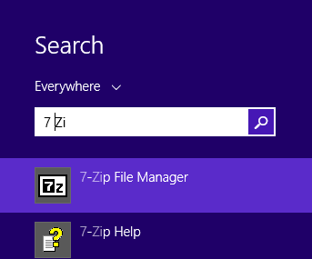

Figure Search for 7 Zip [This example is Window 8 search]

In 7-Zip File Manager, browse to dir where zip files are, and **select ONLY the FIRST one CSCIE-55_VM.zip.001**

Click 'Extract' as shown below.

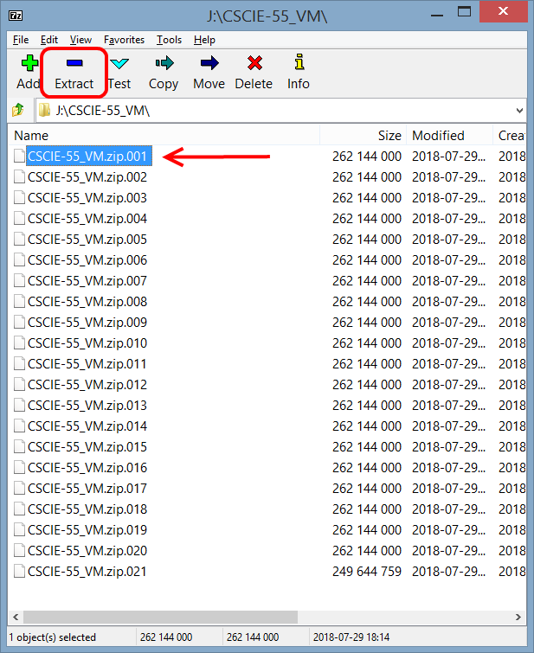

## **Import the VM into VirtualBox**

Browse to your VirtualBox VMs/CSCIE-55 path in the 'Extract to' field and click OK.

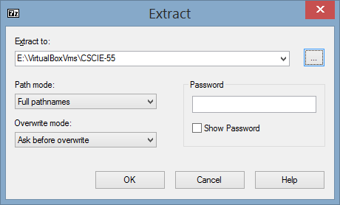

You will see a progress report that looks like the following screenshot:

Note that the file being created as the 21 zip files are assembled is named “CSCIE-55 2.ova”

# **Launch Virtual Box**

In your VirtualBox application, click **File -> Import Appliance**

Browse to location of CSCIE-55 2.ova under VirtualBox VMs and click Open.

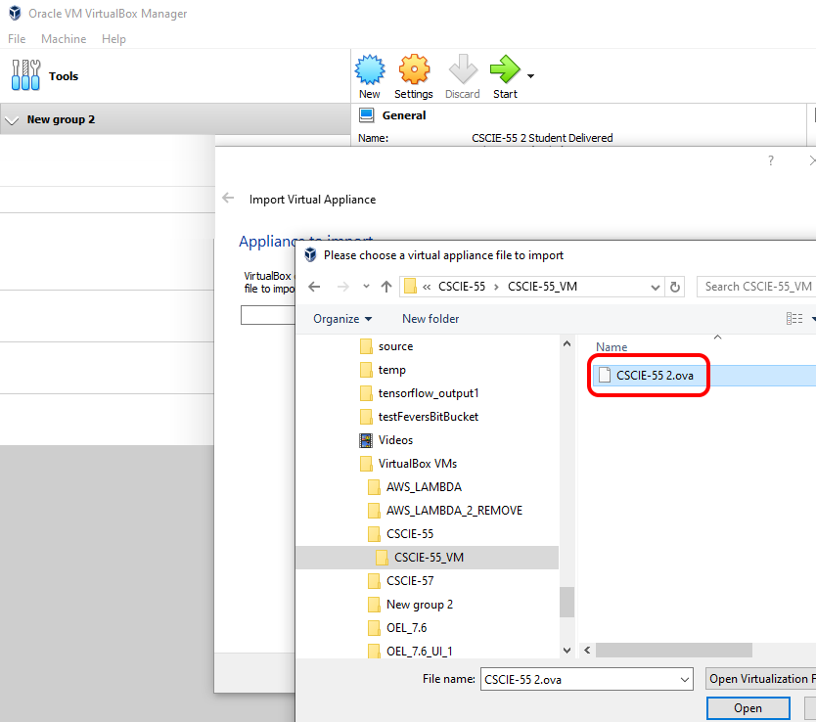

When Appliance settings dialog appears, Deselect the USB Controller.

You have the option to select another location for storing the VM image that will be generated as highlighted below.

Click ‘Import’. This takes a couple of minutes.

You have imported the Virtual Machine!

**FIRST-TIME ONLY**: Select VM in menu, click Settings button. Select Network -> Advanced. Click the refresh mac address button:

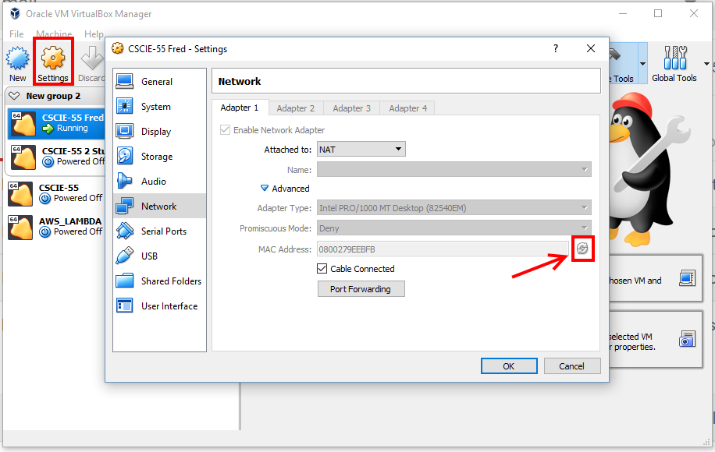

## **Using the VM.**

Launch VM by selecting in left menu and clicking Green Start arrow

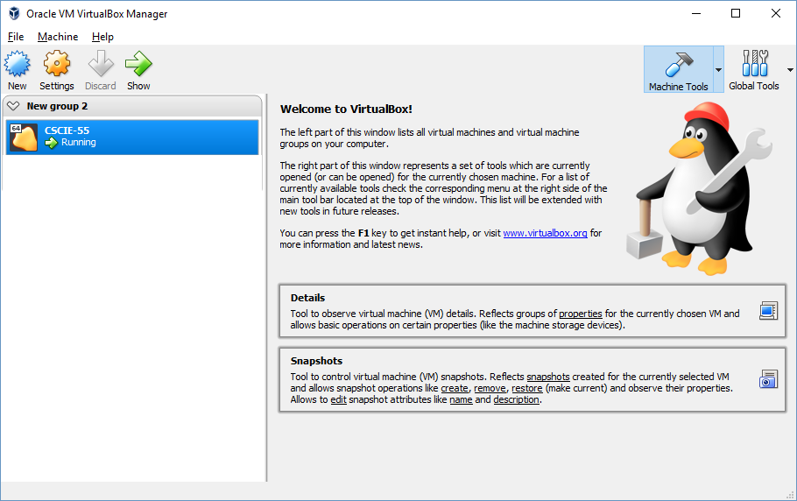

Password is ***cscie-55***. [This is also the password for SUDO – superuser, i.e. the ‘root’ password.]

Right-click on the UI and select ‘Konsole’.

This VM is provisioned with Java 10, Git, Maven and Intelli-J Idea.

On the command line type ‘idea’ and Intelli-J will open.

Type Firefox and a browser will open.

Please read