**02-REACTJS HANDSON**

1. Create a React project named “StudentApp” type the following command in terminal of Visual studio:



1. Create a new folder under Src folder with the name “Components”. Add a new file named “Home.js”
2. Type the following code in Home.js

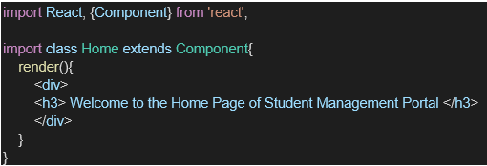

1. Under Src folder add another file named “About.js”
2. Repeat the same steps for Creating “About” and “Contact” component by adding a new file as ”About.js”, “Contact.js” under “Src” folder and edit the code as mentioned for “Home” Component.
3. Edit the App.js to invoke the Home, About and Contact component as follows:

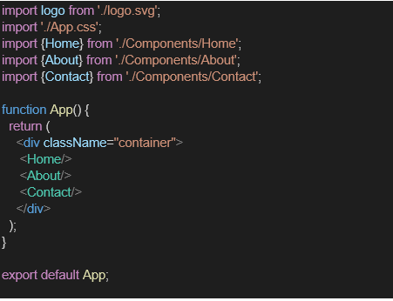

1. In command Prompt, navigate into StudentApp and execute the code by typing the following command:



1. Open browser and type “localhost:3000” in the address bar:

**Code:**

About.js  
  
import React from 'react';

class About extends React.Component {

  render() {

    return (

      <div>

        <h2>Welcome to the About page of the Student Management Portal</h2>

      </div>

    );

  }

}

export default About;

Contact.js  
import React from 'react';

class Contact extends React.Component {

  render() {

    return (

      <div>

        <h2>Welcome to the Contact page of the Student Management Portal</h2>

      </div>

    );

  }

}

export default Contact;

Home.js  
  
import React from 'react';

class Home extends React.Component {

  render() {

    return (

      <div>

        <h2>Welcome to the Home page of Student Management Portal</h2>

      </div>

    );

  }

}

export default Home;

App.js  
import React from 'react';

import Home from './Components/Home';

import About from './Components/About';

import Contact from './Components/Contact';

function App() {

  return (

    <div *className*="App">

      <Home />

      <About />

      <Contact />

    </div>

  );

}

export default App;

Output:  
  
