CS 3810 Principles of Database System

Project Proposal for Grade Book DB Design

Requirements Specifications / Business Rules

Design Document

09/17/18

Team member(s);

Abinet Kenore

Brook Beyene

Mutumba Tonny

Rohit Shrestha

**GRADE BOOK DATABASE DESIGN**

|  |  |  |  |  |  |  |  |  |  |  |
| --- | --- | --- | --- | --- | --- | --- | --- | --- | --- | --- |
| STUDENT INFO .. keys | | | COURSE INFO | | GRADING/EVALUATION OF THE COURSE........... | | GRADE  Num . .ltr | |  | |
| First_name | Str |  | Course_name | Str | Class_work/cw |  | 90 -100 | A |  |  |
| Last_name | Str |  | Course_num | Int | Homework/hw |  | 80 -90 | B |  |  |
| Email | Str |  | Credit_hr | Int | Tests/ts |  | 70_80 | C |  |  |
| Date_birth | DATE |  | Course_id | Int | Class_pro/cp |  | 60-70 | D |  |  |
| Student_id | int |  |
| Sex | Str |  | Course_descrp |  | Final_exam/fe |  | <=59 | F |  |  |
| Phone | Str |  |  |  | Consider the date exam taken |  |  |  |  |  |
| City | Str |  |  |  |  |  |  |  |  |  |
| State | Str |  |  |  |  |  |  |  |  |  |
| Zip | Int |  |  |  |  |  |  |  |  |  |

figure 1.1

The project that we will like to go ahead and do is grade book DB. We fill that by creating a grade book DBS, manly teachers might be interested accumulating multiple students’ class-oriented records and be able to retrieve them easily. That being said, some of the important features we would like to include for the teachers grading will have some of these segments for; student, course, universal grading metrics, and other related info.

The basic idea for the segments we will feature are displayed in figure 1.1. Also, in this DB system, we will provide a professor the required DB query implementation (CRUD).

The design will be implemented using a programing language Java, for a DB config MySQL5, and GUI if we have enough time.

**Note:** There may be a change in the tools we use for the seek of implementation and easiness of the work!

At the end of the semester we will provide a presentation for the class and a documentation of the project for the professor for the later use.

Gradebook consists of having many different things playing their own parts, in order to correctly evaluate the individual student work. Below is list of requirements we seek to incorporate within our design.

List of requirements:

* Student:
  + Student identification number (SIN), First, last name, major, student email address (SEA).
* Course:
  + Course record number (CRN), section identification number (SIN), course name, course number (CN), term, year.
* Instructor:
  + Instructor, first, Last name, department, instructor identification number (IIN), instructor email address (IEA).
* Grading system:
  + Raw score, letter grade, student identification number (SID), course record number (CRN).
* Assignment:
  + Student assignment, course record number (CRN), assignment name, average points, maximum point, weight, assignment identification number (AIN).

Below we have the design document (figure 1.2) how we are to create a grading book. Then right below that we have the rules (figure 1.3) of our ER diagram for this particular design.

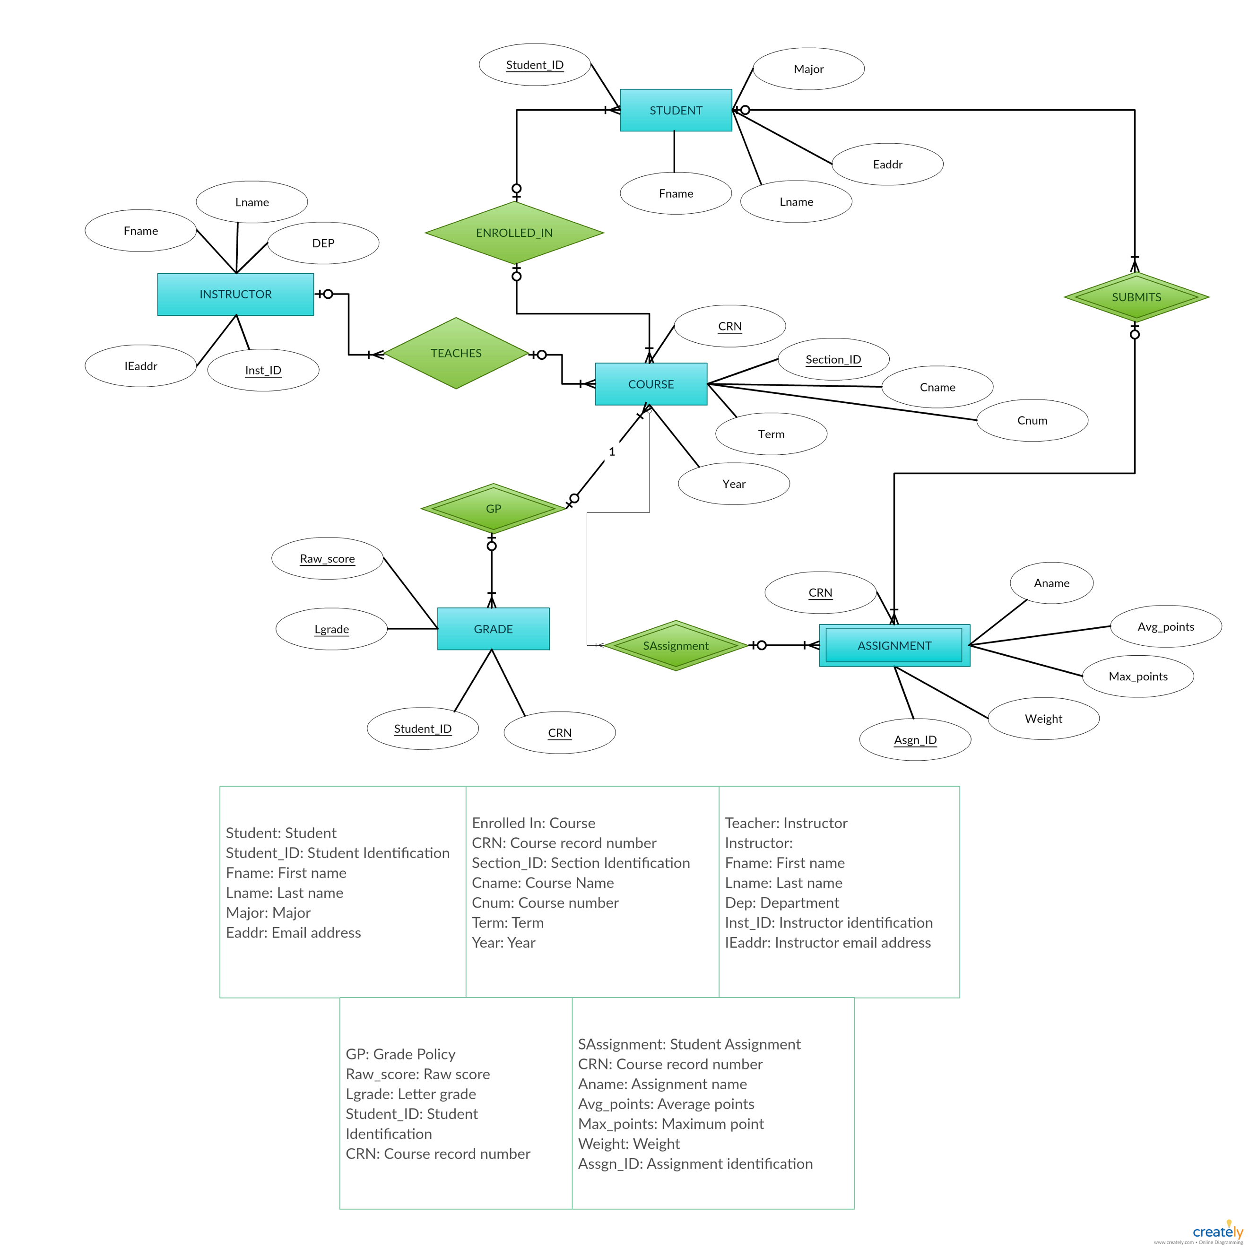

figure 1.2



figure 1.3