99



ID NO: S1064

Hon Vincent Orcio

**Timekeeper**

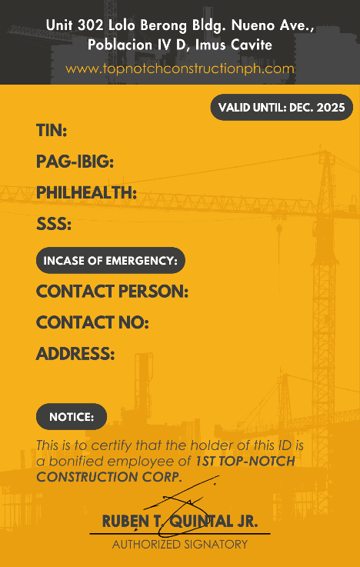

Charmaine Abarera

0906 087 8352

98 Summerville st. Brgy Delapaz Antipolo City

**335-400-978-000**

**121241055747**

**03-026170654-3**

**34-6904496-3**