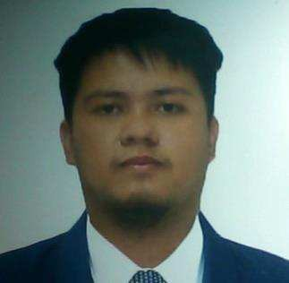ADRIAN PHILLIP T. TAPERE

Las Brisas Tierra Del Sol, Ivanna st. Tanauan Tanza, Cavite, Philippines 09668742884

[adriantapere2@yahoo.com](mailto:adriantapere2@yahoo.com)

# PERSONAL INFORMATION

Born September 16, 1995 in Philippines Citizenship: Filipino

Marital status: Single

# ABOUT

I am a skilled individual with a great analytical skill. I have a strong ability to think critically and solve issues to challenge my problem-solving skills while being detail-oriented quality with my output. I am enthusiastic to learn and undertake new challenges.

# SKILLS

* MS Office Word, Powerpoint, Excel
* RDBMS (MSSQL)
* ASP.NET Programming (JavaScript, C#, Html, Bootstrap)
* GitHub
* Computer Network/Software/Hardware Troubleshooting
* Biometrics Management
* Digital Image Editing

# CAREER OBJECTIVE

To use and improve my abilities and grow as an individual while contributing to the progress of the company.

# EDUCATION

**2012-2018 LYCEUM OF THE PHILIPPINES UNIVERSITY**

# Bachelor of Science in Information Technology

**SEMINARS ATTENDED**

* IM SET (Image and Skill Enhancement Training)
* YIPPee (Young IT Practitioners of the Philippines)

# WORK EXPERIENCE

* Provincial Information and Communications Technology Office – IT Staff(Intern)
* Freelancing – Web Design
* Top-Notch Construction Company – Jr. Web & App Developer