**Introduction**

This document provides a guide on deploying a sample application using Kubernetes. The process includes creating a Deployment and a Service configuration, applying them using kubectl, and accessing the deployed service through Minikube.

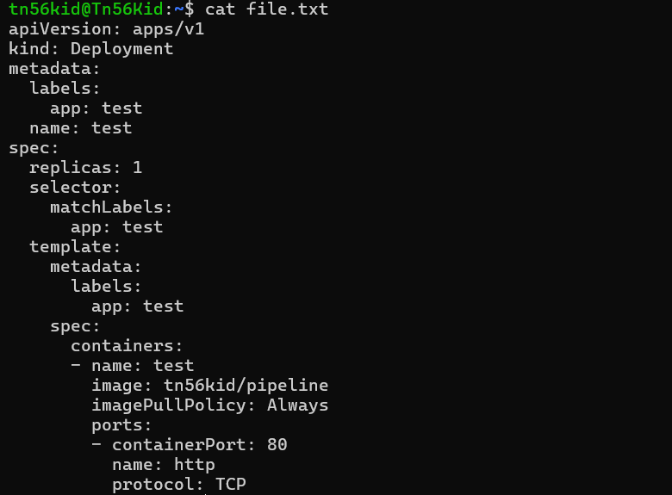

The cat command in UNIX/Linux is short for "concatenate" and is used to display the content of files.

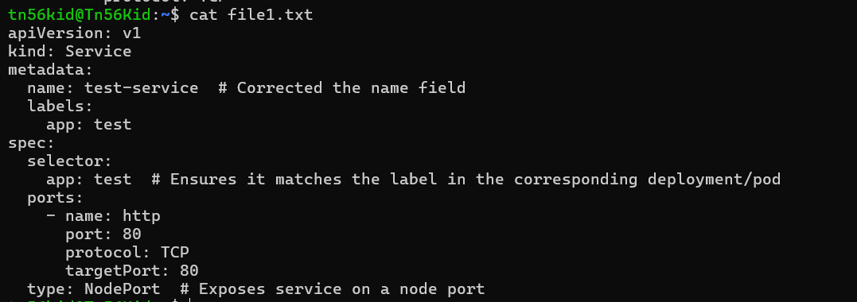

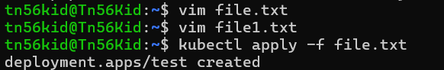

The **vim command** is used to open the Vim text editor, which is a highly configurable and powerful text editor that is commonly used in UNIX/Linux environments.

**kubectl apply -f t1.txt**

This command applies the Deployment configuration and creates the deployment named test.

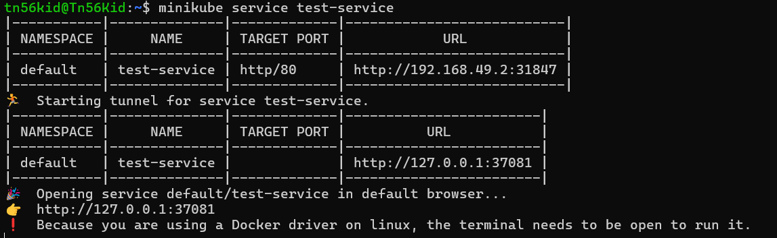

**kubectl apply -f t2.txt**

This command applies the Service configuration and creates the service named test-service.

**minikube service test-service**

This command starts a tunnel for the service and provides a URL to access the deployed application.

**Output**

