File SFEXMPL1.DOC contains the following bookmarks. Select the topic you are trying to find from the list and double click the highlighted text.
Examples in other files
HREF="sfexmpl2.doc
HREF="sfexmpl3.doc

Examples\RadioFrequency subdirectories discussed in this file

Topics

File SFEXMPL1.DOC Table of Contents
XVI. RF Field Examples (Autofish, Fish, CFish)
A. The PillboxCavities directory
1. PILL1.AF, a short pillbox cavity
2. MODPILL.AF, a pillbox cavity with bore tube
B. The CFish directory
a. Coaxial waveguide example
b. Pillbox with dielectric rod
c. Power losses in dielectrics
d. Waveguide power splitter
C. The FrequencyScan directory
a. The on-axis coupled cavity and resonance searches
b. Frequency scans
c. Plotting fields along segments
D. The SphericalCavity directory
E. The RFQCavity directory
a. One-eighth of an RFQ cavity
b. One-fourth of an RFQ cavity
F. The QuarterWaveResonator directory
G. The FerriteCavity directory
H. The Waveguides directory
1. Rectangular waveguide TE modes
2. Hexagonal waveguide TE modes

RF Field Examples (Autofish, Fish, CFish)
The Examples\RadioFrequency subdirectory include the files in Table XVI-1 plus several subdirectories containing rf field problems. Your installation may include HREF="sfintro.doc#ExamplesDirectory subdirectories under Examples for other types of problems. Batch file Run_RF.BAT runs all the examples. If you want to see the field plots as Run_RF finishes with each problem, type “Run_RF p”. Use a lower-case letter p. Otherwise, just type Run_RF. The batch file Show_RF.BAT runs WSFplot in each directory to display data from each solution. Run_RF.BAT must finish before you run Show_RF.BAT. After you have finished inspecting the results of the Run_RF run, you can run CLR_RF.BAT to delete all the files made by Run_RF.BAT.
Table XVI-1. Files in directory Examples\RadioFrequency.
Files | Description
Run_RF.BAT | Batch file that runs all examples in other directories.
Show_RF.BAT | Batch file that displays results of all runs.
CLR_RF.BAT | Batch file that deletes all files made by Run_RF.BAT.

Each subdirectory under Examples\RadioFrequency includes one or two batch control files. Files named RUNxxx.BAT runs the appropriate codes for all the example files in the subdirectory. Files named SHWxxx.BAT run WSFplot on each HREF="sffiles.doc#BinarySolutionFile to display the results. Subdirectories that have only one problem file do not contain a SHWxxx.BAT file. The batch files make use of the default settings in the SF.INI file shipped with this distribution. Binary solution files have extension T35. The batch files will not run WSFplot unless you call the batch process with a lower-case letter p on the run line. The codes create the binary solution file and the OUTxxx.TXT file appropriate to each code. In directories with multiple input files, the batch file copies some output files to other files. When the run finishes, you can inspect all the OUTxxx.TXT files. Files named OUTxxx1.TXT correspond to the first calculation in a directory, OUTxxx2.TXT to the second, and so forth. Files OUTxxx.TXT (without a number appended) corresponds to the most recent calculation.

The PillboxCavities directory
Table XVI-2 lists the files in the PillboxCavities directory for three pillbox cavity problems. The batch file RUNPILL.BAT shown in Figure XVI-1 runs Autofish to solve these problems. You also can run the individual programs Automesh, Fish, and SFO.
Table XVI-2. Files in directory RadioFrequency\PillboxCavities.
File | Description
PILL1.AF | Automesh input file for a short pillbox cavity.
PILL1.SEG | SFO input for PILL1 for normalization to E0.
PILL1B.SEG | SFO input for PILL1 for normalization to E0*T.
PILL1C.SEG | SFO input for PILL1 for normalization to HPHI.
PILL1D.SEG | SFO input for PILL1 using ASCALE for normalization.
PILL1E.SEG | SFO input for PILL1 for normalizing to user-defined integral.
PILL2.AF | Automesh input file for a long pillbox cavity.
PILL2.SEG | SFO input file for PILL2.
MODPILL.AF | Automesh input file for a pillbox with a bore tube.
RUNPILL.BAT | Batch file for running the codes.
SHWPILL.BAT | Batch file for viewing the results.

The two examples PILL1.AF and PILL2.AF are simple pillbox cavities for program Autofish. For these simple cavities, you can calculate analytically the resonant frequency, stored energy, cavity Q, and other properties. In the next section, we examine the input files associated with the PILL1.AF example. The PILL2.AF example has the same diameter as PILL1.AF, but a different length. We include it only because it exercises a different part of the code in Fish that solves the tridiagonal matrix. The code manipulates square submatrices of dimension equal to the smaller of KMAX and LMAX, where KMAX is the number of columns and LMAX is the number of rows in the logical mesh.

PILL1.AF, a short pillbox cavity
Figure XVI-3 shows a simple pillbox cavity. The input file PILL1.AF shown in Figure XVI-2 is among the simplest of all the rf-cavity examples. The problem geometry is a rectangular box defined by the five lines of PO namelist. Comments after semicolons in the REG namelist describe functions of the variables. The left side Figure XVI-3 of the mesh generated by Automesh for the PILL1.AF example. The right side shows contours of equal H_{φ} after running Autofish (or after running codes Automesh and Fish).
The PILL1.AF problem has five SEG files for SFO listed in Figure XVI-4 through Figure XVI-8. These files illustrate different methods for HREF="sfpostp.doc#FieldNormalizationInSFO after having solved an rf problem. In every case, if you know the normalization method you plan to use before running Automesh or Autofish, you can enter all of the necessary parameters in the first REG namelist section of the Automesh input file. When batch file RUNPILL.BAT (see Figure XVI-1) runs Autofish on this problem, the SFO part of the code automatically opens the file PILL1.SEG shown in Figure XVI-4. The other four SEG files do not have the same filename as the Automesh input file. To make SFO use these files, RUNPILL.BAT includes each filename on the respective SFO command line.
Neither the input file PILL1.AF nor the file PILL1.SEG contains any normalization data. Therefore, Autofish uses the default field normalization EZERO = 10⁶ V/m. The separate SFO runs in RUNPILL.BAT change the field normalization. For example, the command “SFO PILL1B.SEG” uses the file listed in Figure XVI-5 and renormalizes the field so that E₀T = 2 × 10⁶ V/m. The fourth line in the file sets NORM = 1 and the next line sets the value of EZEROT = 2 × 10⁶. Look in file PILL1B.SFO to see that SFO now reports the computed value EZERO = 3142365.69. If you run SFO again without specifying a new normalization (for example, with input from file PILL1.SEG), the field normalization remains the same as the last time SFO ran.

START /W “ “ “%SFDIR%autofish” pill1
copy outaut.txt outaut1.txt
copy outfis.txt outfis1.txt
copy pill1.sfo pill1a.sfo
START /W “ “ “%SFDIR%sfo” pill1b.seg
copy pill1.sfo pill1b.sfo
START /W “ “ “%SFDIR%sfo” pill1c.seg
copy pill1.sfo pill1c.sfo
START /W “ “ “%SFDIR%sfo” pill1d.seg
copy pill1.sfo pill1d.sfo
START /W “ “ “%SFDIR%sfo” pill1e.seg
copy pill1.sfo pill1e.sfo
if (%1)==(p) START /W “ “ “%SFDIR%WSFplot” pill1.t35 3

START /W “ “ “%SFDIR%autofish” pill2
copy outaut.txt outaut2.txt
copy outfis.txt outfis2.txt
if (%1)==(p) START /W “ “ “%SFDIR%WSFplot” pill2.t35 3

START /W “ “ “%SFDIR%autofish” modpill
if (%1)==(p) START /W “ “ “%SFDIR%WSFplot” modpill.t35 3
Figure XVI-1. The batch file RUNPILL.BAT.
This batch file executes Autofish on the three input files PILL1.AF, PILL2.AF, and MODPILL.AF. Copy commands save the output files for later inspection. If you start RUNPILL with letter “p” on the command line, then WSFplot displays field lines for 3 seconds after each solution.

2.4-GHz TM010 Short Pillbox Cavity
In this problem, Kmax < Lmax

$reg kprob=1, ; declares a Superfish problem
dx=.2, ; X mesh spacing
freq=2400., ; starting frequency in MHz
xdri=1.,ydri=4.7 $ ; drive point location

$po x=0.0,y=0.0 $ Start of the boundary points
$po x=0.0,y=4.7 $
$po x=3.0,y=4.7 $
$po x=3.0,y=0.0 $
$po x=0.0,y=0.0 $
Figure XVI-2. The PILL1.AF input file for Autofish.
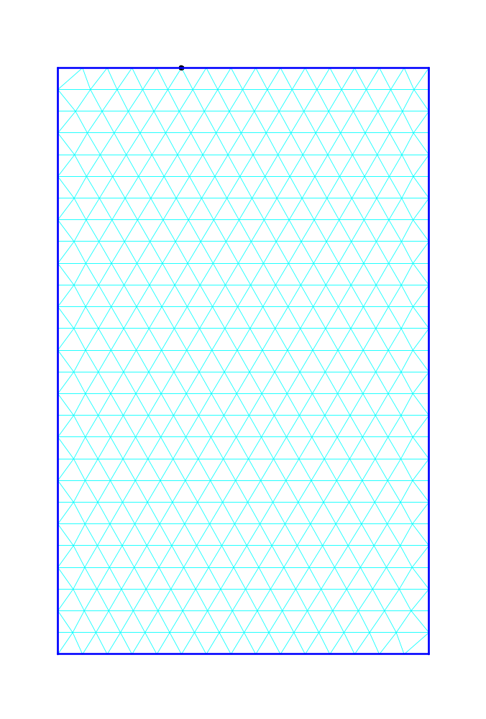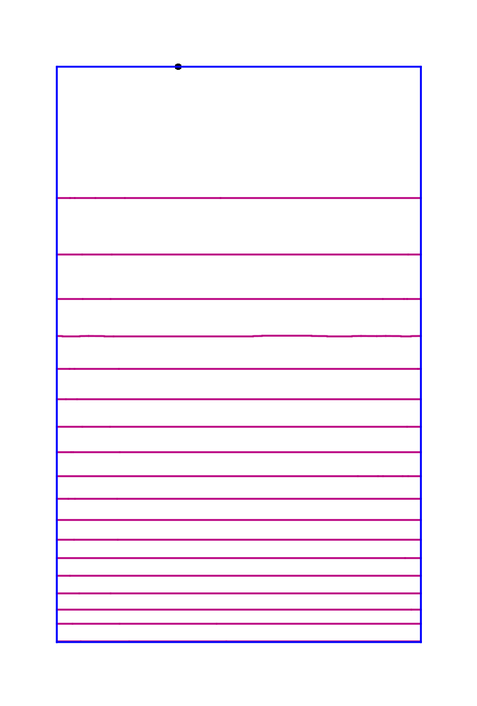
Figure XVI-3. Triangular mesh and field contours for the PILL1.AF example.
The dot on the upper boundary indicates the drive-point location. The field contours use the default SF.INI setting that increases the line density near the beam axis where H_{φ} = 0.
GeometryPhaseLength = 90 ; DPHI, phase length of cavity in degrees
FieldSegments
1 2 3 ; segment numbers
EndData
End
Figure XVI-4. Input file PILL1.SEG for SFO.
This file does not include any normalization data. SFO uses the field normalization parameters already stored in file PILL1.T35.

NormalizationCode = 1 ; NORM, normalize fields to EZEROT
E0T = 2.e6 ; EZEROT in Volts/meter
GeometryPhaseLength = 90 ; DPHI, phase length of cavity in degrees
FieldSegments
1 2 3 ; segment numbers
EndData
End
Figure XVI-5. Input file PILL1B.SEG for SFO.
Line 1 sets NORM = 1, which normalizes fields to EZEROT = 2 × 10⁶ V/m given on line 5.
Another way to normalize the field is to specify the magnitude of H_{φ} at the end of one of the boundary segments. The file PILL1C.SEG listed in Figure XVI-6 sets NORM = 2 and specifies a field H_{φ} = 3500 A/m at the outer wall of the pillbox cavity. Line 2 sets the segment number NRMSEG = 2. According to file PILL1B.SFO, this normalization corresponds to the computed EZERO of approximately 2.553 MV/m.

GeometryPhaseLength = 90 ; DPHI, phase length of cavity in degrees
NormalizationSegment = 2 ; NRMSEG
SegmentH = 3500 ; HPHI
NormalizationCode = 2 ; NORM, normalize fields to HPHI at end of segment NRMSEG
FieldSegments
1 2 3 ; Segment numbers
EndData
End
Figure XVI-6. Input file PILL1C.SEG for SFO.
Line 4 sets NORM = 2, which normalizes fields so that at the end of segment 2, H_{φ} = 3500 A/m.
One method to normalize the field is to specify the magnitude of ASCALE, which is a multiplier used in the code SFO. The file PILL1D.SEG listed in Figure XVI-7 sets NORM = 3 and specifies a value for ASCALE. This method might be used to provide the same normalization computed in a previous run on the same geometry. Look for the value of ASCALE near the end of the SFO output file.

ScalingFactor = 3767.30313461771 ; ASCALE
NormalizationCode = 3 ; NORM, normalize fields using supplied ASCALE
GeometryPhaseLength = 90 ; DPHI, phase length of cavity in degrees
FieldSegments
1 2 3 ; Segment numbers
EndData
End
Figure XVI-7. Input file PILL1D.SEG for SFO.
Line 2 sets NORM = 3, which normalizes fields using the value of ASCALE on line 1.
The last normalization method, illustrated by file PILL1E.SEG in Figure XVI-8, specifies the value of the field integral along a line between two points in the problem. This technique ordinarily would not be used on an axially symmetric accelerating cavity such as the pillbox cavity. The method is appropriate for problems that do not have a nonzero component of axial electric field. See, for example, the problem.
Xstart = 0.0 ; XNORM1
Ystart = 0.0 ; YNORM1
Xend = 3.0 ; XNORM2
Yend = 0.0 ; YNORM2
En = 1.d6 ; ENORM
NormalizationCode = 4 ; NORM, normalize fields to ENORM between points:
GeometryPhaseLength = 90 ; DPHI, phase length of cavity in degrees
FieldSegments
1 2 3 ; Segment numbers
EndData
Endend
Figure XVI-8. Input file PILL1E.SEG for SFO.
Line 6 sets NORM = 4, which normalizes fields so that the electric-field integral along a line from point (XNORM1,YNORM1) to point (XNORM2,YNORM2) is equal to ENORM.

MODPILL.AF, a pillbox cavity with bore tube
The file MODPILL.AF listed in Figure XVI-10 is an example from the 1987 User’s Guide, Section 1.4. The file includes a few changes appropriate to the present code version. For example, the REG namelist variables XDRI and YDRI locate the drive point. Previously, the drive point appeared as a separate point region. The MODPILL.AF example uses the default cylindrical coordinate system for Superfish problems in which (x, y) corresponds to (z, r). The z axis at the bottom of Figure XVI-9 is the axis of symmetry and the left edge is a plane of reflection symmetry. Figure XVI-9 shows the (z, r) coordinates of the seven PO namelist points around the closed boundary of the cavity.
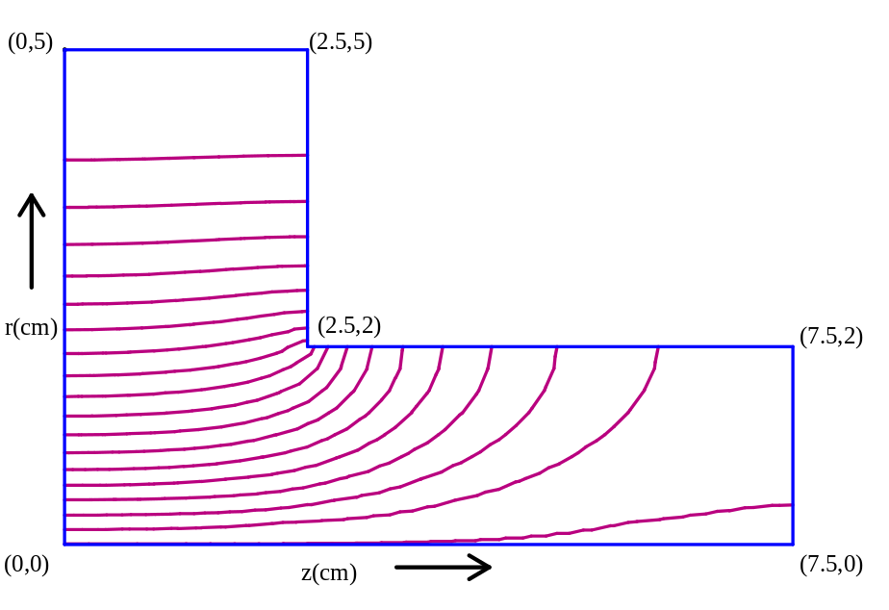
Figure XVI-9. Field distribution for the modified pillbox cavity.

Because there is no SEG file for this problem, the SFO section of Autofish makes certain assumptions about the problem to compute the cavity properties. The code assumes that segments 2, 3, and 4 are the only metal surfaces in the problems and that they have the resistivity of room-temperature copper. SFO normalizes fields so that the average axial field E₀ = 1 MV/m. The transit-time-factor integrals use the particle velocity β = 0.95, which is supplied as variable BETA in file MODPILL.AF.

2.4-GHz TM010 Modified Pillbox Cavity
Pillbox cavity with a 2-cm-radius bore tube
[Originally appeared in the 1987 User's Guide 1.4]

&reg kprob=1, ! Superfish problem
icylin=1 ! Cylindrical symmetry
dx=.25, ! Mesh interval
freq=2378.184, ! Starting frequency
xdri=0,ydri=5, ! Drive point coordinates
beta=0.95 & ! Particle velocity for transit-time integrals

&po x=0.0,y=0.0 &
&po x=0.0,y=5.0 &
&po x=2.5,y=5.0 &
&po x=2.5,y=2.0 &
&po x=7.5,y=2.0 &
&po x=7.5,y=0.0 &
&po x=0.0,y=0.0 &
Figure XVI-10. The MODPILL.AF input file for Autofish.
This example uses the default boundary conditions and coordinate system for Superfish problems. Thus, cylindrical symmetry is assumed, the axis at the bottom edge of the geometry will use a Dirichlet boundary condition and all the other edges will use the Neumann boundary condition.

The CFish directory
The CFish directory includes files in Table XVI-3 for several problems solved by CFish, the complex version of the Fish code.

Coaxial waveguide example
File COAXWG.AM shown in Figure XVI-11 is an Automesh input file for a CFish problem. The code solves for the fields in a long round coaxial waveguide (shown in Figure XVI-12) that has a block of lossy dielectric material on the end opposite the drive at the left edge of the geometry. The fields attenuate in the dielectric.
The SFO input file COAXWG.SEG shown in Figure XVI-13 illustrates how to normalize the fields to a particular value at a point in the mesh. The SF7 calculation for COAXWG.AM produces the Tablplot input file COAXWG01.TBL showing the fields E_{r} and E versus position at radius r = 2.5 cm. In Figure XVI-14, the flat curve for E up to the start of the dielectric indicates that the voltage standing wave ratio (VSWR) is unity. The dielectric absorbs the entire forward wave and there is no reflected wave. By making similar plots for other geometries you can adjust parameters to find a matched condition (for which VSWR = 1).
Table XVI-3. Files in directory RadioFrequency\CFish.
File | Description
DIROD.AM | Automesh input file for a dielectric rod in a pillbox.
COAXWG.AM | Automesh input file for lossy dielectric plug.
COAXWG.SEG | SFO input file for COAXWG.
COAXWG.IN7 | SF7 input file for COAXWG.
QZTUBE.AM | Automesh input for gas-filled quartz tube in a pillbox.
QZTUBE.SEG | SFO input file for QZTUBE.
QZTUBE.IN7 | SF7 input file for QZTUBE.
SPLITTER.AM | Automesh input file for a waveguide tee splitter.
RUNCFish.BAT | Batch file for running the codes.
SHWCFish.BAT | Batch file for viewing the results.

CFish Test: Coax with Lossy Dielectric on One End
Uses line drive at X = 0.

&reg kprob=1, ; Superfish problem
dx=.2, ; Mesh interval
maxcy=1, ; Stop after one cycle
freq=805.0, ; Frequency
xreg1=60.,xreg2=70. & ; X line regions where mesh doubles

&po x=0.,y=1.657 &
&po x=0.,y=3.81 &
&po x=150.,y=3.81 &
&po x=150.,y=1.657 &
&po x=0.,y=1.657 &

&reg mat=2 &
&po x=50.,y=1.657 &
&po x=50.,y=3.81 &
&po x=150.,y=3.81 &
&po x=150.,y=1.657 &
&po x=50.,y=1.657 &

&reg mat=1,ibound=-1,hdrive=1.0 &
&po x=0.,y=1.657 &
&po x=0.,y=3.81 &

&mt mtid=2
epsilon=0.6,0.8
mu=0.6,0.8 &
Figure XVI-11. The COAXWG.AM input file for Automesh.
This example uses the default boundary conditions and coordinate system for Superfish problems.

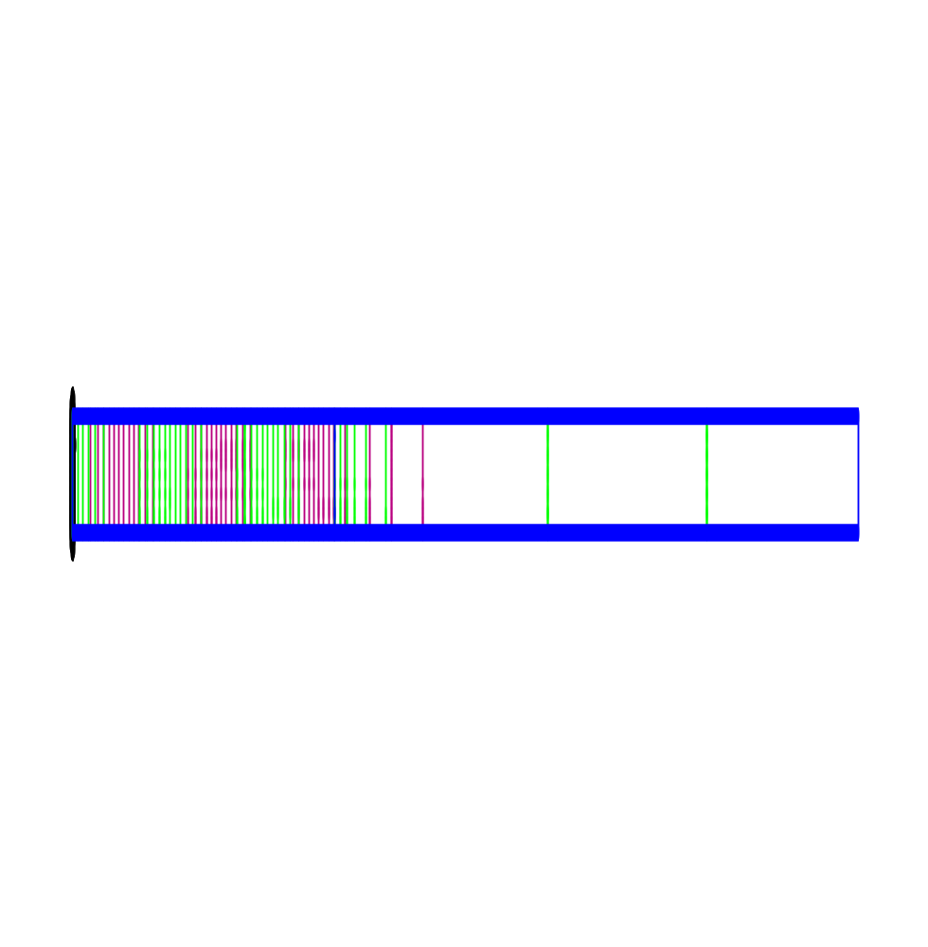
Figure XVI-12. Field contours for the coaxial line problem.
The vertical scale has been expanded by a factor 3. The line pattern is difficult to see in black-and-white. The WSFplot color display shows the real part of the H_{φ} contours in magenta and the imaginary part in green. The row of black dots along the left edge represents a line drive.

NormalizationSegment = 1 ; NRMSEG
SegmentH = 1000. ; End of segment number 1 has H = 1000
NormalizationCode= 2 ; NORM = 2 option
FieldSegments
2 3 4 6 7 8 ; Segment numbers
Enddata
End
Figure XVI-13. SFO input file COAXWG.SEG.
This file sets NORM = 2 to normalize the fields to the value HPHI at the end of segment NRMSEG.
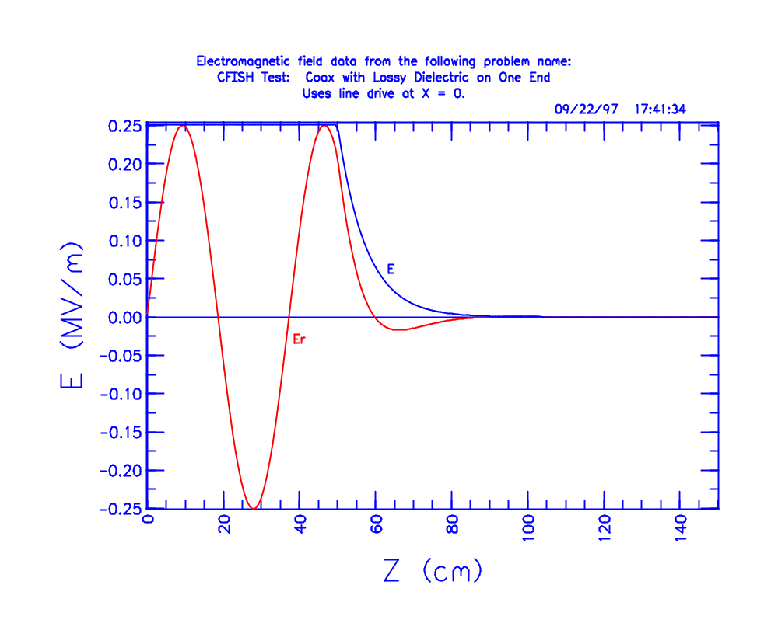
Figure XVI-14. Tablplot display of fields.
The plot shows the radial component and magnitude of electric field versus position.

Pillbox with dielectric rod
File DIROD.AM uses CFish to solve for the fields in a short pillbox cavity that has an extremely lossy dielectric rod on the axis.

Power losses in dielectrics
Example file QZTUBE.AM shows how to use CFish and SFO to get power losses in dielectric materials. The MT namelist has the complex permittivity for quartz and for a slightly lossy gas (loss tangent of 1/8000) inside the quartz tube. The SFO run shows that you can calculate fields on segments that are not on metal boundaries without causing an error in total cavity power. Segment 15 is between two dielectric materials. The batch file also runs SF7 to get the fields along the cavity axis and at r = 1.9 cm (just inside the quartz tube). Files QZTUBE01.TBL and QZTUBE02.TBL are Tablplot data files made by SF7. For this problem geometry, file QZTUBE.SFO reports about 65 W lost in the quartz and about 10 W in the gas inside the tube, compared to 130 W dissipated in the copper cavity walls.

Waveguide power splitter
Jim Potter of JP Accelerator Works, Inc. supplied the example file SPLITTER.AM. This rectangular waveguide problem uses the sinusoidal drive feature for CFish. It also demonstrates using HREF="sfcodes.doc#ComplementarySolution (that is, with H and E interchanged) in CFish to design a rectangular waveguide component. To achieve the desired mode in the guide, the input file includes the following entries in the first REG namelist:
NBSLO = 1
NBSUP = 0
NBSLF = 0
NBSRT = 0

These settings specify a Neumann boundary condition at the bottom edge of the geometry (a plane of symmetry) and Dirichlet boundary conditions along the other three edges (metal surfaces). The plotting code WSFplot produced Figure XVI-15, which shows contours of constant H_{z} that are parallel to the metal edges. These lines are interpreted as contours of constant E_{z}, which means that it is actually the magnetic field that is parallel to the metal surfaces.

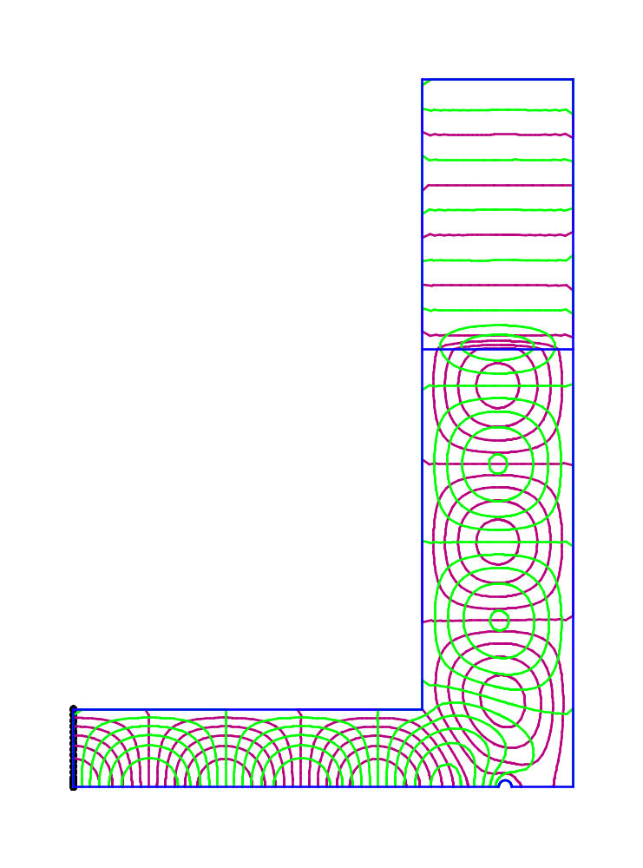
Figure XVI-15. Field contours for the waveguide power splitter.
The WSFplot color display shows the real part of the E_{z} contours in magenta and the imaginary part in green. The row of black dots along the left edge represents a sinusoidal line drive.

The FrequencyScan directory
Table XVI-4 lists files in the FrequencyScan subdirectory and Figure XVI-16 shows the batch file RUNSCAN.BAT that runs the codes. These examples demonstrate how to set up a frequency scan to look for modes in a cavity, and how to generate a plot file of the electric and magnetic fields along boundary segments.
Table XVI-4. Files in directory RadioFrequency\FrequencyScan.
File | Description
MODE825.AF | Autofish input file to search for the higher-frequency mode.
MODE825.SEG | SFO input file for problem MODE825.AF.
MODE763.AF | Autofish input file to search for the lower-frequency mode.
MODE763.SEG | SFO input file for problem MODE763.AF.
MODE763.SGF | Input file for program SegField.
SCAN.AM | Automesh input file for a frequency sweep.
RUNSCAN.BAT | Batch file for running the codes.
SHWSCAN.BAT | Batch file for viewing the results.

The on-axis coupled cavity and resonance searches
Richard K. Cooper supplied the on-axis coupled cavity used for this example. The cavity has two modes near 800 MHz. Figure XVI-17 shows the Autofish input file that searches for the lower-frequency mode. The batch file first runs Automesh and Fish on input file SCAN.AM (see Figure XVI-18), which defines a frequency scan over 100 MHz starting at 750 MHz. Note that the frequency scan did not write anything to binary solution file SCAN.T35.
Running Autofish on file MODE825.AF computes the fields for the mode at 825.180 MHz. Another Autofish run on file MODE763.AF finds the lower-frequency mode at 763.088 MHz. Figure XVI-19 show the field contours for both modes of the cavity.

Rem Delete any old plot file, then do frequency scan.
if exist FishScan.TBL del FishScan.TBL
START /W “ “ “%SFDIR%automesh” scan
START /W “ “ “%SFDIR%fish” scan
copy outfis.txt outfis1.txt
copy FishScan.TBL FS.TBL
if (%1)==(p) START /W “ “ “%SFDIR%Tablplot” FishsScan.tbl 3

Rem Run Autofish to find the higher-frequecy mode near 825 MHz.
START /W “ “ “%SFDIR%autofish” mode825
if (%1)==(p) START /W “ “ “%SFDIR%WSFplot” mode825.t35 3
copy outfis.txt outfis2.txt

Rem Run Autofish to find the lower-frequecy mode near 763 MHz.
START /W “ “ “%SFDIR%autofish” mode763
if (%1)==(p) START /W “ “ “%SFDIR%WSFplot” mode763.t35 3
copy outfis.txt outfis3.txt

Rem Plot fields on segments 2 through 7 for the 763-MHz mode.
START /W “ “ “%SFDIR%segfield” mode763.sgf
if (%1)==(p) START /W “ “ “%SFDIR%Tablplot” Segs.tbl 3
Figure XVI-16. The batch file RUNSCAN.BAT
This file runs Autofish to search for the two modes at 825 MHz and 763 MHz. Program SegField generates a plot file of the fields along all metal segments.

On-Axis Coupled Cavity, Resonance search for zero mode at 763 MHz
[courtesy of R. Cooper]

&reg kprob=1, ; Superfish problem
freq=763, ; Frequency in MHz
ccl=1, ; Coupled-cavity linac cell
dphi=180, ; Phase change over the cell length
dx=0.2, ; Mesh spacing
xdri=1., ; Drive point X coordinate
ydri=8., ; Drive point Y coordinate
dslope=-1 & ; Allows FISH to converge in 1 iteration

&po x=0.,y=0. &
&po x=0.,y=16.24 &
&po x=1.4899,y=16.24 &
&po nt=2,x0=1.4899,y0=10.74,x=5.5,y=0.0 &
&po x=6.9899,y=7.64 &
&po nt=2,x0=7.85895,y0=7.64,y=0,x=0.86905 &
&po x=8.728,y=17.2 &
&po x=9.4,y=17.2 &
&po x=9.4,y=0. &
&po x=0.,y=0. &
Figure XVI-17. The input file MODE763.AF.
This file sets FREQ = 763 to search for the lower-frequency mode of the cavity. The other input files use the same geometry, but file MODE825.AF searches for the higher-frequency mode and SCAN.AM sets up a frequency scan.

On-Axis Coupled Cavity, Frequency scan over 100 MHz
[courtesy of R. Cooper]

&reg kprob=1, ; Superfish problem
nstep=81, ; Number of steps in frequency scan
delfr=1.25, ; Frequency step in MHz
freqs=750.0, ; Starting frequency in MHz
Figure XVI-18. The first few lines of input file SCAN.AM.
For a frequency scan, the lines defining NSTEP, DELFR, and FREQS replace the line containing the starting frequency of a resonance search.

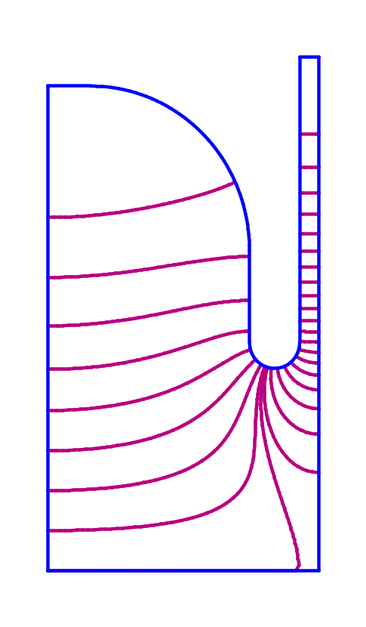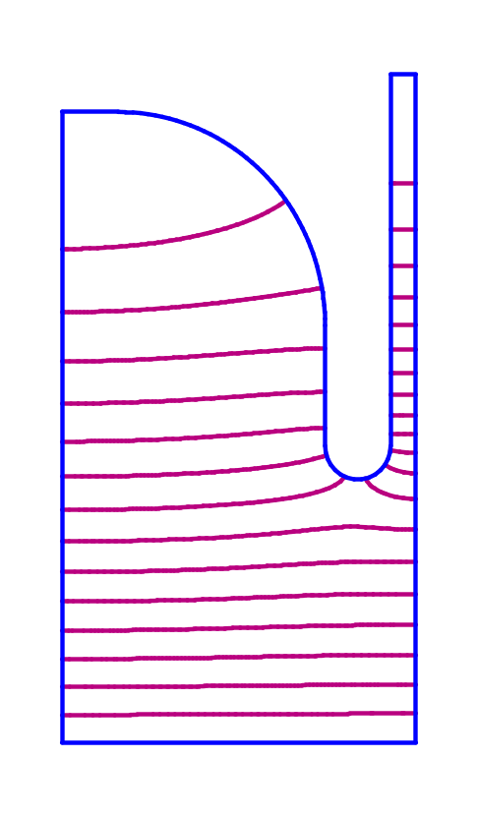
Figure XVI-19. Modes in the on-axis coupled cavity.
The figure at left from WSFplot shows the π mode, whose frequency is 825.180 MHz. The figure at right shows the zero mode at 763.088 MHz.

Frequency scans
Example file SCAN.AM demonstrates the HREF="sfcodes.doc#FrequencyScans in Fish that scans a frequency range to make a plot of the D(k²) function. Resonances occur at roots of D(k²) where the slope equals −1. The wave number k = ω/c = 2πf/c, where f is frequency and c is the speed of light. The batch file RUNSCAN.BAT runs Automesh, then Fish to create file FishScan.TBL, which contains the results of the frequency scan. A copy of this plot file renamed FS.TBL is distributed with the codes. Use Tablplot to plot either FS.TBL or FishScan.TBL.
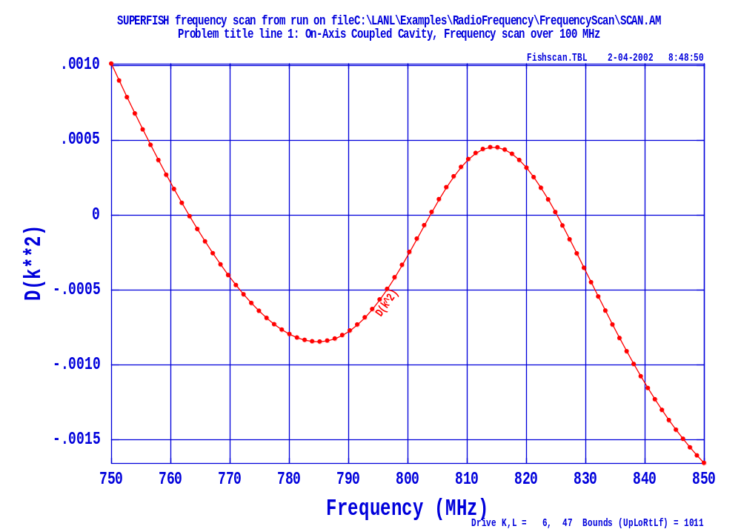
Figure XVI-20. Tablplot screen showing data in FishScan.TBL.
The two zero crossings of function D(k²) near 763 MHz and 825 MHz give the frequencies of the resonant modes. The positive-slope crossing at about 804 MHz is not a mode.

Plotting fields along segments
The last calculation in batch file RUNSCAN.BAT shows how to use program HREF="sfcodes3.doc#SegField to create a plot file containing electric and magnetic fields along segments of a Superfish cavity. Program SegField reads the input MODE763.SGF shown in Figure XVI-21 and creates the output file SEGS.TBL. Figure XVI-22 shows the resulting plot screen displayed by program Tablplot.
; SegField control file
OUTPUT_file segs
INPUT_filename mode763

SEGment_numbers 2 to 7
E0T = 1
ENDFILE
Figure XVI-21. Input file MODE763.SGF for program SegField.
This file names the input and output files, requests field data for segments 2 through 7 (all the metal boundary segments), and specifies a value for field normalization.

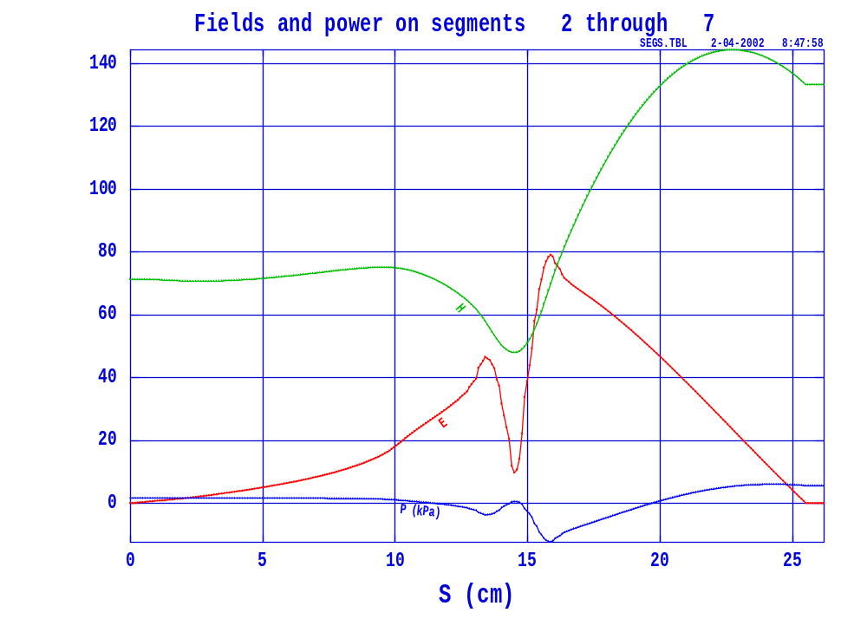
Figure XVI-22. Tablplot screen showing data in SEGS.TBL.
The plot uses the default setting written in the output file by SegField, namely to plot E, H and radiation pressure as a function of distance along the boundary.

The SphericalCavity directory
Table XVI-5 lists files in the SphericalCavity subdirectory. This is the 1-m-diameter spherical cavity example from the 1987 Reference Manual, Section C.12.1. The batch file RUNSPHER.BAT in Figure XVI-23 runs Autofish to solve this problem. You also can run the individual programs Automesh, Fish, and SFO. Figure XVI-24 shows the Automesh input file. This problem does not require a SEG file for SFO. The post processor SFO will automatically compute fields and power along segment 2, the circular arc.
Table XVI-5. Files in directory RadioFrequency\SphericalCavity.
File | Description
SPHERE.AF | Automesh input file for a spherical cavity.
RUNSPHER.BAT | Batch file for running the codes.

START /W “ “ “%SFDIR%autofish” sphere
if (%1)==(p) START /W “ “ “%SFDIR%WSFplot” sphere.t35 3
Figure XVI-23. The two-line batch file RUNSPHER.BAT.

There is nothing particularly remarkable about the uniform mesh generated by Automesh for this problem so we do not show it here. The input file sets DSLOPE = −1, allowing the Fish solver to stop after just one iteration provided the computed step size in k² is small enough. Ordinarily, the HREF="sfcodes.doc#ConvergenceCriteriaInfish includes a tolerance on the slope of the function D(k²), but the code cannot compute the slope until after the second iteration. If you know that the starting frequency is very near the mode of interest, you can use this technique to speed up the calculation. Figure XVI-25 shows the field contours for the cavity’s lowest mode at about 130 MHz.
Spherical Cavity
[Originally appeared in 1987 Reference Manual C.12.1]

&reg kprob=1, ; Superfish problem
dx=1.9, ; X mesh spacing
freq=130.91416, ; Starting frequency in MHz
dslope=-1, ; Allow convergence on first iteration
xdri=0.,ydri=100.0 & ; Drive point location

&po x=0.0,y=0.0 & ; Start of the boundary points
&po x=0.0,y=100. &
&po nt=2,r=100.0,theta=0.0 &
&po x=0.,y=0. &
Figure XVI-24. The Automesh input file SPHERE.AF.
This input file uses all the default boundary conditions for Superfish problems. The codes will also assume cylindrical symmetry about the Z (i.e. X) axis.

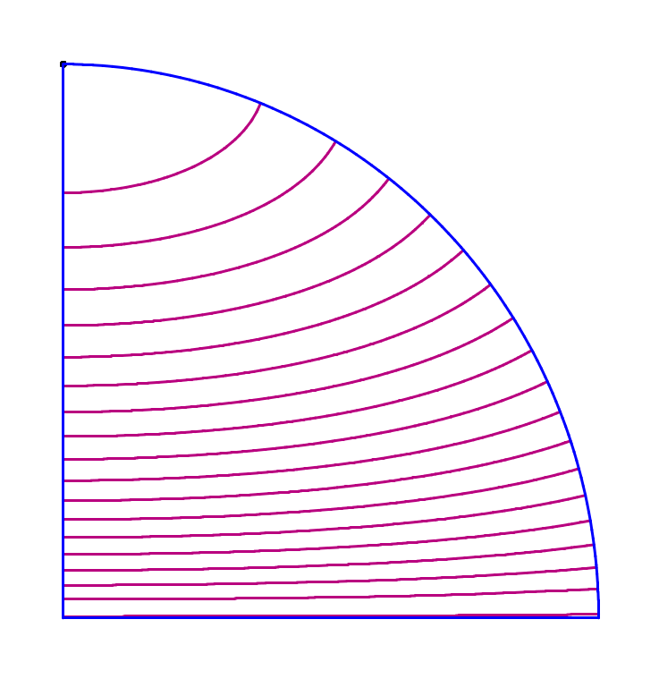
Figure XVI-25. Field contours for the spherical cavity mode at 130 MHz.

The RFQCavity directory
Table XVI-6 lists files in the RFQCavity subdirectory. Figure XVI-26 shows the batch file that runs two sample RFQ cavities, using program Autofish to solve for the fields. The problems use rectangular coordinates to get the transverse fields at a particular longitudinal position in a radio-frequency quadrupole accelerator. The batch file runs Autofish to solve these problems. You can also run the individual programs Automesh, Fish, and SFO.
Table XVI-6. Files in directory RadioFrequency\RFQCavity.
File | Description
4THRFQ.AF | Automesh input file for one quadrant of an RFQ.
4THRFQ.SEG | SFO input file for 4THRFQ.
8THRFQ.AF | Automesh input file for half of an RFQ quadrant.
8THRFQ.SEG | SFO input file for 8THRFQ.
RUNRFQ.BAT | Batch file for running the codes.
SHWRFQ.BAT | Batch file for viewing the results.

START /W “ “ “%SFDIR%autofish” 4thrfq
copy outaut.txt outaut1.txt
copy outfis.txt outfis1.txt
if (%1)==(p) START /W “ “ “%SFDIR%WSFplot” 4thrfq.t35 3

START /W “ “ “%SFDIR%autofish” 8thrfq
if (%1)==(p) START /W “ “ “%SFDIR%WSFplot” 8thrfq.t35 3
Figure XVI-26. The batch file RUNRFQ.BAT.

One-eighth of an RFQ cavity
File 8THRFQ.AF shown in Figure XVI-27 sets up the geometry for half of an RFQ quadrant. Automesh generates the mesh shown in Figure XVI-28. You may notice that although the input file contains three HREF="sfcodes.doc#LineRegions along each coordinate, the lines themselves are not evident in the mesh. The setting LINES = 0 in file 8THRFQ.AF allows Automesh to include the non-boundary points along these lines in the relaxation calculation. That is, the line-region points not on actual boundary segment are free to move.
One eighth of the full geometry is appropriate for cases in which the RFQ quadrants themselves are symmetric about the line at 45 degrees. You cannot use this geometry to solve for the dipole modes of the cavity. Figure XVI-29 shows the field contours plotted by WSFplot for the lowest quadrupole mode at about 425 MHz. Figure XVI-30 shows expanded-scale views of the mesh and field contours.

RFQ half quadrant
Quadrupole mode resonant frequency = 425.25 MHz
Bore radius at quadrupole symmetry point r0 = 0.297 cm
Vane-tip radius of curvature rho = 0.24371 cm

&reg kprob=1, ; Superfish problem
; Define X (physical) and K (logical) line regions:
xreg1=0.70, kreg1=50,
xreg2=1.4, kreg2=80,
xreg3=2.1, kreg3=95,
kmax=120,
; Define Y (physical) and L (logical) line regions:
yreg1=0.70, lreg1=50,
yreg2=1.4, lreg2=80,
yreg3=2.1, lreg3=95,
lmax=110,
icylin=0, ; Cartesian coordinates
freq=425.25137, ;Starting frequency
dslope=-1, ; Allow convergence in one iteration
rfq=1, ; Cavity type is RFQ
lines=0 & ; allow line region points to move in mesh optimization

&po x=0.,y=0. &
&po x=5.9131, y=5.9131 &
&po x=8.3624, y=3.4638 &
&po x=8.3624, y=3.0630 &
&po nt=2, x0=7.7274, y0=3.0630,x=0.,y=-.635 &
&po x=7.6203, y=2.428 &
&po x=5.7469, y=1.7267 &
&po x=3.8734, y=1.0253 &
&po x=2.000, y=.3420 &
&po x=1.07680,y=.342 &
&po x=.49839, y=.24001 &
&po nt=2,x0=0.54071,y0=0.,x=-.24371,y=0. &
&po x=0.,y=0. &
Figure XVI-27. The input file 8THRFQ.AF.
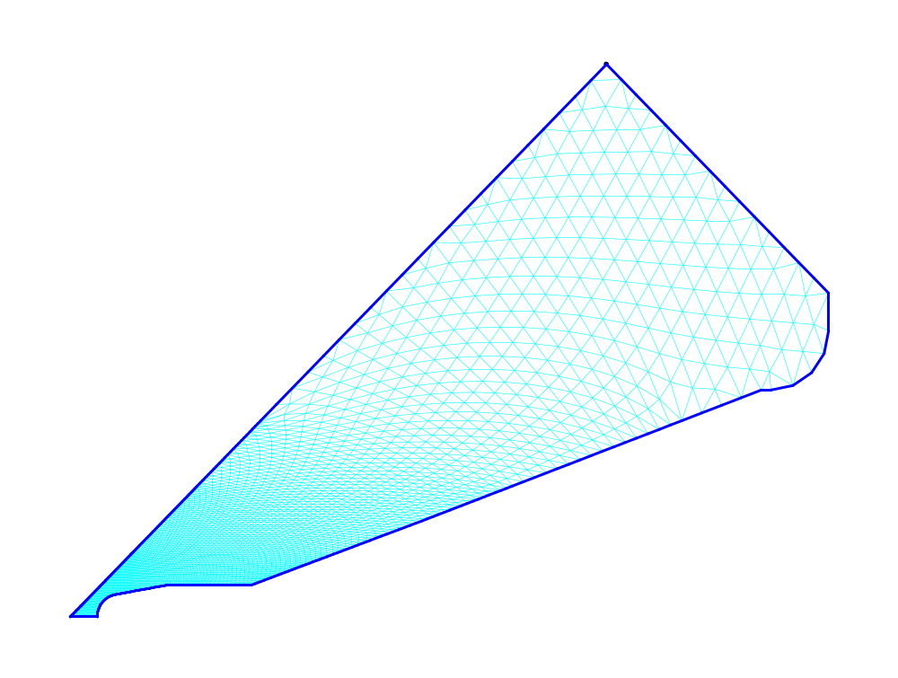
Figure XVI-28. Triangular mesh for file 8THRFQ.AF.
The mesh is very dense (0.014-cm spacing) near the vane tip at the bottom left in the figure. The mesh spacing increases three times in each direction to a maximum of 0.25 cm in the predominantly magnetic-field region of the cavity.
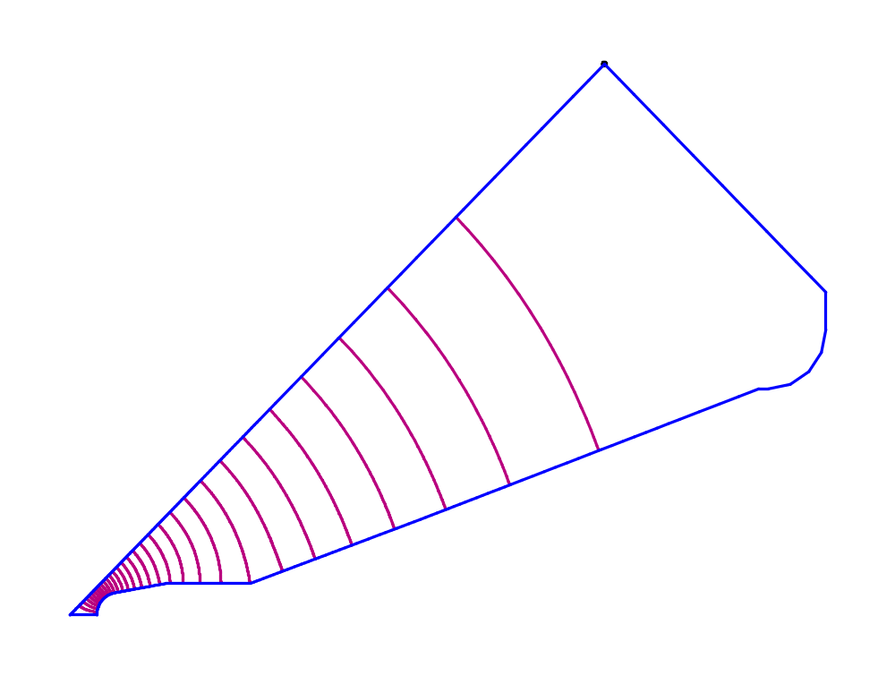
Figure XVI-29. Field contours for the half-quadrant RFQ.
These contours show the lowest quadrupole (TE₂₁-like) mode of the cavity. The vane tips concentrate the electric field near the origin at the lower left.

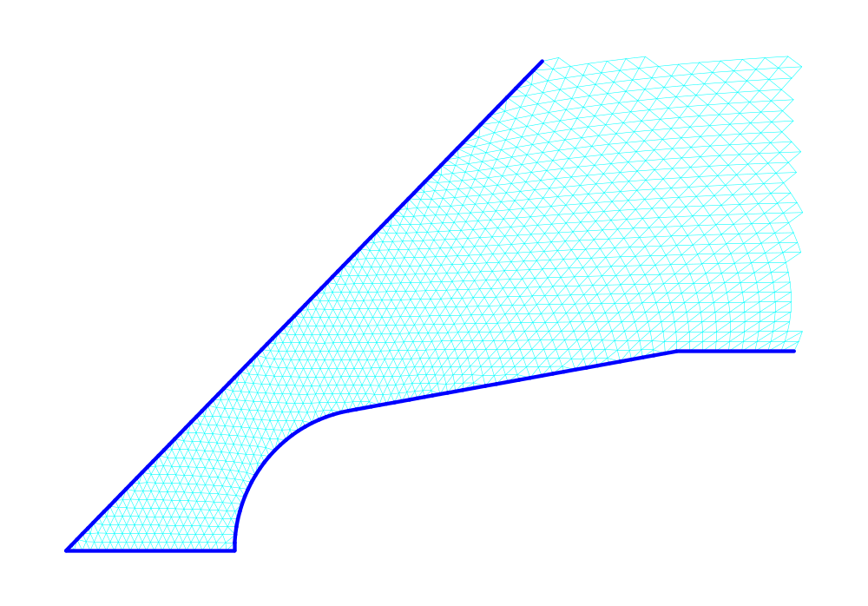
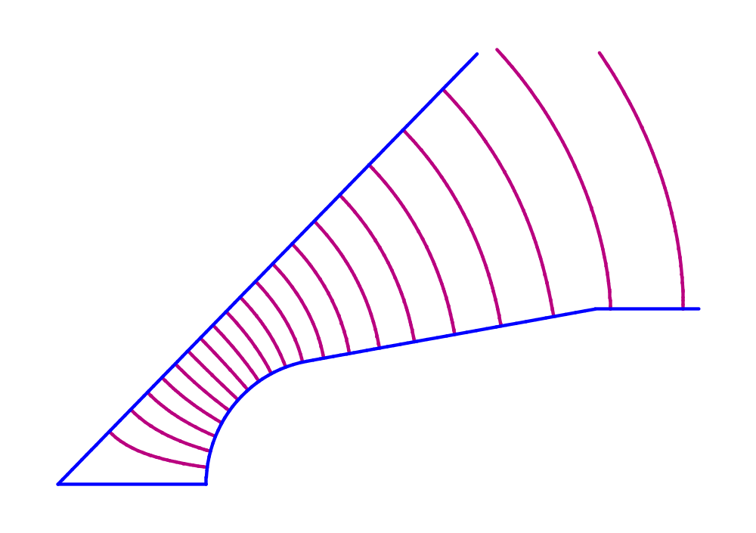
Figure XVI-30. Mesh and field contours near an RFQ vane tip.

One-fourth of an RFQ cavity
File 4THRFQ.AF shown in Figure XVI-31 and Figure XVI-32 sets up the geometry for a full RFQ quadrant. One quadrant is the minimum geometry needed to solve for dipole (TE₁₁-like) modes of the cavity. File 4THRFQ.AF specifies the Neumann boundary condition at the left edge with the setting NBSLF = 1, which is the default for Superfish problems. Figure XVI-33 shows the field contours for the lowest dipole mode, which occurs at a frequency of about 412 MHz. To find quadrupole modes, set NBSLF = 0 to indicate a Dirichlet boundary condition at the left edge. This geometry also allows for cases in which the quadrant has asymmetries about the line at 45 degrees.

RFQ full quadrant
Lowest dipole-mode frequency = 412.043 MHz
Bore radius at quadrupole symmetry point r0 = 0.297 cm
Vane-tip radius of curvature rho = 0.24371 cm

&reg kprob=1, ; Superfish problem
; Define X (physical) and K (logical) line regions:
xreg1=0.70, kreg1=50,
xreg2=1.4, kreg2=80,
xreg3=2.1, kreg3=95,
kmax=120,
; Define X (physical) and K (logical) line regions:
yreg1=0.70, lreg1=50,
yreg2=1.4, lreg2=80,
yreg3=2.1, lreg3=95,
lmax=120,
icylin=0, ; Cartesian coordinates
freq=412.04344, ; Starting frequency
dslope=-1, ; Allow convergence in one iteration
rfq=1, ; Cavity type is RFQ
; The following line is for dipole modes; use nbslf=0 for quadrupole modes
nbslf=1, ; Neumann boundary condition at left edge
lines=0 & ; allow line region points to move in mesh optimization
Figure XVI-31. Title and REG namelist in Autofish input file 4THRFQ.AF.

&po x=0.,y=0. &
&po x=0.,y=.297 &
&po nt=2,x0=0.,y0=.54071,y=-0.04232,x=.24001 &
&po x=.342,y=1.07680 &
&po x=.342,y=2.0 &
&po x=1.0253,y=3.8734 &
&po x=1.7267,y=5.7469 &
&po x=2.428,y=7.6203 &
&po x=2.428,y=7.7274 &
&po nt=2,x0=3.063,y0=7.7274,x=0.,y=.635 &
&po x=3.4638, y=8.3624 &
&po x=8.3624, y=3.4638 &
&po x=8.3624, y=3.0630 &
&po nt=2, x0=7.7274, y0=3.0630,x=0.,y=-.635 &
&po x=7.6203, y=2.428 &
&po x=5.7469, y=1.7267 &
&po x=3.8734, y=1.0253 &
&po x=2.000, y=.3420 &
&po x=1.07680,y=.342 &
&po x=.49839, y=.24001 &
&po nt=2,x0=0.54071,y0=0.,x=-.24371,y=0. &
&po x=0.,y=0. &
Figure XVI-32. PO NAMLIST entries in Autofish input file 4THRFQ.AF.
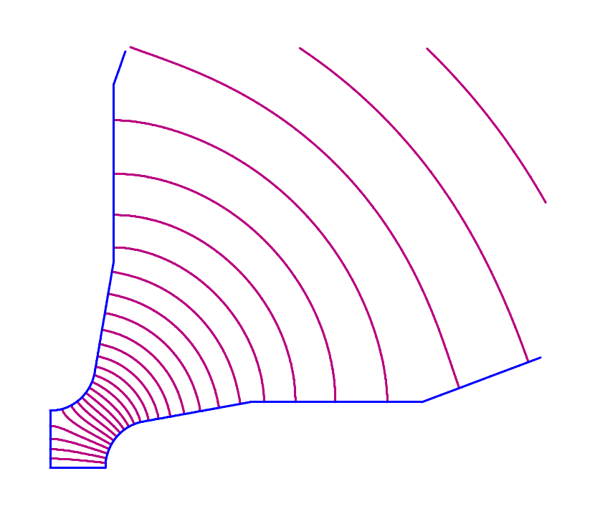
Figure XVI-33. Field contours for a dipole mode in an RFQ quadrant.
The default Neumann boundary condition at the left edge is appropriate for the dipole (TE₁₁-like) modes. To solve for quadrupole (TE₂₁-like) modes, the left edge must be a Dirichlet boundary.

The QuarterWaveResonator directory
Table XVI-7 lists files in the QuarterWaveResonator subdirectory for a quarter-wave cavity resonator. This example shows how to normalize the fields to an integral of the electric field between two arbitrary points in the geometry. The input file QWAVE.AF includes entries for the endpoints of the integration path XNORM1,YNORM1 and XNORM1,YNORM1. The integrated value of the electric-field component along the path is ENORM. Setting NORM = 4 selects this normalization option. You can also run Autofish to solve this problem. The batch file runs the individual programs Automesh, Fish, and SFO.
Table XVI-7. Files in directory RadioFrequency\QuarterWaveResonator.
File | Description
QWAVE.AF | Automesh input file for a quarter-wave cavity resonator.
QWAVE.SEG | SFO input for QWAVE with segments for power calculations.
RUNQWAVE.BAT | Batch file for running the codes.

The FerriteCavity directory
Table XVI-8 lists files in the FerriteCavity subdirectory for a ferrite-tuned cavity solved by Fish. This example appeared in the 1987 Reference Manual, Section C.12.2. Figure XVI-34 shows an outline of the cavity sections. The problem has cylindrical symmetry, so the rectangular blocks of ferrite and ceramic in the upper right part of the cavity represent annular rings of material. The batch file RUNFTEST.BAT, shown in Figure XVI-35, runs the programs Automesh and Fish. Figure XVI-38 shows the first part and Figure XVI-39 the last part of the Automesh input file FTEST.AM.
The FTEST file differs in several ways from the original file in the 1987 manual. We eliminated 5 of the 6 ferrite regions by using one region to define a large block of ferrite material on which we later superimpose the ceramic spacers. The first REG namelist uses HREF="sfcodes.doc#LineRegions to make the mesh finer in some parts of the geometry. For example, ferrite and spacer regions require a finer mesh than the long coaxial pipe. File FTEST.AM uses variable FREQ to define the starting frequency. It also includes three MT namelist regions to define the properties of materials with MAT = 2, 3, and 4.
Figure XVI-36 shows the field contours displayed by WSFplot after running Fish. The default setting in WSFplot displays more field contours near rH_{φ} = 0. For this cavity, contours with equal intervals in rH_{φ} might be more appropriate to see the behavior of the field in the vicinity of the ferrite and ceramic. Figure XVI-37 shows the a WSFplot display after setting RF_RZ_PowerLaw = 1 in the [WSFplot] section of file HREF="sfintro.doc#ContourIntervalsInWSFplotMACROBUTTON.
Table XVI-8. Files in directory RadioFrequency\FerriteCavity.
File | Description
FTEST.AM | Automesh input file for ferrite tuned cavity.
RUNFTEST.BAT | Batch file for running the codes.

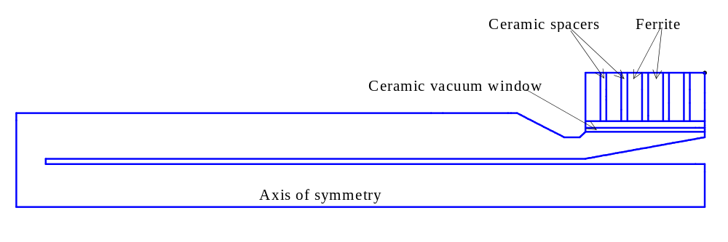
Figure XVI-34. Outline of regions in the ferrite-tuned cavity.

START /W “ “ “%SFDIR%automesh” ftest
START /W “ “ “%SFDIR%fish” ftest
if (%1)==(p) START /W “ “ “%SFDIR%WSFplot” 3
Figure XVI-35. The batch file RUNFTEST.BAT

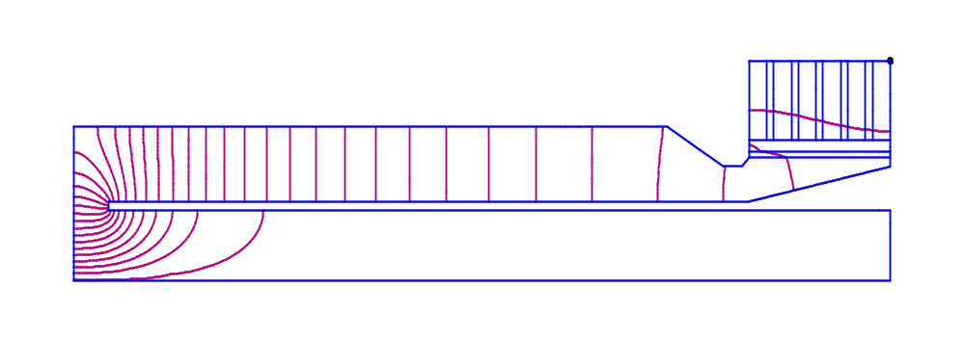
Figure XVI-36. Contours of rH_{φ} in the ferrite cavity.
WSFplot uses the default display with contours G(n) = G(1)n² (where G is rH_{φ}) for rf problems because it is the setting preferred by accelerator designers interested in the electric field distribution near the axis of an accelerator gap. Figure XVI-37 shows contours equal intervals of rH_{φ}.

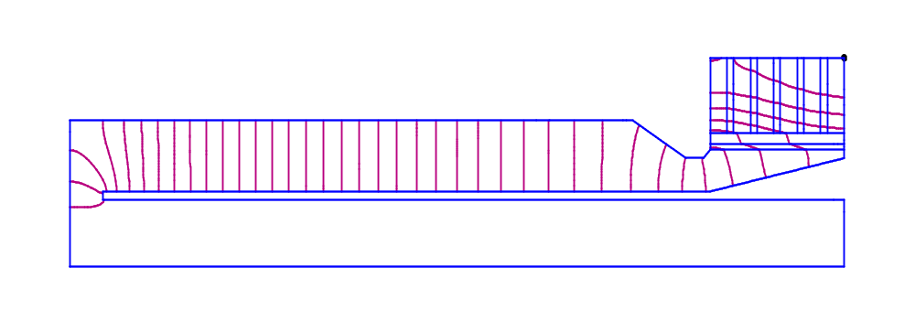
Figure XVI-37. Equally spaced field contours in the ferrite-tuned cavity.
WSFplot will display contours with equal intervals of rH_{φ} for the SF.INI setting RF_RZ_PowerLaw = 1. Figure XVI-36 shows contours that are concentrated near rH_{φ} = 0.

Ferrite tuner example
Six ferrite blocks: Material 2, Epsilon = 14.5, Mu = 1.5
Five ceramic-spacers: Material 4, Epsilon = 10.0, Mu = 1.0
Ceramic vacuum window: Material 3, Epsilon = 9.0, Mu = 1.0
Initialize one large ferrite block, then superimpose ceramic spacers
[Originally appeared in 1987 Reference Manual C.12.2]

&reg kprob=1, ! Superfish problem
icylin=1 ! Cylindrical symmetry
freq=57.76775, ! Starting frequency
dslope=-1, ! Allow convergence after one iteration
xreg1=94.0, ! X line region
kreg1=188, ! Logical coordinate for XREG1
yreg1=8,yreg2=9, ! Y line regions
yreg3=13,yreg4=17.5
lreg1=12,lreg2=15, ! Logical coordinates for YREGs
lreg3=21,lreg4=31
kmax=260,lmax=43 & ! Maximum X and Y logical coordinates

&po x=0.0,y=0.0 &
&po x=116.88,y=0.0 &
&po x=116.88,y=8.0 &
&po x=5.0,y=8.0 &
&po x=5.0,y=9.0 &
&po x=96.64,y=9.0 &
&po x=116.88,y=13.0 &
&po x=116.88,y=25.0 &
&po x=96.64,y=25.0 &
&po x=96.64,y=14.0 &
&po x=95.64,y=13.0 &
&po x=93.0,y=13.0 &
&po x=85.0,y=17.5 &
&po x=0.0,y=17.5 &
&po x=0.0,y=0.0 &

&reg mat=2 & ; Ferrite region
&po x=96.64,y=16.0 &
&po x=96.64,y=25.0 &
&po x=116.88,y=25.0 &
&po x=116.88,y=16.0 &
&po x=96.64,y=16.0 &
Figure XVI-38. First part of Automesh input file FTEST.AM.
The points in the first region trace the outer boundary of the problem including the hollow center conductor. The second region defines a single block of ferrite material (MAT = 2) in the upper right part of the geometry. The remainder of the input file appears in Figure XVI-39.

&reg mat=3 & ; Ceramic vacuum window region
&po x=96.64,y=14.0 &
&po x=116.88,y=14.0 &
&po x=116.88,y=14.75 &
&po x=96.64,y=14.75 &
&po x=96.64,y=14.0 &

&reg mat=4 & ; First ceramic-spacer region
&po x=99.18,y=16.0 &
&po x=100.18,y=16.0 &
&po x=100.18,y=25.0 &
&po x=99.18,y=25.0 &
&po x=99.18,y=16.0 &

&reg mat=4 & ; Second ceramic-spacer region
&po x=102.72,y=16.0 &
&po x=103.72,y=16.0 &
&po x=103.72,y=25.0 &
&po x=102.72,y=25.0 &
&po x=102.72,y=16.0 &

&reg mat=4 & ; Third ceramic-spacer region
&po x=106.26,y=16.0 &
&po x=107.26,y=16.0 &
&po x=107.26,y=25.0 &
&po x=106.26,y=25.0 &
&po x=106.26,y=16.0 &

&reg mat=4 & ; Fourth ceramic-spacer region
&po x=109.80,y=16.0 &
&po x=110.80,y=16.0 &
&po x=110.80,y=25.0 &
&po x=109.80,y=25.0 &
&po x=109.80,y=16.0 &
Figure XVI-39. Second part of Automesh input file FTEST.AM.
Regions with MAT = 4 define individual ceramic spacers that fit between the ferrite blocks. These regions replace the properties on some of the mesh points previously defined as ferrite material by the second region shown in Figure XVI-38. The remaining points in the original ferrite region become six separate ferrite blocks.

&reg mat=4 & ; Fifth ceramic-spacer region
&po x=113.34,y=16.0 &
&po x=114.34,y=16.0 &
&po x=114.34,y=25.0 &
&po x=113.34,y=25.0 &
&po x=113.34,y=16.0 &

; These MT namelists will be numbered 2, 3, and 4 by Automesh.
; The numbers correspond to MAT numbers is the REG namelists.

&mt epsilon = 14.5, mu = 1.5 &
&mt epsilon = 9, mu = 1 &
&mt epsilon = 10, mu = 1 &
Figure XVI-40. Last part of Automesh input file FTEST.AM.

The Waveguides directory
Table XVI-9 lists files in the Waveguides subdirectory for some simple waveguide problems in Cartesian coordinates. The first problem models a rectangular waveguide to find the first few TE cutoff modes of the guide. The second problem is for a hexagonal waveguide. Figure XVI-41 shows the batch file RUNWG.BAT for running both problems.
Table XVI-9. Files in directory RadioFrequency\Waveguides.
File | Description
WR2300.AM | Automesh input file for WR2300 waveguide.
WGHEX.AM | Automesh input file for a hexagonal waveguide.
RUNWG.BAT | Batch file for running the codes.
SHWWG.BAT | Batch file for viewing the results.

START /W “ “ “%SFDIR%automesh” wr2300
START /W “ “ “%SFDIR%cfish” wr2300
copy outaut.txt outaut1.txt
copy outfis.txt outfis1.txt
if (%1)==(p) START /W “ “ “%SFDIR%WSFplot” wr2300.t35 3

START /W “ “ “%SFDIR%automesh” wghex
START /W “ “ “%SFDIR%cfish” wghex
copy outaut.txt outaut2.txt
copy outfis.txt outfis2.txt
if (%1)==(p) START /W “ “ “%SFDIR%WSFplot” wghex.t35 3
Figure XVI-41. The batch file RUNWG.BAT.

Waveguide problem for WR2300 (23 inches x 11.5 inches)
Models one quarter of a full-height guide
This guide is used with some 350-MHz accelerators

&reg kprob=1, ; Superfish problem
conv=2.54 ; Dimensions are inches
icylin=0 ; Cartesian coordinates
; Uncomment only one of the following lines to find each mode:
freq=256,nbslo=1,nbslf=0 ; Frequency and boundary conditions for TE10 mode
;freq=513,nbslo=1,nbslf=1 ; Frequency and boundary conditions for TE20 mode
;freq=574,nbslo=0,nbslf=0 ; Frequency and boundary conditions for TE11 mode
;freq=726,nbslo=0,nbslf=1 ; Frequency and boundary conditions for TE21 mode
;freq=770,nbslo=1,nbslf=0 ; Frequency and boundary conditions for TE30 mode
;freq=925,nbslo=0,nbslf=0 ; Frequency and boundary conditions for TE31 mode
dx=.2, ; Mesh size
xdri=8,ydri=2 & ; Drive point

&po x=0.0, y=0.0 &
&po x=11.5, y=0.0 &
&po x=11.5, y=5.75 &
&po x=0.0, y=5.75 &
&po x=0.0, y=0.0 &
Figure XVI-42. Automesh input file WR2300.AM.

Rectangular waveguide TE modes
Figure XVI-42 lists the Automesh input file WR2300.AM, which models the waveguide WR2300. The guide dimensions are 23 inches × 11.5 inches. This size guide is used with some 350-MHz accelerators. The geometry includes one-fourth of a full-height guide. With appropriate boundary conditions, one can find cutoff frequencies of TE modes. The input file includes several lines with different starting frequencies and left and lower boundary conditions appropriate for the six lowest TE modes. You can run the problem several times, removing the semicolon from just one of these lines to compute the fields for that mode. Figure XVI-43 shows the resulting field patterns for these modes.
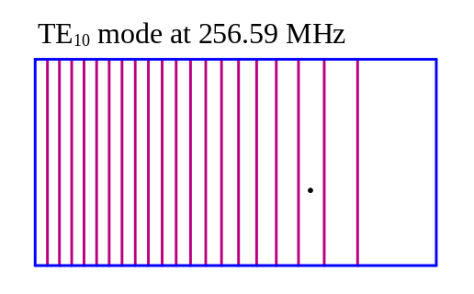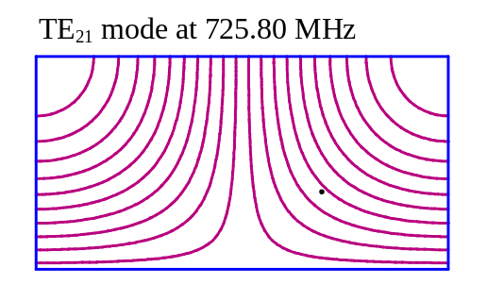
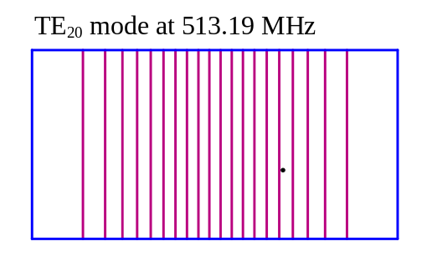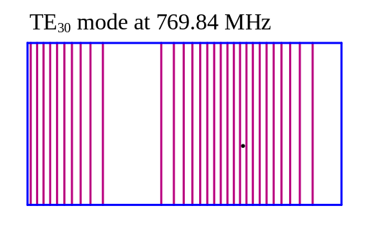
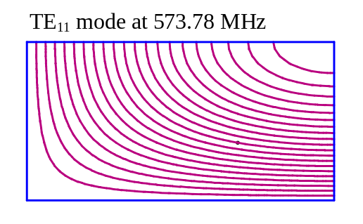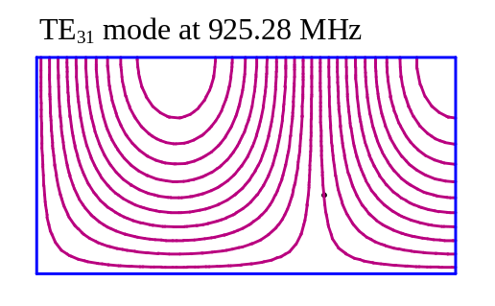
Figure XVI-43. Several waveguide TE modes.
The figures show the upper right quadrant of the guide cross section. The right and top boundaries have Neumann boundary conditions in all six problems. The left side has a Neumann boundary conditions only for the TE₂₀ and TE₂₁ modes. The lower edge has a Neumann boundary conditions for the TE₁₀, TE₂₀, and TE₃₀ modes. All other cases use a Dirichlet boundary at the left and lower edges.

Hexagonal waveguide TE modes
Figure XVI-44 lists the Automesh input file WGHEX.AM, which models a full hexagonal waveguide. Each of the six sides of the guide is 10 inches. The bottom leg includes a small perturbation that helps to orient the degenerate modes. Placement of the drive point can also influence the orientation of the modes. Even with the perturbation, the field pattern may be different for different placement of the drive point for modes that have similar field patterns at the location of the bump on the wall.
Because the geometry includes the entire cross section of the guide, Neumann boundary conditions are appropriate on all the edges for the TE modes. The input file includes several lines with different starting frequencies for four TE modes. You can run the problem several times, removing the semicolon from just one of these lines to compute the fields for that mode. Figure XVI-45 shows the resulting field patterns for these modes, which resemble the modes in a circular waveguide.

Waveguide problem for WR2300 (23 inches x 11.5 inches)
Models one quarter of a full-height guide
This guide is used with some 350-MHz accelerators

&reg kprob=1, ; Superfish problem
conv=2.54 ; Dimensions are inches
icylin=0 ; Cartesian coordinates
; Uncomment only one of the following lines to find a mode
freq=377.0 ; Starting frequency for mode 1
;freq=620.0 ; Starting frequency for mode 2
;freq=788.0 ; Starting frequency for mode 3
;freq=940.0 ; Starting frequency for mode 4
dx=.3, ; Mesh size
nbslo=1,nbslf=1 ; Neumann boundary conditions bottom and left
nbsup=1,nbsrt=1 ; Neumann boundary conditions top and right
xdri=4,ydri=1 & ; Drive point

&po x=-10, y=0.0 &
&po x=-5, y=-8.66025 &
&po x=-1, y=-8.66025 & ; This small perturbation removes degeneracy
&po x=-0.3,y=-8.33 &
&po x=0.3, y=-8.33 &
&po x=1, y=-8.66025 & ; End of small perturbation
&po x=5, y=-8.66025 &
&po x=10, y=0.0 &
&po x=5, y=8.66025 &
&po x=-5, y=8.66025 &
&po x=-10, y=0.0 &
Figure XVI-44. Automesh input file WR2300.AM.

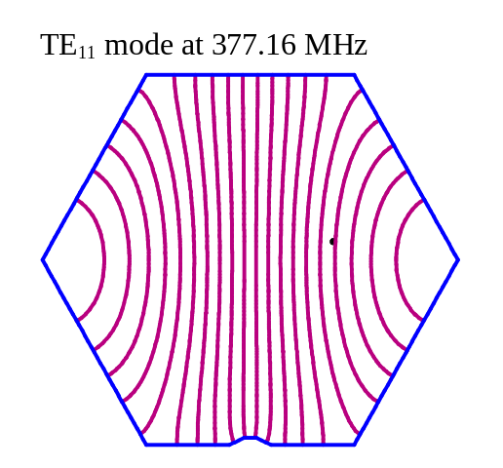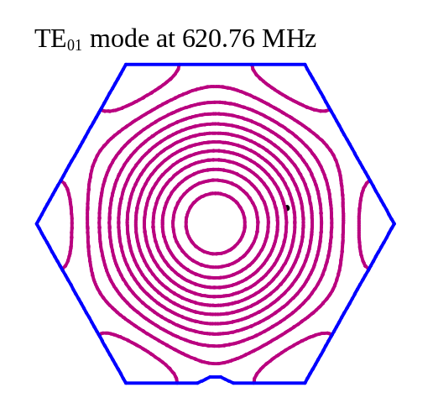
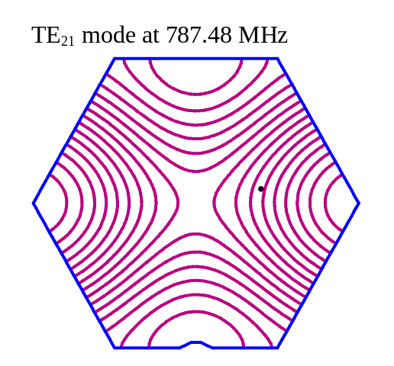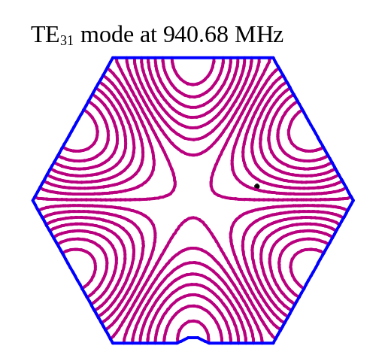
Figure XVI-45. Waveguide modes in the hexagonal guide.
The modes are labeled using circular waveguide notation, where the first index refers to the number of azimuthal cycles and the second index refer to the number of radial zeros.

