File SFEXMPL2.DOC contains the following bookmarks. Select the topic you are trying to find from the list and double click the highlighted text.
NOTE: This file is still under development. Eventually it will contain figures showing the computed results for most of the example files. We also hope to provide hyperlinks to appropriate sections of the documentation in other files.
Examples in other files
HREF="sfexmpl1.doc
HREF="sfexmpl3.doc

Magnetostatic directories discussed in this file

Electrostatic directories discussed in this file

Topics

File SFEXMPL2.DOC Table of Contents
XVII. Magnetostatic Examples (Poisson, Pandira)
A. The H-Magnet directory
1. The H-shaped magnet example HTEST1
2. The H-shaped magnet example HTEST2.AM
3. Full-geometry example HFULL.AM for the H-shaped magnet
4. Force calculation for problem HFULL.AM
B. The Dipoles directory
C. The Quadrupoles directory
D. The ForceTest and ForceOnWires directories
1. Force between current loops
E. The PMCylinders directory
F. The PMDipoles directory
1. Dipole magnet made from blocks of permanent-magnet material
2. Permanent-magnet dipole with variable easy axis direction
G. The PMQuads directory
1. Full geometry permanent-magnet quadrupole
2. Permanent-magnet quadrupole with variable easy axis direction
3. Quarter geometry permanent-magnet quadrupole
H. The POAsample directory
I. The Septum directory
J. The Solenoids directory
K. The Shielding directory
L. The StoredEnergy directory
XVIII. Electrostatic Examples (Poisson, Pandira)
A. The ChargeDensity directory
B. The CoaxCapacitor directory
C. The CoaxCylinder directory
D. The Dielectrics directory
E. The IonSource directory
F. The Plates directory
G. The QuadLens directory
H. The StoredEnergy directory

Magnetostatic Examples (Poisson, Pandira)
The Examples\Magnetostatic subdirectory include the files in Table XVII-1 plus several subdirectories containing magnet problems for Poisson or Pandira. Your installation may include HREF="sfintro.doc#ExamplesDirectory subdirectories under Examples for other types of problems. Batch file Run_MAG.BAT runs all the examples. If you want to see the field plots as Run_MAG finishes with each problem, type “Run_MAG p”. Use a lower-case letter p. Otherwise, just type Run_MAG. The batch file Show_MAG.BAT runs WSFplot in each directory to display data from each solution. Run_MAG.BAT must finish before you run Show_MAG.BAT. After you have finished inspecting the results of the Run_MAG run, you can run Clr_MAG.BAT to delete all the files made by Run_MAG.BAT.
Table XVII-1. Files in directory Examples\Magnetostatic.
Files | Description
Run_MAG.BAT | Batch file that runs all examples in other directories.
Show_MAG.BAT | Batch file that displays results of all runs.
Clr_MAG.BAT | Batch file that deletes all files made by Run_MAG.BAT.

Each subdirectory under Examples\Magnetostatic includes one or two batch control files. Files named RUNxxx.BAT runs the appropriate codes for all the example files in the subdirectory. Files named SHWxxx.BAT run WSFplot on each HREF="sffiles.doc#BinarySolutionFile to display the results. Subdirectories that have only one problem file do not contain a SHWxxx.BAT file. The batch files make use of the default settings in the SF.INI file shipped with this distribution. Binary solution files have extension T35. The batch files will not run WSFplot unless you call the batch process with a lower-case letter p on the run line. The codes create the binary solution file and the OUTxxx.TXT file appropriate to each code. In directories with multiple input files, the batch file copies some output files to other files. When the run finishes, you can inspect all the OUTxxx.TXT files. Files named OUTxxx1.TXT correspond to the first calculation in a directory, OUTxxx2.TXT to the second, and so forth. In some cases, the procedure deletes the last OUTxxx.TXT files. In other cases, files OUTxxx.TXT (without a number appended) corresponds to the most recent calculation.

The H-Magnet directory
Table XVII-1 lists files in the H-Magnet directory. The H-magnet example appeared in the Reference Manual, Chapter B.2 and again in the User’s Guide, Chapter 10.2. Input files HTEST1.AM and HTEST2.AM use the same single-quadrant geometry, but illustrate different features available in the codes. File HFULL.AM is a similar H-shaped magnet that includes all four quadrants of the geometry. The batch file uses Pandira to solve the HFULL.AM problem since it is faster than Poisson for this problem. The other problems also can be solved with Pandira, but Pandira cannot adjust XJFACT as Poisson does for the HTEST2.AM problem. Batch file RUNHTEST.BAT shown in Figure XVII-1 runs Automesh and then either Poisson or Pandira to solve these problems. For the HFULL.AM example, program Force computes the net force on a portion of the iron yoke.
Table XVII-1. Files in directory Magnetostatic\H-Magnet.
File | Description
HTEST1.AM | Automesh input for an H magnet with harmonic analysis.
HTEST2.AM | Automesh input the H magnet with special options.
HFULL.AM | Automesh input for a full H magnet (all four quadrants).
HFULL.FCE | Force input file for HFULL.
RUNHTEST.BAT | Batch file for running the codes.
SHWHTEST.BAT | Batch file for viewing the results.

The solutions for HTEST1.AM and HFULL.AM both use a fixed value of reluctivity FIXGAM because the parameter MODE = −1. File HTEST2.AM sets MODE = 0 and uses the default internal HREF="sfcodes.doc#InternalPermeabilityTables. The resulting fields for HTEST2.AM differ from those in the 1987 User’s Guide because the older codes were run with the older permeability table for decarburized iron. If you would like to compare numerical results to those in the 1987 manuals, set MTID = −1 in the REG namelist with MAT = 2 to use the older table.
START /W “ “ “%SFDIR%automesh” htest1
START /W “ “ “%SFDIR%poisson” htest1
copy outaut.txt outaut1.txt
copy outpoi.txt outpoi1.txt
if (%1)==(p) START /W “ “ “%SFDIR%WSFplot” htest1.t35 3

START /W “ “ “%SFDIR%automesh” htest2
START /W “ “ “%SFDIR%poisson” htest2
copy outaut.txt outaut2.txt
copy outpoi.txt outpoi2.txt
if (%1)==(p) START /W “ “ “%SFDIR%WSFplot” htest2.t35 3

START /W “ “ “%SFDIR%automesh” hfull
START /W “ “ “%SFDIR%pandira” hfull
START /W “ “ “%SFDIR%force” hfull
if (%1)==(p) START /W “ “ “%SFDIR%WSFplot” hfull.t35 3
Figure XVII-1. The batch file RUNHTEST.BAT.
This batch file executes Automesh on the three input files HTEST1.AM, HTEST2.AM, and HFULL.AM. It runs Poisson to solve the HTEST1.AM and HTEST2.AM problems, and Pandira to solve the full-geometry problem HFULL.AM. The Force run on HFULL.AM computes the net force on the upper part of the iron yoke. Copy commands save the output files for later inspection. If you start RUNHTEST with letter “p” on the command line, then WSFplot displays field lines for 3 seconds after each solution.

The H-shaped magnet example HTEST1
Figure XVII-2 and Figure XVII-3 show sections of the input files HTEST1.AM for one quadrant of an H-shaped dipole magnet. The first REG namelist includes settings for the HREF="sfcodes.doc#HarmonicAnalysis. Comments after semicolons in the REG namelist describe functions of the variables.
Figure XVII-4 shows the boundary segments defined by the same set of PO namelist lines in files HTEST1.AM and HTEST1.AM. Figure XVII-5 shows a WSFplot picture of the triangular mesh generated by Automesh. This simple geometry illustrates an important point about the way Automesh initializes points in the mesh. If a new region occupies the same space as part of a region previously defined, the properties of the new region take precedence. Thus, the order of appearance of overlapping regions in the Automesh input file is important.
The example HTEST1.AM differs in some respects from H-magnet example discussed in the 1987 Reference Manual. The boundary points are the same, but we have reduced the mesh size from 0.45 cm to 0.3 cm to avoid problems with field interpolation that can result from having HREF="sfcodes.doc#MeshSizeGuidelines between the coil and iron regions. Figure XVII-5 shows that with the smaller mesh, two mesh intervals fit in the air space between the coil and iron. Another difference is that the older example did not specify a value for MODE, so the codes assumed MODE = −2, or infinite permeability. File HTEST1.AM sets MODE = −1 and uses the default value of FIXGAM = 0.005 for the iron permeability.
H-Shaped Magnet
Including harmonic analysis for H type dipole magnet
Field output is requested along the X axis
[Originally appeared in 1987 Reference Manual B.2.1]

&reg kprob=0, ; Declares a Poisson problem
dx=.3, ; Mesh interval
mode=-1 ; Use fixed gamma for material 2
xminf=0,xmaxf=22, ; X range for field interpolation
yminf=0,ymaxf=0, ; Y range (along x axis: y = 0)
; The next 6 terms refer to the harmonic analysis:
ktype=6, ; H dipole symmetry
nterm=7, ; Number of coefficients
nptc=11, ; Number of arc points for interpolation
rint=1.5, ; Radius of the arc
angle=90, ; Angular extent of arc (default start = 0)
rnorm=1.5 & ; Aperture radius
Figure XVII-2. Title and REG namelist from input file HTEST1.AM.
This listing shows the 3-line title and the first REG namelist in the input file. The rest of the input file appears in Figure XVII-3.

&po x=0.,y=0. & ; Start of the air-region points
&po x=22.,y=0. &
&po x=22.,y=13. &
&po x=0.,y=13. &
&po x=0.,y=0. &

&reg mat=2 & ; Start of the iron region
&po x=0., y=2. &
&po x=5.1,y=2. &
&po x=5.5,y=2.4 &
&po x=5.5,y=6. &
&po x=15.,y=6. &
&po x=15.,y=0. &
&po x=22.,y=0. &
&po x=22.,y=13. &
&po x=0.,y=13. &
&po x=0.,y=2. &

&reg mat=1,cur=-25455.791 & Start of the coil region
&po x=6.,y=0. &
&po x=14.5,y=0. &
&po x=14.5,y=5.5 &
&po x=6.0,y=5.5 &
&po x=6.,y=0. &
Figure XVII-3. Air points and iron and coil regions HTEST1.AM and HTEST2.AM.
The first region consists of air points because the code assumes material MAT = 1 if it is not specified. The iron region (MAT = 2) and coil region (MAT = 1 with a nonzero current term CUR) overwrite the properties of region 1.
After running Poisson on this problem, WSFplot displays the solution shown in Figure XVII-6. The plot shows lines of constant vector potential A_{z}. Note that the code used the HREF="sfcodes.doc#BoundaryConditionVariablesMACROBUTTON for magnet problems. The bottom edge is a Neumann boundary and the other three edges are Dirichlet boundaries. These are the appropriate boundary conditions for this single-quadrant geometry. If you require different boundary conditions you must include one or more of the variables NBSUP, NBSLO, NBSLF, and NBSRT to define them.
After running Poisson or Pandira on the HTEST1.AM problem, file OUTPOI.TXT or OUTPAN.TXT will include three tables of data giving the results of the harmonic analysis. The first table, shown in Figure XVII-7, lists the data points used in the analysis. Columns X and Y are the rectangular coordinates corresponding to the polar coordinates (r,θ), where r is the normalization radius RNORM, and θ is the angle listed in column 2. File HTEST1.AM did not specify the starting angle ANGLZ, whose default value is zero. The variable ANGLE is the angular range starting at ANGLZ. The “Avector” column is the interpolated vector potential A_{z}(X,Y). The next two tables, shown in Figure XVII-8, list the fitted values of the requested coefficients that describe the vector potential and the magnetic field components B_{x} and B_{y}.

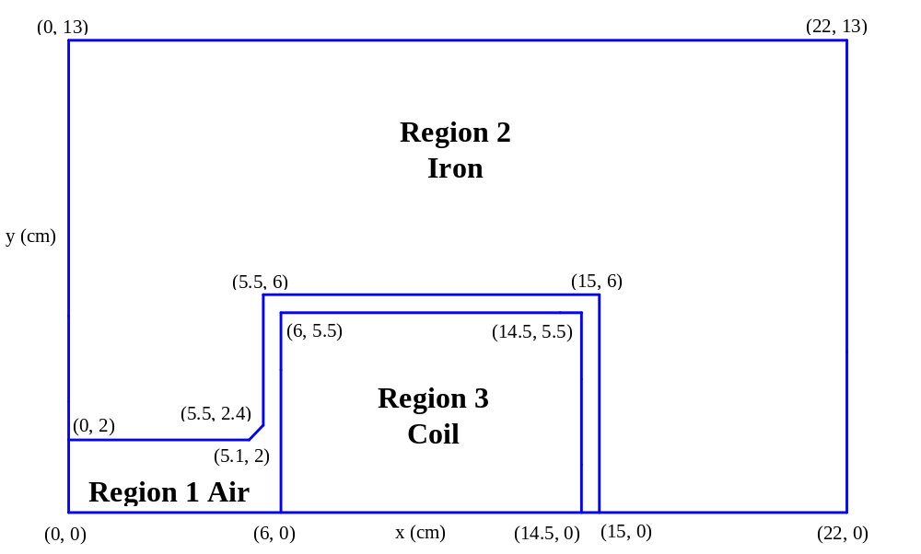
Figure XVII-4. One quadrant of the H magnet geometry.
Files HTEST1.AM and HTEST2.AM set up the outer boundary first. The iron and coil regions are then superimposed on the air region.

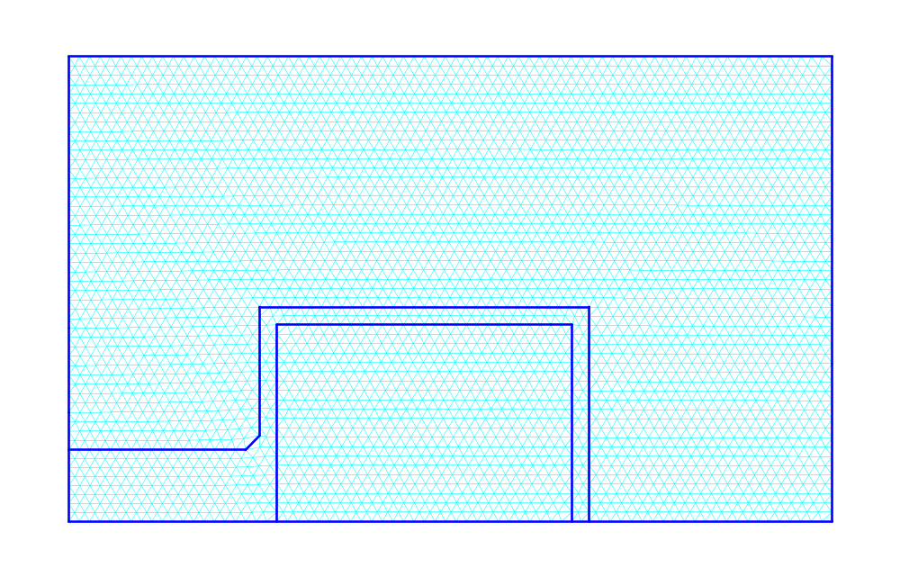
Figure XVII-5. Triangular mesh for the HTEST1 and HTEST2 examples.
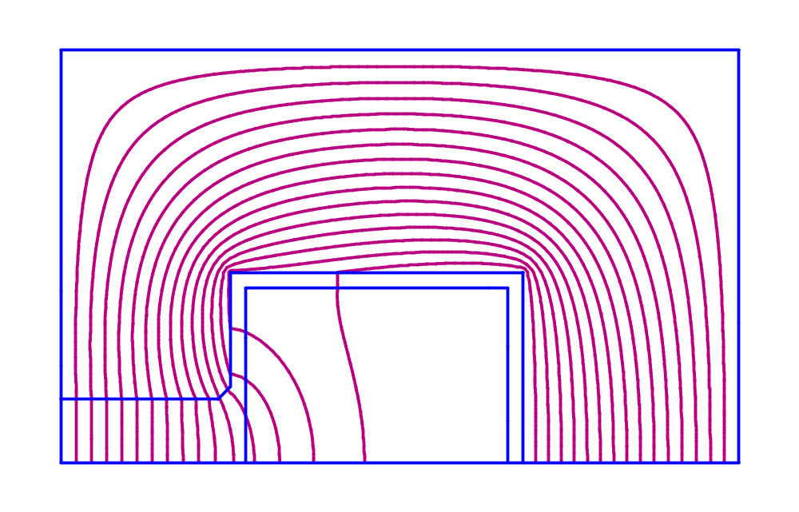
Figure XVII-6. Field contours for the HTEST1.AM and HTEST2.AM examples.
The plot shows lines of constant vector potential A_{z}. The example used the default boundary conditions for magnet problems. The bottom edge is a Neumann boundary and the other three edges are Dirichlet boundaries.
In this one-quadrant problem, we have specified the type of symmetry to use in the harmonic analysis. The H-shaped dipole magnet symmetry (KTYPE = 6) eliminates the even-numbered coefficients for the analysis since they must be identically zero. This symmetry type also assumes that B_{y} is zero and that the vector potential A_{z} = A_{z}(x) and does not vary with y.
Harmonic analysis
Interpolated points on an arc of radius = 1.50000
K,L is nearest mesh point to physical coordinates X,Y:
n Angle X Y K L Avector
1 0.0000 1.5000 0.0000 6 1 -2.26302E+04
2 9.0000 1.4815 0.2347 6 2 -2.23524E+04
3 18.0000 1.4266 0.4635 6 3 -2.15260E+04
4 27.0000 1.3365 0.6810 6 4 -2.01678E+04
5 36.0000 1.2135 0.8817 5 5 -1.83138E+04
6 45.0000 1.0607 1.0607 5 5 -1.60082E+04
7 54.0000 0.8817 1.2135 4 6 -1.33076E+04
8 63.0000 0.6810 1.3365 4 6 -1.02789E+04
9 72.0000 0.4635 1.4266 2 7 -6.99675E+03
10 81.0000 0.2347 1.4815 2 7 -3.54204E+03
11 90.0000 0.0000 1.5000 1 7 -1.38640E-12
Figure XVII-7. List of points used for HTEST1.AM harmonic analysis.

Vector potential coefficients
Normalization radius = 1.50000
A(x,y) = Re( sum (An + iBn) * (z/r)**n )
n An Bn Abs(Cn)
1 -2.2635E+04 0.0000E+00 2.2635E+04
3 3.4319E+00 0.0000E+00 3.4319E+00
5 7.6872E-01 0.0000E+00 7.6872E-01
7 2.4230E-01 0.0000E+00 2.4230E-01
9 2.0776E-01 0.0000E+00 2.0776E-01
11 2.4415E-01 0.0000E+00 2.4415E-01
13 1.6478E-01 0.0000E+00 1.6478E-01

Field coefficients
Normalization radius = 1.50000
(Bx - iBy) = i[sum n*(An + iBn)/r * (z/r)**(n-1)]
n n(An)/r n(Bn)/r Abs(n(Cn)/r)
1 -1.5090E+04 0.0000E+00 1.5090E+04
3 6.8638E+00 0.0000E+00 6.8638E+00
5 2.5624E+00 0.0000E+00 2.5624E+00
7 1.1307E+00 0.0000E+00 1.1307E+00
9 1.2466E+00 0.0000E+00 1.2466E+00
11 1.7904E+00 0.0000E+00 1.7904E+00
13 1.4281E+00 0.0000E+00 1.4281E+00
Figure XVII-8. Coefficients computed by the harmonic analysis for HTEST1.

The H-shaped magnet example HTEST2.AM
The HTEST2.AM example uses the same geometry as HTEST1.AM. An inspection of Figure XVII-9 shows a few differences in the first REG namelist compared to Figure XVII-2 for HTEST1.AM. HTEST2.AM does not include a harmonic analysis of the solution field. Because HTEST2.AM includes a nonzero value for BDES (the desired B field), Poisson HREF="sfcodes.doc#ScalingToDesiredMagneticField by modifying the value of XJFACT during the over-relaxation calculation. In this example, the parameters XBZERO and YBZERO specify the physical location at which to make the field B = BDES. Supplying the physical coordinates is the recommended procedure. You can also supply the logical coordinates KBZERO and LBZERO, if desired, but then the physical location will move if you later run the same problem with a different mesh size. To supply logical coordinates, first run Automesh and WSFplot. Position the mouse cursor near the point you would like to use and read its logical coordinates from the display window.
Unlike older versions of the code, it is not necessary for Poisson to complete the first solution before specifying a desired field value in BDES.
H-Shaped Magnet with special options
Adjust XJFACT to make B = 16 kG at X,Y = 0.5,0.25.
[Originally appeared in 1987 User's Guide 10.2]

&reg kprob=0, ; Declares a Poisson problem
dx=.3, ; Mesh interval
mode=0, ; Use B,gamma table for material 2
ktop=4, ; Field interpolation at 4 points along X
ltop=3, ; Field interpolation at 3 points along Y
xminf=0,xmaxf=2.5, ; X range for field interpolation
yminf=0,ymaxf=5, ; Y range
bdes=16000, ; B field for scaling option
xbzero=0.5,ybzero=0.25 & ; Location X,Y = 0.5,0.25 for scaled B field
Figure XVII-9. Title and REG namelist from input file HTEST2.AM.
This listing shows the 2-line title and the first REG namelist in the input file. The rest of the input file appears in Figure XVII-3.

Full-geometry example HFULL.AM for the H-shaped magnet
File HFULL.AM in Figure XVII-10 describes an H-shaped magnet that includes all four quadrants of the geometry. Figure XVII-11 lists an extra region added to HFULL.AM that retraces the path for calculating the force on a portion of the yoke. This example inserts the regions in a different order than the order used in the one-quadrant examples. The first region consists of iron (MAT = 2). The air region (MAT = 1) overwrites points in the iron region, then the two coil regions overwrite points in the air region. Unlike the HTEST1.AM and HTEST2.AM examples, the HREF="sfcodes.doc#BoundaryConditionVariablesMACROBUTTON are not appropriate for the full geometry. The input file sets all four variables NBSUP, NBSLO, NBSLF, and NBSRT equal to zero to specify Dirichlet boundaries. All but NBSLO might have been omitted because they are zero by default, but including all four avoids any ambiguity.
We also have added several HREF="sfcodes.doc#LineRegions to make the mesh reasonably fine in the coil and gap areas of the geometry, but coarser in the iron near the edges of the geometry. We took some care to make the mesh as symmetric as possible about X = 0 and about Y = 0 for comparing the harmonic analysis results to the one-quadrant results from file HTEST1.AM. Using pairs of line regions two logical rows apart (for example, XREG1 = −15, XREG2 = −14.5, KREG1 = 12,KREG2 = 14) ensures two mesh intervals in the narrow spaces between the coils and the iron. Figure XVII-12 shows the mesh generated by Automesh, and Figure XVII-13 shows the field contours displayed by WSFplot after running Pandira.
Full H-Shaped Magnet including all four quadrants
with harmonic analysis with no-symmetry option

&reg kprob=0, mode=-1
mat=2,nbslo=0,nbsup=0,nbslf=0,nbsrt=0,
xreg1=-15,xreg2=-14.5,xreg3=14.5,xreg4=15,
kreg1=12,kreg2=14,kreg3=106,kreg4=108,kmax=119,
yreg1=-6,yreg2=-5.5,yreg3=5.5,yreg4=6
lreg1=12,lreg2=14,lreg3=53,lreg4=55,lmax=66
ktype=1,nterm=9,nptc=41,rint=1.5,angle=360,rnorm=1.5 &

&po x=-22.,y=-13. & ; Entire geometry is iron, initially
&po x=22.,y=-13. &
&po x=22.,y=13. &
&po x=-22.,y=13. &
&po x=-22.,y=-13. &

&reg mat=1 & ; Start of air region
&po x=-15.,y=-6. &
&po x=-5.1,y=-6. &
&po x=-5.1,y=-2. &
&po x=5.1,y=-2. &
&po x=5.1,y=-6. &
&po x=15.,y=-6. &
&po x=15.,y=6. &
&po x=5.1,y=6. &
&po x=5.1,y=2. &
&po x=-5.1,y=2. &
&po x=-5.1,y=6. &
&po x=-15.,y=6. &
&po x=-15.,y=-6. &

&reg mat=1,cur=-50911.582 & ; Start of right-side coil
&po x=6.,y=-5.5 &
&po x=14.5,y=-5.5 &
&po x=14.5,y=5.5 &
&po x=6.0,y=5.5 &
&po x=6.,y=-5.5 &

&reg mat=1,cur=50911.582 & ; Start of left-side coil
&po x=-6.,y=-5.5 &
&po x=-14.5,y=-5.5 &
&po x=-14.5,y=5.5 &
&po x=-6.0,y=5.5 &
&po x=-6.,y=-5.5 &
Figure XVII-10. Automesh input file HFULL.AM.
The first region is iron because the first REG namelist includes MAT = 2. The air region (MAT = 1) and coil regions (MAT = 1 with a nonzero current term CUR) overwrite the properties of region 1. Figure XVII-11 lists the last region of this file.

; Retrace a section of the iron for calculating the force on it.
; Use a finer mesh than this example for better accuracy.
&reg mat=2 &
&po x=-22.,y=6. &
&po x=-22.,y=13. &
&po x=22.,y=13. &
&po x=22.,y=6. &
&po x=5.1,y=6. &
&po x=5.1,y=2. &
&po x=-5.1,y=2. &
&po x=-5.1,y=6. &
&po x=-22.,y=6. &
Figure XVII-11. Last region in Automesh input file HFULL.AM.
This region is not needed to compute the fields. It shows a convenient way to define a section of the iron yoke on which to compute the force.
The setting KTYPE = 1 in file HFULL.AM indicates that harmonic analysis will assume no symmetry in the geometry. The one-quadrant example HTEST1 used KTYPE = 6 for dipole-magnet symmetry. Figure XVII-14 lists the data points used in the full-geometry analysis and Figure XVII-15 contains the two tables of fitted coefficients that describe the vector potential and the magnetic field components B_{x} and B_{y}. It is interesting to compare the results in Figure XVII-8 to the full-geometry analysis. Both analyses used 9-degree steps around an arc of radius 1.5 cm. Both input files generate nearly equilateral triangles in the region of the harmonic analysis. For best accuracy, the step size around the arc for the normalization data (in Figure XVII-7 and Figure XVII-14) span approximately one mesh interval (K or L change only by about 1 or 2 units at each step).
The one-quadrant example computes the odd-numbered coefficients up to the n = 13 term; the full-geometry example computes all terms to n = 9. The n = 1 terms agree to about 1 part in 10,000. Figure XVII-15 shows that the odd-numbered coefficients 9 or 10 orders of magnitude smaller than the leading term for the mesh we used. These terms are sensitive to the details of the mesh. If you change the number of mesh points slightly, the odd terms may change by large factors, but will still remain many orders of magnitude below the n = 1 term. You can try this yourself: set KREG3 = 107, KREG4 = 109, and KMAX = 120 in file HFULL.AM and rerun Automesh and Pandira. Exercises such as this can give you an indication of the accuracy of the solution.
The B_{n} terms in Figure XVII-15 are also small indicating little variation of the fields with y. After the n = 1 term, the next two odd-numbered A_{n} coefficients are slightly higher than the corresponding terms for the one-quadrant example. But, by n = 5, the full-geometry coefficients are smaller.
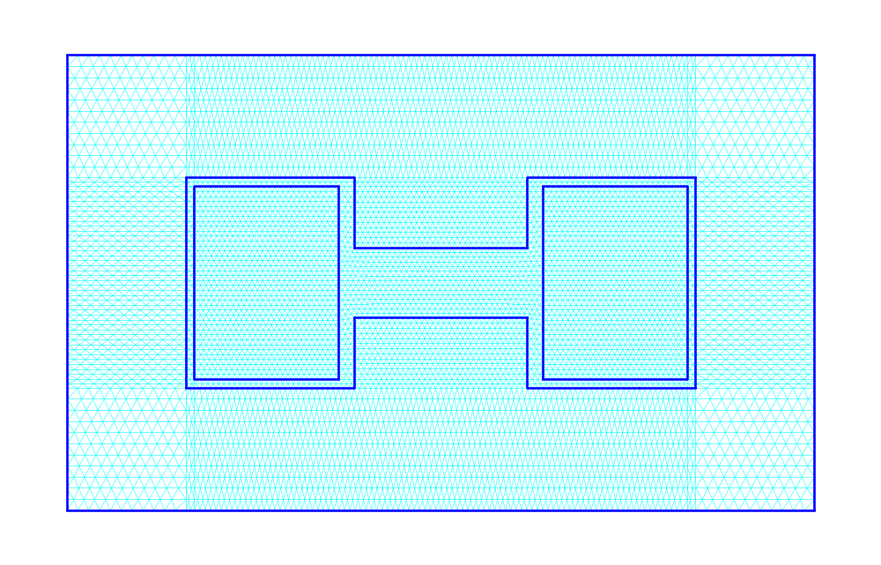
Figure XVII-12. Triangular mesh for the HFULL.AM example.
This mesh shows how line regions can divide the geometry into fine and coarse sections in both X and Y.

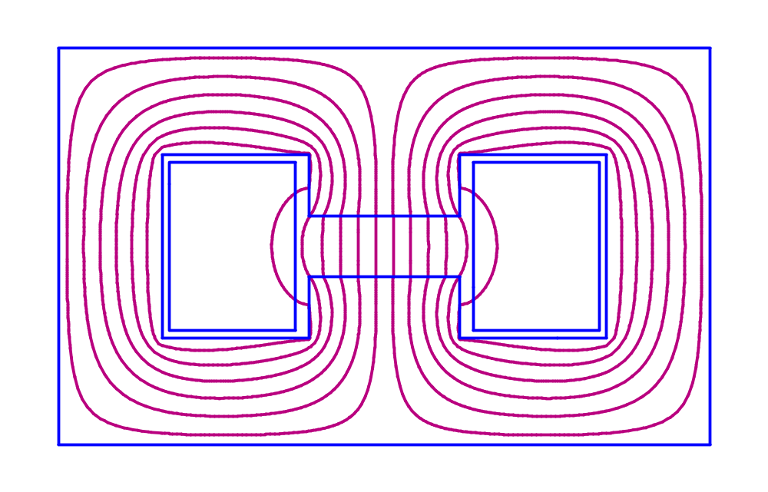
Figure XVII-13 Field contours for the HFULL.AM example.
The plot shows lines of constant vector potential A_{z}. This example used a Dirichlet boundary condition for all four edges of the geometry.
Harmonic analysis
Interpolated points on an arc of radius = 1.50000
K,L is nearest mesh point to physical coordinates X,Y:
n Angle X Y K L Avector
1 0.0000 1.5000 0.0000 65 34 -2.26265E+04
2 9.0000 1.4815 0.2347 65 34 -2.23489E+04
3 18.0000 1.4266 0.4635 64 35 -2.15224E+04
4 27.0000 1.3365 0.6810 65 36 -2.01662E+04
5 36.0000 1.2135 0.8817 64 37 -1.83131E+04
6 45.0000 1.0607 1.0607 63 37 -1.60082E+04
7 54.0000 0.8817 1.2135 63 38 -1.33080E+04
8 63.0000 0.6810 1.3365 62 39 -1.02793E+04
9 72.0000 0.4635 1.4266 61 39 -6.99713E+03
10 81.0000 0.2347 1.4815 61 39 -3.54239E+03
11 90.0000 0.0000 1.5000 60 39 -3.00346E-01
12 99.0000 -0.2347 1.4815 59 39 3.54179E+03
13 108.0000 -0.4635 1.4266 58 39 6.99654E+03
14 117.0000 -0.6810 1.3365 58 39 1.02787E+04
15 126.0000 -0.8817 1.2135 58 38 1.33073E+04
16 135.0000 -1.0607 1.0607 57 38 1.60074E+04
17 144.0000 -1.2135 0.8817 56 37 1.83125E+04
18 153.0000 -1.3365 0.6810 56 36 2.01657E+04
19 162.0000 -1.4266 0.4635 55 35 2.15219E+04
20 171.0000 -1.4815 0.2347 56 34 2.23488E+04
21 180.0000 -1.5000 0.0000 55 33 2.26265E+04
22 189.0000 -1.4815 -0.2347 55 33 2.23489E+04
23 198.0000 -1.4266 -0.4635 56 32 2.15224E+04
24 207.0000 -1.3365 -0.6810 55 31 2.01661E+04
25 216.0000 -1.2135 -0.8817 56 30 1.83130E+04
26 225.0000 -1.0607 -1.0607 57 30 1.60081E+04
27 234.0000 -0.8817 -1.2135 57 29 1.33079E+04
28 243.0000 -0.6810 -1.3365 58 28 1.02793E+04
29 252.0000 -0.4635 -1.4266 59 28 6.99710E+03
30 261.0000 -0.2347 -1.4815 59 28 3.54236E+03
31 270.0000 0.0000 -1.5000 60 28 2.68918E-01
32 279.0000 0.2347 -1.4815 61 28 -3.54182E+03
33 288.0000 0.4635 -1.4266 62 28 -6.99657E+03
34 297.0000 0.6810 -1.3365 62 28 -1.02787E+04
35 306.0000 0.8817 -1.2135 62 29 -1.33073E+04
36 315.0000 1.0607 -1.0607 63 29 -1.60075E+04
37 324.0000 1.2135 -0.8817 64 30 -1.83125E+04
38 333.0000 1.3365 -0.6810 64 31 -2.01657E+04
39 342.0000 1.4266 -0.4635 65 32 -2.15219E+04
40 351.0000 1.4815 -0.2347 64 33 -2.23488E+04
41 360.0000 1.5000 0.0000 65 34 -2.26265E+04
Figure XVII-14 List of points used for the HFULL.AM harmonic analysis.
Vector potential coefficients
Normalization radius = 1.50000
A(x,y) = Re( sum (An + iBn) * (z/r)**n )
n An Bn Abs(Cn)
1 -2.2633E+04 -3.6469E-01 2.2633E+04
2 5.4075E-05 1.5660E-05 5.6297E-05
3 4.8586E+00 -8.9066E-02 4.8594E+00
4 2.8694E-05 7.8525E-06 2.9749E-05
5 1.0646E+00 -2.6709E-04 1.0646E+00
6 1.6957E-06 5.3710E-06 5.6323E-06
7 1.2733E-01 3.0081E-03 1.2737E-01
8 -6.0739E-06 2.9064E-06 6.7335E-06
9 1.1238E-02 -1.1834E-02 1.6319E-02

Field coefficients
Normalization radius = 1.50000
(Bx - iBy) = i[sum n*(An + iBn)/r * (z/r)**(n-1)]
n n(An)/r n(Bn)/r Abs(n(Cn)/r)
1 -1.5088E+04 -2.4313E-01 1.5088E+04
2 7.2100E-05 2.0880E-05 7.5062E-05
3 9.7172E+00 -1.7813E-01 9.7188E+00
4 7.6518E-05 2.0940E-05 7.9331E-05
5 3.5487E+00 -8.9031E-04 3.5487E+00
6 6.7827E-06 2.1484E-05 2.2529E-05
7 5.9422E-01 1.4038E-02 5.9439E-01
8 -3.2394E-05 1.5501E-05 3.5912E-05
9 6.7425E-02 -7.1003E-02 9.7916E-02
Figure XVII-15 Coefficients computed by the harmonic analysis for HTEST1.AM.

Force calculation for problem HFULL.AM
The Force program cannot make use of symmetries in the problem geometry. Thus the full geometry of the H-shaped magnet is required to compute the force on a coil or on a portion of the iron yoke. Figure XVII-16 is the input file HFULL.FCE for program Force. It refers to region 5 listed in Figure XVII-11. This example uses the simplest way to specify the path around a region, namely by entering a single physical point on the region boundary. Force finds the closed path around the region an calculates the vector sum of the force on the perimeter. The code reports a net force of 1.72 N/m (about 982 pounds per inch) acting on this iron region. The line of action of the force is straight down.
5 ; Region 5
-22 6 count ; Starting point in region 5
end
Figure XVII-16. Force input file HFULL.FCE.
Region 5 on the second line refers to the last region in file HFULL.AM, which retraced a path around the upper portion of the iron.

The Dipoles directory
Table XVII-2 lists files in the Dipoles directory for the two dipole magnet problems that first appeared in the User’s Guide, Chapters 10.10 and 10.11. Magnetic material properties are in the MT namelist sections of the Automesh input files.
Table XVII-2. Files in directory Magnetostatic\Dipoles.
File | Description
DIPOLE1.AM | Automesh input file for a dipole magnet.
DIPOLE2.AM | Automesh input file for a dipole magnet end fields.
RUNDPOLE.BAT | Batch file for running the codes.
SHWDPOLE.BAT | Batch file for viewing the results.

File DIPOLE1.AM has several line regions not found in the example problem in the User’s Guide. These line regions make the mesh spacing fine enough to follow some of the smaller features in the geometry. The table of permeabilities in DIPOLE1.AM includes a few more values at high fields than the older example.

The Quadrupoles directory
Table XVII-3 lists files in the Quadrupoles directory. File QTEST1.AM is the quadrupole magnet example for Poisson that first appeared in 1987 Reference Manual, Section B.12.2. File QTEST2.AM is a somewhat different quadrupole magnet problem that first appeared in the 1987 User’s Guide, Chapters 10.3 and 10.4. Both of these examples use the HREF="sfcodes.doc#IBOUND_SpecialBoundaryIndicator variable to define the boundary condition along part of a region boundary. You also can run Pandira on either of these problems.
Table XVII-3. Files in directory Magnetostatic\Quadrupoles.
File | Description
QTEST1.AM | Automesh input for a magnetic quadrupole.
QTEST2.AM | Automesh input for another magnetic quadrupole.
RUNQTEST.BAT | Batch file for running the codes.
SHWQTEST.BAT | Batch file for viewing the results.

In problem QTEST1.AM, with MODE = 0, the Poisson solution converges in about 2450 iterations. You might try changing MODE to either −1 or −2 and compare the number of iterations required and also the fields in the gap that the code calculates for these different iron permeability options. Also, note that the example uses a finer mesh than the example in the Reference Manual. As a result, the codes get different coefficients in the harmonic analysis. Smaller values for the higher order coefficients indicate a purer quadrupole field.
File QTEST2.AM demonstrates reading a permeability table for the pole-tip iron. Long-time code users may notice some differences between file QTEST2.AM and the input file presented in the 1987 User’s Guide:
- No values of XMAX and YMAX appear because Automesh finds the limits of the problem geometry by examining region 1.
- The present code version does not support the PO namelist variable NEW. The code does not suffer from the problem described in the User’s Guide.
- The harmonic analysis for QTEST2.AM described on page 10-14 of the User’s Guide evaluates the vector potential on several points that are actually outside the mesh geometry. We set up the harmonic analysis to do a better job. In the Automesh input file, we set RINT = 7.0, ANGLE = 45, and RNORM = 1.0. Note that the quadrupole coefficient has about the same value it had originally, but all the higher-order coefficients are many orders of magnitude smaller.

The ForceTest and ForceOnWires directories
Two directories contain some simple magnetostatic problems that use the Force program. Directory ForceTest (see Table XVII-4) contains two problems in cylindrical coordinates involving a current carrying wire loop and an iron cylinder nearby. The two problems IRON1 and IRON2 are similar, but they exercise different parts of the code. Problem IRON1 includes an iron tube and uses infinite permeability for the iron. Problem IRON2 includes a solid rod of finite, but fixed, permeability iron. In both examples, program Force calculates the force on the wire loop and the force on the piece of iron. Since there are no other objects in the problem geometry, these forces should balance.
Table XVII-4. Files in directory Magnetostatic\ForceTest.
File | Description
IRON1.AM | Automesh input file for a wire loop near an iron tube.
IRON1.FCE | Force input file for the IRON1 problem.
IRON2.AM | Automesh input file for a wire loop near an iron cylinder.
IRON2.FCE | Force input file for the IRON2 problem.
RUNIRON.BAT | Batch file for running the codes.
SHOWIRON.BAT | Batch file for viewing the results.

Table XVII-5 lists files in the ForceOnWires directory. Batch file RUNWIRES.BAT uses Pandira to solve these problems because it take less time than Poisson does.
The 1WIRE problem is an infinitely long wire inside an iron pipe. By specifying Dirichlet boundaries on all sides of the problem it is unnecessary to make the problem boundaries wider than the iron pipe. For the 1WIRE problem, program Force computes the force on the wire and on the iron pipe. These two forces should, of course be equal and opposite. The Force results do indeed show forces in opposite directions and the magnitudes agree to about 0.4%.
Files 1W45 and 1W90 are similar to the 1WIRE problem, except that the current-carrying wire is in a different location. Force computes the same magnitude of the force for these three problems. The analytic result for the force is 0.00135962 kg/m. The calculated force differs from the analytic result by about 0.5%.
Table XVII-5. Files in directory Magnetostatic\ForceOnWires.
File | Description
1WIRE.AM | Automesh input file for a long wire inside an iron pipe.
1WIRE.FCE | Force input file for the 1WIRE problem.
1W45.AM | Same as 1WIRE problem with wire at 45 degrees.
1W45.FCE | Force input file for the 1W45 problem.
1W90.AM | Same as 1WIRE problem with wire at 90 degrees.
1W90.FCE | Force input file for the 1W45 problem.
2WIRE.AM | Automesh input file for two long current carrying wires.
2WIRE.FCE | Force input file for the 2WIRE problem.
LOOP1.AM | Automesh input file for a wire loop in uniform B field.
LOOP1.FCE | Force input file for the LOOP1 problem.
LOOP2.AM | Automesh input file for force between two current loops.
LOOP2.FCE | Force input file for the LOOP2 problem.
RUNWIRES.BAT | Batch file for running the codes.
SHWWIRES.BAT | Batch file for viewing the results.

The 2WIRE.AM problem involves two parallel current-carrying wires whose centers are 2.0 cm apart. Each wire carries 1000 A. The wires attract one another. The analytically calculated force per unit length on either wire is exactly 10.0 N/m or 1.01972 kg/m. The code get forces of 1.0212 kg/m and 1.0243 kg/m on the two wires. The average value of 1.0227 kg/m differs by about 0.3% from the analytic result.
Problems LOOP1.AM and LOOP2.AM have cylindrical symmetry. The LOOP1.AM problem places a small wire with a square cross section in a magnetic field B = 1000 Gauss produced by a current sheet at radius r = r_{max}. The field is nearly undisturbed by the presence of the wire loop, which carries a current of 10 A. The force on this loop is directed radially outward. The analytic result is a force of magnitude 0.05 N/radian. The code calculates 0.050045 N/radian.

Force between current loops
The LOOP2.AM problem calculates the force between two wire loops separated by a distance of 10 cm. The loop radius is 10 cm. Richard K. Cooper supplied the following derivation of an analytic result for this problem.
One can calculate the strength and direction of the magnetic field generated by a short length of wire dl carrying a current I by the law of Biot and Savart
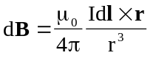, (XVII-1)
where the vector r points from the element of current to the point at which the field is to be calculated. The quantity r is the length of vector r. The permeability of free space μ₀ has the value 4π × 10⁻⁷ T-m/A.
When the observation point is not on the axis, the radius vector from a point on the loop (R cos θ, R sin θ, 0) to the observation point (x, y, z) is
, (XVII-2)
and has the length 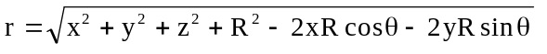. The vector product
dl × r is
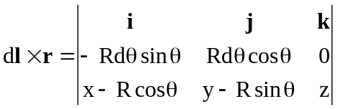,
, (XVII-3)
The magnetic field at the point (x, y, z) will be given by
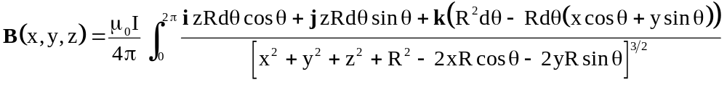. (XVII-4)
The complete elliptic integrals are defined as
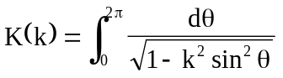 (XVII-5)
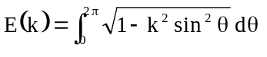 (XVII-6)
Finally, we have the radial and longitudinal components of the magnetic field
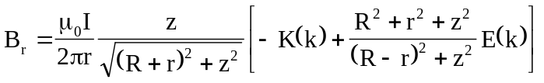. (XVII-7)
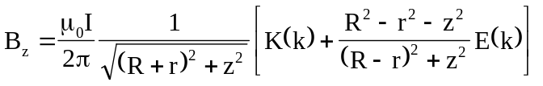. (XVII-8)
where 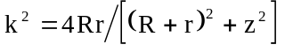.
The quantity k² is zero on the axis (where r = 0). It has the maximum value of 1 at the loop itself, that is, where (r, z) = (R, 0).
A second loop with the same radius R coaxial and parallel with the first loop and located a distance c from that loop will experience a force in the z direction
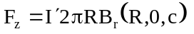
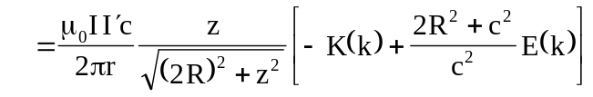, (XVII-9)
where 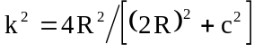. We now substitute the values associated with problem LOOP2.AM into equation XVIII-9, namely,
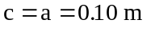 and 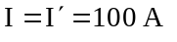, (XVII-10)
and after evaluating the elliptic integrals, find that
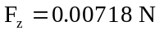. (XVII-11)

The PMCylinders directory
Table XVII-6 lists files in the PMCylinders subdirectory for a cylindrical permanent magnet problem that first appeared in the User’s Guide, Chapter 10.6. In the User’s Guide, some variables were supplied as input to Lattice, and others were part of the input to Pandira. All variables are now entered in the Automesh input file as variables MODE, ICYLIN, NBSLO, and KTYPE, as in this example. The magnetic material properties are in the MT namelist sections of the Automesh input file PMCYLIN.AM.
Table XVII-6. Files in directory Magnetostatic\PMCylinders.
File | Description
PMCYLIN.AM | Automesh input file for cylindrical permanent magnets.
RUNPMCYL.BAT | Batch file for running the codes.

The PMDipoles directory
Table XVII-7 lists files in the PMDipoles directory for solving two permanent-magnet dipole problems. The problem file PMDIPOLE.AM originally appeared in Chapter 10.5 of the 1987 User’s Guide. This problem uses several blocks of permanent magnet material to produce a dipole field. The other problem illustrates the use of the feature in Pandira that allows a HREF="sfphys1.doc#VariableEasyAxisDirection. Figure XVII-17 shows the batch file RUNPMDIP.BAT, which runs Automesh and Pandira on each problem. The batch file also runs postprocessor SF7 after solving the PMDIPOLE.AM problem. The SF7 run generates plot files for program Tablplot.
Table XVII-7. Files in directory Magnetostatic\PMDipoles.
File | Description
PMDIPOLE.AM | Automesh input file for a permanent magnet dipole.
PMDIPOLE.IN7 | SF7 input file for PMDIPOLE.
PMDVAR.AM | Automesh input file for a dipole with variable easy axis option.
RUNPMDIP.BAT | Batch file for running the codes.
SHWPMDIP.BAT | Batch file for viewing the results.

START /W “ “ “%SFDIR%automesh” pmdipole
START /W “ “ “%SFDIR%pandira” pmdipole
START /W “ “ “%SFDIR%sf7” pmdipole
copy outaut.txt outaut1.txt
copy outpan.txt outpan1.txt
if (%1)==(p) START /W “ “ “%SFDIR%WSFplot” pmdipole.t35 3
if (%1)==(p) START /W “ “ “%SFDIR%Tablplot” dipo02.tbl 3

START /W “ “ “%SFDIR%automesh” pmdvar
START /W “ “ “%SFDIR%pandira” pmdvar
if (%1)==(p) START /W “ “ “%SFDIR%WSFplot” pmvar.t35 3
Figure XVII-17. The batch file RUNPMDIP.BAT.

Dipole magnet made from blocks of permanent-magnet material
Figure XVII-18 shows the geometry of the PMDIPOLE.AM problem and Figure XVII-19 shows the input file. The full geometry would consist of 8 blocks of permanent magnet material surrounding an octagonal air region. All the blocks have the same shape, but the direction of the easy axis increases by 90 degrees as one moves to the next block in the counterclockwise direction. Three blocks of permanent magnet material with the easy axis directions ϕ_{E} shown in Figure XVII-18 produce a dipole field in one quadrant of the full geometry. Figure XVII-20 is a WSFplot display of the resulting field contours.
The first REG namelist section of file PMDIPOLE.AM defines the X and Y limits. The problem uses the default boundary conditions for Poisson and Pandira problems, namely Dirichlet boundaries on all sides except the lower edge, which is a Neumann boundary. The PO namelist section for the first region draws a box around the upper right quadrant of the magnet. The setting MODE = 0 indicates that at least some materials will have variable permeability.
The remainder of the file defines the 3 blocks of material. Associated with each block is a unique material number and a material ID number. The material ID number refers to the MT namelist that defines the permeability for the region. The setting MSHAPE = 1 for the 3 blocks indicates that the material is anisotropic.
The magnetic material properties are in the MT namelist sections of the file near the bottom of Figure XVII-19. All three regions of permanent magnet material have the same permeability as defined by the settings HCEPT and BCEPT. However, each region has a different direction of the easy axis. The half block lying along positive X axis has the easy axis direction ϕ_{E} = 90 degrees, i.e. pointing up. Moving around the circle in the counterclockwise direction, the angle ϕ_{E} increases in steps of 90 degrees at each block. The block at 45 degrees has ϕ_{E} = 190 degrees and the half lying along positive Y axis has ϕ_{E} = −90 degrees (same as 270 degrees).
The PMDIPOLE.AM example shows how to use the postprocessor program SF7 to make plot files of the interpolated fields. File PMDIPOLE.IN7 includes commands for SF7 to interpolate 50 points along each of three lines and write the results to Tablplot input files. The plot filenames consist of a sequence number added to the first 6 characters in the Automesh filename plus the extension TBL. Thus, these files will be PMDIPO1.TBL, PMDIPO2.TBL, and PMDIPO3.TBL.
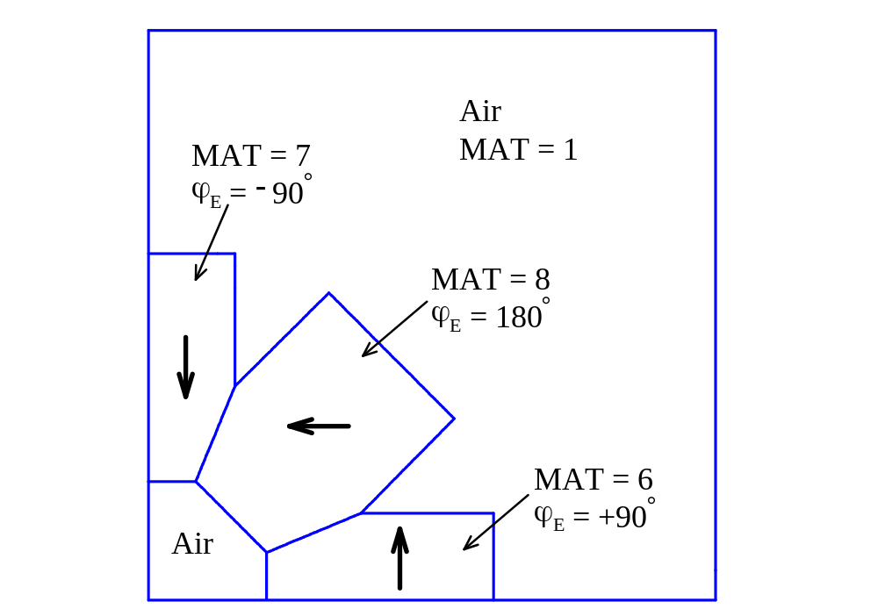
Figure XVII-18. Geometry of the permanent magnet dipole.
Three blocks of material have the their easy axes in the directions shown by the heavy arrows. For this problem the left edge has a Dirichlet boundary condition and the bottom edge has a Neumann boundary condition.

Permanent-Magnet Dipole (for PANDIRA)
[Originally appeared in 1987 User's Guide, Chapter 10.5]

&reg kprob=0, ; Poisson or Pandira problem
mode=0, ; Some materials have variable permeability
dx=0.09,dy=0.09, ; Mesh intervals
nbslo=1, ; Neumann boundary condition on lower edge
nbsup=0, ; Dirichlet boundary condition on upper edge
nbslf=0, ; Dirichlet boundary condition on left edge
nbsrt=0, ; Dirichlet boundary condition on right edge
xreg1=7.3, ; X Line region where mesh interval doubles
yreg1=7.3 & ; Y Line region where mesh interval doubles

&po x=0.0,y=0.0 &
&po x=12.0,y=0.0 &
&po x=12.0,y=12.0 &
&po x=0.0,y=12.0 &
&po x=0.0,y=0.0 &

&reg mat=6,mshape=1,mtid=1 &
&po x=2.5,y=0.0 &
&po x=7.3,y=0.0 &
&po x=7.3,y=1.8285 &
&po x=4.5,y=1.8285 &
&po x=2.5,y=1.0 &
&po x=2.5,y=0.0 &

&reg mat=7,mshape=1,mtid=2 &
&po x=0.0,y=2.5 &
&po x=1.0,y=2.5 &
&po x=1.8285,y=4.5 &
&po x=1.8285,y=7.3 &
&po x=0.0,y=7.3 &
&po x=0.0,y=2.5 &

&reg mat=8,mshape=1,mtid=4 &
&po x=2.5,y=1.0 &
&po x=4.5,y=1.8285 &
&po x=6.47,y=3.82 &
&po x=3.82,y=6.47 &
&po x=1.8285,y=4.5 &
&po x=1.0,y=2.5 &
&po x=2.5,y=1.0 &

&mt mtid=1,aeasy= 90,gamper=1 ; Material ID, Easy axis direction, Gamma along hard axis
hcept=-10800,bcept=11600. & ; H and B intercepts
&mt mtid=2,aeasy= -90,gamper=1,hcept= -10800,bcept=11600. &
&mt mtid=4,aeasy= 180,gamper=1,hcept= -10800,bcept=11600. &
Figure XVII-19. The Automesh input file PMDIPOLE.AM.

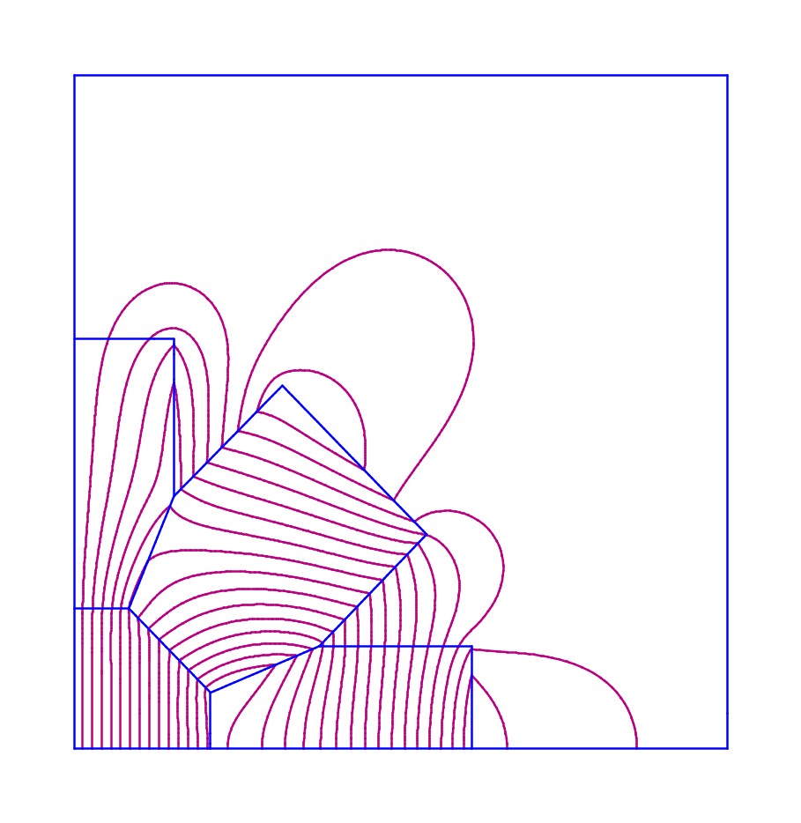
Figure XVII-20. Field contours for problem PMDIPOLE.AM.

Permanent-magnet dipole with variable easy axis direction
File PMDVAR.AM uses the Pandira option that allows the easy axis direction to be a function of angle around the center of a circle. Although there is no natural material for which the direction of the easy axis is a function of position in the plane, as seen in the previous example, wedge-shaped slabs of permanent magnet material can be assembled to approximate this behavior. Figure XVII-21 shows the Automesh input file PMDVAR.AM, which makes use of this variable direction for the easy axis. The HREF="sfcodes.doc#VariableEasyAxisDirection near the bottom of the file specifies PHIA = 0 degrees and MULTA = 2. The easy axis direction varies with position and is given by
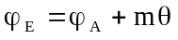,
where ϕ_{A} is the entry for PHIA, θ is the polar angle to the centroid of a mesh triangle with respect to the offset origin (X_{A}, Y_{A}), and m is the multiplier MULTA.

Permanent-Magnet Dipole (for Pandira)
Full geometry uses the variable easy axis option

&reg kprob=0, ; Poisson or Pandira problem
mode=0 ; Some materials have variable permeability
dx=0.18, ; Mesh size
nbslo=0, ; Dirichlet boundary condition on lower edge
nbsup=0, ; Dirichlet boundary condition on upper edge
nbslf=0, ; Dirichlet boundary condition on left edge
nbsrt=0, ; Dirichlet boundary condition on right edge
ibound=0 & ; Dirichlet boundary conditions on entire outer boundary

&po x=3.5,y=0 &
&po nt=2,r=3.5,theta=90 &
&po nt=2,r=3.5,theta=180 &
&po nt=2,r=3.5,theta=270 &
&po nt=2,r=3.5,theta=360 &

&reg mat=3,mshape=1,mtid=1 &
&po x=3,y=0 &
&po nt=2,r=3,theta=90 &
&po nt=2,r=3,theta=180 &
&po nt=2,r=3,theta=270 &
&po nt=2,r=3,theta=360 &

&reg mat=1 &
&po x=1.0,y=0 &
&po nt=2,r=1.0,theta=90 &
&po nt=2,r=1.0,theta=180 &
&po nt=2,r=1.0,theta=270 &
&po nt=2,r=1.0,theta=360 &

&mt mtid=1, ; Material ID
x0a=0,y0a=0, ; Center of circle for variable easy axis
phia=0, ; Starting angle for variable easy axis
multa=2, ; Multiplier for dipole with variable easy axis
gamper=1, ; Gamma along hard axis
hcept=-10800,bcept=11600. & ; H and B intercepts
Figure XVII-21 The Automesh input file PMDVAR.AM.
Figure XVII-22 plots the field lines for the solution computed by Pandira. Comparing this figure with Figure XVII-20 shows that both types of geometry result in a dipole field pattern inside the inner circle. The settings in file PMDVAR.AM produce a horizontal dipole field in the central air region. A vertical dipole pattern would result if the value of PHIA were changed from zero to 90 degrees. While the idealized option of variable easy axis direction in Pandira is useful for visualization, we recommend setting up the actual geometry for design work. The option in Pandira was probably added to an early version of the code because the code at the time did not allow enough material types to solve the quadrupole problem discussed in the next section.
Also compare Figure XVII-22 with Figure XVII-27 for the quadrupole magnet. The only significant differences between file PMDVAR.AM and the input file PMQUAD2.AM are in the MT namelist defining the easy axis direction. Changing MULTA from 2 to 3 changes the field from dipole to quadrupole.

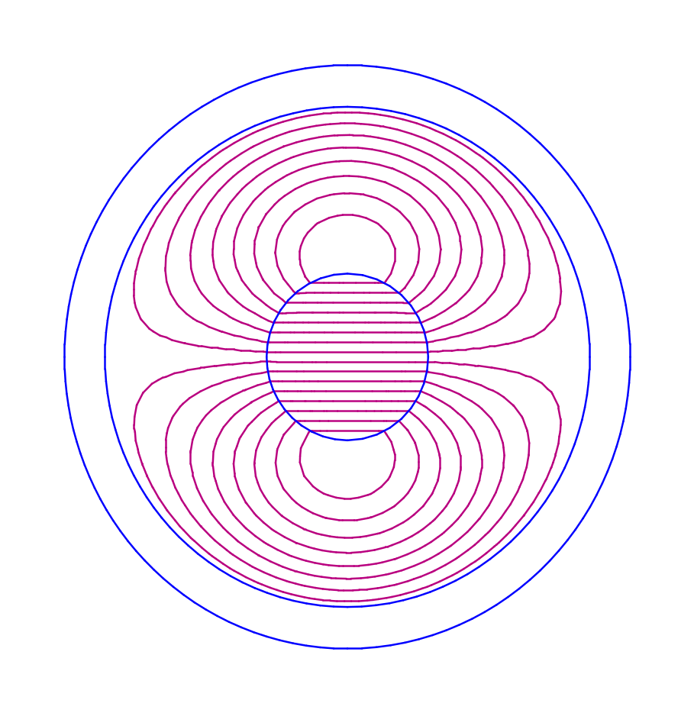
Figure XVII-22. Field contours for the PMDVAR.AM example.
The plot shows lines of constant vector potential A_{z}. This example uses a Dirichlet boundary condition around the outer circle of the geometry.

The PMQuads directory
Table XVII-8 lists files in the PMQuads directory for the permanent-magnet quadrupole problems. The drift-tube linac (DTL) can use permanent magnets of this type inside the drift tubes. These compact magnets provide strong transverse focusing in DTLs at relatively high frequency. For example, in the 1980s Los Alamos built 10 small DTL tanks at 850 MHz containing a total of 140 permanent magnet quadruples. The magnets were less than 5 cm in diameter and had a 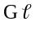 product of about 2 T.
We include three examples files. The first file PMQUAD1.AM is the full geometry consisting of 16 wedges of permanent magnet material. The second file PMQUAD2.AM is also the full geometry, but instead of individual wedges of material, this example uses the feature in Pandira that allows a HREF="sfphys1.doc#VariableEasyAxisDirection. The third example is the same magnet in the PMQUAD1.AM, but only one-quarter of the geometry. Figure XVII-23 shows the batch file RUNPMQ.BAT, which runs Automesh and Pandira on each of the three problems.
Table XVII-8. Files in directory Magnetostatic\PMQuads.
File | Description
PMQUAD1.AM | Input file for full quadrupole with 16 wedges of material.
PMQUAD2.AM | Input file for full geometry with variable easy axis option.
PMQUAD3.AM | Input file for a one quadrant with wedges of permanent magnet material.
RUNPMQ.BAT | Batch file for running the codes.
SHWPMQ.BAT | Batch file for viewing the results.

START /W “ “ “%SFDIR%automesh” pmquad1
START /W “ “ “%SFDIR%pandira” pmquad1
copy outaut.txt outaut1.txt
copy outpan.txt outpan1.txt
copy outpan.tbl outpan1.tbl
if (%1)==(p) START /W “ “ “%SFDIR%WSFplot” pmquad1.t35 3

START /W “ “ “%SFDIR%automesh” pmquad2
START /W “ “ “%SFDIR%pandira” pmquad2
copy outaut.txt outaut2.txt
copy outpan.txt outpan2.txt
copy outpan.tbl outpan2.tbl
if (%1)==(p) START /W “ “ “%SFDIR%WSFplot” pmquad3.t35 3

START /W “ “ “%SFDIR%automesh” pmquad3
START /W “ “ “%SFDIR%pandira” pmquad3
copy outaut.txt outaut3.txt
copy outpan.txt outpan3.txt
copy outpan.tbl outpan3.tbl
if (%1)==(p) START /W “ “ “%SFDIR%WSFplot” pmquad3.t35 3

del outaut.txt
del outpan.txt
del outpan.tbl
Figure XVII-23. The batch file RUNPMQ.BAT.

Full geometry permanent-magnet quadrupole
The input file PMQUAD1.AM is shown in Figure XVII-24, which appears in several sections on the next few pages. The first REG namelist section sets up boundary conditions and defines the X and Y limits. The PO namelist section for the first region draws a box around the entire problem geometry. The setting MODE = 0 indicates that at least some materials will have variable permeability. The remainder of Figure XVII-24a and all of parts b and c define 16 wedges of material, each wedge having an angular width of 22.5 degrees. Associated with each wedge is a unique material number and a material ID number. The material ID number refers to the MT namelist that defines the permeability for the region. The setting MSHAPE = 1 for the 16 wedge-shaped regions indicates that the material is anisotropic.

Permanent-Magnet Quadrupole (for Pandira)
Full geometry using 16 wegdes of permanent magnet material

&reg kprob=0, ; Poisson or Pandira problem
mode=0, ; Some materials have variable permeability
dx=0.11, ; Mesh interval
nbslo=0, ; Dirichlet boundary condition on lower edge
nbsup=0, ; Dirichlet boundary condition on upper edge
nbslf=0, ; Dirichlet boundary condition on left edge
nbsrt=0 & ; Dirichlet boundary condition on right edge

&po x=-3.5,y=-3.5 & ; Outer boundary of geometry
&po x=3.5,y=-3.5 &
&po x=3.5,y=3.5 &
&po x=-3.5,y=3.5 &
&po x=-3.5,y=-3.5 &

&reg mat=2, ; Material 2, first of 16 wedges of permanent magnet
mshape=1, ; Anisotropic material
mtid=1 & ; Properties defined in MT namelist with MTID = 1
&po r=1,theta=-11.25 &
&po r=3,theta=-11.25 &
&po nt=2,r=3,theta=11.25 &
&po r=1,theta=11.255 &
&po nt=2,r=1,theta=-11.25 &

&reg mat=3,mshape=1,mtid=2 &
&po r=1,theta=11.25 &
&po r=3,theta=11.25 &
&po nt=2,r=3,theta=33.75 &
&po r=1,theta=33.75 &
&po nt=2,r=1,theta=11.25 &

&reg mat=4,mshape=1,mtid=3 &
&po r=1,theta=33.75 &
&po r=3,theta=33.75 &
&po nt=2,r=3,theta=56.25 &
&po r=1,theta=56.25 &
&po nt=2,r=1,theta=33.75 &
Figure XVII-24a. Start of Automesh input file PMQUAD1.AM.
This part includes the REG namelist, outer boundary, and first 4 wedges of permanent magnet material.

&reg mat=5,mshape=1,mtid=4 &
&po r=1,theta=56.25 &
&po r=3,theta=56.25 &
&po nt=2,r=3,theta=78.75 &
&po r=1,theta=78.75 &
&po nt=2,r=1,theta=56.25 &

&reg mat=6,mshape=1,mtid=5 &
&po r=1,theta=78.75 &
&po r=3,theta=78.75 &
&po nt=2,r=3,theta=101.25 &
&po r=1,theta=101.25 &
&po nt=2,r=1,theta=78.75 &

&reg mat=7,mshape=1,mtid=6 &
&po r=1,theta=101.25 &
&po r=3,theta=101.25 &
&po nt=2,r=3,theta=123.75 &
&po r=1,theta=123.75 &
&po nt=2,r=1,theta=101.25 &

&reg mat=8,mshape=1,mtid=7 &
&po r=1,theta=123.75 &
&po r=3,theta=123.75 &
&po nt=2,r=3,theta=146.25 &
&po r=1,theta=146.25 &
&po nt=2,r=1,theta=123.75 &

&reg mat=9,mshape=1,mtid=8 &
&po r=1,theta=146.25 &
&po r=3,theta=146.25 &
&po nt=2,r=3,theta=168.75 &
&po r=1,theta=168.75 &
&po nt=2,r=1,theta=146.25 &

&reg mat=10,mshape=1,mtid=9 &
&po r=1,theta=168.75 &
&po r=3,theta=168.75 &
&po nt=2,r=3,theta=191.25 &
&po r=1,theta=191.25 &
&po nt=2,r=1,theta=168.75 &

&reg mat=11,mshape=1,mtid=10 &
&po r=1,theta=191.25 &
&po r=3,theta=191.25 &
&po nt=2,r=3,theta=213.75 &
&po r=1,theta=213.75 &
&po nt=2,r=1,theta=191.25 &
Figure XVII-24b. Continuation of Automesh input file PMQUAD1.AM.
The next 6 wedges of permanent magnet material with material ID numbers 5 through 10.

&reg mat=12,mshape=1,mtid=11 &
&po r=1,theta=213.75 &
&po r=3,theta=213.75 &
&po nt=2,r=3,theta=236.25 &
&po r=1,theta=236.25 &
&po nt=2,r=1,theta=213.75 &

&reg mat=13,mshape=1,mtid=12 &
&po r=1,theta=236.25 &
&po r=3,theta=236.25 &
&po nt=2,r=3,theta=258.75 &
&po r=1,theta=258.75 &
&po nt=2,r=1,theta=236.25 &

&reg mat=14,mshape=1,mtid=13 &
&po r=1,theta=258.75 &
&po r=3,theta=258.75 &
&po nt=2,r=3,theta=281.25 &
&po r=1,theta=281.25 &
&po nt=2,r=1,theta=258.75 &

&reg mat=15,mshape=1,mtid=14 &
&po r=1,theta=281.25 &
&po r=3,theta=281.25 &
&po nt=2,r=3,theta=303.75 &
&po r=1,theta=303.75 &
&po nt=2,r=1,theta=281.25 &

&reg mat=16,mshape=1,mtid=15 &
&po r=1,theta=303.75 &
&po r=3,theta=303.75 &
&po nt=2,r=3,theta=326.25 &
&po r=1,theta=326.25 &
&po nt=2,r=1,theta=303.75 &

&reg mat=17,mshape=1,mtid=16 &
&po r=1,theta=326.25 &
&po r=3,theta=326.25 &
&po nt=2,r=3,theta=348.75 &
&po r=1,theta=348.75 &
&po nt=2,r=1,theta=326.25 &
Figure XVII-24c. Continuation of Automesh input file PMQUAD1.AM.
The next 6 wedges of permanent magnet material with material ID numbers 11 through 16.

&mt mtid=1. ;Material ID number
aeasy=0.0, gamper=1 ; Easy axis direction, Gamma perpendicular to easy axis
hcept=-10800,bcept=11600. & ; H and B intercepts

&mt mtid=2,aeasy=67.5,gamper=1,hcept=-10800,bcept=11600. &
&mt mtid=3,aeasy=135,gamper=1,hcept=-10800,bcept=11600. &
&mt mtid=4,aeasy=202.5,gamper=1,hcept=-10800,bcept=11600. &
&mt mtid=5,aeasy=270,gamper=1,hcept=-10800,bcept=11600. &
&mt mtid=6,aeasy=337.5,gamper=1,hcept=-10800,bcept=11600. &
&mt mtid=7,aeasy=45,gamper=1,hcept=-10800,bcept=11600. &
&mt mtid=8,aeasy=112.5,gamper=1,hcept=-10800,bcept=11600. &
&mt mtid=9,aeasy=180,gamper=1,hcept=-10800,bcept=11600. &
&mt mtid=10,aeasy=247.5,gamper=1,hcept=-10800,bcept=11600. &
&mt mtid=11,aeasy=315,gamper=1,hcept=-10800,bcept=11600. &
&mt mtid=12,aeasy=22.5,gamper=1,hcept=-10800,bcept=11600. &
&mt mtid=13,aeasy=90,gamper=1,hcept=-10800,bcept=11600. &
&mt mtid=14,aeasy=157.5,gamper=1,hcept=-10800,bcept=11600. &
&mt mtid=15,aeasy=225,gamper=1,hcept=-10800,bcept=11600. &
&mt mtid=16,aeasy=292.5,gamper=1,hcept=-10800,bcept=11600. &
Figure XVII-24d. Continuation of Automesh input file PMQUAD1.AM
The MT namelist sections that define properties of the 16 materials with material ID numbers 1 through 16. All materials have the same permeability, but the direction of the easy axis is different in each wedge of material.
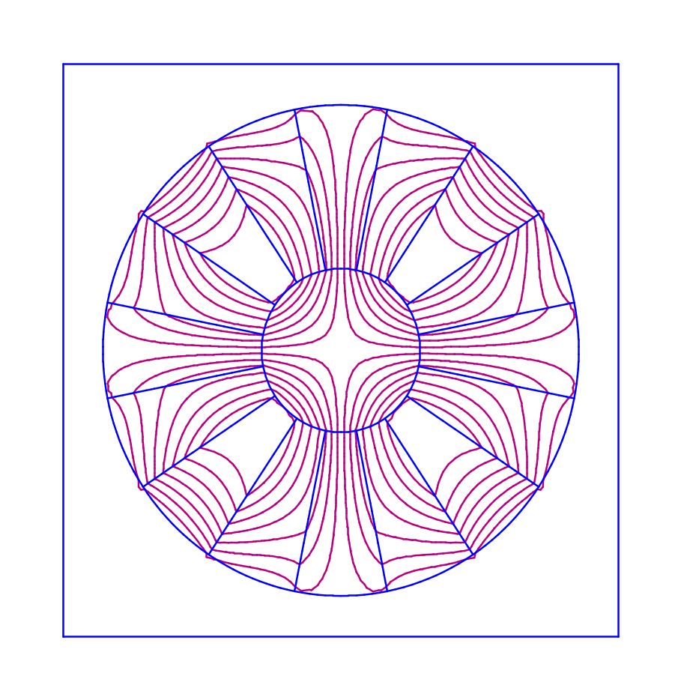
Figure XVII-25. Field contours for problem PMQUAD1.AM.
The MT namelist sections appear in Figure XVII-24d. All 16 regions of permanent magnet material have the same permeability as defined by the settings HCEPT and BCEPT. However, each region has a different direction of the easy axis. A HREF="sfphys1.doc#PermanentMagnetQuadWith16Wedges in the discussion of anisotropic magnetostatics shows the easy axis directions for this magnet. The first wedge centered along the positive X axis has the easy axis direction ϕ_{E} = 0 degrees, i.e. pointing to the right. Moving around the circle in the counterclockwise direction, the angle ϕ_{E} increases in steps of 67.5 degrees at each wedge.

Permanent-magnet quadrupole with variable easy axis direction
Pandira includes an option that allows the easy axis direction to be a function of angle around the center of a circle. Although there is no natural material for which the direction of the easy axis is a function of position in the plane, as seen in the previous example, wedge-shaped slabs of permanent magnet material can be assembled to approximate this behavior. Figure XVII-26 shows the Automesh input file PMQUAD2.AM, which makes use of this variable direction for the easy axis. The HREF="sfcodes.doc#VariableEasyAxisDirection near the bottom of the file specifies PHIA = 180 degrees and MULTA = 3. The easy axis direction varies with position and is given by
,
where ϕ_{A} is the entry for PHIA, θ is the polar angle to the centroid of a mesh triangle with respect to the offset origin (X_{A}, Y_{A}), and m is the multiplier MULTA.
Permanent-Magnet Quadrupole (for Pandira)
Full geometry using the variable easy axis option

&reg kprob=0, ; Poisson or Pandira problem
mode=0, ; Some materials have variable permeability
dx=0.11, ; Mesh interval
nbslo=0, ; Dirichlet boundary condition on lower edge
nbsup=0, ; Dirichlet boundary condition on upper edge
nbslf=0, ; Dirichlet boundary condition on left edge
nbsrt=0, ; Dirichlet boundary condition on right edge
ibound=0 & ; Dirichlet boundary conditions on entire outer circle

&po x=3.5,y=0 &
&po nt=2,r=3.5,theta=90 &
&po nt=2,r=3.5,theta=180 &
&po nt=2,r=3.5,theta=270 &
&po nt=2,r=3.5,theta=360 &

&reg mat=3,mshape=1,mtid=1 &
&po x=3,y=0 &
&po nt=2,r=3,theta=90 &
&po nt=2,r=3,theta=180 &
&po nt=2,r=3,theta=270 &
&po nt=2,r=3,theta=360 &

&reg mat=1 &
&po x=1.0,y=0 &
&po nt=2,r=1.0,theta=90 &
&po nt=2,r=1.0,theta=180 &
&po nt=2,r=1.0,theta=270 &
&po nt=2,r=1.0,theta=360 &

&mt mtid=1,x0a=0,y0a=0,phia=180,multa=3, ; Material ID, variable easy axis parameters
gamper=1,hcept=-10800,bcept=11600. & ; Gamma along hard axis, H and B intercepts
Figure XVII-26. The Automesh input file PMQUAD2.AM.

Figure XVII-27 plots the field lines for the solution computed by Pandira. Comparing this figure with Figure XVII-25 shows that both type of geometry results in a quadrupole field pattern inside the inner circle. While the idealized option of variable easy axis direction in Pandira is useful for visualization, we recommend setting up the actual geometry for design work. The option in Pandira was probably added to an early version of the code because the code at the time did not allow enough material types to solve the real problem.
As mentioned in the previous section on permanent magnet dipole geometries, the only significant differences between file PMQUAD2.AM and the input file PMDVAR.AM are in the MT namelist defining the easy axis direction. Changing MULTA from 3 to 2 changes the field from quadrupole to dipole.

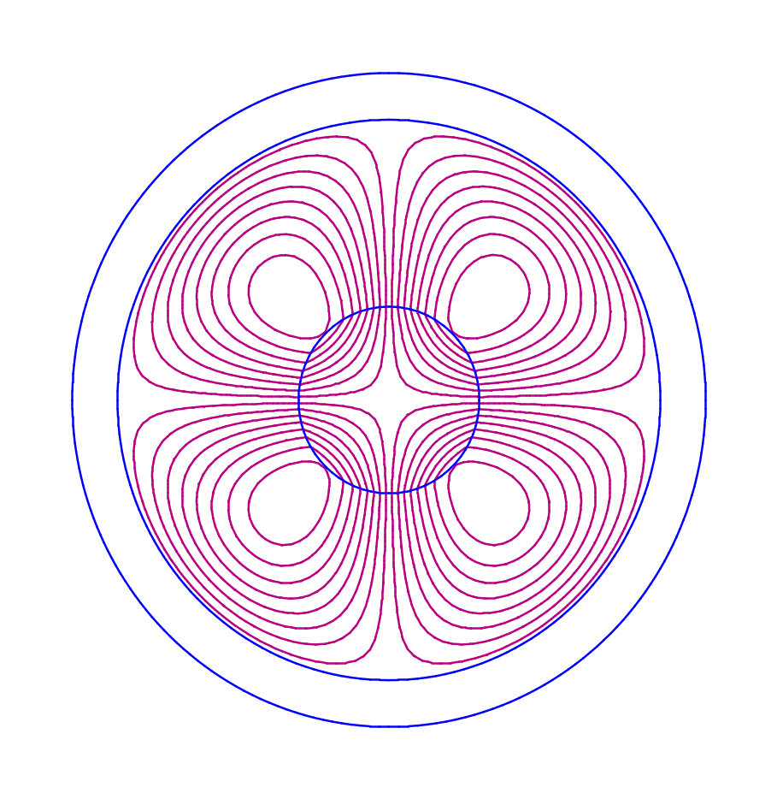
Figure XVII-27 Field contours for the PMQUAD2.AM example.
The plot shows lines of constant vector potential A_{z}. This example uses a Dirichlet boundary condition around the outer circle of the geometry.

Quarter geometry permanent-magnet quadrupole
The input file PMQUAD3.AM is shown in Figure XVII-28, which appears in two parts. The first REG namelist section sets up boundary conditions and defines the X and Y limits. The PO namelist section for the first region draws a box around the upper right quadrant of the problem shown in Figure XVII-25. The other settings are similar to those in file PMQUAD1.AM for the full geometry. The remainder of the file in Figure XVII-28b defines 3 full wedges and 2 half wedges of permanent magnet material. Again, the full angular width of a wedge is 22.5 degrees.
Permanent-Magnet Quadrupole (for Pandira)
One quadrant of the geometry
3 full wedges and 2 half wedges of permanent magnet material

&reg kprob=0, ; Poisson or Pandira problem
mode=0, ; Some materials have variable permeability
dx=0.09, ; Mesh interval
nbslo=0, ; Dirichlet boundary condition on lower edge
nbsup=0, ; Dirichlet boundary condition on upper edge
nbslf=0, ; Dirichlet boundary condition on left edge
nbsrt=0 & ; Dirichlet boundary condition on right edge

&po x=0,y=0 &
&po x=4,y=0 &
&po x=4,y=4 &
&po x=0,y=4 &
&po x=0,y=0 &
Figure XVII-28a. Start of Automesh input file PMQUAD1.AM.
Though the magnet wedges are the same as those in the upper right quadrant of file PMQUAD1.AM, the maximum X and Y extent of the geometry in PMQUAD3.AM is a little larger and the mesh size of 0.09 cm is slightly smaller than the mesh size used in the full geometry.
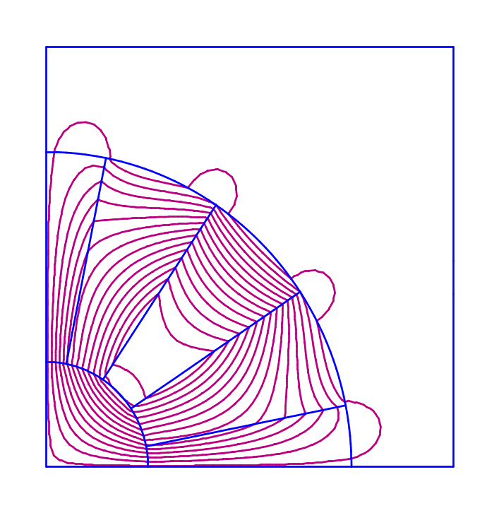
Figure XVII-29. Field contours for the PMQUAD3.AM example.
Dirichlet boundary conditions on the left and bottom edges are appropriate for this geometry. Compare to the field contours in Figure XVII-25 and Figure XVII-27.

&reg mat=2,mshape=1,mtid=1 &
&po x=1,y=0 &
&po x=3,y=0 &
&po nt=2,r=3,theta=11.25 &
&po r=1,theta=11.255 &
&po nt=2,r=1,theta=0, &

&reg mat=3,mshape=1,mtid=2 &
&po r=1,theta=11.25 &
&po r=3,theta=11.25 &
&po nt=2,r=3,theta=33.75 &
&po r=1,theta=33.75 &
&po nt=2,r=1,theta=11.25 &

&reg mat=4,mshape=1,mtid=3 &
&po r=1,theta=33.75 &
&po r=3,theta=33.75 &
&po nt=2,r=3,theta=56.25 &
&po r=1,theta=56.25 &
&po nt=2,r=1,theta=33.75 &

&reg mat=5,mshape=1,mtid=4 &
&po r=1,theta=56.25 &
&po r=3,theta=56.25 &
&po nt=2,r=3,theta=78.75 &
&po r=1,theta=78.75 &
&po nt=2,r=1,theta=56.25 &

&reg mat=6,mshape=1,mtid=5 &
&po r=1,theta=78.75 &
&po r=3,theta=78.75 &
&po nt=2,r=3,theta=90 &
&po r=1,theta=90 &
&po nt=2,r=1,theta=78.75 &

&mt mtid=1, aeasy=0.0,gamper=1 ; ID, Easy axis direction, Gamma along hard axis
hcept=-10800,bcept=11600. & ; H and B intercepts
&mt mtid=2,aeasy=67.5,gamper=1, hcept=-10800,bcept=11600. &
&mt mtid=3,aeasy=135,gamper=1,hcept=-10800,bcept=11600. &
&mt mtid=4,aeasy=202.5,gamper=1,hcept=-10800,bcept=11600. &
&mt mtid=5,aeasy=270,gamper=1,hcept=-10800,bcept=11600. &
Figure XVII-28. Continuation of Automesh input file PMQUAD3.AM.
Materials 2 and 6 are half wedges with one edge on a problem boundary. The MT namelist sections define the same properties of the first 5 materials with material ID numbers 1 through 5 in file PMQUAD1.AM. All materials have the same permeability, but the direction of the easy axis is different in each wedge of material.

The POAsample directory
Table XVII-3 lists files in the POAsample directory. Files POA1.AM and POA2.AM contains a simple dipole magnet, which we assume comes from a conformally mapped quadrupole magnet. Figure XVII-30 shows the mesh and solution computed by Poisson. This type of problem would generally have a more complicated pole-tip shape, but the purpose of this example is to show how to create file POA2.AM from mesh data computed by running Automesh first on POA1.AM.
Table XVII-9. Files in directory Magnetostatic\POAsample.
File | Description
POA1.AM | Automesh input for a magnetic dipole.
POA2.AM | Same as POA1.AM with A_{z} specified on arc points.
RUNPOA.BAT | Batch file for running the codes.
SHWPOA.BAT | Batch file for viewing the results.

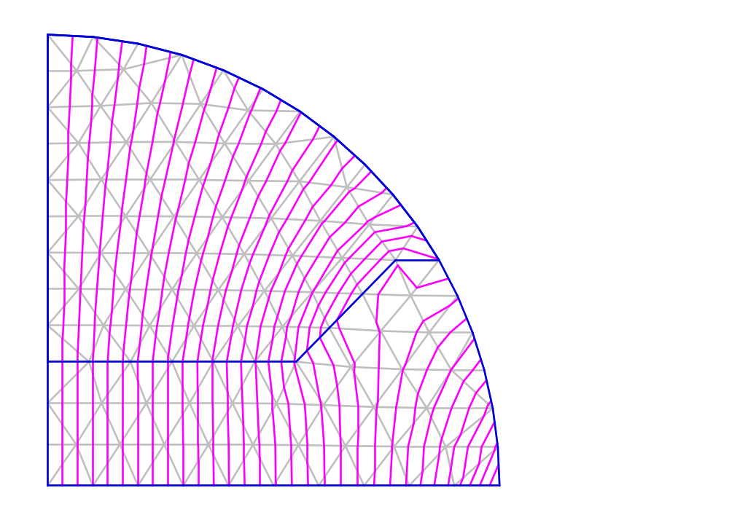
Figure XVII-30. Solution of dipole problem from file POA2.AM.
The upper region is part of the iron pole tip and the lower region is air. In this problem a POA namelist defines the vector potential A_{z} on all mesh points along the arc.

Region 1 mesh points
K L X Y
1 1 0.00000000 0.00000000
2 1 1.00000000 0.00000000
3 1 2.00000000 0.00000000
4 1 3.00000000 0.00000000
5 1 4.00000000 0.00000000
6 1 5.00000000 0.00000000
7 1 6.00000000 0.00000000
8 1 7.00000000 0.00000000
9 1 8.00000000 0.00000000
10 1 9.00000000 0.00000000
11 1 10.0000000 0.00000000
11 2 9.96292929 0.86025570
10 3 9.85165806 1.71605170
11 4 9.66601501 2.56284096
10 5 9.40574898 3.39586309
10 6 9.07057597 4.21006551
9 7 8.66025404 5.00000000
9 8 8.18617544 5.74339026
8 9 7.64034430 6.45175472
8 10 7.02346452 7.11835277
7 10 6.33694557 7.73583356
6 11 5.58325760 8.29621809
6 12 4.76622735 8.79107939
5 12 3.89144047 9.21176916
4 12 2.96654993 9.54984720
3 13 2.00142290 9.79766842
2 13 1.00801310 9.94906577
1 13 0.00000000 10.0000000
1 12 0.00000000 9.19444444
1 11 0.00000000 8.38888889
1 10 0.00000000 7.58333333
1 9 0.00000000 6.77777778
1 8 0.00000000 5.97222222
1 7 0.00000000 5.16666667
1 6 0.00000000 4.36111111
1 5 0.00000000 3.55555556
1 4 0.00000000 2.75000000
1 3 0.00000000 1.83333333
1 2 0.00000000 0.91666666
1 1 0.00000000 0.00000000
Figure XVII-31. Region 1 mesh-point list from file OUTAUT.TXT.
The points highlighted in bold text are all the points along the 90-degree arc for problem POA1.AM. We use these points to create POA namelist sections in file POA2.AM.
In order to define a potential value on every mesh point along a boundary segment, you need to run Automesh twice, once to get the necessary coordinates from file OUTAUT.TXT, and then a second time after setting up the POA namelist sections. Suppose we know the value of the vector potential A_{z} along an arc in the quadrupole problem. We would like to supply these values of A_{z} at the conformally mapped coordinates in the dipole problem. The number of intermediate points on the arc depends on the mesh intervals DX and DY in use in the region containing the line segment. This example uses a very coarse mesh just to illustrate the procedure. Figure XVII-31 is an excerpt from file OUTAUT.TXT after running Automesh on file POA1.AM. This table lists all the mesh points for region 1, the boundary that encloses the entire geometry for this problem. The points on the arc correspond to the lines highlighted in bold text. Figure XVII-32 shows the POA namelist sections created from the X and Y coordinates of the arc points. In a POA namelist they use variables XA and YA. For this illustration, we linearly interpolated values of A_{z} between 0 and 1000 and define these values using variable ASET in each POA namelist.

&poa xa=10.0000000,ya=0.00000000,aset=1000.000 &
&poa xa=9.96292929,ya=0.86025570,aset=941.1765 &
&poa xa=9.85165806,ya=1.71605170,aset=882.3529 &
&poa xa=9.66601501,ya=2.56284096,aset=823.5294 &
&poa xa=9.40574898,ya=3.39586309,aset=764.7059 &
&poa xa=9.07057597,ya=4.21006551,aset=705.8824 &
&poa xa=8.66025404,ya=5.00000000,aset=647.0588 &
&poa xa=8.18617544,ya=5.74339026,aset=588.2353 &
&poa xa=7.64034430,ya=6.45175472,aset=529.4118 &
&poa xa=7.02346452,ya=7.11835277,aset=470.5882 &
&poa xa=6.33694557,ya=7.73583356,aset=411.7647 &
&poa xa=5.58325760,ya=8.29621809,aset=352.9412 &
&poa xa=4.76622735,ya=8.79107939,aset=294.1176 &
&poa xa=3.89144047,ya=9.21176916,aset=235.2941 &
&poa xa=2.96654993,ya=9.54984720,aset=176.4706 &
&poa xa=2.00142290,ya=9.79766842,aset=117.6471 &
&poa xa=1.00801310,ya=9.94906577,aset=58.82350 &
&poa xa=0.00000000,ya=10.0000000,aset=0.000000 &
Figure XVII-32. POA namelist sections in file POA2.AM.
The values of XA and YA came from file OUTAUT.TXT shown in Figure XVII-32.

The Septum directory
Table XVII-10 lists files in the Septum directory for the septum magnet problem that first appeared in the 1987 User’s Guide, Chapter 10.9.
Table XVII-10. Files in directory Magnetostatic\Septum.
File | Description
SEPTUM.AM | Automesh input file for a permanent magnet septum.
RUNSEPTM.BAT | Batch file for running the codes.

In comparing the results of the harmonic analysis, note that the example uses the default 1010 steel permeability table. The example in the User’s Guide used the older table for decarburized iron. If you would like to compare numerical results to those in the 1987 manuals, set MTID = −1 in the REG namelist with MAT = 2 to use the older table. Values for the larger magnitude coefficients should be in reasonable agreement.

The Solenoids directory
Table XVII-11 lists files in the Solenoids directory for two solenoid-magnet problems. File SOLL1.AM is the permanent-magnet solenoid for Pandira from the Reference Manual, Section B.12.2. File SOLL2.AM is a solenoid magnet with an additional “bucking coil.” This separate coil has the current adjusted to cancel the magnetic field from the other coil near Z = 0 (which corresponds to Y = 0). SF7 creates a file SOLL201.TBL for Tablplot that shows the field component B_{z} on axis. To display it, type Tablplot SOLL201 after running the batch file.
Table XVII-11. Files in directory Magnetostatic\Solenoids.
File | Description
SOLL1.AM | Automesh input file for a permanent magnet solenoid.
SOLL2.AM | Automesh input file for a solenoid with bucking coil.
SOLL2.FCE | Force input file for the SOLL2 problem.
SOLL2.IN7 | SF7 input file for the SOLL2 problem.
RUNSOLL.BAT | Batch file for running the codes.
SHWSOLL.BAT | Batch file for viewing the results.

The Shielding directory
Table XVII-12 lists files in the Shielding subdirectory for the vector potential example from the 1987 User’s Guide, Chapter 10.7. Figure XVII-33 is a listing of the batch file, which uses Pandira to solve for the fields. Poisson also can solve the problem, but takes several times longer than Pandira. A plot of the solution appears in Figure XVII-34 and Figure XVII-35 lists the Automesh input file VECP.AM. The file is an example of a magnetic shielding problem that uses very thin sheets of permeable material.
Table XVII-12. Files in directory Magnetostatic\Shielding.
File | Description
VECP.AM | Automesh input file for the vector potential example.
RUNVECP.BAT | Batch file for running the codes.

START /W “ “ “%SFDIR%automesh” vecp
START /W “ “ “%SFDIR%pandira” vecp
if (%1)==(p) START /W “ “ “%SFDIR%WSFplot” vecp.t35 3
Figure XVII-33. The batch file RUNVECP.BAT

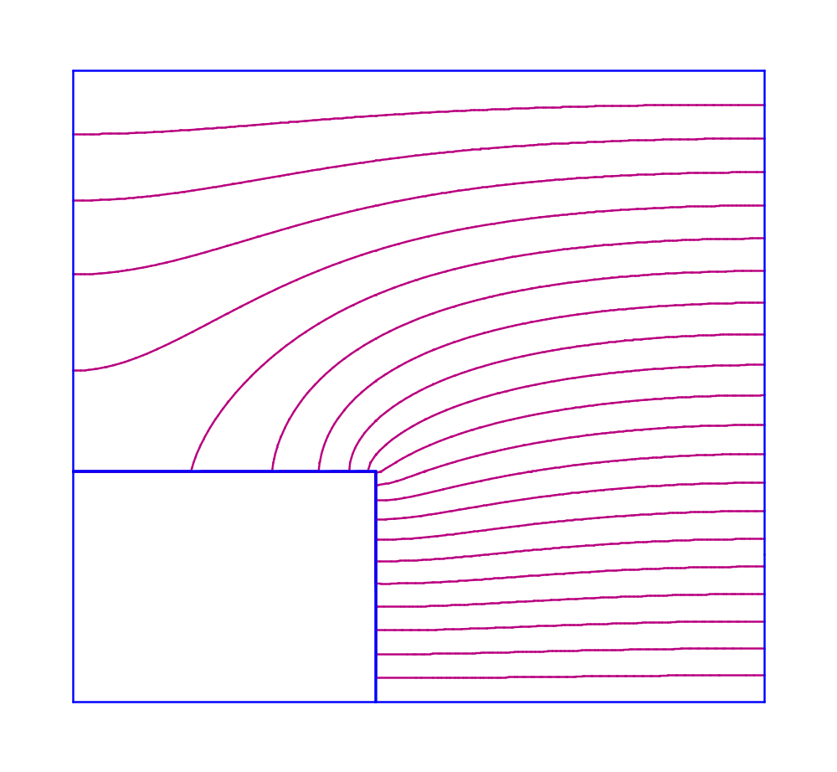
Figure XVII-34. Lines of constant A_{z} for the VECP.AM problem.
The very thin regions of permeable material shield nearly all of the magnetic field from the box at the lower left corner.
Vector potential problem
Magnetic shielding produced by thin, highly permeable sheet
Geometry has very large changes in triangle size near the metal.
[Originally appeared in 1987 User's Manual 10.7]

&reg kprob=0, ; Poisson or Pandira problem
mode=-1, ; Use fixed but finite permeability
fixgam=0.00005, ; Reluctivity (reciporocal permeability)
nbslo=0, ; Dirichlet boundary condition on lower edge
nbsup=0, ; Dirichlet boundary condition on upper edge
nbslf=1, ; Neumann boundary condition on left edge
nbsrt=1, ; Neumann boundary condition on right edge
; Define X (physical) and K (logical) line regions:
xreg1=175.2,kreg1=36,
xreg2=175.4,kreg2=40,
kmax=86 ; Logical coordinate for XMAX
; Define Y (physical) and L (logical) line regions:
yreg1=129.5,lreg1=26,
yreg2=129.7,lreg2=30,
lmax=76 & ; Logical coordinate for YMAX

&po x=0.0,y=0.0 & ; Rectangular box
&po x=400.4,y=0.0 &
&po x=400.4,y=354.7 &
&po x=0.0,y=354.7 &
&po x=0.0,y=0.0 &

&reg mat=2 & ; Thin permeable metal box
&po x=175.2,y=0.0 &
&po x=175.4,y=0.0 &
&po x=175.4,y=129.7 &
&po x=0.0,y=129.7 &
&po x=0.0,y=129.5 &
&po x=175.2,y=129.5 &
&po x=175.2,y=0.0 &

&reg mat=1,cur=10.0,ibound=-1 & ; Current sheet along lower edge
&po x=0.0,y=0.0 &
&po x=400.4,y=0.0 &

&reg mat=1,cur=188.0,ibound=-1 & ; Current sheet along upper edge
&po x=0.0,y=354.7 &
&po x=400.4,y=354.7 &
Figure XVII-35. Automesh input file VECP.AM.
Older versions of Automesh could not mesh this problem because of the very thin metal regions. The present version has no difficulty with it. There is another serious problem with the older Automesh that would occur for this problem if it could mesh the thin metal regions. The vector potential example has two “special fixed-potential boundaries” specified by a value of −1 for IBOUND. The XREG1 and XREG2 line regions intersect these fixed-potential boundaries. Ordinarily, Automesh would place all the line regions after the PO namelist regions, so later, when generating the mesh, the code would write zeros over the previously defined fixed potential values. The present code avoids an error by reordering the regions so that all regions starting with the first fixed-potential region appear in the Automesh temporary file TAPE36 after the line regions. The old LATTICE input file in the User’s Guide correctly placed the regions with IBOUND = −1 at the end of the file.
Figure XVII-36 shows two expanded displays of the mesh in the vicinity of the corner of the box at the lower left of Figure XVII-34. There are four rows and columns of mesh triangles between the line regions defined in the VECP.AM input file. The change is the mesh interval is very large. Such large changes are not recommended for accurate field interpolation, but it can help get an approximate solution quickly without the need for an enormous solution array.

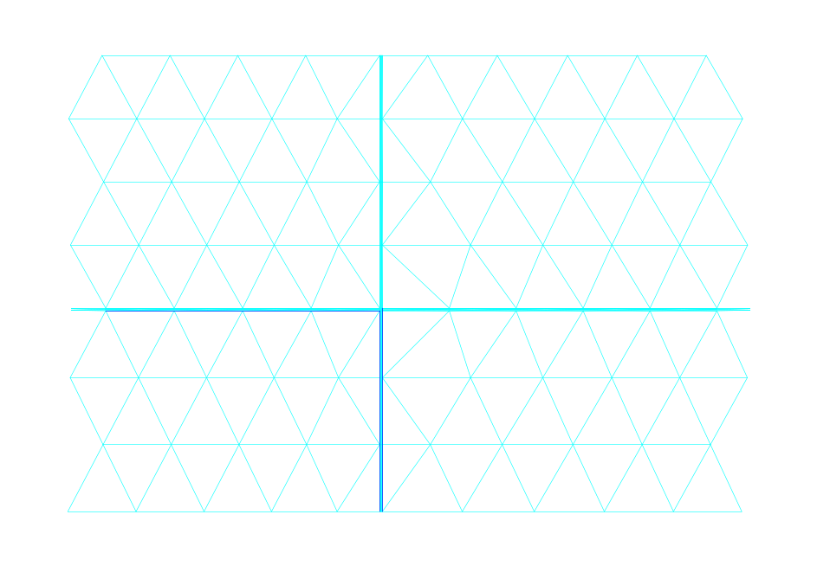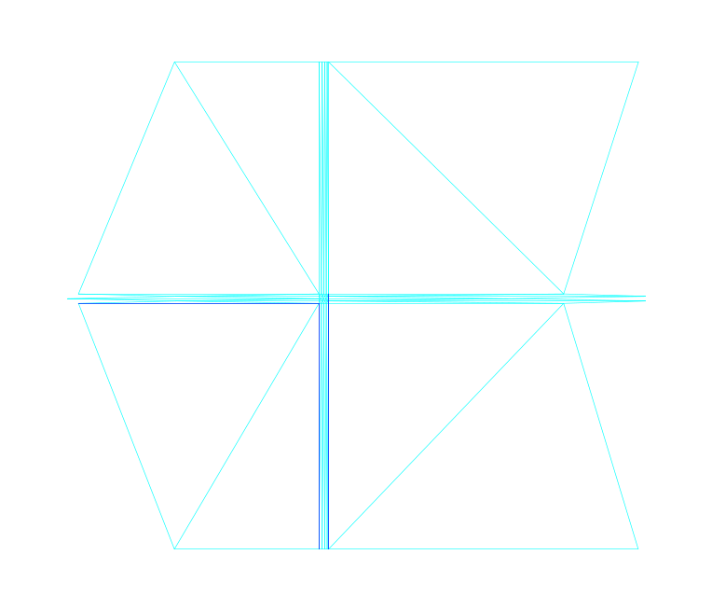
Figure XVII-36. Two expanded displays of the VECP mesh.
These two displays show details of the mesh near the corner of the box at the lower left part of the VECP.AM problem geometry.

The StoredEnergy directory
Table XVII-13 lists files in the StoredEnergy directory. These files contain magnetostatic Poisson and Pandira problems for which you can calculate the stored energy analytically. The default is not to compute the stored energy. This feature can be controlled with the ComputeStoredEnergy parameter in the [Poisson] and [Pandira] sections of SF.INI. The input files in this directory use IENERGY = 1 to override the SF.INI setting.
Table XVII-13. Files in directory Magnetostatic\StoredEnergy.
File | Description
MSE1.AM | Automesh input for magnetic stored energy in a coaxial line (XY geometry).
MSE2.AM | Automesh input for an ideal solenoid (RZ geometry).
MSE3.AM | Automesh input for a solenoid surrounded by highly permeable metal.
RUN_MSE.BAT | Batch file for running the codes.
SHW_MSE.BAT | Batch file for viewing the results.

The batch file uses Pandira to solve the problems, but you can also use Poisson. To get the same accuracy as Pandira, the convergence tests in Poisson should probably use a smaller value for EPSILA.

Electrostatic Examples (Poisson, Pandira)
The Examples\Electrostatic subdirectory include the files in Table XVII-1 plus several subdirectories containing electrostatic problems for Poisson or Pandira. Your installation may include HREF="sfintro.doc#ExamplesDirectory subdirectories under Examples for other types of problems. Batch file Run_ES.BAT runs all the examples. If you want to see the field plots as Run_ES finishes with each problem, type “Run_ES p”. Use a lower-case letter p. Otherwise, just type Run_ES. The batch file Show_ES.BAT runs WSFplot in each directory to display data from each solution. Run_ES.BAT must finish before you run Show_ES.BAT. After you have finished inspecting the results of the Run_ES run, you can run Clr_ES.BAT to delete all the files made by Run_ES.BAT.
Table XVIII-1. Files in directory Examples\Electrostatic.
Files | Description
Run_ES.BAT | Batch file that runs all examples in other directories.
Show_ES.BAT | Batch file that displays results of all runs.
Clr_ES.BAT | Batch file that deletes all files made by Run_ES.BAT.

Each subdirectory under Examples\Electrostatic includes one or two batch control files. Files named RUNxxx.BAT runs the appropriate codes for all the example files in the subdirectory. Files named SHWxxx.BAT run WSFplot on each HREF="sffiles.doc#BinarySolutionFile to display the results. Subdirectories that have only one problem file do not contain a SHWxxx.BAT file. The batch files make use of the default settings in the SF.INI file shipped with this distribution. Binary solution files have extension T35. The batch files will not run WSFplot unless you call the batch process with a lower-case letter p on the run line. The codes create the binary solution file and the OUTxxx.TXT file appropriate to each code. In directories with multiple input files, the batch file copies some output files to other files. When the run finishes, you can inspect all the OUTxxx.TXT files. Files named OUTxxx1.TXT correspond to the first calculation in a directory, OUTxxx2.TXT to the second, and so forth. . In some cases, the procedure deletes the last OUTxxx.TXT files. In other cases, files OUTxxx.TXT (without a number appended) corresponds to the most recent calculation.

The ChargeDensity directory
Table XVIII-2 lists files in the ChargeDensity directory for several variants of a Poisson electrostatic problem. The problems also can be solved with Pandira. File C1Q.AM models one quadrant of a circular pipe containing a uniform charge density in a region on axis of radius 0.5 cm. The charge density DEN = 4 nC/cm³, which corresponds to a line charge of 0.7854 nC/cm for the 1-quadrant geometry or 3.1416 nC/cm for the full 4-quadrant geometry. The problem uses Neumann boundary conditions at the symmetry planes on the lower and left edges, and Dirichlet boundary conditions along the top and right edges and on the circular boundary of the pipe. File C1Qc.AM is the same as C1Q.AM except that the charge region uses the CHARGE variable to specify a line charge of 0.7854 nC/cm instead of the charge density. This charge refers to the area of the 90-degree circular sector in the 1-quadrant geometry.
File C1Qmm.AM is the same geometry, but uses millimeters instead of centimeters for linear dimensions. In this problem, the charge density becomes 400 nC/cm³ in order to produce the same equivalent line charge used in C1Q.AM.
File C4Q.AM is the 4-quadrant version of C1Q.AM. The charge density entry remains 4 nC/cm³, which for the full 4-quadrant geometry corresponds to a line charge of 3.1416 nC/cm. This problem uses Dirichlet boundary conditions on all 4 edges of the problem geometry and along the circular boundary of the pipe. File C4Qtri.AM is the same as C4Q.AM except that all charge the is in one mesh triangle centered on the origin. In this case, DEN = 4.534 μC/cm³, which is larger than 4 nC/cm³ by the ratio of the area of the charge regions (0.7854 cm² for the circle, and 6.9282 10⁻⁴ cm² for the triangle). File C4Qpnt.AM is the same as C4Q.AM except that the line charge of 3.1416 nC/cm appears as a point region at the origin.
Table XVIII-2. Files in directory Electrostatic\ChargeDensity.
File | Description
C1Q.AM | Automesh input file for 1-quadrant space-charge problem.
C1Qc.AM | Same as C1Q.AM with total charge instead of charge density.
C1Qmm.AM | Same as C1Q.AM using units of mm.
C4Q.AM | 4-quadrant version of C1Q.AM.
C4Qtri.AM | Same as C4Q.AM with all charge in one central mesh triangle.
C4Qpnt.AM | Same as C4Q.AM with all charge in a central point region.
C1Qmm.IN7 | SF7 input file for the C1Qmm.AM problem.
IN7 | SF7 input file for all problems except C1Qmm.AM.
Run_CHG.BAT | Batch file for running the codes.

The batch file Run_CHG.bat solves these problems in the order show in Table XVIII-2 and runs postprocessor SF7 to interpolate the fields along a short radial line segment. Figure XVIII-1 shows the Poisson solution for the first problem C1Q.AM and Figure XVIII-2 shows the interpolated fields. For all the problems, the field plot looks like Figure XVIII-2. You can solve the line-charge problem analytically for comparison with the code results.

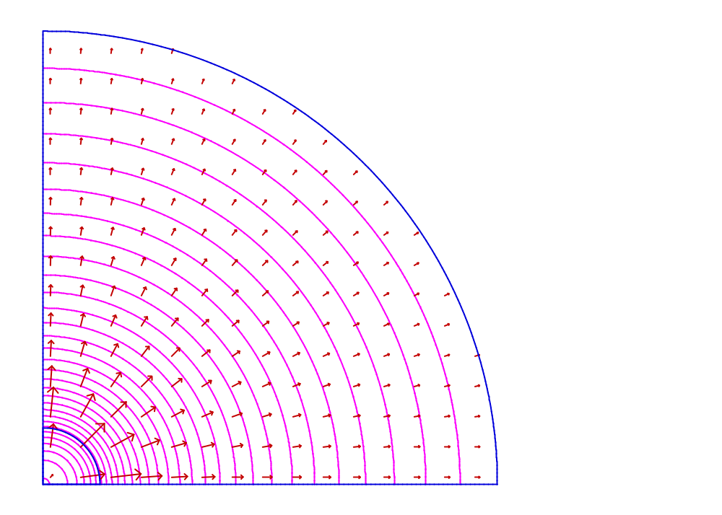
Figure XVIII-1. WSFplot display for problem C1Q.AM.
Equipotentials are 200 V apart. Arrow lengths are proportional to electric field strength.
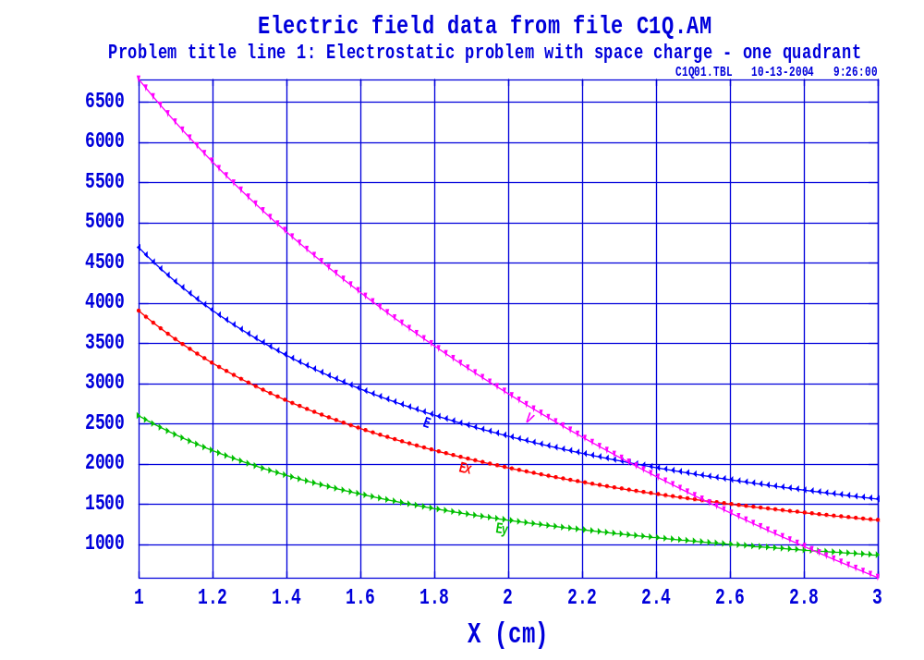
Figure XVIII-2. Interpolated fields for problem C1Q.AM.
SF7 interpolated 101 points from (x,y) = (1.0,0.66667) to (3.0,2.0). Units of V are Volts, and units of E, E_{x} and E_{y} are Volts/cm.

The CoaxCapacitor directory
Table XVIII-3 lists files in the CoaxCapacitor directory for several Poisson electrostatic problems. These problems also can be solved with Pandira. Files CAPRZ.AM and CAPXY.AM both model a coaxial capacitor for which you can easily obtain an analytic solution. File CAPRZ.AM uses cylindrical coordinates with the axis of symmetry to the left of the problem geometry; CAPXY.AM solves the same problem using rectangular coordinates viewing the coax end on.
Table XVIII-3. Files in directory Electrostatic\CoaxCapacitor.
File | Description
CAPRZ.AM | Automesh input file for a coaxial capacitor in cylindrical coordinates.
CAPXY.AM | Automesh input file for a coaxial capacitor in rectangular coordinates.
RUNCap.BAT | Batch file for running the codes.
SHWCap.BAT | Batch file for viewing the results.

The CoaxCylinder directory
Table XVIII-4 lists files in the CoaxCylinder directory. This simple coaxial cylinder problem first appeared in the 1987 Reference Manual, Section B.12.2. The example uses Poisson to solve for the electrostatic field in a coaxial cylinder.
Table XVIII-4. Files in directory Electrostatic\CoaxCylinder.
File | Description
COAXTEST.AM | Automesh input file for a coaxial cylinder.
RUNCOAX.BAT | Batch file for running the codes.

The Dielectrics directory
Table XVIII-5 lists files in the Dielectrics subdirectory. Files 1EPSILON and 2EPSILON show two methods for entering permittivity data for electrostatic problems. For a single dielectric material, file 1EPSILON.AM specifies FIXGAM=9 for the relative permittivity. For more than one material, 2EPSILON.AM uses two MT namelist sections to define the material data.
Table XVIII-5. Files in directory Electrostatic\Dielectrics.
File | Description
1EPSILON.AM | Automesh input file for one dielectric region.
2EPSILON.AM | Automesh input file for two dielectric regions.
RUNEPS.BAT | Batch file for running the codes.
SHWEPS.BAT | Batch file for viewing the results.

The IonSource directory
Table XVIII-6 lists files in the IonSource directory for a sputter-type ion source. This source, which produced metal negative ions, was developed by Hugh T. Richards and his students at the University of Wisconsin in the early 1980s. The solution, of course, does not include the effects of the cesium and negative-ion beams that are present during operation. This example shows how to use SFO to get the fields along boundary segments of a Poisson or Pandira problem. Regions 3 through 7 are circular rings that represent a turns of a tungsten filament. File OUTAUT.TXT lists the boundary segment numbers for each region (after line regions have been added by Automesh). File SPSOURCE.SEG includes segments numbers for region 3: 36, 37, 38, and 39.
Table XVIII-6. Files in directory Electrostatic\IonSource.
File | Description
SPSOURCE.AM | Automesh input file for a sputter-type ion source.
SPSOURCE.SEG | SFO input file for SPSOURCE.
RUNSPS.BAT | Batch file for running the codes.

The Plates directory
Table XVIII-7 lists files in the Plates subdirectory. The PLATE.AM file first appeared in the 1987 User’s Guide, Chapter 10.8. It uses Poisson to solve for the electrostatic field between two parallel plates at fixed potential inside of an infinite pipe.
Table XVIII-7. Files in directory Electrostatic\Plates.
File | Description
PLATE.AM | Automesh input file for electrostatic plates
PLATE.IN7 | SF7 input file
RUNPLATE.BAT | Batch file for running the codes

The QuadLens directory
Table XVIII-8 lists files in the QuadLens directory for electrostatic quadrupole lens problems. These problems also can be solved with Pandira. File ESQUAD.AM calculates fields for an electrostatic quadrupole lens mounted inside a grounded circular pipe. The poles have a radius of 1.15 cm and the radial aperture is 1.0 cm. SFO reports the fields on all surfaces in the problem. File ESQUAD8.AM is another input file that makes use of the symmetry in the electrostatic quadrupole problem and solves for the fields in just one eighth of the original geometry. Even with half the mesh size, ESQUAD8.AM uses only 71% the number of mesh points as ESQUAD.AM.
Table XVIII-8. Files in directory Electrostatic\QuadLens.
File | Description
ESQUAD.AM | Automesh input file for an electrostatic quadrupole lens.
ESQUAD8.AM | Automesh input for 1/8th of the electrostatic quadrupole.
ESQUAD8.SEG | SFO input file for ESQUAD8.
RUNESQ.BAT | Batch file for running the codes.
SHWESQ.BAT | Batch file for viewing the results.

The StoredEnergy directory
Table XVIII-9 lists files in the StoredEnergy directory. These files contain electrostatic Poisson and Pandira problems for which you can calculate the stored energy analytically. The default is not to compute the stored energy. This feature can be controlled with the ComputeStoredEnergy parameter in the [Poisson] and [Pandira] sections of SF.INI. The input files in this directory use IENERGY = 1 to override the SF.INI setting.
Table XVIII-9. Files in directory Electrostatic\StoredEnergy.
File | Description
ESE1.AM | Automesh input for parallel plate capacitor (XY geometry).
ESE2.AM | Automesh input for parallel plate capacitor (RZ geometry).
RUN_ESE.BAT | Batch file for running the codes.
SHW_ESE.BAT | Batch file for viewing the results.

The batch file uses Pandira to solve the problems, but you can also use Poisson. To get the same accuracy as Pandira, the convergence tests in Poisson should probably use a smaller value for EPSILA.

