File SFEXMPL3.DOC contains the following bookmarks. Select the topic you are trying to find from the list and double click the highlighted text.
Examples in other files
HREF="sfexmpl1.doc
HREF="sfexmpl2.doc

Examples\CavityTuning directories discussed in this file

Topics

File SFEXMPL3.DOC Table of Contents
XIX. Tuning Program Examples
A. The CCL directory
1. A conventional CCL cell
2. Special shape option for the cavity wall
B. The CCDTL directory
1. Full-cavity 1-drift-tube example
2. Half-cavity 2-drift-tube cavity
C. The DTL directory
1. Using different tuning surfaces
2. Computing the fields for a specific design without tuning
D. The EllipticalCavity directory
1. Symmetric half cell
2. Full cell at the end of a multicell cavity
3. ELLCAV, generation of the multicell cavity
4. SegField, displaying fields along the cell boundary
E. The MulticellDTL directory
F. The RFQ directory
1. Several tuning options for RFQ cavities
2. LANSCE RFQ design examples
G. The SideCouplingCell directory

Tuning Program Examples
This section describes a few example control files for the HREF="sfcodes2.doc#TuningCodes CCLfish, CDTfish, DTLfish, ELLfish, MDTfish, RFQfish, and SCCfish. Your installation will include HREF="sfintro.doc#ExamplesDirectory subdirectories under Examples for other types of problems. Some of the control-file keywords used in these are HREF="sfcodes2.doc#ControlFileCommonKeywords in all the tuning programs. Documentation for the tuning programs also discusses HREF="sfcodes2.doc#ControlFileKeywordsForEachCode for each program. For each type of cavity, one figure shows the control file, and another figure shows WSFplot displays generated from one or more of the final problem files. Each subdirectory under Examples\CavityTuning includes a batch file that runs the tuning code on one or more control files. The name of the file starts with the characters “Run_” (e.g., Run_CCL.BAT). Except for the MulticellDTL directory, which contains only one problem geometry, the directories also contain batch files that start with the characters “Shw_”(e.g., Shw_CCL.BAT) for displaying the results.

The CCL directory
Table XIX-1 lists files in the CavityTuning\CCL directory for the program CCLfish. The main use of CCLfish is to tune coupled-cavity linac (CCL) cells, but it also can tune other cavity types. The two problems in file 805CCL.CCL instruct CCLfish to tune a CCL cell by adjusting the tank diameter and the gap. File 425EW.CCL demonstrates using the special end-wall shape option in CCLfish.
Table XIX-1. Files in directory CavityTuning\CCL.
File | Description
805CCL.CCL | CCLfish input file for tuning 805-MHz CCL cavities.
425EW | CCLfish input file using special end-wall shape option.
Run_CCL.BAT | Batch file for running the codes.
Shw_CCL.BAT | Batch file for viewing the results.

A conventional CCL cell
Figure XIX-1 shows a CCLfish control file that tunes two 805-MHz CCL cells. The first problem tunes a cell by varying the tank diameter. The second problem uses the diameter calculated in the first problem and switches to a gap specified in terms of βλ rather than physical length in cm. (This gap is only slightly different from the original value set by the GAP_Length keyword.) The second problem varies the gap length. The keyword PREVIOUS on the DIAMeter line for the second problem indicates that the code should use the calculated value of the diameter from the first problem. Figure XIX-2 shows the WSFplot displays of the mesh and contour lines for the second problem in file 805CCL.CCL.
; CCLfish control file 805CCL.CCL

TITLE
Sample problems for tuning coupled-cavity linac cells.
Resonant frequency = 805 MHz, Bore radius = 2.25 cm
ENDTitle

PLOTTING OFF
PARTICLE H+

FILEname_prefix 805CCL
SEQuence_number 1
PI_MODE
FREQuency 805
LENGTH 8.1
DIAMeter 28.365
GAP_Length 3.957
E0_Normalization 1.5
OUTER_CORNer_radius 3
INNER_CORNer_radius 0.5
INNER_NOSE_radius 0.085
OUTER_NOSE_radius 0.25
FLAT_length 0
CONE_angle 20
SEPTUM_thickness 1.524
BORE_radius 2.25
PHASE_length 90
DELTA_frequency 0.02
MESH_size 0.044
INCrement 2
START 2

DIAMeter PREVIOUS
G_OVER_Beta_lambda 0.24
E0_Normalization 1.5
START 4

ENDFILE
Figure XIX-1. CCLfish control file 805CCL.CCL.
This file sets up the geometry for conventional coupled-cavity linac cells. The PREVIOUS keyword on the DIAMeter line means that the second problem uses the diameter calculated by tuning the first cavity.

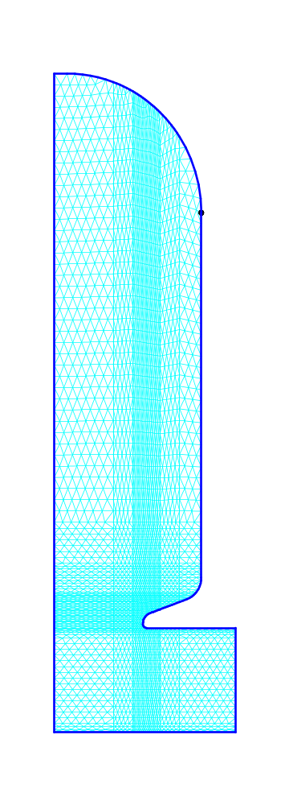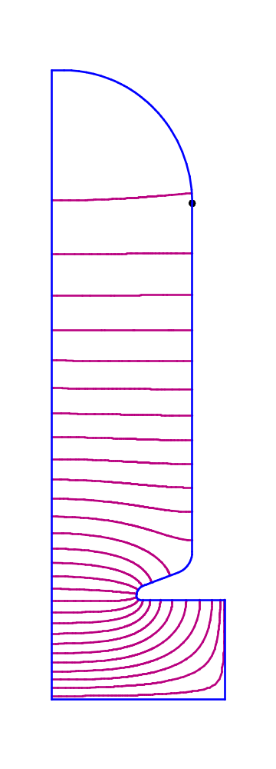
Figure XIX-2. Mesh and field contours for input file 805CCL2.AM.
For this standard CCL cavity, the left WSFplot display shows the mesh generated by Automesh and the right side shows contours of constant Hφ from the solution computed by Fish.
; CCLfish control file 425EW.CCL

TITLE
Sample problem using special shape option for a CCL cell
Resonant frequency = 425 MHz, Bore radius = 0.8 cm
ENDTitle

PLOTTING Off
PARTICLE H+

FILEname_prefix 425EW
SEQuence_number 1
PI_MODE
FREQuency 425
LENGTH 15.4
DIAMeter 47.8
GAP_Length 4.1
E0_Normalization 1.5
E0T_Normalization 0
ENDWALL_Radius 20.263
ENDWALL_Center 13.2
OUTER_NOSE_radius 1.25
INNER_NOSE_radius 0.4
FLAT_length 0.635
CONE_angle 50
SEPTUM_thickness 1
BORE_radius 0.8
PHASE_length 90
DELTA_frequency 0.01
MESH_size 0.08
INCrement 2
START 4

ENDFILE
Figure XIX-3. CCLfish control file 425 EW.CCL.
This cavity uses the special shape option for the end-wall radius of curvature.

Special shape option for the cavity wall
Figure XIX-3 shows sample control file 425EW.CCL, which contains a single problem. This cavity, shown in Figure XIX-4, uses the special shape option for the end-wall radius of curvature. The code tunes the cavity by adjusting the gap. Such a cavity might be used for a buncher in a beam-transport line.
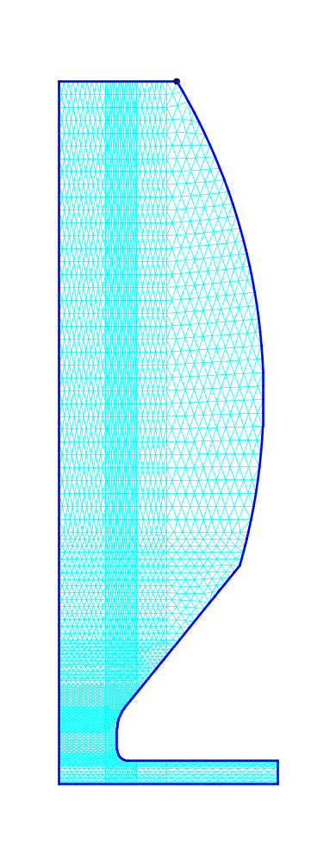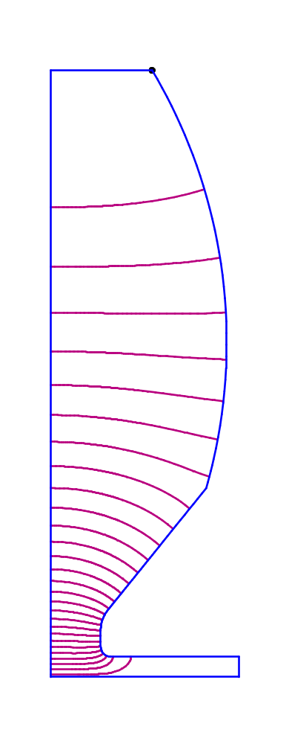
Figure XIX-4 Mesh and field contours for input file 425EW1.AM.
The left WSFplot display shows the mesh generated by Automesh and the right side shows contours of constant Hφ form the solution computed by Fish. This type cavity might be used in an application where a magnet or other beam-line element fits into the enlarged nose.

The CCDTL directory
Table XIX-2 lists files in the CCDTL directory for the program CDTfish. CDTfish runs Superfish repetitively, varying the cell geometry to tune each cell to a specified frequency. The mesh size and cavity shapes used in these examples were modified to speed up the calculation. The results do not represent an optimized design.
Table XIX-2. Files in directory CavityTuning\CCDTL.
File | Description
1DTFC.CDT | CDTfish input file for tuning a 1-drift-tube CCDTL cavity.
2DTHC.CDT | CDTfish input file for tuning a 2-drift-tube CCDTL cavity.
Run_CDT.BAT | Batch file for running the codes.
Shw_CDT.BAT | Batch file for viewing the results.

Full-cavity 1-drift-tube example
The control file 1DTFC.CDT, shown in Figure XIX-5, sets up a full-cavity calculation for a coupled-cavity drift-tube linac (CCDTL). The cavity contains a single drift tube and two gaps. Figure XIX-6 shows the mesh and field contours. Program CDTfish tunes this cavity by adjusting the cavity diameter. In this example, the cavity length and gap lengths are defined in terms of the particle velocity β. The 3-cm bore tube appended to the right-hand side models a structure consisting of pairs of 2-gap cavities back to back. Cavity pairs are separated by a drift space for focusing magnets and diagnostic elements. This geometry also is appropriate to model the end cavity of a longer chain of 2-gap cavities. To model an interior cavity in a chain of cavities, set both bore-tube parameters to zero and switch to a half-cavity problem. A HREF="sfintro.doc#DirichletBoundary on the left edge of the problem geometry is appropriate when the electric-field direction in the adjacent cavity is in the opposite direction. Because neither a Dirichlet nor a Neumann boundary condition is appropriate for the open bore tube at the right edge, the bore-tube extension must be long enough so that the fields have attenuated to negligible values at the right edge.

Half-cavity 2-drift-tube cavity
The control file 2DTHC.CDT, shown in Figure XIX-7 sets up a half-cavity calculation for a CCDTL. The cavity contains two drift tubes and three gaps, but the problem geometry models only one and a half gaps. Figure XIX-8 shows the mesh and field contours. As in the full-cavity example above, the code tunes the cavity by adjusting the cavity diameter, and the cavity length and gap lengths are defined in terms of the particle velocity β. This problem uses different inner and outer face angles on the drift tubes in order to reduce the difference in voltage gain between the middle cell and the other two cells. The 2-cm bore tube appended to the right-hand side models a single 3-gap cavity. To model the end cavity of a chain of cavities correctly would require a full-cell calculation.
; CDTfish control file 1DTFC.CDT

TITLE
Example 1-drift-tube CCDTL cavity
700-MHz full cell with 3-cm-long bore tube on right side
ENDTitle

PLOTTING OFF
PARTICLE H+
TEMPerature 25

FULL_cavity
FILEname_prefix 1DTFC
SEQuence_number 1
FREQuency 700
BETA 0.29
DIAMeter 27.4
G_OVER_Beta_lambda 0.24
EQUATOR_flat 5
E0T_Normalization 1.5
NUMBER_of_gaps 2
INNER_CORNer_radius 0.25
OUTER_nose_radius 0.4
INNER_nose_radius 0.2
FLAT_length 0
CONE_angle 30
SEPTUM_thickness 1
BORE_radius 1.5
LEFT_BEAM_TUBE 0
RIGHT_BEAM_TUBE 3
DT_DIAMeter 7.4
DT_CORNer_radius 0.25
DT_OUTER_NOSE_radius 0.4
DT_INNER_NOSE_radius 0.2
DT_FLAT_length 0
DT_STEM_Diameter 1.1
DT_STEM_Count 2
DT_FACE_angle 45
DELTA_frequency 0.05
MESH_size 0.065
INCrement 2
START 2

ENDFILE
Figure XIX-5. CDTfish control file 1DTFC.CDT.

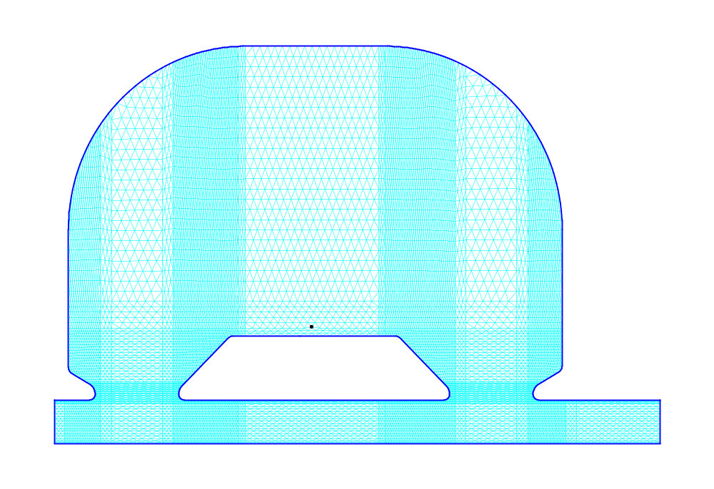
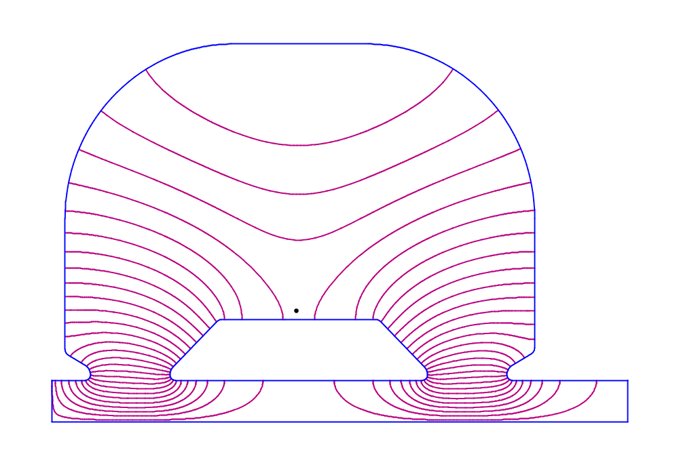
Figure XIX-6. Mesh and field contours for a 1-drift-tube CCDTL cavity.
These WSFplot displays show a full symmetric CCDTL cavity containing one drift tube. The bore-tube extension on the right side is the appropriate geometry for a structure in which pairs of adjacent cavities are separated by a drift space for a focusing magnet and diagnostics. The field direction is the same in the two gaps of this cavity, but the adjacent cavity has field in the opposite direction.
;CDTfish control file 2DTHC.CDT

TITLE
Example 2-drift-tube CCDTL cavity
700-MHz half cell with 2-cm-long bore tube
Tuned by adjusting the cavity diameter
Unequal face angles on drift tubes
ENDTitle

PLOTTING OFF
PARTICLE H+
TEMPerature 25

HALF_cavity
FILEname_prefix 2DTHC
SEQuence_number 1
FREQuency 700
BETA 0.14
DIAMeter 28.9
G_OVER_Beta_lambda 0.15
E0T_Normalization 2
NUMBER_of_gaps 3
EQUATOR_flat 4
INNER_CORNer_radius 0.25
OUTER_NOSE_radius 0.4
INNER_NOSE_radius 0.2
FLAT_length 0
CONE_angle 30
SEPTUM_thickness 1
BORE_radius 1
LEFT_BEAM_tube 0
RIGHT_BEAM_tube 2
DT_DIAMeter 5
DT_CORNer_radius 0.25
DT_OUTER_NOSE_radius 0.4
DT_INNER_NOSE_radius 0.2
DT_FLAT_length 0
DT_STEM_Diameter 1.1
DT_STEM_Count 2
DT_OUTER_FACE_angle 60
DT_INNER_FACE_angle 20
DELTA_frequency 0.05
MESH_size 0.065
INCrement 2
START 2

ENDFILE
Figure XIX-7. CDTfish control file 2DTHC.CDT.

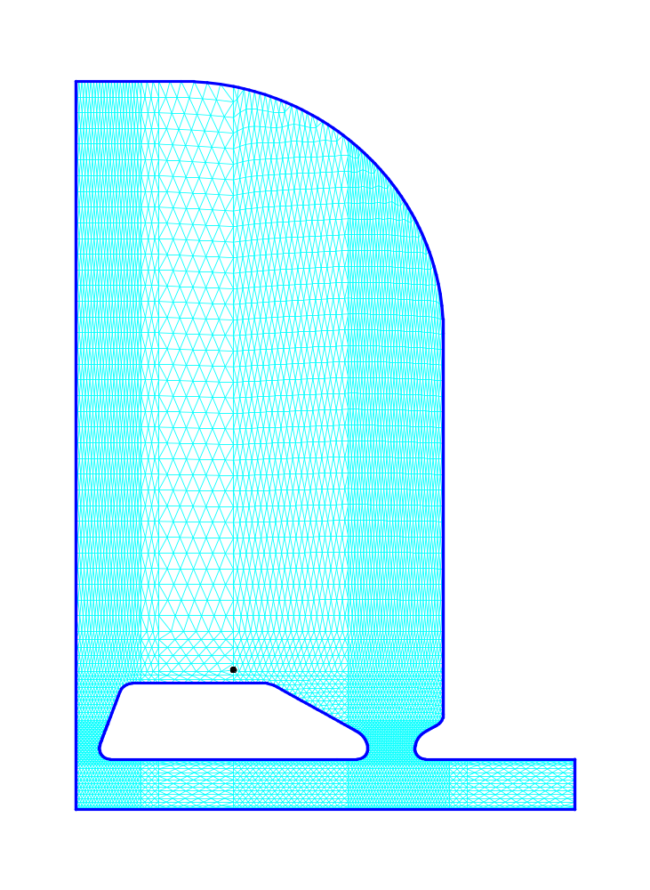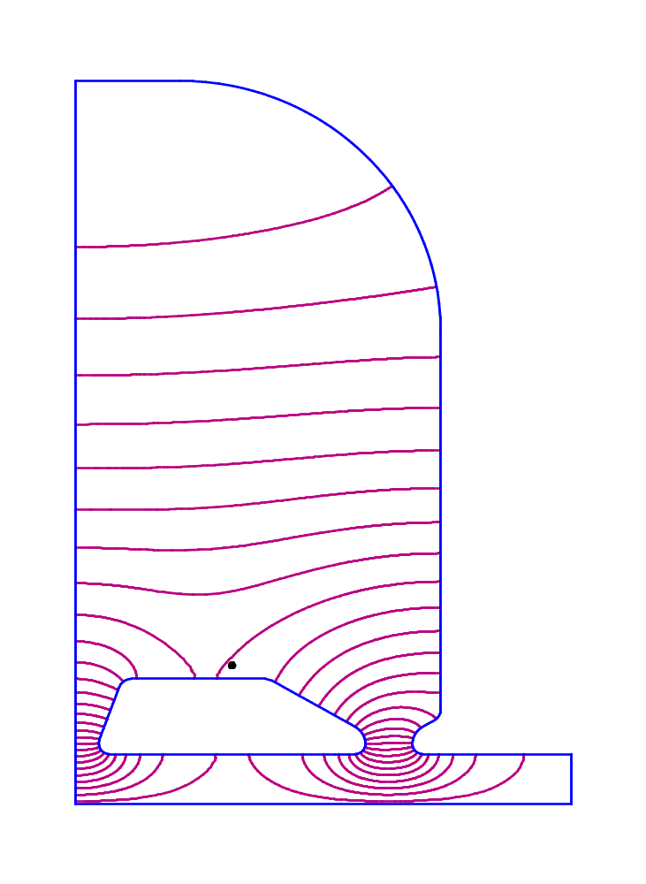
Figure XIX-8. Mesh and field contours for a 2-drift-tube CCDTL cavity.
These WSFplot displays show the right half of a symmetric CCDTL cavity containing two drift tubes. The bore-tube extension on the right side is the appropriate geometry for a structure in which single cavities are separated by a drift space for a focusing magnet and diagnostics. The field direction is the same in all three gaps of this cavity. The problem geometry includes the right half of the middle gap and all of the right-hand gap.

The DTL directory
Table XIX-3 lists files in the DTL directory, which contains two example control files for program DTLfish. One example uses different methods to tune a drift-tube-linac cell and another simply computes the fields for several DTL cells of a particular design.
Table XIX-3. Files in directory CavityTuning\DTL.
File | Description
DTLTEST.DTL | DTLfish input file.
RGDTL.SFT | Control file for SFOtable.
RGFISH.DTL | Another DTLfish input file.
Run_DTL.BAT | Batch file for running the codes.
Shw_DTL.BAT | Batch file for viewing the results.

;DTLfish control file DTLTEST.DTL

TITLE
Sample problems for tuning drift-tube linac cells.
Resonant frequency = 425 MHz
ENDTitle

PLOTTING Off
PARTICLE H+

FILEname_prefix TEST
SEQuence_number 1
FREQuency 425
LENGTH 6.075783
DIAMeter 43
GAP_Length 1.1
E0_Normalization 4.4
CORNER_radius 0.5
INNER_nose_radius 0.325
OUTER_nose_radius 0.325
FLAT_length 0
FACE_angle 5
DRIFT_TUBE_Diameter 8.0594
BEAD_radius 0
GAP_Change 0
STEM_diameter 1.905
BORE_radius 0.4
PHASE_length 180
DELTA_frequency 0.01
MESH_size 0.05
INCrement 2
START 2
Figure XIX-9a. First part of DTLfish control file DTLTEST.DTL.

Using different tuning surfaces
The control file DTLTEST.DTL listed in Figure XIX-9a and Figure XIX-9b illustrates the different methods for tuning drift-tube linac cells. The example file tunes a cell three times. Program SFO normalizes the fields to E₀ = 4.4 MV/m for each problem. The gap length for the first problem is specified in terms of the length βλ. The “START 2” line tells the code to vary the cavity diameter. The PREVIOUS keyword on the DIAMETER line for the second problem indicates that the code should use the calculated value of the diameter from the first problem.
For the second and third problems, the gap length appears in cm again (rather than in terms of βλ) on the GAP_Length line. The second problem adjusts the drift-tube diameter (START 3) to tune the cavity. The “START 4” line means that the code adjusts the gap to tune the cavity. Because the GAP_Change parameter appears before the START line of the last problem, DTLfish calculates the fields for a change in the gap length after tuning the original cell. The BEAD_radius line requests DTLfish to run SF7 to interpolate the fields along the path of a bead in a bead-perturbation measurement.

G_OVER_Beta_lambda 0.091
DIAMeter PREVIOUS
DRIFT_TUBE_Diameter 8.0594
START 3

LENGTH 6.075783
DIAMeter 43
GAP_Length 1.1
DRIFT_TUBE_Diameter 8.0594
START 4

FILEname_prefix TEST TESTP
SEQuence_number 4
BEAD_radius 0.15875
GAP_Change −0.00508
LENGTH 6.075783
DIAMeter 43
GAP_Length 1.1
DRIFT_TUBE_Diameter 8.0594
START 5

ENDFILE
Figure XIX-9b. Second part of DTLfish control file DTLTEST.DTL.

Computing the fields for a specific design without tuning
The control file RGFISH.DTL shown in Figure XIX-10 (a and b) sets up problem geometries for eleven representative cells of the Los Alamos/Grumman RGDTL cavity. The acronym RGDTL stands for Ramped-Gradient Drift-Tube Linac. This 425-MHz DTL was built and tested in the mid 1980s. The cells were tuned by a previous run of DTLfish by varying the gap length. Thus, the code is not instructed to tune the cells. Instead, it simply calculates the fields for the given geometry. The actual cavity had 30 cells. These 11 cells correspond to H⁻ -ion energies of 2.0 to 7.0 MeV in steps of 0.5 MeV. Superfish data from these calculations were supplied to the program Parmila to design the linac.
;DTLfish control file RGFISH.DTL

TITLE
Los Alamos/Grumman Ramped Gradient Drift-Tube Linac
Representative cells used for Parmila design work
Machine was designed, built, and tested between 1985 and 1988
Resonant frequency = 425 MHz, Initial beam energy = 2.0 MeV Final beam energy = 6.7 MeV
ENDTitle

PLOTTING Off
PARTICLE H-
TEMPerature 32.2
FILEname_prefix RGDTL
SEQuence_number 1
FREQuency 425
LENGTH 4.598352
DIAMeter 42.27576
DRIFT_TUBE_Diameter 8.0594
FACE_angle 3
GAP_Length 0.770385880354
E0_Normalization 1
CORNER_radius 0.5
OUTER_nose_radius 0.325
INNER_nose_radius 0.325
BORE_radius 0.5
BEAD_radius 0
GAP_Change 0
FLAT_length 0
STEM_Diameter 1.905
STEM_Count 1
PHASE_length 180
DELTA_frequency 0.005
MESH_size 0.05
INCrement 2
START 1

LENGTH 5.139065
GAP_Length 0.907114350502
START 1
Figure XIX-10a. First part of DTLfish control file RGFISH.DTL.
This part of the file defines variables common to all the cells and the START lines for the first two problems. The START code is 1 to compute the fields without any tuning adjustments.

LENGTH 5.627322
GAP_Length 1.036000000000
START 1

LENGTH 6.075783
GAP_Length 1.158691486877
START 1

LENGTH 6.492702
GAP_Length 1.276702105615
START 1

LENGTH 6.883813
GAP_Length 1.390680343087
START 1

LENGTH 7.253294
GAP_Length 1.501417343718
START 1

LENGTH 7.604299
GAP_Length 1.609423181560
START 1

LENGTH 7.939280
GAP_Length 1.714437431887
START 1

LENGTH 8.260188
GAP_Length 1.817670604388
START 1

LENGTH 8.568605
GAP_Length 1.919426322518
START 1

ENDFILE
Figure XIX-10b. Second part of DTLfish control file RGFISH.DTL.
This part of the file includes the cell length and gap length and START lines for the last nine problems.

After completing all RGFISH.DTL problems, the batch file Run_DTL.BAT calls program SFOtable. This code reads control file RGDTL.SFT and creates a Tablplot file of cavity parameters from the family of RGDTL SFO files. Figure XIX-12 shows the Tablplot display.

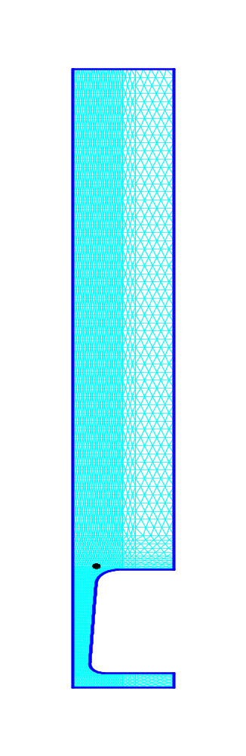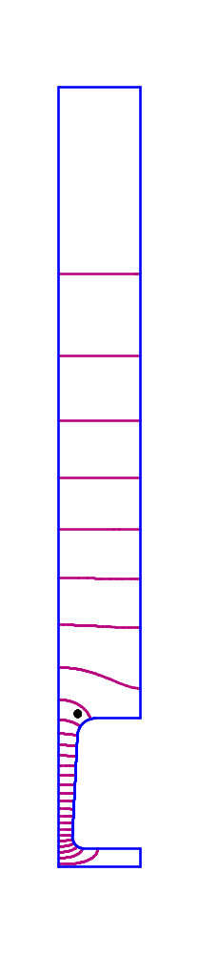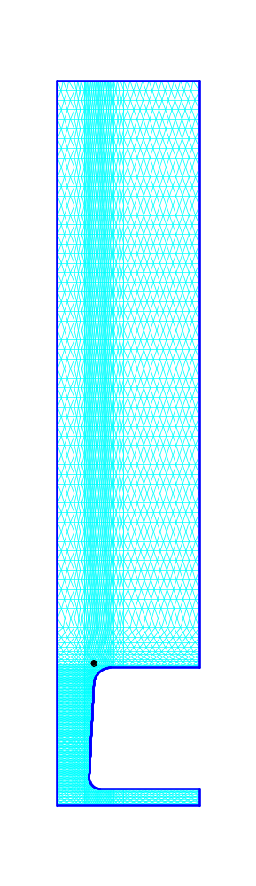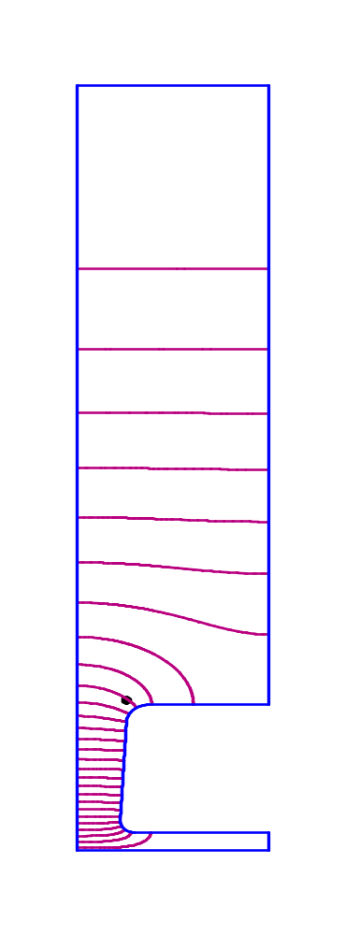
Figure XIX-11. Mesh and field contours for two RGFISH.DTL examples.
The two WSFplot displays on the left correspond to the input file RGDTL1.AM, which is 2.0-MeV cell for H⁻ ions. The displays at right are from input file RGDTL11.AM for a 7.0-MeV cell.

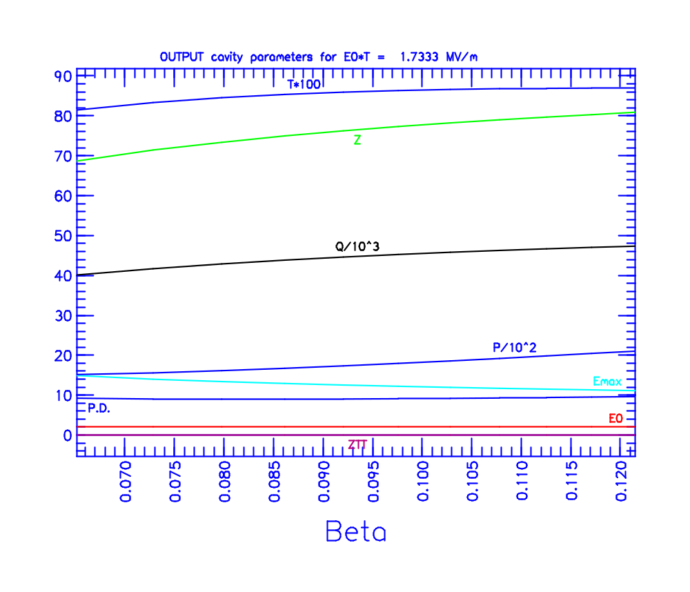
Figure XIX-12. Tablplot display of cavity parameters in file RGDTL.TBL.
The data in this Tablplot input file were generated by the program SFOtable, which reads the data from a set of SFO output files. Though we do not consider this type of plot suitable for presentation graphics, the SFOtable program provides a fast and convenient method to view the results of a tuning program session.

The EllipticalCavity directory
Table XIX-1 lists files in the EllipticalCavity directory for the program ELLfish, which tunes the elliptical cavities used in superconducting applications. These cavities feature elliptical segments at the dome of the cavity and near the bore radius (iris). The problem in file 82B.ELL instructs ELLfish to tune a symmetric half cell by adjusting the cavity diameter. The problem in file 82BE.ELL uses the geometry of the left side of the 82B.ELL cavity and adjusts the outer radius of curvature on the right side to tune the end cell of a multicell structure. Both example input files include the keyword SUPERConductor with three parameters in the Piel formula for the surface resistance.
Table XIX-4. Files in directory CavityTuning\EllipticalCavity.
File | Description
82B.ELL | ELLfish input file for tuning a β = 0.82 interior cell.
82BE.ELL | ELLfish input file for tuning a β = 0.82 end cell.
Run_ELL.BAT | Batch file for running the codes.
Shw_ELL.BAT | Batch file for viewing the results.
SEGFLD.SGF | Control file for program SegField.

START /W “ “ “%SFDIR%ellfish” 82b
START /W “ “ “%SFDIR%ellfish” 82be
START /W “ “ “%SFDIR%ellcav” 82be00
START /W “ “ “%SFDIR%autofish” 8c82be1
START /W “ “ “%SFDIR%sfo” 8c82be1.seg
START /W “ “ “%SFDIR%segfield” segfld.sgf
Figure XIX-13. The file Run_ELL.BAT.

; ELLfish control file 82B.ELL

Title
Sample problem for tuning elliptical cavity
Design beta = 0.82
Resonant frequency = 700 MHz, Bore radius = 8 cm
ENDTitle

PLOTting OFF
PARTICLE H+
SUPERConductor 2 9.2 1.00000E-08

NumberOfCells 8 ; used by the ELLCAV code
HALF_cavity

FILEname_prefix 82B
SEQuence_number 1
FREQuency 700
BETA 0.82
DIAMeter 40.5
E0T_Normalization 10
DOME_B 5.5
DOME_A/B 0.85
WALL_Angle 7
EQUATOR_flat 0
IRIS_flat 0
RIGHT_BEAM_tube 0
IRIS_A/B 0.5
BETASTART 0
BETASTOP 0
BETASTEP 0
BETATABLE 0
BORE_radius 8
SECOND_Beam_tube 0
SECOND_TUBE_Radius 0
DELTA_frequency 0.01
MESH_size 0.2
INCrement 2
START 2

ENDFile
Figure XIX-14. ELLfish control file 82B.ELL.

Symmetric half cell
File 82B.ELL, shown in Figure XIX-14 is an ELLfish input file for an elliptical cavity designed for β = 0.82. The keyword HALF_cavity selects the symmetric half-cell geometry. Figure XIX-15 shows the results of the calculation. For the symmetric half cell ELLfish uses a Neumann boundary condition at the cavity midplane on the left side of the geometry and a Dirichlet boundary condition at the right edge of the cavity. The Dirichlet boundary condition corresponds to the field distribution for an interior cell in a structure operating in the π mode. Fields in adjacent cavities are in opposite directions.
The 82B.ELL cavity does not use the optional flat section at the cavity equator (F_{Eq} = 0). The wall angle α_{w} = 7 degrees and the corner radius R_{c} = 5.156 cm. The code computed the length of the cell from the value of BETA. ELLfish assumes that the full-cell length is βλ/2, the distance traveled by the particle of velocity βc in half an rf period. The initial diameter of the cavity is D = 40.5 cm. The START 2 line instructs the code to tune the cavity by varying D.

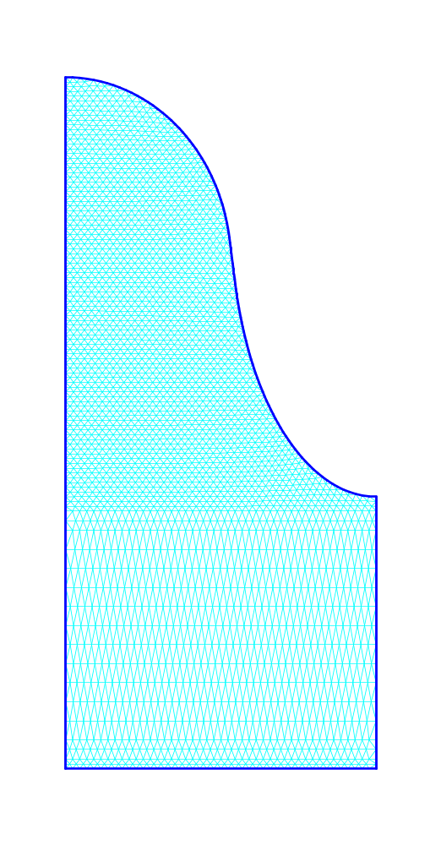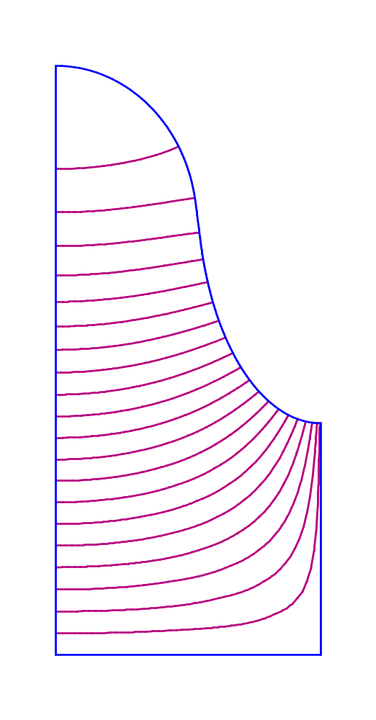
Figure XIX-15. Mesh and field contours for input file 82B1.AM.
The left WSFplot display shows the mesh generated by Automesh and the right side shows contours of constant H_{φ} from the solution computed by Fish.

Full cell at the end of a multicell cavity
File 82BE.ELL, shown in Figure XIX-17 is an ELLfish input file for the end cell of the β = 0.82 cavity discussed in the previous section. The keyword FULL_cavity selects the full-cell geometry and keyword RIGHT_BEAM_tube specifies a 30-cm-long beam tube connected to the cavity. Figure XIX-16 shows the results of the calculation. For the full cell problem ELLfish uses the Dirichlet boundary condition at both edges of the problem geometry. However, neither the Neumann nor the Dirichlet boundary condition is appropriate at the right edge. The beam tube must be long enough that the fields attenuate to negligible values within the beam tube.
The DIAMeter line in Figure XIX-17 specifies the diameter calculated by the 82B.ELL problem. In this example, the left- and right-side wall angles are the same as in problem 82B.ELL (α_{L} = α_{R} = 7 degrees) and the equator flat is still zero on both side of the cavity. However, the designer is free to select different values for these parameters on the right side of the cavity. The left-side dome parameters are b_{D} = 5.5 cm and a_{D}/b_{D} = 0.85, which are the same values used in the 82B.ELL problem, but the starting value of the dome parameters on the right side is b_{D} = 5.1 cm and a_{D}/b_{D} = 0.8. The START 3 line instructs the code to tune the cavity by varying b_{D}. As you can see by running the problem, the tuned value is b_{D} = 5.0821 cm.
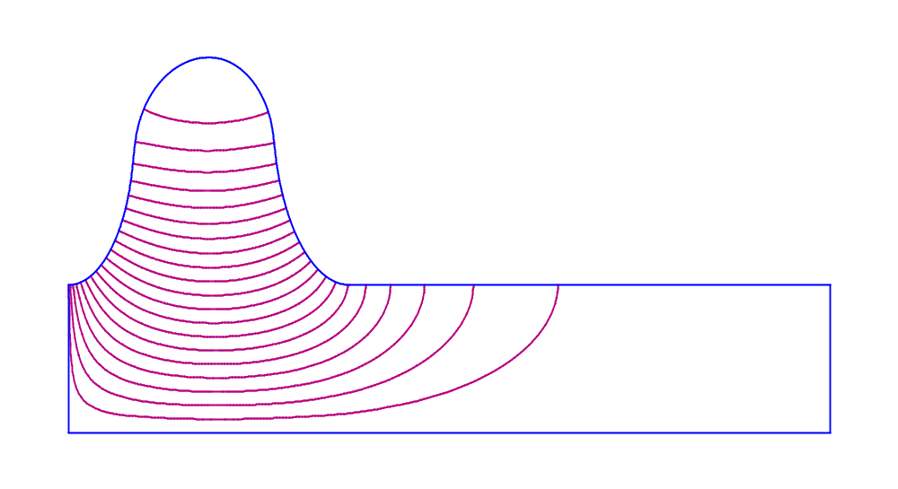
Figure XIX-16. Field contours for input file 82BE1.AM.
The WSFplot display shows contours of constant H_{φ} from the solution computed by Fish. The bore tube is long enough that the fields attenuate to negligible values at the far right side of the problem geometry.

Title
Sample problem for tuning elliptical cavity (end cell)
Design beta = 0.82
Resonant frequency = 700 MHz, Bore radius = 8 cm
Left side from 82B cavity
Right side tuned by adjusting outer radius
ENDTitle

PARTICLE H+
SUPERConductor 2 9.2 1.00000E-08

NumberOfCells 8 ; used by the ELLCAV code
FULL_cavity

FILEname_prefix 82BE
SEQuence_number 1
FREQuency 700
BETA 0.82
DIAMeter 40.67397631147
E0T_Normalization 10
DOME_B 5.5
LEFT_DOME_B 5.5
RIGHT_DOME_B 5.1
DOME_A/B 0.85
LEFT_DOME_A/B 0.85
RIGHT_DOME_A/B 0.8
WALL_Angle 7
LEFT_Wall_angle 7
RIGHT_Wall_angle 7
EQUATOR_flat 0
LEFT_Equator_flat 0
RIGHT_Equator_flat 0
IRIS_flat 0
LEFT_Iris_flat 0
RIGHT_Iris_flat 0
RIGHT_BEAM_tube 30
IRIS_A/B 0.5
LEFT_IRIS_A/B 0.5
RIGHT_IRIS_A/B 0.5
BETASTART 0.6
BETASTOP 0.99
BETASTEP 0.01
BETATABLE 2
BORE_radius 8
LEFT_BORE_radius 8
RIGHT_BORE_radius 8
SECOND_Beam_tube 0
SECOND_TUBE_Radius 0
DELTA_frequency 0.01
MESH_size 0.2
INCrement 2
START 3
ENDFile
Figure XIX-17. ELLfish control file 82BE.ELL.
This file uses the diameter computed by the 82B.ELL run for a symmetric half-cell. The full-cell problem starts with smaller value of the right-side dome size and aspect ratio.

ELLCAV, generation of the multicell cavity
AFTER the ELLfish run has finished with file 82BE.ELL, it writes file 82BE00.ELL containing the tuned value of the dome vertical semiaxis b_{D}. The command “ELLCAV 82BE00” in the example batch file creates files 8C82BE1.AF and 8C82BE1.SEG. File 8C82BE1.AF is an Autofish input file containing half the geometry for the full 8-cell cavity (see Figure XIX-18). File 8C82BE1.SEG is an SFO input file containing settings for the multicell features in the SFO postprocessor. The SEG file includes comment lines with instructions for using other features of SFO. Figure XIX-18 shows the π-mode field pattern for the mode at 700 MHz. To find other modes of this cavity, the user can perform two HREF="sfcodes.doc#FrequencyScans, one with the same boundary conditions found in the original input file, and another with the setting NBSLF = 1, which changes the boundary condition on the left edge of the geometry to a Neumann boundary.
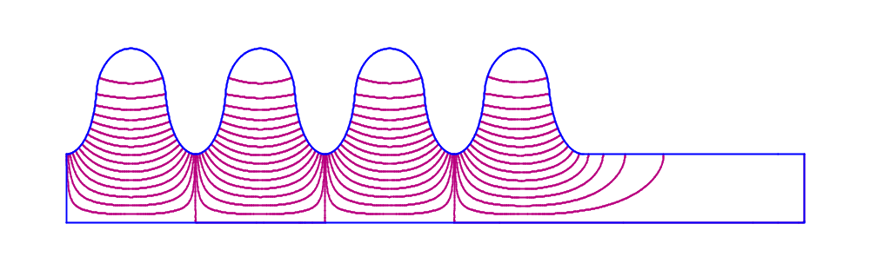
Figure XIX-18. Half of the full 8-cell cavity.
This figure shows the π-mode field pattern for the multicell cavity. To find the 0 mode, the user can change the boundary condition on the left edge of the geometry and perform a frequency scan.

SegField, displaying fields along the cell boundary
The last line in batch file Run_ELL.BAT run the program SegField to compute the electric and magnetic fields along all the boundary segments in the multicell cavity. Input to SegField consists of the control file SEGFLD.SGF and the file 8C82BE1.SFO, whose name appears in the control file. The result of this calculation is the plot file 8CFILED.TBL, which contains the fields, power density and radiation pressure along the specified boundary segments (in this case all the segments). Figure XIX-19 shows the Tablplot display. Note that the radiation pressure has been multiplied by 100 in this plot to show details. The data in this output file can be imported into other plotting programs or spreadsheets.
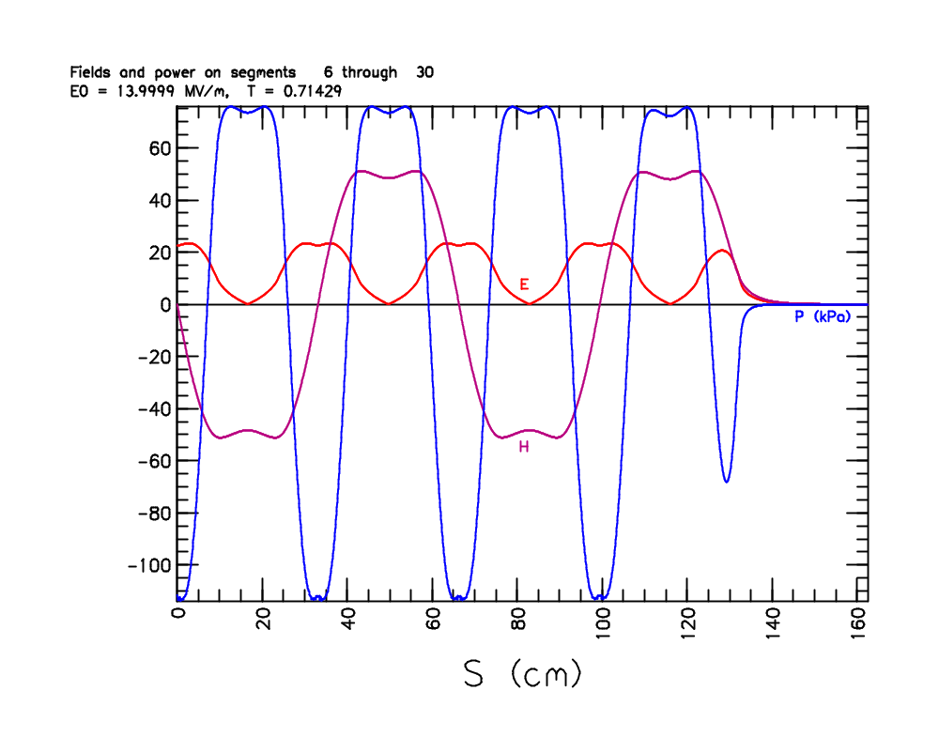
Figure XIX-19. Tablplot screen showing the fields and radiation pressure.
In this plot, the radiation pressure has been multiplied by 100 in order to show its features.

The MulticellDTL directory
Table XIX-5 lists files in the MulticellDTL directory for the program MDTfish, which sets up the geometry for multiple-cell sections of drift-tube-linac tanks. The Superfish mesh can be very large for a many cell problem. Poisson Superfish codes allocate large enough arrays for the mesh points, boundary points, segments, and line regions. Your computer must have enough free memory to accommodate these arrays. File MDTTEST.MDT, shown in Figure XIX-20, sets up a relatively small example so that most users will be able to run it. The input file defines three cells and calculates the fields for a previously tuned problem. Figure XIX-21 shows the mesh and contour lines.
Table XIX-5. Files in directory CavityTuning\MulticellDTL.
File | Description
MDTTEST.MDT | MDTfish input file for a 3-cell cavity.
Run_MDT.BAT | Batch file for running the codes.

; MDTfish sample control file MDTTEST.MDT
TITLE
Sample Multiple Drift Tube Cavity, Resonant frequency = 850 MHz
Tuning errors produce an end-to-end field “tilt” in this 3-cell cavity
ENDTitle

PARTICLE H+
FILEname_prefix TEST_
SEQuence_number 1
FREQuency 850
DIAMeter 17.633
DRIFT_TUBE_Diameter 5.50672
BORE_radius 0.5
LEFT_WALL_shift 0
RIGHT_WALL_shift 0
LEFT_BEAM_tube 0
RIGHT_BEAM_tube 0
STEM_diameter 1.27
PHASE_per_cell 720
DELTA_frequency 0.02
MESH_size 0.05
INCrement 2

POST_DATA
−1 0.9525000 5.5730000
1 0.9525000 5.5730000
2 0.9525000 5.5730000
−2 0.9525000 5.5730000
EndData

Cell_Data 1
;GapCen GapLen AngL AngR Rc Rni_L Rni_R FlatL FlatR Rno_L Rno_R Length E0
3.15655 1.0483 41.55 40.0 0.254 0.15 0.15 0.554 0.554 0.635 0.635 7.33618784 3.19674310
3.65731 1.0766 40.00 40.0 0.254 0.15 0.15 0.254 0.254 0.635 0.635 7.42908408 3.29715543
3.71868 1.1067 40.00 40.0 0.254 0.15 0.15 0.254 0.254 0.635 0.635 7.52938968 3.39312782
EndData

; Start codes for MDTFISH on CELL_DATA line:
; 1 No tuning
; 2 Adjust diameter
; 3 Adjust gaps proportionally

EndFile
Figure XIX-20. Control file MDTTEST.MDT for program MDTfish.

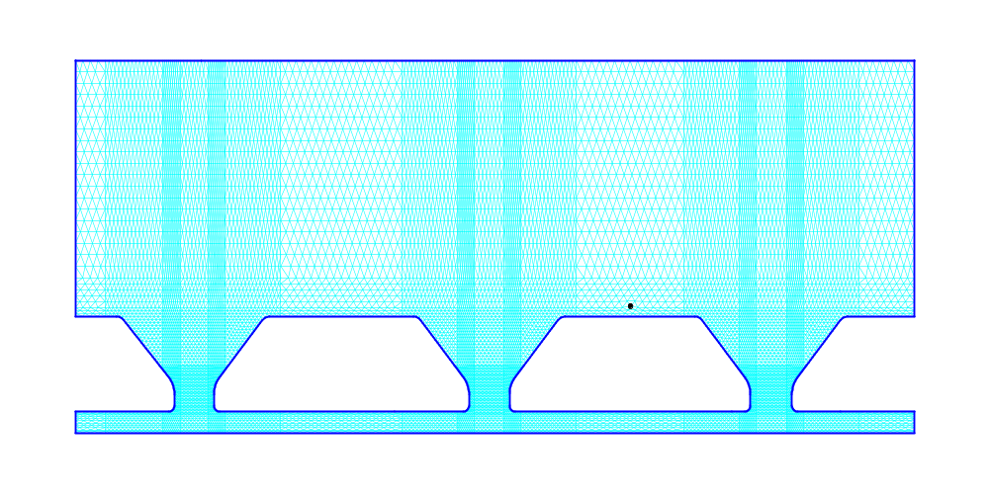
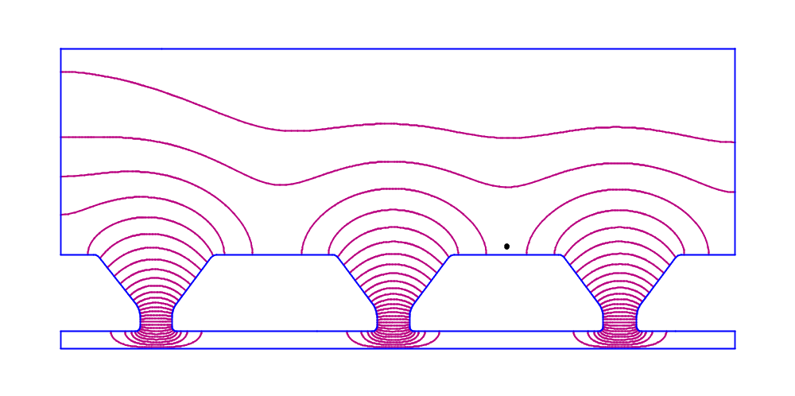
Figure XIX-21. Mesh and field contours for the 3-cell DTL problem.

The RFQ directory
Table XIX-6 lists files in the RFQ directory. Program RFQfish sets up the XY cross section of one quadrant of a radio-frequency quadrupole cavity and tunes the cavity to a specified frequency adjusting a tuning surface.
Table XIX-6. Files in directory CavityTuning\RFQ.
File | Description
RFQTEST.RFQ | RFQfish input file for 350-MHz RFQ.
LANSCE.RFQ | RFQfish input file for a 201.25-MHz RFQ.
Run_RFQ.BAT | Batch file for running the codes.
Shw_RFQ.BAT | Batch file for viewing the results.

Several tuning options for RFQ cavities
File RFQTEST.RFQ, shown in Figure XIX-22 (a and b), demonstrates several options for tuning an RFQ cavity. The file generates six basic shapes. Figure XIX-23 shows the mesh generated for the input file RFQ_A1.AM, including a detail near the vane tips. Figure XIX-24shows a typical field plot for the quadrupole mode using the file RFQ_A1.AM as an example. Figure XIX-25 shows the cavity shapes for the eight problems. For the first three problems RFQ_A1, RFQ_B1, and RFQ_C1, the code adjusts the vane height H (see HREF="sfcodes2.doc#RFQfish) to tune the cavity. Problems RFQ_A1 and RFQ_B1 have the same geometry except for the corner radius, which is R_{c} = 1.0 cm for RFQ_A1 and R_{c} = 0.0 cm for RFQ_B1. The third problem RFQ_C1 retains all the geometry of RFQ_B1, except for α₂, the vane angle from the shoulder to the base, which is set to zero for RFQ_C1.
For the next three problems RFQ_D1, RFQ_D2, and RFQ_D3, the control file reduces the mesh size from 0.035 cm to 0.03 cm and restores the corner radius to R_{c} = 1.0 cm. Table XIX-7 lists the vane parameters used for these three problems. For problem RFQ_D1, the code adjusts the vane height H to tune the cavity, and for problems RFQ_D2 and RFQ_D3, it adjusts the vane base half width W_{b}.
Table XIX-7. RFQ vane parameters for three problems.
Problem | r₀ | V_{g} | ρ | W_{s} and W_{b} | Adjust
RFQ_D1 | 0.38 | 0.07 | 0.3315 | 1.500000000000 | H
RFQ_D2 | 0.30 | 0.06 | 0.2550 | 1.873804140320 | W_{b}
RFQ_D3 | 0.25 | 0.06 | 0.2125 | 2.221233041589 | W_{b}

For problem RFQ_E1, the control file uses keyword RHO/R0 to specify the ratio ρ/r₀ at the point of quadrupole symmetry. RFQfish calculates ρ = 0.24 cm from this ratio (ρ/r₀ = 0.8) and the specified value of r₀ = 0.3 cm. Note the use of a zero placeholder for ρ in the DATA table (see Figure XIX-22b). Problem RFQ_F1 changes the ratio to ρ/r₀ = 0.85, for which RFQfish calculates ρ = 0.255 cm. In addition, problem RFQ_F1 changes the corner radius again to R_{c} = 0.0 cm and tunes the cavity by adjusting the vane half width W. The initial value is W = 0.

; RFQfish control file RFQTEST.RFQ

TITLE
Sample Tuning of Radio-Frequency Quadrupole Cavities
Target frequency = 350 MHz
ENDTitle

PLOTTING ON
PARTICLE H+
FILEname_prefix RFQ_A
SEQuence_number 1
RFQ_MODE
FREQuency 350
CORNer_radius 1
BREAK_out_angle 10
RHO/R0 0.85
BLANK_Width 0.4
BLANK_Depth 2
VANE_ANGLE_1 20
VANE_ANGLE_2 20
DELTA_frequency 0.05
MESH_size 0.035
INCrement 2

DATA
;R0, Vg, rho, Ws, Ls, Wb, H, W, Nv
0.3 0.06 0.255 1 1. 1.5 9.452896754653 0 7
ENDDATA

FILEname_prefix RFQ_B
SEQuence_number 1
CORNer_radius 0

DATA
;R0, Vg, rho, Ws, Ls, Wb, H, W, Nv
0.3 0.06 0.255 1 1 1.5 9.452896754653 0 7
ENDDATA
FILEname_prefix RFQ_C
SEQuence_number 1
VANE_ANGLE_2 0

DATA
;R0, Vg, rho, Ws, Ls, Wb, H, W, Nv
0.3 0.06 0.255 1 0 1.5 9.452896754653 0 7
ENDDATA
Figure XIX-22a. First part of file RFQTEST.RFQ for program RFQfish.

FILEname_prefix RFQ_D
SEQuence_number 1
CORNer_radius 1
MESH_size 0.03

DATA
;R0, Vg, rho, Ws, Ls, Wb, H, W, Nv
0.38 0.07 0.3315 1.500000000000 0 1.500000000000 9.69927320455 0 7
0.30 0.06 0.2550 1.873804140320 0 1.873804140320 9.69927320455 0 6
0.25 0.06 0.2125 2.221233041589 0 2.221233041589 9.69927320455 0 6
ENDDATA

FILEname_prefix RFQ_E
SEQuence_number 1
RHO/R0 0.8
VANE_ANGLE_2 10

DATA
;R0, Vg, rho, Ws, Ls, Wb, H, W, Nv
0.3 0.06 0 1 0 1.5 9.452896754653 0 7
ENDDATA

FILEname_prefix RFQ_F
SEQuence_number 1
CORNer_radius 0
RHO/R0 0.85

DATA
;R0, Vg, rho, Ws, Ls, Wb, H, W, Nv
0.3 0.06 0.255 1 0 1.5 9.452896754653 0 8
ENDDATA

ENDFILE
Figure XIX-22b. Second part of file RFQTEST.RFQ for program RFQfish.

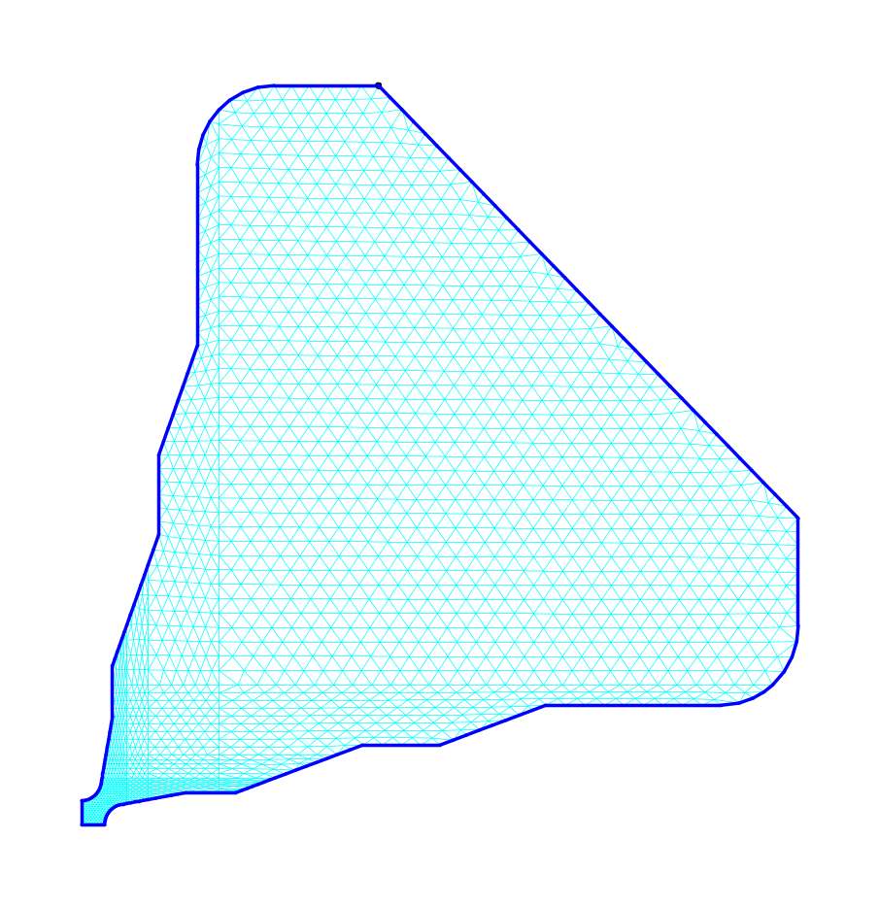
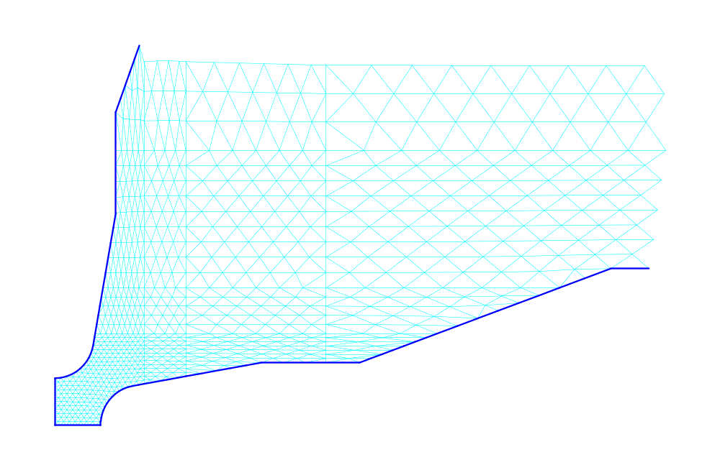
Figure XIX-23. Mesh generated for input file RFQ_A1.AM.
The top figure shows the entire quadrant. The bottom figure shows more detail near the vane tips.

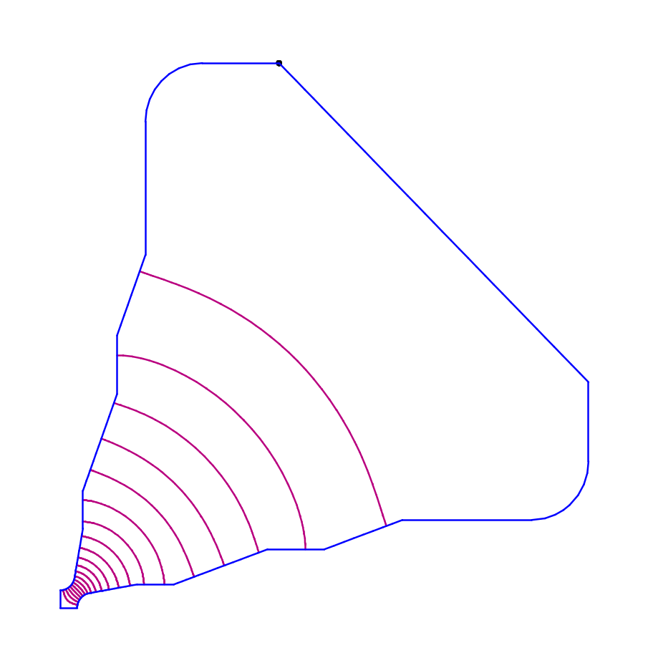
Figure XIX-24. Field contours for file RFQ_A1.
This field pattern is typical of the quadrupole mode in all the RFQ example problems. The contours are lines of constant H_{z}.

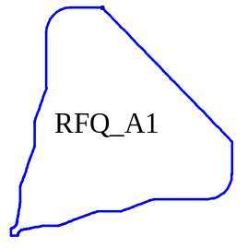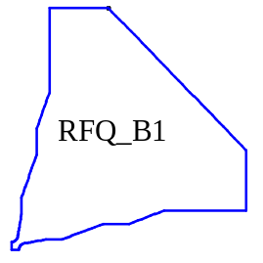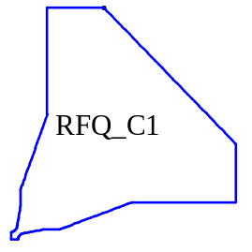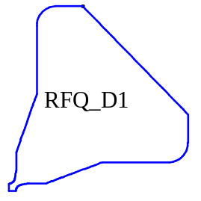
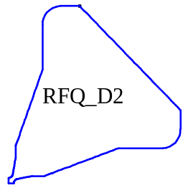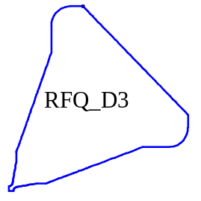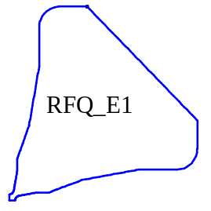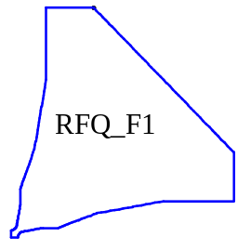
Figure XIX-25. Cavity shapes for the eight RFQTEST.RFQ problems.
The problem filenames appear inside each cavity shape.

LANSCE RFQ design examples
The file LANSCE.RFQ, shown in Figure XIX-26 was used to investigate some 201.25-MHz RFQ designs that could replace the Cockroft-Walton injector and part of the drift-tube linac at the Los Alamos Neutron Science Center (LANSCE, formerly LAMPF: Los Alamos Meson Physics Facility). Program RFQfish tunes the first cell of each shape by varying the vane height, and the second cell by adjusting the vane thickness. After the vane height is adjusted for the first cell, the code will use the vane height from the first cell for the second cell. RFQfish then adjusts the vane width for the same frequency as the first cell, but with a different value of r₀, the radial aperture at point of quadrupole symmetry. Figure XIX-27 shows the cavity shapes for these four RFQ cavities. The field pattern is similar to the one shown in Figure XIX-24.

; RFQfish control file LANSCE.RFQ

TITLE
RFQ conceptual design at 201.25 MHz
Los Alamos Neutron Science Center (LANSCE) accelerator
ENDTitle

PLOTTING Off
PARTICLE H+

FILEname_prefix LA
SEQuence_number 1
RFQ_MODE
FREQuency 201.25
CORNer_radius 0.767
BREAK_out_angle 20
RHO/R0 0.85
BLANK_Width 1.2
BLANK_Depth 3.5
VANE_ANGLE_1 25.5
VANE_ANGLE_2 0
DELTA_frequency 0.01
MESH_size 0.05
INCrement 2

DATA
;R0, Vg, rho, Ws, Ls, Wb, H, W, Nv
0.5946 0.1040 0.50541 5.6 0 5.6 17.85701821595 0 7.
1.1134 0.2491 0.94639 4.0 0 4.0 17.85701821595 0 6.
ENDDATA

BREAK_out_angle 15
BLANK_Width 0.9
VANE_ANGLE_1 21.5

DATA
;R0, Vg, rho, Ws, Ls, Wb, H, W, Nv
0.4219 0.08000 0.358615 5.6 0 5.6 17.02566577503 0 7.
0.8575 0.15522 0.000000 4.0 0 4.0 17.02566577503 0 6.
ENDDATA

ENDFILE
Figure XIX-26. RFQfish control file LANSCE.RFQ.

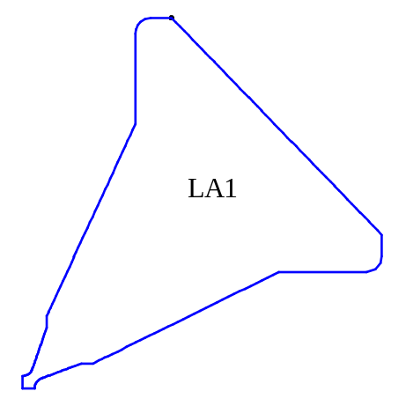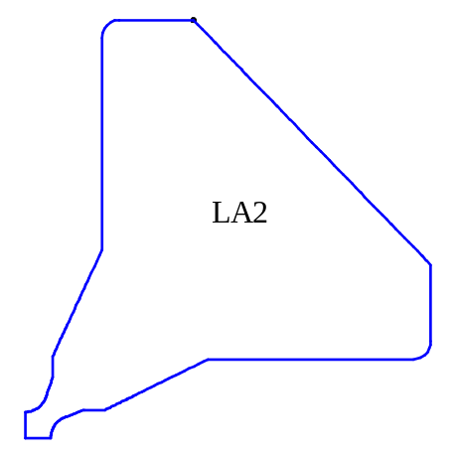
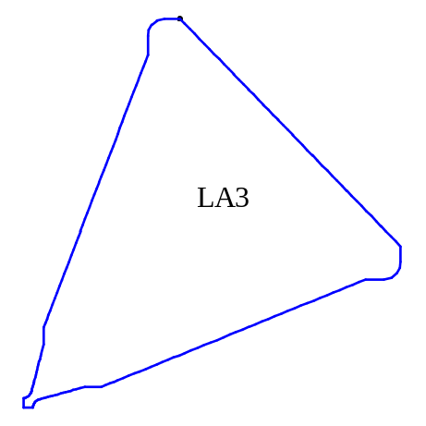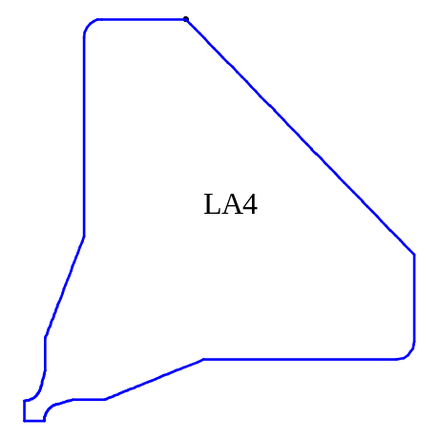
Figure XIX-27. Cavity shapes for the four LANSCE.RFQ problems.

The SideCouplingCell directory
Table XIX-2 lists files in the SideCouplingCell CCDTL directory for the program SCCfish. SCCfish runs Superfish repetitively, varying the cell geometry to tune each cell to a specified frequency. The control file 805CC.SCC, shown in Table XIX-8, sets up two calculations. For the first problem with input file 805CC1.AM, the mesh appears on the left of Figure XIX-29 and the field contours are on the left of Figure XIX-30. This cavity is the simplest shape possible for a coupling cell with a tuning post. There are no radii in any of the corners and the tuning post does not have a face angle. The other problem with input file 805CC1.AM includes all these features. The mesh and contours for this problem are on the right of the two figures. Program SCCfish tunes both cavities by adjusting the post length.
Table XIX-8. Files in directory CavityTuning\SideCouplingCell.
File | Description
805CC.SCC | SCCfish input file for tuning side coupling cavities.
Run_SCC.BAT | Batch file for running the codes.
Shw_SCC.BAT | Batch file for viewing the results.

; SCCfish control file 805CC

TITLE
Sample problems for coupling cells.
Resonant frequency = 805 MHz
ENDTITLE

PLOTTING OFF

FILEname_prefix 805cc
SEQuence_number 1
FREQuency 805
LENGTH 9.13156
DIAMeter 17.4498
POST_Length 3.35
POST_Diameter 8.7249
OUTER_CORNer_radius 0
INNER_CORNer_radius 0
INNER_POST_radius 0
OUTER_POST_radius 0
FLAT_length 0
FACE_angle 0
DELTA_frequency 0.02
MESH_size 0.04
START 3

OUTER_CORNer_radius 0.9525
INNER_CORNer_radius 0.3175
INNER_POST_radius 0.5
OUTER_POST_radius 0.3175
FLAT_length 2
FACE_angle 10
START 3

ENDFILE
Figure XIX-28 SCCfish control file 805CC.SCC.
This input file generates two cavities. The first one is a simple geometry with no radii on corners and no face angle on the tuning post. The other problem has all the features included.

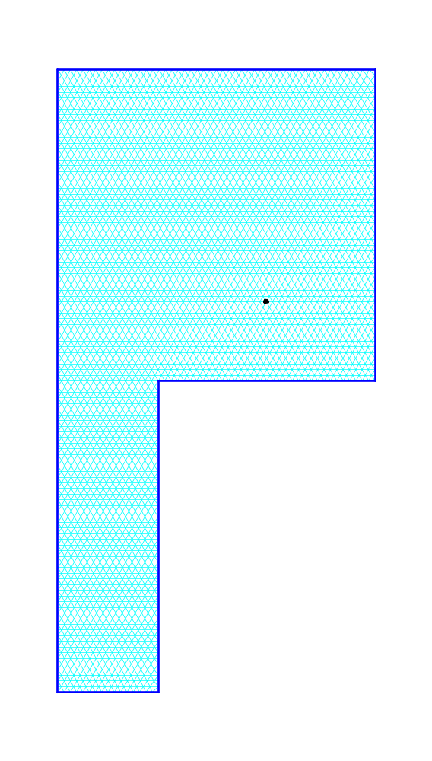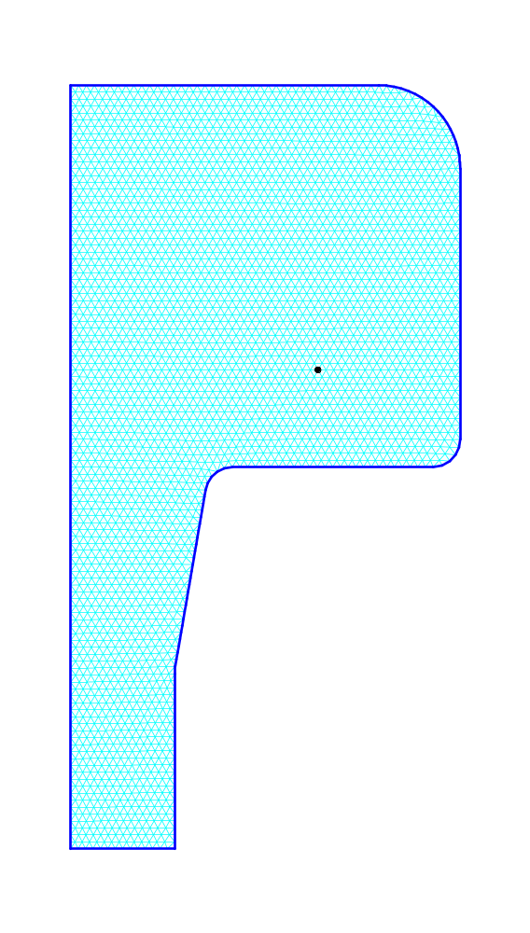
Figure XIX-29. Mesh for problems 805CC1.AM and 805CC2.AM.

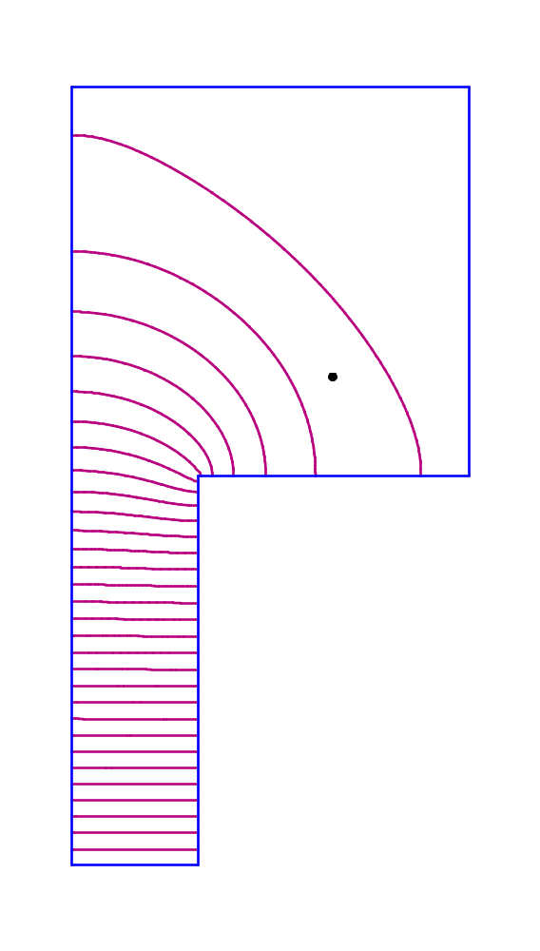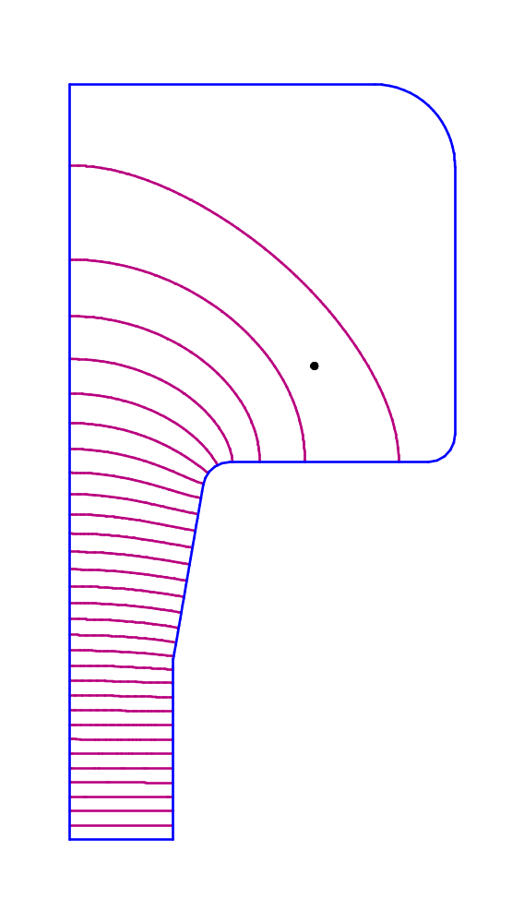
Figure XIX-30. WSFplot field contours for problems 805CC1.AM and 805CC2.AM.

