File SFPHYS2.DOC contains the following bookmarks. Select the topic you are trying to find from the list and double click the highlighted text.

Physics discussions in other files
HREF="SFPHYS1.DOC | Theory of electrostatics and magnetostatics
HREF="SFPHYS3.DOC | Boundary conditions and symmetries
HREF="SFPHYS4.DOC | Numerical methods in Poisson and Pandira
HREF="SFPHYS5.DOC | RF cavity theory

File SFPHYS2.DOC Table of Contents
XXI. Properties of Static Magnetic and Electric Fields
A. Energy stored in the field
B. Fields and their derivatives
C. Forces and torques

Properties of Static Magnetic and Electric Fields
This section is based upon the treatment in Part B, Chapter 13.2 by John L. Warren in the 1987 publication Reference Manual for the POISSON/SUPERFISH Group of Codes, LA-UR-87-126. The original chapter was titled “Auxiliary Properties of Static Magnetic and Electric Fields.” We reproduce it here in essentially its original form as reference material to the physics in the Poisson Superfish codes. The equation sequence numbers are the same as in the original. We have corrected a few typographical errors in the original, including the following:
- In Equation XXI-22, the number 2 in the denominator is actually a 4. Correction of this error leads to several other needed corrections.
- The 2 in the denominator of the second term on the right-hand side of Equation XXI-51 also should be a 4.
- There should be a 2 in the denominator of the terms 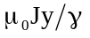 and 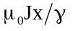 in Equation XXI-52, and in the denominator of the terms 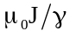in Equations XXI-53 and XXI-58.
- In Equation XXI-64, the number 2 in the denominator is actually a 4.
- The right-hand side of Equation XXI-29 is negative.
- In Table XXI-2, the fifth scalar polynomial in the 1987 Reference Manual was
z⁵−4z³r²/3+zr⁴/2. The correct expression is z⁵−5z³r²+15zr⁴/8.
Where appropriate we have added material to explain differences between the methods described by John Warren and new methods now used in the Poisson Superfish codes. In this chapter, such additional material is enclosed in square brackets [such as this].
The previous section on the HREF="sfphys1.doc showed how the static Maxwell’s equations give rise to the generalized Poisson equation for the static electric (scalar) and magnetic (vector) potentials. The present section shows how the potentials are used to obtain the stored energy in the field, to obtain the fields and their derivatives, and to obtain the forces and torques on current-carrying coils and iron regions in magnetic fields. We will also obtain the forces and torques on charged plates and dielectric materials. These derivations will be done for both Cartesian and cylindrical coordinates. In discussing the fields and their derivatives in Cartesian coordinates, we will make use of complex variables and the theory of analytic functions.

Energy stored in the field
The general expression for the energy in any volume V containing an electromagnetic field is
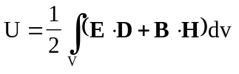. (XXI-1)
For electrostatic problems the term B⋅H is zero and for magnetostatic problems the term E⋅D is zero. Our aim is to reduce Equation XXI-1 to area and contour integrals over potentials in two-dimensional Cartesian coordinates and cylindrical coordinates. We begin by substituting
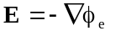 and 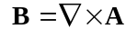 (XXI-2)
into Equation XXI-1and using vector identities to get
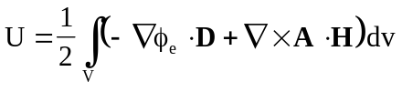
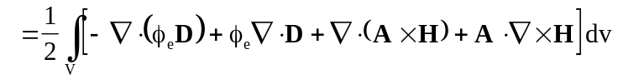. (XXI-3)
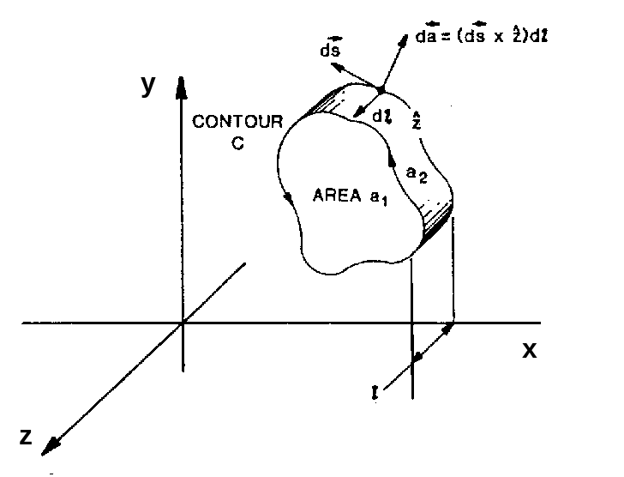
Figure XXI-1. An arbitrary volume with 2-D Cartesian symmetry.
The front and back surfaces have area a₁. The edge has area a₂ and width .
Green’s theorem can be used to turn the integral over the volume of the divergence into an integral over the surface ∂V. We use Maxwell’s equations to express the volume integral in terms of the charge density ρ and the current density J. The result is
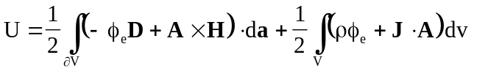. (XXI-4)
Let us consider Cartesian coordinates first. We assume that all functions are independent of the z coordinate. Consider an arbitrary volume as shown in Figure XXI-1. The integration over z can be done immediately. The front and back plane surfaces have equal areas but opposite vector direction. Thus, the surface integral over the front cancels the surface integral over the back. The result is
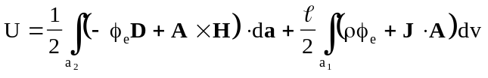. (XXI-5)
The element of area on the ribbon edge can be written as
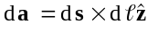, (XXI-6)
where is the unit vector in the z direction. The magnitude of the vector ds is the element of length along the counterclockwise contour C enclosing the area a₁ (see Figure XXI-1). Therefore, we can turn the first integral into a contour integral around the area a₁. Furthermore, both J and A must be in the z direction. With these simplifications we find that
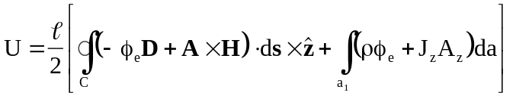. (XXI-7)
The first integral can be simplified further by using the vector identities
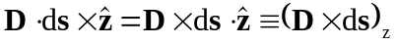, (XXI-8)
and
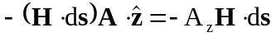. (XXI-9)
The latter equation holds because H has no z component. For Cartesian symmetry, the codes calculate the energy per unit length using the formula
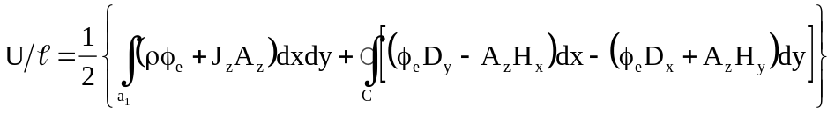. (XXI-10)
In all cases handled by Poisson, the contour integral vanishes on the boundary of the region because the boundary conditions are either pure Dirichlet (A_{z} = 0 or φ_{e} = 0) or pure Neumann (B⋅ = 0 or E⋅= 0). For example, consider the integral in Equation XXI-5
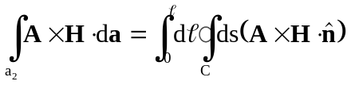, (XXI-11)
where , being the normal vector to the ribbon area a₂, is also the normal to the contour C. The differential element ds is still the element of distance along the contour. Figure XXI-2 illustrates the typical contour for one-quarter of an H-shaped magnet.

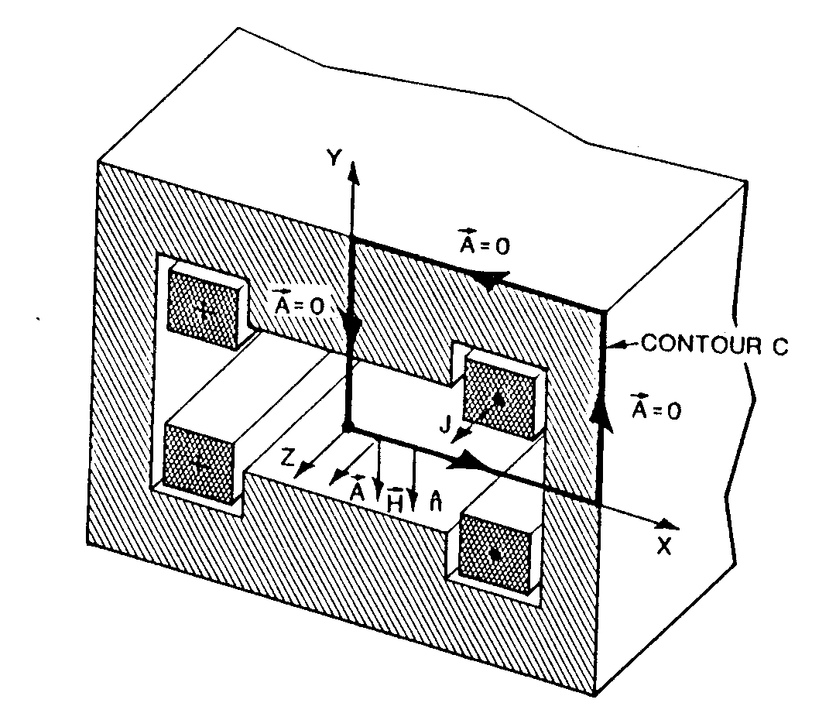
Figure XXI-2. Contour C for an H-shaped magnet.
The vector potential A vanishes on three sides because of Dirichlet boundary conditions. The quantity A×H⋅ vanishes on the bottom because A×H is parallel to the contour.

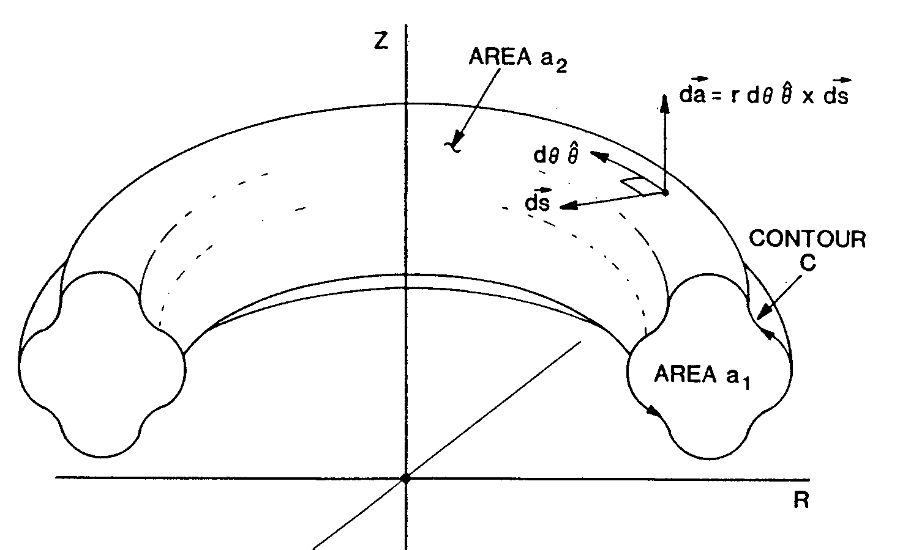
Figure XXI-3. A general volume in cylindrical symmetry.
The cross sectional area of the torus is a₁.

As seen in the figure, the contour integral vanishes. The energy per unit length reduces to
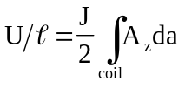, (XXI-12)
which is J/2 times the integral of the magnetic potential over the area of the coil.
For permanent magnet problems (solved by Pandira), where there is no current density, the energy per unit length should be calculated from the contour integral where the contour goes around the permanent magnet material and not around the boundary of the whole region.
For cylindrical symmetry, the volume of integration is illustrated by Figure XXI-3. The energy integral can be written as
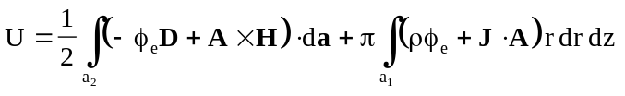. (XXI-13)
The integral over the volume of the torus has been simplified by an integration over the cylindrical angle θ. Once again the surface integral can be reduced to a contour integral by expressing the element of area as
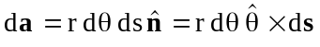, (XXI-14)
where is the unit normal vector and is the unit vector in the θ direction (see Figure XXI-3). After integrating over angle θ, noting that A and J have only θ components, and D has no θ component, we get
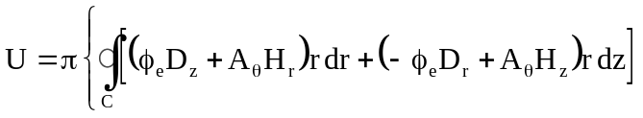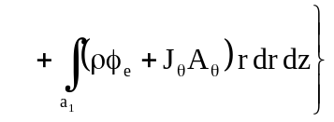. (XXI-15)
The same arguments can be given to show that the contour integral vanishes on the boundary of the whole region, thus providing a simplification in Poisson calculations.

Fields and their derivatives
In principle, one could obtain the fields by numerical differentiation of the potentials, but this is not a very accurate way of doing it. Furthermore, since the potentials are known only on points of the mesh, it would not be easy to calculate fields at points other than mesh points. Older versions of Poisson and Pandira fit a power series to the potential at a given point and then analytically took the derivatives of the series to get the field and its derivatives. [Though we include the following discussion from the 1987 Reference Manual, the present version of Poisson and Pandira does not expand the fields in a power series expansion about the point (x₀, y₀) = (0, 0). The method described is not practical because it often results in taking the differences between very large numbers. Instead, the present HREF="sfintro.doc#FieldInterpolatorDescription uses only a few of the lowest-order harmonic polynomials and chooses (x₀, y₀) as the interpolation point itself. Differences between the mesh-point coordinates (x_{i}, y_{i}) and the point (x₀, y₀) are small numbers, of the order of one or two mesh intervals. In addition, the interpolator chooses harmonic polynomials that satisfy nearby boundary conditions when appropriate. The treatment that follows does mention some things used by the present interpolator: the equations for the field components and a list first few harmonic polynomials.]
There is an important difference between the formulation of the problem in Cartesian coordinates and cylindrical coordinates. In the Cartesian case one can use the theory of complex variables, which has several advantages. The theory for cylindrical coordinates will be treated separately at the end of this section. In two-dimensional, Cartesian coordinates, Maxwell’s equations, for the magnetic induction are
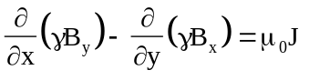, (XXI-16)
and 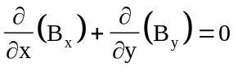. (XXI-17)
Equation XXI-17 can be satisfied by either
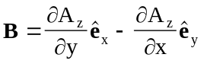, (XXI-18)
or 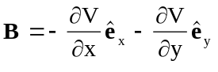, (XXI-19)
where 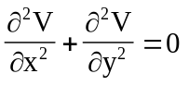. (XXI-20)
The potential V(x, y) is not a solution of Equation XXI-16 unless the current density
J(x, y) vanishes in the region under consideration. If we make one reasonable approximation, it is possible to reformulate the problem in terms of complex variables. Since we are interested in finding the magnetic potential A_{z}(x, y) in the vicinity of a given point (x, y), we can assume that the reluctivity γ and the current density J are essentially constant in the vicinity of the given point. This assumption allows us to move the reluctivity out of the differentiation and to the right-hand side of Equation XXI-16. One obtains the equation
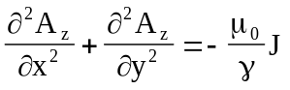 (XXI-21)
for the potential A_{z}(x, y). The solution to this equation can be written as the solution to the homogeneous equation plus a particular solution. It is easily verified that a solution is
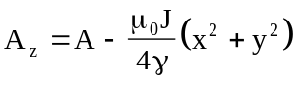, (XXI-22)
where 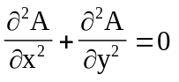. (XXI-23)
We are now in a position to convert to the notation of complex variables. Let z = x + iy be a number in the complex plane. Mathematically speaking, there is an isomorphism between complex numbers z and points (x, y) in the Cartesian plane. In current-free regions the components of the magnetic induction B can be written in terms of either A or V as
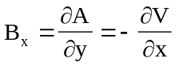, (XXI-24)
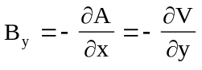. (XXI-25)
These relations between A and V are the same as the Cauchy-Riemann conditions for a complex, analytic function
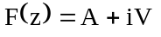. (XXI-26)
This is easily seen by noting that
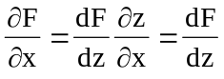, (XXI-27)
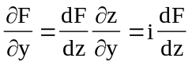, (XXI-28)
and hence 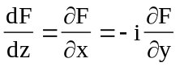. (XXI-29)
If we define a complex, magnetic-induction function
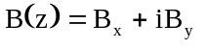, (XXI-30)
then 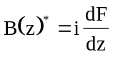, (XXI-31)
where * denotes complex conjugation. As the notation implies, B(z) is also a complex, analytic function, which means that B(z) can be expanded in a convergent power series in the variable z, provided that B(z) is a single-valued function without a singularity in the region of interest.
From Equations XXI-19, XXI-20, and XXI-23 we see that both A(x, y) and V(x, y) satisfy Laplace’s equation. In the theory of complex variables, functions with this property are called harmonic functions. Two other consequences of the Cauchy-Riemann conditions are:
- Given the vector potential A(x, y), it is always possible to find the scalar potential
V(x, y) by integrating Equations XXI-24 and XXI-25; and
- The curves V(x, y) = v and A(x, y) = a are orthogonal to one another for any constants v and a. Because the magnetic field lines are also orthogonal to the lines of constant potential, one can use the orthogonality of A and V to create plots of the field lines.
Let us turn now to the power series representation of the vector potential about a point z₀. We write this series as
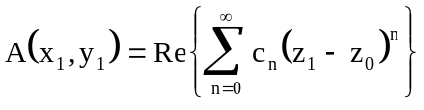, (XXI-32)
or 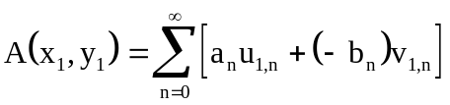, (XXI-33)
where 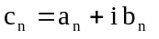, (XXI-34)
and . (XXI-35)
The polynomials u_{n} and v_{n} are called harmonic polynomials because they are also solutions of Laplace’s equation. Table XXI-1 shows the first 10 harmonic polynomials. The polynomials used in Equation XXI-33 are obtained from the polynomials in the table by replacing x with (x₁ − x₀) and y with (y₁ − y₀).
Table XXI-1. The first 10 harmonic polynomials.
n | u_{n}(x, y) | v_{n}(x, y)
1 | x | y
2 | x²−y² | 2xy
3 | x³−3xy² | 3x²y−y³
4 | x⁴−6x²y²+y⁴ | 4x³y−4xy³
5 | x⁵−10x³y²+5xy⁴ | 5x⁴y−10x²y³+y⁵
6 | x⁶−15x⁴y²+15x²y⁴−y⁶ | 6x⁵y−20x³y³+6xy⁵
7 | x⁷−21x⁵y²+35x³y⁴−7xy⁶ | 7x⁶y−35x⁴y³+21x²y⁵−y⁷
8 | x⁸−28x⁶y²+7x⁴y⁴−28x²y⁶+y⁸ | 8x⁷y−56x⁵y³+56x³y⁵−8xy⁷
9 | x⁹−36x⁷y²+126x⁵y⁴−84x³y⁶+9xy⁸ | 9x⁸y−84x⁶y³+126x⁴y⁵−36x²y⁷+y⁹
10 | x¹⁰−45x⁸y²+210x⁶y⁴−210x⁴y⁶+45x²y⁸−y¹⁰ | 10x⁹y−120x⁷y³+252x⁵y⁵−120x³y⁷+10xy⁹

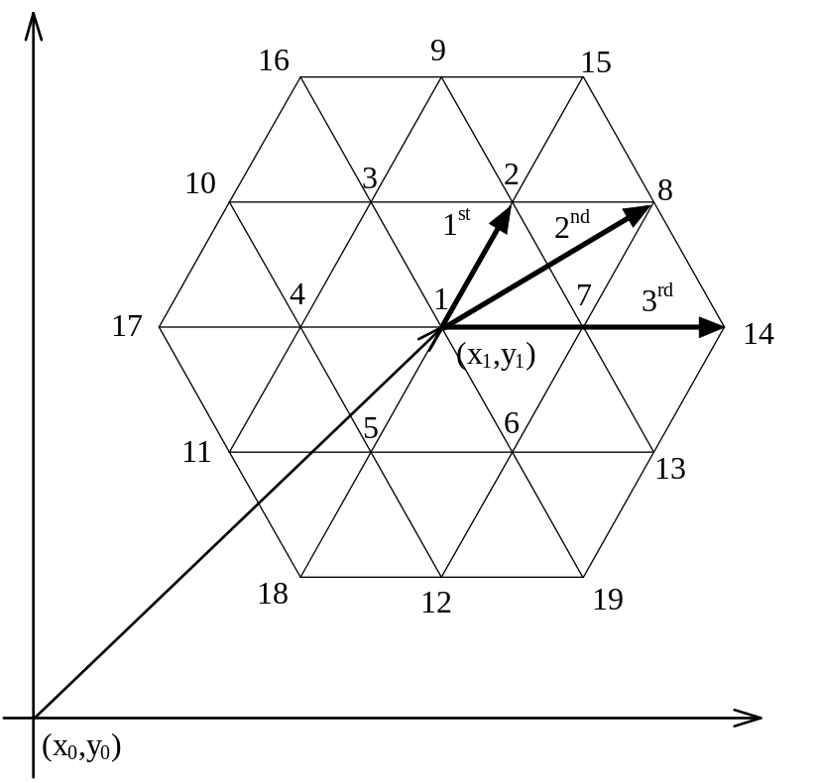
Figure XXI-4. First, second, and third neighbors of point 1.
Point 1 at (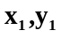) on a regular triangular mesh has six first nearest neighbors (points 2 through 7), six second nearest neighbors (points 8 through 13), and six third nearest neighbors (points 14 through 19). The origin for the series expansion is the point (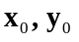).

The coefficients a_{n} and b_{n} are determined by truncating the power series at N terms and least-squares fitting the function A(x, y) at neighboring points on the mesh. On a regular triangular mesh there are 6 first nearest neighbors, 6 second nearest neighbors and 6 third nearest neighbors, as illustrated in Figure XXI-4. Even after the mesh is distorted to conform to the boundaries of the physical regions, one call still identify these 18 points. Holsinger and Halbach lump the second and third neighbors together and call them second neighbors in the distorted mesh. Henceforth, we will speak of six first neighbors and 12 second neighbors.
Suppose that we make a column matrix of the values of A(x, y) evaluated at the point (x₁,y₁) and at its 18 nearest neighbors. We can make a column matrix out of the first N = 7 pairs of coefficients (a_{n}, b_{n}). Next, we construct a 19 x 14 matrix Z, whose rows are the coordinates of the points raised to the appropriate power and expressed in terms of the harmonic polynomials. Equation XXI-33 can be written as
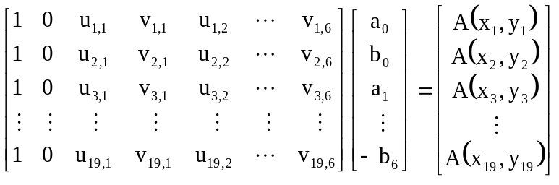
or in matrix form
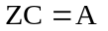, (XXI-36)
Because the number of rows in Z is larger than the number of columns, this set of linear equations must be solved by a least-squares procedure. There exist standard routines for this purpose. One advantage of using least-squares is that the analytic function A(x, y) will be smoother in the neighborhood of (x₁,y₁) than the values determined by Poisson in the neighborhood of this point. One disadvantage of this approach is the power series developed around the point (x₁,y₁) may not be consistent with the power series for the potential developed around the neighboring points (x₂,y₂), etc. In particular, unphysical discontinuities are sometimes seen at points midway between neighboring points. This behavior is a result of the truncation of the power series. [Indeed, this behavior of the power series expansion about a point (x₀,y₀) is the primary reason that this method is no longer used in the Poisson Superfish codes.] The accuracy of the approximation depends on the distance between mesh points in the vicinity of the given point and the how rapidly the function A(x, y) is changing.
One way to make the power series expansion more accurate is to increase the number N, while still keeping the number of unknown coefficients a_{n} and b_{n} less than the 19 data points used in the least-squares fit. This method can be used if there is any symmetry to the magnetic field. Suppose that the point (x₀,y₀) is a symmetry point of the magnet, that is, suppose that an axis of rotational symmetry passes through this point or that it lies in a plane of reflection symmetry. If there is a rotational axis, then some of the coefficients c_{n} must vanish. If there is a reflection plane, then c_{n} must be a real or imaginary number, depending on whether reflection changes the sign of the field or not. Figure XXI-5 illustrates four types of symmetry that can occur in magnets. Figure XXI-5a shows a case of four-fold rotation symmetry for which no change in field polarity occurs with the rotation. Figure XXI-5b shows the same fourfold rotation symmetry, but this time, the field changes polarity. The change of polarity occurs because the current generating the field changes direction. This type of symmetry is like a reflection through the plane of the paper. Figure XXI-5c shows a case of reflection symmetry, where the reflection plane is perpendicular to the plane of the paper and passes through the x axis. Finally, Figure XXI-5d illustrates a reflection symmetry in which the polarity of the field changes sign. All other symmetries are combinations of these basic symmetries. One can construct the set of all symmetry elements that leave the potential function A(z, J) unchanged and use quite general group theoretical methods to eliminate some of the coefficients c_{n}.
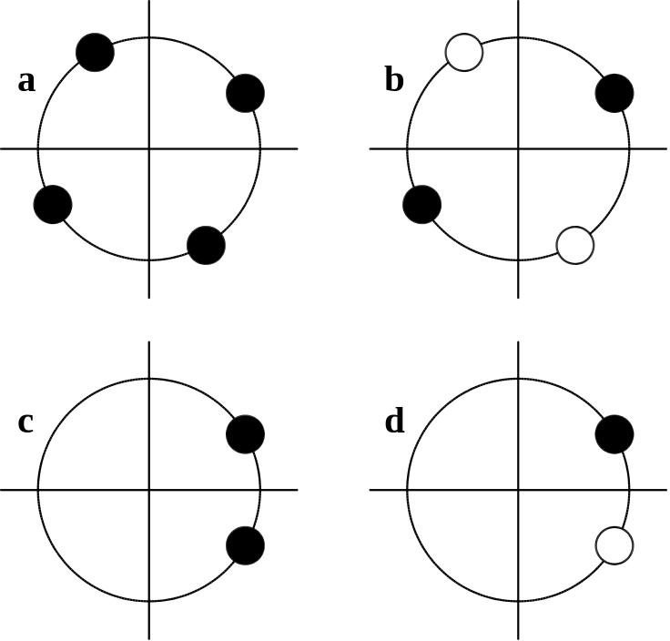
Figure XXI-5. Four types of magnet symmetry.
The four types of symmetry are a. rotation, b. rotation and change of polarity, c. reflection, and d. reflection and change of polarity. Polarity is indicated by color: black or white.
Let us treat the rotational symmetry first. The effect of a rotation by an angle α on a point (x, y) is
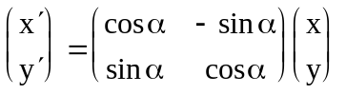. (XXI-37)
In complex notation this equation can be written
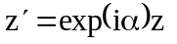. (XXI-38)
The effect of this rotation on the vector potential is
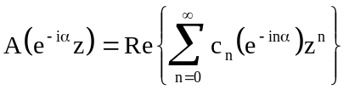. (XXI-39)
For convenience, we shall assume that the symmetry point z₀ is the origin of coordinates. If this rotation is to leave the function invariant, then all the coefficients c_{n} must vanish except for values of n that satisfy the equation
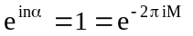, (XXI-40)
where M is any integer. Furthermore, we know that the angle α must be some fraction of the number 2π. Let us write α = 2π/m and solve Equation XXI-40 for n. The result is
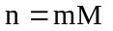. (XXI-41)
For example, in the case illustrated in Figure XXI-5a, m = 4 and the only non-vanishing coefficients are c₀, c₄,…, c_{4M}. If the rotation changes the polarity of the field, as in Figure XXI-5b, then the condition for non-vanishing coefficients is
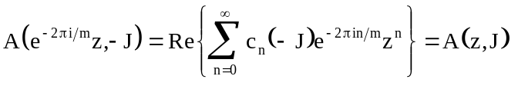. (XXI-42)
Since changing direction of the current must change the sign of the potential, we will assume that
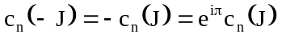. (XXI-43)
This equation is equivalent to the condition that
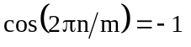. (XXI-44)
Hence the argument of the cosine must be an odd multiple of π,
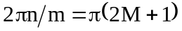, (XXI-45)
After solving for the integer n, we observe that m must be an even integer:
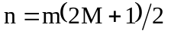. (XXI-46)
Let us now discuss the effects of reflection symmetry. This symmetry does not eliminate any of the coefficients, but instead tells us whether the coefficients c_{n} are real or imaginary. The coordinate system can usually be arranged so that the x axis is in a plane of reflection. This arrangement means that a reflection, which changes (x + iy) to (x − iy), is equivalent to complex conjugation. The effect of reflection on the vector potential is to replace z by z* in its argument. The invariance condition becomes
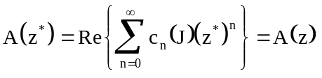. (XXI-47)
One can show that
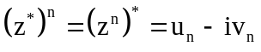, (XXI-48)
and hence invariance requires that
. (XXI-49)
This relation implies that Im(c_{n}) must be identically zero. In the same manner, Re(c_{n}) must vanish when A(z, J) is invariant under reflection followed by a change in sign of the current. This type of symmetry changes c_{n}(J) to −c_{n}(J).
In summary then, symmetry reduces the number of unknown coefficients a_{n} and b_{n}, which means that one can include higher powers in the least-squares fit to the power series representation of the vector potential in the vicinity of a symmetry point. The use of symmetry also reduces the amount of information needed to generate the mesh for the problem. For example, only one-fourth of an H-shaped dipole magnet is required to describe the field for the full magnet. Finally, the scalar potential
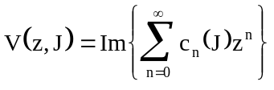 (XXI-50)
satisfies the same symmetry conditions.
Given the power series for either the vector potential or the scalar potential, it is easy to generate analytic expressions for the magnetic field and its derivatives. The magnetic field is given by
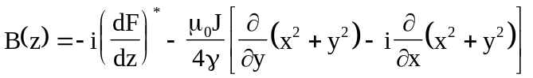. (XXI-51)
The second term comes from the particular solution to the homogeneous equation (see Equations XXI-21 and XXI-22). Substitution of the power series for F(z) gives the result
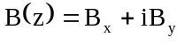
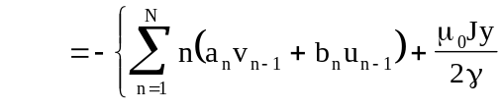
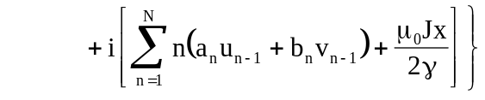. (XXI-52)
The first derivatives of the field are found as follows. Take the complex conjugate of equation XXI-51 and then solve for dF/dz. The derivative of the complex potential function F(z) can be written
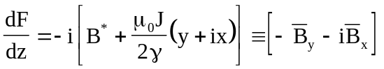. (XXI-53)
From this expression we can derive the Cauchy-Riemann conditions on the analytic function dF(z)/dz, namely,
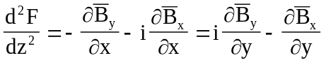, (XXI-54)
or 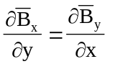, (XXI-55)
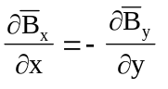. (XXI-56)
Equation XXI-55 is just the statement that 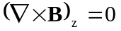, and Equation XXI-55 that 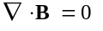. Since the power series for the second derivative of F can be written
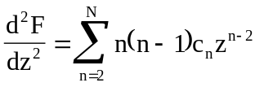
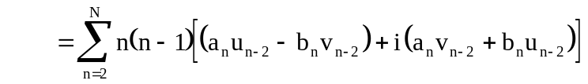, (XXI-57)
it follows that
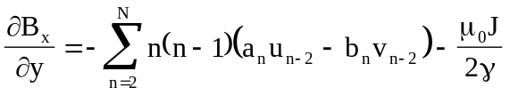, (XXI-58)
and 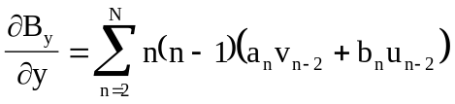. (XXI-59)
As seen above, symmetry simplifies these general expressions even further.
The electrostatic problem can be formulated in terms of the same complex potential F(z). The only difference comes in the definition of E as the gradient of A instead of the curl of A. If we make the approximation that the permittivity ε and the charge density ρ are constant, then Maxwell’s equations are
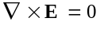, (XXI-60)
and 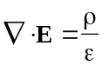. (XXI-61)
Equation XXI-60 has a solution of the form
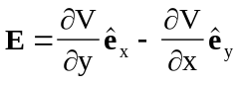 (XXI-62)
in two dimensions, where the function V(x, y) satisfies Laplace’s equation. The solution to Equation XXI-61 can be written in the form
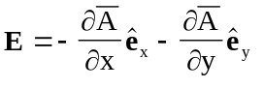, (XXI-63)
where 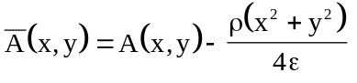, (XXI-64)
and A(x, y) also satisfies Laplace’s equation in two dimensions. The electrostatic potentials A and V are completely analogous to the magnetostatic potentials except for physical units (Volts as compared with Tesla-meters) and the fact that the electric field is calculated as the gradient of A as compared with calculating the magnetic induction as the curl of A.
In the discussion so far, we have assumed Cartesian coordinates in which the functions have no z dependence. The whole scheme will also work for cylindrical symmetry, but some changes are needed in the formulas. The isomorphism to the complex plane is lost. The scalar and vector potentials must be treated separately. One wishes to express the potentials in the vicinity of a point (z₀, r₀) as a sum of polynomials. For convenience, we shall assume that the point (z₀, r₀) is the origin of coordinates. For the scalar potential we write
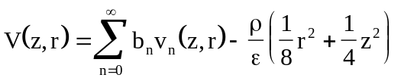, (XXI-65)
where 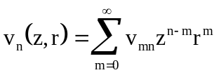. (XXI-66)
These polynomials must satisfy Laplace’s equation in cylindrical coordinates, namely,
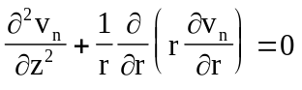. (XXI-67)
By carrying out the above differentiation, we find that
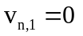 for all n, (XXI-68)
and 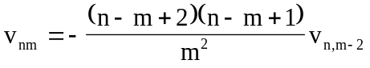. (XXI-69)
Taken together, these relations imply that v_{nm} = 0 for all odd m. Table XXI-2 gives the first ten polynomials.
Table XXI-2. Harmonic polynomials for cylindrical coordinates.
n | Scalar Potential v_{n}(z, r) | Vector Potential v_{n}(z, r)
1 | z | r²
2 | z²−r²/2 | zr²
3 | z³−3zr²/2 | z²r²−r⁴/4
4 | z⁴−3z²r²+3r⁴/8 | z³r²−3zr⁴/4
5 | z⁵−5z³r²+15zr⁴/8 | z⁴r²−3z²r⁴/2+r⁶/8
6 | z⁶−15z⁴r²/2+45z²r⁴/8−5r⁶/16 | z⁵r²−5z³r⁴/2+5zr⁶/8
7 | z⁷−21z⁵r²/2+105z³r⁴/8−35zr⁶/16 | z⁶r²−15z⁴r⁴/4+15z²r⁶/8−5r⁸/64
8 | z⁸−14z⁶r²+105z⁴r⁴/4−35z²r⁶/4+35r⁸/128 | z⁷r²−21z⁵r⁴/4+35z³r⁶/8−35zr⁸/64
9 | z⁹−18z⁷r²+189z⁵r⁴/4−105z³r⁶/4+315zr⁸/128 | z⁸r²−7z⁶r⁴+35z⁴r⁶/4−35z²r⁸/16+7r¹⁰/128
10 | z¹⁰−45z⁸r²/2+315z⁶r⁴/4−525z⁴r⁶/8+1575z²r⁸/128−63r¹⁰/256 | z⁹r²−9z⁷r⁴+63z⁵r⁶/4−105z³r⁸/16+63zr¹⁰/128

The θ component of the vector potential A_{θ}(z, r) also can be written as a sum of polynomials, but it is more convenient for computational purposes to multiply A_{θ} by r and write a polynomial series for the product, namely,
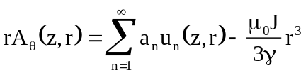, (XXI-70)
where 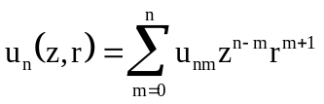, (XXI-71)
and where the u_{n}(z, r) coefficients must satisfy the ∇×∇×A equation
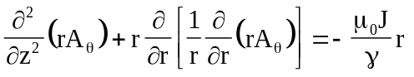. (XXI-72)
Once again, one can show that
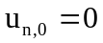 for all n, (XXI-73)
and 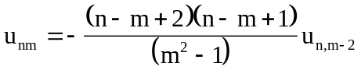. (XXI-74)
Taken together, these equations imply that u_{nm} = 0 for even n. The first five polynomials are given in Table XXI-2. The coefficients a_{n} and b_{n} are obtained by least-squares fit to the potentials at nodes of the mesh as described above for Cartesian coordinates.
For electrostatic problems the field components are
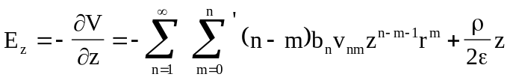, (XXI-75)
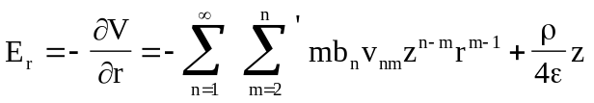, (XXI-76)
where the prime on the summation symbol means a summation over even values of m. For magnetostatic problems the components of the induction are
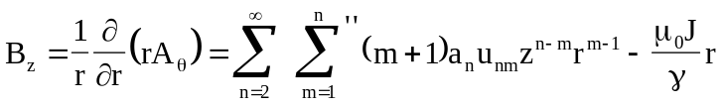, (XXI-77)
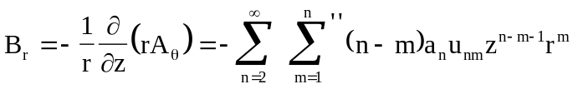, (XXI-78)
where the double prime on the summation symbol means a summation over odd values of m. Programs Poisson and Pandira do not calculate any derivatives of the electrostatic field. They do calculate the derivative of B_{z} with respect to r, which is given by the formula
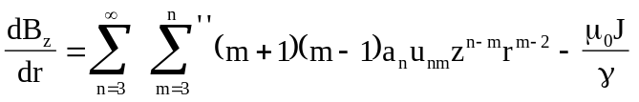. (XXI-79)

Forces and torques
Consider a conductor of cross sectional area S with the current flowing in the z direction as shown in Figure XXI-6. The force F on a section of thickness dz is given by the formula
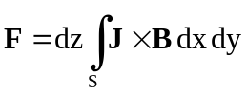. (XXI-80)
We will assume that the current density J is constant over the cross section, that is, independent of x and y. The magnetic induction B is independent of z and hence the vector potential A need only have a z component. Thus, we can write
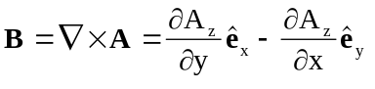. (XXI-81)
It follows that we can write J × B in the form
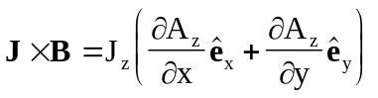. (XXI-82)
We would like to use Stoke’s theorem to convert the integral in Equation XXI-80 from an area integral into a line integral. First, we must convert the integral into vector form. Let the vector differential area be written as
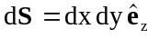. (XXI-83)
Using the following identities
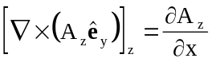, (XXI-84)
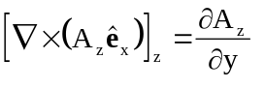, (XXI-85)
we can write the force as
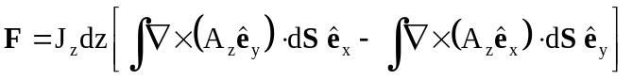. (XXI-86)
Stoke’s theorem can now be applied to each integral. The result is
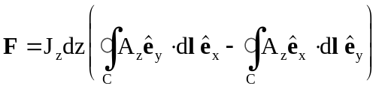. (XXI-87)
This equation also can be written as
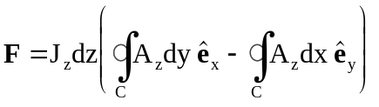. (XXI-88)

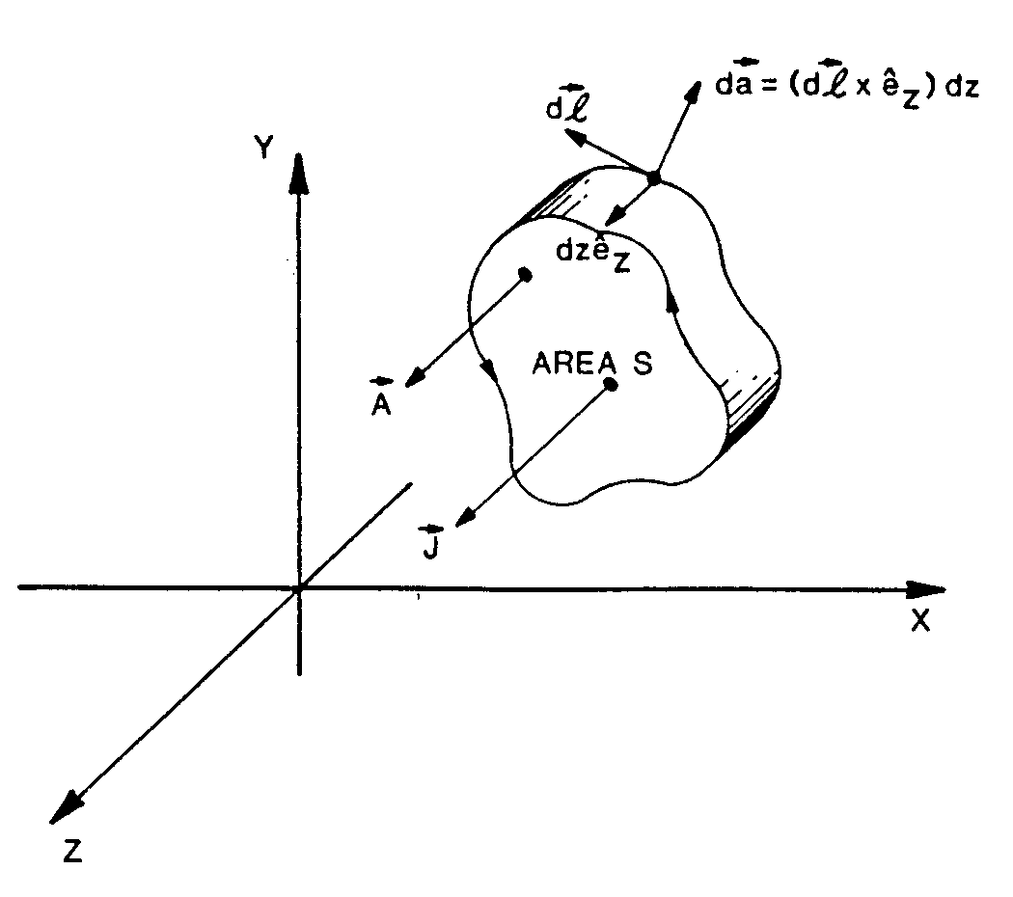
Figure XXI-6. Conductor of constant cross section.
The figure shows a slab of conductor of thickness dz. The current flows in the z direction.
The HREF="sfpostp.doc#Force program uses the form in Equation XXI-88 to compute the force on a current carrying element.
The general formula for the torque on a thin slice of the conductor is given by
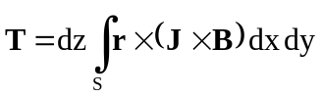, (XXI-89)
where 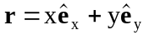. (XXI-90)
By using Equations XXI-81 and XXI-82 we find that
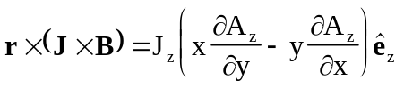. (XXI-91)
Once again, we want to convert the area integral into a contour integral. We can use the following identity
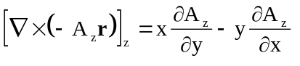. (XXI-92)
It follows that the torque can be written in any of the following three forms:
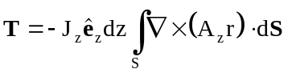, (XXI-93)
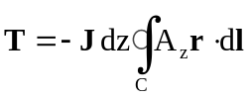, (XXI-94)
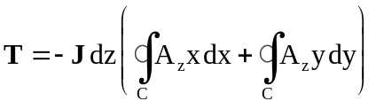. (XXI-95)
Equation XXI-95 is the form used in Force for the torque on a current carrying element. Note that the torque vector is parallel to the current density J.
For problems with cylindrical symmetry, one calculates the force and torque on a thin wedge of material. See Figure XXI-7 for a picture of the geometry in the case of a toroidal conductor. For the general case, the cross section of the conductor need not be a circle. The force on a wedge of angular width dθ is given by the formula
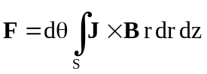. (XXI-96)
Assuming that J is independent of r and z, and that B is independent of θ, one finds that
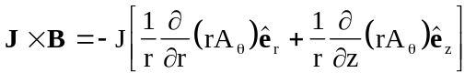 (XXI-97)
and hence the force is
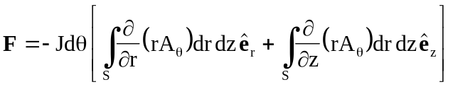. (XXI-98)
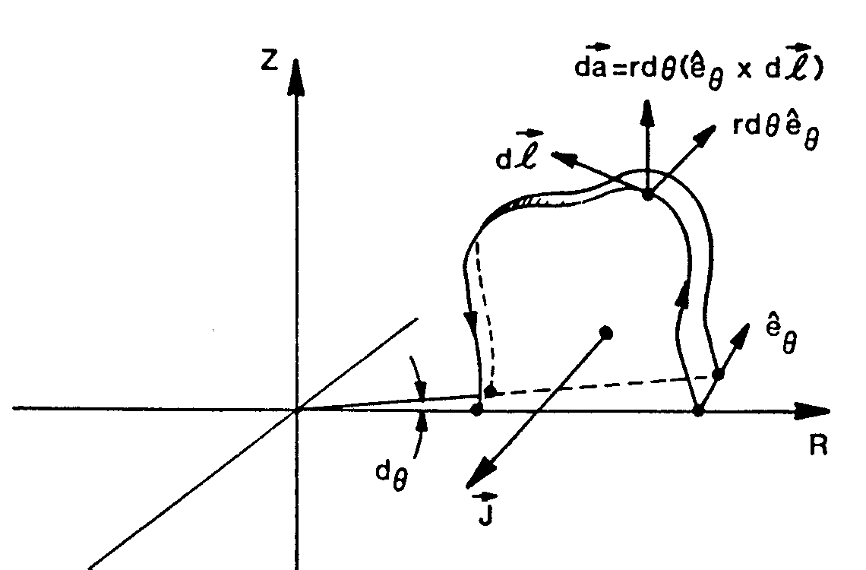
Figure XXI-7. Cylindrically symmetric conductor.
The conductor carries a current density J = −J_{θ}, where _{θ} = _{z}×_{r}.

We can see that the function rA_{θ} in cylindrical coordinates is just like the function A_{z} in Cartesian coordinates. The change from area integrals to line integrals is completely analogous to the Cartesian coordinate derivation. The final result is
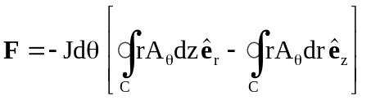. (XXI-99)
The final equation for the torque in cylindrical coordinates is
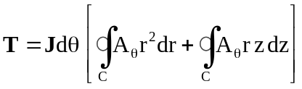. (XXI-100)
The above treatment must be generalized when one wants to calculate the force and torque on the iron, which does not carry a current density J. We will generalize the problem further by simultaneously treating electric as well as magnetic forces. The force density on a piece of ponderable matter is
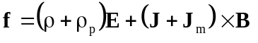, (XXI-101)
where ρ_{p} is the polarization charge density and J_{m} is the magnetization current density caused by aligning atomic magnetic dipole. It can be shown that
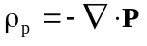, (XXI-102)
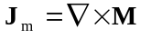, (XXI-103)
where 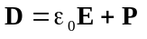, (XXI-104)
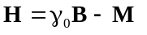. (XXI-105)
Maxwell’s equations in the static approximation are
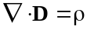 (XXI-106)
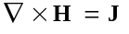. (XXI-107)
Equations XXI-101 through XXI-107 give the following equation for the force density,
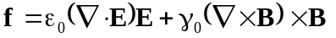. (XXI-108)
We next use two vector identities to convert this equation into one involving the electromagnetic stress tensor. The identities are
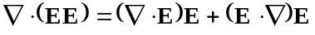, (XXI-109)
, (XXI-110)
where is the identity tensor. Equation XXI-109 is the divergence of a tensor formed from a product of the field vectors. Equation XXI-110 is the gradient of the scalar product. The gradient also can be written as the divergence of a diagonal tensor. Combining these equations gives the relation
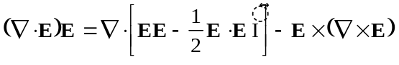. (XXI-111)
The last term in this equation is zero because of Maxwell’s equations. The quantity in the square bracket is the electric part of the electromagnetic stress tensor,
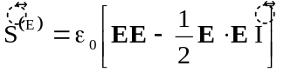. (XXI-112)
The magnetic part of the force also can be expressed as the divergence of a tensor. We use the same vector identities written in terms of B,
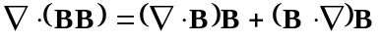, (XXI-113)
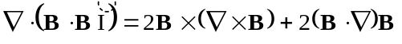. (XXI-114)
Combining these equations gives
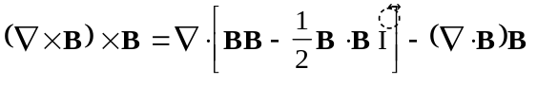. (XXI-115)
Again, the last term vanishes because of Maxwell’s equations. The magnetic stress tensor is defined as
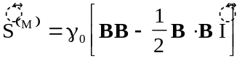. (XXI-116)
The total force on a volume V is
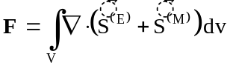. (XXI-117)
This result can be transformed into a surface integral by Green’s theorem
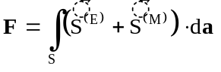. (XXI-118)
Let us consider the volume shown in Figure XXI-6. For two-dimensional Cartesian coordinates, we assume that B_{z} = 0 and B is independent of the z coordinate. Therefore, the integral over the front and back surfaces contribute nothing to the surface integral. The area element da is perpendicular to B and E and, therefore,
. (XXI-119)
For the (E⋅E + B⋅B) term, the contribution from the front face cancels the contribution from the back face. The integral on the ribbon edge of thickness dz is the whole integral. The differential area da can be written
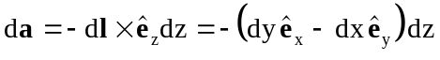, (XXI-120)
where the differential vector dl is pointing counterclockwise along the contour of the edge. The integrand is independent of z and, therefore, the surface integral becomes a contour integral in the x-y plane. After some algebra the contour integral can be expressed in Cartesian components. The resulting expressions for the components of the force are
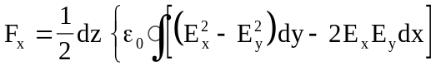
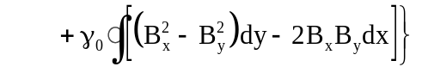. (XXI-121)
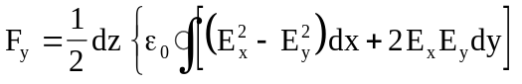
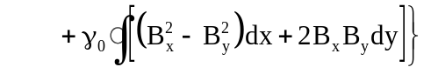. (XXI-122)
The beauty of these results is that in deriving them we had to make no assumption about the linearity of the relation between the fields E and D and between B and H. They are true with and without external charges and currents. Furthermore, there was no requirement that the charge or current densities be constant over the cross section of the material. The parallelism between the electric and magnetic parts of the force suggest that the coding will be the same for electrostatic and magnetostatic problems.
For completeness we give the formulas for the torque in Cartesian coordinates, and for the force and torque in cylindrical coordinates. Because of the parallelism between electric and magnetic forces, only the magnetic part is recorded in these formulas:
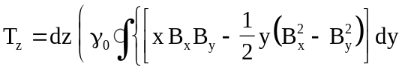
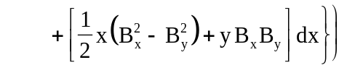. (XXI-123)
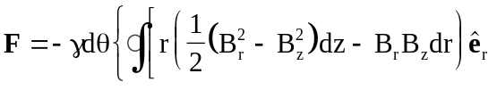
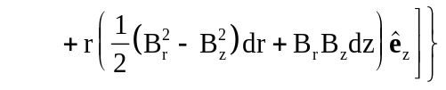. (XXI-124)
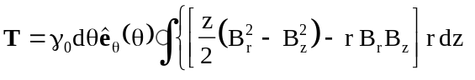
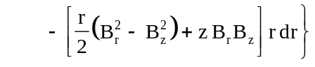. (XXI-125)
Note that the torque depends on the angle θ through the unit vector 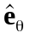. When integrated over the angle θ the result is identically zero.
In the case of Cartesian symmetry, the magnetic force and torque can be written in complex variables as
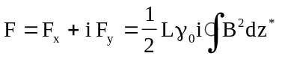, (XXI-126)
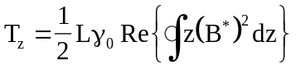. (XXI-127)

