File SFPHYS3.DOC contains the following bookmarks. Select the topic you are trying to find from the list and double click the highlighted text.

Physics discussions in other files
HREF="SFPHYS1.DOC | Theory of electrostatics and magnetostatics
HREF="SFPHYS2.DOC | Properties of static magnetic and electric fields
HREF="SFPHYS4.DOC | Numerical methods in Poisson and Pandira
HREF="SFPHYS5.DOC | RF cavity theory

File SFPHYS3.DOC Table of Contents
XXII. Boundary Conditions and Symmetries
A. Boundary conditions
1. Magnetic field near Dirichlet boundary
2. Electric field near Dirichlet boundary
3. Magnetic field near Neumann boundary
4. Electric field near Neumann boundary
B. Symmetry considerations
1. Reflection symmetry
2. Rotational symmetry

Boundary Conditions and Symmetries
This section is based upon the treatment in Part B, Chapter 13.5 by John L. Warren in the 1987 publication Reference Manual for the POISSON/SUPERFISH Group of Codes, LA-UR-87-126. The original chapter was titled “Boundaries and Meshes,” but the section on meshes was never completed.
The equation sequence numbers are the same as in the original. We have updated and expanded the discussion of boundary conditions and their relation to symmetries in the problem geometry.

Boundary conditions
The solution to a two-dimensional, second-order, partial differential equation like Poisson’s equation is not uniquely determined by the equation itself. One needs to place a constraint on the solution by specifying the value of the solution, and/or its derivative, along some closed boundary line.
Boundary conditions cannot be imposed arbitrarily. The most general allowed boundary condition depends on the type of differential equation (e.g., hyperbolic, elliptic, or parabolic). Poisson’s equation for the vector potential A(x, y) and reluctivity γ(A(x, y)) takes the form
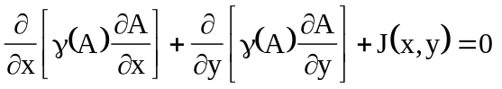, (XXII-1)
and is an elliptic differential equation. The most general boundary condition for elliptic equations is of the form
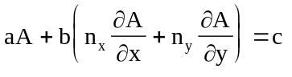, (XXII-2)
where a, b, and c are functions of position on the boundary curve. The quantities n_{x} and n_{y} are components of an inward pointing unit vector normal to the boundary curve.
In Poisson, the boundary curve is the perimeter of the mesh region. The boundaries between regions do not require imposed boundary conditions. The functions a, b, and c are piecewise constant on portions of the boundary. In fact, c is normally zero and either
a = 0 or b = 0 on a given portion of the boundary. This specialized form of boundary condition is rarely absolutely correct on the outer boundary of a meshed region. The error resulting from using incorrect boundary conditions is usually of little practical importance when one is concerned about the magnetic field far from the boundary. An excellent discussion of this point can be found in the book Computer-Aided Design in Magnetics by D. A. Lowther and P. P. Silvester (Springer-Verlag, Berlin 1986). When a portion of a boundary is a line of symmetry, then the boundary condition on that portion of the boundary can be exact. On other portions of the boundary, it may not be obvious how to impose a boundary condition. The magnet designer must rely on previous experience and on expectations for the final field.
We will define the nomenclature and derive some simple rules for choosing boundary conditions. The nomenclature used in the general theory of partial differential equations includes the terms in Table XXII-1. The boundary conditions allowed by Poisson Superfish codes are a special form of the inhomogeneous, intermediate case. Instead of a specification everywhere on the boundary, the codes allow specification of a boundary condition on some portion of the boundary. Thus, in the Automesh setup for a problem geometry, a Dirichlet boundary has A(x, y) = c, and a Neumann boundary has ⋅∇A specified on some portion of the boundary. The order in which regions appear in the Automesh input file affects the final boundary conditions. This order is especially important for HREF="sfcodes.doc#OverlappingRegions, which is discussed under Automesh.
Table XXII-1. Boundary condition terminology.
Term | Description
Dirichlet | A(x, y) is specified everywhere on the boundary.
Neumann | ⋅∇A is specified everywhere on the boundary.
Intermediate | Linear combination (see Equation XXII-2) is specified on the boundary.
Homogeneous | The specified value c in Equation XXII-2 is zero on the boundary.
Inhomogeneous | The specified value on the boundary is not zero .

Usually, the constant c is zero, but Automesh provides the means to set the potential on some portion of a boundary to a nonzero constant value. For CFISH problems, it is possible to specify a varying value of the real and imaginary parts of the magnetic field on a portion of the boundary. For example, along a radial boundary line in cylindrically symmetric coaxial lines, the code will make the field H_{φ} proportional to 1/r. Also, along a boundary of a rectangular waveguide in Cartesian coordinates one can define a sinusoidally varying field.
The boundary of the problem geometry has been divided into four pieces corresponding to the four sides of the rectangle at X locations X_{min} and X_{max} and at Y locations Y_{min} and Y_{max}. The Automesh input variables NBSLF, NBSUP, NBSRT, and NBSLO specify either pure Dirichlet (value = 0) or pure Neumann (value = 1) boundary conditions on the left, upper, right, or lower sides of the problem geometry, respectively. Because Automesh finds the values of X_{min}, X_{max}, Y_{min}, and Y_{max} by examining the region 1 data, the code ensures that the specified boundary conditions at the edge of the geometry are applied properly.
For users who are more familiar with the direction of the magnetic induction B or the electric field E than with the behavior of A(x, y), we present the following information. We derive equations that relate Dirichlet and Neumann boundary conditions to the field direction at the boundary. We start by writing the inward pointing unit vector normal to the boundary in the form
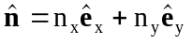. (XXII-3)
The unit vector , which is tangent to the boundary at this point and perpendicular to can be shown to be
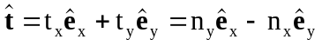. (XXII-4)
Table XXII-2 lists the magnetic and electric field directions near both types of boundary. The next few sections present the equation on which these conclusions are based.
Table XXII-2. Field directions near Dirichlet and Neumann boundaries.
Field | Dirichlet | Neumann
Magnetic | parallel to boundary. | perpendicular to boundary.
Electric | perpendicular to boundary. | parallel to boundary.

Magnetic field near Dirichlet boundary
For the Dirichlet boundary condition, since A(x, y) is constant on the boundary, the component of the gradient of A(x, y) parallel to the boundary is zero. This type of condition results in the relation
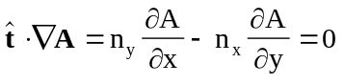. (XXII-5)
But we know that B_{x} = ∂A/∂y and B_{y} = −∂A/∂x. After making these substitutions, we can write Equation XXII-5 as
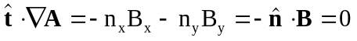. (XXII-6)
This equation implies that the magnetic field must be parallel to the Dirichlet boundary.

Electric field near Dirichlet boundary
For electrostatic problems, if V(x, y) is constant on the boundary we have the relation
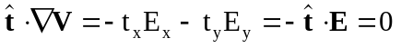, (XXII-7)
which implies that the electric field must be perpendicular to the Dirichlet boundary.

Magnetic field near Neumann boundary
For the Neumann boundary condition, the normal derivative of A(x, y) vanishes and leads to the relation
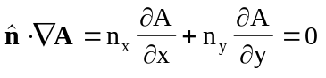. (XXII-8)
Again, after making the substitutions B_{x} = ∂A/∂y and B_{y} = −∂A/∂x, and noting from Equations XXII-4 that that n_{x} = −t_{y} and n_{y} = t_{x}, we can write Equation XXII-8 as
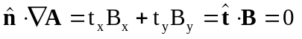, (XXII-9)
which implies that the magnetic field must be perpendicular to the Neumann boundary.

Electric field near Neumann boundary
For electrostatic problems, the Neumann boundary condition ⋅∇V(x, y) = 0 leads to the two equations
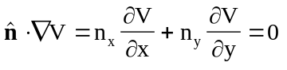, (XXII-10)
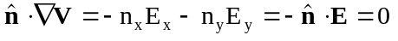, (XXII-11)
which implies that the electric field must be parallel to the Neumann boundary.

Symmetry considerations
In cases with symmetry, a Neumann or Dirichlet boundary condition can hold exactly. There are two main types of two-dimensional symmetry: reflection and rotation. Each type has two subtypes: the electric currents either change sign or they do not.

Reflection symmetry
Figure XXII-1 shows the two types of reflection symmetry and the directions of the field lines. The plane between two equal and opposite currents, which is called a separatrix, has ⋅B = 0 and corresponds to a Dirichlet boundary condition. The plane between currents of the same sign, called an “even line,” is a Neumann boundary. Note that both field patterns in Figure XXII-1 also have a horizontal even line not shown in the figure. Each problem can be solved using only a quarter of the geometry with the appropriate boundary conditions.
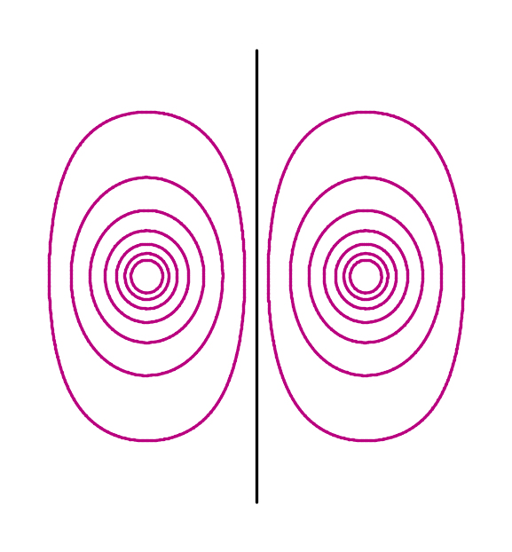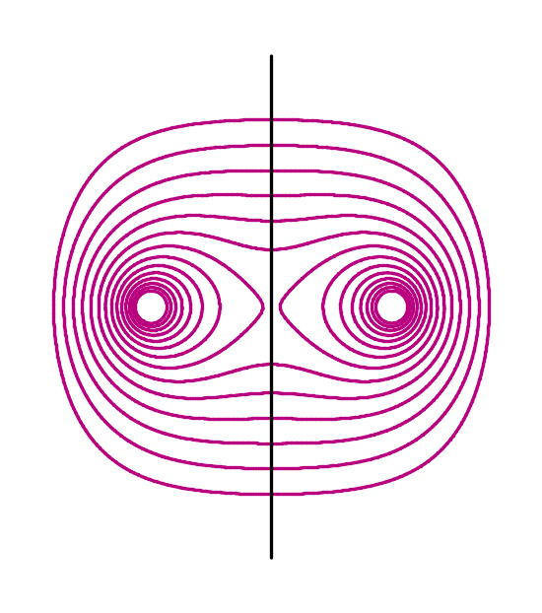
Figure XXII-1. Magnetic field lines for two type of reflection symmetry.
The field pattern at left has odd symmetry and the vertical line is known as a separatrix. The pattern at right has even symmetry and the vertical line is called an “even line.”

Rotational symmetry
Rotational symmetry introduces angular arrays of separatrices and/or even lines as illustrated in Figure XXII-2. If one of these special lines corresponds to the boundary of problem, then one can use these rules:
- For a separatrix, use a Dirichlet boundary condition, and
- For an even line, use a Neumann boundary condition.
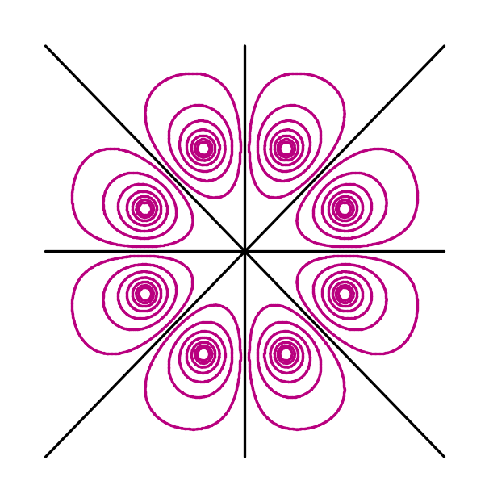
Figure XXII-2. Rotational symmetry.
A problem with rotational symmetry has arrays of reflection lines. In this example, only one octant is sufficient to define the problem.

When one cannot use symmetry or iron boundaries, then the allowed boundary conditions will only be approximate. It is still useful to look for separatrices between currents of different sign. When a separatrix coincides with a problem boundary, that boundary tends to be nearly a Dirichlet boundary. See the example in Figure XXII-3. Just outside of an iron region the field tends to be normal to that surface. These facts may help in choosing an appropriate (though approximate) boundary condition.

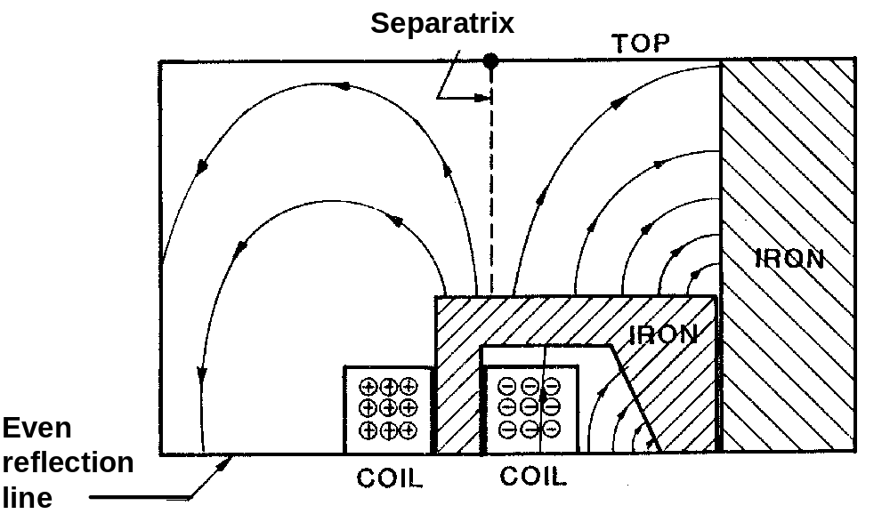
Figure XXII-3. Using a separatrix to choose an approximate boundary condition.
The separatrix (dashed line) intersects the top edge of the problem geometry. Hence, the field will be approximately parallel to the top boundary, so a Dirichlet boundary condition would be the appropriate choice.

