File SFPHYS5.DOC contains the following bookmarks. Select the topic you are trying to find from the list and double click the highlighted text.

Physics discussions in other files
HREF="SFPHYS1.DOC | Theory of electrostatics and magnetostatics
HREF="SFPHYS2.DOC | Properties of static magnetic and electric fields
HREF="SFPHYS3.DOC | Boundary conditions and symmetries
HREF="SFPHYS4.DOC | Numerical methods in Poisson and Pandira

File SFPHYS5.DOC Table of Contents
XXIV. RF Cavity Theory
A. Introduction to rf cavity theory for Superfish
1. TM and TE modes in cylindrical coordinates
2. TE modes in Cartesian coordinates
3. Formulas for auxiliary quantities in cylindrical coordinates
a. Energy per unit volume
b. Power losses on walls
c. Power losses on stems
d. Average accelerating field
e. Shunt impedance
f. Quality factor
g. Maximum electric field
h. Frequency perturbations
4. Units
5. Method of solution using a drive point
B. Detailed development of the RF cavity theory
1. Maxwell’s equations in cylindrical coordinates
2. Application of Poynting’s theorem
3. The D(k²) function
4. Solving problems in Cartesian coordinates

RF Cavity Theory
This section is based upon two chapters by John L. Warren from Part C in the 1987 publication Reference Manual for the POISSON/SUPERFISH Group of Codes, LA-UR-87-126. The Reference Manual chapters are Part C, Chapter 1 with the title “Summary of the Basic Theory” and Part C, Chapter 13 with the title “RF Cavity Theory”. We reproduce it here as reference material to the physics in the Poisson Superfish codes.
Part C, Chapter 1 included some information about equations used in the postprocessor SFO (called SFO1 in the older version). We have omitted the discussion of the transit-time factor in section A.3 below because the HREF="sfpostp.doc#SFO chapter contains a more detailed description.
We have made some modifications to reflect changes that have occurred in the codes. For consistency with the rest of this document, we have replaced the symbol θ with φ for the azimuthal angle. We also have corrected a few typographical errors in the original, including the following:
- The right-hand sides of Equations XXIV-51 and XXIV-52 (formerly C.13.1.22 and C.13.1.22), should not contain the factor 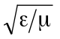.
- The sign on the right-hand side of Equation XXIV-51 should be positive.
- The left-hand side of Equation XXIV-59 (formerly C.13.1.30) was missing the volume element dv.

Introduction to rf cavity theory for Superfish
In 1976, Holsinger and Halbach published a paper describing a new way of solving the generalized Helmholtz equation
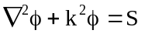
for the eigenvalues k and the eigenfunctions φ(x). The quantity S is called the source term. The applications were to rf waveguides in two dimensions and cylindrically symmetric rf cavities in three dimensions. The Helmholtz equation is an elliptic partial differential equation, hence the same type of boundary conditions are required for its solution as for the generalized Poisson equation, namely, φ(x) or its derivative must be specified on all portions of the mesh boundary, but not both on the same portion.
The first step in solving the problem is to define physical regions internal to the cavity and overlay these regions within a logical triangular mesh, which is then deformed into the so-called physical mesh. The sides of the triangles in the physical mesh conform as closely as possible to the physical boundaries of the regions. These steps are accomplished by program HREF="sfcodes.doc#Automesh.
The next step is to solve the Helmholtz eigenvalue problem. This task is performed by several codes that use the Superfish solver algorithm. The solution gives either the TM or TE modes of the cavity depending on the boundary conditions. Given the solutions, the user usually wants auxiliary properties such as plots of the electric field, transit-time factors, power losses on the cavity walls, and sensitivity of the eigenfrequencies to small perturbations of the cavity structures. Many of these auxiliary calculations are done in the postprocessors HREF="sfpostp.doc#WSFplot and HREF="sfpostp.doc#SFO.
In the sections that follow we present the basic forms of the Helmholtz equation for cylindrical and Cartesian coordinates, list the definitions of some auxiliary quantities calculated by the postprocessors and discuss the system of units used in the codes. This is followed by a short discussion of the numerical method used to solve the eigenvalue problem. In particular we discuss the significance of the drive point in obtaining a solution.

TM and TE modes in cylindrical coordinates
The most common application of Superfish is for finding the accelerating modes of a cylindrically symmetric accelerating cavity. These modes most often have TM₀₁₀-like field patterns. Section B, Detailed development of the RF cavity theory, shows that Maxwell’s equations take the form
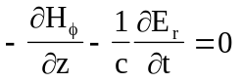, (XXIV-1)
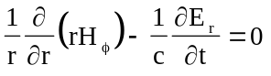, (XXIV-2)
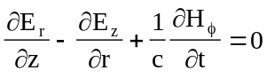, (XXIV-3)
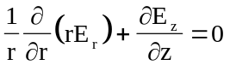, (XXIV-4)
where H_{φ} is the azimuthal component of the magnetic field expressed in electric field units. The true magnetic field is times H_{φ}. The permittivity and permeability are related to the speed of light as
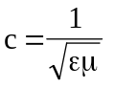. (XXIV-5)
The relative permittivity κ_{e}, and the relative permeability κ_{m}, are input parameters for each region, and they are used when printing quantities that use the true magnetic field (for example, in the postprocessors). Figure XXIV-1 shows the direction of the fields.
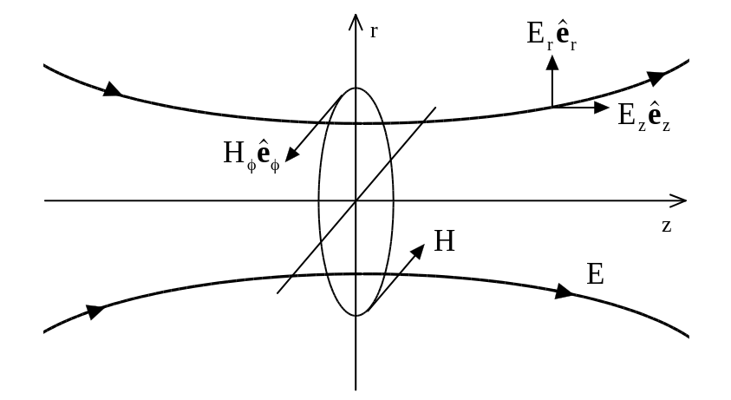
Figure XXIV-1 Field lines for the TM mode in a cylindrically symmetric rf cavity.
The magnetic field lines are out of the plane of the paper above the z axis and into the paper below the z axis.
In the TM mode, the r and z components of the magnetic field and the φ component of the electric field vanish. The equations for the TE modes of an rf cavity are very similar to those for the TM modes, namely,
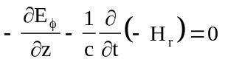, (XXIV-6)
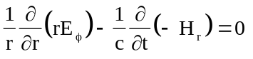, (XXIV-7)
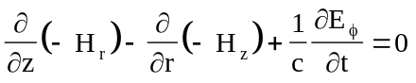, (XXIV-8)
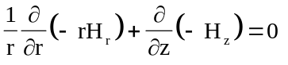. (XXIV-9)
The only differences between the equations for TE and TM modes are the interchange of E for H and the minus sign appearing before H_{r} and H_{z}. The output of Superfish assumes field components for the TM modes. The user can reinterpret the results for TE modes, if necessary. Generally speaking, the only difference between solving a problem for TE modes instead of TM modes is the boundary conditions.
We will work with the equations for the TM mode. If we assume that
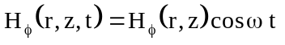, (XXIV-10)
and define the wave number
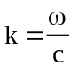, (XXIV-11)
then Equations XXIV-1 through XXIV-4 can be reduced to the form
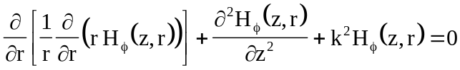, (XXIV-12)
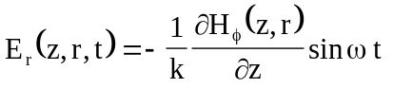, (XXIV-13)
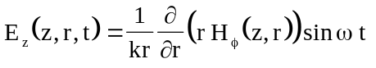. (XXIV-14)
Equation XXIV-12 is the Helmholtz eigenvalue equation, which can also be written as 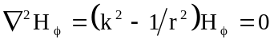. The other two equations define the electric-field components.

TE modes in Cartesian coordinates
Superfish also solves Maxwell’s equations in two-dimensional Cartesian coordinates. The main applications are to waveguides and cross sections of an RFQ accelerating cavity. We assume that the waveguide is infinitely long in the z direction and the fields are independent of z. That is, the program solves for the cut-off wavelength and fields. For Cartesian coordinates, one is usually interested in the TE mode. The geometry of the fields is illustrated in Figure XXIV-2. For the mode shown, the magnetic field is coming out of the end of the cavity. The equations solved by the code are

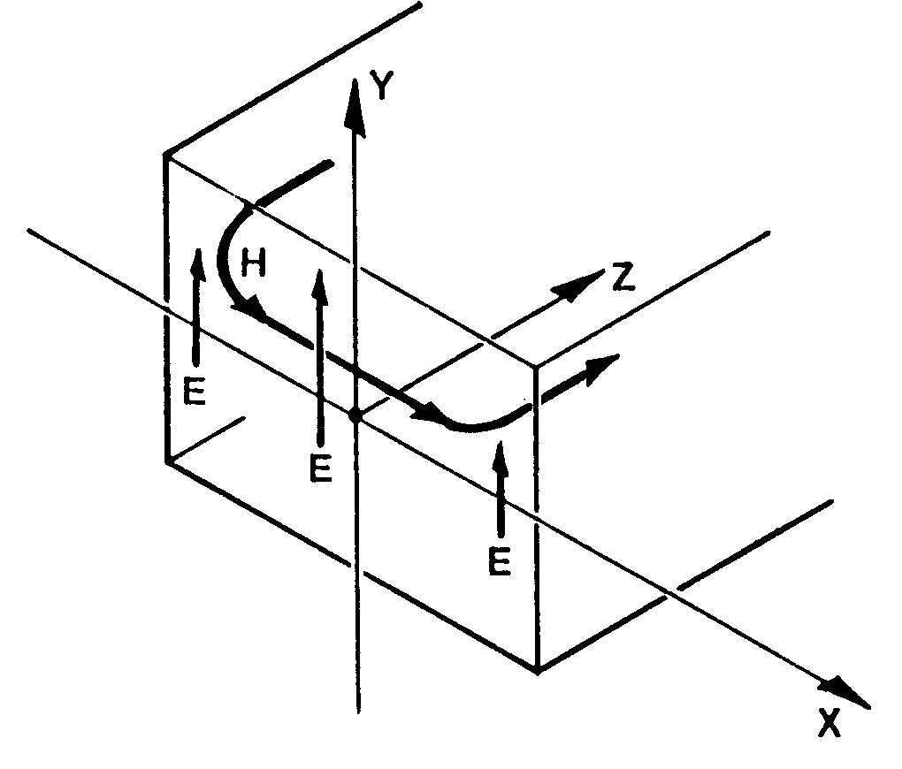
Figure XXIV-2. Waveguide geometry.
The figure shows the coordinate system for a rectangular waveguide with uniform cross section. Other shapes of arbitrary but uniform cross section may also be solved in Cartesian coordinates.

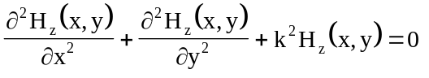, (XXIV-15)
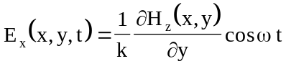, (XXIV-16)
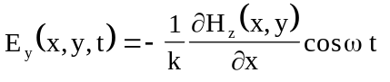. (XXIV-17)
The eigenvalue k is again given by Equation XXIV-11 and the component H_{z} is assumed to be proportional to cos ωt.

Formulas for auxiliary quantities in cylindrical coordinates
We describe here briefly several of the quantities computed by the postprocessor SFO. For more information, refer to the chapter on HREF="sfpostp.doc#SFO.

Energy per unit volume
In a high-Q rf cavity, the electric and magnetic fields are very nearly 90 degrees out of phase. The energy stored in the field shifts back and forth between the magnetic and electric field, but remains a constant, independent of time. Therefore, the energy per unit volume
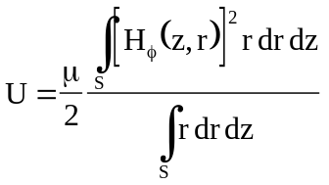 (XXIV-18)
can be evaluated when the magnetic field is maximum and the electric field is zero, without loss of generality. The integral is over the z-r cross section of the cavity. The integration over the angle φ has been carried out analytically.

Power losses on walls
If the electrical resistivity ρ of the cavity walls were zero, there would be no power loss and the electric field amplitude would go to zero at the wall. For walls with finite resistivity, the electric field penetrates into the wall and causes a current to flow. The power loss is given by the formula
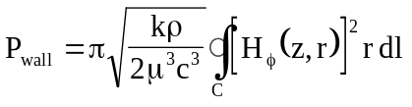. (XXIV-19)
The main approximation is that the field energy in the wall is much less than the field energy in the cavity. In cylindrical coordinates, the integral over the surface of the cavity is easily changed to a line integral around the cross section of the cavity in the z-r plane. Program SFO also includes options for computing the surface resistance of superconducting materials.

Power losses on stems
In drift-tube linac (DTL) tanks, the drift tubes are supported by cylindrical stems. The power dissipation on a stem of radius R_{stem} is give by
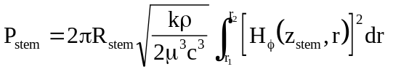, (XXIV-20)
where r₁ is the outer radius of the drift tube, r₂ is the radius of the tank holding the drift tubes, and z_{stem} is the z coordinate of the stem.

Average accelerating field
The average accelerating field E₀ is defined as the integral of the z component of the field along the beam direction:
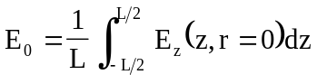. (XXIV-21)
The rf cell has length L and, in this formula, is assumed to be symmetric with the center of the gap between drift tubes located at z = 0. A more general treatment that can deal with asymmetric cells appears in the discussion of the HREF="sfpostp.doc#TransitTimeIntegrals under SFO.

Shunt impedance
Shunt impedance Z has dimensions of Ω/m and serves as a figure of merit for the accelerating efficiency. The larger the accelerating field for a given power loss per unit length, the more efficient the accelerator. For a total power loss P_{T}, the shunt impedance is give by
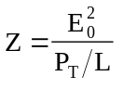. (XXIV-22)
In the case of a DTL cell, the power P_{T} includes both the wall losses and the stem losses. The SFO chapter includes a discussion of other accelerator HREF="sfpostp.doc#AcceleratorFiguresOfMerit.

Quality factor
The quality factor Q is a ratio of the energy stored in the cavity to the energy dissipated in the walls per rf cycle. A high Q is desirable if it means low power dissipation, but is not necessarily desired if it means large stored energy because it implies a sensitivity to frequency errors. For pulsed systems, high Q also implies a long time constant for filling the cavity with rf energy.

Maximum electric field
The maximum electric field E_{max} on a metal boundary is important because it determines whether and where electrical breakdown will occur. The code SFO searches for this location while computing power and fields on all of the segments. The code reports the peak electric field in the output summary.

Frequency perturbations
It is also useful to know how sensitive the resonant frequency is to errors in the size of the cavity. The frequency sensitivity is determined from the Slater-perturbation theorem, which states that for small perturbations the relative change in resonant frequency caused by a perturbation that decreases the volume of the cavity by an amount δV is given by
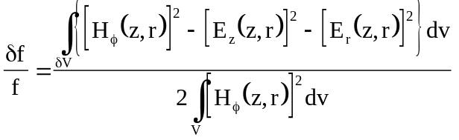, (XXIV-23)
where the integral in the denominator is over the cavity volume. When the perturbation is a stem, the formula is
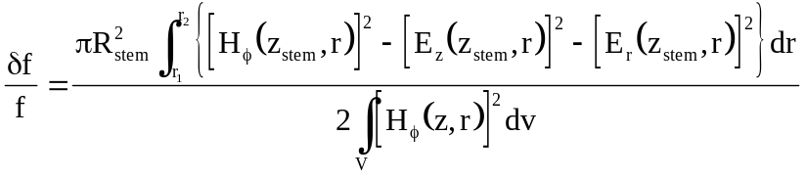. (XXIV-24)

Units
Before running Superfish the user must define the cavity and give a starting frequency in HREF="sfcodes.doc#Automesh. Input and output length units may be defined by the user relative to the default units of cm. The Automesh input variable CONV is the number of centimeters per unit length desired. Angles entered in Automesh are in degrees. The starting frequency f (= ω/2π) is in MHz.
All quantities appearing in the output of Superfish will have properly identified units. In SFO, quantities such as power losses, electric fields, etc. are normalized to the average axial electric field E₀, which has a default value of 1.0 MV/m.

Method of solution using a drive point
The solution method in the rf solver codes is based on Stoke’s Theorem in vector analysis. Equations XXIV-12 and XXIV-15 are special cases of the equation
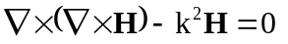 (XXIV-25)
where H is a function of (z, r) in cylindrical coordinates or of (x, y) in Cartesian coordinates. To solve this equation in the region of interest, we introduce a triangular mesh and derive a linear difference equation at each mesh point. Figure XXIV-3 shows the neighborhood of a given mesh point.
We introduce a secondary mesh by drawing connecting lines between the “center of mass” of every triangle and the center of each of the six lines connecting point 0 to its nearest neighbors 1 through 6. The mesh point 0 is now surrounded by a unique 12-sided polygon. The secondary mesh of dodecagons covers completely the whole region of the problem. The difference equations for H are now obtained by integrating Equation XXIV-25 over the area, one dodecagon at a time. This yields the equation
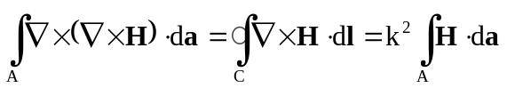. (XXIV-26)
If we assume that H can be approximated by a linear function of the variables (z, r) or the variables (x, y) within every triangle, then H inside every triangle is uniquely determined by the values of H at the three corner mesh points of the triangle. The integrals in Equation XXIV-26 can be done analytically and the results expressed in terms of the value of H at the mesh point n and its six nearest neighbors, giving a set of homogeneous equations of the form
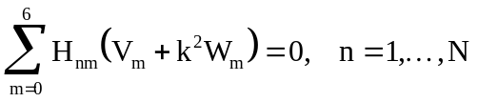, (XXIV-27)
where N is the number of mesh points. This set of equations can be thought of as an N by N matrix of coefficients multiplying a column matrix containing the values of H at the mesh points. This matrix is very sparse with at most six entries in each row. The equations then take the form
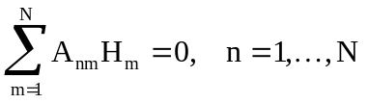, (XXIV-28)
where the single index m on the field H now runs from 1 to N. We use the so-called direct method for solving this set of equations, which requires converting this set of homogeneous equations into a set of inhomogeneous equations. This conversion is accomplished by replacing one of the equations (say, the equation for mesh point p) by the simple equation
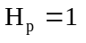. (XXIV-29)
The prescription for making the set of equations inhomogeneous is as follows: Set equal to zero every matrix element in row p and in column p, except for the (p, p) diagonal element, which is set equal to one. Column p is moved to the right side of the equation and its sign is changed except for the element in row p, which is set equal to one.

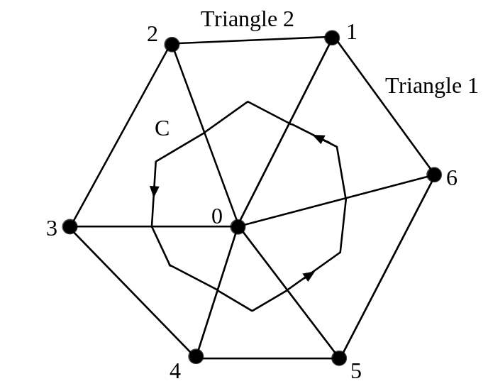
Figure XXIV-3 Six nearest neighbors of point 0 in a triangular mesh.
The contour C is the path of integration in Stoke’s Theorem.

The direct solution then gives values of H at all other mesh points. If we take the original difference equation for the mesh point p, we can solve for H_{p}. This value will in general differ from one except at resonance. The difference can be interpreted as being proportional to the current I(k) necessary at that point to drive the cavity to the prescribed amplitude of H = 1 at the mesh point p. For this reason, we refer to this mesh point as the “driving point.” In essence, Superfish finds the eigenvalues k by numerically finding the zeros of a functional proportional to I(k).
The location of the drive point is arbitrary. In practice, the drive point should not be placed at a point where the value of the magnetic field in the TM mode of interest is nearly zero. This placement would result in a current I(k) that is very flat as a function of frequency, making it difficult to find the zero crossing. The algorithm for choosing the default location of the drive point usually leads to quick convergence, but for cavities with unusual shapes the default drive point location may not be optimum.

Detailed development of the RF cavity theory
This section presents the theory behind Superfish. The problem is to find the electromagnetic resonance frequencies and evaluate the field components in a cavity surrounded by perfectly conducting walls. As with Poisson, there are two geometries that can be handled: three-dimensional geometries with cylindrical symmetry and two-dimensional geometries in Cartesian coordinates. The theory will be presented for cylindrical symmetry. At the end we will indicate the modifications for Cartesian coordinates.
Although there are no real currents or charges in the cavity, we introduce a fictitious magnetic current density K, and magnetic charge density σ that will “drive” the fields in the cavity. At resonance, the amount of current needed to drive the cavity approaches zero. The criterion in the codes used to determine the resonance frequency during the iteration sequence relies on this fact.
We shall assume that the medium in the cavity is homogeneous, isotropic, and non-conducting, with piecewise constant permittivity and permeability so that
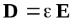, (XXIV-30)
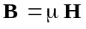. (XXIV-31)

Maxwell’s equations in cylindrical coordinates
With cylindrical symmetry E, H, K, and σ are independent of φ. Maxwell’s equations can be written in two sets, which are
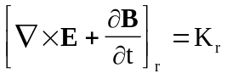 or 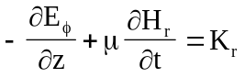, (XXIV-32)
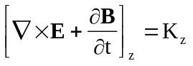 or 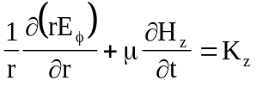, (XXIV-33)
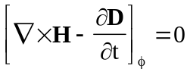 or 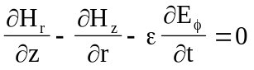, (XXIV-34)
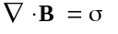 or 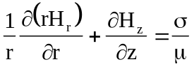, (XXIV-35)
and
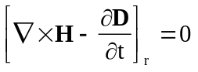 or 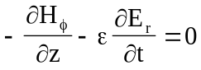, (XXIV-36)
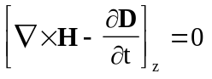 or 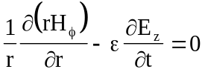, (XXIV-37)
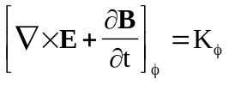 or 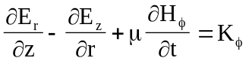, (XXIV-38)
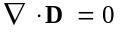 or 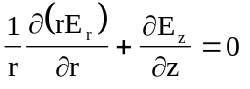. (XXIV-39)
Note that, the first four equations involve the field components H_{r}, E_{φ}, and H_{z}, while the last four are nearly identical but involve E_{r}, H_{φ}, and E_{z}. This grouping corresponds to a separation into transverse electric (TE) modes for which E_{φ} ≠ 0 and transverse magnetic (TM) modes for which H_{φ} ≠ 0. It is usually the TM modes of the cavity that are of interest to accelerator designers, because they have nonzero axial E_{z}, which can be used to accelerate a beam of charged particles. The Automesh chapter includes a discussion of settings necessary for the HREF="sfcodes.doc#ComplementarySolution.
Equations XXIV-32 through XXIV-34 can be combined to give a second-order partial differential equation for E_{φ} alone. Differentiate Equation XXIV-32 by z, differentiate Equation XXIV-33 by r, subtract the two results, and make use of Equation XXIV-34 to eliminate the combination ∂H_{r}/∂z − ∂H_{z}/∂r. The result is
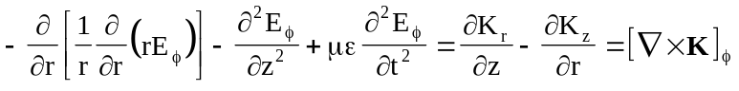. (XXIV-40)
Similarly, we can obtain an equation for H_{φ} by using Equations XXIV-36 through XXIV-38. The result is
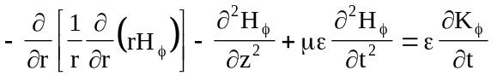. (XXIV-41)
We are interested in solutions that are periodic in time. Let us arbitrarily assume that
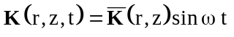, (XXIV-42)
where ω is an angular frequency (ω = 2πf). It then must follow from Equations XXIV-40 and XXIV-41 that
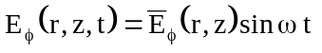, (XXIV-43)
and 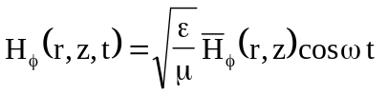. (XXIV-44)
This definition of 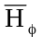 makes 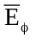 and have the same dimensions. As a result, the same coding can be used for both the TE and TM modes in Superfish. When these assumptions are put into Equation XXIV-40 and Equation XXIV-41, the results are
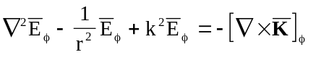, (XXIV-45)
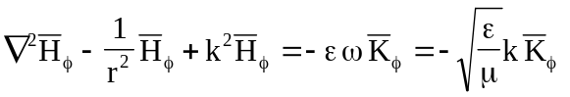, (XXIV-46)
where 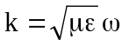 (XXIV-47)
is called the eigenvalue and
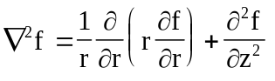 (XXIV-48)
is the two-dimensional Laplacian in cylindrical coordinates. Given and from these equations, one can use Equation XXIV-32 through Equation XXIV-37 to find H_{r}, H_{z}, E_{r}, and E_{z}. The integration over time is trivial. The constants of integration just determine the initial phase of the fields at time t = 0 and can be set equal to zero for our purposes. The results are
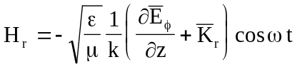, (XXIV-49)
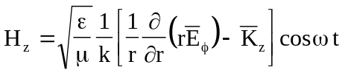, (XXIV-50)
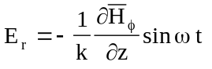, (XXIV-51)
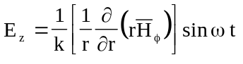. (XXIV-52)
It is easily seen that Equation XXIV-39 is identically satisfied and that Equation XXIV-35 is satisfied if
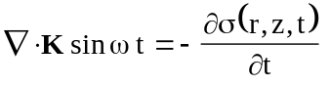. (XXIV-53)
Equation XXIV-53 is just the equation of continuity for magnetic current with the magnetic charge given by
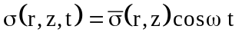. (XXIV-54)
Note that in the TM mode, the electric field lines are parallel to the lines of constant rH_{φ}, which can be seen as follows. A field line is a curve r(z) whose tangent is proportional to the ratio of the electric field components, thus
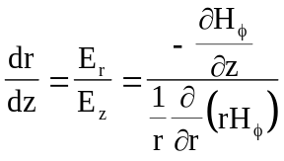. (XXIV-55)
This equation implies that
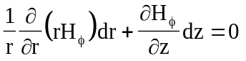, (XXIV-56)
or, multiplying through by r,
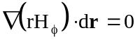, (XXIV-57)
which implies that rH_{φ} is a constant along an electric field line. This result is used in the plotting program WSFplot.

Application of Poynting’s theorem
It is helpful in understanding the Halbach and Holsinger paper [“SUPERFISH -- A Computer Program for Evaluation of RF Cavities with Cylindrical Symmetry,” Particle Accelerators 7 (4), 213-222 (1976)] to apply the Poynting theorem to the cavity fields. Poynting’s theorem in this case can be written as
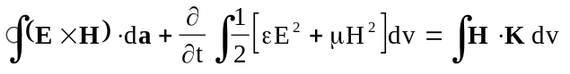, (XXIV-58)
where the first term on the left is interpreted as the flow of energy out across the cavity surface a, enclosing the volume v. The second term on the left is the change in energy of the electromagnetic fields in the enclosed volume. The term on the right is the rate of work being done on the field by the magnetic current. Let us introduce the time dependence and carry out the time derivative. Since the cavity is closed, the surface integral must vanish. The result is
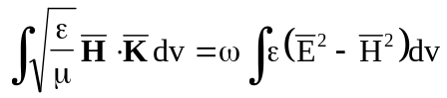, (XXIV-59)
where 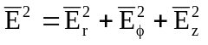 and 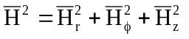. (XXIV-60)
This is the generalized version of Equation 8 in the Halbach and Holsinger paper for cavities containing dielectric or permeable material. Equation XXIV-59 differs from their result in that it is no longer possible to take k out of the integral because ε and μ need not be constants. Only the frequency ω can be factored out of the integral.

The D(k²) function
[The 1987 Reference Manual used the notation D(ω²) to refer to the function D(k²). For consistency with other parts of this document, we use the notations D(k²), where the wave number k = ω/c = 2πf/c. Halbach and Holsinger also use this notation in their paper on Superfish.]
Equation XXIV-59 gives us a frequency dependent quantity proportional to the fictitious magnetic current that can be used to determine when resonance occurs. The program uses the normalized quantity
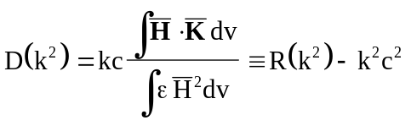. (XXIV-61)
From Equation XXIV-59, it is easily seen that
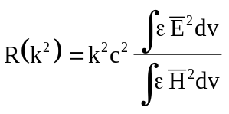. (XXIV-62)
Resonance occurs when D(k²) = 0, which implies that no magnetic current is required to maintain fields in the cavity. It also means that R(k²) = k²c² = ω², which implies that the energy stored in the electric field is equal to the energy in the magnetic field.
The criterion that D(k²) = 0 is not sufficient to determine the resonances. It is also necessary that dD(k²)/d(k²) = −1. Between pairs of D(k²) roots where the slope is −1 there is also a root where the slope is +1, which can be seen as follows. Let the derivative with respect to k² be denoted by a prime,
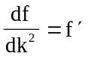. (XXIV-63)
In vector form, after the time dependence has been removed, Maxwell’s equations become
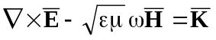, (XXIV-64)
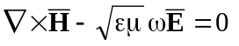. (XXIV-65)
These equations imply that
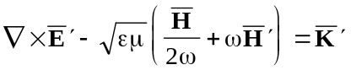, (XXIV-66)
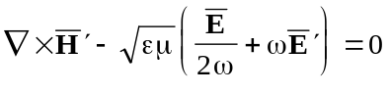. (XXIV-67)
If now we calculate
, (XXIV-68)
we find that
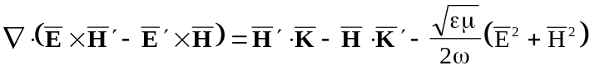. (XXIV-69)
If now we integrate over the volume of the cavity and note that the expression
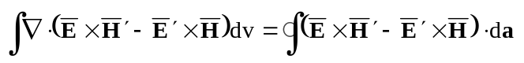 (XXIV-70)
can be made to vanish with the proper boundary conditions, then
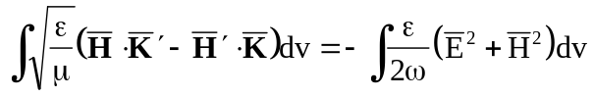. (XXIV-71)
If we let the fictitious current 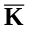vary with ω in such a way that 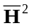 is not changed as we approach resonance, then 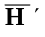 = 0 and we get the formula
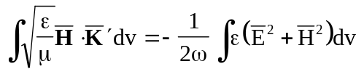. (XXIV-72)
Next, we take the derivative of D(k²) in Equation XXIV-61, obtaining the result
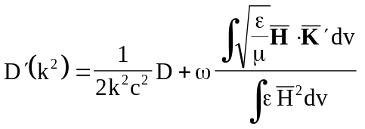, (XXIV-73)
or 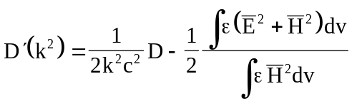. (XXIV-74)
At resonance, D = 0 and the electric energy equals the magnetic energy so that
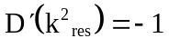. (XXIV-75)
Suppose ω₁ and ω₂ are two adjacent resonant frequencies corresponding to wave numbers k₁ and k₂. At these frequencies, D = 0 and D′ = −1, as illustrated in Figure XXIV-4. If D is a continuous function, somewhere between ω₁ and ω₂ there must be a place where D = 0 but D′ > 0, which is a “false” resonance root. The data shown in Figure XXIV-4 comes from a sample problem in directory HREF="sfexmpl1.doc#FrequencyScan. This on-axis coupled cavity has two modes at frequencies 762.998 MHz and 824.558 MHz, which correspond to k₁ and k₂ in the figure.
The radio-frequency solver programs use properties of the D function to improve convergence to a resonance. There have been HREF="sfintro.doc#RootFinderHistory in the root finder in the present version of the codes compared to the original root finder.
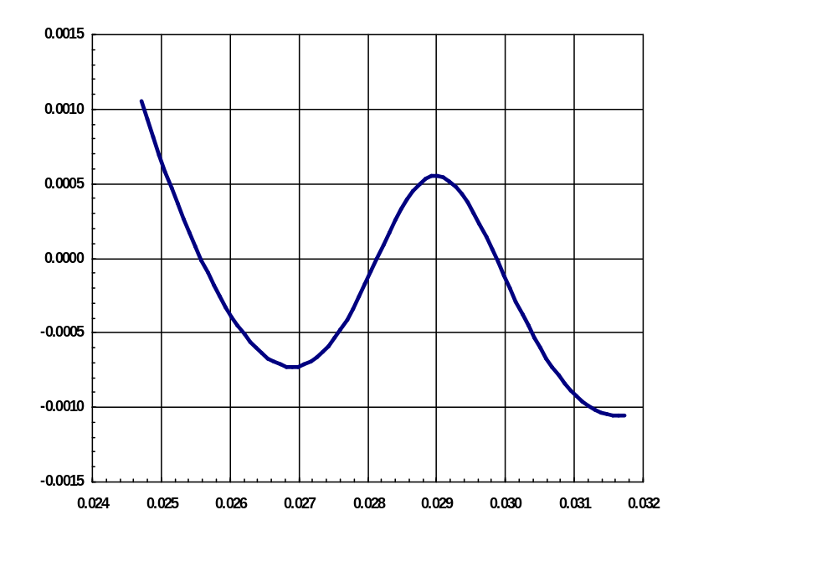
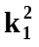
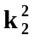
k²
D(k²)
Figure XXIV-4 Demonstration that D(k²) has a “false” zero.
The points at and where the slope is −1 are true resonances. The zero crossing where the slope is +1 does not correspond to a resonance.

Solving problems in Cartesian coordinates
The modifications to the above theory for application to waveguides, cross sections of radio-frequency quadrupole (RFQ) cavities, and other uniform shapes are straightforward. All that must be done is to replace the Laplacian given in cylindrical coordinates by the Laplacian given in Cartesian coordinates. Refer again to Figure XXIV-2, which shows a waveguide of uniform cross section. The directions of the coordinate axes are indicated on the figure.
The only waveguide modes that can be calculated by Superfish are the TE and TM cutoff modes, namely, those modes that have zero propagation vector along the z axis. Fortunately, these are the modes of interest in the design of an RFQ cavity. Let us repeat the derivation given for cylindrical coordinates, but with a slight variation. Once again, we start with Maxwell’s equations
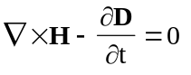, 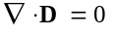, (XXIV-76)
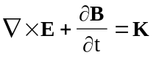, 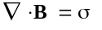. (XXIV-77)
To see more clearly what Holsinger and Halbach have done in the code, we write the material relations in the following form
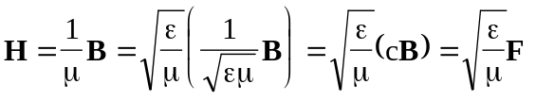, (XXIV-78)
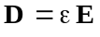. (XX-79)
The field F has the same physical dimensions as those of the electric field E. In terms of E and F, Maxwell’s equations take the form
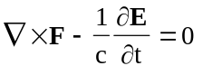, 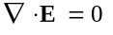, (XXIV-80)
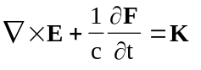, 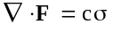. (XXIV-81)
In the usual fashion, we can derive the wave equation for F by taking the curl of the first equation and substituting for the curl of E from the third equation. This procedure leads to the following sequence of equations
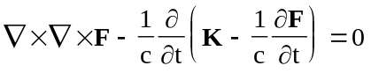, (XXIV-82)
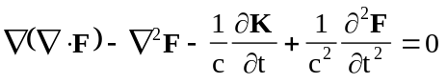, (XXIV-83)
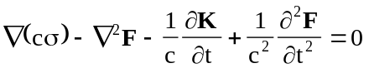, (XXIV-84)
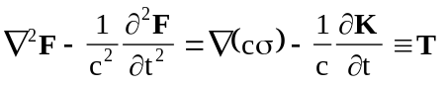. (XXIV-85)
By taking the curl of the third Maxwell equation and substituting for the curl of F from the first equation, one can derive a wave equation for the electric field E, which takes the form
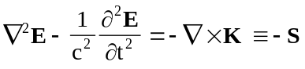. (XXIV-86)
A trial solution for the TE propagating wave mode in Cartesian coordinates takes the form
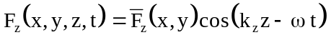. (XXIV-87)
When this function is substituted into the z component of Equation XXIV-85, one obtains the equation
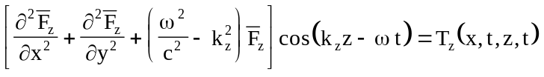. (XXIV-88)
The z and t dependence can be removed from this equation by assuming that the fictitious driving magnetic current and charge take the following form
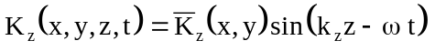, (XXIV-89)
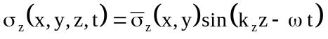. (XXIV-90)
The final equation for 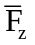 is
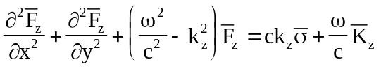. (XXIV-91)
It can be shown that, if we assume the following relations for E_{z}, K_{x}, and K_{y},
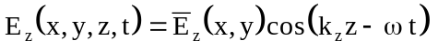, (XXIV-92)
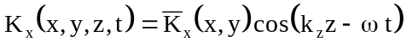, (XXIV-93)
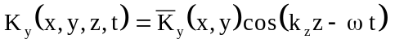, (XXIV-94)
then the wave equation for 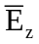 reduces to
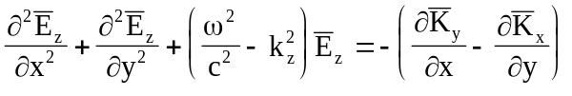. (XXIV-95)
One can get a self-consistent set of equations by assuming further the following relations
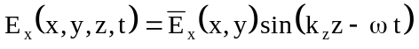, (XXIV-96)
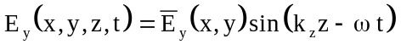, (XXIV-97)
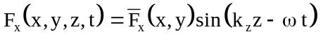, (XXIV-98)
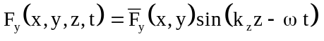. (XXIV-99)
When these relations are put into the first and third Maxwell equations, the result is
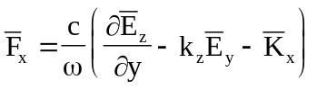, (XXIV-100)
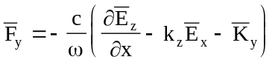, (XXIV-101)
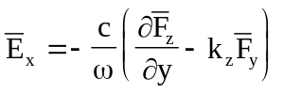, (XXIV-102)
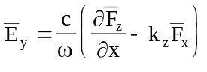. (XXIV-103)
Since the quantities 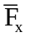, 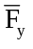, 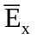, and 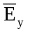 occur on both sides of the above four equations one can further simplify the equations by proper substitutions. The final result is
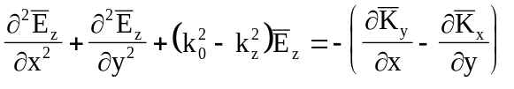, (XXIV-104)
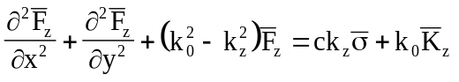, (XXIV-105)
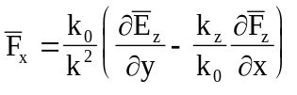, (XXIV-106)
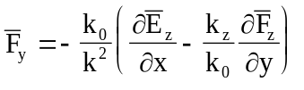, (XXIV-107)
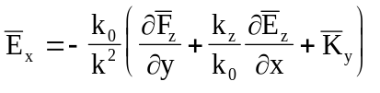, (XXIV-108)
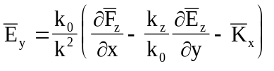, (XXIV-109)
where the quantities k and k₀ are defined by the relations
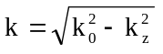, (XXIV-110)
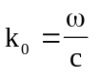. (XXIV-111)
These equations cannot be further separated unless we assume that we are dealing with the cutoff mode for which the wave vector k_{z} is zero. Under these circumstances the equations above break into two sets. The first set involves the field components 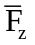, and . This set corresponds to the TE mode. The second set of equations involves the field components , , and , which corresponds to the TM mode. There is no need to be concerned about the magnetic current and charge densities in these equations, because they will vanish at resonance.
The theory for finding the resonant modes in Cartesian coordinates follows very closely the theory presented above in cylindrical coordinates.

