Phase 2 Assessment:Flyaway Airlines

-Nancy T Thomas

Intern

Trivium eSloutions

Project Objective: design and develop an airline booking portal named as FlyAway. Use the GitHub repository to manage the project artifacts.

The project has the required features:

* A search form in the homepage to allow entry of travel details, like the date of travel, source, destination, and the number of persons.
* Based on the travel details entered, it will show the available flights with their ticket prices.
* Once a person selects a flight to book, they will be taken to a register page where they must fill in their personal details.
* In the next page, they are shown the flight details of the flight that they are booking, and the payment is done via a dummy payment gateway.
* On completion of the payment, they are shown a confirmation page with the details of the booking.

An admin will be there at the backend with the following features:

* An admin login page where the admin can change the password after login, if he wishes
* A master list of places for source and destination
* A master list of airlines
* A list of flights where each flight has a source, destination, airline, and ticket price

SCREENSHOTS OF THE PROJECT:

ADMIN LOGIN

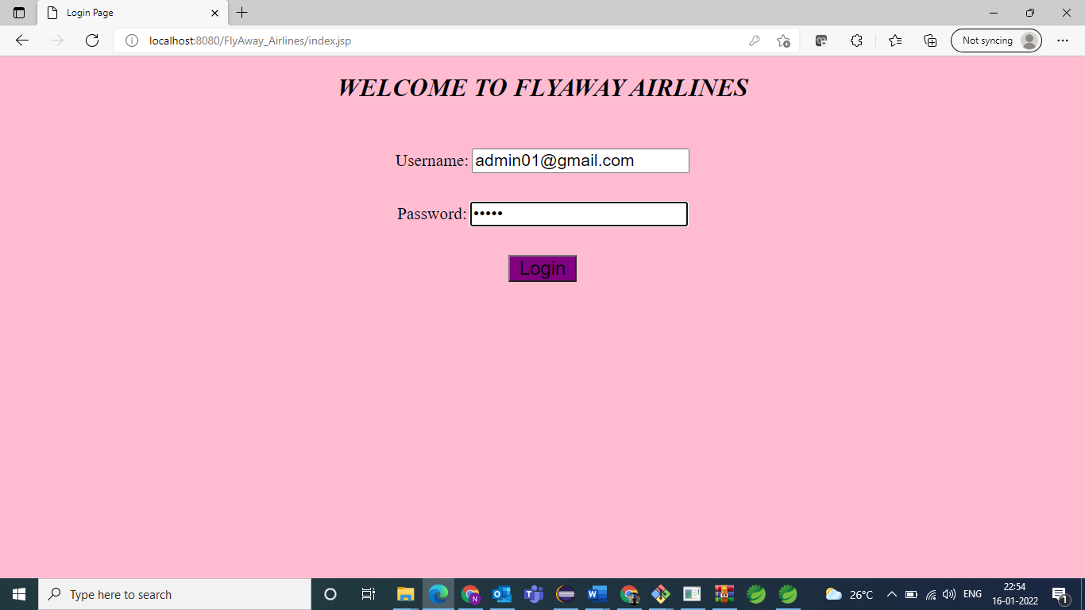

Admin’s password before updating

Admin resetting the password

Updated Password is reflected on the table

USER LOGIN

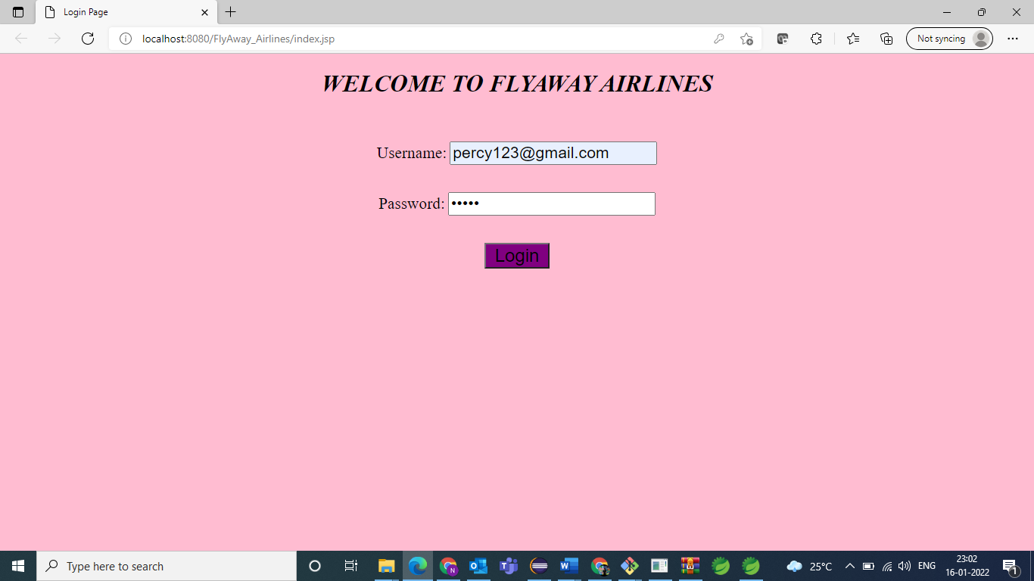

Booking Information

Flight details

Registration

Payment

Confirmation Slip

Login page is is displayed after clicking on go back home

Tables in the database

