**Setup SOAP Project**

(1)First download the project [SOAPUI-SOAPProject.xml](https://github.com/tnaswin1/soapuiprojects/blob/master/SOAPUI-SOAPProject.xml) from repository

(2)Import the project into your SOAPUI workspace as below

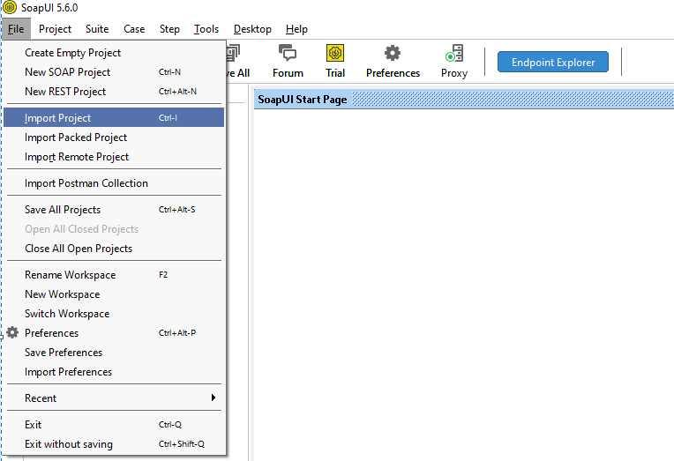

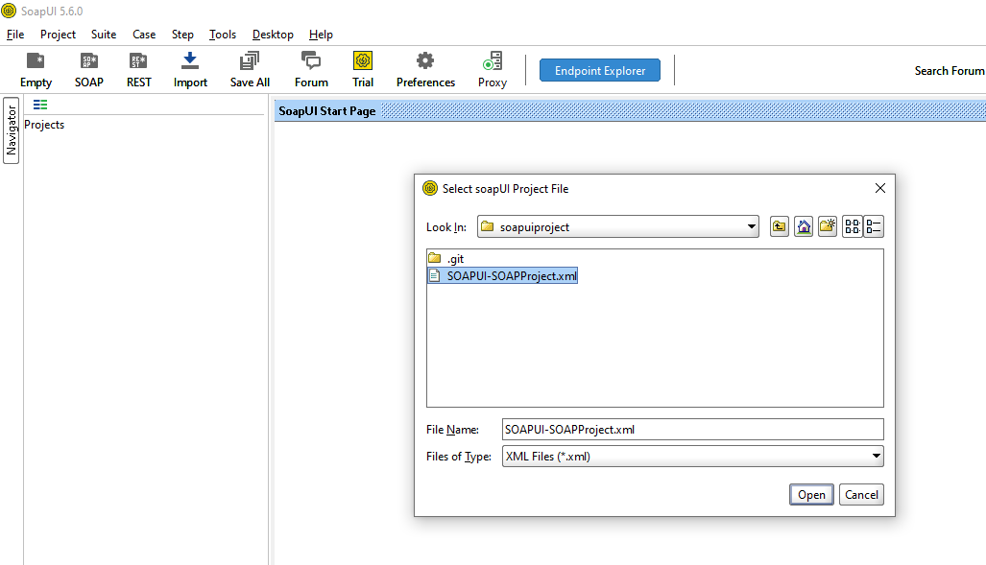

(3)This is the standard demo project that comes as part of the SOAPUI tutorials. On top of it additional test cases have been added to explain various SOAPUI features including Groovy automation

(4)Start the SOAPUI project service that will make the service active before you start running any test case as below

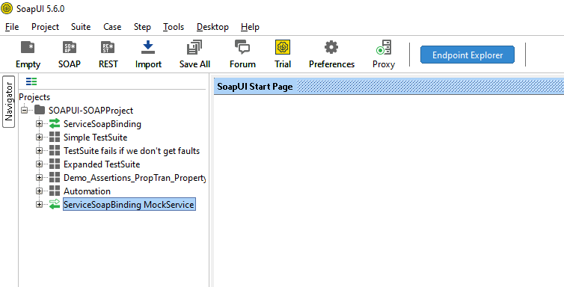

Double click on ServiceSoapBinding MockService highlighted above

Click on the play button in green to make the service active

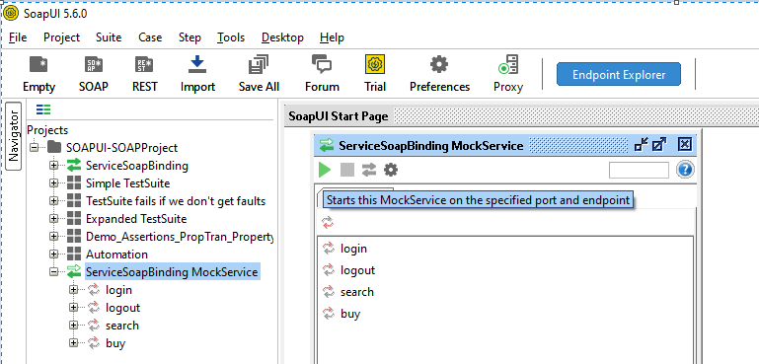

Service will start running on a port. Below its running on port 8088

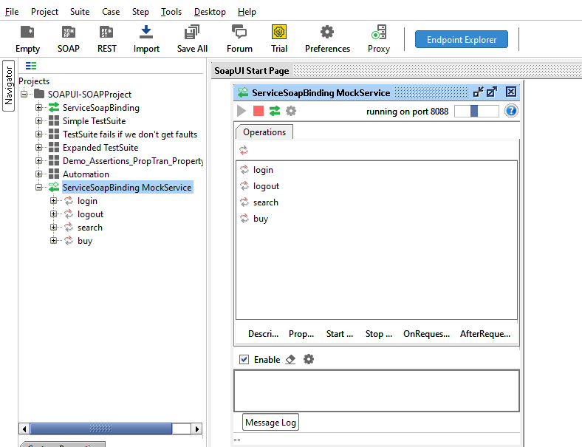

(5)Now the SOPAUI project test cases are ready to be run

