Git and Github:
https://github.com/PushpalathaSK/Batch1/blob/main/Materials/Git%20and%20GitHub.pdf

Local to Github Workflow:
https://docs.google.com/document/d/1oZKD8ktn3vWoqRYSk5Bbf8_O5vnOsEGo/edit?usp=sharing&ouid=113796576448524507522&rtpof=true&sd=true
If Git is connected to Other Profiles
Reference:
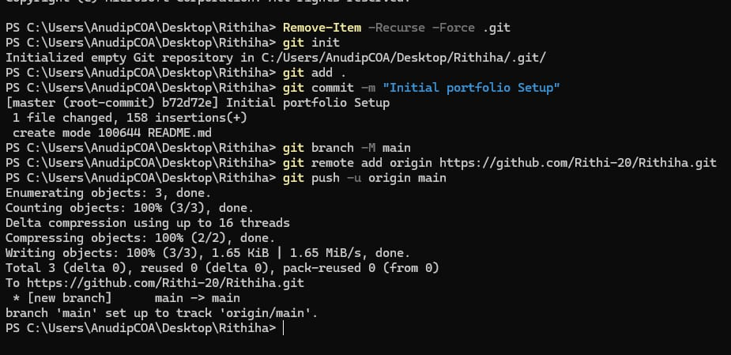
Additional resources:
https://www.youtube.com/watch?v=S7XpTAnSDL4
Git commands story.png

LinkedIn Ref Profile
Ref profile:
https://www.linkedin.com/in/kunal-kushwaha/

