**Rates of biome shift predict diversification dynamics in flowering plants**

James D. Boyko12*   
Thais Vasconcelos1  
1 Department of Ecology and Evolutionary Biology, University of Michigan, Ann Arbor, Michigan 48109, USA  
2 Michigan Institute of Data Science, University of Michigan, Ann Arbor, Michigan 48109, USA

* Corresponding author

# **Abstract**

The remarkable diversity of angiosperm species has prompted a search for universal drivers that modulate rates of speciation and extinction across this clade. To date, attempts to explain differences in species diversity have focused on the potential correlation of diversification rates with particular key traits. However, an often-overlooked explanation is that evolutionary lability, here defined as the rates of trait change, is a better predictor of the diversification dynamics than the observed traits themselves. This hypothesis, first proposed in the context of biome shifts 50 years ago, is based on the idea that the capacity to adapt to environmental changes is the key element defining angiosperm diversification dynamics. Using a phylogenetic dataset of 49 angiosperm clades including 18,617 species we demonstrate that the propensity of change between open and closed-canopy biomes is significantly correlated with lineage speciation and extinction rates across clades. Additionally, we find that transition rates tend to be faster from open to closed-canopy biomes. This results in ancestral state estimates that favor several deep time origins of open-canopy biomes, contrary to prevailing ideas that lineages occurring in open-canopy biomes tend to emerge from closed-canopy ones in angiosperms. We propose that a shift in focus from static traits to dynamic evolutionary processes may provide a more comprehensive understanding into how biodiversity is generated and maintained, in angiosperms and other organisms.

**Significance Statement**

That rates of diversification differ between lineages is well established in evolutionary biology. To date, most explanations of this heterogeneity have focused on finding key traits that moderate evolutionary rates. However, heterogeneity can manifest itself as trait lability and diversification may be better predicted by this than a single trait. Here, we demonstrate this by using hidden-Markov models, which allow for several rate classes associated with speciation, extinction, and transition between trait states across a phylogeny. We show that the rate of transition between traits is positively correlated with speciation and extinction rates across clades. This demonstrates that although generalities in single traits have seldom been supported, a potential generality is that rates of change correlate with rates of diversification.

**Key words:** Angiosperm Diversification, hidden Markov models, Evolutionary Lability, Speciation and Extinction rates

**Introduction**

Angiosperms, or flowering plants, are by far the most diverse clade of green plants alive today with c. 300,000 described species [1]. Less appreciated is that the same degree of disparity in species richness between angiosperms and other green plant clades is repeatedly observed among clades within angiosperms. For example, there are ten times more species of daisies (Asteraceae) than those of primroses (Primulaceae s.s.) and nine times more species of grasses (Poaceae) than sedges (Cyperaceae) [2]. This disparity is observed at all taxonomic levels and also between clades that share a direct common ancestor and have had the same amount of time for species accumulation [3]. Explanations of this uneven diversity within angiosperm clades have relied heavily on the search for innovative traits, novel landscapes, or a combination of both (“key opportunities”)[4,5]. Such events are theorized to correlate with increased or decreased chances of speciation or extinction due to the opportunity for population isolation, differentiation, or resilience against extinction [4-7].

In the last decade, hundreds of studies focusing on specific angiosperm clades or the group as a whole have attempted to identify the traits and geographic areas that explain this variation (reviewed in [8] and [9]). Although many of these studies support a correlation between a trait or habitat and variations in speciation and/or extinction rates, a series of criticisms and recent reviews have put in doubt the generality of these results. First, the most widely used model for assessing rate variation as a function of a character state or area, the State-dependent Speciation and Extinction (SSE) models, was found to frequently support key innovation hypotheses due to model misspecification rather than genuine biological causes [10,11]. Studies using newer extensions that allow for rate heterogeneity across different parts of phylogenetic trees and better null models (e.g. [11]) have found generally lower support for the link between diversification and specific characters [9]. Secondly, studies that combine and discuss results across several clades often find conflicting results. This suggests that there is no single key innovation that is widely supported as a trigger for speciation and/or extinction across multiple unrelated clades [7,9]. As such, the pursuit for a consistent and universal driver of diversification within angiosperms, has, so far, proved unfruitful.

This lack of generalities suggests that alternative explanations for observed heterogeneity in rates of diversification should be sought. One potential venue that has been suggested is that rates of speciation and extinction correlate with rates of trait change – that is, trait lability [4,8,12]. The botanist G. Ledyard Stebbins was perhaps one of the first to explicitly suggest this possibility in flowering plants [13]. He proposed that the high capacity of angiosperms to adapt to environmental change was the key to their rich diversity. His mechanism was that long term climatic instability led to cyclical changes in the location of climatic zones [14]. For lineages in these unstable regions, the constant fluctuation in the climatic setting would be responsible for continuous allopatry and adaptive pressure for phenotypic change, as well as leading to many ephemeral species and subsequent extinction [13,15]. In other words, the continuous movement of lineages between biome types would increase probabilities of both speciation and extinction over time, i.e. evolutionary turnover (*sensu* [16]). This mechanism necessarily invokes elements of the niche conservatism hypothesis. Specifically, it is expected that, although plant lineages track their environment [17,18], when change is rapid, tracking is likely to be imperfect, and phenotypic change or extinction will follow [13,15]. Alternative mechanisms linking diversification and biome shifts should also be considered. For example, adaptive radiations are thought to be a consequence of lineages seizing ecological opportunity after a shift to a new environment [19]. Similarly, unidirectional shifts from tropical to temperate biomes are often associated with a change in life history, which can result in large diversification differences [18]. The difference between these alternative theories and that of increased lability explaining diversification lies in whether phenotypic shifts occur frequently and repeatedly. For the hypotheses of trait lability to be supported, plant lineages that change their biomes most frequently should have higher rates of both speciation and extinction.

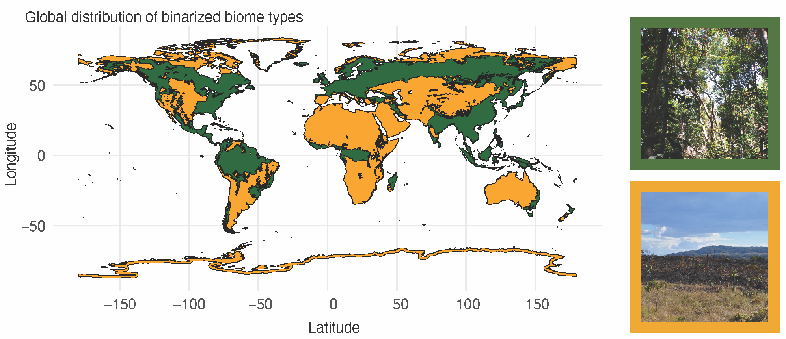

**Figure 1.** Global distribution of binarized biome types used to categorize the main biome type for 18,617 species based on their distribution. Dark green indicates closed-canopy biomes and orange open-canopy biomes. Photos depict examples of closed-canopy biome (tropical rainforest, top-right) and open-canopy biome (savanna grassland, bottom-right).

The macroevolutionary dynamics of biome transitions in angiosperms has seen intense debate in the biogeography community, particularly in relation to the frequency and prevalent directions of shifts (reviewed in [20]). Here, we test the hypothesis that rates of transition between open-canopy biomes and closed-canopy biomes positively correlate with turnover rates across many angiosperm clades. To this end, we use a modeling framework that combines properties of the hidden-Markov models [21] and SSE models [11] to allow for both jointly estimating transition and diversification dynamics in a clade and accounting for heterogeneity in those rates at different parts of the phylogenetic tree, i.e. different rate classes (Figure S1). For our dataset, we sample 49 flowering plant clades (Figure 2a), which combined span about 18,617 species where 10,035 species are found in closed-canopy, 4,760 in open-canopy and 3,822 are widespread across both biomes. For each clade, we build SSE models and interpret parameter estimates using phylogenetic regressions. In this way, we are able to explicitly test whether rate classes with faster transition rates between biomes also tend to be those with faster rates of speciation and extinction.

# **Results and Discussion**

## *Biome shift rate is positively correlated with speciation and extinction rates*

We found that rate classes with faster transition rates among biomes also tend to have higher mean turnover rates, consistent with the idea that trait lability predicting speciation and extinction is a generality across flowering plants. Linear phylogenetic regressions of the differences between mean turnover rates and mean transition rates in different rate classes shows a significant positive correlation (p = 0.018, R2 = 0.113). The coefficient for the difference in turnover rates was estimated to be 0.325, with a 95% confidence interval (CI) ranging from 0.067 to 0.579 (Figure 3B,C). The intercept was not significantly different from 0 (p = 0.26). These results infer that for every order of magnitude difference in transition rates, the difference in turnover rates is approximately doubled. However, although most clades follow this trend, a few clades show the opposite pattern. Clades such as *Eucalyptus* (Myrtaceae) and *Salvia* (Lamiaceae) were inferred to have higher turnover rates when the transition rates in a rate class were low (top left and bottom right quadrants, Figure 3C). One possible explanation for these exceptions to the general pattern might be that they represent instances where patterns are driven by particular subclades which have high turnover rates but low transition rates. This may arise from scenarios where clades shift in geographical location, allowing for bursts in diversification, without changing their preferred habitat (i.e. niche conservatism [17]) (see Supporting Information for individual results).

A misconception that may arise from the interpretation of these results is that clades with more species will tend to have higher rates of speciation and will also be more likely to present more events of transition between biomes, simply due to their size. This is a misinterpretation for two reasons: (1) we are analyzing rates of both speciation and extinction combined, so that we are not focused on the increase in number of species, but in the number of possible macroevolutionary events; (2) rates are a number of events per unit of time, so a larger clade does not necessarily have to have faster rates of speciation than the small ones; they may have the same rate of speciation if the larger clade is older than the small one. However, it is true that larger clades will generally be more likely to support hidden Markov models because of the increased power to fit complex models [21], and they are more likely to have experienced heterogeneous diversification and character evolution at some point in their history[22].

*Faster transition rates from open to closed-canopy habitats*

When looking at the observed states – that is, the transition rates between closed and open canopy regardless of rate class – our results show that lineages in closed canopy biomes have significantly lower turnover rates (median 0.65 events per million years, e/my) than those in open canopy biomes (0.73 e/my; phylo t-test comparison p = 0.030) or widespread (0.78 e/my phylo t-test comparison p = 0.017) across all clades (Figure 2B). Turnover in open-canopy biomes and widespread across both biomes were not found to be significantly different from one another (phylo t-test comparison p = 0.219). Lower turnover rates in closed-canopy environments has several potential explanations: (1) long-lived life forms that dominate lineages in these areas generally have longer generation times, which tends to correlate with slower rates of molecular evolution and adaptations, thus lower speciation rates [23]; (2) many closed canopy biomes in the tropics, where most of flowering plant diversity occurs, are thought to have been more stable through time than open ones which have been more impacted by sea level fluctuations, mountain uplift, and climate change, which would in turn increase both local speciation and extinction rates (e.g. [24, 25]).

Mean transition rates across the 49 clades show a general trend of faster rates of transition from open-canopy biomes into closed-canopy ones, with rates from widespread to closed-canopy being about four times higher than those from widespread to open-canopy habitats (Figure 2C). These rates can be explained by the general proportion of lineages in each biome type across time, as the proportion of lineages in open canopy biomes tends to decrease through time whereas those of closed canopy increase through time. Interestingly, these results support another of Stebbins’ ideas, in which evolution into closed-canopy biomes where resources abound should be more frequent than to open canopy biomes, which are more challenging for survival [13]. This however contradicts many studies that have found that lineages in open canopy biomes tend to evolve from closed canopy ones, with the frequent narrative that open canopy biomes, such as those in dry, cold areas and mediterranean, are more recent (e.g. [20,26]). It is important to note here that most of these studies have not used models that account for variations in speciation and extinction, and that these impact ancestral state and range reconstructions [15]. We therefore reinforce here, as have others [27,28], that SSE models should be also used for analyses of ancestral state and range reconstructions, which is one of the goals they were originally developed for [29], with the potential to change narratives that depend on direction and frequency of transitions between states and areas.

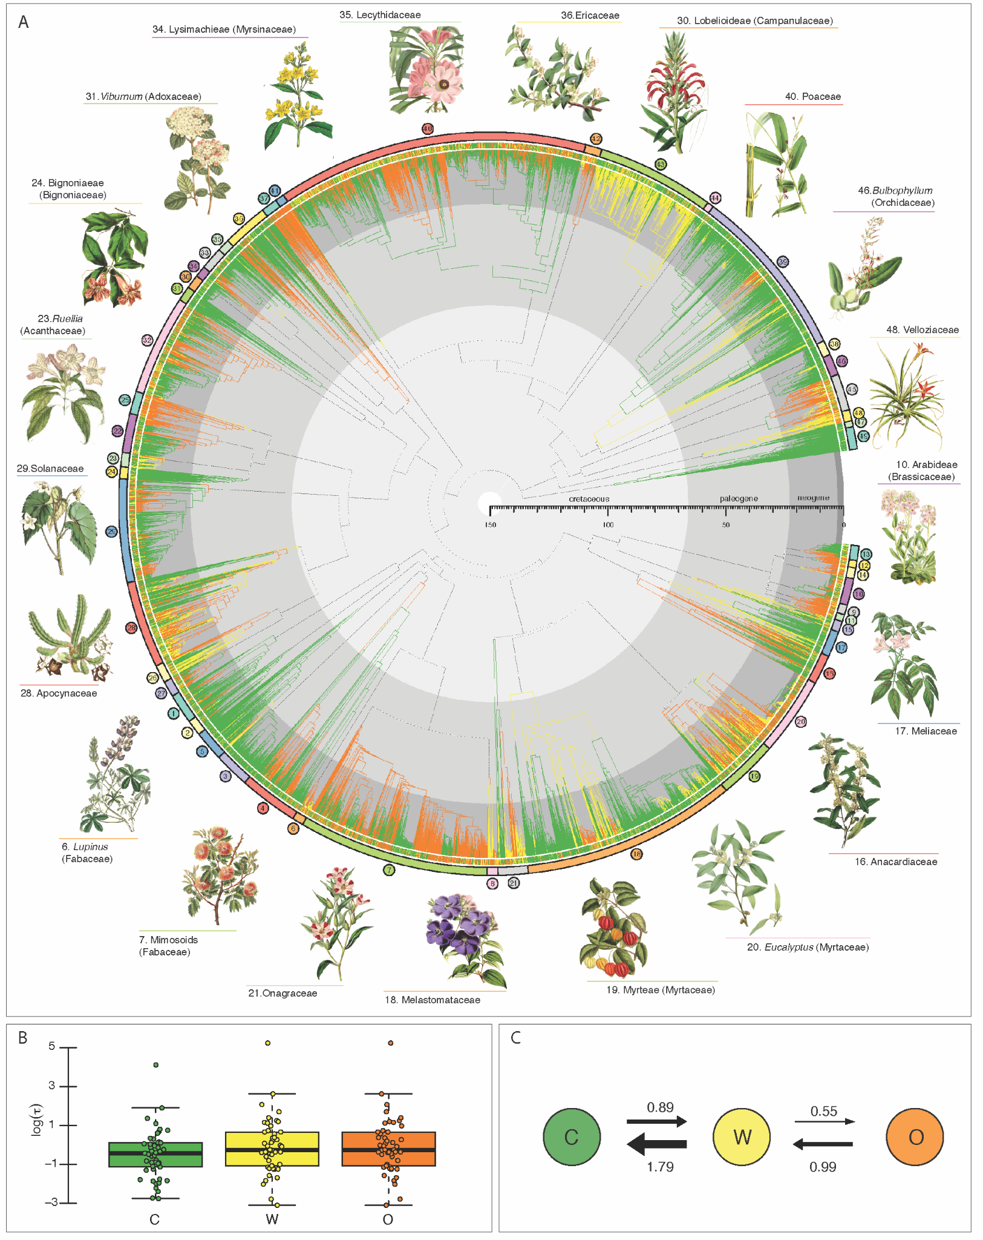  
**Figure 2:** (A) Phylogenies of 49 clades with branches colored as the most likely ancestral biome type based on MuHiSSE models (see TableS1 for all clade names). Dark green indicates closed-canopy biomes, orange open-canopy biomes and yellow widespread across both biome types. Backbone phylogeny connecting all clades based on their relationships is depicted as dashed lines. Botanical illustrations highlight some of the clades targeted in our analyses. (B) Box plots of the log turnover rates associated with closed canopy (dark green), open canopy (orange), and widespread (yellow). Turnover rates of lineages in closed canopy biomes were significantly lower than both open canopy and widespread lineages, with closed canopy biomes expected to have one fewer speciation or extinction event every million years. (C) Transition rates between observed states. Transitions from widespread to closed canopy were significantly faster than widespread to open habitats.  
 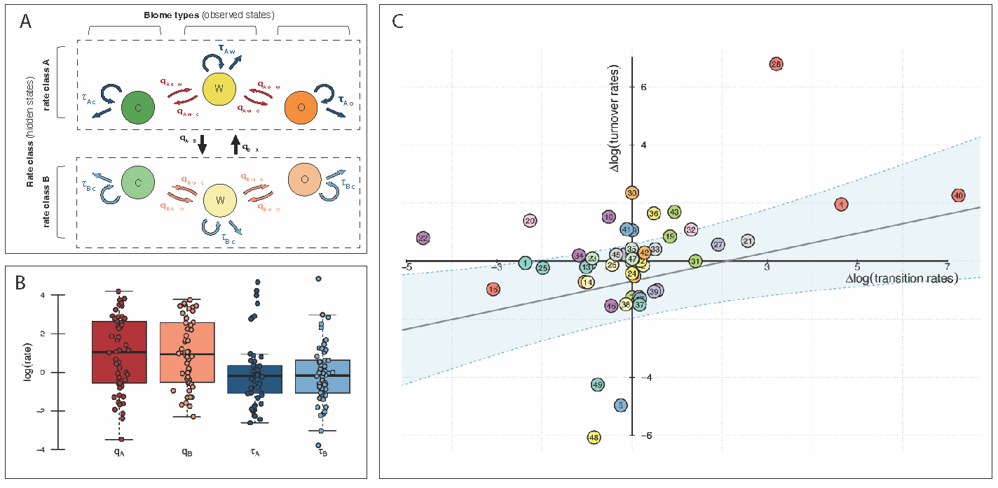

**Figure 3.** (A) Schematic drawing of the MuHiSSE model used in our analyses. Trait lability is here modeled as different rate classes within each biome type (observed states). C: closed-canopy biome, W: widespread between both biome types, O: open-canopy biome (B) Box plots of the log transition rates in rate classes (qA, qB, red) and log turnover rates (τA, τB, blue). (C) A phylogenetic regression depicting the relationship between rate class differences of average turnover (y-axis) and transition rate (x-axis). Values which show a positive relationship (higher transition rates associated with higher turnover rates) are in the bottom left and top right quadrants. Values with a negative relationship (higher transition rates associated with lower turnover rates) are in the top left and bottom right quadrants. The significantly positive slope (p = 0.018, R2 = 0.113) supports our main hypothesis that more rapid shifts in biome lead to higher speciation and extinction rates.

*An alternative perspective on diversification analyses*

State dependent diversification analyses (SSE models) began as a way to correct biases in transition rates due to the unequal distribution of tip states and the possibility that observed states may be correlated with speciation and extinction rates [29]. It was later discovered that this class of models was biased towards finding associations between a focal character and diversification rates [10,11]. This was because SSE models included heterogeneity in diversification parameters that would outperform alternative models which did not, regardless of whether there was a true association between diversification rates and the focal character [10]. Hidden Markov SSE models, which were introduced as a more biologically plausible model of evolution by allowing for rate heterogeneity independent of the focal character (e.g. HiSSE, [11]) were able to be utilized as better null hypotheses and thus overcame challenges of previous SSE models. This body of work set the stage for the typical diversification analysis in which biologists test for an association between the focal character and diversification parameters with the inclusion of a hidden Markov model as a null hypothesis.

Although treating hidden Markov SSE models as null hypotheses is common practice, we argue, as exemplified by our framework, that this is a suboptimal approach as they are more informative than one would usually consider a null hypothesis to be. Hidden Markov models are explicitly parameterized by the dynamics of the observed characters, as this is where the information for estimating rate classes is derived from [21]. This means that evidence for hidden rate models can come from both differences in diversification dynamics and differences in observed character transition rates, and the potential relationships between these processes has been generally under-explored. This is not to say that biologists have ignored the potential for trait lability to drive patterns of diversification. Several studies have attempted to correlate these processes using independent modeling results (e.g. [8,30]), but never in a framework where the diversification and trait evolution parameters were estimated jointly. By using hidden Markov SSE models to frame our hypothesis with the rate classes themselves being of primary interest, the test of whether rates of biome shifts are positively correlated with rates of turnover is explicitly modeled in a joint framework. This modeling does not require any new methodological developments, instead relies on evolutionary biologists to refocus their hypotheses in an examination of how different processes influence diversification rather than particular character traits.

**Conclusion**

In this study, we have found a significant correlation between the rates of biome shifts and species turnover across a broad range of angiosperm clades, highlighting the role of evolutionary lability in shaping speciation and extinction dynamics. Our findings challenge the traditional focus on static traits and instead emphasize the importance of dynamic evolutionary processes in understanding biodiversity. The observed patterns suggest that the capacity for angiosperms to transition between biomes, particularly from open to closed-canopy environments, plays an important role in their diversification. This insight aligns with Stebbins’ hypothesis on biome shifts, underscoring the influence of habitat adaptability in the evolutionary trajectory of flowering plants. Finally, our results are grounded in a robust analytical framework which jointly account for trait evolution and diversification, not only advancing our understanding of angiosperm evolution but offering a fresh perspective on how to approach diversification analyses. This study emphasizes that future research should consider the possibility that diversification dynamics are influenced by how trait evolution occurs rather than just the traits themselves.

# **Methods**

## *Dataset assembly*

The criterion to select the 49 clades used in this study was to pick clades that had a minimum of 80 tips, with at least 0.1 of sampling fraction for the ingroup; i.e. inclusion of at least 10% of the species diversity assigned to the corresponding clades. Though this is a somewhat arbitrary threshold, less than 0.1 sampling fraction has shown to lead to inaccurate parameter estimates in diversification analyses [31] and small trees are unlikely to present rate class heterogeneity. We also focused on trees produced by taxonomists of each group, since they are more careful about voucher identification and choice of molecular markers used in reconstructions (e.g. [32]). We avoided using large trees inferred by genbank scraping (e.g. [33]) because of issues with uneven sampling across the tree. In that way, we combined strengths of the large sample approach in which to observe generalities from with the care for accuracy that comes from small trees (see debate between [22] and [34]). Finally, we also excluded trees that were not reciprocally monophyletic, keeping only the ones with larger sampling and/or more tips when the same clade appears in more than one tree (e.g. we excluded the *Acacia* phylogeny of [35] and kept the phylogeny of Mimosoid legumes of [36], which includes *Acacia*). Trees root ages ranged from 3.87 (*Heliconia*; [37]) to 117.28 (Ericaceae; [38]) million years to the root and from 85 (Cyclanthaceae; [39]) to 3,588 (Poaceae, [40]) tips, accounting for 26,232 species in total, c. 8% of flowering plant diversity.

To score the main biome type for each species, we first standardized all tip names according to the GBIF taxonomic backbone using the R package *taxize* [41] and removed outgroups following the original publications of each phylogeny. We also pruned trees to remove tips of species with multiple entries in some phylogenies, leaving only one tip per species. We then downloaded all the 6,734,171 occurrence points linked with preserved herbarium specimens for the originally 26,232 species sampled in the 49 trees from GBIF [42], using POWO [43] taxonomy and geographical information to filter non-native distributions and distribution inaccuracies. Because GBIF is prone to sampling bias, we also thinned occurrence points to one representative occurrence point per 1x1 grid cell for all species before further analyses (see [44] for detailed methodology). Our filtering was conservative and decreased the number of species with trustworthy information to 18,617.

The remaining 1,425,819 points after filtering were overlaid on the World Wildlife Fund (WWF) map of terrestrial biomes [45]. Biomes are generally defined as a combination of climatic factors that drive convergent and/or parallel evolution in certain plant traits, leading to characteristic vegetation types (or physiognomies) under specific climatic conditions [46]. Following Stebbins’ hypothesis, we binarized the original 13 terrestrial biomes into closed or open-canopy, dividing them along a precipitation gradient. Occurrence points placed on biomes where precipitation is higher ("Tropical & Subtropical Moist Broadleaf Forests", "Tropical & Subtropical Dry Broadleaf Forests", "Tropical & Subtropical Coniferous Forests", "Temperate Broadleaf & Mixed Forests", "Temperate Conifer Forests", and "Boreal Forests/Taiga") were scored as closed-canopy biomes. Those occurring in areas of lower precipitation ("Tropical & Subtropical Grasslands, Savannas & Shrubland", "Temperate Grasslands, Savannas & Shrublands", "Flooded Grasslands & Savannas", "Montane Grasslands & Shrublands", "Tundra","Deserts & Xeric Shrublands", "Mediterranean Forests, and Woodlands & Scrub") as well as “Mangroves” were scored as open-canopy biomes. Of course, that does not mean that closed canopy biomes only have closed canopy habitats, as open canopy vegetations are often found within closed canopy biomes and vice versa (e.g. prairies in temperate rainforests, riverine forests in tropical savannas). It means closed canopy biomes are dominated by closed canopy vegetations and open canopy biomes by open canopy vegetations. Species were scored as occurring in closed or open-canopy biomes when at least 25% of their occurrence points were found in that biome type. If at least 25% of their occurrence points were found in both biomes types, then the species was scored as widespread. All datasets and R scripts used in the curation process are available at <https://github.com/tncvasconcelos/biome_shifts>.

## *Diversification and hidden state modeling*

We use hidden Markov and observed state-dependent speciation and extinction (SSE) models that allow transition rates between biome types and diversification dynamics to vary within a clade. We then assess whether these within clade correlations are consistent across our 49 clades of angiosperms. We test the relationship between frequency of biome shifts and rates of species speciation and extinction by correlating average time to a biome shift with lineage turnover rates, expecting that they will be inversely related, that is, a shorter expected time to transition leads to higher lineage turnover. Turnover, under this definition, gives us a measure of how frequently an “event” of either speciation or extinction will occur and is more consistent with the ideas put forth by Stebbins [13] than either net diversification rates or speciation rates.

Our analysis utilizes the MuHiSSE model implemented in the R-package ‘hisse’ [47] to test for correlations between diversification dynamics and rate of biome shift. We fit a set of 36 models: 4 without hidden states and 32 with two rate classes. The basic discrete character model of evolution was an all-rates-different model, in which transitions between open and closed canopy biome could only occur through an intermediate widespread state. Models with two rate classes were categorized into two types of discrete character models. The first type allows for discrete character rate heterogeneity by permitting transition rates to differ between rate classes. The second type has transition rates that are fixed to be equal between rate classes.

The other parameters of interest for a MuHiSSE model are extinction fraction (extinction/speciation) and turnover (speciation+extinction). For single rate class models, parameters are fixed to be equal for all observed states (no trait-dependent diversification) or all are set to be different (diversification parameters are freely estimated for each observed state). For two rate class models, we explore 4 different parameterizations: (1) no observed trait-dependent diversification and no hidden trait-dependent diversification, (2) observed trait-dependent diversification, but no hidden trait-dependent diversification, (3) no observed trait-dependent diversification, but hidden trait-dependent diversification, and (4) both observed trait-dependent diversification and hidden trait-dependent diversification. We examine all possible combinations of the parameterizations resulting in 4 models without hidden states and 32 with hidden states. Estimates of sampling fraction, a fixed parameter in the model, were gathered from the literature of each clade (Table S1).

*Parameter interpretation and analyses*

To test whether higher rates of biome shift are associated with higher rates of speciation and extinction across angiosperms, we compare the log differences of the rate class parameters within clades. That is to say, for each model, we take the mean of transition rates (or turnover rates) for a particular rate class and compute the log of the ratio of *Rate Class B* over *Rate Class A*. This relativizes the differences around zero, where a value of zero represents no difference between rate classes since when the rate classes have the same average parameter value, the ratio will equal one and the log of the ratio is therefore zero. If *Rate Class B* is greater than *Rate Class A*, then the ratio is greater than 1 and the log of that ratio is between 0 and positive infinity. In contrast, if *Rate Class A* is greater than *Rate Class B*, we will get a ratio below 1 and the log of that ratio is between 0 and negative infinity. We calculate log ratios for all models with two rate classes, and for each clade calculate model averaged values.

Our methodology contrasts the typical approach one uses to test hypotheses correlating phenotypic evolution dynamics with diversification dynamics. Typically, analysis is done by comparing parameter estimates directly or reconstructed values via tip rates [48]. Specifically, one would estimate transition rates and diversification rates across several clades and then compare those estimates to determine whether a correlation is supported. However, one outstanding problem with this typical approach is that the age of a clade can impact rate estimates, with older clades resulting in lower rates than younger ones [49]. As such, without accounting for age, one would expect that rates of turnover would be correlated with rates of transition because older clades would have generally lower rates than young clades. Our methodology of comparing within clade dynamics ensures that the age of the clade is no longer a confounding factor, since we are explicitly comparing differences in dynamics within clades. In a sense, the differences in rates we examine are standardized relative to the absolute rate values of the clade. For example, even if an old clade is expected to have relatively lower rates, we are interested in whether given those lower absolute rates does the clade still demonstrate a pattern in which higher transition rates are associated with higher turnover rates.

To test for a correlation between differences in turnover rates and differences in mean transition rates, we fit a phylogenetic linear regression model [50] using a backbone tree derived from [33] where each tip represents one of our 49 clades (Figure S2). We conduct 1000 bootstrap replicates to estimate upper and lower confidence intervals around the slope, intercept, and variance rate of the regression model. A regression with a significantly non-zero and positive slope would support our main conjecture that species which transition in biome more often also have higher rates of speciation and extinction. One issue with our analysis is that the labeling of model dynamics within an HMM as either *Rate Class A* or *Rate Class B* is arbitrary (known as the label switching problem; [51]). Put another way, there is no difference in the likelihood if you were to completely swap hidden *Rate Class A* with hidden *Rate Class B* because it only means that you have swapped their labels, not altered the parameters describing the rate classes. In the context of our analysis, this means that the order of the subtraction between rates is arbitrary. To ensure that our analysis is robust to this issue, we randomly shuffle rate classes and refit the model 1,000 times. We find that in 94.5% of cases a significantly positive slope is found and all slope estimates are within the 95% confidence intervals with a mean of 0.33 and standard deviation of 0.033 (see Supporting Information).

**Acknowledgments**

The authors thank the Smith lab, the Rabosky lab, Brian O’Meara, and Jeremy Beaulieu for their thoughtful feedback that greatly improved this work. This study was funded by grants from National Science Foundation (grant DEB−1916539 and grant DEB−1916558). This project is supported by the Eric and Wendy Schmidt AI in Science Postdoctoral Fellowship, a Schmidt Sciences Futures program.

**References**

[1] Govaerts, R., Nic Lughadha, E., Black, N., et al. (2021). The World Checklist of Vascular Plants, a continuously updated resource for exploring global plant diversity. *Scientific Data*, 8(1), 215.

[2] Stevens, P. F. (2001 onwards). *Angiosperm Phylogeny Website.* Version 14, July 2017 [and more or less continuously updated since].

[3] Magallon, S., & Sanderson, M. J. (2001). Absolute diversification rates in angiosperm clades. *Evolution*, *55*(9), 1762-1780.

[4] Donoghue, M. J., & Sanderson, M. J. (2015). Confluence, synnovation, and depauperons in plant diversification. *New Phytologist*, *207*(2), 260-274.

[5] Givnish, T. J. (2015). Adaptive radiation versus ‘radiation’and ‘explosive diversification’: why conceptual distinctions are fundamental to understanding evolution. *New Phytologist*, *207*(2), 297-303.

[6] Givnish, T. J. (2010). Ecology of plant speciation. *Taxon*, *59*(5), 1326-1366.

[7] Anderson, B., Pannell, J., Billiard, S., Burgarella, C., de Boer, H., Dufay, M., ... & Glémin, S. (2023). Opposing effects of plant traits on diversification. *Iscience*, *26*(4).

[8] Onstein, R. E. (2020). Darwin’s second ‘abominable mystery’: Trait flexibility as the innovation leading to angiosperm diversity. *New Phytologist*, *228*(6), 1741-1747.

[9] Helmstetter, A. J., Zenil‐Ferguson, R., Sauquet, H., et al. (2023). Trait‐dependent diversification in angiosperms: Patterns, models and data. *Ecology Letters*, *26*(4), 640-657.

[10] Rabosky, D. L., & Goldberg, E. E. (2015). Model inadequacy and mistaken inferences of trait-dependent speciation. *Systematic Biology*, *64*(2), 340-355.

[11] Beaulieu, J. M., & O’Meara, B. C. (2016). Detecting hidden diversification shifts in models of trait-dependent speciation and extinction. *Systematic Biology*, *65*(4), 583-601.

[12] Ricklefs, R. E., & Renner, S. S. (1994). Species richness within families of flowering plants. *Evolution*, *48*(5), 1619-1636.

[13] Stebbins, G. L. (1974). *Flowering plants: evolution above the species level*. Harvard University Press, Cambridge, MA, USA.

[14] Jansson, R., & Dynesius, M. (2002). The fate of clades in a world of recurrent climatic change: Milankovitch oscillations and evolution. *Annual Review of Ecology, Evolution, and Systematics*, *33*(1), 741-777.

[15] Vasconcelos, T., O’Meara, B. C., & Beaulieu, J. M. (2022). Retiring “cradles” and “museums” of biodiversity. *The American Naturalist*, *199*(2), 194-205.

[16] Vrba, E. S. (1985). Environment and evolution: alternative causes of the temporal distribution of evolutionary events. *South African Journal of Science*, *81*(5), 229-236.

[17] Wiens, J. J., & Donoghue, M. J. (2004). Historical biogeography, ecology and species richness. *Trends in Ecology & Evolution*, *19*(12), 639-644.

[18] Donoghue, M. J. (2008). A phylogenetic perspective on the distribution of plant diversity. *Proceedings of the National Academy of Sciences*, *105*, 11549-11555.

[19] Schluter, D. (2000). *The ecology of adaptive radiation*. Oxford University Press Oxford, UK.

[20] Donoghue, M. J., & Edwards, E. J. (2014). Biome shifts and niche evolution in plants. *Annual Review of Ecology, Evolution, and Systematics*, *45*, 547-572.

[21] Boyko, J. D., & Beaulieu, J. M. (2021). Generalized hidden Markov models for phylogenetic comparative datasets. *Methods in Ecology and Evolution*, 12(3), 468-478.

[22] Beaulieu, J. M., & O'Meara, B. C. (2019). Diversity and skepticism are vital for comparative biology: a response to Donoghue and Edwards (2019). *American Journal of Botany*, *106*(5), 613-617.

[23] Petit, R. J., & Hampe, A. (2006). Some evolutionary consequences of being a tree. *Annual Review of Ecology, Evolution, and Systematics*, *37*, 187-214.

[24] Madriñán, S., Cortés, A. J., & Richardson, J. E. (2013). Páramo is the world's fastest evolving and coolest biodiversity hotspot. *Frontiers in Genetics*, *4*, 192.

[25] Vasconcelos, T. N., Alcantara, S., Andrino, C. O., et al. (2020). Fast diversification through a mosaic of evolutionary histories characterizes the endemic flora of ancient Neotropical mountains. *Proceedings of the Royal Society B*, *287*(1923), 20192933.

[26] Antonelli, A., Zizka, A., Carvalho, F. A., et al. (2018). Amazonia is the primary source of Neotropical biodiversity. *Proceedings of the National Academy of Sciences*, *115*(23), 6034-6039.

[27] Holland, B. R., Ketelaar-Jones, S., o’Mara, A. R., et al (2020). Accuracy of ancestral state reconstruction for non-neutral traits. *Scientific Reports*, *10*(1), 7644.

[28] Herrera‐Alsina, L., Algar, A. C., Lancaster, L. T., et al. (2022). The missing link in biogeographic reconstruction: Accounting for lineage extinction rewrites history. *Journal of Biogeography*, *49*(11), 1941-1951.

[29] Maddison, W. P., Midford, P. E., & Otto, S. P. (2007). Estimating a binary character's effect on speciation and extinction. *Systematic Biology*, *56*(5), 701-710.

[30] Rabosky, D. L., & Adams, D. C. (2012). Rates of morphological evolution are correlated with species richness in salamanders. *Evolution*, *66*(6), 1807-1818.

[31] Chang, J., Rabosky, D. L., & Alfaro, M. E. (2020). Estimating diversification rates on incompletely sampled phylogenies: theoretical concerns and practical solutions. *Systematic Biology*, *69*(3), 602-611.

[32] Neotropical Myrtaceae Working Group (2024). Towards a species-level phylogeny for Neotropical Myrtaceae: notes on topology and resources for future studies. *American Journal of Botany*, e16330.

[33] Smith, S. A., & Brown, J. W. (2018). Constructing a broadly inclusive seed plant phylogeny. *American Journal of Botany*, *105*(3), 302-314.

[34] Donoghue, M. J., & Edwards, E. J. (2019). Model clades are vital for comparative biology, and ascertainment bias is not a problem in practice: a response to Beaulieu and O'Meara (2018). *American Journal of Botany*, *106*(3), 327-330.

[35] Renner, M. A., Foster, C. S., Miller, J. T., et al. (2020). Increased diversification rates are coupled with higher rates of climate space exploration in Australian *Acacia* (Caesalpinioideae). *New Phytologist*, *226*(2), 609-622.

[36] Ringelberg, J. J., Koenen, E. J., Sauter, B., et al. (2023). Precipitation is the main axis of tropical plant phylogenetic turnover across space and time. *Science Advances*, *9*(7), eade4954.

[37] Iles, W. J., Sass, C., Lagomarsino, L., et al. (2017). The phylogeny of Heliconia (Heliconiaceae) and the evolution of floral presentation. *Molecular Phylogenetics and Evolution*, *117*, 150-167.

[38] Schwery, O., Onstein, R. E., Bouchenak‐Khelladi, Y., et al. (2015). As old as the mountains: the radiations of the Ericaceae. *New Phytologist*, *207*(2), 355-367.

[39] Leal, E. S., Vasconcelos, T. N., Tuberquia, D., et al. (2022). Phylogeny and historical biogeography of the Panama‐hat family (Cyclanthaceae, Pandanales). *Taxon*, *71*(5), 963-980.

[40] Spriggs, E. L., Christin, P. A., & Edwards, E. J. (2014). C4 photosynthesis promoted species diversification during the Miocene grassland expansion. *PloS one*, *9*(5), e97722.

[41] Chamberlain, S. A., & Szöcs, E. (2013). taxize: Taxonomic search and retrieval in R. F1000Research, 2, 191. https://doi.org/10.12688/ f1000research.2-191.v1

[42] GBIF.org (04 May 2023) GBIF Occurrence Download <https://doi.org/10.15468/dl.9y3t82>

[43] POWO. 2023. Plants of the World Online Facilitated by the Royal Botanic Gardens, Kew. [WWW document] URL http://www.plantsoftheworldonline. org/ [accessed May 2023].

[44] Boyko, J. D., Hagen, E. R., Beaulieu, J. M., et al. (2023). The evolutionary responses of life‐history strategies to climatic variability in flowering plants. *New Phytologist*, *240*(4), 1587-1600.

[45] Olson, D. M., Dinerstein, E., Wikramanayake, E. D., et al. (2001). Terrestrial Ecoregions of the World: A New Map of Life on Earth: A new global map of terrestrial ecoregions provides an innovative tool for conserving biodiversity. *BioScience*, *51*(11), 933-938.

[46] Mucina, L. (2019). Biome: evolution of a crucial ecological and biogeographical concept. *New Phytologist*, *222*(1), 97-114.

[47] Beaulieu, J., O'Meara, B., Caetano, D., Boyko, J., et al. (2023). Package ‘hisse’.

[48] Vasconcelos, T., O'Meara, B. C., & Beaulieu, J. M. (2022). A flexible method for estimating tip diversification rates across a range of speciation and extinction scenarios. *Evolution*, *76*(7), 1420-1433.

[49] Henao Diaz, L. F., Harmon, L. J., Sugawara, M. T., et al. (2019). Macroevolutionary diversification rates show time dependency. *Proceedings of the National Academy of Sciences*, *116*(15), 7403-7408.

[50] Tung Ho, L. S., & Ané, C. (2014). A linear-time algorithm for Gaussian and non-Gaussian trait evolution models. *Systematic biology*, *63*(3), 397-408.

[51] Spezia, L. (2009). Reversible jump and the label switching problem in hidden Markov models. *Journal of Statistical Planning and Inference*, *139*(7), 2305-2315.