**Biome shifts predict diversification dynamics in angiosperms more than the biomes themselves**

James Boyko, Thais Vasconcelos

# **Abstract (250 words)**

The remarkable diversity of angiosperm species have prompted a search for universal drivers that modulate rates of speciation and extinction across this clade. To date, most attempts to define differences in diversification have correlated diversification rates with the presence or absence of a discrete trait. However, an often-overlooked explanation is that the evolutionary lability, here defined as the rates of trait change, is a better predictor of the diversification dynamics than the observed traits themselves. This hypothesis, first proposed half a century ago in the context of biome shifts, is based on the idea that the capacity to adapt to environmental changes is the key element defining angiosperm diversification dynamics. Using a phylogenetic dataset of 51 angiosperm clades including 18,852 species (10,191 in closed-canopy biomes, 4,792 in open-canopy biomes, and 3,869 widespread across both biome types) we demonstrate that the propensity of change between biomes is significantly correlated with lineage speciation and extinction rates across clades. Additionally, we find that transition rates tend to be faster from open to closed-canopy biomes, contrary to prevailing ideas in the field that lineages occurring in open-canopy biomes tend to emerge from closed-canopy ones in angiosperms. We propose that a shift in focus from static traits to dynamic evolutionary processes may provide a more comprehensive understanding of how biodiversity is generated and maintained, in angiosperms and other organisms.

**Significance Statement (120 words)**

Rates of phenotypic evolution and diversification differ between lineages. Most explanations of this heterogeneity have focused on finding particular key traits that moderate evolutionary rates. However, the way that changes occur in phenotypes may be a better predictor of diversification rates than single key traits. Here, we demonstrate this by using hidden-Markov models, which allow for several different rate classes associated with speciation, extinction, and transition among phenotypic states across a phylogenetic tree. We show that the rate of transition between traits is positively correlated with speciation and extinction rates. This study is the first to empirically demonstrate that even when key traits do not modulate shifts in diversification, the way that traits evolve can correlate with cladewise diversification dynamics.

**Keywords:** angiosperms, comparative methods, rate heterogeneity, trait lability, turnover

# **Introduction**

Angiosperms, or flowering plants, are the most highly diverse clade of green plants alive today with c. 300,000 described species (Govaerts et al., 2021). The same degree of disparity in the number of species that is observed between angiosperms and other green plant clades that led Darwin to think of this group as an “abominable mystery” is also observed among clades within angiosperms. For example, there are ten times more species of daisies (Asteraceae) than those of primroses (Primulaceae s.s.) and nine times more species of grasses (Poaceae) than sedges (Cyperaceae) (Stevens, 2001; APGIV, 2016). This disparity is observed at all taxonomic levels and also between clades that share a direct common ancestor and have had the same amount of time for species accumulation over time (e.g. Magallon and Sanderson, 2001). Factors that might explain this uneven diversity within angiosperm clades have relied heavily on the search for key-innovative traits, key-landscapes, or a combination of both (“key-opportunities”) that might impact the rates in which lineages diversify through time (Donoghue and Sanderson, 2015; Givnish, 2015; Nurk et al., 2020). These key events are suggested to correlate with increased or decreased chances of speciation or extinction, with the explanation usually associated with some mechanism linked to opportunity for population isolation, differentiation, or resilience against extinction (e.g. Givnish, 2010, 2015; Donoghue and Sanderson 2015; Anderson et al. 2023).

In the last decade, hundreds of studies focusing on specific angiosperm clades or the group as a whole attempted to identify and explain which traits or areas may explain this variation (Onstein, 2020; reviewed in Helmstetter et al. 2022). Though many of these studies support a correlation between a trait or habitat and variations in speciation and/or extinction rates, a series of criticisms and recent reviews have put in doubt the generality of these results. Firstly, the most widely used model for assessing rate variation as a function of a character state or area, the State-dependent Speciation and Extinction (SSE) models, was found to have high rates of type I error (Rabosky and Goldberg, 2015; O’Meara and Beaulieu, 2016; Beaulieu and O’Meara, 2016). Studies using newer extensions that allow for rate heterogeneity across different parts of phylogenetic trees and better null models (e.g., Beaulieu and O’Meara, 2016) have found generally lower support for the link between speciation and extinction and specific characters or areas. Secondly, studies that combine and discuss results across different groups find conflicting results, in the sense that no single universal driver such as a trait or geographic area is widely supported as a trigger for speciation and/or extinction across multiple unrelated clades (Helmstetter et al., 2023). Although a certain pattern in the spatial distribution of speciation rates has been recovered when large areas are considered (e.g., Igea and Tanentzap, 2020), uneven rates of species accumulation through time are often observed even in lineages that share similar traits and coexist in the same landscape (e.g. Vasconcelos et al., 2020). In other words, there is little support for the idea that single traits or landscapes correlate with higher or lower rates of speciation or extinction across several angiosperm clades. The pursuit for a key innovation, or even a key opportunity, that has a similar impact on the diversification rates across many angiosperm lineages has so far proved unfruitful.

This lack of generalities suggests that alternative explanations for observed heterogeneity in rates of diversification should be sought. One potential venue that has been suggested (Ricklefs and Renner, 1994; Donoghue and Sanderson, 2015; Onstein, 2020) is that rates of speciation and extinction correlate with rates of trait change – that is, trait lability (Figure 1). Stebbins (1974) was perhaps one of the first to explicitly suggest this possibility in flowering plants. He suggested that it was in their high capacity to adapt to environmental changes where the key to angiosperm diversification lay. He proposed a mechanism in which long-term climatic instability would lead to cyclical changes in the location of climatic zones (see also Jansson and Dynesius, 2002). The constant movement of plant lineages back and forth areas that promote the formation of closed-canopy biomes, such as rainforests, and areas of open-canopy biomes, such as grasslands and savannas, would be responsible not only for continuous allopatry and external pressure to change, but would also lead to many ephemeral species to extinction (Vasconcelos et al., 2022). In other words, the continuous movement of lineages between biome types would increase the probabilities of both speciation and extinction over time, i.e. evolutionary turnover (*sensu* Vrba 1985).

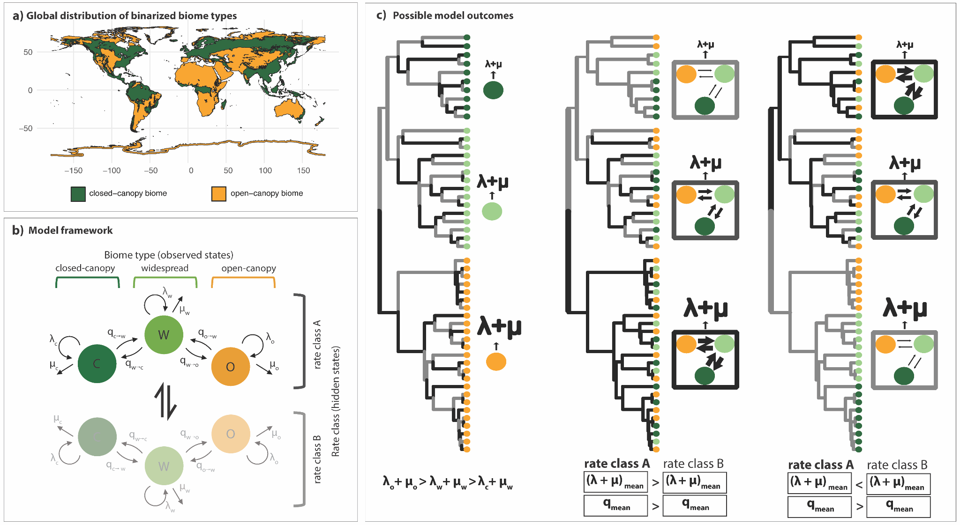

*Figure 1. (a) One potential way that key innovations may drive diversification dynamics. Here focal characters (yellow, light green, and dark green) lead to increases or decreases in turnover rates throughout the clade. This is what is typically modeled by a BiSSE analysis. (b) Trait lability, here modeled as faster (red) or slower (blue) transition rates between the observed states, is positively associated with turnover rates, such that more labile lineages also experience higher speciation and extinction rates. This can be modeled using hidden Markov models, where the red and blue paintings are hidden states describing the dynamics of the observed states. (c) The reverse pattern shown in (b). Here, lineages with lower transition rates experience higher turnover rates.*

Here, we test Stebbins’ hypothesis that rates of transition between open-canopy biomes and closed-canopy biomes positively correlate with turnover rates across many angiosperm clades. To this end, we use a modeling framework that combines properties of the Hidden Markov models (Beaulieu et al., 2013, Boyko and Beaulieu, 2022) and SSE models (Beaulieu and O’Meara; 2016) to allow for both jointly estimating transition and diversification dynamics in a clade and accounting for heterogeneity in those rates at different parts of the phylogenetic tree, i.e., different rate classes (Vasconcelos et al., 2023). Testing the trait lability hypothesis in the context of biome shifts is compelling because it can also shed light on the macroevolutionary dynamics of biome transitions in angiosperms, which has been a topic of intense debate in the biogeography community, particularly regarding the frequency and prevalent directions of shifts (reviewed in Donoghue and Edwards, 2014). We sample 51 flowering plant clades, which combined spam about 19,375 species in a sample where 10,636 species are found in closed-canopy, 4,818 in open-canopy, and 3,921 are widespread across both biomes. We build models where transition, speciation, and extinction rates are free to vary between biome types, disallowing only direct transitions between open and closed canopy biomes – i.e., lineages have to transition to an intermediate widespread state to complete a transition between open and closed canopy (Figure 1).

# **Results and Discussion**

## *Biome shift rate is positively correlated with speciation and extinction rates*

Results show that rate classes with faster transition rates among biomes also tend to have higher mean turnover rates across all biomes. Linear phylogenetic regressions of the differences between mean turnover rates and mean transition rates in different rate classes show a significant positive correlation (p = 0.019, R2 = 0.106). The coefficient for the difference in turnover rates was estimated to be 0.303, with a 95% confidence interval (CI) ranging from 0.070 to 0.546 (Figure 2). This suggests that for every order of magnitude difference in transition rates, the difference in turnover rates is approximately doubled. In sum, these results support a positive correlation between rates of biome shifts and turnover across the 51 clades, consistent with the idea that trait lability predicting speciation and extinction is perhaps a generality across flowering plants.

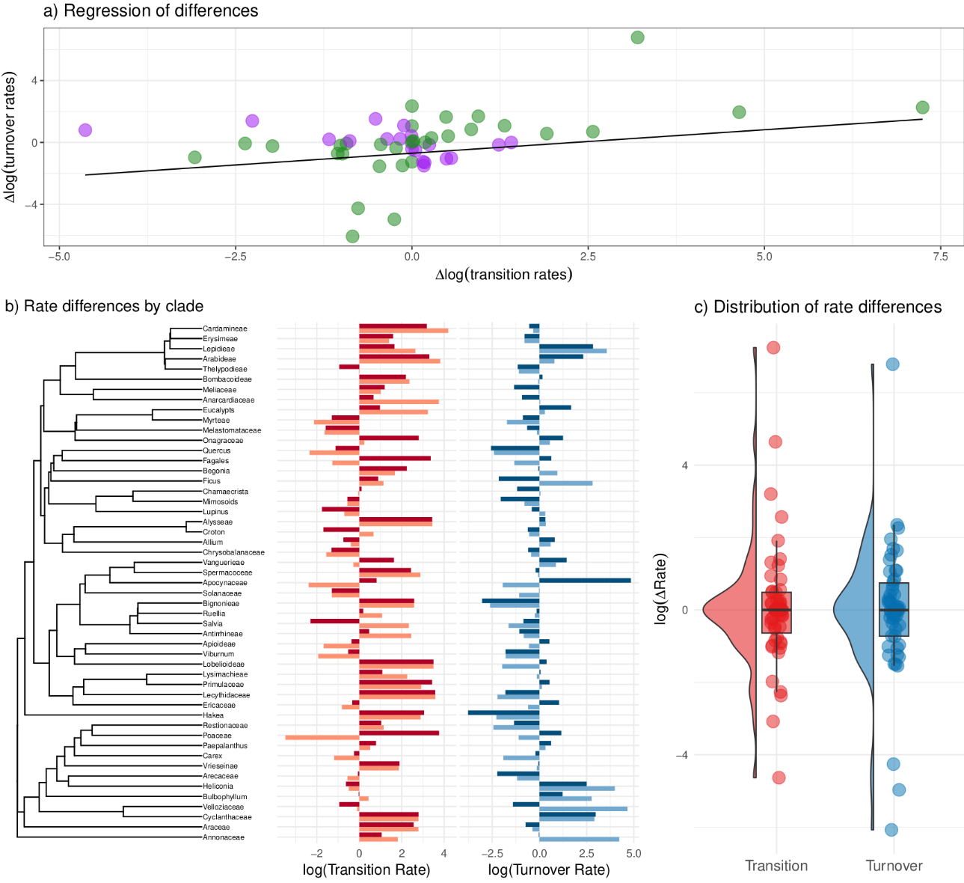***Figure 2. (****a) A phylogenetic regression depicting the relationship between rate class differences of average turnover (y-axis) and transition rate (x-axis). Values that show a positive relationship (higher transition rates associated with higher turnover rates) are colored in green. Values with a negative relationship (higher transition rates associated with lower turnover rates) are colored purple. The significantly positive slope (p = 0.019, R2 = 0.106) supports our main hypothesis that more rapid shifts in biome lead to higher speciation and extinction rates. (b) Left: The backbone phylogeny based on Smith and Brown (2018). Right: Bar charts of the log of the transition rate (red) or turnover rate (blue) for each clade. Each clade has two values, one for each hidden rate class. There is a great deal of variation in the distribution of turnover and transition rates and the absolute values of each parameter. (c) Box plots and distribution of the log transition rates (red) and log turnover rates (blue). There is little difference between the parameters on average.*

A misconception that may arise from the interpretation of these results is that clades with more species will tend to have higher rates of speciation and will also be more likely to present more events of transition between biomes, simply due to their size. This is a misinterpretation for two reasons: (1) we note that we are analyzing rates of both speciation and extinction combined, so that we are not focused on the increase in the number of species, but in the number of possible macroevolutionary events; (2) rates are several events per unit of time, so a larger clade does not necessarily have to have faster rates of speciation than the small ones; they may have the same rate of speciation if the larger clade is older than the small one. However, it is true that larger clades will generally be more likely to support hidden Markov models because of the increased power to fit complex models, and they are more likely to have experienced heterogeneous diversification and character evolution (Beaulieu and O’Meara, 2018).

There are any number of factors that may cause a clade to show elevated biome transition or turnover rates, ranging from the age of the clade (Henao-Diaz et al., 2019) to their geographic distribution (Donoghue and Edwards, 2014). However, these clade-wide factors would confound our hypothesis, and muddle any signal of the correlation between biome transitions and diversification dynamics. In this context, applying these models to evaluate rate differences within clades and then generalizing findings across several clades, instead of analyzing a single large clade, has the benefit of better accounting for the unique historical contexts of individual clades and the distinct factors influencing them. Focusing on intra-clade dynamics allows us to better control for historical contingency and examining these dynamics across several clades allows us to search for more general patterns.

## *Faster transition rates from open to closed-canopy habitats*

When looking at the observed states – that is, the transition rates between closed and open canopy regardless of rate class (Figure 2) – our results show that lineages in closed canopy biomes have significantly lower turnover rates (median 0.65 events per million years, e/my) than those in open canopy biomes (0.73 e/my; phylo t-test comparison p = 0.030) or widespread (0.78 e/my phylo t-test comparison p = 0.017) across all clades (Figure 3a). Turnover rates in open-canopy biomes and widespread across both biomes were not found to be significantly different from one another (phylo t-test comparison p = 0.219). Lower turnover rates in closed-canopy environments have several potential explanations: (1) long-lived life forms that dominate lineages in these areas generally have longer generation times, which tends to correlate with slower rates of molecular evolution and adaptations, thus lower speciation rates (Petit and Hampe, 2006); (2) many closed canopy biomes in the tropics are thought to have been more stable through time than open ones which have been more impacted by sea level fluctuations, mountain uplift, and climate change, which would, in turn, increase both local speciation and extinction rates (e.g. Madriñán et al., 2013; Vasconcelos et al., 2020). It is important to note, however, that although these differences make biological sense, they cease being significant when only the 26 clades with support for more than one rate class are kept (Supplementary Information x). That can be related to either a lack of power to find significance, since the sample size is smaller, or a statement of what has been observed in the recent literature on trait-dependent diversification: once rate heterogeneity is considered, then observed states are poor predictors of speciation and extinction rates (Helmstetter et al., 2023).

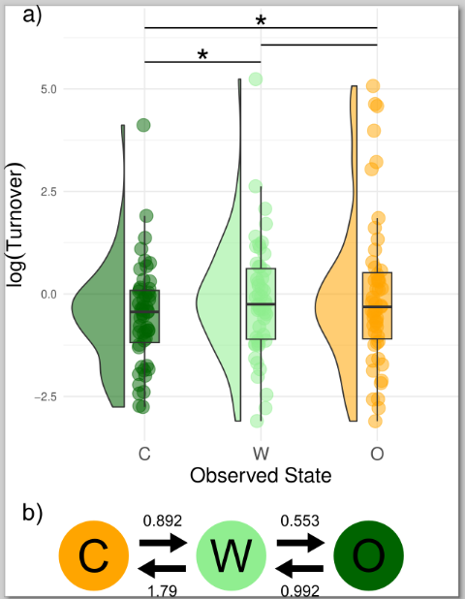

**Figure 3:** *Box plots and distribution of the log turnover rates associated with closed canopy (orange), open canopy (dark green), and widespread (light green). We found that turnover rates of the closed canopy habitat were significantly lower than both open canopy and widespread lineages, with closed canopy habitats expected to have one fewer speciation or extinction event every million years. (b) Transition rates between observed states. Transitions from widespread to closed canopy were significantly faster than widespread to open habitats.*

Mean transition rates across the 51 clades show a general trend of faster rates of transition from open-canopy biomes into closed-canopy ones, with rates from widespread to closed-canopy being about four times higher than those from widespread to open-canopy habitats (Figure 3b). Interestingly, this also supports another of Stebbins’ ideas, in which evolution into closed-canopy biomes where resources abound should be more frequent than open-canopy biomes, which are more challenging for survival (Stebbins, 1974). This however contradicts many studies that have found that lineages in open-canopy biomes tend to evolve from closed-canopy ones, with the frequent narrative that open-canopy biomes, such as those in dry, cold areas and the mediterranean, are more recent (e.g. Antonelli et al. 2018; reviewed in Donoghue and Edwards, 2014). It is important to note here that most of these studies have not used models that account for variations in speciation and extinction, and that these impact ancestral state and range reconstructions (Vasconcelos et al. 2022). We reinforce here, as have others (Holland et al., 2020; Herrera‐Alsina et al., 2022), that SSE models should be also used for analyses of ancestral state and range reconstructions, which is one of the goals they were originally developed for (Maddison et al., 2007), with the potential to change narratives that depend on direction and frequency of transitions between states and areas.

*An alternative perspective on diversification analyses*

State-dependent diversification analyses (SSE models) began as a way to correct biases in transition rates due to the unequal distribution of tip states and the possibility that observed states may be correlated with speciation and extinction rates (Maddison et al., 2007). It was later discovered that this class of models was biased towards finding associations between a focal character and diversification rates (Rabosky and Goldberg, 2016; Beaulieu and O’Meara, 2016). This was because SSE models included heterogeneity in diversification parameters that would outperform alternative models which did not, regardless of whether there was a true association between diversification rates and the focal character (Rabosky and Goldberg, 2016). To resolve this, hidden Markov SSE models were introduced, which allow for heterogeneity in diversification processes independent of the focal character (e.g., HiSSE; Beaulieu and O’Meara, 2016). This body of work set the stage for the typical diversification analysis in which biologists test for an association between the focal character and diversification parameters with the inclusion of a hidden Markov model as a null hypothesis.

Although treating hidden Markov SSE models as null hypotheses is common practice, we argue, as exemplified by our approach, that this is a suboptimal approach as they are more informative than one would usually consider a null hypothesis to be. Hidden Markov models are explicitly parameterized by the dynamics of the observed characters, as this is where the information for estimating rate classes is derived from (Boyko and Beaulieu, 2021). This means that evidence for hidden rate models can come from both differences in diversification dynamics and differences in observed character transition rates, and the potential relationships between these processes have been generally under-explored. This is not to say that biologists have ignored the potential for trait lability to drive patterns of diversification. Several studies have attempted to correlate these processes using independent modeling results (e.g. Rabosky and Adams, 2012; Onstein, 2020), but never in a framework where the diversification and trait evolution parameters were estimated jointly. By using the hidden Markov SSE framework to frame our hypothesis with the rate classes themselves being of primary interest, the test of whether rates of biome shifts are positively correlated with rates of turnover is explicitly modeled in a joint framework. This modeling framework does not require any new methodological developments, instead relies on evolutionary biologists to refocus their hypotheses in an examination of how different processes influence diversification rather than particular character traits.

**Conclusion**

In this study, we have found a significant correlation between the rates of biome shifts and species turnover across a broad range of angiosperm clades, highlighting the role of evolutionary lability in shaping speciation and extinction dynamics. Our findings challenge the traditional focus on static traits and instead emphasize the importance of dynamic evolutionary processes in understanding biodiversity. The observed patterns suggest that the capacity for angiosperms to transition between biomes, particularly from open to closed-canopy environments, plays an important role in their diversification. This insight aligns with Stebbins’ hypothesis on biome shifts, underscoring the influence of habitat adaptability in the evolutionary trajectory of flowering plants. Finally, our results are grounded in a robust analytical framework which jointly account for trait evolution and diversification, not only advancing our understanding of angiosperm evolution but offering a fresh perspective on how to approach diversification analyses. This study emphasizes that future research should consider the possibility that diversification dynamics are influenced by how trait evolution occurs rather than just the traits themselves.

# **Methods**

## *Dataset assembly*

The criterion to select the 51 clades used in this study was to pick clades that had a minimum of 80 tips, with at least 0.1 of sampling fraction for the ingroup; i.e. inclusion of at least 10% of the species diversity assigned to the corresponding clades. Though this is a somewhat arbitrary threshold, less than 0.1 sampling fraction has been shown to lead to inaccurate parameter estimates in diversification analyses (Chang et al., 2020) and small trees are unlikely to present rate class heterogeneity. We also focused on trees produced by taxonomists of each group, since they are more careful about voucher identification and choice of molecular markers used in reconstructions (e.g. NMWG, 2023). We avoided using large trees inferred by Genbank scraping (e.g. Smith and Brown, 2018) because of issues with uneven sampling across the tree. In that way, we combined the strengths of the large sample approach in which to observe generalities with the care for accuracy that comes from small trees (see debate between Beaulieu and O’Meara, 2019 and Donoghue and Edwards, 2019). Finally, we also excluded trees that were not reciprocally monophyletic, keeping only the ones with larger sampling and/or more tips when the same clade appears in more than one tree (e.g. we excluded the *Acacia* phylogeny of Renner et al., 2020 and kept the phylogeny of Mimosoid legumes of Ringelberg et al., 2023, which includes *Acacia*). Trees’ root ages ranged from 3.87 (*Heliconia*; Iles et al., 2017) to 121.68 (Araceae; Nauheimer et al., 2012) million years to the root and from 85 (Cyclanthaceae; Leal et al., 2022) to 3,588 (Poaceae, Spriggs et al. 2014) tips, accounting for 26,232 species in total, c. 8% of flowering plant diversity.

To score the main biome type for each species, we first standardized all tip names according to the GBIF taxonomic backbone using the R package *taxize* (Chamberlain and Szöcs, 2013) and removed outgroups following the original publications of each phylogeny. We also pruned trees to remove the tips of species with multiple entries in some phylogenies, leaving only one tip per species. We then downloaded all the 6,734,171 occurrence points linked with preserved herbarium specimens for the originally 26,232 species sampled in the 51 trees from GBIF (2023), using the POWO (2023) taxonomy and geographical information to filter non-native distributions and distribution inaccuracies. Because GBIF is prone to sampling bias, we also thinned occurrence points to one representative occurrence point per 1x1 grid cell for all species before further analyses (see Boyko et al., 2023 for detailed methodology). Our filtering was conservative and decreased the number of species with trustworthy information to 18,852.

The remaining 1,425,819 points after filtering were overlaid on the World Wildlife Fund (WWF) map of terrestrial biomes (Olson et al., 2001). Biomes are generally defined as a combination of climatic factors that drive convergent and/or parallel evolution in certain plant traits, leading to characteristic vegetation typer (or physiognomies) under specific climatic conditions (Mucina 2019). Following Stebbins’ hypothesis, we binarized the original 13 terrestrial biomes into closed or open-canopy, dividing them along a precipitation gradient (Supplementary Information x). Occurrence points placed on biomes where precipitation is higher ("Tropical & Subtropical Moist Broadleaf Forests", "Tropical & Subtropical Dry Broadleaf Forests", "Tropical & Subtropical Coniferous Forests", "Temperate Broadleaf & Mixed Forests", "Temperate Conifer Forests", and "Boreal Forests/Taiga") were scored as closed-canopy biomes. Those occurring in areas of lower precipitation ("Tropical & Subtropical Grasslands, Savannas & Shrubland", "Temperate Grasslands, Savannas & Shrublands", "Flooded Grasslands & Savannas", "Montane Grasslands & Shrublands", "Tundra”, “Deserts & Xeric Shrublands", "Mediterranean Forests, and Woodlands & Scrub") as well as “Mangroves” were scored as open-canopy biomes (Figure sx). Species were scored as occurring in closed or open-canopy biomes when at least 25% of their occurrence points were found in that biome type. If at least 25% of their occurrence points were found in both biome types, then the species was scored as widespread. All datasets and R scripts used in the curation process are available at xx.

## *Diversification and hidden state modeling*

We use hidden Markov and observed state-dependent speciation and extinction (SSE) models that allow transition rates between biome types and diversification dynamics to vary within a clade. We then assess whether these within-clade correlations are consistent across our 51 clades of angiosperms. We test the relationship between the frequency of biome shifts and rates of species speciation and extinction by correlating average time to a biome shift with lineage turnover rates, expecting that they will be inversely related, that is, a shorter expected time to transition leads to higher lineage turnover. Turnover, under this definition, gives us a measure of how frequently an “event” of either speciation or extinction will occur and is more consistent with the ideas put forth by Stebbins (1974) than either net diversification rates or speciation rates.

Our analysis utilizes the MuHiSSE model (Nakov et al., 2019) implemented in the R-package ‘hisse’ (Beaulieu and O’Meara, 2016; Beaulieu et al. 2023) to test for correlations between diversification dynamics and the rate of biome shift. We fit a set of 36 models: 4 without hidden states and 32 with two rate classes. The basic discrete character model of evolution was an all-rates-different model, in which transitions between open and closed canopy biome could only occur through an intermediate widespread state. Models with two rate classes were categorized into two types of discrete character models. The first type allows for discrete character rate heterogeneity by permitting transition rates to differ between rate classes. The second type has transition rates that are fixed to be equal between rate classes (Supplementary information).

The other parameters of interest for a MuHiSSE model are extinction fraction (extinction/speciation) and turnover (speciation+extinction). For single rate class models, parameters are fixed to be equal for all observed states (no trait-dependent diversification) or all are set to be different (diversification parameters are freely estimated for each observed state). For two rate class models, we explore 4 different parameterizations: (1) no observed trait-dependent diversification and no hidden trait-dependent diversification, (2) observed trait-dependent diversification, but no hidden trait-dependent diversification, (3) no observed trait-dependent diversification, but hidden trait-dependent diversification, and (4) both observed trait-dependent diversification and hidden trait-dependent diversification. We examine all possible combinations of the parameterizations resulting in 4 models without hidden states and 32 with hidden states. Estimates of sampling fraction, a fixed parameter in the model, were gathered from the literature of each clade (Supplementary Information x).

*Parameter interpretation and analyses*

The simplest way to test our hypothesis would be to correlate the transition rates with the diversification rates of hidden states. However, there are at least two outstanding problems with this approach. First, the model space is much larger than a comparison of two models (one with hidden states and one without) and there is evidence that an incomplete model set has the potential to bias our results (Boyko and Beaulieu, 2023). This necessitates looking at a more complete set of models, which we described in the previous section. However, with a larger set of models, each individual model can contribute some amount of information to our inferences, and it is unlikely that examining the best-fitting model is sufficient for analysis (Anderson and Burnham, 2002). Thus, for robust inference, we integrate over-model uncertainty by employing model averaging based on AIC weights (Anderson and Burnham, 2002; AIC paper). This leads to the second outstanding problem, which is that the automatic labeling of model dynamics by the HMM as either *Rate Class A* or *Rate Class B* is arbitrary (label switching chapter). Put another way, there is no difference in the likelihood if you were to completely swap hidden *Rate Class A* with hidden *Rate Class B* because it only means that you have swapped their labels, not altered the parameters describing the rate classes. This poses a problem for model averaging because when examining many hidden rate models, the choice of rate class label is arbitrary even for a single dataset. Thus, we need to compare parameters in such a way that we can validly conduct model averaging without worrying about the label-switching problem.

The approach we take is to compare the log differences of the rate class parameters (Figure x). For each model, we take the mean of transition rates (or turnover rates) for a particular rate class and compute the log of the ratio of *Rate Class B* over *Rate Class A*. This relativizes the differences around zero. A value of zero represents no difference between rate classes since when the rate classes have the same average parameter value, the ratio will equal one and the log of the ratio is therefore zero. If *Rate Class B* is greater than *Rate Class A*, then the ratio is greater than 1 and the log of that ratio is between 0 and positive infinity. In contrast, if *Rate Class A* is greater than *Rate Class B*, we will get a ratio below 1 and the log of that ratio is between 0 and negative infinity. We calculate log ratios for all models with two rate classes, and for each clade calculate model averaged values.

To test for a correlation between differences in turnover rates and differences in mean transition rates, we fit a phylogenetic linear regression model (Ho and Ane, 2014) using a backbone tree derived from Smith and Brown (2018) where each tip represents one of our 51 clades. We conduct 1000 bootstrap replicates to estimate upper and lower confidence intervals around the slope, intercept, and variance rate of the regression model. A regression with a significantly non-zero and positive slope would support our main conjecture that species that transition in biome more often also have higher rates of speciation and extinction.

An alternative way to formulate a test for this hypothesis would be to examine a correlation between turnover rates and transition rates without taking their differences between rate classes. While we do conduct this analysis (Supplementary Information), we focus primarily on the ratios between rate classes because this better controls for historical contingency, i.e, we use within-clade ratios for our analysis and ask whether, for a given clade, is there evidence that differences in transition rates are correlated with differences in turnover rates. This helps control for the heterogeneity of absolute rate values that is likely to occur when examining many ecologically distinct groups and helps avoid problems related to Simpson’s paradox (citation). For example, if we were to examine only the raw rates, it is possible that in a particular clade transition and turnover rates are relatively high, but within that clade, the observed pattern is that high turnover rates are associated with low transition rates. Although within the clade the nature of the relationship is contrary to our hypothesis, we may find that when adding it to a comparison of several clades it contributes to a positive slope since in general the transition and turnover rates are higher than that of the average clade. Examining ratios avoids this problem and allows us to infer general trends without being subject to Simpsons’ paradox.

References

Anderson, B., Pannell, J., Billiard, S., Burgarella, C., de Boer, H., Dufay, M., ... & Glémin, S. (2023). Opposing effects of plant traits on diversification. *Iscience*, *26*(4).

Anderson D, Burnham K. 2002. Model selection and multi-model inference. Second. NY: Springer-Verlag 63(2020): 10.

Antonelli, A., Zizka, A., Carvalho, F. A., Scharn, R., Bacon, C. D., Silvestro, D., & Condamine, F. L. (2018). Amazonia is the primary source of Neotropical biodiversity. *Proceedings of the National Academy of Sciences*, *115*(23), 6034-6039.

Angiosperm Phylogeny Group, Chase, M. W., Christenhusz, M. J., Fay, M. F., Byng, J. W., Judd, W. S., ... & Stevens, P. F. (2016). An update of the Angiosperm Phylogeny Group classification for the orders and families of flowering plants: APG IV. *Botanical journal of the Linnean Society*, *181*(1), 1-20.

Beaulieu, J. M., O'Meara, B. C., & Donoghue, M. J. (2013). Identifying hidden rate changes in the evolution of a binary morphological character: the evolution of plant habit in campanulid angiosperms. *Systematic biology*, *62*(5), 725-737.

Beaulieu, J. M., & O’Meara, B. C. (2016). Detecting hidden diversification shifts in models of trait-dependent speciation and extinction. *Systematic biology*, *65*(4), 583-601.

Beaulieu, J. M., & O'Meara, B. C. (2018). Can we build it? Yes we can, but should we use it? Assessing the quality and value of a very large phylogeny of campanulid angiosperms. *American Journal of Botany*, *105*(3), 417-432.

Beaulieu, J. M., & O'Meara, B. C. (2019). Diversity and skepticism are vital for comparative biology: a response to Donoghue and Edwards (2019). *American Journal of Botany*, *106*(5), 613-617.

Beaulieu, J., O'Meara, B., Caetano, D., Boyko, J., & Vasconcelos, T. (2023). Package ‘hisse’.

Boyko, J. D., & Beaulieu, J. M. (2021). Generalized hidden Markov models for phylogenetic comparative datasets. Methods in Ecology and Evolution, 12(3), 468-478.

Boyko, J. D., & Beaulieu, J. M. (2023). Reducing the biases in false correlations between discrete characters. *Systematic Biology*, *72*(2), 476-488.

Boyko, J. D., Hagen, E. R., Beaulieu, J. M., & Vasconcelos, T. (2023). The evolutionary responses of life‐history strategies to climatic variability in flowering plants. *New Phytologist*, *240*(4), 1587-1600.

Chamberlain, S. A., & Szöcs, E. (2013). taxize: Taxonomic search and retrieval in R. F1000Research, 2, 191. https://doi.org/10.12688/ f1000research.2-191.v1

Chang, J., Rabosky, D. L., & Alfaro, M. E. (2020). Estimating diversification rates on incompletely sampled phylogenies: theoretical concerns and practical solutions. *Systematic Biology*, *69*(3), 602-611.

Donoghue, M. J., & Edwards, E. J. (2014). Biome shifts and niche evolution in plants. *Annual Review of Ecology, Evolution, and Systematics*, *45*, 547-572.

Donoghue, M. J., & Sanderson, M. J. (2015). Confluence, synnovation, and depauperons in plant diversification. *New Phytologist*, *207*(2), 260-274.

Donoghue, M. J., & Edwards, E. J. (2019). Model clades are vital for comparative biology, and ascertainment bias is not a problem in practice: a response to Beaulieu and O'Meara (2018). *American Journal of Botany*, *106*(3), 327-330.

GBIF.org (04 May 2023) GBIF Occurrence Download <https://doi.org/10.15468/dl.9y3t82>

Govaerts, R., Nic Lughadha, E., Black, N., Turner, R., & Paton, A. (2021). The World Checklist of Vascular Plants, a continuously updated resource for exploring global plant diversity. Scientific Data, 8(1), 215.

Givnish, T. J. (2010). Ecology of plant speciation. *Taxon*, *59*(5), 1326-1366.

Givnish, T. J. (2015). Adaptive radiation versus ‘radiation’and ‘explosive diversification’: why conceptual distinctions are fundamental to understanding evolution. *New Phytologist*, *207*(2), 297-303.

Helmstetter, A. J., Zenil‐Ferguson, R., Sauquet, H., Otto, S. P., Méndez, M., Vallejo‐Marin, M., ... & Käfer, J. (2023). Trait‐dependent diversification in angiosperms: Patterns, models and data. *Ecology Letters*, *26*(4), 640-657.

Henao Diaz, L. F., Harmon, L. J., Sugawara, M. T., Miller, E. T., & Pennell, M. W. (2019). Macroevolutionary diversification rates show time dependency. *Proceedings of the National Academy of Sciences*, *116*(15), 7403-7408.

Hernández-Hernández, T., & Wiens, J. J. (2020). Why are there so many flowering plants? A multiscale analysis of plant diversification. *The American Naturalist*, *195*(6), 948-963.

Herrera‐Alsina, L., Algar, A. C., Lancaster, L. T., Ornelas, J. F., Bocedi, G., Papadopulos, A. S., ... & Travis, J. M. (2022). The missing link in biogeographic reconstruction: Accounting for lineage extinction rewrites history. *Journal of Biogeography*, *49*(11), 1941-1951.

Tung Ho, L. S., & Ané, C. (2014). A linear-time algorithm for Gaussian and non-Gaussian trait evolution models. *Systematic biology*, *63*(3), 397-408.

Holland, B. R., Ketelaar-Jones, S., o’Mara, A. R., Woodhams, M. D., & Jordan, G. J. (2020). Accuracy of ancestral state reconstruction for non-neutral traits. *Scientific Reports*, *10*(1), 7644.

Iles, W. J., Sass, C., Lagomarsino, L., Benson-Martin, G., Driscoll, H., & Specht, C. D. (2017). The phylogeny of Heliconia (Heliconiaceae) and the evolution of floral presentation. *Molecular Phylogenetics and Evolution*, *117*, 150-167.

Jansson, R., & Dynesius, M. (2002). The fate of clades in a world of recurrent climatic change: Milankovitch oscillations and evolution. *Annual review of ecology and systematics*, *33*(1), 741-777.

Leal, E. S., Vasconcelos, T. N., Tuberquia, D., Soto Gomez, M., Michelangeli, F. A., Forzza, R. C., & de Mello‐Silva, R. (2022). Phylogeny and historical biogeography of the Panama‐hat family (Cyclanthaceae, Pandanales). *Taxon*, *71*(5), 963-980.

Maddison, W. P., Midford, P. E., & Otto, S. P. (2007). Estimating a binary character's effect on speciation and extinction. *Systematic biology*, *56*(5), 701-710.

Madriñán, S., Cortés, A. J., & Richardson, J. E. (2013). Páramo is the world's fastest evolving and coolest biodiversity hotspot. *Frontiers in genetics*, *4*, 192.

Magallon, S., & Sanderson, M. J. (2001). Absolute diversification rates in angiosperm clades. *Evolution*, *55*(9), 1762-1780.

Mucina, L. (2019). Biome: evolution of a crucial ecological and biogeographical concept. *New Phytologist*, *222*(1), 97-114.

Nakov, T., Beaulieu, J. M., & Alverson, A. J. (2019). Diatoms diversify and turn over faster in freshwater than marine environments. *Evolution*, *73*(12), 2497-2511.

Nauheimer, L., Metzler, D., & Renner, S. S. (2012). Global history of the ancient monocot family Araceae inferred with models accounting for past continental positions and previous ranges based on fossils. *New Phytologist*, *195*(4), 938-950.

Neotropical Myrtaceae Working Group, Staggemeier, V., Amorim, B., Bunger, M., R. Costa, I., Quintino de Faria, J. E., ... & Vasconcelos, T. (2023). Towards a species-level phylogeny for Neotropical Myrtaceae: notes on topology and resources for future studies. *bioRxiv*, 2023-10.

Nürk, N. M., Linder, H. P., Onstein, R. E., Larcombe, M. J., Hughes, C. E., Piñeiro Fernández, L., ... & Pirie, M. D. (2020). Diversification in evolutionary arenas—Assessment and synthesis. *Ecology and Evolution*, *10*(12), 6163-6182.

Olson, D. M., Dinerstein, E., Wikramanayake, E. D., Burgess, N. D., Powell, G. V., Underwood, E. C., ... & Kassem, K. R. (2001). Terrestrial Ecoregions of the World: A New Map of Life on Earth: A new global map of terrestrial ecoregions provides an innovative tool for conserving biodiversity. *BioScience*, *51*(11), 933-938.

O'Meara, B. C., & Beaulieu, J. M. (2016). Past, future, and present of state‐dependent models of diversification.

Onstein, R. E. (2020). Darwin’s second ‘abominable mystery’: Trait flexibility as the innovation leading to angiosperm diversity. *New Phytologist*, *228*(6), 1741-1747.

Petit, R. J., & Hampe, A. (2006). Some evolutionary consequences of being a tree. *Annu. Rev. Ecol. Evol. Syst.*, *37*, 187-214.

POWO. 2023. Plants of the World Online Facilitated by the Royal Botanic Gardens, Kew. [WWW document] URL http://www.plantsoftheworldonline. org/ [accessed May 2023].

Rabosky, D. L., & Adams, D. C. (2012). Rates of morphological evolution are correlated with species richness in salamanders. *Evolution*, *66*(6), 1807-1818.

Rabosky, D. L., & Goldberg, E. E. (2015). Model inadequacy and mistaken inferences of trait-dependent speciation. *Systematic biology*, *64*(2), 340-355.

Renner, M. A., Foster, C. S., Miller, J. T., & Murphy, D. J. (2020). Increased diversification rates are coupled with higher rates of climate space exploration in Australian Acacia (Caesalpinioideae). *New Phytologist*, *226*(2), 609-622.

Ricklefs, R. E., & Renner, S. S. (1994). Species richness within families of flowering plants. *Evolution*, *48*(5), 1619-1636.

Ringelberg, J. J., Koenen, E. J., Sauter, B., Aebli, A., Rando, J. G., Iganci, J. R., ... & Hughes, C. E. (2023). Precipitation is the main axis of tropical plant phylogenetic turnover across space and time. *Science Advances*, *9*(7), eade4954.

Smith, S. A., & Brown, J. W. (2018). Constructing a broadly inclusive seed plant phylogeny. *American journal of botany*, *105*(3), 302-314.

Spriggs, E. L., Christin, P. A., & Edwards, E. J. (2014). C4 photosynthesis promoted species diversification during the Miocene grassland expansion. *PloS one*, *9*(5), e97722.

Vasconcelos, T. N., Alcantara, S., Andrino, C. O., Forest, F., Reginato, M., Simon, M. F., & Pirani, J. R. (2020). Fast diversification through a mosaic of evolutionary histories characterizes the endemic flora of ancient Neotropical mountains. *Proceedings of the Royal Society B*, *287*(1923), 20192933.

Vasconcelos, T., O’Meara, B. C., & Beaulieu, J. M. (2022). Retiring “cradles” and “museums” of biodiversity. *The American Naturalist*, *199*(2), 194-205.

Vasconcelos, T., O'Meara, B. C., & Beaulieu, J. M. (2023). A flexible method for estimating tip diversification rates across a range of speciation and extinction scenarios. *Evolution*, *76*(7), 1420-1433.

Vrba, E. S. (1985). Environment and evolution: alternative causes of the temporal distribution of evolutionary events. *South African Journal of Science*, *81*(5), 229-236.