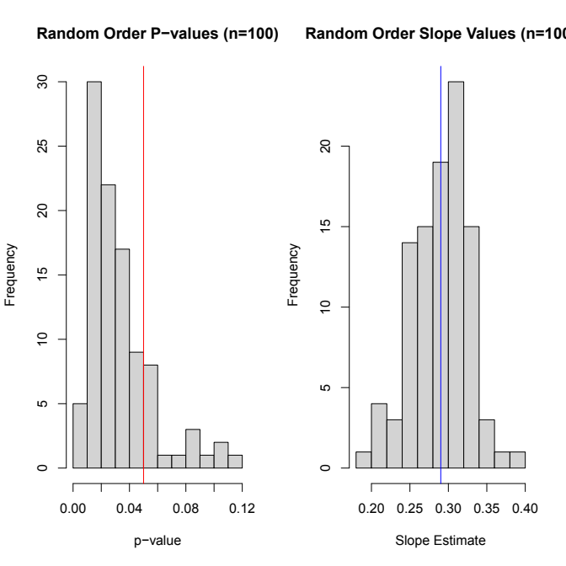Figure SX. 100 random assignments of rate class A and rate class B with estimated p-values and slopes. 83% of the random permutations resulted in a p-value less than 0.05. This test was done to ensure that the arbitrary nature of rate class assignment (see label switching problem in main text) did not drive a false positive.