Thẻ 1
Group 18 - Class Specification

Design for class “IPaymentCreditCard”
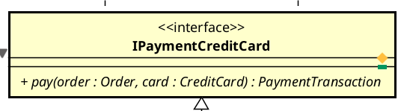
Description: A general interface defining the contract for credit card payment processing. It decouples the AIMS system from specific payment gateway implementations.

Table 1. Attribute design
# | Name | Data type | Default value | Description

Table 2. Operation design
# | Name | Return type | Description (purpose)
1 | pay | PaymentTransaction | Executes a payment for a specific order using a credit card.

Parameters :
- order: An instance of Order containing total amount and ID
- card: An instance of CreditCard containing card details
Exceptions:
- PaymentException: Thrown if the transaction fails due to various gateway or network issues.
Methods:
- pay: Takes order details and card information to initiate a transaction via the concrete subsystem implementation.

Design for class “PayPalSubsystem”
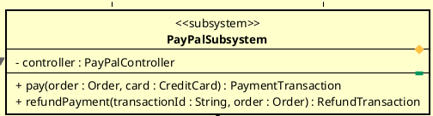
Description: The Facade class for the PayPal subsystem. It implements the payment and refund interfaces to provide a simplified entry point for the rest of the AIMS application.

Table 1. Attribute design
# | Name | Data type | Default value | Description
1 | controller | PayPalController | null | The internal controller that handles subsystem logic

Table 2. Operation design
# | Name | Return type | Description (purpose)
1 | pay | PaymenTransaction | Orchestrates the payment process by calling the controller
2 | refundPayment | RefundTransaction | Orchestrates the refund process for a specific transaction

Methods:
- Acts as a wrapper; it delegates the pay and refundPayment calls directly to the PayPalController.

Design for class “PayPalGateway”
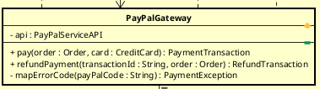
Description: Acts as an Adapter/Gateway that translates domain-specific data (Order, CreditCard) into PayPal-specific API requests and handles error mapping.

Table 1. Attribute design
# | Name | Data type | Default value | Description
1 | api | PayPalServiceAPI | null | The boundary object used to communicate with PayPal's external REST API

Table 2. Operation design
# | Name | Return type | Description (purpose)
1 | pay | PaymentTransaction | Coordinates DTO creation, API calling, and response mapping
2 | mapErrorCode | PaymentException | Translates PayPal-specific error strings into AIMS Exceptions
3 | refundPayment | RefundTransaction | The method for implementing the refund process for customers.

Exceptions:
- InsufficientBalanceException: If PayPal returns "INSTRUMENT_DECLINED".
- PaymentDeclinedException: If the card is rejected by the processor.
Methods:
- pay: Converts Order and CreditCard into a PayPalOrderRequest, calls api.createOrder, then api.capturePayment, and finally maps the response to a PaymentTransaction.

Design for class “PayPalServiceAPI”
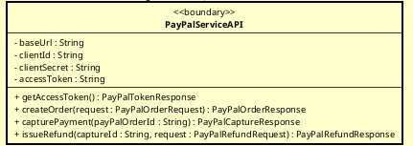
Description: A Boundary class responsible for the actual HTTP communication with the PayPal REST API v2.

Table 1. Attribute design
# | Name | Data type | Default value | Description
1 | baseUrl | String | "https://api-m.sandbox.paypal.com" | The endpoint for PayPal API
2 | clientId | String |  | Unique identifier for the AIMS PayPal account
3 | accessToken | String | null | Bearer token for OAuth 2.0 authentication

Table 2. Operation design
# | Name | Return type | Description (purpose)
1 | getAccessToken | PayPalTokenResponse | Requests a new OAuth2 token using client credentials
2 | createOrder | PayPalOrderResponse | Sends a POST request to /v2/checkout/orders
3 | capturePayment | PayPalCaptureResponse | Finalizes the payment after the order is created

Methods:
- createOrder: Marshals the PayPalOrderRequest into JSON and executes the HTTP POST request with the current accessToken.

Design for class “CreditCard”
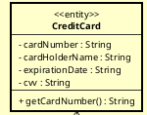
Description: An entity class that stores the customer's credit card details required for payment. AIMS does not validate these details; they are passed directly to PayPal for processing.
Table 1. Attribute design
# | Name | Data type | Default value | Description
1 | cardNumber | String |  | The 16-digit card number
2 | cardHolderName | String |  | Name printed on the card
3 | expirationDate | String |  | Expiry date (MM/YY)
4 | cvv | String |  | Security code

Table 2. Operation design
# | Name | Return type | Description (purpose)
1 | getCardNumber | String | Returns the card number for display or processing

Methods:
- getCardNumber: Accesses the cardNumber attribute to provide it to the PayPalOrderRequest mapper.

Design for class “PaymentTransaction”
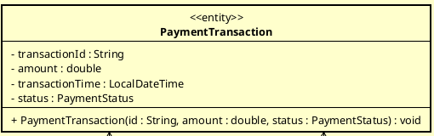
Description: An entity class that records the details of a completed or attempted payment transaction.

Table 1. Attribute design
# | Name | Data type | Default value | Description
1 | transactionId | String |  | Unique ID returned by PayPal after capture
2 | amount | double | 0.0 | Total amount paid (VAT included)
3 | status | PaymentStatus | PENDING | The current state of the payment (COMPLETED, FAILED, PENDING)
4 | transactionTime | LocalDateTime | null | The timestamp when the transaction occurred

Table 2. Operation design
# | Name | Return type | Description (purpose)
1 | PaymentTransaction | (Constructor) | Initializes a transaction record with provided ID and status

Parameters :
- id: String (No default). The ID from the gateway.
- amount: double (No default). The actual charged amount.
- status: PaymentStatus (No default). The outcome of the payment.
Methods:
- Constructor: Assigns parameters to internal attributes and sets transactionTime to the current system time.

Design for class “Order”
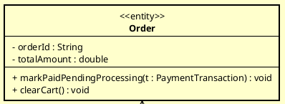
Description: Represents a customer's order in the AIMS system. It is updated once a payment transaction is successful.

Table 1. Attribute design
# | Name | Data type | Default value | Description
1 | orderId | String | "" | Unique identifier for the order.
2 | totalAmount | double | 0.0 | The sum of product prices (with VAT) and shipping fees.

Table 2. Operation design
# | Name | Return type | Description (purpose)
1 | markPaidPendingProcessing | void | Updates order status to "pending processing" after payment.
2 | clearCart | void | Empties the shopping cart once the order is successfully paid.

Parameters :
- t: PaymentTransaction. The transaction object used to link payment to the order.

Methods:
- markPaidPendingProcessing: Uses the t.status to confirm the payment is COMPLETED before updating the order state to "Pending Processing".

Design for class “PayPalOrderRequest”
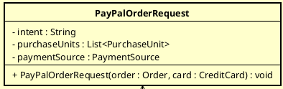
Description: A Data Transfer Object used to structure the request body for PayPal's "Create Order" API.

Table 1. Sttribute design
# | Name | Data type | Default value | Description
1 | intent | String | "CAPTURE" | The payment intent (CAPTURE or AUTHORIZE).
2 | purchaseUnits | List<PurchaseUnit> | null | Details of the items and total price.
3 | paymentSource | PaymentSource | null | Contains the CreditCard details for the API.

Table 2. Operation design
# | Name | Return type | Description (purpose)
1 | PayPalOrderRequest | (Constructor) | Maps AIMS domain objects to PayPal DTO structure.

Design for class “PayPalCaptureResponse”
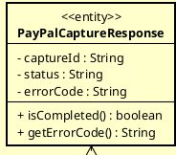
Description: An entity class that acts as a Data Transfer Object (DTO). it captures the JSON response from the PayPal "Capture Payment for Order" API endpoint. It contains the final status of the fund transfer and any error codes returned by the processor.
Table 1. Attribute design
# | Name | Data type | Default value | Description
1 | captureId | String | "" | The specific ID for the captured funds.
2 | status | String | "" | PayPal status (e.g., "COMPLETED").
3 | errorCode | String | null | Specific PayPal error code if the capture fails.

Table 2. Operation design
# | Name | Return type | Description (purpose)
1 | isCompleted | boolean | Returns true if the status is "COMPLETED".
2 | getErrorCode | String | Returns the error code for exception mapping.

Design for class “PaymentException”
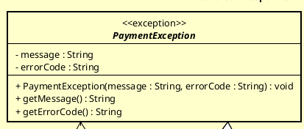
Description: An abstract base class for all payment-related errors in the system.
Table 1. Attribute design
# | Name | Data type | Default value | Description
1 | message | String | "" | Error message for the user.
2 | errorCode | String | "" | Internal code for debugging.

Table 2. Example of operation design
# | Name | Return type | Description (purpose)
1 | PaymentException | void | Constructor to initialize the exception with a specific message and error code.
2 | getMessage | String | Returns the human-readable error message associated with the exception.
3 | getErrorCode | String | Returns the internal error code associated with the exception.

Exceptions:
- InsufficientBalanceException: If PayPal returns "INSTRUMENT_DECLINED".
- PaymentDeclinedException: If the transaction is rejected by the bank.
- PaymentTimeoutException: If the API call fails to respond within the required time.

Design for class “RefundTransaction”
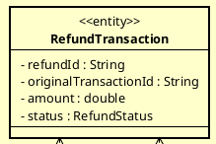
Description: Records information about a refund issued to a customer.

Table 1. Attribute design
# | Name | Data type | Default value | Description
1 | refundId | String | "" | The unique ID for the refund transaction.
2 | originalTransactionId | String | "" | Link to the original payment ID.
3 | amount | double | 0.0 | The amount refunded.
4 | status | RefundStatus | FAILED | Result: SUCCESS or FAILED.

Table 2. Operation design
# | Name | Return type | Description (purpose)

Design for class “IRefundGateway”
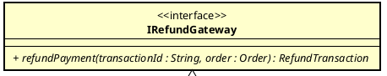
Description: An interface that defines the contract for refunding payments. It allows the AIMS system to process refunds through any payment gateway that implements this interface.

Table 1. Attribute design
# | Name | Data type | Default value | Description

Table 2. Operation design
# | Name | Return type | Description (purpose)
1 | refundPayment | RefundTransaction | Processes a refund for a previously captured payment.

Parameters :
- transactionId: String. Default: none. The ID of the original payment transaction to be refunded.
- order: Order. Default: none. The order object associated with the refund.
Methods:
- refundPayment: Uses the transactionId to identify the funds at the gateway and the order's total amount to determine the refund value.

Design for class “PayPalController”
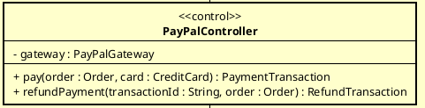
Description: A control class that coordinates the logic within the PayPal subsystem, acting as a bridge between the Subsystem Facade and the Gateway.

Table 1. Example of attribute design
# | Name | Data type | Default value | Description
1 | gateway | PayPalGateway | null | The adapter used to communicate with the PayPal API.

Table 2. Operation design
# | Name | Return type | Description (purpose)
1 | pay | PaymentTransaction | Coordinates the payment flow.
2 | refundPayment | RefundTransaction | Coordinates the refund flow.

Parameters :
- order: Order. Current order to pay/refund.
- card: CreditCard. Required for payment operations.
- transactionId: String. Required for refund operations.
Methods:
- pay: Invokes gateway.pay(order, card) and handles high-level subsystem logic.
- refundPayment: Invokes gateway.refundPayment(transactionId, order).

Design for class “PayPalOrderResponse”
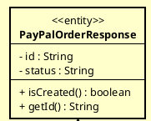
Description: An entity class representing the response received from PayPal after an order creation request.

Table 1. Attribute design
# | Name | Data type | Default value | Description
1 | id | String | "" | The Order ID generated by PayPal.
2 | status | String | "" | The status of the created order (e.g., "CREATED").

Table 2. Operation design
# | Name | Return type | Description (purpose)
1 | isCreated | boolean | Checks if the order was successfully created on PayPal's side.
2 | getId | String | Returns the PayPal Order ID.

Design for class “PayPalRefundRequest”
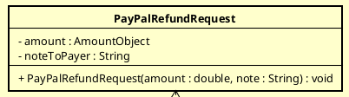
Description: A DTO (Data Transfer Object) used to encapsulate data for the PayPal Refund API request.
Table 1. Attribute design
# | Name | Data type | Default value | Description
1 | amount | AmountObject | null | Object containing value and currency code.
2 | noteToPayer | String | "" | An optional message sent to the customer regarding the refund.

Table 2. Operation design
# | Name | Return type | Description (purpose)
1 | PayPalRefundRequest | (Constructor) | Creates a request object with specific amount and note.

Parameters :
- amount: double. The numeric value to refund.
- note: String. The reason or note for the refund.

Design for class “PayPalRefundResponse”
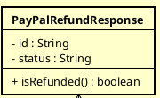
Description: Represents the result returned by the PayPal API after a refund attempt.

Table 1. Attribute design
# | Name | Data type | Default value | Description
1 | id | String | "" | The unique ID for the refund transaction.
2 | status | String | "" | Current status (e.g., "COMPLETED", "CANCELLED").

Table 2. Operation design
# | Name | Return type | Description (purpose)
1 | isRefunded | boolean | Returns true if the status is "COMPLETED".

Design for class “PayPalTokenResponse”
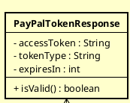
Description: Holds the OAuth 2.0 access token and its metadata required for authenticated API calls.

Table 1. Attribute design
# | Name | Data type | Default value | Description
1 | accessToken | String | "" | The token string used in Authorization headers.
2 | tokenType | String | "Bearer" | The type of token.
3 | expiresIn | int | 0 | Token validity duration in seconds.

Table 2. Operation design
# | Name | Return type | Description (purpose)
1 | isValid | boolean | Checks if the token is present and not expired.

Design for class “InsufficientBalanceException”
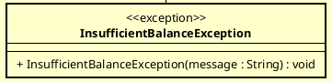
Description: A specialized exception thrown when the customer's credit card has insufficient funds to complete the transaction.

Table 1. Attribute design
# | Name | Data type | Default value | Description

Table 2.Operation design
# | Name | Return type | Description (purpose)
1 | InsufficientBalanceException | (Constructor) | Creates an exception with a specific error message.

Parameters :
- message: String. Default: "Your card has insufficient balance."
Methods:
- Calls super(message, "INSUFFICIENT_FUNDS") to initialize the base PaymentException.

Design for class “PaymentDeclinedException”
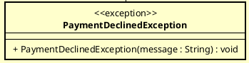
Description: Thrown when the payment is rejected by the issuing bank for reasons other than balance (e.g., card blocked, expired, or fraud suspicion).

Table 1. Attribute design
# | Name | Data type | Default value | Description

Table 2. Operation design
# | Name | Return type | Description (purpose)
1 | PaymentDeclinedException | (Constructor) | Creates an exception for declined payments.

Parameters :
- message: String. Description of why the card was declined.
Methods:
- Calls super(message, "PAYMENT_DECLINED").

Design for class “PaymentStatus”
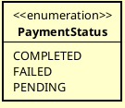
Description: Defines the possible states of a payment transaction within the AIMS system.
Table 1.Values

Value | Description
COMPLETED | The funds have been successfully captured from the customer.
FAILED | The payment process stopped due to an error or declination.
PENDING | The payment has been initiated but not yet finalized.

Design for class “RefundStatus”
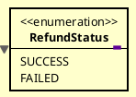
Description: Defines the outcome of a refund request.

Value | Description
SUCCESS | The money has been successfully sent back to the customer.
FAILED | The refund could not be processed by the gateway.

Design for class “PaymentTimeoutException”
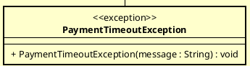
Description: It is thrown by the PayPalGateway when a network request to the external PayPal API fails to receive a response within the system's defined time limits.

Table 1. Attribute design
# | Name | Data type | Default value | Description
1 | message | String | (Inherited) | A descriptive message explaining the timeout error to the user.
2 | errorCode | String | (Inherited) | A specific code used to identify the timeout failure internally.

Table 2. Operation design
# | Name | Return type | Description (purpose)
1 | PaymentTimeoutException | void | Constructor to initialize the exception with a specific error message.

Parameters :
- message: String. Default value: none. The error message providing details about the connection or response timeout.
Exceptions:
- This class is an exception itself and does not throw other exceptions during instantiation.

Design for class “IPaymentQRCode”
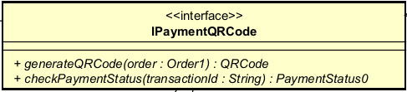
Description: Interface that defines the common contract for QR-code-based payment. It allows the application layer (PaymentService) to generate QR codes and query transaction status without coupling to any specific payment gateway (VietQR, ZaloPay, etc.). All implementations are responsible for handling HTTP communication, authentication, and internal response mapping
Table 1. Example of attribute design
# | Name | Data type | Default value | Description
— | — | — | — | Interface carries no state

Table 2. Example of operation design
# | Name | Return type | Description (purpose)
1 | generateQRCode | QRCode | Creates a payment QR code from the supplied order information. Validates input, delegates to the subsystem, and returns a QRCode entity ready for display.
2 | checkPaymentStatus | PaymentStatus | Queries the status of a transaction by its transactionId. Returns PENDING, SUCCESS, or FAILED.

Parameters :
Parameter | Type | Constraint
order | Order | Non-null; must carry a non-null orderId, an amount greater than zero, and a payment content string.
transactionId | String | Non-null, non-blank transaction identifier.

Exceptions:

Exception | Condition
PaymentException | Base exception; raised when the operation fails for any payment-related reason.
PaymentTimeoutException | Raised when authentication or an API call exceeds the allowed timeout.
InvalidTransactionException | Raised when transactionId is null, blank, or does not correspond to a known transaction.

Methods:
- generateQRCode: requires a non-null order; delegates to the subsystem realization and returns the resulting QRCode.
- checkPaymentStatus: requires a non-blank transactionId; delegates to the subsystem and returns the corresponding PaymentStatus.

Other diagrams

Design for class “VietQRSubsystem”

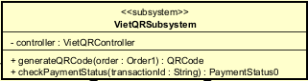
Description: The sole externally visible façade of the VietQR package. Realises IPaymentQRCode and delegates all processing to VietQRController. All internal classes (Controller, Gateway, ServiceAPI) must remain hidden; external callers interact exclusively through this interface.

Table 1. Example of attribute design
# | Name | Data type | Default value | Description
1 | controller | VietQRController | null | Internal controller; not accessible from outside the subsystem.

Table 2. Example of operation design
# | Name | Return type | Description (purpose)
1 | generateQRCode | QRCode | Validates the order and delegates to the controller. Propagates any exception without wrapping.
2 | checkPaymentStatus | PaymentStatus | Validates the transactionId and delegates to the controller. Propagates any exception without wrapping.

Parameters :

Parameter | Type | Constraint
order | Order | Non-null; must have amount > 0 and a non-null orderId.
transactionId | String | Non-null, non-blank.

Exceptions:

Exception | Condition
PaymentException | Raised when order is null.
InvalidTransactionException | Raised when transactionId is null or blank.
(propagated) | All exceptions originating from the controller are surfaced to the caller unchanged.

Methods:
- generateQRCode: guards against a null order, then delegates to the controller. All PaymentException subclasses propagate to the caller without wrapping.
- checkPaymentStatus: guards against a null or blank transactionId, then delegates to the controller. All PaymentException subclasses propagate to the caller without wrapping.

Design for class “VietQRController”
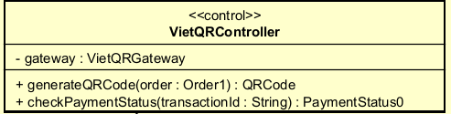
Description: Coordinates the internal payment workflow within the subsystem. Receives requests from VietQRSubsystem and delegates all API communication to VietQRGateway. Does not issue HTTP calls directly and does not construct domain entities.
Table 1. Example of attribute design
# | Name | Data type | Default value | Description
1 | gateway | VietQRGateway | null | Gateway used for all API interactions; injected via constructor.

Table 2. Example of operation design
# | Name | Return type | Description (purpose)
1 | generateQRCode | QRCode | Receives an order from the subsystem, delegates to the gateway, and returns the result.
2 | checkPaymentStatus | PaymentStatus | Receives a transactionId from the subsystem, delegates to the gateway, and returns the result.

Parameters :

Parameter | Type | Constraint
order | Order | Non-null Order supplied by VietQRSubsystem.
transactionId | String | Non-blank transaction identifier.

Exceptions:

Exception | Condition
InvalidQRCodeException | Propagated from gateway when the QR code received from the API is null or empty.
PaymentTimeoutException | Propagated from gateway when authentication or an API call times out.
InvalidTransactionException | Propagated from gateway when the transaction cannot be found.

Methods:
- generateQRCode: delegates directly to the gateway and returns the resulting QRCode. All PaymentException subclasses are propagated to the subsystem.
- checkPaymentStatus: delegates directly to the gateway and returns the resulting PaymentStatus. All PaymentException subclasses are propagated to the subsystem.

Design for class “VietQRGateway”
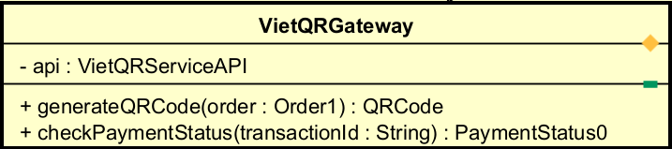
Description: Adapter between the controller and VietQRServiceAPI. Orchestrates the API call sequence (build request → authenticate → call endpoint) and maps VietQRResponse objects to domain objects (QRCode or PaymentStatus). The controller is shielded from HTTP concerns and response structure details.

Table 1. Example of attribute design
# | Name | Data type | Default value | Description
1 | api | VietQRServiceAPI | null | HTTP client for all communication with the VietQR API; injected via constructor.

Table 2. Example of operation design
# | Name | Return type | Description (purpose)
1 | generateQRCode | QRCode | Builds the request, authenticates, calls the QR-generate endpoint, and maps the response to a QRCode entity.
2 | checkPaymentStatus | PaymentStatus | Authenticates, calls the transaction-status endpoint, and maps response.status to a PaymentStatus enum value.

Parameters :

Parameter | Type | Constraint
order | Order | Non-null; amount > 0, orderId non-null.
transactionId | String | Non-blank transaction identifier.

Exceptions:

Exception | Condition
PaymentTimeoutException | Raised when the token response is null or the token string is blank (authentication failure).
InvalidQRCodeException | Raised when VietQRResponse.qrCode is null or blank.
InvalidTransactionException | Raised when VietQR returns HTTP 404 for the transaction query.
PaymentException | Raised for any other HTTP error.

Methods:
- generateQRCode: requests a QR payload by first obtaining an access token via the API, then calling the QR-generation endpoint. Validates that the token and the returned QR code are both non-blank before constructing and returning a new QRCode entity.
- checkPaymentStatus: obtains an access token, queries the transaction-status endpoint, and maps the string status field in the response to the corresponding PaymentStatus constant. Returns PENDING if the response is null or the status is unrecognised.

Design for class “VietQRServiceAPI”
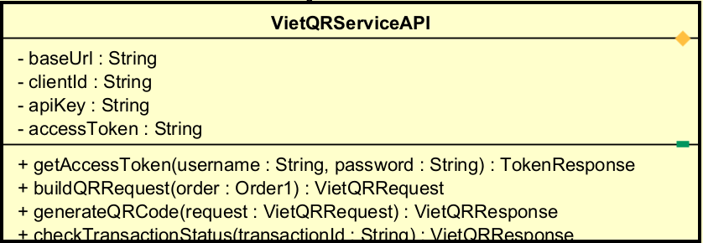
Description: Pure HTTP client for the VietQR API. Manages the access token, constructs request objects, dispatches HTTP calls, and parses JSON responses into entity objects. Contains no business logic.

Table 1. Example of attribute design
# | Name | Data type | Default value | Description
1 | baseUrl | String | "" | Base URL of the VietQR REST API.
2 | clientId | String | "" | Client ID credential for authentication.
3 | apiKey | String | "" | API key credential for authentication.
4 | accessToken | String | "" | Bearer token stored after a successful getAccessToken call.

Table 2. Example of operation design
# | Name | Return type | Description (purpose)
1 | getAccessToken | TokenResponse | Sends a POST to the auth endpoint and stores the token.
2 | buildQRRequest | VietQRRequest | Constructs a VietQRRequest from an Order. Issues no HTTP call.
3 | generateQRCode | VietQRResponse | Sends a POST to the QR-generation endpoint and parses the JSON response.
4 | checkTransactionStatus | VietQRResponse | Sends a GET to the transaction-status endpoint and parses the JSON response.

Parameters :

Parameter | Type | Constraint
username | String | Authentication username (clientId-based).
password | String | Authentication password (apiKey-based).
order | Order | Must have amount > 0 and a non-null orderId.
request | VietQRRequest | Pre-built object produced by buildQRRequest().
transactionId | String | Non-blank VietQR transaction identifier.

Exceptions:

Exception | Condition
PaymentException | Raised when the HTTP status is not 200 (getAccessToken, generateQRCode).
PaymentException | Raised in buildQRRequest when order.amount ≤ 0 or order.orderId is null.
InvalidTransactionException | Raised in checkTransactionStatus when VietQR returns HTTP 404.
PaymentException | Raised in checkTransactionStatus for any other HTTP error.

Methods:
- getAccessToken: posts credentials to the auth endpoint, stores the resulting bearer token, and returns a TokenResponse. Raises PaymentException if the response status is not 200.
- buildQRRequest: Validates order fields and constructs a VietQRRequest from order data and static configuration (bank code, account, holder name). Does not communicate with the network.
- generateQRCode: Attaches the stored bearer token as an Authorization header, serialises the request to JSON, and posts to the QR-generation endpoint. Returns the parsed VietQRResponse; raises PaymentException on a non-200 status.
- checkTransactionStatus: Attaches the stored bearer token and issues a GET to the transaction endpoint. Returns the parsed VietQRResponse; raises InvalidTransactionException on HTTP 404, or PaymentException for other HTTP errors.

Design for class “QRCode”
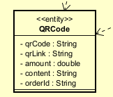
Description: Immutable domain entity representing the QR code returned to the caller. Carries all information required to display a payment QR code to the end user.
Table 1. Example of attribute design
# | Name | Data Type | Default | Description
1 | qrCode | String | "" | Base64-encoded QR code string.
2 | qrLink | String | "" | Direct URL to the QR image (used in an <img> element).
3 | amount | double | 0.0 | Payment amount in VND.
4 | content | String | "" | Payment content embedded in the QR.
5 | orderId | String | "" | Order ID linking the QR to the transaction.

Table 2. Example of operation design
# | Name | Return Type | Description
1 | QRCode | void (constructor) | Creates the entity; validates that qrCode and qrLink are non-blank before assigning all fields.

Parameters :
- qrCode : String, Non-null, non-blank.
- qrLink : String,Non-null, non-blank.
- amount : double, Payment amount in VND.
- content : String,Payment description.
- orderId : String, Order identifier.
Exceptions:
- IllegalArgumentException Raised by the constructor when qrCode is null or blank
- IllegalArgumentException Raised by the constructor when qrLink is null or blank
Methods:
- Constructor : Validates that qrCode and qrLink are each non-null and non-blank, then assigns all fields. The object is immutable after construction.

Design for class “VietQRRequest”

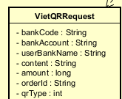
Description: Data Transfer Object serialised to a JSON body when calling the VietQR QR-generation endpoint. Fields map directly to the VietQR API contract. Created exclusively by VietQRServiceAPI.buildQRRequest().

Table 1. Example of attribute design
# | Name | Data Type | Default | Description
1 | bankCode | String | "" | VietQR bank code (e.g. "VCB", "TCB").
2 | bankAccount | String | "" | Destination account number.
3 | userBankName | String | "" | Account holder name.
4 | content | String | "" | Payment description (max 50 characters per VietQR spec).
5 | amount | long | 0 | Payment amount in VND (whole number, no decimals).
6 | orderId | String | "" | Order ID for reconciliation.
7 | qrType | int | 0 | 0 = dynamic QR, 1 = static QR.

Table 2. Example of operation design
# | Name | Return Type | Description
1 | VietQRRequest | void (constructor) | All-args constructor; assigns all fields.

Parameters :
- bankCode, bankAccount, userBankName, content : String
- amount : long
- orderId : String
- qrType : int
Methods:
- Constructor : Directly assigns all supplied parameters to the corresponding fields. No validation is performed; validation is the responsibility of VietQRServiceAPI.buildQRRequest().

Design for class “VietQRResponse”
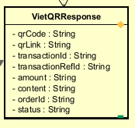
Description: Holds the parsed JSON response from the VietQR API, covering both QR generation and transaction-status queries. VietQRGateway reads this object and maps it to the appropriate domain object (QRCode or PaymentStatus).

Table 1. Example of attribute design

# | Name | Data Type | Default | Description
1 | qrCode | String | "" | QR code string (present in generateQRCode responses only).
2 | qrLink | String | "" | QR image URL (present in generateQRCode responses only).
3 | transactionId | String | "" | VietQR-internal transaction ID.
4 | transactionRefId | String | "" | Merchant-side reference ID for reconciliation.
5 | amount | String | "" | Amount as a string per API contract (requires parsing before use).
6 | content | String | "" | Payment description echoed from the request.
7 | orderId | String | "" | Order ID echoed from the request.
8 | status | String | "" | Transaction status: "SUCCESS" | "FAILED" | "PENDING".

Table 2. Example of operation design
# | Name | Return Type | Description
1 | VietQRResponse | void (constructor) | No-args constructor for JSON deserialisation (setter-based).
2 | isSuccess | boolean | Returns true when status equals "SUCCESS". Convenience method for VietQRGateway.

Methods:
- isSuccess : Returns true if and only if the status field equals the string "SUCCESS".

Design for class “TokenResponse”
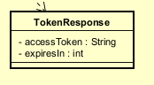
Description: Carries the bearer token returned by the VietQR auth endpoint. Used by VietQRGateway to confirm that authentication succeeded before issuing subsequent API calls.

Table 1. Example of attribute design
# | Name | Data Type | Default | Description
1 | accessToken | String | "" | Bearer token used in the Authorization header.
2 | expiresIn | int | 0 | Token lifetime in seconds (e.g. 3600).

Table 2. Example of operation design

# | Name | Return Type | Description
1 | TokenResponse | void (constructor) | Constructor accepting accessToken and expiresIn.
2 | isValid | boolean | Returns true when accessToken is non-null and non-blank.
3 | getAccessToken | String | Returns the accessToken value. Used by VietQRServiceAPI when building the Authorization header.

Methods:
- isValid : Returns true if and only if accessToken is non-null and non-blank.
- getAccessToken : Returns the stored accessToken string.

